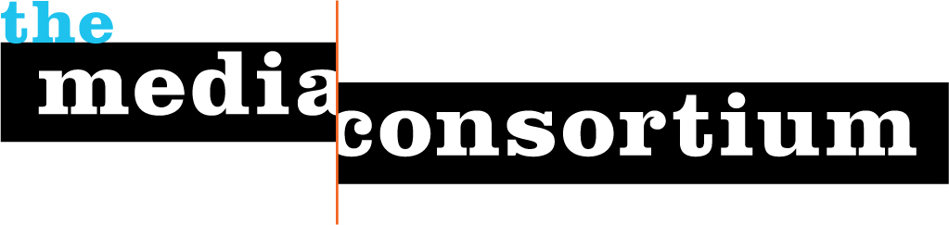

For Immediate Release: April 9, 2012
Contact: Jo Ellen Green Kaiser, Executive Director
joellen@themediaconsortium.com/ 415-878-3862

Press Background Briefing on April 11, 3pm ET:
Will Your City Have Community Radio?
With Prometheus Radio’s Brandy Doyle

Even in this digital age, radio remains an essential media tool for building community capacity. In the words of Chris Arsenault, ‘community radio gives marginalized people the tools they need to tell their stories.” (Rabble, 2010). Ninety percent of Americans listen to radio at least once a week. Community radio is particularly important for ethnic and immigrant communities, particularly communities where the first language of most speakers is not English. Yet, until the passage in 2010 of the Local Community Radio Act, people living in urba markets could not apply for low power fm (LPFM). Now, two years later, the FCC has finally announced it will accept new applications for LPFM stations by the end of this year. Yet, will those licenses actually go to all urban communities? Not unless advocates succeed in changing FCC rules to give those applicants a better shot.
As part of its Media Policy Reporting and Education Project, The Media Consortium, a national network of over 60 leading independent media outlets, has assembled an in-depth press briefing on LPFM licensing. This background briefing is designed to help journalists understand the LPFM landscape, who is most likely to apply for licenses, and the roadblocks still in the way of ethnic and immigrant urban organizations seeking community radio in metro areas. All journalists are invited to attend.
Registration for this briefing is now open at http://www.anymeeting.com/PIID=ED54DD82864C
The briefing will begin with expert Brandy Doyle, Policy Director at Prometheus Radio, who will provide background and explain why advocacy groups are concerned about the FCC rulemaking process. After she speaks, we will hear comments from Luis Avila, producer for El Break Radio in Phoenix, Arizona. Journalists will have ample opportunity to ask questions. The briefing will last one hour.
Brandy Doyle is Policy Director at the Prometheus Radio Project, where she leads the organization's advocacy on behalf of community radio and democratic media. The Prometheus Radio Project has been the leading advocate for low power community radio since 1998. Prometheus led a decade-long grassroots campaign to pass the bipartisan Local Community Radio Act, succeeding in 2010. Over its history, Prometheus has supported hundreds of communities in licensing, building, and operating their own radio stations.
Luis Avila is a producer with El Break Radio in Phoenix, Arizona. El Break engages and informs immigrant youth with thoughtful, entertaining radio about the Latino experience in Arizona. The organization also provides scholarships for undocumented youth. El Break is working with other immigrant rights organizations to apply for a low power license in Phoenix.
Mahamed Cali is executive director of Somali American Community of Minneapolis. The Somali American Community of Minneapolis welcomes Somali immigrants to the Twin Cities, helping them to settle, go to school, gain citizenship, and get the services they need. More than 100,000 Somali immigrants live in Minnesota, with more than 50,000 in the Twin Cities. Mahamed Cali and the Somali American Community of Minneapolis organized their community to help pass the Local Community Radio Act, and have been working towards a radio license for more than two years while purchasing time on a local station.

The Media Consortium is a national network of leading, progressive independent media. Our members include magazines, web sites, television networks, radio, and film producers. www.themediaconsortium.org Our thanks to the Media Democracy Fund for making this policy briefing and MPREP program possible.

