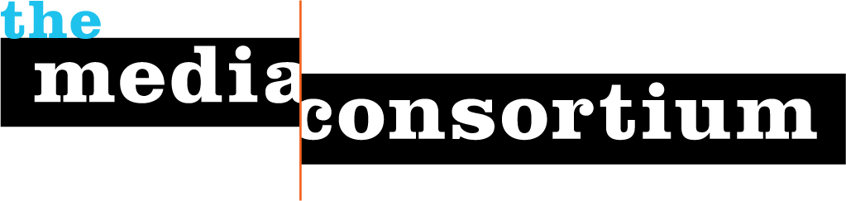

25 January 2008

Lynne Rosenthal
Leo S. Guthman Fund
495 Westover Road
Stamford, CT 06902

Dear Lynne,

Thank you for your generous contribution of $5,000 to Live from Main Street with Laura Flanders, a project of The Media Consortium. We’re excited about the project’s progress and will be sure to keep you apprised of any future developments.

Your contribution is helping build a healthy future for progressive, independent media. The Media Consortium is dedicated to fostering collaborative work amongst progressive media outlets with the belief that now is the time to reach out and change the debate in this country. For more information, please visit www.TheMediaConsortium.org.

On behalf of the Media Consortium and its member organizations, I thank you.

Sincerely,
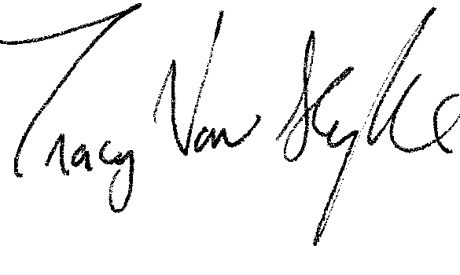
Tracy Van Slyke
Project Director/The Media Consortium

