Kathlyn Stone Responses to Media Consortium Questionnaire
- Tell us about your organization’s mission and vision.
Flesh and Stone is a public interest news site delivering informative, independent reporting on health care and science news, trends, and commentary. We look at how medical and scientific discoveries are influenced by politics and the economy.
Our sources are experts in their fields. Contributors are writers, physicians, researchers and patients providing different perspectives on the issues. We encourage health and science policy discussions that may influence positive policy changes. We envision a site where contributors and readers share views and ideas for the betterment of society in an open dialogue. We hope to especially engage women in health policy discussions since research shows most of the health-related news geared for women does not take into account political or economic influences.
Another goal is to generate enough revenue to support and encourage other independent writers by providing a stipend for their work.
Why do you want to join The Media Consortium?
My main reason for wanting to join the consortium is to support independent media. Flesh and Stone is a news web site, not a blog. However, a small operation in a Midwest state providing news has an uphill challenge being heard and viewed as a news site instead of a blog. Networking with other independent journalists and organizations that can share content and build awareness in collaboration seems like an ideal way to go about supporting independent media.

Corporate or mainstream media has let citizens down in so many instances. Its slanted coverage of the invasion and occupation of Iraq, its neglect in adequately covering the breakdowns in our electoral system, and the lack of investigations into criminal behavior by elected officials and media self-censorship have left many Americans uninformed or misinformed about important events and policies. I believe people want higher standards of journalism and free and vigorous national debates. Therefore I support the Media Consortium’s operating principles.

- How do you see your organization as a fit for The Media Consortium?

Flesh and Stone is a niche media source. The focus is on health and science. I can only cover a small percentage of the many developments in health and science, but with the help of researchers, doctors, medical students, patients and other professional writers I can add depth and present other perspectives. I watch how corporate media covers medical news and health and science policies and where coverage is lacking, and try to fill in the blanks, dispel stereotypes and bring a new, progressive perspective.

Through syndication services (BlogBurst and Newstex) Flesh and Stone articles are regularly republished on mainstream media sites including Chicago Sun Times, Time Warner publications, Dayton Daily News and other coxohio.com sites, Reuters, Wall Street Journal, Houston Chronicle and even Fox News.com. Getting progressive voices published in mainstream sites should be seen as a positive step.

Some articles distributed to mainstream sites during the last 2 weeks.
Article Title | Post Date | Publisher | Post Views | View On Site
Health reform director’s industry ties quest | 7/3/2009 | Chicago Sun Times | 3 | View
Iranian-Americans send message of solidarity to pr | 6/25/2009 | Time Warner | 2 | View
At FDA, fewer inspectors trace more device complai | 7/7/2009 | Chicago Sun Times | 1 | View
How will Universal Health Coverage Affect Native A | 6/24/2009 | Time Warner | 1 | View
How will Universal Health Coverage Affect Native A | 6/24/2009 | Chicago Sun Times | 1 | View
Iranian-Americans send message of solidarity to pr | 6/25/2009 | Chicago Sun Times | 1 | View
Novelist accurately portrays semantic dementia dec | 6/1/2009 | coxohio.com | 1 | View
Shifting dental care to the ER could further decay | 4/16/2009 | coxohio.com | 1 | View

- How would you describe your primary audience in terms of size, diversity/demographics, lifestyle and geography?

I use several analytic and tracking tools but cannot attest to the accuracy of any one of them. Flesh and Stone went live in February 2008 and has enjoyed slow but steady growth. The site draws more women to articles on medical safety issues and new developments in health care and men tend to respond to more politically charged or controversial issues. In general, the audience is equally balanced between men and women and draws readers from every state. (See chart below. As of 7/12 I have not yet had a visit from Montana but there are 3 weeks to go.)

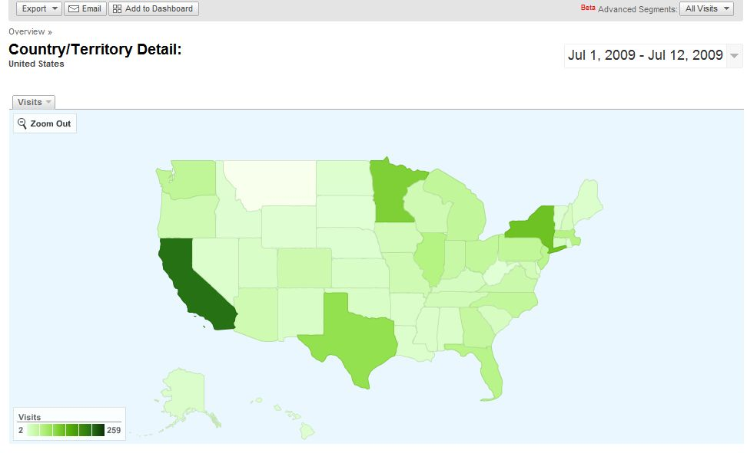

Ages range from 35 to 50+, with a higher preponderance of visitors with college degrees or advanced college degrees, and from the lowest and the highest income groups. People who visit Flesh and Stone are also interested in science/nature, politics/commentary, non-profits, children, religion, science and technology, schools/universities, children’s education, home and gardening, and family and geology.

Awstats:

Month | Unique visitors | Number of visits | Pages | Hits
Feb 2009 | 5247 | 9279 | 38631 | 95562
Mar 2009 | 6934 | 12344 | 56048 | 139696
Apr 2009 | 6399 | 13104 | 57109 | 134139
May 2009 | 6216 | 12680 | 66349 | 137588
Jun 2009 | 7562 | 15385 | 92811 | 215325
Jul 2009 | 4024 | 7202 | 37347 | 105882

Quantcast: Monthly Traffic

 | People |  | Page Views
US | 2.5K |  | 5.7K
GLOBAL | 3.5K |  | 7.0K

Google Analytics Page Rank: 4
Alexa traffic rank for fleshandstone.net as of 7/12/09: 603,475

- What is your operating budget?

I have invested several thousand dollars into site design, developer fees and hosting as well as countless hours of writing, editing and image acquisition. Currently I am generating about $100 monthly in Google ad clicks and a few dollars a month in syndication fees. I am not making a profit but I’m not at all dissuaded. Despite the lack of an advertising campaign or sponsorships the audience continues to grow. I’m committed to growing Flesh and Stone as a widely read and credible source for health and science news. I believe the revenue will come eventually.

- What are your primary platforms? (e.g., print, radio, online, video, tv, books, social networks, etc.)

Primarily online and through social networking sites. I recently was a guest on Mike McIntee’s (of The Uptake) Air America program and would be interested in discussing health and science issues on air more in the future.

- How do you reach your audience? Please list subscriptions, online presence, listservs, or any other platforms (e.g., YouTube, MySpace, FaceBook) that your organization uses to engage your audience.

Association of Health Care Journalists, members’ listserve

I regularly post articles on Facebook, Twitter, digg, delicious, Stumbleupon, Friendfeed, Blog Catalog, Wikio, Newstin, and a few others.

My articles are also syndicated by BlogBurst and Newstex (which includes Lexis-Nexis), and indexed by Google.

I have a blog on TPM, and contribute stories to Twin Cities Daily Planet, Huffington Post, Natural News, Media With Conscience, Digital Journal, Oh My News International, and a few others and have had articles published in CounterPunch and truthout.

In addition, as a free lance health and science writer, I write breaking news and features for the medical trade press and cover medical conferences for online sites. In this way I am sometimes able to introduce a progressive viewpoint to a physician/scientific research audience.

- What infrastructure is your organization looking to build? (e.g., advertising, web strategies, editorial planning, etc.)

All of the above. I’m also plan to invest time into learning more about advertising strategies and funding options for independent news media whether it be advertising, foundations or sponsorships.

- Does your organization have any areas of expertise that could be helpful to The Media Consortium and its members?

See #7. In addition to syndication of articles appearing on Flesh and Stone, I’m a health and science journalist with decades of reporting experience and insight. In previous jobs I have been a media relations manager and a communications director so I may be able to assist the Consortium with awareness-building strategies. I was also a founding board member of an international non-profit, the Project Management Institute Health Care Group, so I understand the process of building a non-profit.

- How does your organization fit into the progressive media network? (e.g., media producer, distributor, monitor, reform/justice, etc.)

Media producer and distributor. I have been active in media reform efforts, both nationally and locally, and attended two national conferences on media reform sponsored by Free Press, of which I am a member. I also disclose that I have been active in election reform efforts as the media coordinator for Citizens for Election Integrity Minnesota, and am a past board member of Women Against Military Madness.

- Is your senior management willing and able to contribute to Consortium discussions, meetings, and projects?

Yes. I have published two Weekly Pulse articles and have recently started submitting articles to The Ladder. I would be available to participate in other discussions and projects and could commit to at least one meeting a year.

- Who will be the primary MC contacts for your organization? (We recommend having one editorial contact and one business contact.) These representatives will be expected to attend MC meetings, convey pertinent information regarding our projects to your staff, and ensure that your organization is involved in MC-related projects and conversations. If these contacts are unable to participate, who will be serve this role in their place?
Primary: Kathlyn Stone, Editor and Publisher
There are some regular contributors to Flesh and Stone that I could ask to participate in an event or planning discussion if I am unavailable. But for all practical purposes, Flesh and Stone is presently a one-woman shop.

