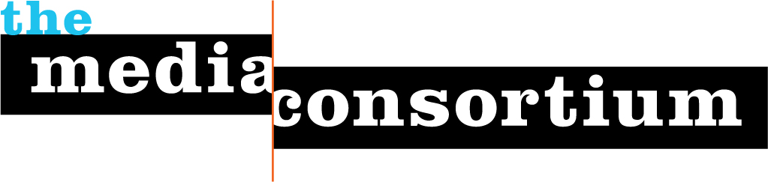

Come to the 8th Annual Media Consortium Meeting
Make an Impact
February 6-8, Baltimore, MD

Who: The 58 current members of the Media Consortium, plus a few special guests!

What: We will share skills, learn new ideas, and identify concrete strategies for making impact! Get ready for sessions on mobile strategy, organizing a multi-partner collaboration, advanced analytics, and much more!

PLUS, this year we are offering a pre-meeting on February 6 from 10-5 for those of you who publish in print. Even if you don’t go to the pre-meeting, come in Feb 6 for a cocktail party Wednesday night!

Where: The Wyndham Peabody Hotel, located in the cultural and civic center of Baltimore. Act now to reserve your $109 room (includes wireless and breakfast—scroll down and click the second “reserve” button)!

When: The meeting proper begins promptly at 8:30 am on February 7 and ends with a business meeting for TMC members in good-standing on February 8 from 12-3:30. In between, you’ll get cutting-edge talks on business, technology and editorial strategies, time to interact with your peers, plus a cocktail party + film event!

Why: Nothing beats face-to-face, in-depth conversations with your colleagues. The Media Consortium’s annual meeting brings together everyone you want to talk to, learn from, & negotiate with, all in one time and place.

How: Registration fees for this meeting are included in member dues. So TMC members, all you have to do is pay your dues, and fill out our registration form.

What if I’m not a TMC member? Good news! For the first time this year, we are opening our annual meeting to up to 15 non-members. To apply for one of these spots, please fill out this form. Conference fees for non-members will be $250/outlet, which includes lunch Feb 6 & 7 and registration for two staffers.

