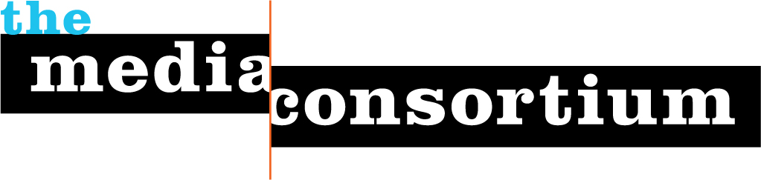

Finding Campaign Cash Ad Buys Outside the Major Media Markets
A presentation on recent research by Free Press

Tuesday, September 11
3:00 ET
Conference Call: 309-944-9515
Participant access code: 617 9505

Who is behind the big political ad buys? The FCC now mandates that broadcasters in the top 50 media markets disclose who's paying for political ads--but a lot of the action is happening outside those markets, especially in swing states. Luckily, Free Press staffers have been getting some answers. On this call, Free Press staff will tell you which small markets are stuffed with superpac ads, who is making the most ad buys, and how you can get more information.

This briefing is required for current Media Policy Reporters. All other reporters welcome to attend. Please register at http://www.anymeeting.com/PIID=E150DC81804B

