No Secrets: Journalism in the Age of Surveillance
University Center Conference Center
February 27, 2013
Sponsored by Chicago-Kent College of Law
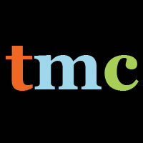
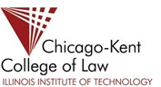
8:00 Coffee/ Pastries

8:30 Welcome
Jo Ellen Green Kaiser, Executive Director, the Media Consortium
Linda Jue, George Washington Williams Center for Independent Journalism

9:00 More than a Face: What Social Media Know About You
Lori Andrews, Director, Institute for Science, Law, and Technology, IIT

10:00 Coffee Break

10:15 Citizen Journalism and Police Surveillance
Moderator: Tim McNulty, Co-Director, National Security Journalism Initiative at Northwestern Univeristy, Medill School of Journalism
amalia deloney, Associate Director, Center for Media Justice
Josh Stearns, Press Freedom Director, Free Press

12:00 Lunch

12:30 Why NSA Surveillance Matters
Moderator: Laura Flanders, Grit TV
Gavin MacFayden, Director, Centre for Investigative Journalism, City University, London
Bea Edwards, Director, Government Accountability Project

1:30 Ignite-Style Talks on Tools: Moderator Daniel Massoglia

2:00 Hands-On Learning
Featuring stations that people will rotate through all afternoon

- Learn PGP with Joel Luellwitz, Jennifer Helsby and Freddy Martinez
- Learn Tor with Kelley Misata, Founder of the Tor Project
- Learn about Instacam & Obscuracam with Diana Del Olmo, Guardian Project
- Learn Secure Drop and Surveillance Self-Defense with Eva Galperin, EFF
- One-on-One help for your security issue

4:00 Closing Discussion: Resources
4:30 Free Screening: Shadows of Liberty, Courtesy of Bullfrog Productions

