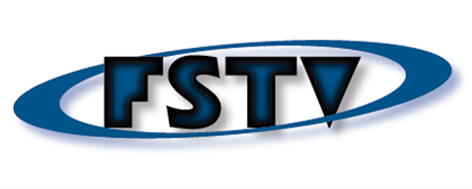

October 4, 2007

Dear Laura,

I’m writing in support of your Media Consortium proposal for a series of multi-media Town Halls leading up to the 2008 Presidential Elections. I truly believe that this project, if it gets the support it both deserves and needs, will be an historic step for independent media in the U.S. And I know I don’t need to tell you that we need that step now more than ever.

I’m particularly interested in making sure that there is a national television outlet available for these events. The majority of people in this country still get their news from television. No matter what you care about — war or abortion rights, the environment or economics — television influences the perceptions of citizens and politicians. Information is the lifeblood of democracy, and when viewpoints are cut off and ideas can’t find an outlet, democracy suffers. Today, 5 corporations control the media in the U.S. But they don’t control independent media. This project, if it’s pulled off, would generate a critical mass of independent platforms, the kind that could transform our atomized efforts into a force that can compete with corporate news outlets, and effectively shift debate in our national public discourse.

Free Speech TV is very enthusiastic about this project, and I’m willing to bet that our viewers and our funders will be as well. As you know, Free Speech TV is a public interest, non-commercial network. We reach some 30 million homes across the U.S via satellite on DISH Network (channel 9415), and on 175 community cable stations.

Please keep me apprised of your efforts, and best of luck to you and the team on this project.

Sincerely yours,

Eric Galatas
Free Speech TV
Program Director

Free Speech TV - P.O. Box 44099 Denver CO 80201 - 303.442.8445 - www.freespeech.org

