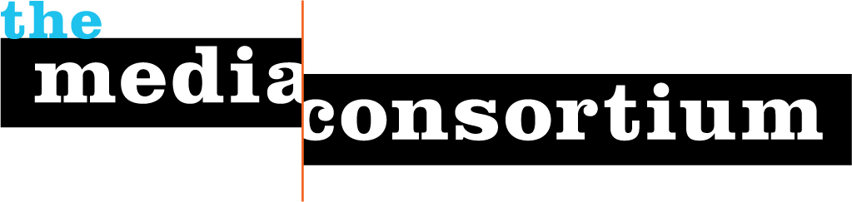 &

Reporter Education and Training Project
An Overview

Purpose: The goal of the Environmental Reporting and Education Project (ERE Project) is threefold: (1) to train independent and mainstream journalists in varying fields to integrate environmental content and (2) to facilitate increased dialog between environmental policy organizations and reporters, and (3) to engage media-industry focused journalists in covering the mainstream media’s lack of environmental reporting.
Need Paragraph/Statement?
The partnership scales-up and expands an existing journalism training program that has been in operation since 2011 for independent news organizations and run by the Media Consortium. The Media Consortium (TMC) is a national network of 58 independent news outlets, including Grist, Mother Jones, Free Speech Radio News, Yes!, Democracy Now!, In These Times, The Nation, and many others and reaching collectively, a US audience of 80 million. The mission of the Media Consortium is to support and grow the independent media sector. The Project for Improved Environmental Coverage (PIEC) is working to catalyze improved environmental coverage in the mainstream news media. The program is in the midst of implementing a multi-year initiative that is drawing attention to the lack of coverage and engaging a wide range of news organizations to measurably innovate.
The ERE project ’s structure on the reporting side is simple: Independent and mainstream outlets will enroll reporters in the program which offers up to 12 webinar-style press briefings per year on the intersection of environmental issues and a range of issue areas (security, health, economy, technology, public affairs, etc.). Additionally, two webinar briefings will focus on the lack of environmental coverage in the news and be designed for media writers and critics. Nonprofit outlets may also receive a minigrant to participate in the program. PIEC and TMC staff will identify the organizations and issues most ripe for the reporting project, and use this information to create briefing materials and trainings for reporters. Participants will be encourage to write at least 1-2 stories and provided with technical assistance if necessary.

The Media Consortium has had success with exactly this kind of project through its Media Policy Reporting and Education Project. Through MPREP, the Media Consortium trained reporters at 12 outlets, pushed out over 130 stories on media policy, and reached over 1.7 million people. TMC brought together eleven different media policy organizations to participate in briefings and to provide mentorships to reporters. As a result, in the words of amalia deloney from the Center for Media Justice, MPREP has enabled advocacy organizations to “deepen and broaden their reach and impact.”

Benchmarks Section Here:

Issue and Organization Integration:
As mentioned earlier, one of the primary objectives of this partnership is to engage journalists and news organizations that don’t traditionally cover the environment and to facilitate connections between civil society experts and reporters. To this end, some of the prospective topics and organizational partners include:

Government/Policy:
Issues: Environmental ramifications of varying policies at the federal and state levels
Prospective Partners: Apollo Alliance, Union of Concerned Scientists, (JE: others?)

Security:
Issues: Where are the intersections between environmental innovation and military policy and spending
Prospective Partners: National Priorities Project, New America Foundation, Rocky Mountain Institute, others

Health:
Issues: What are the myriad ways in which health and environmental issues are connected
Prospective Partners: Environmental Working Group, Safer Chemicals Healthy Families Coalition, others

Economy/Jobs:
Issues: Jobs potential for the full build-out of the green economy with sector-specific and scaling inquiry
Prospective Partners: Green For All, Living Economies Forum, Columbia University, Natural Capitalsim Inst.

International:
Issues: Success models in other countries (ex: Sweden 50% wind, China & solar), indigenous impacts, etc.
Prospective Partners: Worldwatch, Global Footprint Network, Amazon Watch,

Paragraph talking about the power of this approach w/ testimonials?

The ERE Project is a true win-win-win. The convened policy and advocacy organizations benefit both from working more closely with each other on this project, and also from developing relationships with a wide range of reporters. Reporters benefit by learning more about the intersection of environmental and other policies; by developing sources at policy organizations; and by receiving briefings they can easily turn into stories. SEE Innovation and the Media Consortium benefit by fulfilling our respective missions. Most of all, the public benefits by learning why environmental issues really do impact them at home, at work, and in the course of their lives.

We appreciate you taking the time to learn more and look forward to providing more information.

