The Big Thaw
Charting a New Future for Journalism

A guide to the evolution of independent media

Game Changer Box Set

Vol. 1 | Beyond the Old Media Paradigm
Vol. 2 | Dissonance & Opportunity
Vol. 3 | The Future?

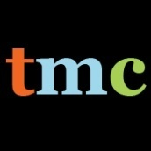

The Media Consortium
www.themediaconsortium.org

By Tony Deifell, Q Media Labs

July 2009
Revised 9/09

Acknowledgements
Special thanks to Nicole Anne Boyer of Adaptive Edge
for partnering on this project and to Jessica Clark, Steve Moss,
Erin Polgreen, Ben Rigby and Tracy Van Slyke for review and editing.

Welcome to the The Big Thaw. It's an apt metaphor for journalism’s current environment: As the business and editorial structures that have historically sustained media melt away, new innovations in reporting and monetization are rapidly reforming the business. But a key question remains: Can media producers adapt and lead this evolution, or will they disappear with Journalism’s Ice Age?
The Media Consortium (TMC), a network of the country's leading progressive, independent media outlets, commissioned this report because we want to lead our members and other independent media outlets into a new era of sustainable and powerful journalism.
Media Consortium members share a belief in the common good that unites us all. However, we define “progressive” broadly, as many individuals and organizations relate to the term differently. Our members actively champion to hold government, corporations and other institutions accountable. Our journalism illuminates issues related to social, racial and gender justice.
Progressive media outlets produce journalism that is a vital part of a flourishing democracy. The progressive media sector is highly influential and can reach and inform tens of millions of actively engaged citizens on a daily basis. In 2006, 16 TMC members submitted their various constituency lists—including subscribers, donors, registered online users and newsletter subscribers—to Paradyz-Matera, a third-party list-management analysis firm. Participating organizations had a combined list size of 2.9 million confirmable names, which didn't even include the millions of radio listeners, television audiences, website visitors, newsstands purchasers and more. What’s more, there was only a one in four overlap of names matched to two or more members.
In 2009, Catalist, analyzed almost one million names from another group of 15 consortium members and matched them with their database of 250 million voting-age citizens. They found that 72% participated in the 2008 General Election, compared to just over 60% of U.S. registered voters and represented a wide range of the voting-age population.
These numbers demonstrate the significant influence and reach of the progressive media. But to survive and thrive after the thaw, media-makers need to shift their understanding of journalism: Who produces it, what the audience wants, and how they want to consume it. Media organizations must match their production and delivery strategies to new consumer demand, technology and business models. Now is the time to stretch creative boundaries and evolve so that we can strengthen independent journalism for the long-term.
Now is our time to thrive. I invite you to join us in charting a new future for journalism.
Sincerely,

Tracy Van Slyke
Executive Director, The Media Consortium

How to use this report
The Big Thaw is a “box set” with three volumes that can be used separately.
- Vol. 1: Beyond the Old Media Paradigm
This volume focuses on our research’s implications, plus project ideas for The Media Consortium (TMC), collected from people from both inside and outside the consortium. The volume can be viewed as a compendium of potential solutions, a dynamic roadmap for going forward or a tool for strategic conversations as TMC builds a shared vision for the future. This volume is for internal TMC use only.
Quotes in the Big Thaw are from original interviews listed in Appendix A unless otherwise noted.

- Vol. 2: Dissonance & Opportunity
This volume focuses on in-depth analysis that compares journalism’s old paradigm to its emerging realities. Vol. 2’s analysis is intended to benefit individual TMC members and other media organizations as they adapt to the changes around them.
- Vol. 3: Future Uncertainties & Possibilities
This volume surfaces some key uncertainties and future possibilities that are important to consider and may change the game further in coming years.

While much of the analysis focuses on journalism, the implications span all types of content and forms of media.
You could use the Big Thaw in the following ways:
- Tool for internal planning and strategy
The New Competencies chapter in Vol. 2 and its summary of shifting roles on page 41 can be used to assess your organizational structure and the human resources needed to succeed in the new competitive landscape. The New Sources of Value chapter can help you prioritize the products and services you provide and the New Business Models chapter to structure your organization financially.
- Conversation starter among staff, board or other key stakeholders
Appendix B includes a worksheet for facilitating group discussions. The worksheet includes four provocative statements, based on our research, to spark debate—feel free to add others. Use this process to identify the implications of the new industry dynamic on your organization’s future strategies.
- Tool for innovation
Use Vol. 3, Future Possibilities to help create new business models, product strategies and operating tactics. This volume only begins to identify potential game changers, but it can be used as a starting point for you to identifyothers.
- Knowledge development
Share selections of the Big Thaw with staff members who want to learn more about the changing media industry. You could also conduct further research on areas of particular interest to your organization.
- Partnership development
Use the Competitive Landscape chapter in Vol. 2 to explore the types of partnerships you could build to succeed.
- Funder conversations
Share the Big Thaw with funders that are interested in learning about new media’s emerging realities and may want to explore your organization’s role in the new media environment.
- Online discussion
Share portions of the Big Thaw with your users to engage them with the industry’s shifting dynamics and solicit comments and discussion to further your strategic thinking.
For online discussion or to download copy of The Big Thaw: www.themediaconsortium.org/thebigthaw

Table of Contents
The Big Thaw: Charting a new Future for Journalism
Game Changer Box Set

Executive Summary i
Introduction: Strategic Dissonance vi
Box Set Vol. 1
Beyond the Old Media Paradigm
New Strategic Intent & Actions Ideas 1-17
Box Set Vol. 2
Dissonance & Opportunity
Old Paradigm of Journalism 1
New & Emerging Realities 6
CHAPTER 1
NEW COMPETITIVE LANDSCAPE:
How is the playing field changing? 8
New abundances & their effects 10
New scarcities & their effects 11
Device proliferation, convergence & their effects 13
Dawn of a demographic revolution 14
Next phase of globalization & its effects 15
Declining institutional control & affiliations 17
Mirage of The Long Tail 18
CHAPTER 2
NEW COMPETENCIES:
What new capabilities are needed to succeed? 22
Getting serious about community 24
Strategic technology 25
Being multiplatform 26
Tightly integrating functions 27
Experimentation 27
Counterintuitive ways of working 27
Shifting roles 29
CHAPTER 3
NEW SOURCES OF VALUE:
What needs can be met, problems solved or desires met? 31
Progressive ideas 33
“My ideas” 33
Now is the time for immediacy 34
Solving filter failure 35
From using users to a Conversation Economy 36
From audiences to communities 37
CHAPTER 4
NEW BUSINESS MODELS:
How are media organizations structured to capture value? 40
Emerging operation models & cost structures 42
Emerging revenue models 43
Diversification & tension 49
Box Set Vol. 3
The Future?
Future Uncertainties
What don’t we know? 2
How will consumers act? 2
What trends will last?
What will happen to serious news?
Will online media broaden or narrow perspectives?
Will online media help or hurt democracy?
What will happen with paper? 6
How will the big players affect the game? 6
What will commercial media & technology companies do?
What role will government play?
Will philanthropy adjust its role?
Future Possibilities
Mobile mass-media 13
Multisensory web 13
Rise in alternatives economies 15
Human-centered design 15
Location based mobile 16
Social reading 17
Radical new ways of meaning making & filtering 16
New value chain of journalism 21
Real identity & converting reputation 27

Conclusion

Appendices
A. List of participants & process
B. TMC members’ discussion summary
C. TMC history & membership
D. Guidelines for generating game changing ideas
E. Innovators to watch
F. Notes & sources

Executive Summary

PHOTO
This page has limited text so the designer can make a transition page here using a large photo. Example of great transition pages:
http://digitaloutlook.razorfish.com/publication/?i=13617

The photo can take the whole page,
I just have this here as a place marker.

“No society in history has ever existed without storytelling. [Storytellers] tell stories that are true and important. Sure, there may be many distinctions between professionals and amateurs, between breaking news and follow up pieces, between long or short, and so forth. But these are just artifacts of production methods rather than deep truths. And we have to have truth tellers.”
– Clay Shirky

Journalists and independent media makers will always be society’s most valuable truth tellers. However, the old media system that historically supported them is melting away. Some outlets have succumbed to the old system’s big thaw and shut down or drastically cut news operations. Others have made small changes to their journalism and business models that will keep them afloat one more day.
The Big Thaw: Charting a New Future for Journalism focuses on how independent media organizations can navigate the currents of change to reach higher ground over the long term.

“While changes to the news industry advanced at a glacial pace for many years, [...] transition can come as quickly as the levees that broke in New Orleans. Trigger events cause sudden floods before a new system is in place to prevent it. News organizations are facing flash floods and many are in a mode akin to sudden-death, wilderness survival. Laurence Gonzalez, in his book, Deep Survival: Who Lives, Who Dies, and Why, explained that those people who most quickly surrender to their new circumstances, take decisive action, and believe anything is possible are the ones most likely to survive. Each independent media organization must answer two questions in order to survive, 'What will you be standing on when the flood reaches you?' and 'How will you boldly move to higher ground?’”
– The Big Thaw, Vol. 1, p4
Although many see this moment as a meltdown, it is an opportunity. Much like the annual flooding of the Nile, media’s big thaw has the potential to revitalize the landscape. Our means of using information are changing, and great opportunities lie ahead.
- Mobile devices are transforming our relationships with people, events and places.
- Everyone can gather, share and produce news.
- U.S. demographics and global audiences are revolutionizing the media marketplace.
- New types of media-makers are pursuing journalism’s public-service aim in brand new ways.

Between 2008-09, The Media Consortium (TMC), a network of 45 leading independent media organizations, conducted a Game Changer Strategy Project that resulted in this report. A broad array of information was collected via scenario building, member surveys, interviews with outside thought-leaders and a scan of current reporting and commentary. The project’s goal was to enable TMC and its members to make bold moves that increase their impact and influence by reaching five times their current collective audience within the next five years. A proxy for TMC’s collective online reach as of June 2009 was 17 million monthly website visits. TMC members’ collected constituency lists surpass 2.9 million names.
The Media Consortium
Mission Statement:
To amplify our voices; increase our collective clout; leverage our current audiences and reach out to new ones; attract financial resources; strengthen and transform our individual businesses and our sector’s position in a rapidly changing media and political environment; and redefine ourselves and progressivism for a new century.

- Appendix A
List of Participants

For decades, progressive media has provided quality reporting, deep investigative journalism and lifted voices ignored by mainstream media. While journalists cannot preserve the old media system, they can deepen their legacy of truth-telling and fighting for justice—but only with the correct strategy.

New & Emerging Realities | Volume 2
This volume examines the most important realities of the new media landscape. Four strategic questions frame the new challenges and opportunities for media organizations (outlined in the diagram below).
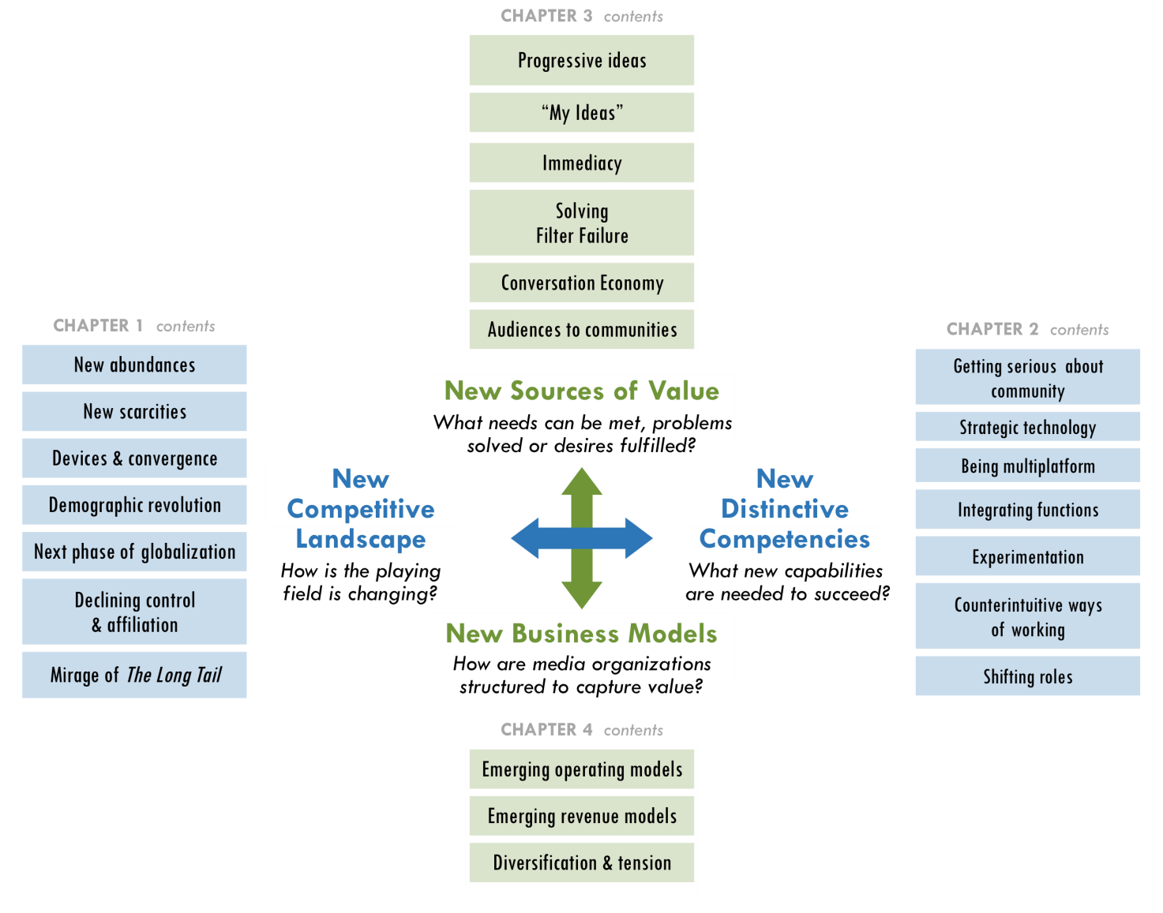

- New Sources of Value will create new Business Models. Traditional business models, based on the value created between publishers and readers, have declined for a decade. The world economic crisis accelerated this meltdown, and organizations have redoubled efforts to find new sources of value and cut costs.
- Organizations’ Distinctive Competencies must match media’s new Competitive Landscape. In the new environment, collective action by a consortium of organizations has great potential to increase the power of independent media. However, bold collective steps will require a shared perspective about media’s new realities their implications.
The Future? | Volume 3
Many uncertainties and opportunities remain on the horizon.
- Industry leaders are unsure how consumers will act, which trends will last, whether online media is helping or hurting our democracy and how the biggest players will affect the game.
The rule of thumb is to expect the unexpected. Radical changes in technology will continue to affect the competitive landscape and the new competencies outlined in Vol. 2 will become even more important.
- Independent media-makers must keep their eye on game changers to come (diagram below). Most of these trends are in their early stages. While they have yet to reach game-changing scale, many of them will.
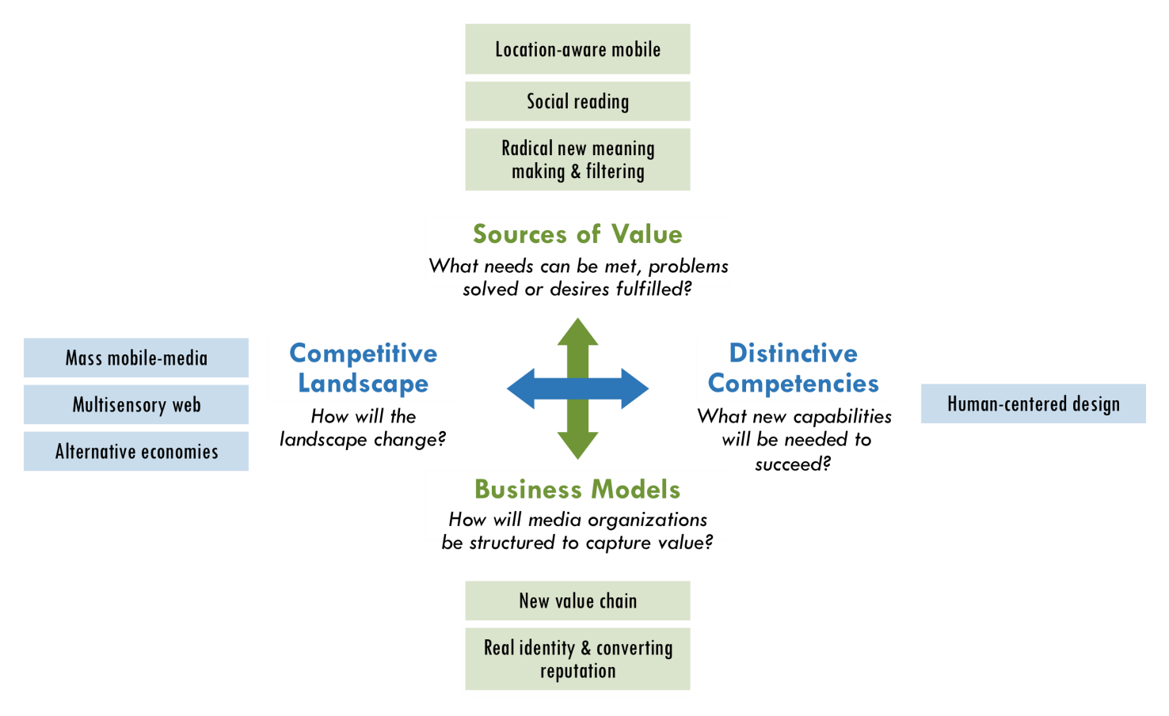

Recommendations
The Media Consortium, other media networks and individual independent media organizations can take advantage of emerging and future industry conditions by making four decisive moves:
- Change internally
New models will most likely come from new players. The first and deepest change is to rethink how media organizations and formal networks (such as TMC) are structured. By integrating technologists, entrepreneurs and individual media-makers, independent media will cultivate new competencies and strategies to change the journalism field.
- Increase experimentation
Greater experimentation will win. Journalism organizations must increase their capacity to innovate with new technology, journalistic practices and business models. They can do this by pursuing “rapid, low-cost innovation” and pooling their experimental efforts. Experiments will range from mobile technology (e.g. location awareness) to new forms of visual storytelling (e.g. data visualization), convergence of content across multiple platforms, filtering of information and new ways of generating revenue and reducing costs. Funders must invest in the long-term sustainability of journalism’s truth-telling by investing in greater experimentation among both new and existing players.
- Leverage unique role of a consortium
Standing together will be more valuable than working alone. Since independent media will continue to grow more diverse and fragmented, it is critical that media-makers break out of organizational silos and work together. Media outlets are finding new ways to connect and collaborate with each other to share strategies, resources and editorial content. The more that TMC members leverage their collective power, the more they can negotiate deals, influence public policy and build journalism’s new ecosystem.
- Building audiences as communities
The product of journalism is no longer content, but community. It is not enough to talk about community or simply enable users to comment on stories. Media organizations must create platforms for users to participate in the journalistic process, work with each other on projects and build their own online communities independent of publishers.
Decentralized communities will have the greatest impact. Media consumers have more power than ever before. They will be attracted to the most user-focused media ventures. Media organizations will grow their audiences by building deeper communities while also reaching broader networks. People today are less tied to formal institutions, and they increasingly affiliate with decentralized networks of individuals and groups. As a result, TMC members can not only reach broader domestic and global audiences by collaborating, but they can also engage those audiences more effectively by tapping users’ full potential as producers, community builders and agents of social change.
Beyond the Old Media Paradigm | New strategic intent for Independent Media
Most people assume that the future is something to be predicted rather than created. The future does not simply happen to us; we shape it. TMC members and other independent media organizations can use the four recommendations above to ask “What if?” Together, we can plan for a better future. The Big Thaw is a guide to chart the course.
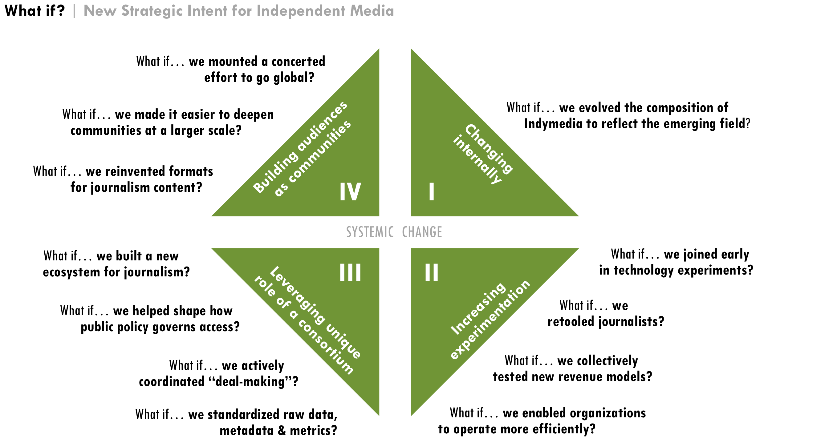

The research and analysis for this report led to 16 recommended project ideas for TMC and its members, which will be used internally. For more information, please contact TMC Project Director Tracy Van Slyke at tracy@themediaconsortium.com.

Introduction: Strategic Dissonance
The Media Consortium (TMC) began this strategy project by looking for “game changers” it could create (working definition at right). During the research process, we realized that the most effective aim was not to introduce new game changers, but to identify strategic responses to a game that has already changed considerably.
“Game Changers are developments (projects, initiatives, strategies, new models, innovations) that can ‘change the game’ for independent media by increasing their impact
and influence in the next five years.
These are not incremental strategies, but rather big bold moves that The Media Consortium could develop to take advantage of a rapidly changing media landscape.”
– TMC’s working definition, Appendix D

“How much more of the game needs to change, really?” asked David Weinberger, a journalist, author of Everything is Miscellaneous and fellow at Harvard Law School’s Berkman Center for the Internet and Society. “There’s a lot of handwringing about the future of media,” Katrin Verclas, co-founder of MobileActive, told us, “but look around, it’s kind of happening.”
PHOTO
This page has limited text so the designer can make a transition page here using a large photo. Example of great transition pages:
http://digitaloutlook.razorfish.com/publication/?i=13617

The photo can take the whole page, I just have this here as a place marker.

To make sense of these new realities, we have modified a model from Andy Grove’s work as the former CEO of Intel. Terms are defined in the right margin.
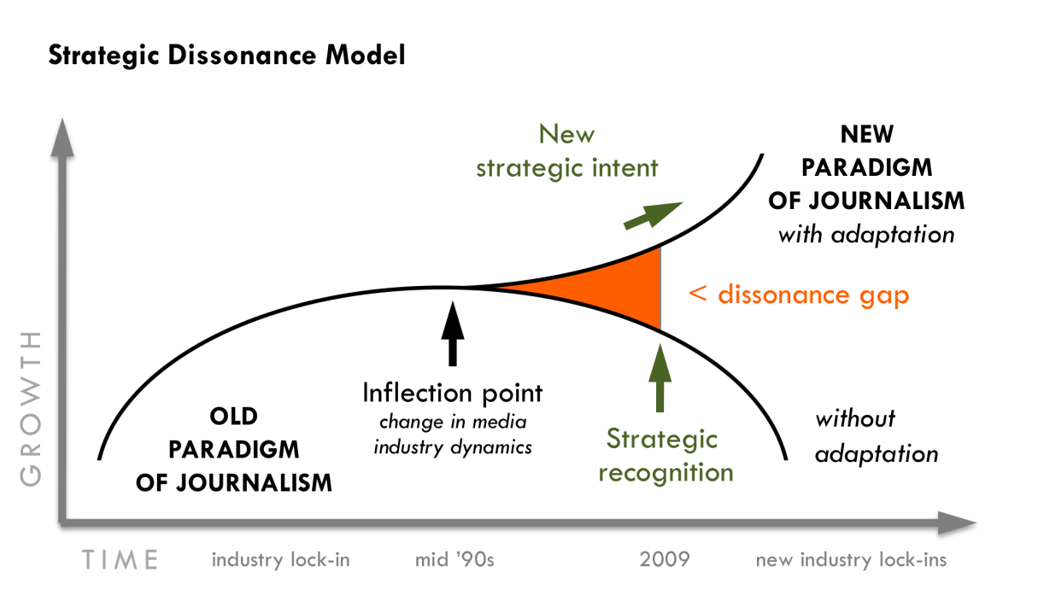

Explaining the model:
Inflection point: The starting point when one type of industry dynamic or existing paradigm gives way to a new one.
Strategic recognition: Identifying the importance of emerging practices and approaches after they arise but before unequivocal environmental feedback is available to make their significance obvious.
Dissonance gap: The gap between the inflection point and strategic recognition when diverging ideas, practices and approaches cause conflicting opinions.
New strategic intent:
Leaders’ ability to make sense of conflicting information generated by dissonance to create a new strategic direction that fully takes advantage of new industry conditions.
Source: Andy Grove

The above model demonstrates how the media landscape has shifted in recent years. A ten-year gap before incumbent players—independent media, in this case—recognize the strategic importance of an inflection point is not unusual. Grove calls this gap “strategic dissonance,” where changing dynamics cause tension with many conflicting opinions about how best to react. Yet, this very tension can help create a new strategic intent. In this time of strategic dissonance, independent media have an opportunity to establish a new operational approach to the new paradigm rather than be ruled by a tyranny of how they believe things still “should be.”

Two causes of dissonance
In order to turn dissonance into action, we must identify its causes. This can be done by analyzing the changing dynamics across the two overlapping axes of what we call the “Adaptive Strategy Matrix” on the following page.
Vol. 2 of the Game Changer Box Set analyzes these areas in depth.

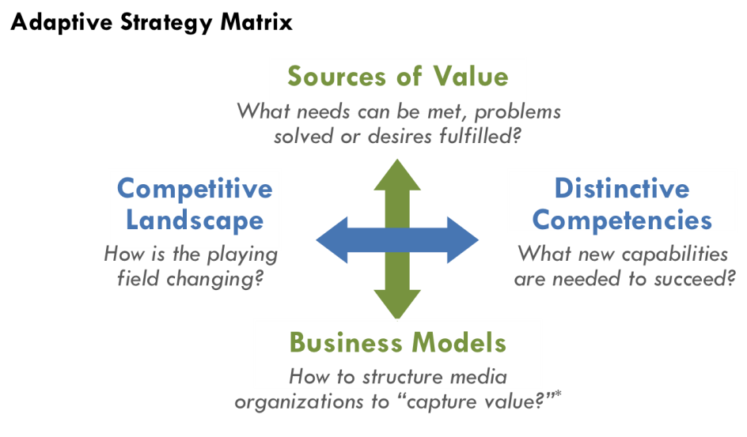

* “Capturing value” is
the ability to convert the value of products and services into resources (commercial or philanthropic) while retaining enough money to cover costs and grow.


The first cause of dissonance is the divergence between the industry’s new competitive landscape and an organization’s distinctive competencies to succeed in it. For example, as the amount of information and number of voices have become more abundant online, a news organization’s ability to “cover” the news with a deep bench of staff or freelance reporters has become less of a competitive advantage. News outlets have gained ground by aggregating stories from many sources (including users) for targeted audiences. This divergence between the new competitive landscape and old competencies has occurred in many areas described further in Vol. 2. The good news, however, is that where there is dissonance, there are also new strategies to discover.
“The 18th century was messy with newspaper wars, so it will shake out again.”
– John Bracken, MacArthur Foundation

Competitive forces and organizational competencies often evolve on independent paths and can be a major challenge for leaders to keep aligned. As a result, Grove describes this divergence as not easily visible, yet most fundamental. While the inertia of existing business models can cause competencies to lag, new competencies can also emerge in the margins of the organization and make surprising new opportunities possible.
“We’re in a transition and there is so much opportunity in transition but there is also so much loss and so much fear.”
– John Battelle, Federated Media & author of
The Search


The second cause of dissonance is the divergence between what customers value the most and old business models. Existing structures often reflect current leaders’ beliefs about historical success in their organizations or field. Grove points out that career tracks, emotional attachment and corporate identity deeply influence current leaders’ perceptions, as well as hesitation to change strategies when the consequence are not completely clear. This is why inertia is a major driver of dissonance and inaction.
The people interviewed in the Big Thaw believe the media industry has crossed a critical threshold and is moving out of the current stage of dissonance. Some predict that a major industry restructuring will settle out in the next two years. The financial crisis accelerated this shift and has caused so many newspapers and magazines to close in 2008-09. “While people in media were starting to realize this,” NYU adjunct professor Clay Shirky noted, “they were suddenly robbed of the four to five years they thought they had to respond.” Andrew Golis, deputy publisher of Talking Points Memo (TMC member) noted a key casualty: “I think many of the best publications haven’t been ready for the transition and so the sharpest minds have lost prominence in the debate as a result.”
“The stakes are very high for independent media. Will it change? Or, will it atrophy? Independent media can become the dominant media in society. Who would have dreamed that 30 years ago?”
– Don Tapscott, author of Wikinomics
PHOTO
This page has limited text so the designer can make a transition page here using a large photo. Example of great transition pages:
http://digitaloutlook.razorfish.com/publication/?i=13617

Beyond the Old Media Paradigm
New Strategic Intent & Action Ideas

Game Changer Box Set
Vol. 1

What if?
The Media Consortium’s (TMC) historical underpinnings create opportunities to lead the field, as well as potential challenges to making bold, game-changing moves. TMC’s strategic decisions must take into account its current realities, as summarized below.
- Appendix C
TMC history & members

- Historical underpinnings: TMC began in 2005, and its founding members originated in print publishing. Three quarters of its 45 current members originated offline and approximately one quarter are “net native” (designed from the start for the web).
- Content: Most members are “pure-play” journalism organizations with an emphasis on underserved and underrepresented communities.
“You just take the word ‘progressive’ out, and the substantive question is, ‘How do you build a successful media company?’”
– Adam Berrey, Senior Vice President, Brightcove

- Primary medium: 49% text (magazines, books and online), 19% TV/video, 12% radio (includes overlap), 12% other (training, syndication, production, networking organizations). All members have online distribution and most are increasingly becoming multi-platform publishers.
- Membership composition is biased towards non-profits (84% of membership).
- Current definitions of “independent” and “progressive” are ambiguous among TMC members. Furthermore, all outside experts interviewed for the Big Thaw asked what TMC means by the two terms and questioned their continued relevance.
Vol. 1 indentifies four broad areas for strategic renewal and innovation. Each area is not necessarily a game changer alone since these are rare and often emerge in combination. Nevertheless, the “What ifs?” can serve as a dynamic map for going forward and can help TMC identify the most important projects now and in the future.
“The platform shift is real. We get it. … But let’s please get to the solutions.”
– Member of CA Media Workers Guild^{A}

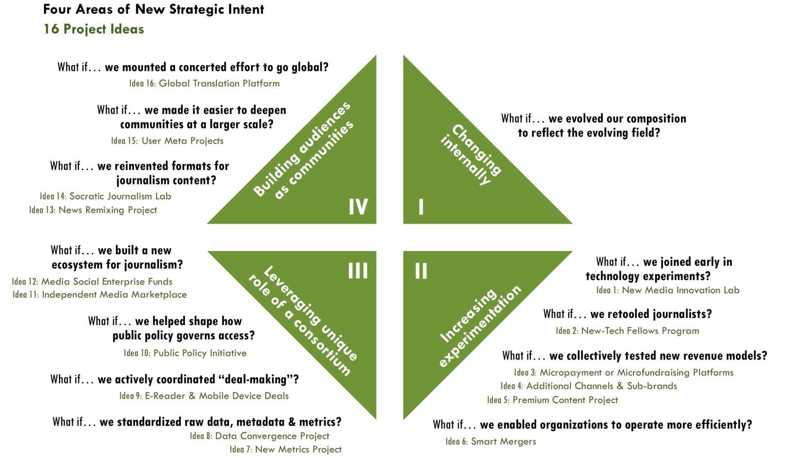

Strategic way of changing internally
TMC began this Game Changer Strategy Project to strengthen the power of independent media. Specifically, TMC wanted to grow the collective reach of its members to an audience of three to five times beyond its existing scale. A proxy for TMC’s collective online reach as of June 2009 was 17 million website visits (Appendix C). However, as we consider the shift away from the old paradigm of journalism where the ability to “cover” the news rested on centralized media outlets, the field-building strategy to improve individual media organizations’ reach may no longer sufficiently strengthen the independent media field. There may be a more powerful, decentralized strategy.
- Analysis in Vol. 2
Media as watchtower, p2
Abundance of independent voices, p14
Dawn of a demographic revolution, p19
Declining institutional control &affiliations, p24
“Journalpreneurs,” p41

What if… we evolved our composition to reflect the emerging field?
Perhaps the most radical game changer TMC could tackle is to change itself from the inside out. One of independent media’s primary purposes is to be a corrective feedback loop for excess and corruption in our economy, government and society. However, its strength must be relative to what it is trying to correct. For example, a thermostat may work fine on a cold winter day, but open all the windows and its corrective power will fail. As a result, TMC may have to reexamine whether the work of its 45 members alone is strong enough relative to the impact it was originally intended to correct. Would TMC’s larger purpose of strengthening independent media be better served by building a stronger corrective feedback loop? That is to say, could TMC and its field-leading members support a broader, more diverse ecosystem of journalists that produce content in non-traditional and entrepreneurial ways, including citizen-journalists, technologists and an emerging segment of “Journalpreneurs,” as described on p42 of Vol. 2?
“We do not know who discovered water, but we are fairly sure that it was not a fish.”
– Marshall McLuhan^{B}
Many efforts are emerging to help both amateurs and professionals take digital journalism on full force. TMC’s unique strength is the leverage of current members’ brands, strong journalistic traditions and credibility. As a result, TMC is well positioned to integrate new entrepreneurial efforts that both build the field and benefit its members via tighter affiliation with emerging players.
“Some of the recent hires by companies or deans of journalism, they are still the old guard, they don’t truly understand the technology piece.”
– Ashish Soni, USC Viterbi School of Engineering

This area of strategic intent does not include specific projects. Rather, it is an internal shift that underpins many of the following 16 project ideas and would take full advantage of new industry conditions. Such a shift would require a deliberate recruitment strategy to achieve.


Strategic ways of increasing experimentation
- Analysis in Vol. 3
What don’t we know?, p3
What trends will last?, p3
“No one experiment is going to replace what we are now losing with the demise of news on paper, but over time, the collection of new experiments that do work might give us the journalism we need,” wrote Shirky.

What if… we joined early in technology experiments?
First-mover advantage can be critical to reach the largest scale. Quickly adopting technologies and platform as they emerge would enable TMC members to build large audiences before others can do so. A potential leverage point for TMC is to help its members get ahead of the curve on testing and adopting innovations, particularly involving mobile technology. In fact, as described below, the consortium could use its collective power to be included in technology innovations early-on.

Idea 1: New Media Innovation Lab
Goal: Create a sub-group of opt-in members who agree to terms of participation, assign staff to participate in trainings and manage mini-experiments in their organizations.
“Mostlycompanies aren’t set up for rapid innovation. By contrast, big media companies only know how to do big money projects that take six months or more to complete. So they are not set up to move fast. Companies have traditionally been set up with huge profit/revenue streams so they could get 20 people to do an experiment. So in this day and age, rapid low cost experimentation skills are lacking, to execute and to even think in that way.”
– Ashish Soni

- Analysis in Vol. 2
Power Law & the Mirage of the “Long Tail” p27
Experimentation, p39
- “This sort of TMC innovation sub-group would develop viable new distribution mechanisms and other technologies to reach wider market and bypass problems with current distribution systems,” wrote Linda Jue, Director and Executive Editor of New Voices in Independent Journalism (TMC member).
- “Classic independent media outlets are slow to adapt to changes in audience composition, preferences, styles, platforms (thinking of younger audiences and of people of color audiences that currently are not served by us),” wrote Steve Katz, Vice President of Strategy & Development for Mother Jones (TMC member).
Key TMC-led activities
- Organize small-scale experimentation in a relatively contained cluster, suggested TMC members Johanna Vondeling of Berrett-Kohler Publishers and Ann Friedman of The American Prospect.
- Support experimentation with opt-in members through an ongoing series of TMC-organized workshops. Members can compare results of experimentation, learn from experts in new technology, multi-platform content development and human-centered design, take learning journeys to technology companies and agree on subsequent collective experiments.
- Analysis in Vol. 2
Rapid, low-cost innovation, p37
Being multiplatform, p37
- Help members conduct rapid prototyping as a low-cost way to test which new business models, technology and content development work without hurting their bottom lines and at a scale they would not be able to achieve alone.
- Broker deals between the consortium and new technology ventures (see idea #9) to learn about forthcoming opportunities.
- Facilitate agreements with commonly-used tech vendors to enable greater coordination and learning.
- Analysis in Vol. 3
Multisensory , p21
Human-centered design, p23
- Coordinate low-cost marketing experiments, such as using search technology to understand user behavior, interests and desires. Hire outside marketing experts to define customers’ motivations, suggested Vondeling and Friedman.
- Work with members and outside experts to choose first phase of lab-based experimentation and implementation. Initial focus could be on mobile technology and explore the following questions:
- Analysis in Vol. 2
Mobile revolution, p17

- Analysis in Vol. 3
Location based mobile, p25
  - What do mobile users most want and need?
  - What are the most effective ways journalists are using mobile devices?
  - What future developments are coming (new apps & devices), particularly related to location-based capabilities?
  - What deals are happening (especially in advertising), how do they work and who are the key deal-makers?
Key benefits to members
- Learn from information, reports, lessons learned from the smaller group of opt-in participants in the innovation lab.
- Identify new opportunities to self-organize, expand test pilots and manage entrepreneurial spin-off projects.
- Identify cutting-edge stories at the intersection of technology, online-journalism and community organizing.

What if… we retooled journalists?
“As with any trade, you have to learn the craft. And the craft now includes tools like Twitter and Google and telling your stories in ways that are native to these environments. Getting some fluency in these tools will open up amazing vistas,” suggested John Battelle, journalist and author of The Search: How Google and Its Rivals Rewrote the Rules of Business and Transformed Our Culture.

Idea 2: New-Tech Fellows Program
Goal: Create a fellowship program to train and retool journalists as technologists and technologists as journalists.
- Analysis in Vol. 2
Merging roles of journalist and technologist, p37
Being multiplatform, p37
- The fellowship program could be designed to overlap, in part, with the New Media Innovations Lab (idea #1) and provide stipends to offset the cost required to participate.
- Fellowships are attractive programs to some foundations.
Key TMC-led activities
- Select annual classes of fellows who build strong professional ties.
- Organize a series of gatherings over the period of a year for fellows to hone their skills in latest technology, take learning journeys to technology companies; and design action projects to build their host organizations’ capabilities.
- Focus on using the newest technology for maximum impact.
  - Create greater interactivity, feedback and horizontal communication, suggested TMC members Frank Emspak, Executive Producer of Workers Independent News, and David Michaels, Senior Editor of Current Affairs.
  - Harness social networking/news convergence, suggested TMC member Emily Douglas, Content Editor of RH Reality Check.
  - Simplify, enhance and lower the costs of research and
content output.
- Develop selection criteria and measurable program goals.
Key benefit to members
- Bring new capabilities into member organizations, which would be the primary focus for the fellows.
- Increase the speed and agility with which independent media organizations can innovate—a potential competitive advantage over big media companies that typically move slowly.

What if… we collectively tested new revenue models?
Idea 3: Micropayment or Microfundraising Platforms
Goal: Build a micropayment and/or microfundraising platform for reader-supported journalism to span TMC members’ sites.
- Analysis in Vol. 2
Micropayment & micro-fundraising from users, p65
- Analysis in Vol. 3
Real identity & converting reputation, p40
- Readers would show their support for certain types of reporting by using an “electronic wallet” and making micro-donations. For example, just as a reader would tag an article on Digg, they could easily donate a few cents for a story they like or larger amounts for publishers to investigative a topic or sponsor a reporter.
- Micropayments have been tried before, and many new experiments are emerging as described in Vol. 2, p65. Although there is much debate on the viability of such platforms, a collective effort by a consortium has potential to coordinate the large-scale participation that could be necessary for such a project to work.
Key TMC-led activities
- Facilitate coordinated campaigns to sign up members’ users on one common platform and familiarize users with the new payment tool.
- Develop standardized revenue-share agreements.
- Explore critical questions like: Does the consortium build its own platform or form a deal with an emerging platform?
Key benefits to members
- Reduce one of the primary barriers to widespread user adoption by sharing an easier and more intuitive user-interface across multiple publishers.
- Leverage a key user motivation (e.g. reputational value) via real-time recognition of highest donors to specific reporters, issues and the overall publication. If recognition were reflected across multiple member sites, the reputational value could be even higher.
- Analysis in Vol. 2
Scarcity of reputation, p15
- Utilize micropayments to enable a more valuable supplementary rating system for content. With “skin in the game,” users would put more thought into their ratings than they do with no-cost “thumbs up” ratings.
Idea 4: Additional Channels& Sub-Brands
Goal: Create additional channels and sub-brands to reach greater scale.
- “Additional channel,” in this case, means entering a new market with a new product to reach greater scale, such as making an MSNBC-type channel in partnership with current TMC members, suggested Jay Harris, publisher of Mother Jones.
- Analysis in Vol. 2
Adding distribution channels& sub-brands, p64
- Analysis in Vol. 2
Counterintuitive ways of doing business, p39
News as a loss leader, p67
- Some possibilities include:
  - Ten-minute weekly online talk show that could include reporter roundtables, interviews, TMC members’ stories and Bill Maher-style debates integrated with pop culture guests.
  - Daily one-minute video roundup that delivers headlines in a hip-hop or comedic style with links to full stories by TMC members.
- Harris suggested some key factors to consider.
  - As resources get tighter, funders will be looking for ways to do more with the same or fewer resources.
  - TMC members may have come to the party identified with one medium, but “We are all multi-media now,” Harris said.
  - In independent media organizations, there a duplication of resources in some areas and perhaps not enough market-development talent in general.
Key TMC-led activities
- Facilitate partnerships among members to create new channels.
- Support and advise members in creating or acquiring additional sub-brands to distribute the same content to different audiences.
Key benefits to members
- Drive more traffic, create greater impact and potentially earn more revenue from the same content.
Idea 5: Premium Content Project
Goal: Create a new tier of premium content from specialized data, possibly through partnerships among members.
- TMC members have highly skilled journalists who often collect and synthesize more information than is published or relevant to core users/readers.
- Analysis in Vol. 2
Free + premium content, p64
- Specialized synthesis of surplus reporting, which is not of general interest to readers, could be packaged and sold. For example, overall findings from an investigative piece could be free to the public, but detailed financial analysis of a company or industry could cost extra.
- A publication might choose to pay freelance economists or other specialists to create premium reports to sell or provide as a benefit to paid subscribers.
Key TMC-led activities
- Develop pricing, revenue-sharing, metrics and distribution strategies.
- Promote “temporary exclusives” as premium content that could emerge with improved metrics, where bloggers and aggregators could calculate the value of such content and pay for its use.
- Define “conceptual scoops” as a potential area to capture value.
- Analysis in Vol. 2
Will there be a new demand for quality journalism?, p35
Conceptual Scoops, p35
  - Battelle said that the stories that really break are “conceptual scoops”—that is, stories that not only break new information, but also create new frames and understandings of social and political issues. Such radical new ideas, insights or news usually come from investigative reporting and could capture additional value. For example, what happens when the pipeline for conceptual scoops dries up with so many journalism outlets closing? Will there be an emerging willingness to pay for content if there is such a scarcity (regardless of whether it comes from an organization or individual)? Could there be a potential new business-to-business model, where publishers or writers sell investigative content as temporary exclusives to other sites that chase eyeballs?
Key benefits to members
- Capture additional revenue by synthesizing data from multiple publishers.
- Create greater impact due to higher perceived value of paid content, especially for publishers trying to reach influential audiences.

What if… we collectively enabled organizations operate more efficiently?
Incremental innovations that significantly reduce costs can become game changers, particularly when they are combined with other innovations. For example, Dell changed the PC industry by using a new “just in time” inventory process to underprice other manufacturers. A new collaborative venture among The New York Times, ProPublica, TMC member Talking Points Memo and others, will build a unified database of original source documents called “DocumentCloud”that will make it significantly more efficient to examine large sets of documents.
To reduce costs, TMC members have expressed interest in using online collaborative tools such as DocumentCloud or creating new platforms to “eliminate the middleman” (intermediaries such as publishers, sales reps and vendors), which can have the added benefit of putting publishers in direct communication with users. Yet disintermediation also has drawbacks because it shifts mediation to new areas of control such as filtering and search. Opportunities to reduce costs significantly will continue to emerge and could include taking dramatic steps such as “smart mergers,” which Harris suggested.
Idea 6: Smart Mergers
Goal: Facilitate smart mergers among TMC members who may be stronger together.
- Analysis in Vol. 2
New scarcities & their effects, p14
Lean and mean, p61
- “By [smart mergers] I mean really understanding, beyond what a deal looks like on paper, what it takes to pull off a successful merger and bringing that knowledge into the sector,” wrote Harris.
- Sufficient willingness to merge would be necessary, which may be greater if the alternative is folding or losing influence.
- When asked if non-profit mergers would work, John Bracken of the MacArthur Foundation told us, “A lot depends on personalities.”
- Different levels of merging could include sharing databases or technology platforms and consolidating back-office functions.
Key TMC-led activities
- Conduct feasibility study by interviewing thought leaders or hiring business-school interns who have been part of mergers and acquisitions or academics who have studied them.
- Analysis in Vol. 2
Adding distribution channels& sub-brands, p64
- Hire an expert who has managed corporate mergers to advise the process and evaluate the opportunities and consequences of mergers within the sector.
- Distribute the results and identify opportunities for TMC members who want to explore this idea.
Key benefits to members
- Gain power and influence, increase impact and build stronger multiplatform capacity. However, the potential benefit would need to be sufficient to compel such a difficult process as merging.
- Tap the value of keeping separate co-existing sub-brands in merged organizations as described in idea #4.


Strategic ways of leveraging the unique role of a network
An ongoing question since TMC’s inception has been “How can the sum be greater than its parts?” While many ideas in the Big Thaw are relevant to individual TMC members, the question of broader purpose remains: What can TMC do as a consortium to affect the larger independent media system and lift the tide for everyone?
The consortium structure has already helped facilitate greater scale in advertising across members’ sites. Four TMC members (Air America, AlterNet, Mother Jones and The Nation) have come together to start an online vertical ad network on the Adify platform. The “Ad Progress Network” launched Spring 2009. This venture is a smart strategic move, given the continually increasing competition online. Although TMC members’ sites are growing in traffic, they still may be challenged to keep ahead of overall audience growth and fragmentation online. Many progressive media companies—even the larger ones—have relatively small audiences compared to major media companies such as the New York Times. An ad network enables publishers to leverage a greater scale of ad impressions to attract ad buyers that may not otherwise spend the time to buy ads on a single publisher’s site. The unique role of a consortium is ideal for other projects like this, some of which are listed below.
- Analysis in Vol. 2
Getting more from advertising, p67

What if… we standardized raw data, metadata & metrics?
Media consumption is increasingly dictated by how people pull many fragmented pieces of content together, which means that new models of content distribution are more important than developing content itself. Partnerships related to information structuring, filtering, bundling and mash-ups are critical for content to reach users anytime, anywhere, on any device. Metadata, which is simply data about data, is a pivotal piece of the online distribution equation and described in more detail in Vol. 2.
Idea 7: New Metrics Project
Goal: Standardize practices that would more reliably measure the value of TMC members’ social impact (e.g. diversity & community engagement), possibly designed in collaboration with investors.
- Nielsen Media Research explains on their website, “a well-measured medium is a more valuable medium.” Online commercial media is making progress in technology and standards for measurement, which independent media can influence as it codifies.
- Independent media have even greater challenges in measuring the less tangible goal of impact. Non-profit media organizations are primarily driven by social purpose rather than financial goals, which are based on commercial-focused metrics. Yet, measuring social impact is difficult, especially when it comes to goals such as influencing the political dialogue, promoting progressive values or launching a new meme into public consciousness. Most independent media organizations still demonstrate their ultimate social impact via anecdotes. There is no agreed-upon system of reliable impact measurement to help inform business models (commercial or philanthropic). However, the more reliably that media outlets can demonstrate impact, the more funding they can secure.
- Analysis in Vol. 2
Non-profit, philanthropy model, p63
, p32
Will more reliable & consistent measures create greater distribution of value?, p37
- Although performance-pay models like Gawker’s are not popular with journalists, they may still grow more prevalent. A New Metrics Project could help shape the changing incentive structures, including rewarding reporters for investigative stories that break. The incentive structure could mirror performance pay, but would adapt performance metrics to “conceptual scoops” and social impact in addition to traditional traffic measures.
Key TMC-led activities
- Standardize new measures for impact, both quantitative and qualitative, that can be used across TMC members.
- Experiment with new types of metrics (e.g. reputation) that incentivize long-term connection and community.
Key benefits to members
- Provide funders and investors with new rationales for funding projects by measuring impact more reliably.
- Promote commonly-accepted metrics that will help TMC members better communicate the value they create for their users.
- More clearly measure the value created by content producers in order to capture that value for the organization and reward producers’ work.
- Enable more distribution deals by promoting reliable and standardized measurement for use beyond TMC members.
- Improve members’ products and services with more sophisticated data about their impact.
- Link revenue more closely to activities and outcomes.
Idea 8: Data Convergence Project
Goal: Standardize raw data and metadata to enable greater re-bundling, linking filtering and information collection.
- Raw data (i.e. data such as date, time or location that has not been processed for use) and related metadata could be standardized through a structured protocol for TMC members to use to code all finished content and data from investigative research.
- Analysis in Vol. 2
Device proliferation, convergence & their effects, p17
Error: Reference source not found, pError: Reference source not found
Relevancy is king, p50
- Analysis in Vol. 3
Location based mobile, p25
Real identity & converting reputation, p40
- “There might be a financial model that comes from the standardization of raw data, together with mash-up client services,” suggested Shirky, “there might be the creation of novel value for no additional costs required, which also binds users to the service, because once they have the service they go back over and over again. It’s getting this kind of combinatorial power that lends itself to the work of consortia. Just sharing of data, this makes so much sense, even though it’s often hard to do.”
- TMC is beginning to experiment with re-bundling data through its Media Wire project.
Key TMC-led activities
- Facilitate a TMC-wide process of determining standards and protocols.
- Standardize issue-based tags to help create vertically integrated content streams that match activist and political campaigns.
- Negotiate partnerships to plug TMC members’ content into emerging “Semantic Web” models for search and user interaction such as Wolfram Alpha, a knowledge engine by Stephen Wolfram that computes answers (in contrast to search) from large datasets.
- Lead research on trends in metadata, SEO optimization, and other emerging technologies/platforms for members to use.
- Hire a technologist to help advise members in developing their IT systems and commonly-shared protocols.
- Provide trainings and initial investment in platform for metadata management.
Key benefits to members
- Increase relevancy of content for search and discovery by users.
- Build a new core asset: databases of accurate, verified raw data and metadata. This would only be valuable if it reached a large enough scale, which could only be achieved by collaborating across many publications.
- Create new revenue streams from datasets through revenue-sharing agreements within the consortium.
- Enable TMC members to prepare their content for republication across multiple platforms (e.g. online, mobile and gaming)

What if… we actively coordinated “deal-making”?
Leveraging the power of a consortium is not just about partnering in a traditional sense, but also brokering “deals” that are clear transactional relationships that help TMC members expand their work. For example, in June 2009, Associated Press announced a deal to distribute content from four non-profit journalism organizations. TMC could collectively facilitate such deals.
- Analysis in Vol. 2
Micropayment & micro-fundraising from users, p65
News as a loss leader, p67
- Analysis in Vol. 3
What will happen with paper?, p8
Idea 9: E-Reader & Mobile Device Deals
Goal: Negotiate a deal with Amazon, Apple, Sony or others to distribute TMC members’ content on E-Readers and other mobile devices.
- With the decline of paper, e-readers could increasingly replace print news and also save in distribution costs.
- The driving business model in e-paper comes from selling the device and using content as a loss leader, as Apple did with iTunes. While TMC could not become a device manufacturer, it may be able to use its collective news-production capacity to cut deals with those companies that do have such capacity. Many companies are coming out with new e-readers in 2009 and 2010.
Key TMC-led activities
- Coordinate agreement among members for distribution standards and processes to enable collective deal-making.
- Hire business development consultant or staff with deal-making experience in mobile technology.
- Link to Micropayments & Microfundraising Platform (idea #3), if it catches on substantially.
Key benefits to members
- Leverage collective negotiating power to build distribution opportunities.

What if… we helped shape how public policy governs access?
- Analysis in Vol. 3
What role will government play?, p12
While TMC can view public policy as a topic for reporting, it can also view policy as a business area and leverage its network role to mobilize broader change. Many trade associations work to affect public policy on behalf of members, which ensures that they can thrive in a competitive environment.
Idea 10: Public Policy Initiative
Goal: Wield TMC’s collective influence to shape media policy, reform and support.
“Media Consortium itself is a good example of the power of collaboration. (An Obama Presidency will) swing the balance in the FCC, freeing up Copps and Edelman to make some major changes in the media landscape around consolidation and access to bandwidth.”
– Kim Spencer, Link TV

- “There is this massive behind-the-scenes, epic, political battle being waged inside the beltway right now,” said Sascha Meinrath, Research Director for the New America Foundation. The battle is between an open, decentralized telecommunications future and one that is command-and-control.
Key TMC-led activities
- Hire lobbyists to represent TMC interests in Washington, D.C. and weigh in on current battles about many critical issues.
- Collaborate with other organizations involved in public policy work.
- Conduct policy-related research and analysis to inform TMC’s organizational activities.
Key benefits to members
- Promote the sharpest progressive minds that have lost prominence in shaping the discourse about new media policy because “many of the best publications haven’t been ready for the transition” as Golis pointed out.
- Influence policymakers’ agendas in a more powerful way.

What if… we built a new ecosystem for journalism?
“The best scenario for the future of media is this: The largest possible variety of writers and creators are working. There’s an ecosystem that supports many, many different types of productions,” said Weinberger. However, a new ecosystem that benefits the independent media field will not happen on its own. Vivian Schiller, CEO of National Public Radio predicted that “There will be more partnerships among quality news organizations so that we can support each other.”
- Analysis in Vol. 2
, p32
Counterintuitive ways of doing business, p39
TMC members, together with users, can help shape a new ecosystem for journalism. To do this, TMC needs a value-chain road map—a vision for how the value chain of journalism could emerge. Such a systemic view of all the players and how value is exchanged would enable TMC members to discover where new value could be created; determine where market gaps exist that require government or philanthropic subsidy; build new types of business relationships among all players in the field; advance models that work; and shape the new marketplace for independent media outlets.
- A value-chain map would help differentiate the activities around which TMC members believe they are competing and where they can compliment each other and benefit everyone.
- A value-chain map would constantly evolve to clarify how value flows across the field. The map would be a living document and used to structure conferences and other TMC projects.
- A working group of TMC members could create this vision. It would help inform the strategy for other project ideas listed in the report, such as:
“(TMC needs to) break down the entire life cycle, the ecosystem, the whole puzzle and look for changes they can make across the ecosystem and look at how other parts would respond to such changes.”
– Ashish Soni
  - Testing new business models and technology platforms
(see New Media Innovation Lab, idea # 1),
  - Standardizing new measurements to enable new value chain to emerge (see New Metrics Project, idea # 8),
  - Facilitating deals with big companies (see E-Reader & Mobile Device Deals, idea # 9),
  - Advocating for public policy that supports the new ecosystem
(see Public Policy Initiative, idea # 10), and
  - Building a marketplace for new players (see Independent Media Marketplace, idea # 11).
Idea 11: Independent Media Marketplace
Goal: Host gatherings that build a marketplace for both “net native” entrepreneurial journalists (“Journalpreneurs”) and established progressive media organizations.
- Analysis in Vol. 2
“Journalpreneur,” p41
- Gatherings would be a mix between blogger and technology conferences with a focus on entrepreneurial approaches to journalism.
Key TMC-led activities
- Initiate two types of gatherings that support and compliment each other: Informal “BarCamp” gatherings and a formal national conference.
- Launch & promote BarCamps as decentralized, informal gatherings.
  - BarCamps are a popular model of user-generated conference, use a format similar to Open Space Technology and are cheaper and more replicable than a traditional conference.
  - TMC could create a BarCamp template that would facilitate regional caucuses/meetings and would allow its members and interested parties to self-organize and potentially piggyback on other conferences.
  - TMC would be able to reach localized media organizations efficiently and include them in its network.
- Host an annual national “Journalpreneur” Conference.
  - Primary purpose would be to build a marketplace for the field by structuring the conference around pitching new ideas, deal-making between organizations and continually developing and promoting the BarCamp template.
  - Secondary purpose would be for training in new approaches to reporting, strategic technology, marketing and business skills.
  - TMC members could invite their leading users who want to mount Meta User Shared Projects (idea #15) and sign on other TMC members to participate.
Key benefits for TMC members
- While there are already many formal journalism conferences, such a gathering creates strategic advantages for a consortium, especially in combination with the informal networked-approach of BarCamps.
- Benefits of a national conference would include:
  - Identifying TMC as a field-building leader and influence the field’s evolving definitions and standards,
  - Disseminating TMC field-building knowledge such as the value-chain map, Socratic Journalism Lab methods (idea #14), case studies from New Media Innovation Lab (idea #1),
  - Enabling TMC members to more easily identify and recruit talent, form new content-supplier partnerships and nurture existing relationships,
  - Continually identifying further innovations for the field, the likes of which we cannot yet anticipate,
  - Attracting funders and thought-leaders who are important to the field, but less likely to come to informal BarCamp gatherings,
  - Create a financially self-sustaining TMC event that could potentially earn money to support other TMC programs.
Idea 12: Media Social Enterprise Funds
Goal: Create or encourage foundations to start funds specializing in low-cost debt financing for earned-revenue strategies that improve the long-term sustainability of independent media organizations.
- Analysis in Vol. 2
Non-profit, philanthropy model, p63
- Analysis in Vol. 3
Will philanthropy adjust its role?, p14
- This fund would not simply grant money. Rather, it would help media organizations with set-up and working-capital costs to build earned-revenue strategies. Examples of fundable projects might include direct-mail campaigns and starting new online advertising program.
- TMC members echoed the need for this sort of fund. Jue wrote: “micro-financing operations like revolving loans to help indies with biz operations, especially with marketing and promotions.”
- Revolving loan funds have been tried before, by organizations such as the Independent Press Association (IPA). Although some no longer exist, the need is still substantial. Social capital markets are fragmented and insufficient, particularly related to debt financing. For example, since the IPA loan fund’s total assets were $500K, it could not accommodate the full request of some organizations without limiting the financing available to others. There are few other funds currently available for such financing.
Key TMC-led activities
- Encourage foundations to start many such funds.
- Enable funders to converse with each other outside pressures from grant seekers (a key to a successful implementation). For example, TMC could work through the Council on Foundation’s affinity group, “Grantmakers in Film + Electronic Media,” or start a new group. Another possible tactic could be hosting a funders-only gathering to work on ways to capitalize the field.
- Explore whether TMC should take a more active role by starting a fund, finding investors or partnering with other organizations, such as EBS Companies, Democracy Alliance, Calvert Foundation or others.
- Explore other types of funds, including one for start-up ventures similar to what the Echoing Green Foundation provides for social entrepreneurs.

Key benefits for TMC members
- Attract significantly more capital to the field to support the sustainability and growth of independent media.
- Strengthen members’ business practices, help them become more responsive to customers and diversify their revenue beyond big philanthropic sources.


Strategic ways of building audiences
Everyone who participated in this project said that building audiences as communitieswas the biggest new source of value in media. Some viewed the term “audience” as an anachronism because it still puts too much emphasis on content as the primary product. Today, journalism is more of a process that also involves users in content generation and dialogue that reflects the emerging value of “co-meaning making.”
- Analysis in Vol. 2
From audiences to communities, p53
Co-meaning making, p53

What if… we reinvented formats for journalism content?
Idea 13: News Remixing Project
Goal: Remix the news with other entertainment and cultural formats to engage new audiences.
- Analysis in Vol. 2
Counterintuitive ways of reporting news, p40
- “There is value to creating echo-chambers. But there is potential to find common ground in unexpected places,” Vondeling and Friedman reported from their conversation.
- Examples of other possible formats include comedy, rapping the news (e.g. InFiNiTe-1 on E! and “The Week in Rap” on Channel One) and reality TV (e.g. Michael Moore meets The Apprentice).
Key TMC-led activities
- Facilitate new relationships among unlikely partners that share common interests such as driving traffic or reaching new audiences.
- Utilize formal and informal gatherings (idea #11) to promote news remixing and experiment with formats through the Socratic Journalism Lab (idea #14).
- Integrate successful remixing models with members’ efforts to create Additional Channels & Sub-brands (idea # 4).
Key benefits for TMC members
- Reach diverse new audiences, especially young people.
- Cross-promote content with entertainment media outlets.
- Create new kinds of conversation-generating events.
Idea 14: Socratic Journalism Lab
Goal: Experiment with an open system of reporting that engages users as story develops and promotes the best emerging new practices.
- Old physical limits required full stories to be formed before publishing. Now, story development and publishing occur simultaneously, which enables a “Socratic reporting” process, an open method of systematically questioning an issue or news event with users. A reporter uses his or her own skills and knowledge, combined with that of users, to reach an outcome that is simultaneously more immediate, suspenseful, engaging, credible, and ultimately more comprehensive.
  - Brave New Films (TMC member) has advanced such an approach to online documentary projects with Robert Greenwald’s “Rethink Afghanistan.”
- Analysis in Vol. 2
Declarative& adaptive reporting, p35
Counterintuitive ways of reporting news, p40
- Analysis in Vol. 3
Social reading&Socratic Journalism, p27
- Publishers would use the lab to develop more sophisticated ways of engaging users in content development via user-driven recommendations, ratings and other mechanisms.
Example
  - Media outlet(s) announce that they are planning a story/product/series/issue that they want to cover over period of time, which could be framed as a “journalistic mission.” Invite community to be part of process in specific ways such as voting on key issues, sourcing information and creating derivative products (mashups). A “community organizer/editor” works with users and reporters throughout the process as a conduit for information, facilitating and coaching. (Many other tactics and processes like this could be explored.)
  - Promote the final outcome (completed missions) that includes reporting, auxiliary info created by users and the resources that users had contributed to the process.
Key TMC-led activities
- Create a test bed for identifying the best content development models and new reporting processes based upon the major trends in the future of journalism, which include community-building, co-creation, co-meaning making and transparency. This lab is distinct from the New Media Innovation Lab (idea # 1), which focuses primarily on building technology capabilities rather than content development.
- Produce case studies and methodologies to disseminate through the Independent Media Marketplace (idea # 11).
- Develop a wiki platform for users to post source materials that could add to the overall story (e.g. interviews, photos, articles, personal anecdotes) and help reporters distill large documents (e.g. databases, government reports).
  - Build a rating system to identify best, verifiable resources contributed by users. Over time, this would establish their reputations as credible sources and help both editors and users sift through resources by knowing the trustworthiness of information.
  - Allow users to pull data from open wiki to create extra auxiliary products that could be built around a story. Users get the opportunity to interact with raw data and produce “extras” that media outlets do not have time, money or expertise to produce.
  - Design incentives for users, such as contribution bylines, top-users awards, opportunities to be featured/promoted broadly or small financial rewards.
  - Explore the possibility of using Google Wave (coming fall 2009), a new open-source software platform for integrating content and conversation across the web. TMC can customize it as a shared TMC platform by hiring a programmer.
- Build buzz about “journalistic missions” that are underway to report a story. Ask participating users to spread stories through their networks and target media outlets, politicians, corporate executives and other decision makers. TMC could track such distribution online to measure its value.
- Incorporate Micropayments or Microfundraising Platform (idea #3) and User Meta Projects (idea # 15), which would enable users who participate in story development to support it financially. For example, a subscription model could be tested for a sub-group of users who participate in story development and get a user-contribution byline.
Key benefits for TMC members
- Develop new ways to tap the storytelling benefit of drama, which now unfolds real-time on the web.
- Enable rapid iteration in designing new content-development processes.
- Build a more loyal community of users by enabling them to feel part of the solution if stories result in real impact (e.g. policy change).
- Build members’ brands through the guerilla activities of its user community.
- Develop new journalism standards of quality and ethics commensurate with new media practices.
- Create new business models and fundraising opportunities such as:
  - Putting wiki-source content behind a wall after a month or two.
  - Fundraising for community supported journalism from foundations (e.g. Knight Foundation).
  - Building a platform TMC can sell to other journalists.

What if… we made it easier to deepen communities at a larger scale?
Idea 15: User Meta Projects
Goal: Enable shared projects among a broad cross-section of users from multiple publishers’ communities.
- Analysis in Vol. 2
Real membership equals shared projects, p34
- For example, the Atheist Bus Campaign mounted a widely successful shared project in the United Kingdom that raised £135,000 to put “There is no God” messages on 800 buses across the country.
- Other examples could include collective petitions, user-generated content, flash mobs or coordinated simultaneous events such as Fox’s “Tea Parties.”
Key TMC-led activities
- Create opportunities for users across TMC members’ sites to self-organize and recruit collaborators, such as at a National Journalpreneur Conference (idea #11).
- Piggyback on existing platforms such as Change.org, Gather.com or Obama’s emerging volunteer project (Serve.gov).

Key benefits for TMC members
- Create greater scale for action and unity in the progressive community.
- Build deeper communities of users at lower cost by sharing costs of coordination and promotion.

What if… we mounted a concerted effort to go global?
“How can we help make the world smaller?” asked Bracken. Katz predicted, “International audiences will be looking for high quality info about U.S. politics. We can do this, by deciding that our audience isn’t just domestic, but global, and then organizing ourselves to serve that audience.” This effort could begin simply with better marketing of U.S. English-language content overseas through partnerships with independent media in other countries and expand to efforts such as a global translation network.
- Analysis in Vol. 2
Next phase of globalization & its effects, p20
Breadth of network, p41
Idea 16: Global Translation Platform
Goal: Build volunteer-run, human-powered translation service for TMC members to reach broader global audiences.
- Automated translation services on the web are inadequate, and there is a need for human interpretation, especially for journalistic content.
“A potential game changing project is universal translation services/software.”
– John Bracken

- This effort would be similar to Global Voices’s Lingua translation project, but for a broad set of publishers. TMC can learn from Lingua’s trial and error and possibly collaborate with them.
- TMC could reach global audiences in many ways, and a tangible, simple translation service could be a useful first step to lead to other relationships and ideas for global reach.
- Translation also has great potential domestically, thanks to the growth of Spanish-language media in the U.S.
Key TMC-led activities
- Begin with one or two languages to ensure high quality and cultural relevance.
- Send top stories from TMC members to a broadly distributed volunteer network for non-English translation.
- Test the idea with simple, off-the-shelf wiki software to post stories that need translation. Eventually, build in recognition and other incentives to reward people for volume and quality.
- Explore the potential of paying people for translations if the pay rate is both attractive locally and cost effective for independent publishers.
- Establish a network of global and non-English domestic partners that want to publish translated stories.
- Select top stories from global partners to translate into English for TMC members to publish, which increases international coverae.
- Host an international gathering with partners to build working relationships and broaden collaborations (long term possibility).
- Incorporate international reporting from partners into TMC’s Data Convergence Project (idea #7), which would expand the value of the datasets it collects.
- Explore key questions such as:
  - How would monetary value flow, if at all? Would partners pay, or would there be a quid pro quo exchange?
  - Where would translated stories live? What content-sharing models would generate the most new traffic?
  - How actively would TMC need to maintain quality control?
Key benefit to members
- Broaden social impact (“make the world smaller”) and leverage greater political power.
- Reach new audiences, both inside and outside the U.S.
- Connect current users to global users more directly. Google Wave has ground-breaking live chat translation that could be used
(see Socratic Journalism Lab, idea #14).
- Build supplier relationships with more publishers worldwide.
- Tap into global social networking sites (e.g. Orkut in Brazil)

Vol. 1 Conclusion
Game changers are often thought of only as revolutionary and disruptive innovations. However, incremental innovations—though not as memorable and flashy—can change the game, particularly when they are combined in novel and timely ways.
The above set of 16 project ideas above offers possible steps for TMC to build the field of independent media. Since the greatest potential value of these ideas comes in combination, their interrelationships should be considered when mapping TMC’s strategy.
- Appendix D
Guidelines for generating game changing ideas
Two examples of these synergistic groupings are highlighted in the graphic below.
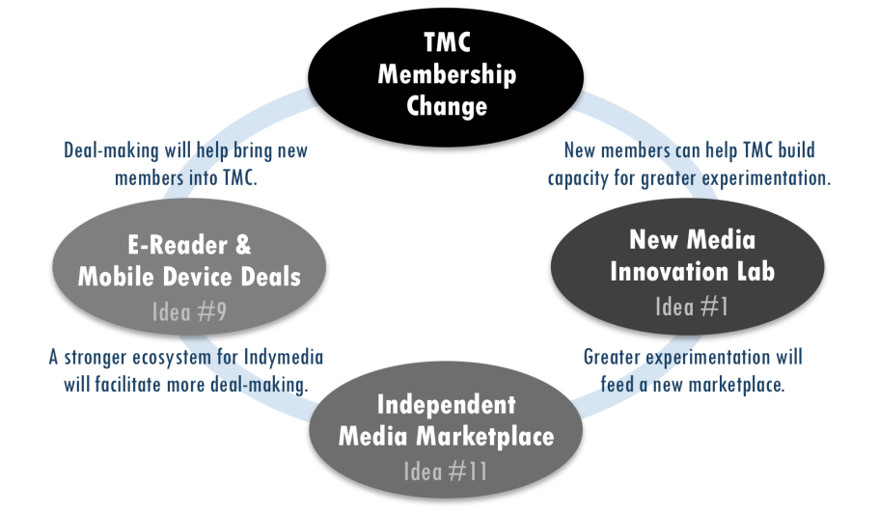
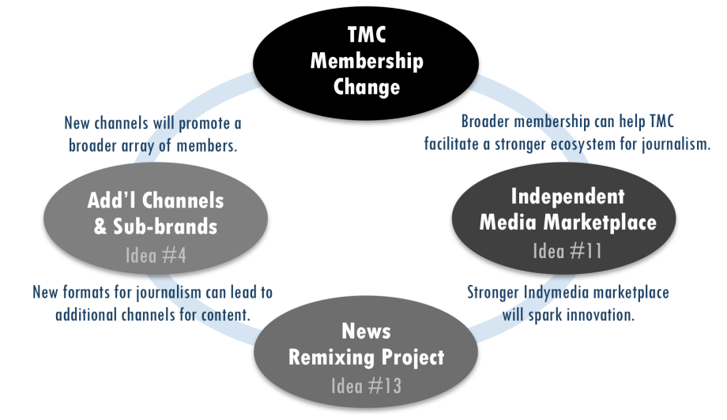
PHOTO
This page has limited text so the designer can make a transition page here using a large photo. Example of great transition pages:
http://digitaloutlook.razorfish.com/publication/?i=13617

Dissonance & Opportunity

Game Changer Box Set
Vol. 2

Old Paradigm of Journalism
Media as watchtower 1
Independent media as watchdog 2
Physical distribution 2
Resistance and denial 3
Tyranny of should 4
Are we facing a glacier or flood? 4

New & Emerging Realities
CHAPTER 1
NEW COMPETITIVE LANDSCAPE:
How is the playing field changing? 10
CHAPTER 2
NEW COMPETENCIES:
What new capabilities are needed to succeed? 31
CHAPTER 3
NEW SOURCES OF VALUE:
What needs can be met, problems solved or desires met? 44
CHAPTER 4
NEW BUSINESS MODELS:
How are media organizations structured to capture value? 58

Old Paradigm of Journalism
The bulk of this report’s analysis focuses on emerging realities and future possibilities. However, for context, it is useful to summarize a few key points about journalism’s old paradigm and why adaptation has been so difficult.
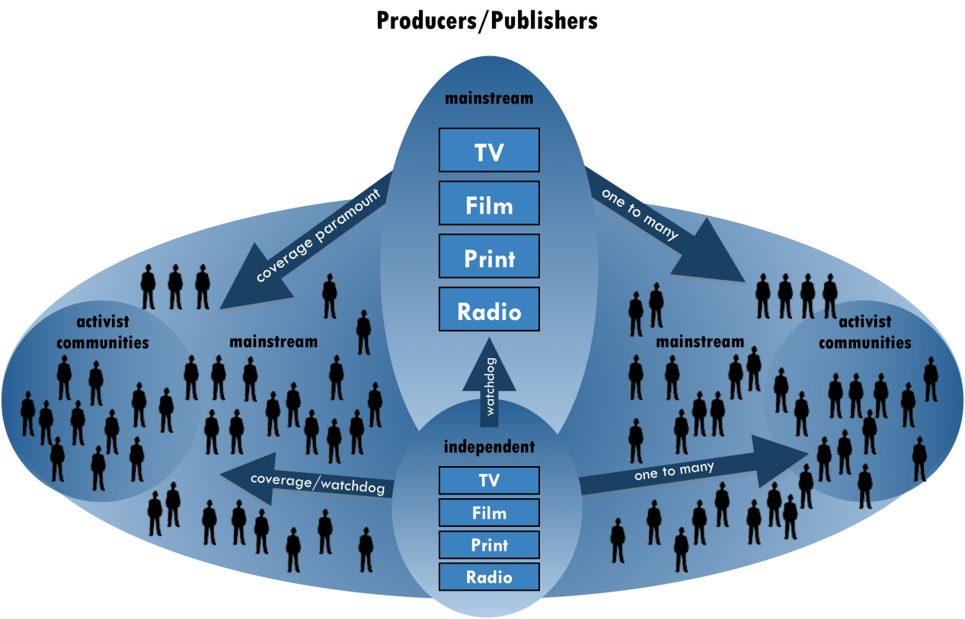

Media as watchtower
David Weinberger used a watchtower as the central metaphor for the old paradigm of journalism (pictured above), where journalists assume responsibility for covering all that is important, which is also their source of perceived authority. “If you don’t notice all the signal flares going off below the watchtower, you’ve missed something. But it makes no sense now—there’s too much to cover,” Weinberger said.
“And what about the next 50 or 100 years? … “Will newsprint (or something like it) survive? Will the digital world finally transform the physical presence of newspapers in some way as yet unforeseen? Who’s to say? In any event, we'll be here—one way or another—with the same values embodied in the same seven words Adolph Ochs put atop the front page more than a century ago.”
– Howell Raines, New York Times Executive Editor, 2001^{C}

“The notion that there is news ‘coverage’ is historically a result of the assumption of scarcity,” he explained. “The world only looks like that if you’re looking at it from a point of view with a finite amount of space and centralized structure for filling that space, like in a newspaper.” Today, lack of coverage is no longer the primary problem for news-seekers. In fact, the amount of information online reveals how much news coverage was missing before the web. Twitter users blindsided CNN in June 2009 for insufficient coverage of Iranian elections.
In 1896, the New York Times offered $100 prize to the reader who submitted a better slogan than “All the news that’s fit to print.” After receiving over 2,000 entries, it kept the original. Although the slogan is the subject of endless debate and parody, Times executive editor Howell Raines explained in 2001: “…We cling to it not because it’s charmingly archaic but because it’s our beacon, the beacon of the values that have guided us for all of the 150 years.” Raines acknowledged the slogan’s flaw in a literal sense, as did a Times editor over 105 years earlier. Although Raines admitted, “Every day, the paper misses a great deal,” they still aim to be a watchtower for the news.
Stemming from the watchtower role, journalists have historically had the authority of an expert or educator, with “beats” to cover and accumulated knowledge in subject areas. Readers often grant this perceived authority to journalists unconsciously, partly due to their role as trained professionals and partly due to the didactic one-to-many information flow from a central tower. These dynamics perpetuate, even if unintended, the myth that “experts know best.” While society needs experts, they do not always know best. Often crowds know better, especially if it is the right crowd. Nevertheless, the perceived authority of journalists is reinforced by the conventional goal of objectivity, where the responsibility of “coverage” includes balancing diverging viewpoints in one story as though the journalist knows enough to strike the right balance. However, as the problem of missing coverage declined with the breadth of voices online, people increasingly question the goal of objectivity in reporting, a notion that many people in independent media have seen as an illusion for some time.

Independent media as watchdog
If a watchtower describes media organizations’ historical role, then an alternative watchtower or, more frequently, a watchdog would describe independent media.
Watchdogs from an array of political perspectives will always be important to a healthy democracy. They provide a corrective feedback mechanism to mainstream watchtowers, including corporations and government. However, if independent media outlets view themselves primarily as watchdogs or alternative watchtowers, they too perpetuate the myth that “experts know best”—even if they believe their experts are more enlightened than mainstream powerbrokers.
“Indymedia and media activists everywhere, from the commie-pinko left, all the way to the completely reactionary wacko right, have been waging a war to establish platforms for telling their stories and narratives, for years now. The goal of all of this work has been to impact mainstream culture and to shift the very foundations of civil discourse.”
– Sascha Meinrath, New America Foundation^{D}

Weinberger pointed out the tension that arises if journalists cling too tightly to these traditional sources of authority: “The motivation of media is not the same as that of the readers/viewers of the media. … We’re reading because it’s interesting to us in some way, not because we want to be well informed.” Nevertheless, most journalism organizations still consider informing readers as central to their mission.

Physical distribution
Physical distribution limits enabled media companies to create and maintain a competitive advantage in the old model. High costs gave outlets greater control of their publication’s distribution channels and reduced competition. For example, the elimination of these limits today has considerably lowered the barriers to entry for new players. In July 2008, Teresa Stack, president of The Nation, wrote in a TMC members’ survey that all the new entrants, and the breakout success of the Huffington Post, were big surprises in the past few years.
- Moore’s Law
An observation by Intel co-founder Gordon Moore that processing speed, memory capacity and other capabilities of digital devices doubles approximately every two years.

Even in the digital world, hardware is no longer a physical limitation in terms of both processing power and data storage due to Moore’s Law (definition in right column). Buying additional storage is easier and less expensive than getting rid of files. In fact, Google designed Gmail based on the idea that a user never needs to delete data.
The historical physicality of media has determined its form. Traditional publishing organizations have found it appealing to think that they might only need digital facelifts of their physical selves, rather than develop entirely new incarnations. But there are drawbacks to creating new forms based on old models. Originally, newspapers treated their homepages like their front pages, yet homepages are shrinking assets since users increasingly interact with sites through other paths.

Resistance and denial
“No one has been ‘caught up in this great upheaval’ about the fall of print business model. This change has been more like seeing oncoming glaciers ten miles off, and then deciding not to move.”
– Clay Shirky
Technological innovations have been changing the game for over a decade. The current monumental shift is nothing new. However, there is a difference between knowing that significant change is coming and recognizing how to best react, which is a process that can take many years.
“Sigmund Freud described denial as a state of ‘knowing-but-not-knowing.’ […] Freud saw denial […] as ‘a state of rational apprehension that does not result in appropriate action.’”
– Richard Tedlow^{E}

First of all, it is difficult to anticipate the full consequences of a broken system until after it breaks. Before the levees broke in New Orleans, it was obvious to many people that a flood was inevitable. It was not as clear, until the city flooded, what the many complex effects would be.
Second, the leaders of independent media organizations still have very rational apprehensions about changing their practices and are uncertain about how significant any changes would need to be. For example, in response to utilizing crowdsourcing (definition p51) in reporting, one TMC member wrote: “I’m not sure I like this idea because it takes away from individual ownership (both outlet and writer) for a story. But it might be the way things are going.”
Business historian Richard Tedlow has studied the role of denial in undermining leaders’ ability to steer their companies through industry shifts. He points to the U.S. automobile industry as one of the best examples. The music industry is another classic illustration. Tedlow explains that denial involves many issues, “From ignoring external forces such as technological innovation and demographic change to overestimating a company’s own capabilities and resources.”
Leverage points are
“places within a complex system (e.g. corporation, city, ecosystem) where a small shift in one thing can produce big changes in everything. … We not only want to believe that there are leverage points, we want to know where they are and how to get our hands on them. Leverage points are points of power.”
– Donella Meadows^{F}

Business historian Richard Tedlow says there are two reasons businesses have failed over the last century: either the business leaves the market, or the market leaves the business.^{G}

One of the biggest barriers to changing an organization or field is leaders’ inability to shed the paradigm from which it arose, which is a deeply held set of shared beliefs and practices about how the world works. Donella Meadows, a pioneering environmental scientist and respected systems thinker, ranked the twelve most effective “leverage points” to change any system. Her second most powerful lever was changing “the mindset or paradigm out of which the system—its goals, structure, rules, parameters—arises.” Interestingly, Meadows notes that the greater the leverage point, the more the current system will resist changing it. Therefore, those who face a completely new paradigm may also face the strongest denial.
The history of failure in the railroad industry illustrates the paradigm-shifting lever’s significance for journalism. James Surowiecki described the parallel in his New Yorker article “News You Can Lose.” If railroad owners had focused on customers instead of products, they may have recognized that they were in the transportation business, not the railroad business, which was quickly losing customers to automobiles and airplanes. Surowiecki wrote, “By extension, many argue that if newspapers had understood they were in the information business, rather than the print business, they would have adapted more quickly and more successfully to the Net.”
Perhaps we are facing a paradigm shift that runs even deeper than Surowiecki suggests. If journalism organizations view themselves as acommunity-building or conversation business, not just the information business, they might rise to higher ground with their customers instead of drowning with an old paradigm they believe “should” still work.

Tyranny of should
An underlying goal of the progressive movement is to change the world as it is into the world as it should be. Certainly, this is the underlying goal of anyone seeking any sort of change, although for many media organizations this might be secondary to the aim of creating quality journalism. The rub comes from differing perspectives of what the world should be.
“Progressives would rather be right than win.”
– Larry Irving

The world would not improve without people fighting for “shoulds” such as women should vote, everyone should reduce their carbon footprint and people should support local media. However, people and organizations can also limit their impact by clinging to “shoulds” that undercut their ability to gain resources (e.g. financial, social, cultural). Sometimes, organizations can even create greater positive change by first meeting people where they are, especially in an online world that is characterized by empowerment of individual users and relevancy of information.
Non-profit and advocacy organizations face a particular challenge with the tyranny of should, as they are driven primarily by social missions. That’s the paradox for progressives. For any type of organization, the best strategic choices usually focus on changes that are within its control. John Bracken, program officer at the MacArthur Foundation said, “I feel like many ‘shoulds’ are uncontrollable. People have been concerned about newspapers, but there are waves of trends going on that we can’t control.”
“Shoulds” come from deeply held beliefs about how the world can be better, which often seed new paradigms that transform complex systems—including capitalism and democracy. However, new paradigms are also trapped by the tyranny of should. Therefore, according to Meadows, the power to transcend paradigms, "to realize that no paradigm is ‘true." is the most effective lever.
“If no paradigm is right,” Meadows points out, “you can choose whatever one will help to achieve your purpose.”
“When we shift our attention from ‘save newspapers’ to ‘save society’, the imperative changes from ‘preserve the current institutions’ to ‘do whatever works.’ And what works today isn’t the same as what used to work.”
– Clay Shirky

The best strategy will stem from asking: “So, what? What will media do for people?” said Amy Gahran of the Poynter Institute. By strengthening the collective agreement about independent media’s ultimate aim, TMC can help its members shift paradigms more easily, choose the most effective game changers and better weather any industry shifts to come.

Are we facing a glacier or flood?
While changes to the news industry advanced at a glacial pace for many years, as Shirky claimed, transitions often come as quickly as the levees that broke in New Orleans. Trigger events can cause sudden floods before new a system is in place to prevent it.
News organizations are facing flash floods and many are in a mode akin to sudden death, wilderness survival. Laurence Gonzales, in his book Deep Survival: Who Lives, Who Dies, and Why, explained that those people who most quickly surrender to their new circumstances, take decisive action, and believe anything is possible are the ones most likely to survive.Each independent media organization must answer two questions in order to survive: “What will you be standing on when the flood reaches you?” and “How will you boldly move to higher ground?”
The collective insights from this project’s participants warn that old ways of thinking can limit media organizations’ chances of survival, especially those outlets that make incremental changes. Small moves prevent organizations from choosing entirely new strategies and developing new competencies quickly enough to remain relevant. However, participants suggested many avenues for making bold moves—outlined in the following four chapters—which can collectively lead independent media to higher ground.

New & Emerging Realities
The dissonance between journalism’s historical role and its new realities can help media organizations identify ideas, practices and approaches for the future.
The new competitive landscape requires media organizations to develop new competencies to succeed. Finding new ways to meet users’ needs, solve their problems and fulfill their desires will be the sources of value that drive new business models. The following chapters address four strategic questions about new realities of the media industry.

PHOTO

This page has limited text so the designer can make a transition page here using a large photo.

Example of great transition pages:
http://digitaloutlook.razorfish.com/publication/?i=13617

The following four chapters begin with a brief chart comparing the old and new paradigms, followed by a detailed analysis of the new paradigm’s opportunities.

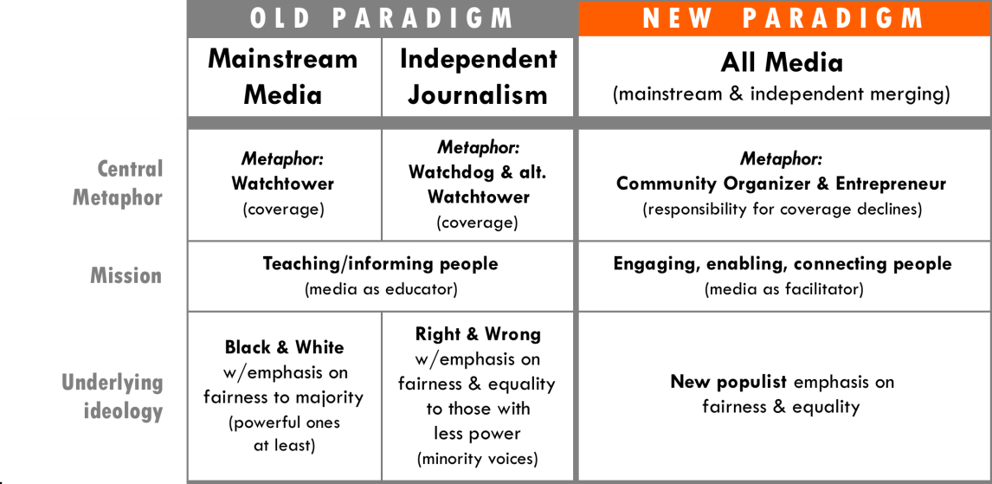

CHAPTER 1
NEW COMPETITIVE LANDSCAPE: How is the playing field changing?
When the media industry was more stable, the primary risks were clearer. For mainstream media, risk centered primarily on rivalry among existing commercial competitors. The risk for independent media centered on competing against the mainstream as controlled by corporate conglomerates and government powerbrokers. Today, risk comes from all directions. The competitive forces in mainstream and independent media overlap almost indistinguishably. As Weinberger put it, “There is no more mainstream.” An important aim of progressive media could be to fight to keep it that way.
PHOTO

This page has limited text so the designer can make a transition page here using a large photo.

Example of great transition pages:
http://digitaloutlook.razorfish.com/publication/?i=13617

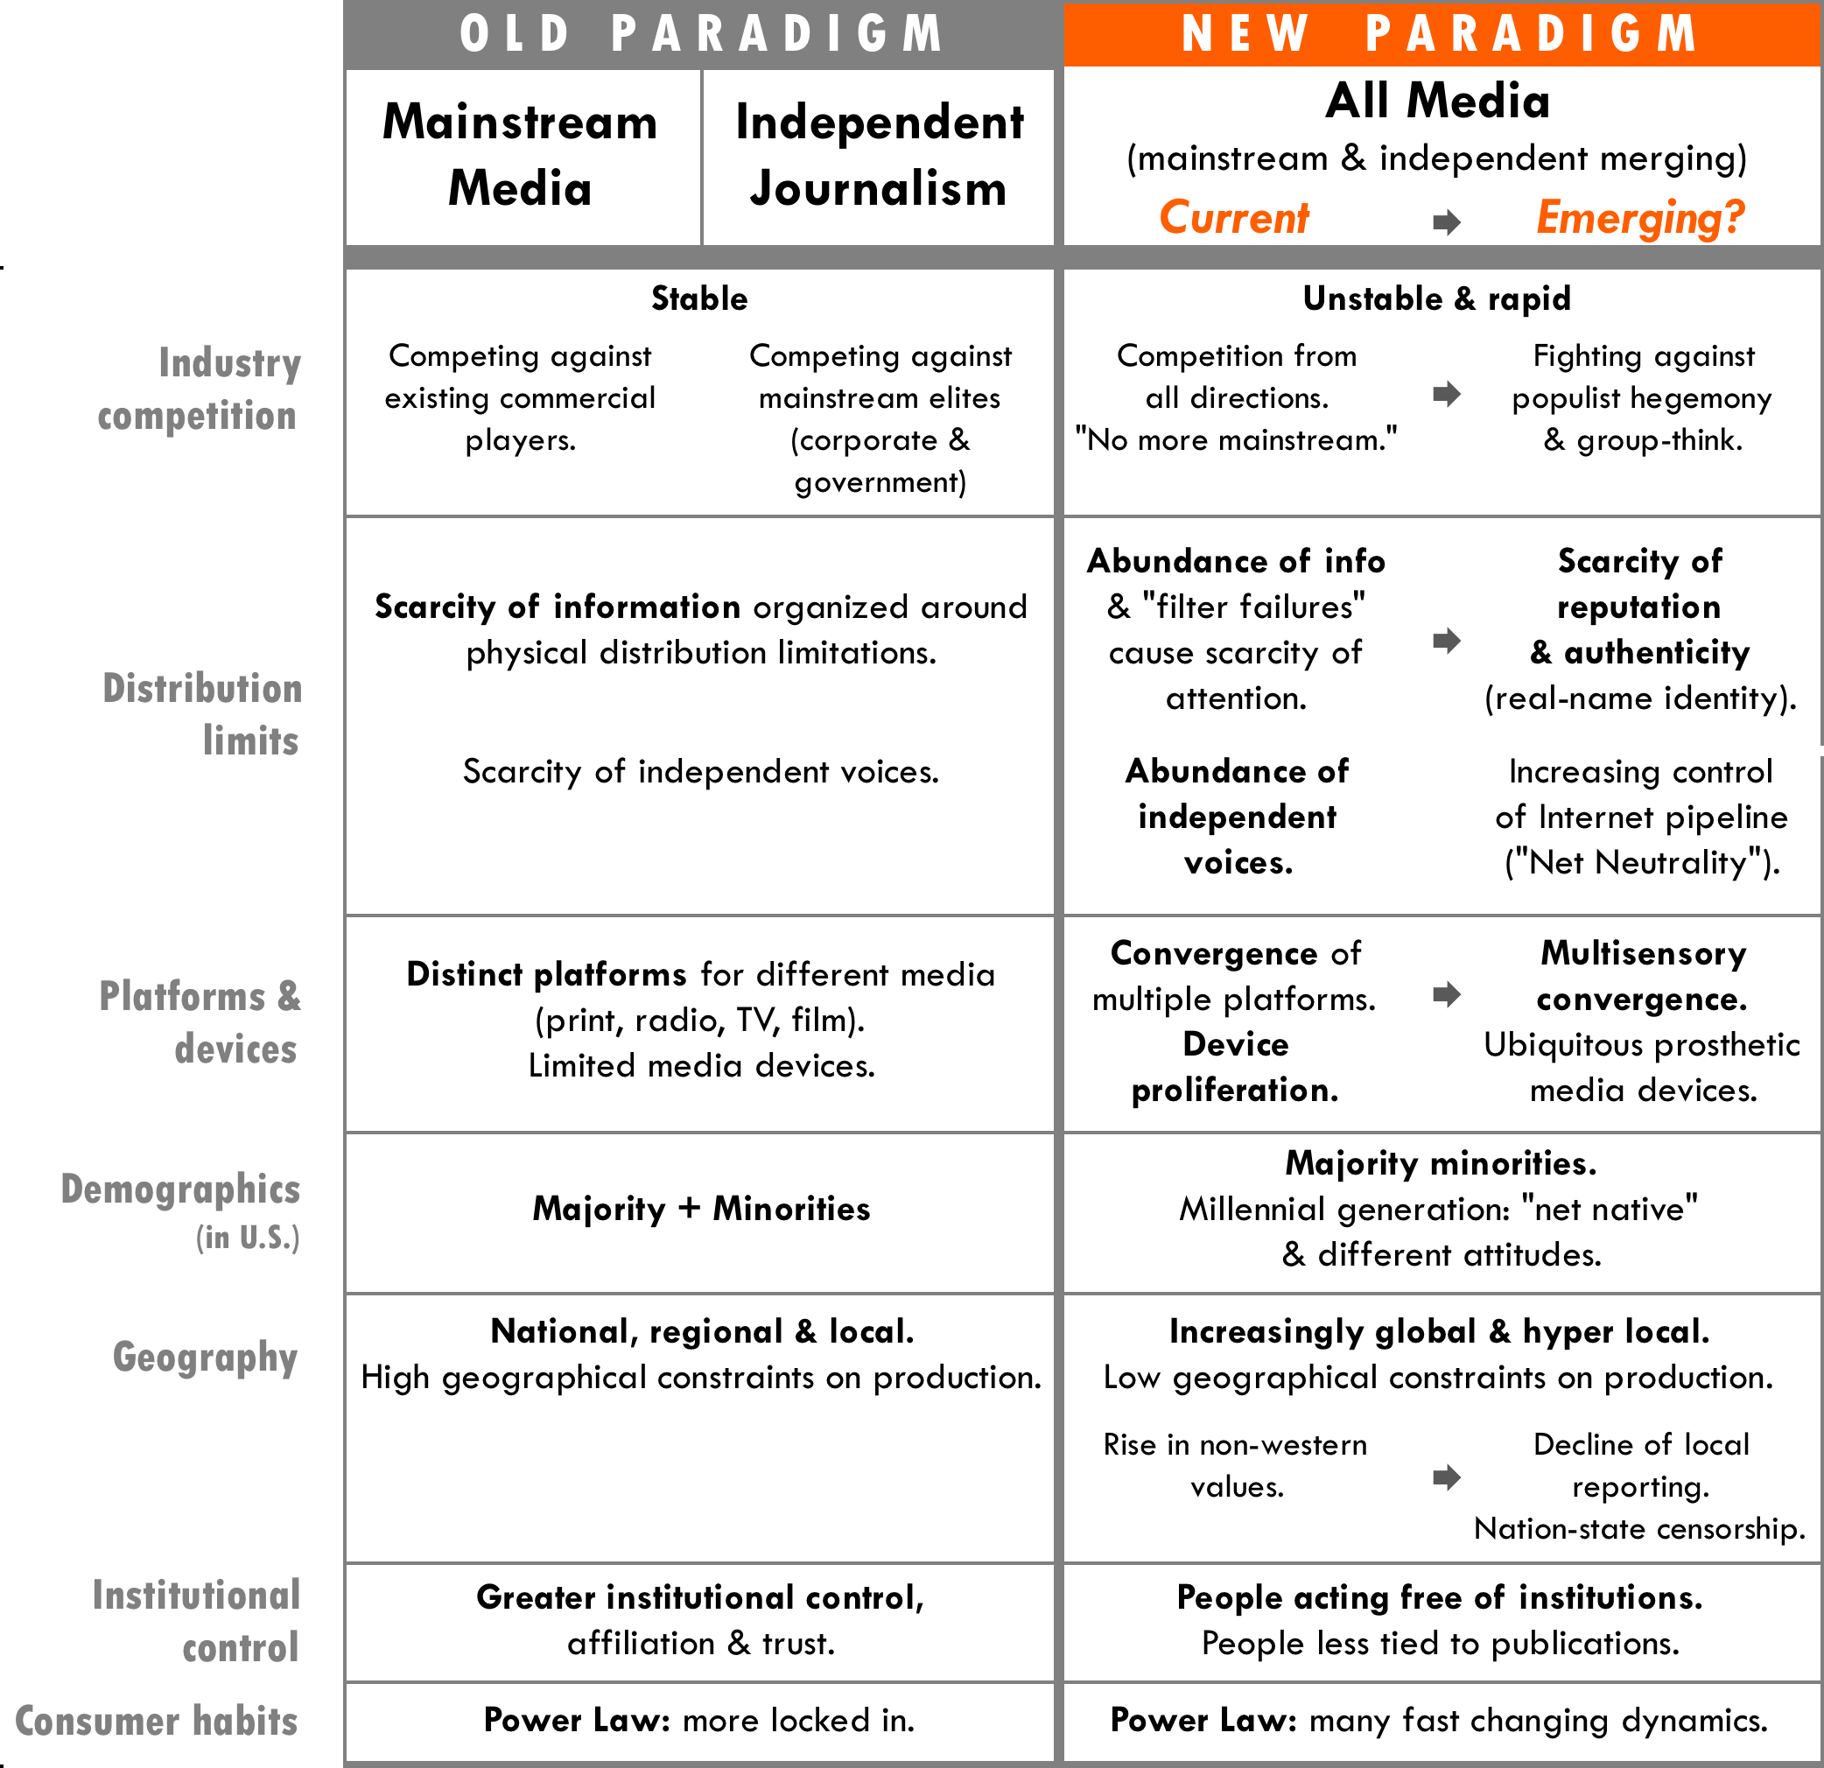
“Independent media will be part of normal everyday media, integrated as mainstream media, part of the usual.”
– Craig Newmark, Craigslist

The basis for competition has changed due to significant shifts in abundances and scarcities, which underlie the basic principles of supply and demand. The proliferation of media devices and convergence of content on them exacerbates these dynamics. Furthermore, globalization and demographic shifts have made audiences more complex, yet their consumption habits still fall into familiar patterns described by “power law” (defined below). This chapter covers the following changes in the competitive landscape.

New abundances & their effects
As physical limitations decline, the competitive landscape changes fundamentally: New abundances have turned the economics of distribution on its head.
Jump Forward
News as a loss leader, Vol.2, p67

For example, “loss-leader strategies” are inverted. Companies used to give away 1% of a product, such as perfume, to get the samplers to buy the other 99%. Now, companies such as Flickr or Skype give away 99% (often called a “freemium”) to sell 1% in the form of premium purchases. For example, Flickr Pro costs $25 per year. This flip has generated new abundances of products.
The inversion has fundamentally shifted systems of distribution by creating a new, self-reinforcing positive feedback loop in which the more you give away for free, the more you must give away for free in order to compete. Meadows said that positive feedback loops, if unchecked, can become a “race to the bottom,” in which a system ultimately destroys itself. In the old paradigm, the price of creating and sharing information was a useful corrective feedback loop. A photographer, for example, limited the number of images she or he shot due to the cost of film, processing and printing.

Abundance of information
The media-as-watchtower role worked well in a world of information scarcity. “Now there’s an abundance of everything—content, reporters reporting on it, commentators to make sense of it, and lots of ways to put it together, such as emailing links, doing a ‘Digg.’ It’s entirely about abundance,” Weinberger explained. “The only thing that scales is the massive effort of readers doing it for themselves.”
“What does the Internet display-ad market have in common with Zimbabwe? Both are printing nearly-limitless amounts of their main currency, vastly diminishing its value and undermining their future. (This) isn't just about a cyclical downturn caused by the recession.”
– Martin Peers^{I}
“Forty years ago, the principal nutritional problem in America was hunger; now it’s obesity.”
– Chris Anderson^{H}
This abundance has another effect, according to writer Nicholas Carr: “What the Internet has done is broken the geographical constraints on news distribution and flooded the market with stories, with product. Supply so far exceeds demand that the price of the news has dropped to zero.”
Of course, an abundance of content also leads to an oversupply of available advertising space, which causes ad prices to decline. At any given time, 30 to 50% of available advertising impressions can go unsold on a site, even with the help of advertising networks that efficiently reach more advertisers. Although Wenda Harris Millard, president of Martha Stewart Living Omnimedia, warned in early 2008 that companies should not sell their web inventory like “pork bellies”, publishers often need to lower their prices to compete.
Content oversupply can have similar effects on philanthropy, making it harder for content producers to raise funds. More producers are competing for limited grants, and funders can find producers willing to develop content for less. Like advertisers, foundations now have more options than ever before to direct their funds in support of the content they want to reach people, diluting both investment in—and possibly impact of—media projects.

Abundance of independent voices
The good and bad news are now one and the same: There are more independent voices than ever before. Within the old media structure, there were too few independent voices, but that is no longer the major problem. “Empirically there are so many, many, many, ways for alternative voices to emerge. For instance, the Al Jazeera Twitter feed is going strong with the war in Gaza with a fairly large following,” Clay Shirky said.
Despite talk of reaching niche audiences, it would be silly to believe that any independent media producer wants to reach just 12 people—unless that group is the President’s cabinet. The growing ease of “few-to-few” communication is valuable in many ways, but information usually must reach a large-scale audience to have power. Scale is hard to control with many fragmented voices, which makes it more challenging for any one content-producing organization to sustain itself. While the emergence of many new, independent voices may represent the future we have been waiting for, it also might threaten the existence of organizations whose value was largely based on their “independence” from large commercial media companies. Katrin Verclas, co-founder of MobileActive, went as far as to contend that in 10 years media organizations are not going to look the same. , “I don’t think there will be such a thing as independent media anymore in terms of organizational structure.” Even if such organizations do not disappear altogether, the abundance of independent voices will inevitably change the form they take.

New scarcities & their effects
Some people have viewed the new media paradigm as a perpetual rise in disintermediation, where authors go directly to readers. Nevertheless, mediation—and the organizations that benefit from it—may simply be shifting from one place of control to another. Companies such as Google are dominating the new forms of mediation: search and filtering.
“Publishing has only two indispensable participants: authors and readers. As with music, any technology that brings these two groups closer makes the whole industry more efficient–but hurts those who benefited from the distance between them.”
– The Economist^{J}

In a keynote at Nokia World 2007 about the “taxonomy of free,” Chris Anderson of Wired Magazine said that time and money are no longer the chief scarcities for people. The new scarcities include time, money, attention and reputation. He asked the audience, “Which economy are you playing in?”

Scarcity of attention
Anderson views total attention as a fixed sum; you can gain or lose share. Media companies not only compete with each other for users’ attention, but also compete with the time someone takes to attend their child’s soccer game. To make matters worse, people are increasingly multitasking (e.g. checking email and watching TV). Attention is valuable because it is so scarce.
Jump Forward, Vol. 2
Now is the time for immediacy, p48
Depth of community, p54

As the marginal costs of sharing information approach zero, so do the costs for users to switch between information sources. Publishers must find other ways to maintain users’ attention online, which they can achieve by increasing connection with and among users. Media outlets can also compete by using live online events to tap the growing value of immediacy.
- Strategic recognition
What if… we made it easier to deepen communities at a larger scale?

Scarcity of reputation
Google search built its PageRank on sites’ reputations; eBay built auctions on sellers’ reputations; Prosper.com and Kiva.org are building microfinancing sites on lenders’ and borrowers’ reputations. Digg and StumbleUpon have done the same in filtering news and information. NewsTrust, started in 2005, aims to use reputational value as a credibility filter for online opinion and amateur journalism, thus building greater trust and accuracy. Furthermore, many companies increasingly focus on gaining “mindshare” (a type of reputation). New ways to track online attention and loyalty will make it more reliable to measure the value of reputation.
Jump Forward
Will more reliable & consistent measures create greater distribution of value?, Vol.2, p37

For journalism organizations, building a stronger reputation could be particularly valuable. “Believability ratings for national news organizations remain very low. If anything, believability ratings for major online news outlets—including news aggregators such as Google News and AOL News—are lower than for major print, cable and broadcast outlets,” according to The Pew Research Center for the People & the Press.
Reputation is fragile and perhaps more so than time, money and attention. Like organizational culture, reputation is hard to build and easy to destroy. It can falter with a single act that sparks mistrust. In a New York magazine article, Vanessa Grigoriadis asked, “Why has the number of MySpace visitors remained essentially flat in the past year? Why do social networks fail?” The fragility of users’ trust is a big reason, she explained.
Reputation can be inextricably linked with privacy issues, which John Battelle has written about for years, including a “Data Bill of Rights” in 2007. Even though stronger government regulation needs to protect privacy, consumers are already uneasy about it. They want greater control of their personal information. As a result, the relationship between privacy and reputation could be a differentiating factor for media organizations that manage it well. Publishers can serve as trusted brokers between advertisers who want to reach people and users who do not trust advertisers with their personal information, but would still like to get ads that are relevant and useful.
“A stronger rapport with the public won’t solve journalism’s crisis by itself, but it could be a central component of the solution.”
– Amanda Michel^{K}

“To follow the money, you have to shift from a basic view of a market as a matching of two parties—buyers and sellers—to a broader sense of an ecosystem with many parties, only some of which exchange cash.”
– Chris Anderson^{H}

Battelle has been a proponent of “Conversational Marketing” that depends upon all players’ reputations. As he put it, “conversational marketing is simply the tip of a very large iceberg, representative of a sea change in how all businesses converse with their constituents—be they customers, partners, or employees.” Of course, the conversation involves many more players (both commercial and non-commercial) and hinges on reputation created through greater transparency and dialogue across the board.
As we consider news abundances and scarcities, we must also consider the long-term effects of news organizations shrinking and closing. James Surowiecki claimed, “we’re almost sure to see a sharp decline in the volume and variety of content that newspapers collectively produce.”
Many former journalists are turning into social entrepreneurs—working independently or starting their own ventures—and could benefit from new, networked support systems that a consortium provides. The increasing number of career shifts among journalists has even spawned consulting services. For example, Amy Webb conducts trainings for “newspaper refugees” to build post-mainstream journalism careers. Wherever journalists go, they are not likely to be absorbed back into traditional news organizations that once supported them, yet they could be organized to shape a new future for journalism.
- Strategic recognition
What if… we retooled journalists?

Device proliferation, convergence & their effects
“The future of media for me would be the type of content that I want anytime, anywhere, on any device,” said Ashish Soni, who directs the Information Technology Program at the University of Southern California. One trend that has become very clear in the last few years: Consumers want complete control of the content they consume and access to it on all their devices, platforms and services that allow this. As a result, media content no longer falls neatly along the lines that used to separate print, radio, TV or film.
“The device that wins will seamlessly integrate web content with content from other sources, such as cable, onto the TV, since consumers will undoubtedly want to put their large, flat-panel HDTVs to good use.”
– Razorfish Digital Outlook Report 09

All media organizations will have to reckon with two major game changers that may have the greatest impact on media convergence going forward: Mobile and the ripple effects of television’s analog switch-off.

Mobile revolution
“The big game changer over the next short term is mobility,” said Don Tapscott, author of Wikinomics. “Media is coming into our pocket and is with us at all times on a device that knows where we are.” The mobile revolution will likely have the greatest impact on media convergence, as laptops become more mobile (e.g. netbooks & cloud computing) and mobile phones become more powerful computing devices. In the United States, 15% of the population has smart phones (e.g. iPhone or Blackbery), according to a Pew Research Center study, and 37% of those who own these devices say they get news on them.
“Mobile is the primary means of communications for the majority of the world. If you care about freedom, this is about freedom of location and time.”
– Katrin Verclas
Already, three quarters of the world’s messages are sent via mobile and nine out of 10 in developing countrieswhere mobile phones have “leapfrogged” other technologies. Mobile phones had an estimated 50% penetration rate in developing areas by the end of 2008—up from nearly zero ten years earlier. Worldwide, the number of mobile phone subscriptions are triple the number fixed telephone lines. In fact, Jeffery Sachs, a renowned economist who has focused on the developing world, says mobile devices are part of the reason we might be turning the corner on the digital divide.
Verclas asked, “What do people actually want on the content side—in particular, mobile content? What is needed? What is necessary? What is provided? What is available?” Razorfish’s Digital Outlook Report 09 claimed that growing mobile usage will cause some consumption habits to converge: “As the mobile search experience begins to mirror that of the PC, so too do the expectations for types of content. This means users will increasingly begin to see the mobile device not only as a source of localized information on the go, but as an aid to many of their everyday tasks.”
Jump Forward
Location based mobile, Vol. 3, p25

Analog TV switchoff
Jessica Clark believes that the switch-off of the analog signal in summer 2009 may be a more significant game changer than independent media-makers realize. Clark, who directs the Future of Public Media Project at American University’s Center for Social Media and is former executive editor of In These Times, notes that the switch-off will also generate many new broadcast channels, offering an opportunity for progressive and independent media-makers to generate fresh broadcast content that could also be streamed online.
- Strategic recognition
What if… we helped shape how public policy governs access?, p15
The challenge now comes from the tremendous number of devices that people use, and the fact that consumers increasingly want to access any content, anytime on any device. To that extent, convergence is not only about optimizing content for multiple platforms, but also about enabling people to easily consume and share any type of content using any platform.
- Strategic recognition
What if… we built a new ecosystem for journalism?
To complicate matters, different platforms inevitably have different strengths for different types of content. People often want to check email on a more private device than their TV, for example. Vivian Schiller, CEO of National Public Radio, explained that radio has some built-in advantages over a newspaper or website, which makes radio a complimentary rather than competing form of media. “You can listen to NPR getting dressed in the morning,” she said. “But when you sit down to read a newspaper, you could be going online.”
Nearly all media technology companies, large incumbents and startups alike, have made plays in platform convergence, which will change the competitive landscape in significant ways. “In fact, the word ‘television’ will eventually mean something new—it will need to move beyond the platform itself,” wrote Terri Walter in the Razorfish Digital Outlook Report 09. Convergence technology is quickly improving, and media organizations that make it easiest for consumers to mix platforms will succeed. The whole ecosystem of content creation, ad buying, philanthropic funding and audience building will have to adapt as well, which is where a consortium can play a role.
We are heading into a post-platform economy, where media organizations that can think beyond platforms in overall technology strategy, yet can also efficiently differentiate content form by device, may win.
“(Game changers in the media space) may be in the innovative ways that digital media interacts with legacy media whether it’s print, radio or television. … The opportunity is that we have layers of different kinds of media, each with its own strength. Figuring out a way to interconnect them is the real opportunity.”
– Vivian Schiller, CEO, NPR

- Strategic recognition
What if… we standardized raw data, metadata & metrics?

Dawn of a demographic revolution
“My bottom line is that demographics are changing in this country dramatically. Technology is changing dramatically. Willingness to hear progressive media is increasing dramatically,” said Larry Irving, a technology and media strategist and former Assistant Secretary for Communications and Information at the U.S. Department of Commerce. “There is a certain window of time to make something long-lasting.”

Effects of diversity
“Independent, progressive journalism doesn’t understand that progressives are speaking past Black and Brown audiences, but are dependent on Black and Brown votes,” Irving said. “They are condescending to these communities, afraid of these communities, and are not supporting and building in these communities. The reality is that five to ten years from now Browns and Blacks are going to make up more than 50% of the vote. Progressive media just doesn’t hear it, won’t make the investment and has insular naval-gazing. But I think part of the blame is that Blacks and Browns give their votes to people who don’t pay attention to them.”
Over one third of the nation is now made up of non-white populations. Hispanic and Asian populations grew ten times faster than whites, and Black population four times faster.
– U.S. Census Bureau 2007

“I think of Ebony, I think of it as the kind of magazine that my mother would read, not necessarily the kind of magazine that I would run out and read.”
– K. Tempest Bradford, The Angry Black Woman blog^{L}

Attitudes about diversity are changing in the United States. “There is a lot less concern among the younger generation about the racial divide,” said Irving. “For some Black Americans it’s important that the media they access is Black. But for younger people who want Black perspectives, it doesn’t have to be from Black people all the time. Black is one of the things they are—they have grown up in a diverse world. Some of the walls we’re seeing now are crumbling.”
Shifting demographics create both challenges and opportunities for content producers:Different groups use media in different ways. Irving noted that for Latinos, Facebook, MySpace and SMS texting drove greater adoption of technology. Furthermore, according to a 2008 Pew Research Center study, African-American Internet users are 18% more likely to watch online video than white Internet users and 15% more likely to have a profile page on a social networking site such as MySpace or Facebook. In terms of gender differences, for instance, women tend to watch network TV news (particularly morning programs such as the Today show), while more men watch cable TV shows. It is insufficient for a publisher to simply make content available anytime, anywhere on any device.They must also customize content for different audiences on different devices.

Effects of Millennial Generation
“I’m concerned that independent media organizations are not figuring out how to tap into the next generation of news consumers,” said Erin Polgreen of TMC. Young people (born between mid 1980s to early 1990s) are leaving print and television news, and for a long time incumbent organizations believed that they might eventually come back. “In spite of the increasing variety of ways to get the news, the proportion of young people getting no news on a typical day has increased substantially over the past decade,” according to a 2008 Pew Research Center study. “About a third of those younger than 25 (34%) say they get no news on a typical day, up from 25% in 1998.”
Nevertheless, the Millennial Generation’s members are world-changers with strong democratic values, which indicates that they are interested in information about the world around them. Tapscott, who authored the 2008 book, Grown Up Digital: How the Net Generation is Changing the World, explained: “This is the first generation to come of age in digital age. They have enormously strong values—they care a lot. It’s not true about this being the ‘narcissistic me’ generation. Civic engagement in U.S. has been growing decade to decade and is currently at an all time high, and it has turned into political action. This generation is going to change the world.”
“The engagement of young people that Obama has generated seems cause for optimism. How can we translate that engagement into support for our type of journalism and our values?”
– Teresa Stack, The Nation

If independent media can experiment with bold new ways to engage audiences, they may tap a new generation of users that will transform the world and how the news is reported. “In the progressive community, (young) people will have the more universal POV, and also be the ambassadors for their communities,” Irving says. “Don’t expect progressive media to have a direct path initially. They need to find trusted voices inside the community that can help create the echo chamber.”
- Strategic Recognitions
What if… we joined early in technology experiments?
What if… we reinvented formats for journalism content?

Next phase of globalization & its effects
“The idea that you can have a native political audience that is tied to a publication—like how African-Americans were traditionally Democrats because they had no other place to go—is no longer true,” said Shirky. The same goes for native geographical audiences. The Guardian now has more readers in the United States than in the United Kingdom. Even Wikipedia made a special call this year for volunteers who better represents the diversity of the world.
While expanding to global audiences is an opportunity for individual publishers, it threatens further media fragmentation and redundancy of production capacity. “When the geographical constraints went away,” Nicholas Carr wrote, “all that fragmented (and redundant) capacity suddenly merged together into (in effect) a single production pool serving (in effect) a single market.”
In addition to the economic implications, two key challenges in the next phase of globalization include a reckoning with non-Western values and the growth of filtering and censorship by other countries.

Non-Western values
Publishers cannot simply extrapolate from American experiences alone: The future will be shaped by non-Western values. For example, according to long time Asian correspondent Thomas Crampton, “While U.S. users tend to trust a professionally put-together [website], Chinese users have the opposite reaction and are highly skeptical. Chinese users presume that a professional-looking site was put together to promote a product or service.”
“Chinese have suffered from propaganda and soft content for so long that they are very savvy. Instead of believing what a professional site says, users in China prefer to ask a bulletin board to hear what anonymous users post in reply.”
– Matt Roberts, About.com, China^{M}

Richard MacManus, founder and Editor of ReadWriteWeb explained that one of the main reasons Facebook had almost no presence in three of the markets they cover—China, South Korea and Japan—is the persistent bias from Americans that everything from the U.S. is great, while Asia just copies. If independent media made a concerted effort to go global, it may take careful work to avoid this trap.
The ambiguity surrounding the definition of “progressive” could be further complicated when non-Western values enter the mix. How will global audiences affect content when U.S. media outlets cater to them? What content do global audiences want and for what purpose? Do their desires align with what U.S. independent media wants to cover?
Connecting to a global audience must be a two-way street. Media organizations cannot simply impose stories on users in other countries. They must also pull stories into the U.S. and explain why they are relevant. The U.S. demographic revolution and its growing Spanish-language media create opportunities to support this goal. Learning about technology habits from other countries is another important part of the reciprocal equation. Already, the Western world has a lot to gain from learning how users in Asian markets use mobile media, video games and other technology. In fact, U.S. organizations underutilize foreign markets as a source of innovation.
“There is one thing [progressive media] should be examining—their political assumptions in a global era.”
– Clay Shirky

U.S. media organizations can also build reciprocal relationships by deliberately facilitating connections between their current users, particularly those involved in co-creating content, and international writers, producers and consumers. This would be effective when dealing with global issues such as climate change, trade or public health. Google introduction of a new product called “Google Wave” in late 2009, which has groundbreaking translation capabilities for live chat and could open new possibilities for international user engagement. However, a concerted community organizing effort would need to accompany such a tool.

Global filtering & censorship
Government censorship is increasingly threatening independent voices around the world, as we saw with Iran’s elections. “A simple correlation between the Internet environment and the expansion of global civil society can no longer be taken for granted,” according to Ronald Deibert and Rafal Rohozinski, co-founders of the OpenNet Initiative. A new book they edited, Access Denied: The Practice and Policy of Global Internet Filtering, found growing filtering, censorship and surveillance in the 40 countries they studied—a sharp rise in the number of countries and the extent of control compared to similar research in 2006. Independent media is often the only source of free expression in many states that tightly regulate and control major media outlets. Access Denied reported that 17 countries blocked at least one website that was in the category of “independent media.”
Most alarmingly, filtering and censorship activities are no longer confined to non-democratic countries. Deibert and Rohozinski found that, over the past five years, arrests and intimidation of bloggers worldwide have progressively increased. Governments use denial-of-service tactics to proactively block them, especially in election periods. Hackers have even shut down entire social networking sites to silence one dissident voice.
Government and big corporate players need to fight the rise of censorship and monitoring more actively. Google has begun to collaborate with LiveJournal, Twitter and Facebook to make their platforms a safe haven for “digital refugees.”TMC and its members can contribute. For one, they could join the formidable international movement for Internet protection by using technological tools and publishing information that undermines global filtering measures. Also, the consortium could create projects that build relationships with foreign journalists, translators and organizers to curate the best, most reliable content from international users.
Since news organizations have been shutting down their international bureaus to cut costs, users in the U.S. may need to get more of their news directly from users in other countries. Shirky pointed out that a video of the 2008 Sichuan earthquake in China was online before authorities knew about it. “Compare this with the big quake in the 1970s, when it took three months for the Chinese to confirm that it had even happened. The censorship of the Chinese government is facing the wrong direction,” he said. “They have the in-bound media covered, but they have much less focused on their own people. So their firewall is facing the wrong way.” This could be an opportunity in disguise for independent media, which could source international news more actively from users and outlets in other countries and, in turn, build a reciprocal relationship with global audiences to support greater content distribution.
“A sprawling, distributed, and highly potent sphere of global civic networks has been unleashed that moves in and around sovereign states,” wrote Deibert and Rohozinski. This global movement of change-makers is a powerful potential audience, which Paul Hawken, in his 2007 book Blessed Unrest, calls “humanity’s immune response” to the toxins of injustice, corruption and pollution. Hawken says the movement involves people from many different professions, has no charismatic leader or unifying ideology, and that most people have not fully recognized its potential—especially media outlets.
“The world is in precarious situation and stakes are high. The combination of youth, new media communications and power of organizing, moves us towards first global movement of change.”
– Don Tapscott

- Strategic recognition
What if… we mounted a concerted effort to go global?, p23

Declining institutional control &affiliations
Many people today do not depend on institutions in the same way. This has forced media organizations to compete in a more decentralized, open environment. “There is this weird state of disconnect between existing structures and openness,” said Verclas. “Open networks are where things are evolving; yet media organizations are not. There’s not a lot of pro-activeness but a lot of reactiveness.”

Acting free of institutions
“People are increasingly acting on their own, free of institutions. They are taking distinct actions on distinct issues online,” John Bracken said. “If I was concerned about an issue in the past, I’d start an organization, open an office, get a bank account in order to organize letter-writing campaigns, do outreach to Congress. But, today, I might start a Facebook group and draw awareness without ever opening an office or a bank account.”
Civic engagement, for example, can no longer be measured by formal affiliations (a basis for past research). In Bowling Alone, Robert Putnam claimed a decline in “social capital” by pointing to declining participation in civic organizations. Today, however, affiliations may even be higher—they are simply happening in more informal and decentralized ways. In fact, some research has shown that online social networks have actually increased social capital in many new ways.
“Terrorists get it. They work in these small decentralized cells.”
– Katrin Verclas

The implications for institutions are significant: their relationship with constituents is more casual than what was previously acceptable, traditional organizational hierarchies are flattening, and network effects are amplified independently of institutions. Twitter has succeeded, often in spite formal institution, because of its open platform. The government of Iran couldn’t even shut it down.
Tapscott says that every institution faces a fundamental transformation. “People can now self-organize like never before. Young people have at their fingertips the most powerful tools, to find out what’s going on, to organize collective responses. Every institution in society is going to be naked and if you’re going to be naked, you better be buff.”

Readers not tied to publishers
Today’s online users, particularly casual newsreaders, increasingly receive news from direct referrals and links from their social networks. Only approximately one quarter of casual newsreaders, who comprise most of Americans, say they trust a few news sources more than others. In contrast, two-thirds of hard-core newsreaders feel that way, which indicates the value of trustworthy sources remains high for at least a small segment of consumers. Furthermore, people increasingly consume news from multiple sources. A 2008 Pew Research Center survey asked news consumers to list their most frequented online news sites. The results mostly included portals and TV news sites, yet revealed considerable fragmentation across the board. Only eight websites were mentioned by more than 2% of respondents. Only Google and Yahoo! increased their perceived trustworthiness as news sources, compared to center’s 2006 survey.
“We want quality content, but the trend is against going to a single place to find it.”
– David Weinberger

As a result, publication-centered news may continue to face greater challenges in turning readers’ fragmenting attention into a steady return of visits. Michael Hirschorn went as far as saying that, “The Internet has done much to encourage lazy news consumption, while virtually eradicating the meaningful distinctions among newspaper brands.”
The new rules of online engagement, according to Verclas, mean that there will be no central control. “It mutates and adapts; it’s flexible and agile,” she said. “We have no idea in the media how to do this. With the principles of decentralization, profits go away.”

Mirage of The Long Tail
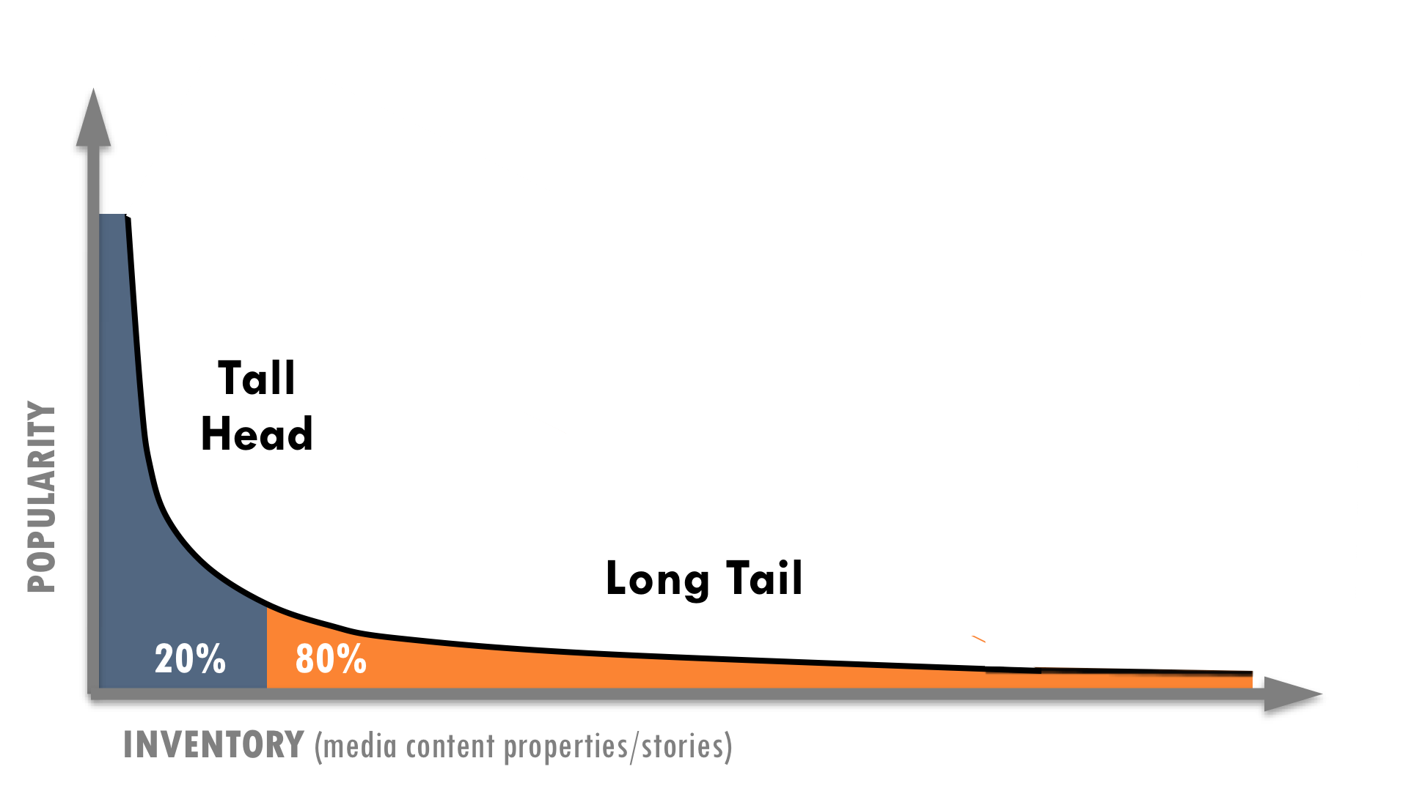
While many consumption patterns are at play in the new competitive landscape, two are particularly important: power law distributions and social cascades(defined in right column below). Both of these are more volatile and less predictable online, which creates opportunities for independent media.
Chris Anderson popularized the term “The Long Tail” in a 2004 Wired magazine article that became the basis for a best-selling book. The concept has become the foundation for countless business models. Before the term was prevalent, Amazon had already grown from the effects of a Long Tail—which describes the graphical representation of the popularity of all books available in the world, 80% or more of which are not sufficiently popular to justify the expense of stocking them in a traditional bookstore. The economics of combining broadly eclectic tastes with efficient online distribution is what make it work.
The Long Tail flips the conventional business logic of “power law” on its head by capturing value from the Long Tail of less popular, less profitable content. In recent years, the promise of The Long Tail has become a mirage for online media-makers. Successful long-tail strategies hinge on companies’ ability to provide a large scale of niche products at little to no marginal distribution costs. If the collective number of products in the tail is not large enough, it will not work. In other words, it mostly serves the interests of big corporations that can accumulate and distribute massive amounts of content, not independent producers who create the content. In fact, in his critique of Anderson in The New Yorker, Malcolm Gladwell asked, “Why are the self-interested motives of powerful companies being elevated to a philosophical principle?”
To make matters worse, since news goes out of date quickly, the value of The Long Tail is limited for journalistic organizations. Furthermore, many types of media require considerable production expense, such as investigative journalism, television dramas or console video games. Even with a long time period, The Long Tailis often insufficient to recoup these costs. For example, Netflix’s long-tail model worked for distributing other producers’ films, but when they tried to produce and fund their own films, costs were prohibitive. As a result, NetFlix closed its Red Envelope Entertainment division in 2008 after investing in more than 100 film productions and losing money every year.
Power law(aka “rich get richer effect”) is a self-reinforcing positive feedback loop. For example, the more babies are born, the more people grow up to have babies; or the more money you have in the bank, the more money you earn to put in the bank. This dynamic shows up in nature, social systems, financial markets and many other places.

The power of “power law”
“Should You Invest in the Long Tail?” Anita Elberse asked in her 2008 Harvard Business Review article. “Although no one disputes the lengthening of the [long] tail,” she wrote, “the tail is likely to be extremely flat and populated by titles that are mostly a diversion for consumers whose appetite for true blockbusters continues to grow.”
The Long Tail is much too intoxicating for media-makers, because it creates opportunities for them to find new audiences. Nevertheless, the greatest power and money arein the tall head of the curve, where most of the action happens.
The value of breaking into the tall head has been reinforced in studies of online media with sites such as YouTube and Flickr. Content that has the most links to it get the most new links. Don Hazen, Executive Director of AlterNet (TMC member), described his site’s historical success in terms of power law. Since AlterNet was one of the first news portals, it had accumulated more backlinks than their peer progressive sites (over 2M on Yahoo! alone), which helps maintain their sizable traffic today (3.2M visits/month in late 2008).
Shirky claims the more that diversity and freedom of choice increases, the more extreme inequality becomes. Power law is a counterintuitive notion that can offend many people’s sense of fairness. Media-makers can deny the phenomenon, ignore it, or choose to leverage it. But independent media producers should not force fit the Long Tail to justify their business models. Rather, in order to succeed, they should take advantage of volatile power-law dynamics that exist online.
Historically, media outlets manufactured popularity by pushing content on consumers by taking advantage of their lock on power-law. Now there are many fast-changing dynamics that constantly create new opportunities. As we have seen with YouTube and Twitter, new platforms create new stars, usually those who are first on the scene. Industry volatility and lower competitive barriers mean that new players can establish a beachhead on a new platform and leave incumbents behind. Yet today, more than ever, independent media has the chance to break through since dominant companies no longer have this advantage. If independent media can strategically innovate, they can leverage their existing audience to become first movers of new technologies and platforms that will inevitably emerge.

Cyber-cascades & superdistribution
Theweb’s viral dynamics cannot be fully understood without considering social cascades (defined in right column). Cass Sunstein, head of President Obama’s White House Office of Information and Regulatory Affairs, described this phenomenon inRepublic.com 2.0. He explained that cascades either lead people to conform in order to protect their reputation, or form an opinion based only on others’ opinions instead of their own judgment. In either case, the “behavior of the first few people can, in theory, produce similar behavior from countless followers.”
A 2008 study comparing dissemination of popular photos on Flickr to epidemiology found that social networks caused popular content to be as much as 38 times as infectious as HIV and 10 times that of measles.^{M}

Definitions
Social cascades describe how information spreads socially. They reinforce or oppose conventional thinking depending on their source.
Superdistribution is an approach to distributing digital products free of physical distribution limits.

“One freak-out that is just getting started is superdistribution,” Shirky noted, which amplifies the effects of social cascades. Since information sharing no longer has transactional costs and has risen to warp speeds, the social cascades that have always existed are now on steroids—which Sunstein calls “cyber-cascades.” As a result, online social networks simultaneously ratchet up both amplification and filtering. Shirky said, “Superdistribution’s remarkable property is that content can spread widely without being sent to people who don’t care about it.”
People have been talking about viral spread for a long time, but superdistribution takes it beyond an important threshold: A single story can now hurdle the readership of its original publication. For instance, Shirky explained that an article in the Boston Globe about the priest abuse scandal had a bigger distribution than the entire nominal circulation of the newspaper. “It used to be that an article was a subset of a newspaper, but that’s not the case anymore,” he noted.

Superdistribution is the new “mainstream”
Superdistribution, which underpins mainstream media’s new distribution system, has potential value to create social good. Sunstein described old mainstream media as a “solidarity product” that was valuable in generating a widely shared experience. “General-interest intermediaries [such as newspapers or TV], if they are operating properly,” he claims, “give many people, all at once, a clear sense of social problems and tasks.” The scale of their reach can help ease social interactions and promote shared hopes, goals and concerns.
“The transformation of newspapers from enterprises devoted to objective reporting to a cluster of communities, each engaged in its own kind of ‘news’––and each with its own set of ‘truths’ upon which to base debate and discussion––will mean the loss of a single national narrative and agreed-upon set of ‘facts’ by which to conduct our politics.
– Eric Alterman^{N}

Independent media has been valuable in creating alternative influences to the shared mainstream experience. A popular metaphor in progressive circles is the “echo chamber,” in which a message pushes the larger public or the mainstream media to acknowledge, respond, and give airtime to progressive ideas because it is repeated many times. If done well, the message within the echo chamber can become the accepted meme, impact political dynamics, shift public opinion and change public policy. If the messages in the echo chamber are not done well, they simply remain insular and preach to the choir.
Today, alternative and mainstream conversations are less clearly differentiated. Since superdistribution’s mega-hits can far surpass a single publication’s circulation, the story itself drives shared experiences more than its source. In many ways, superdistribution determines the new structure of mainstream media,and it is much more unpredictable.
The very uncertainty created by superdistribution is a key opportunity for independent media. Sunstein wrote “the Internet greatly increases the likelihood of diverse but inconsistent (social) cascades.” He recounted an experimental 2006 study about inequality and unpredictability, which compared user’s music consumption. Interestingly, the experiment’s most popular songs varied unpredictably and, for the most part, did not relate to a song’s quality. The researchers claimed, “When individual decisions are subject to social influence, markets do not simply aggregate pre-existing individual preferences.” As a result, individuals and organizations may fail to predict success, although they can help manufacture it. This is how an echo chamber can spark social cascades and be most effective. Yet, echoing messages is not the only solution; technology and community design are equally important. For example, early studies have shown that webpage and community design can have a strong correlation to surges in social cascades that underpin superdistribution.
“As a result of the increased options, the most highly rated show on current network television has far fewer viewers than the fifteen most highly rated shows in a typical year in the 1970s.”
– Cass Sunstein^{O}

Although superdistribution has made one-hit wonders possible without a standing publishing platform, publishers can still use it in clever ways to support their businesses. For example, the proponents of the “free economy” say that if the unit cost of something approaches zero, you should treat it as zero and use it to sell something else. Superdistribution can enable publishers to do just that by treating news as a “loss leader,” especially since they no longer have as much control of capturing value from their content.
Jump Forward
News as a loss leader, Vol.2, p67

The major implication of superdistribution is that independent media needs to adjust how it promotes shared conversations that challenge convention. Instead of fighting for mainstream media’s attention, independent media organizations have greater opportunity than ever before to bypass them altogether, if they focus on understanding their customers and mastering new social media. In fact, the new target of independent media might more ephemeral: The crowd. While the problem of oversimplifying complex issues is nothing new, cyber-cascades and superdistribution feed a decentralized populism that blunts nuanced thinking more than old centralized mainstream media ever did.

Chapter 1 conclusion
THIS CONCLUSION SEEMS FORCED IN AND DOESN'T GO WITH ALL THE PREVIOUS TEXT. WHY ARE WE TALKING ABOUT THE FUTURE OF VIDEO GAMES IN THE CONTEXT OF JOURNALISM REPORT. I CAN SEE IT BEING INTEGRATED AS A WARNING/COMPARISION TO JOURNALISM BUT NOT AS CONCLUSION TO THIS CHAPTER. I THINK WE SHOULD BRING DOWN THE OLD/NEW PARADIGM CHART WITH A SENTENCE OR TWO OF INTRO.
As content on media devices converge, so do the competitive pressures for all types of media organizations. Every segment of the media industry faces tidal waves of change. “While these crashing waves have been most deeply felt by the print media, they are also lapping at the foundation of television, the medium that, for decades, has been the most popular advertising medium of all,” wrote Jack Myer in March 2009.
“Over the past few years, broadcast networks have profited from the economics of a supply-demand model by raising their CPMs as gross ratings points declined and ad inventory decreased. The changes afoot, while challenging, are long overdue.”
– RazorFish Digital Outlook Report 09

In terms of video games, which are often lifted up as hallmarks for the possibilities of new media, Matt Richtel wrote: “Booming video game sales are masking a serious concern for game makers: Their economic model is in peril. Game companies are taking in more money, but, in many cases, not profits. … The problem is a marked shift in the economics surrounding the PlayStation and Xbox consoles. Makers cannot charge enough or sell enough games to cover the cost of producing most titles. As with the Hollywood movie studios, video game makers have to hope for a blockbuster.” Richtel also pointed out a dynamic that is so familiar to newspapers: “Cheap or free games on the web and for smartphones are winning gamers’ time.” The video-game market has expanded with more women and older gamers, yet there are more devices (consoles, computers, cell phones), cheaper games and more consumer choice. As a result, all forms of media must prepare for the floods that have already hit print journalism.

CHAPTER 2
NEW COMPETENCIES: What new capabilities are needed to succeed?
The new competitive landscape requires publishers to build many new competencies, including community-building, strategic use of technology, multi-platform agility, greater integrated organizational functions and an ability to experiment, which may require counterintuitive ways of working.

PHOTO

This page has limited text so the designer can make a transition page here using a large photo.

Example of great transition pages:
http://digitaloutlook.razorfish.com/publication/?i=13617

Media organizations are developing new competencies as they shift from the old to new paradigm highlighted in the chart below.
MOVE CHART INTO CONCLUSION.

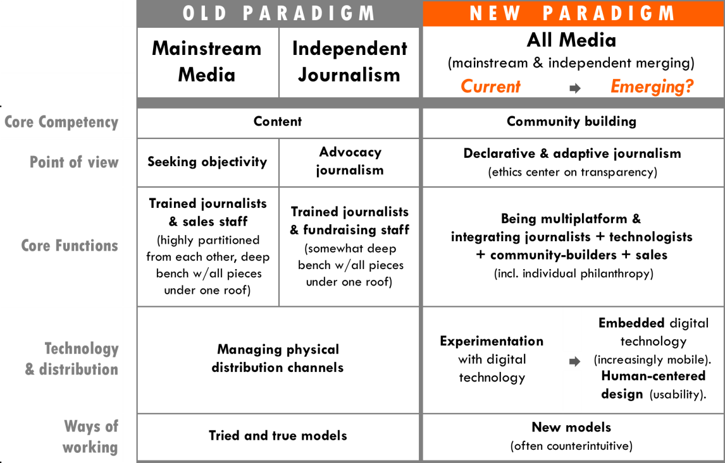

Getting serious about community
Many people in the media industry talk about building community, but what does that really look like? “It’s not enough to have a place where readers talk back—or the classic letters to the editors pattern,” Shirky said. “Rather it’s about providing a platform for readers to coordinate with one another. That’s a really radical shift because in part because it means you have to take community seriously.” In the past, journalism organizations had a deep bench with all the pieces under one roof, but a key competency for the new environment is deeply engaging with users and communities in a way that is also scalable. Independent media could build large-scale communities by building a shared platform across publishers.
“Publishers can fight it and cling to old, crumbling distribution models, or they can get in the game themselves by offering content producers sophisticated ways to reach/observe/respond to reader behavior, directly.”
– Johanna Vondeling,
Berrett-Kohler

Real membership equals shared projects
“The word ‘membership’ has a nice feeling, but what media outlets usually mean by this is: Give me money and we’ll give a product or access. But real membership is about coming together on shared projects, and this is extremely rare.” Shirky claimed, “The convening power of media organizations is a power they haven’t used because of their model, but the potential is huge.”
Jump Forward
Crowdsourcing, co-creation & citizen journalism, Vol. 2, p51

Shared projects are a point on the continuum of user-generated content, from crowdsourcing to co-meaning making. An interesting example in the United Kingdom has been the Atheist Bus Campaign, in which a spontaneous campaign to raise £135 to put “There is no God” messages on 800 buses went global. Online gaming has led innovation in shared projects. “Avante-gaming,” for example, mixes real-world interaction with online communities. Similarly, “micro-volunteering,” simple tasks done on mobile phones, has great potential for journalism and is being developed by organizations such as The Extraordinaries. For example, news stories could spark a coordinated micro-volunteering effort that is reflected beneath stories in real-time and rolled up to reveal all actions taken by the site’s users. Ranking the most active members could build community members’ reputations and sense of loyalty.
“The Metaverse needs to be built differently. It will be so enormous that only distributed approaches to creation have any hope of generating its content, thus users must build the world they live it.”
– Cory Ondrejka,
co-founder Second Life^{P}

Community organizing
Publishers and journalists alike are taking on the role of a classic community organizer. Amanda Michel, a founder of Huffington Post’s OffTheBus who now works for ProPublica, said “I’m not a journalist by training and I directed the project using the online organizing tactics I learned on the campaigns of Howard Dean and John Kerry.”
Traditional journalists often do not like to mix community organizing with journalism because it can contaminate the credibility of the reporting. However, as the competitive landscape shifts from scarcity to abundance of information and voices, the ability to “cover” the news objectively is no longer the most valuable key competency. Building active communities among users is exponentially growing in value.
The Sierra Club, which started in traditional community organizing, provides an interesting comparison. It has its own bimonthly magazine, Sierra, which is free for all members. Although the magazine’s reporting may have less influence in some circles due to the issue-bias of the organization, the club has considerable social and environmental impact because of their strong organizing tactics and 716,000 dues-paying members. These members supported the club to the tune of $40.6M annually in 2007.
Independent media outlets could borrow tactics from other groups. Care2 and Change.org are already mobilizing communities around blogging and journalistic content. What if independent media organizations built more robust membership programs that can support their work and be activated for social action?

Declarative& adaptive reporting
If community building becomes a new competitive advantage, then declaring a perspective may become more valuable than seeking objectivity. Hirschorn wrote that if journalism was no longer weighed down by the need to create an omnibus news product, then “reportage could make the case for why it matters, and why it might even be worth paying for.”
Jonathan Krim of the Washington Post called for “declarative journalism,” where reporters are able to be more honest about their own views. The Economist, a bright spot in the magazine business these days, could be growing thanks to its brazen style. “The aim is not just to tell readers what you think, but to persuade them,” is a core sentiment from the publication’s style guide.Mixing unabashed editorial stances with quality journalism has also been TMC members’ strength.
With a declarative approach, journalists may increasingly become instigators who not only report the news, but also become subjects of it. For example, Jon Stewart’s very public hard-nosed debate about the financial industry on The Daily Show with CNBC’s Jim Cramer made news itself. Similarly, cable news hosts Chris Matthews of MSNBC and Larry Kudlow of CNBC made news when they seriously considered running for political office. Conversely, via outlets like the Huffington Post and Air America, celebrities are increasingly venturing into political commentary and even reporting.
Getting serious about community could require reporters to go one step further to adaptive journalism, where reporters declare a point of view and adapt it based on their engagement with a community of readers. As a result, journalists may need to adapt the ethical framework of their profession in order to build communities. Based on her experience with Huffington Post, Michel wrote, “Transparency and disclosure, rather than neutrality—often tainted if not patently false—must become critical fourth-estate virtues.” Battelle believes that transparency and integrity can be as simple as “telling people what you’re doing, telling people why you’re doing it and letting them make their own decisions. If they think you’re crossing a line, they tell you and then [you] listen to them.”
“If you’re a journalist in traditional environment that is either allergic to or has an immune response against the approach of openness and transparency in how you do your work it’s a terrible, terrible time to be in the media world because you know you just aren’t going to succeed in that new environment.”
– John Battelle

"Our reporters do not cover stories from their point of view. They are presenting them from nobody’s point of view.”
– Richard Salant, President of CBS News (1976)^{Q}

- Strategic recognition
What if… we made it easier to deepen communities at a larger scale?
Journalism that declares a perspective and adapts in response to user engagement may even hold promise for democracy in our country. In the New Yorker’s article “Out of Print: The death and life of the American newspaper,” Eric Alterman drew a contrast between the news cultures in the United States and those in Europe, which “long ago embraced the notion of competing narratives for different political communities, with individual newspapers reflecting the views of each faction. It may not be entirely coincidental that these nations enjoy a level of political engagement that dwarfs that of the United States.”

Strategic technology
Taking community seriously requires a greater allocation of resources toward both technology and the personnel who can use it effectively. “Many organizations only see one piece of the puzzle and want to do small experiments—hire an intern and a few people here and there—without seeing how that impacts the rest of the media,” said Soni. “People who do have knowledge of the other pieces of the puzzle can do real systemic innovation, and this is the highest area to impact.”
“The problem wasn’t getting content; hundreds of submissions came in daily. But the scope of our collaborative-reporting assignments frequently outstripped our writers’ capacity to turn all those data into cogent stories.”
– Amanda Michel, OffTheBusK

- Investing in capacity. “Publishers still see journalists as the core and that budget should go to editors/writers,” Soni noted. “You hear media companies talk about the importance of technology, but pay attention to what they actually do and not what they say. In my experience, they talk about tech but aren’t willing to pay for it.” Sierra Club made significant investments in Care2, a service to acquire emails, and Convio, a new constituent relationship management system (eCRM) that synchronizes communication touch points and membership status across all their databases and 63 chapters. At a large scale, it is often not enough to increase technology investment alone, but also the personnel to use it strategically. The Sierra Club develops waysto increase online fundraising and advocacy effectiveness that are more important than the technology. Similarly, when OffTheBuscrowdsourced fact-checking through a database, their strategy of pairing anecdotes with users’ information and sorting by zip code made the difference. Many people in media talk about the importance of building “lists” (i.e., databases of constituencies, donors or subscribers), but those lists are only as valuable as the engagement they create.
“Most companies and organizations that I see don’t have the ability to use technology strategically.”
– Ashish Soni

- Merging roles of journalist and technologist. Reflecting on her biggest lessons as general manager for NYTimes.com, Schiller said, “Don’t think about technology as the end of the process but as integrated into the process. Developers should be part of the journalistic process, and depending on their training, the right developers are journalists. What the web is doing is not just converting news into an online experience, but it’s creating a whole new journalistic experience.”
- Rapid, low-cost innovation. At a time when companies are cutting back and laying off employees, it is hard for organizations to innovate. “There is often an inability to do what I call rapid, low-cost innovation,” Soni said. “This kind of innovation is important because in these times we don’t know what’ll work and what won’t.All we can do is rapid experimentation and see how the consumer responds.” In this regard, Soni said that using search to understand customers is more valuable than running traditional focus groups. “Search is an active process—not passive. Actively looking for whatdemonstrates an intention makes it real.”
“The number one challenge is that the definition of your list changes in a multi-media environment. Once upon a time, it was simple: you have your subscriber list from which you derive your donor list, list rental revenue, advertising sales, etc., but what do you do if 70% of your traffic comes to read a story on the website and leaves?”
– Jay Harris, Mother Jones

Being multiplatform
The lines separating print, radio, TV or film can still largely define the core competencies of publishers and producers. They have historical roots in these separate forms, each with its own set of business models, distribution systems, practices and professional fields.
Platform convergence can be as much of a cultural and organizational challenge, as a technical one. It can require media organizations to retrain or replace staff who are unable to manage multiplatform production. Adam Berrey, Senior Vice President at Brightcove, a leading online video platform said that one of the mistakes he sees companies make is, “underestimating what it means to be in more than one platform and how each platform is actually distinct, even if you’re carrying a brand across them, and even if you’re leveraging content assets in both places.” For example, selling to advertisers when a publisher goes multi-platform is more complex. “It’s not like, ‘here is my rate card for my website and here is my rate card for print.’ And, even worse, the print staff is selling separately from the web staff, or the print staff is trying to sell the web when they don’t really understand the web.”
“To be a multi-platform media company,” Berrey explained, “means you have a great sales organization on the advertising side that knows how to build products, that knows how to construct sponsorships, that can work with editorial in really, really smart ways, and that can speak to advertisers on these different levels.” This level of multiplatform integration depends on what Battelle calls “Conversational Marketing,” which in a blog post he said meant more than simply putting Twitter search results on your website. “It means taking your core assets—the data that drives value and knowledge inside your enterprise—and offering it as fuel for the collective intelligence of all your partners—your channel, your vendors, and, ultimately, your customers.”

Tightly integrating functions
“When you’re dealing with small organizations (e.g. independent media) and you have one weak link—one or two mediocre people—suddenly that whole part of the organization isn’t nearly what it needs to be.”
– Adam Berrey, Brightcove

Historically, traditional media organizations had their central competencies divided between highly trained journalists and business managers. This structure works when the benefits of specialization are greater than the benefits of being responsive to the market. In today’s rapidly changing market, media organizations need to integrate multiple functions to succeed, sometimes within one employee’s span of responsibilities.
Berrey has worked with many online publishers at Brightcove and believes that a successful media company must integrate three fundamental pillars. “First, can you create and put together content and service that are valuable? Second, can you market this content and service in a way that an audience of consumers is really engaged with and invested in? Lastly, can you turn the attention of that audience into viable advertising products and have a sales team that can really move those products with the advertisers that want to reach your audience?” Berrey went on to explain, “Often times, you’ll see people who might be good at one or two but rarely do you see folks that are really executing all three with excellence.”
Since content, advertising, and the online experience are perpetually evolving, the best way to be market-focused with Berrey’s three pillars is to tightly integrate the functional areas in an organization as Schiller did at the New York Times. “Integrating the print and the online newsrooms was essential,” she said.

Experimentation
“Those that focus their attention on innovative business models and optimized services in the next several years, and who offer vision, expertise and leadership will discover a marketplace that is far more receptive to them than to their competitors who continue to depend on the ‘tried and true.’”
– Jack Meyers^{R}

The Huffington Post, almost by accident, discovered the right formula for online journalism according to Alterman’s New Yorker article. Twitter co-founder Biz Stone as said that the service started simply as a side project. Publishers cannot underestimate the role of serendipity in changing the game for journalism, yet luck is certainly not enough to build a business upon.
“There is such a dearth of models. People try to grasp at straws. [They] need to get out on a limb try new things for where there isn’t a model yet,” said Bracken, although he acknowledged that new, unproven models can be a “hard sell” to funders. Organizations often have to fund experiments internally, which is why Soni suggested “rapid, low-cost innovation” and prototyping are so important. By working together, independent media organizations can reduce their individual risks and help journalism adapt to change faster.
“If the old model is broken, what will take its place?” Answering his own question, Shirky wrote, “Nothing will work, but everything might. Now is the time for experiments, lots and lots of experiments, each of which will seem as minor at launch as Craigslist did, as Wikipedia did, as octavo volumes did.”

Counterintuitive ways of working
Funders and investors are already cautious of funding experiments since most fail. Counterintuitive ways of doing business and producing content may seem even more risky, but they can also be the biggest game changers.

Counterintuitive ways of doing business
Many organizations in both the for-profit and non-profit world view competition for resources as a “zero sum” game rather than a way to lift the tide for everyone. As a result, organizations have embraced the idea of “co-opetition.” Instead of competing in all aspects of their business, organizations cooperate in areas where they do not have competitive advantage.
For example, Hollywood studios believed that VCRs would keep people from going to the movies. The studios were so threatened that they fought to tax blank cassettes. This competitive stance was ultimately not in their interests. The studios were fortunate to lose the fight because VCR movie rentals grew to a $12 billion business by 1997 and tripled Hollywood’s potential revenue sources.
- Strategic recognition
What if… we actively coordinated “deal-making”?
Jump Forward
New value chain of journalism,Vol.2, p32

While the VCR case may now seem intuitive, competitive stances based on conventional business intuition are still commonplace. For a long time, publishers avoided including hyperlinks to other websites for fear that they would simply lead readers away. However, publishers now see how important these links are to improving search engine optimization.
JumpBack
Cyber-cascades & superdistribution, Vol. 2, p28

The secret to co-opetition is for organizations to define very clearly where they are competing and where they should work together. New ways of working that now seem counterintuitive will emerge.

Counterintuitive ways of reporting news
Cyber-cascades and superdistribution may lead journalists to counterintuitive reporting practices. Journalism organizations that make news more entertaining and enjoyable will have much farther reach. According to a 2008 Pew Research Center survey, “Enjoyment of the news has consistently been associated with higher levels of both news interest and news consumption.” In fact, the report claims that no single attitude is more important.

It is no surprise that The Daily Show and the Colbert Report are so popular, particularly with young people. Despite the fact that many debate whether these shows are journalism, Stewart often asks tougher-minded questions than hosts of "serious" TV news shows. It is arguably harder to make people laugh than it is just to give them the facts and surely even more difficult to do both. Stewart also makes people think. As a result, he attracts a well-informed audience. In the Pew Research Center’s survey, 30% of The Daily Show viewers answered three political-knowledge questions correctly, compared to 18% of the general public. In fact, The Daily Show viewers are more well-informed than those who watch CNN, even though a larger proportion of CNN viewers are college graduates and the cable channel has double the portion of viewers over age 50thanThe Daily Show.
Rapping news headlines has proven successful in entertainment news and has begun to catch on for broader topics. Chicago hip-hop artist, InFiNiTe-1 condenses celebrity news in a segment on the E! network’s “The Daily 10,” and Flocabulary produces a broader news recap with The Week in Rap for teens and students.YouTube users such as MCMrNapkins also rap news.
Of course entertainment is not limited to comedy or rapping; online platforms could make news enjoyable in other ways. Nevertheless, instead of shunning entertainment value, journalism could succeed by emphasizing it more.
Jump Back
Cyber-cascades & superdistribution, Vol. 2, p28

The metaphor of “gossip” is another notion that runs counter to traditional journalism. Some reporters and editors may view this approach as too low-brow, but they will lose ground to those who master the social dynamics of gossip to break important stories. Shows such as The Soup, The Dish, and Tosh 2.0, as well as sites like The Daily Beast, Drudge Report and Wonkettecapture audiences with cheeky, gossip-driven coverage salted with political and social commentary.
“Google Wave,” a new approach to online communication and collaboration, could also be a promising tool for journalists. Its founders say Google Wave would be how email would work if it were invented today rather than 40 years ago. Jeff Jarvis, journalist and creator of BuzzMachine claimed, “Wave is what news can be if we invent it today, as we must.”

Shifting roles
The new competencies outlined in this chapter will help media organizations succeed in the new competitive environment. As a result, traditional roles will shift and overlap (see chart on following page). These changes threaten many people’s jobs, pensions and familiar ways of working. Yet, organizations that can successfully make the transition will succeed. One of the reasons for the Boston Globe’s troubles stemmed, in part, from a lifetime job guarantee to advertising employees that preventit from making staff changes necessary to survive.
“Publishers need to think of themselves not as publishers, but as community builders.”
– Don Tapscott

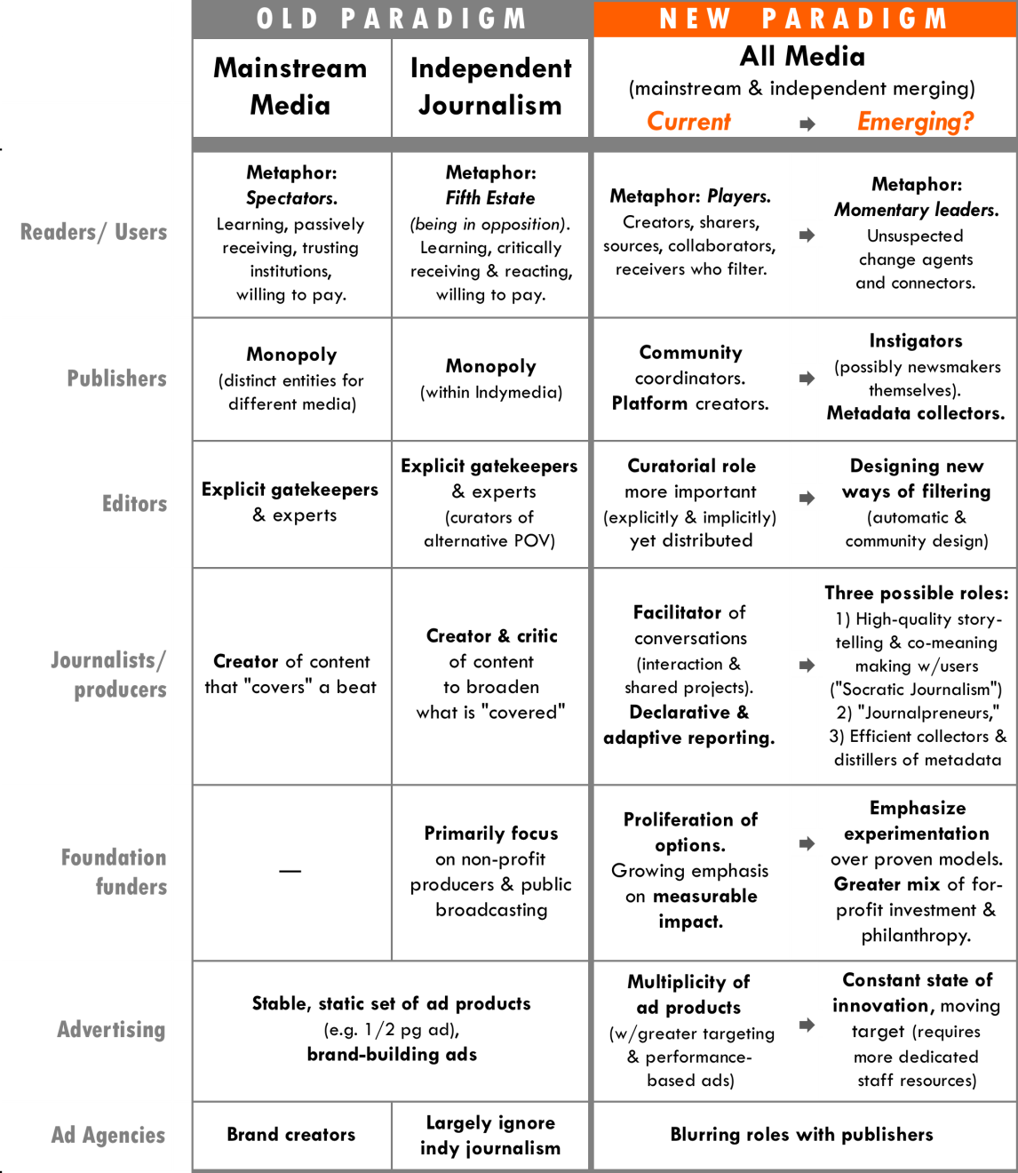

“I think the winners are going to be the entrepreneurs. I think the entrepreneurs who start companies like Huffington Post and Twitter and others are going to be the ones around ten years from now.”
– John Battelle

New role of Journalpreneurs
As the roles in journalism shift, many peoplecould be characterized as “Journalpreneurs” (journalist-entrepreneurs), who integrate the best practices from business and technology with journalism’s traditional public-interest mission.
Demand has grown on different fronts from people who want to be involved in the journalistic process in some way or another. More than 12,000 people signed up to participate in OffTheBus leading up to the Presidential elections, of whom were writers. Many organizations now offer journalistic training to new citizen media-makers, such as J-Lab’s Knight Citizen News Network and the Center for Independent Media.
“The media world needs to act and think more like tech entrepreneurs.”
– Ashish Soni
Professional writers may increasingly strike out on their own. Hirschorn suggested in an Atlantic article that writers such as Thomas Friedman, Paul Krugman, and Andrew Ross Sorkin could be “worth a great deal on the open market” by becoming a brand-of-one and “perhaps more profitable than fighting as part of a union for an extra percentage-point raise in their next contract.”
Journalpreneurs are a slightly different shade of journalist than citizen-writers or professional writers. They work outside traditional journalism institutions and are characterized more by the entrepreneurship of Amanda Michel than the thousands of citizens she coordinated through OffTheBus (the fourth project she has launched). Chris Dykstra and Jason Barnett are Journalpreneurs. They started The UpTake (TMC member), a Minnesota-based citizen journalism venture that helped feed mainstream reporting of the Coleman-Franken Senate race by utilizing low-cost technology such as live broadcasts from cell phone cameras.
“Federated Media, the company that I run, works with about 170 different authors and publishers and of those I’d say the top 20% of those are not only making very good money, they have staff.”
– John Battelle

- Strategic recognition
What if… we evolved our composition to reflect the emerging field?
Some Journalpreneurscame from the professional-journalist ranks such as Battelle, who founded The Industry Standard and now runs Federated Media. Others such as Xeni Jardinstarted in technology and later workedfor news organizations (NPR andWired). She is now co-editorof Boing Boing, where Battelle said, “She’s actually more like publisher as well as a reporter because in this world you need those skills.”
Many serial entrepreneurs, like Michel, Dykstra, Barnett and Jardin,mix a wide array of disciplines such as technology, community organizing, online media and traditional journalism. Journalism students are alsograduating with a greater mix of disciplines. This growing segment of Journalpreneurs could be a key opportunity to grow the independent journalism field.
By integratingJournalpreneursmore actively with its current membership, TMC can help build a broader, more diverse ecosystem of people who produce content in many kinds of non-traditional and entrepreneurial ways. These innovators will push journalism to the forefront of the new media landscape.

CHAPTER 3
NEW SOURCES OF VALUE: What needs can be met, problems solved or desires fulfilled?
In media’s old paradigm, the content that created the greatest value centered on the most popular and noncontroversial ideas. For independent media, the value stemmed from alternative ideas. Today, popular and alternative ideas are intertwined. The greatest value comes from how these ideas relate to “my ideas,”a combination of consumers’ growing personal expression, remixing and filtering.
PHOTO

This page has limited text so the designer can make a transition page here using a large photo.

Example of great transition pages:
http://digitaloutlook.razorfish.com/publication/?i=13617

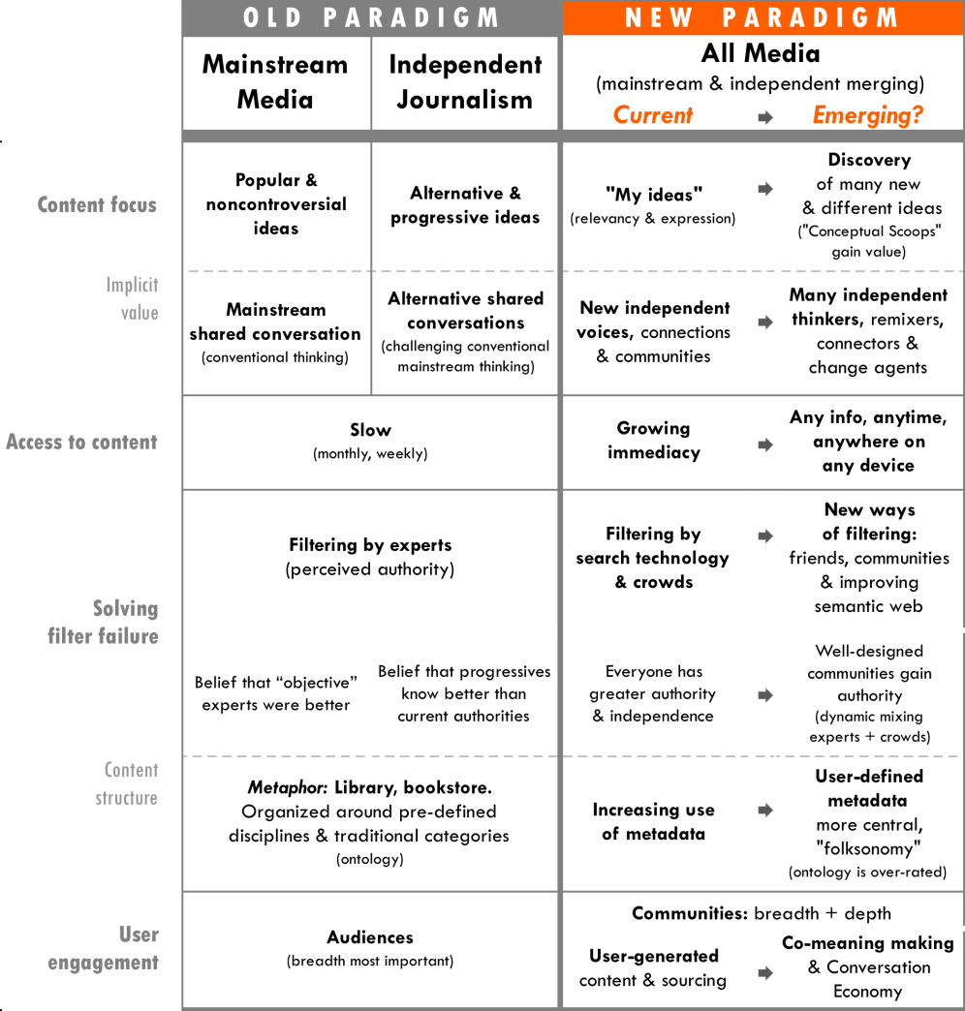

Move to end

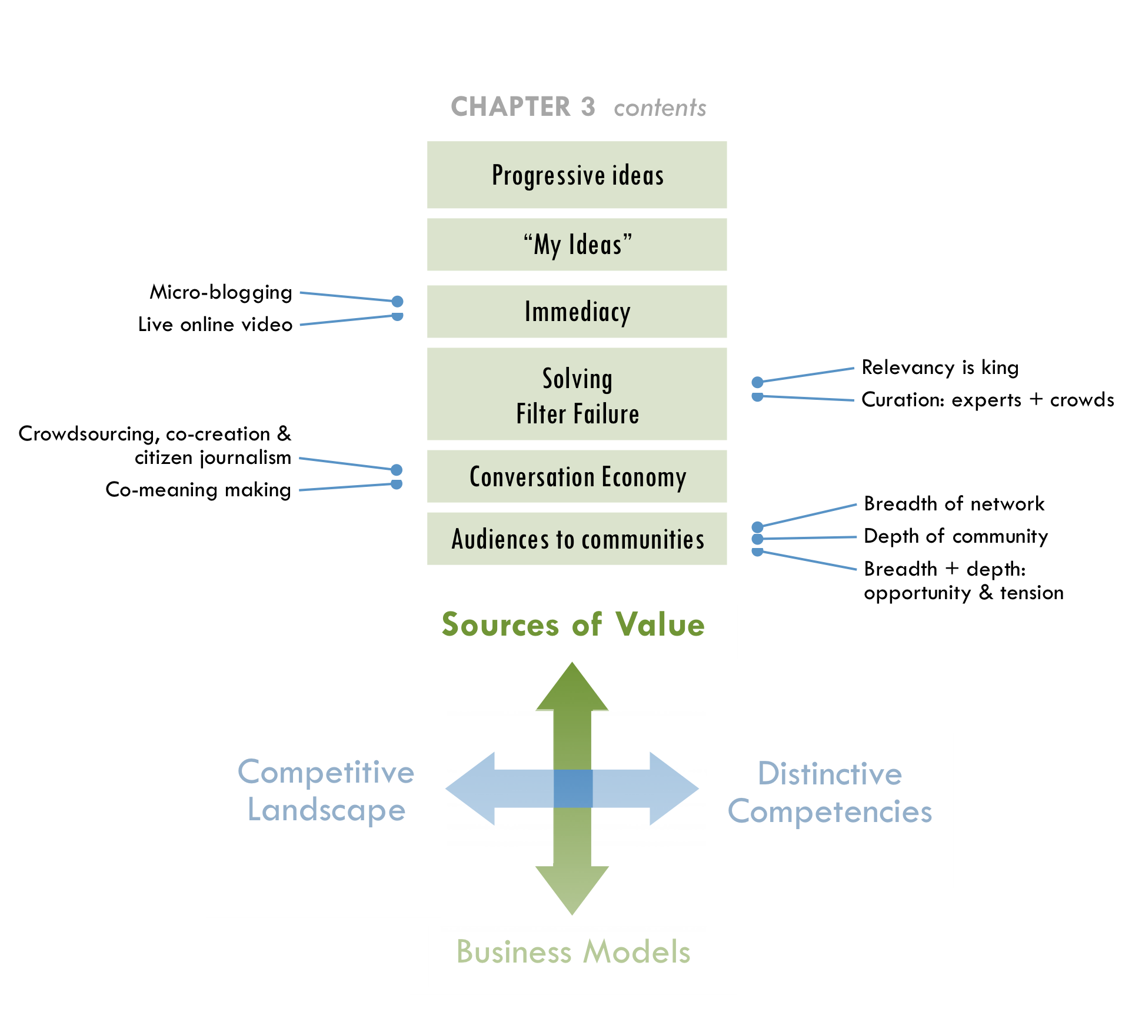

Progressive ideas
Progressive publishers have brought to light many important issues, including the implosion of the housing market and predictions about the Iraq War before the invasion. Independent media’s greatest value is often helping underserved communities address unmet needs.
The new political environment has shifted the context in which progressive publishers operate. In the Bush era, being in opposition had underpinned the identity and tactics of “progressives.” Despite euphoria regarding Barack Obama’s presidency, the new administration will inevitably have its share of disappointments, keeping the role of watchdog important. However, the political shift also affects how progressive publishers generate value. For example, Jay Harris believed that interest in Mother Jones (a TMC member) may have been strengthened due to readers’ concerns about the Bush administration. Many others in progressive media have expressed a similar belief. A clear enemy can help build funders’ and audiences’ perceived value for editorial content with a strong oppositional viewpoint. In the new political context, publishers may generate more value by promoting progressive values of inclusivity and fairness through politically diverse conversations. As a result, the definition of “progressive” may broaden, and the label itself may become an anachronism.
“A broader cross section of people generally, and liberals specifically, have figured out that media was a problem, and say ‘I have doubts about whether preemptive war is a good idea, but I can’t really find out what is going on.’”
– Jay Harris

“We tend to self marginalize. We can be much more inclusive and therefore build much stronger movements, create much more opportunity for diversity among us.”
– Sarah van Gelder

The new political and media environment has caused progressive media organizations to reevaluate their identity and tactics. At aTMC annual meeting in February 2009, members discussed whether the consortium’s workno longer falls within the traditional label of “progressive.”They debated what notions independent media might need to give up if this were true.
One group believed independent media needed to give up one-dimensional political stances and in favor of more broadly inclusive values such as human rights and global perspectives in storytelling. Another group believed that independent media must go even farther by giving up the need to articulate political stances altogether. They believed publishers should look more pragmatically at what works and what people want to know by focusing more on being a trusted source of quality journalism. Identifying where the greatest value lies will help independent media resolve this debate and move forward more powerfully.

“My ideas”
Whether content is mainstream or alternative, its value is increasingly determined by how it relates to “my ideas,”a mélange of concepts and interests that an individual has accumulated. The personal expression of my ideas, mixing of other people’s content to fit my ideas, filtering content to reflect my ideas—all are an evolution of what Nicholas Negroponte of MIT’s Media Lab coined, “The Daily Me.”
“It’s not that there are new sources of content, which is how the media first tried to understand it, but rather it’s about the complete disaggregation of content and our increasing ability to pull together what’s interesting to us. And we do it socially—to others and for others. There is very little relationship to traditional media—both of them have content, but that’s about it.”
– David Weinberger

The proliferation of blogs and user-generated content is already a clichéd example of the demand for personal expressions, but Motoko Rich of the New York Times predicted a more interesting sea change: “The point may soon come when there are more people who want to write books than there are people who want to read them.” To be sure, many forms of media could pass this threshold of a greater demand for expression than consumption, and this dynamic creates opportunities that publishers are beginning to tap as well. For example, Hewlett-Packard’s MagCloud makes it easy for anyone to make their own slick print magazines, produced on-demand.

Now is the time for immediacy
Everything about the web is becoming more “live,” from activity feeds, micro blogging, live streaming video to real-time analytics. Consumers’ demand for accessing news, in particular, has become more immediate and granular. Publishers work hard at adapting to this demand while maintaining the value of content that requires time and synthesis to produce.
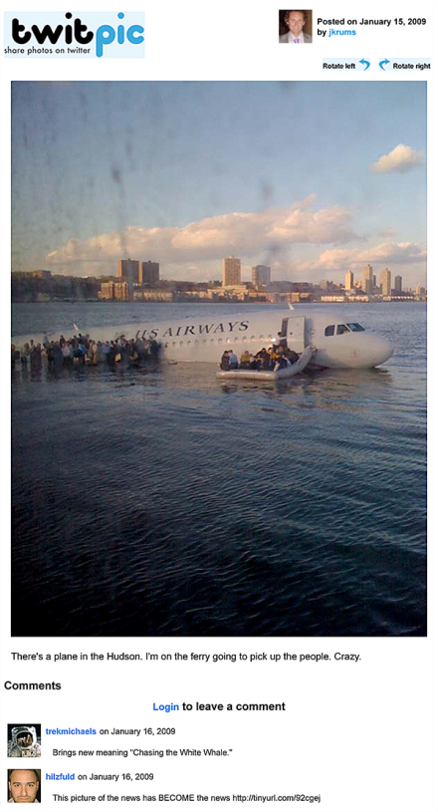
While many journalism organizations have succeeded with shorter cycles of reporting (e.g. daily versus monthly), much of today’s digital media is still prepackaged. In the future, demand for immediacy will become greater and push the limits of reporting and analysis even further. Micro-blogging and live online video lead this trend.

Micro-blogging
Many people are turning to news that is even more direct and immediate, such as the micro-blogging pioneered by Twitter. An evolution of instant messaging in many ways, micro-blogging is asynchronous, hyper-short and enables one-to-many communication. Individuals have also broken important news on Twitter. For example, the first published image of the Hudson River US Airways crash came from a mobile phone via Twitter (right) and content from Twitter led coverage of the Iranian election. In many ways, Iran’s example epitomizes the future of independent journalism. People on the ground posted thousands of first-hand reports a minute that circumvented the government and state-controlled media. Yet, misinformation was rampant. Readers inside and outside the country had difficulty separating the noise from the most relevant and reliable information, and everyone desperately needed help making sense of the information. People turned to curators such as Andrew Sullivan The New Yorker called his Daily Dish “a high point of Web journalism.”Twitter also plans to enable users to verify their real identity as well as protect it from oppressive authorities. In the future, a mix of journalists and technology may solve the noise problem.

Live online video
In late 2008, live streaming video began taking off. Justin.tv has more unique visitors globally (22 million per month in March 2009) than the pre-packaged video site Hulu, and their users are as just as engaged, watching on average just over an hour of video per month. Traffic seems to be largely driven by live sports, although musical artists, churches and politician are also gaining traction as Justin.tv claims 428,000 do-it-yourself channels. Ustream.tv is the closest competitor with 1.4 million visitors per month. Seesmic is an example of real-time video conversation and Qik.com is leading live video for mobile devices. Despite the fact that the quality of video can be low and illegal content proliferates, the value of immediacy is still clear and will increasingly be tapped for online news.
Greater immediacy creates two key puzzles for journalism:
- Immediacy’s demand exceeds journalists’ capacity to write stories, yet it can make reporting more timely and relevant.
- Immediacy makes news both more emotional and biased. This rubs against the traditional value of objective journalism, yet can create a deeper connection with news events (e.g. Iranian elections).
For journalism organizations to stay afloat, they will need to design faster ways to report news and emotionally engage users while maintaining quality. Real-time reporting may lead to solutions by tapping the distributed involvement of users. Old physical limits required stories to be fully thought through before publishing. Now, story development and publishing occur simultaneously, which enables a “Socratic reporting” process, an open method of systematically questioning an issue or news event with users who become emotionally engaged.

Solving filter failure
Jump forward
Socratic Journalism, Vol. 3, p27

Publishers are increasingly concerned about “information overload,” and some believe that technology has made this worse. In an Economist.com debate, Richard Szafranski argued that technology has created “over-choice,” which he describes as a “human response to alternatives and variations so numerous, so potentially satisfying and so complex that humans can no longer decide easily.” Our time is limited and the more choices we have, the more time it takes to choose.
However, Shirky claims that information overload has been a problem long before the digital age, as anyone has experienced entering a library or bookshop. Ever since the amount of available books exceeded a person’s ability to read them, the central problem has been filter failure. “We had a set of filters that we were used to, but are now broken,” Shirky pointed out. The media organizations that help solve filter failure by making information more relevantwill control the new decentralized online distribution channels. Independent media has more power to solve this problem by sharing data and working together.

Relevancy is king
Publishers not only make content relevant by how they create it, but also how users find it. Rarely do people find exactly what they want in their first search. As information proliferates, finding the right content becomes more valuable than the content itself. In fact, customers even want advertisements when they are relevant and interesting.
“The real change has happened around meta-data, not content. It’s not about generating content, because content is cheap (and I say this as a content creator) but rather about which content pieces go together and how we present them.”
– David Weinberger
Jump forward
Radical new ways of meaning-making and filtering, Vol. 3, p28

The “Database of Intentions” is the Holy Grail of online search. It would store every user’s intentions and enable each search to match what he or she wants to find. The perfect such database will never exist. “Search as a problem is about five percent solved,” Udi Manber claimed when he was CEO of Amazon’s A9.com search engine.He is now responsible for core search at Google.

Metadata
Top-down ways of categorizing content for users based on a library/bookstore metaphor have disappeared online. Metadata has enableda more decentralized system for users to findcontent andcontent to find users.
Metadata is simply data about data and comesfrom hyperlink relationships, contextual content, tagging, and provenance (the when, where, and how information originated), among other inputs.Itcan reveal users’ intentions and enablecomputers to infer meaning about personal preferences, trustworthiness andreputation among many other things.Metadata is the secret to findinginformation and making it more relevant and useful.
At first, search relevancy was mostly derived from the text on the page, a user’s search term and a website’s link information. Metadata was an afterthought for publishers; Search took care of itself. Today, publishers use SEO to leverage contextual and link metadata. However, filtering is becoming more complex and important. It includes social connections, location and user behavior such as search history and movement. If independent publishers share metadata in more sophisticated ways, they can make their content relevant and useful across multiple platforms.
Metadata can also increase the value of data as news content. What if journalism organizations provided users and other companies with data that they could both search and compare? Users might uncover more connections than the best investigative journalists could make alone.
“I think on the contrary what the blogosphere has proved to us that we need editors now more than ever.”
– Vivian Schiller

Curation: experts + crowds
While any system implicitly filters information, curators also play an explicit filtering role. Their perceived authority is built upon a combination of a person’s faith in a curator’s access to content, judgment of quality and attention paid by others. However, this authority is fragmenting across a variety of sources (individuals, informal groups and organizations). Publishers do not have as much power as they once commanded as curators.
The wisdom of crowds versus that of expertcurators is slowly finding a balance. Each has its share of criticism. Crowds can lead to mediocrity, noise and groupthink. Individual experts can be limited in variety/scope and are more often than crowds, wrong. Together they can improve each other. Experiments that bring together these two sources of authority have begun to tap this value. For example, rules for self-organizing communities, which Wikipedia has executed so effectively, as well as “curating the crowd” are gaining traction.
News will likely become even more fragmented and granular than it is now. People are already pulling together many tiny pieces of information from lots of sources to form a picture of what is going on. As content further proliferates and converges across devices, users will increasingly turn to curators, whether it’s friends, friends of friends, trusted outsiders, publishers, automated filters, or more likely, a combination of them all. The media organizations that can help solve filter failure—equal to their expertise in content production—will most likely succeed in the future.
“This wisdom of crowds idea, it’s true, but you still have to have the right crowd. You can have stupid crowds.”
– Ashish Soni

- Strategic recognition
What if… we standardized raw data, metadata & metrics?

From using users to a Conversation Economy
With the proliferation of inexpensive production and publishing tools and do-it-yourself movements, everyone can consider themselves an expert. This trend gets mixed reactions from professionals, yet it will have increasing value as “net native” platforms evolve.
“I think the idea that (journalism) organizations can go away because now everybody is a journalist is ridiculous. It takes time, it takes investment, and it adheres to certain standards for it to be credible.”
– Vivian Schiller

Crowdsourcing, co-creation & citizen journalism
Media organizations have used the growing market of amateur user-generated content as a way to reduce costs by “outsourcing” content production and sometimes aiming to tap distributed problem-solving. There are many terms to describe user participation in content production, which often overlap.
- “Crowdsourcing” is typically a broad or targeted “open call,” in contrast to the more integrated cooperative activity of the “open source” movement, and it has drawn skepticism from both traditional journalists and online innovators. For example, 42% of U.S. newspaper editors surveyed in early 2008 had reservations about the role of citizens beyond providing very small stories or basic information, while Jimmy Wales, founder of Wikipedia, called “crowdsourcing” an “incredibly irritating” term. “Any company that thinks it’s going to build a site by outsourcing all the work to its users,” he said, “not only disrespects the users but completely misunderstands what it should be doing. Your job is to provide a structure for your users to collaborate, and that takes a lot of work.”
On the other hand, crowdsourcing has proven to be valuable for source-finding and fact-checking for many journalistic organizations, including Talking Points Memo (TMC member). As another example, OffTheBus on the Huffington Post used 227 contributors to find out everything they could about Superdelegates in the Presidential election. After news broke that Hilary Clinton’s New Hampshire campaign office had been taken hostage, OffTheBus found a nearby member in its database and sent him to the home of Fox News’s alleged hostage taker, only to discover he was not involved.” New efforts such as Help Me Investigateare creating broader platforms for any journalist to use crowdsourcing in investigative journalism.
“We discovered that politically involved people make great sources, especially en masse. They almost always disclosed more information, because they knew more.”
– Amanda Michel^{K}

- New “pro-am” strategies to co-create content have begun to take root, in which people work together across traditional professional-amateur lines. For example, Jay Rosen, a New York University journalism professor, started NewAssignment.Net in 2006 to link professional journalists and amateur contributors. Some organizations have found pro-am projects to be expensive to manage, risky and journalistically uneven.To solve these problems, publications are designing simpler ways to collaborate with users. For example, The Nation, the Washington Times and Personal Democracy Forum collect questions from readers to “Ask the President” during a press conference.
- “Citizen journalism” trains non-professionals in new technology and journalism to do the reporting themselves, and often does not involve professional journalists at all. Critics have said that this form of reporting often abandons “objectivity” and also has uneven quality. Citizen journalism has shown promise for hyper-local sites, including small towns that may no longer be able to support a traditional newspaper.

Co-meaning making
Manyorganizations have developed new ways to engage to users. These innovations tell a larger story about the evolution of co-meaning making, a collective process of making sense of the world. Shirky pointed to developments in the scientific world as an example of the co-meaning making that is beginning to occur in journalism. “The number of papers with multiple co-authors is increasing dramatically. It’s just simply harder and harder to do science as one. That’s because the problems are more combinatorial in nature.”
“There is nothing greater than running through a story with a community that cares about it as well and makes it better.”
– John Battelle

“… publications are conversations between three core parties—the author, the audience, and the advertiser. The best of these have a robust shared grammar, a voice that all three parties understand and respect.”
– John Battelle^{T}

Media organizations can no longer afford to view users only as sources or DIY journalists. Users want to engageas participants and actors in unfolding stories. More sophisticated models are developing, and the nature of storytelling itself is changing. Michel found in her work at Huffington Post, “There was a palpable joy among participants who transcended the role of spectator and created new narratives beyond those they were seeing in their daily newspapers day after day.”
Jump Forward
Getting more from advertising, Vol.2, p67

Battelle calls co-meaning making the “conversation economy,” and it ultimately involves all players in the media ecosystem in a more transparent and adaptive way. This particularly goes for marketers and advertisers who are often walled off by journalists.

From audiences to communities
Everyone who participated in this project said that building audiences as communitieswas the biggest new source of value in media. Some viewed the term “audience” as an anachronism because it still puts too much emphasis on content as the primary product.
Since communities are formed in multiple and co-existing ways, people interviewed for this project varied in their opinions about how best to build communities and capture enough value from them to run a media organization. Audiences can grow in two different directions simultaneously: Broaderand deeper.

Breadth of network
How to scale up independent media projects is largely a question of breadth, whether it is geographical reach, aggregation of many local or “niche” communities, size of membership or the number of links to a site. “PageRank” which is the central measure of Google’s search algorithms is based on the breadth of links to a site. And, when it comes to viral marketing, it is the breadth of a network (formal or informal) that amplifies content. In online advertising, it is the breadth of reach that enables “ad exchanges” to target large enough segments through contextual and behavioral filters.

Depth of community
Jump Back
“My ideas” Vol. 2, p46

Communities are often defined by depth—a measure of participation, identity, interest and expertise—all of which build a sense of loyalty and shared ownership. In many ways, depth is an extension of “my ideas” described earlier with the added value of meaningful connection. Targeted segments (“niches”) of broader audiences can be as valuable for community organizing as they are for advertising. Evidence has shown, however, that the price of advertising has not remained commensurate with the value it creates by targeting. Instead it has been more closely tied to how efficiently ad buyers can reach breadth.
Examples of building community depth include hyper-local “micro news” that targets geographic-focused communities.Many sites are seeking to become their communities’ new digital town squares. However, a Forrester Research report found that customers care less about what happens in their neighborhoods than across the country and also rely more on sources for local business listings (e.g. Craigslist) other than local news outlets, which cause problems for hyper-localbusiness models. For many progressive sites such as Daily Kos, deepening of community centers around ideology or perceived charisma and runs as deep as geographic ties. To this end, publishers have used offline events to help online users connect in person.
“People deeply hunger for the opportunity to get together with the people who care about the same stuff.”
– Johanna Vondeling &
Ann Friedman

One would think that since word of mouth is one of the oldest forms of news, that journalism could find a natural home in the growing social aspects of the web. Approximately 75% of the online population in the United States is now engaged in online social behavior according to Forrester Research, and overall consumption habits are becoming more social through FriendFeed and many other tools. However, forming more connected social networks does not necessarily correlate to consuming news. “Just 10% of (young people) with social networking profiles say they regularly get news from these sites,” according to a 2008 Pew Research Center study.
Publishers and advertisers are learning that “social news” does not mean just distributing news socially. Social news actually means building audiences as communities that engage with news in ways that are social by design. For example, user-generated content can be used as a shared project to form deeper communities across various interest areas, a value beyond providing free content.
Jump Back
Real membership equals shared projects, Vol. 2, p34

Breadth + depth: Opportunity and tension
Most organizations strive to build their community in both directions. National Public Radio has been particularly successful, with a structure of 860 local affiliate stations that provide approximately half of NPR’s annual revenue from affiliate fees as well as a flourishing weekly audience of 32.7 million at a time when audiences are fragmenting for other news organizations. Larger affiliate stations are able to report local stories, while NPR maintains 18 foreign bureaus (more than any of the major broadcast TV networks).
“I get very excited about the combining the power of NPR’s national, international news gathering operation with the power of the local communities—NPR stations in over 800 places across America.”
– Vivian Schiller

Several online ventures provide create-your-own social network platforms that go broad and deep simultaneously. One such platform, Ning, claims that users have built over one million such social networking sites for professions (e.g. firefighters), tastes (e.g. hip-hop music), high schools, cities and many other niches. Jive Software, Pluck and KickApps are providing similar community platforms, but focused more on enterprises such as HBO, Fox and USA Today. In advertising, Adify (bought by Cox Enterprises in April 2008) is a build-your-own vertical ad network platform, which powers SustainLane, Gay Ad Network, Ad Progress Network (created by TMC members), Washington Post Co., and Martha Stewart among others. Vertical ad networks sell advertising for a broad collection of sites that all relate to a targeted category such as “green products” or “men’s fashion.” DoubleClick announced in March 2009 that it plans to make this type of platform available as well.
The challenge with combining breadth and depth is that they often are at odds with each other. For example, NPR has faced tension from the disaffections of local affiliates, as well as criticism of bias from both liberals and conservatives. Also, Ning created significant controversy in March 2009 by combining all the members of their customers’ social networks into one Ning membership—a tactic that some have suggested is to reach more breadth in order to compete with Facebook and MySpace. Google built its business by viewing the new model of media as millions of networks of dozensrather thandozens of networks of millions. However, their ability to target advertising has still required the breadth of millions of networks to reach sufficient scale. Now, they are receiving mounting criticism, just as Microsoft did, because of their concentrated power. The puzzle for independent media is how to harness the breadth of the sector and the depth of individual communities simultaneously.
“Scale still matters, but the choices available that deliver depth and breadth outside of the portals continue to rise.”
– Razorfish Digital Outlook Report 09

- Strategic recognition
What if… we made it easier to deepen communities at a larger scale?

Conclusion
The sources of value for any business model starts with paying customers, whether it is government, philanthropy, other businesses or consumers. Online media has given individuals more negotiating power. As a result, media organizations have had to become more responsive to users’ needs and desires. If they don’t, users will simply leave. MOVE OLD/NEW PARADIGM HERE

CHAPTER 4
NEW BUSINESS MODELS: How to structure media organizations to capture value?
As the sources of value and the competitive landscape have changed, so have the business models that are mostly likely to succeed. Underpinning the dissonance between old and new media is a imbalance between traditional revenue models and their ability to cover the high costs of original content production—particularly for investigative reporting. The financial crisis accelerated this shift, forcing quicker adaptation and shortening the runway for new models to prove themselves.
PHOTO

This page has limited text so the designer can make a transition page here using a large photo.

Example of great transition pages:
http://digitaloutlook.razorfish.com/publication/?i=13617

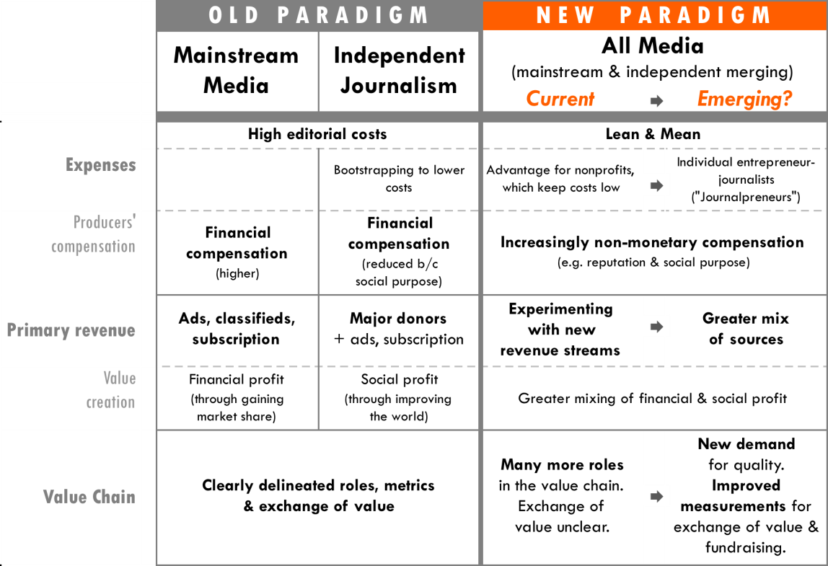

MOVE CHART TO CONCLUSION

Organizations cannot merely create value; they must eventually capture enough value to sustain themselves, whether it is directly from those who benefit or from third parties such as philanthropists. Ventures that make a play for audience first, such as Twitter and YouTube, must eventually capture value. In fact, YouTube is still far short of making enough money: Its costs are nearly three times more than its revenue, as one analyst reported in April 2009. Furthermore, the collapse of the print industry and economic crisis cannot be blamed as the sole cause of magazines’ troubles. Some have continued to grow due to their ability to capture value. Of the 100 magazines with the highest circulations in 2005, 21 were able to increase their print advertising pages from 2005 to 2008.
“For Mother Jones, it’s becoming more and more obvious that the marketplace on its own will not support investigative reporting.”
– Monika Bauerlein^{U}

“The best-case scenario,” according to Shirky, “is where [traditional media organizations] give up on the idea of ‘Plan B’—that is, we’re going to move from one business model to this other business model, because it’s not going to happen this way. In this future you can do news in a much cheaper way with a dramatic range of outlets.”
Business models will change in significant ways, beginning with more efficient operations. Many organizations are testing new revenue models and will likely mix of several of them. As this happens, a new value chain of journalism is coming into focus, which TMC and its members can influence in proactive ways. This chapter covers the following business models.
“We have never seen investigative journalism thrive in print form to be honest—and we have to be honest with ourselves. The New Yorker is not a success as an economic play. It’s only profitable maybe 12 of the last 50 years.”
– John Battelle

Emerging operation models & cost structures
The traditional journalism business has been built on enormous cost structures, partly because publishers built deep benches of reporters to “cover” the news. The New York Times newsroom of 1,200 hundred employees was 50 times larger than the Huffington Post in 2008, while the direct print-plus-online reach of the Times was just a little over three times that of the Huffington Post.The Washington Post and the Los Angeles Times had approximately 850 editorial employees each.
While many prophets of the new era preach about the great potential of online technology for creating media more efficiently, original investigative reporting still takes time, resources and a little shoe leather to do well. “What’s worth saving, as a critical function, is investigative journalism. We need someone, many someones, to do long, deep, boring research, for stories that may not even pan out,” Shirky wrote in a blog post. The online environment has caused some publishers to increase editorial staff rather than cut it. Sometimes they hire additional editors to prevent burnout in a 24/7 news environment. Other times, they discover that they can no longer depend on freelancers to provide timely responses on fast-moving issues while also meeting standards for quality investigative reporting.
“Having all the pieces of the puzzle assembled under one roof, with one group—Watergate journalism if you will—is getting rarer and rarer.”
– Clay Shirky

Lean and mean
A perception still exists that only big organization make for viable media companies. In recent years, lean and mean entrepreneurial approaches have taken off. Boing Boing only has eight staffers and other sites, such as Tech Crunch and Talking Points Memo, have a small staff as well.
A lesser-known, more dramatic example of running lean and mean is Plenty of Fish, a dating site. Although the site’s content is not news, neither were personal classified ads in a newspaper, which historically contributed a great deal to newspaper revenue. Plenty of Fish has become one of the top-10 websites in the US by monthly page views (1.6 billion in late 2008) with only four employees. In fact, founder Markus Frind claims to work only 10-20 hours per week. By comparison, dating pioneer Match has hundreds of employees and one quarter of the pageviews. In 2006, Frind posted his blueprint: “Pick a market in which the competition charges money for its service, build a lean operation with a ‘dead simple’ free website, and pay for it using Google AdSense.”
“I’m spending a lot of my time talking to organizations about mergers and consolidating back offices. This will challenge folks to innovate, but will more than challenge organizations on many fronts. I don’t think it is a good thing overall, although the organizations left standing will be stronger.”
– John Bracken

As large journalistic institutions shrink, salaries will inevitably decline and journalists will also have to produce more and take on more than reporting multifaceted. Media organizations that figure out how to do more with less will likely win. As a result, the lean-and-mean cost structure that nonprofits have already built may have an advantage in the current news industry shakeout.

Shifting compensation
“We get that (news) can be delivered in different ways. That’s not the problem. You need a critical mass, a large enough news organization, a way to pay writers and editors…”
– Member of CA Media Workers Guild^{A}

People create content for many reasons other than earning money media outlets increasingly tap a broader array of human motivation to reduce their costs. Experiments in crowdsourcing and co-creation have done this successfully, although they require greater investment in editors and staff skilled in community organizing.
Reality television provides an interesting parallel. The explosion of this genre in 2000 can be tied to the cost advantages of “unscripted” shows that sidestep the need for high-paid actors. Lower costs, combined with the greater odds of a reality series becoming a breakout hit, fueled this TV genre.
"Some of the biggest game changers tend to be on the alternative side.”
– Ghen Maynard, head of reality programming at CBS^{V}

Long-time journalists may be quick to criticize the quality of citizen journalism as people did with reality television, but they should not overlook its potential. Filmmakers criticized reality TV at first but then discovered that it helped make documentaries more mainstream. Also, Michael Hirschorn points out that the genre has “engaged hot-button cultural issues—class, sex, race—that respectable television, including the august CBS Evening News, rarely touches.”Non-monetary compensation not only enablesorganizations to run lean and mean, but it also creates an opportunity for them to redesign the form journalism takes in the future.

Emerging revenue models
Regardless of making running alean-and-mean organization, media outlets still need to find new ways to generate revenue. Philanthropy has been the most prevalent model for many independent media organizations, although this source of revenue alone is often insufficient. Other possible models include creating additional channels of distribution, combining free and premium content, tapping user subsidies, utilizing news as a “loss leader” to generate funds and sharing revenue with content producers. Increasingly, for-profit and non-profit publishers alike will grow strongest with a greater mix of these revenue streams.
“Journalism has been thought of as business for some years, now by some people are starting to think about it as a charity.”
– John Schwartz,
EBS Companies

Non-profit, philanthropy model
For many years, non-profit publishers, such as many of those in TMC, have generated 50 to 75% of their revenue from philanthropy in order to meet the high costs of their editorial missions. While a dependence on philanthropy could be seen as a market failure just a year ago, it is now viewed as a potential advantage in diversifying revenue. Experts including Charles Lewis, Geneva Overholser and Bob McChesney are suggesting non-profit structures as a potential solution for news. Although many people have called for philanthropy to make up the difference between the cost of journalism and what the market can bear, many in the non-profit world say that there is not enough philanthropic funding available to sustain independent media as it is.
In 2008, ProPublica started a new non-profit investigative newsroom with a grant of $10 million a year from the Sandler Foundation. Some in progressive media criticized this move because they saw it as a duplicative organization. The funds could have strengthened existing journalism organizations. ProPublica does not currently accept advertising, although according to its website, it hopes to build a “brand” to capture other sources of funds. Many non-profit publishers survive largely based on a few major donors such as the Sandlers. They also compete with each other for a limited pool of additional philanthropy.
“All journalism is finding themselves in the gap (between philanthropy and earned revenue). Commercial media is having as hard a time now. Philanthropy won’t pick all that up.”
– John Bracken

It is often difficult to measure the ultimate impact of media production beyond number of viewers, which has discouraged some funders from investing in media. In fact, donors have become increasingly concerned with measuring the social impact of all types of nonprofits. Investors with sufficient resources and inclination often want to ensure that their investments leverage the greatest possible impact, and they have pushed social enterprises to measure results more rigorously.
“Despite the ire it has raised (among nonprofits), the demand for evaluation shows no signs of slowing. This is probably for the best. Trusted with other people’s cash and absolved of taxation, nonprofits and foundations should evaluate themselves and their programs to reassure the paying public that their money is actually making a difference.”
– Alana Conner Snibbe, Stanford Social Innovation Review^{W}

Groups such as Charity Navigator, American Institute of Philanthropy’s CharityWatch.org and Better Business Bureau’s Wise Giving Alliance have also used online technologies to create greater transparency for nonprofit performance, although these services have been criticized for their methodologies and emphasizing the wrong measures. The problem is that different types of organizations often require different types of metrics to demonstrate their impact. Within a group of similar organizations, such as independent media, proactively standardizing measures could help increase the pool of philanthropy.

Adding distribution channels& sub-brands
Jump Forward
Will more reliable & consistent measures create greater distribution of value?, Vol. 3, p37

Axel Springer, which owns the biggest newspaper in Europe, made its highest profit ever in 2008 with 14% of its revenue generated online. The company created or acquired new publications, which enables the same content to be delivered to different audiences. The company’s Berlin newsroom, for instance, produces content for six publications.
“Our books are sold not because of bookstore, but because authors are creating an immersive experience for the reader, who is buying it as a souvenir.”
– Johanna Vondeling,
Berrett-Kohler

By creating sub-brands, media companies could reach new market segments and influence the public dialogue new ways, all with the same content. This strategy has been successful in other industries. For example, Black & Decker bought a small tools manufacturer called “DeWalt” and decided to maintain it as a sub-brand, rather than folding it in to the overall company brand. The DeWalt colors (yellow) spoke to a professional market segment, while the Black & Decker's red & black were considered to be for consumers. They reached two markets, cut costs with consolidated manufacturing. Similarly, Google took this strategy after acquiring YouTube. They decided to keep their existing Google Video as a separate brand because they believed it would reach an older segment and ultimately expanded their reach.
Although the book-publishing industry is waning, some online news publishers have found an additional distribution channel creates social-impact value. A book can support the personal motivations of writers and editors, raise their credibility in leading thought circles, and catapults them into mainstream media and policy discussions. Books also have the added benefit of providing content for websites, building relationships with grassroots groups and advancing social missions.

Free + premium content
“I also subscribe to The Wall Street Journal, one of the few pay newspaper sites. I could cobble together a free version … but I chose to pay the freight. To me, paying for content I want online is not all that different from paying for a DropSend account, which allows me to send and receive large files: the paid option outweighs the hassle and time of the free ones.”
– David Carr^{X}

Many publications have experimented with using free content to sell premium content and services through subscription or single-pay models.
- Wall Street Journal mixes free content with access to premium content at $1.99 per week. This works because financial news is a type of information that users are more likely to hoard than share.
- Cook’s Illustrated attracts 260,000 digital subscribers to pay $35 a year to access their complete database of recipes. One reason that users are willing to pay a subscription fee for full access to
- Consumer Reportsusers pay a fee for full access to reviews that are free of ads. Consumers view the potential editorial influence of advertising as something worth paying to avoid.
- New York Times does not currently charge for content, although Arthur Sulzberger, Jr. said in March 2009 that he would consider charging again. The Times has tried this before (QPass and TimesSelect), so it is uncertain whether it will work.
- Berret-Koehler (TMC member) is experimenting with offering free portions of books, which include the introduction plus one chapter, as a way to sell a full book. They have also begun to break their books into lower-priced, article-length sizes that users can find through a graphic navigator on their website. They designed this tool to search more intuitively by business challenge and potential solution in addition to a more conventional general-topic structure.
“In this environment (of content oversupply), you're about as like to be able to charge for an online news story as you are to charge for air.”
– Nicholas Carr^{Y}
- Subscriptions have been a saving grace for cable television, providing half of its revenue. As a result, the three major news cable channels grew by a third in 2008 and are expected to be as strong in 2009, even though all other forms of news are struggling. While newspapers do not control distribution channels in the same way that cable companies do, subscriptions help insulate fluctuations in advertising.
Jump Forward
Will there be a new demand for quality journalism?, Vol. 3, p35

Despite popular myth, consumers do not expect all content for free. In the future, publishers will find the right mix of free plus premium content. In fact, demand for quality investigative reporting could renew if it becomes scarcer.

Micropayment & micro-fundraising from users
Since the 1990’s, people such as Nicholas Negroponte of MIT’s Media Lab and Jakob Nielsen, a leading web usability consultanthave predicted the rise of micropayments (smallonline transactions by users). Micropayments for news content have also had skeptics, including the Project for Excellence in Journalism and Shirky, who said, “Micropayments work only where the provider can avoid competitive business models.”
“No one is seriously suggesting that the New York Times could pull out of ads in favor of direct user subsidies, but over time the balance might shift. And while this may not make sense for mainstream media, this certainly does for independents.”
– Clay Shirky
Some detractors have argued that users do not like micropayments because they are too inconvenient and a big psychological gap exists between free and “almost free.” However, Nicholas Carr pointed to a classic example of ATM machines that charge small amounts for every withdrawal to prove that if small payments are easy enough and provide value, users are not annoyed. Carr expressed reservations about how valuable it could be for news content.
Over the past year, online and iPhone applications have begun to increase users’ familiarity with micropayments. Also, the gaming world has had success with in-game micropayments, which may indicate the potential of motivations other than convenience—namely, reputation. Potentially, if micropayments were linked to other motivations such as reputation, they might become more valuable for users and publishers alike. For example, a “thumbs up” vote for a story tied to a small user cost could increase the quality of ratings.
Many new ventures are planning to test micropayments in journalism across a wide array of news sites, although nothing has proven successful yet. The Missouri School of Journalism has been promoting The Information Valet Project. Steven Brill, Gordon Crovitz (former Wall Street Journal publisher), and Leo Hindery have started Journalism Online. Kachingle is another example. PayChoice has created a Vendor Relationship Management (the reciprocal of Customer Relationship Management system) that enables micropayments across a wide array of news sites.
"Most people playing in these persistent world environments are building their character … are happy to spend some money there.”
– Joseph Olin, Academy of Interactive Arts & Sciences^{Z}

Non-profit publishers have also utilized micro-fundraising from small individual donors who believe in their social mission. Both Mother Jones and AlterNet saw a rise in small individual donations in 2008, which represented 11 and 14% respectively of their overall revenue. For MotherJones, 9% of their paid print subscribers donated last year, which indicates that there was a large group of readers who recognize the value of Mother Jones’s work beyond what they paid for the content itself.
- Strategic recognition
What if… we collectively tested new revenue models?, p7
As technology makes user subsidies easier (at any amount), news organizations may find value to capture, especially as other motivations come into play.

News as a loss leader
For a long time, publishers have used news as a “loss leader,” a product sold below costs to create other sales. Using free content to sell premium content is just one example. For most of their history, newspapers have provided the paper at a loss in order to sell ads. In the computer industry, printers have been a loss leader to sell ink cartridges. In gaming, Second Life by Linden Labs has provided a free virtual worldpaid for almost entirely by selling virtual real estate.Steve Jobs saw music as a loss leader to sell iPods and iPhones, which is partly what allowed Apple to price songs at 99 cents. This price was attractive to consumers, but not enough to pay for developing the iTunes platform.
“If print wants to perform a cashectomy on users, it should probably look to what happened with music, an industry in which people once paid handsomely for records, then tapes, then CDs, that was overtaken by the expectation that the same product should be free.”
– David Carr^{X}

Many people have criticized the iTunes-for-news idea. Shirky pointed out how the music industry differs from journalism: People consume the same musical content many times, four companies control most of the popular content and have limited alternative models through regulation and legalities (e.g. Napster). However, journalism should not be so quick to dismiss the iTunes example. One aspect is still fundamental: News can be a loss leader to build a brand, create a channel and get users to pay for something else.
While independent media organizations do not have the capacity to become a device manufacturer, TMC members may be able to use their collective news-production capacity to cut deals with companies that can. Publishers do not need manufacturing capabilities to take advantage of using news as a loss leader. Some newspapers have simply looked beyond news as its only product. For example, VG Nett, offshoot of Norway’s largest newspaper, runs a weight-loss club that has 150,000 users paying $90 a year. Furthermore, in Asia, social networking market leaders QQ and Cyworld make most of their money from digital goods such as background music to avatars and casual games. And, according to a ReadWriteWeb interview, “The introduction of an online currency supported by a variety of payment systems has helped lower the payment and monetization barriers dramatically.” Could digital goods be one potential loss leader for news too?

Getting more from advertising
Most publishers have had high hopes for online advertising. Months before the financial crisis was in full swing, Ann Friedman, Deputy Editor of The American Prospect wrote: “In terms of advertising, I think we did expect web revenues to be far higher than they are now. Yeah, we all expected print circulation to continue to decline. But we thought we’d have figured out how to ‘monetize the web’ by this point. Not so.” As it turns out, online advertising has not been enough to cover the cost structure of traditional news gathering, amounting to just one tenth of newspapers’ overall ad revenue, and not growing fast enough to replace losses in print advertising.
“The web is likely heading for a shakeout on a scale unseen since the dot.com bust.”
– Martin Peers, Wall Street Journal^{I}

In the long run, ads alone may be insufficient to sustain online journalism. The average CPM price (cost per thousands) dropped in half from 2007 to 2008 to just 26 cents for newspapers’ online ads, an average that includes both high-priced display ads as well as low-end text ads. Although many publishers (including TMC members) earned six to eight times that amount on average, the trend is still declining. While niche-targeted ads can command a higher price, the real problem is that 30 to 50% of ad impressions often go unsold on websites. Publishers simply have too much advertising real estate on their sites to fill at reasonable prices. To make matters worse, local advertising is not necessarily going online. In early 2009, BusinessWeek reported a big slowdown in local online advertising that they do not expect to rebound when the economy recovers.
“In a year in which we had a historic election and the Olympics, news as a category was down.” Razorfish’s “news” vertical declined from 2006 to 2008 by 36%.
– Razorfish Digital Outlook Report 09

Andrew Golis asked, “what happens to the ad money leaving newspapers?” in a survey of TMC members. eMarketer reported in early 2009 that $7.5 billion in advertising left newspapers in 2008, and estimates another $6 billion in 2009. While some of this is due to the financial crisis, the spending levels will return. Marketing research shows that much of it will move online. In fact, Jeffrey Rayport, founder and chairman of Marketspace, believes the advertising business may emerge from this recession altered in dramatic ways. As a result of sustained growth in online advertising while ad spending in all other media is declining, a new and different advertising equilibrium will emerge as the economy recovers. He said, “it will represent a radical shift from anything we’ve known before.”
Three opportunities stand out for getting more from online advertising.
- Build the capacity for constant innovation. Online ad products are not static; new types of ads that attracts advertisers will continually emerge. As a result, Berrey explained that the most successful online media companies have ad product managers who focus on creating new ad products rather than just selling them. “It's like a magazine saying, 'We’ve got the back cover. We’ve got a full page, a half page’,” he explained. “But when you move online, there is infinite number of different combinations."
When the New York Times Company redesigns About.com in 2009, they plan to take advantage of cost-per-click performance ads to reduce their dependence on display ads.^{AA}

- Experiment with “performance-based” ads. Performance ads now represent the largest portion of online advertising, yet independent publishers primarily use “display” ads based on number of impressions. Although many advertisers still prefer display ads, the market is shifting to performance ads, which are based on the measurable results of users’ actions. From 2006 to 2008, the proportion of total online ad revenue for display ads declined from 48 to 39%, while performance ads increased from 47 to 57%. Advertising experts expect this trend to grow, and independent media organizations that innovate with these types of ads may leverage greater value in the future.
- Multiplatform sponsorship. As independent media companies become multiplatform, they have greater opportunity to attract advertisers with broader sponsorships than simply giving them a rate card. Publishers can give an advertiser access to their audience in a multi-faceted way that creates a deeper relationship with an advertiser’s brand. By combining online, print, TV, radio, co-sponsored events and online advertising in a packaged deal, media organizations can build advertising relationships that will contribute more to their bottom line.
- Strategic recognition
What if… we joined early in technology experiments?
These sorts of efforts usually take specialized staff that focus on designing new ad products, putting together creative sponsorship packages and making deals. For smaller media organizations that do not have this capacity, a consortium-led collaborativeeffort could provide a valuable solution.
Some independent media organizations may be skeptical of advertising, especially if they might not generated significant income and risk their independence or political voice. Advertising has not historically covered the costs of political content on the left or the right as it has done for more mainstream, commercial content. Teresa Stack, president of The Nation (TMC member) wrote, “Yes, we get some money from ads, but most advertisers remain skittish about partisan political content.” For example, Microsoft’s advertising guidelines state, “Advertising that exploits sensitive political issues for commercial gain is not allowed. However, political advocacy is generally allowed.”
Political content has been funded mostly through subscribers and donors, but business models on the Internet have been based mostly on free content supported by ads. Before the advertising market collapsed, Stack questioned the implications of advertising-supported content inprogressive media. “How do we transition to ad-supported content for the first time in history, or is there another way?” Stack’s caution may return to the forefront if the advertising market recovers and other business models are not found. As a result, progressive publishers may still have to figure out a way to get more from advertising than they have in the past, which may include more aggressive marketing efforts.
“Brands are not evil. Brands are human beings who work at places who want the opportunity to have a conversation with an audience saying hey we have something you might want. And if you can have that conversation in a way that doesn’t violate the integrity of the community, then you should.”
– John Battelle

When Battelle started working with Boing Boing, he said they “were not anti-marketing per se, but they were deeply skeptical.” The company founders worried that readers would revolt, that they would not be able to find ads that understood the voice of their site, or that they would not make money if they avoided obnoxious ads. As it turns out, Boing Boing’s users did not revolt and the company has become one of Federated Media’s largest clients.
Battelle believes that many journalists still need to overcome a deeply rooted skepticism toward marketing as a way to reach audiences. “I think that we got really comfortable as journalists saying, ‘We’re an ivory tower and nobody can talk to us and those evil advertisers over there that pay our salaries—they have to stay far away.’ … One of the greatest faults of the traditional press is to presume that the readers just don’t know what’s good for them.”
In the end, advertising still has great potential to generate the resources that independent media-makers need to have a much greater impact, as well as reach new audiences. Many publishers of political content will increasingly need to tap advertising to support their missions, even if they do not depend primarily on it.

Revenue sharing
About.com, owned by the New York Times, has been a leading revenue-share model for writers. It was a top-15 trafficked websites in the U.S. with 47M monthly visitors. In comparison, NYtimes.com had 14M monthly visitors.Many other sites have utilized revenue-sharing models successfully, such as Associated Content and the Gawker family of blogs.
As an example of revenue-sharing structures, About.com contracts with a pre-screened group of 750 writers (called “Guides”) and shares advertising revenue much like a book publisher (advance & royalties). The site claims that they some Guides make as much as $100,000 a year, which is a strong incentive for producing and promoting content. In reality, most Guides make far less, and fees have been further reduced in 2009.This site’s profit margins shrunk in 2008 leading them to make cuts.
Revenue sharing can create a broader network of content creators, it does not necessarily lead to deeper, more loyal connection for audiences. One quarter NYTimes.com’s visits come from people that visit the site over 30 times per month. Only 2% of visits to About.com come to their affiliate sites as often.
Other sites are testing new revenue sharing models. CBSSports.com is trying a “loyalty index” to judging work that may lead to more return visitors, breaking news or original ideas and promoting greater interaction with readers.Although performance-pay models like Gawker’s are not popular with many journalists, they may still grow more prevalent. Independent media could build incentives such as rewarding reporters for investigative stories that break.

Diversification & tension
“I worry that there is not a robust enough understanding or trust in what media is and can do from all of those sources that fund independent media—and I am always trying to think of ways for independent media to become more autonomous.”
– Julie Bergman Sender, Balcony Films

No emerging model is the panacea for journalism, yet together they might be. A diversity of revenue sources not only makes independent media more stable and sustainable, but can also make it more independent.
In fact, deliberately mixing for-profit and non-profit strategies could have great promise for the future of journalism. Advertising revenue will grow by publishing popular stories, which are by definition relevant to many users. Yet, publishers can also push other important stories with foundation and major-donor funds. The right balance enables publishers to stay highly relevant to online audiences, reach their social mission and scale their organization at the same time—a feat that could surely be one solution for journalism.
“Leveraging what you have, and having multiple source of income, is the key to future sustainability.”
– Ashish Soni

PHOTO
This page has limited text so the designer can make a transition page here using a large photo. Example of great transition pages:
http://digitaloutlook.razorfish.com/publication/?i=13617

The Future?
Key Uncertainties & Possibilities

Game Changer Box Set
Vol. 3

Future Uncertainties
What don’t we know? 3
How will consumers act? 3
What trends will last?
What will happen to serious news?
Will online media broaden or narrow perspectives?
Will online media help or hurt democracy?
What will happen with paper? 8
How will the big players affect the game? 10
What will commercial media & technology companies do?
What role will government play?
Will philanthropy adjust its role?
Future Possibilities
Mass mobile-media 20
Multisensory web 21
Rise in alternatives economies 23
Human-centered design 23
Location based mobile 25
Social reading 27
Socratic journalism
Radical new ways of meaning making & filtering 25
Who makes sense of the world?
Value of discovery
New value chain of journalism 32
Will there be a new demand for quality journalism?
Will professionals or amateurs be more valuable?
Will more reliable & consistent measures create greater distribution of value?
Real identity & converting reputation 40

Future uncertainties
The Big Thaw began with David Weinberger’s question: “How much more of the game needs to change, really?” In some ways, this is the future we have been waiting for. Independent media has successfully amplified independent voices and empower communities for many years. The online world has made this more possible than ever before. But in other ways, it might not be the future we had expected.
While people interviewed for The Big Thaw were optimistic about online journalism, they were uncertain regarding how it would affect quality and availability of investigative journalism, how consumers will behave, how the biggest players in the game will act, and which new strategies and business models succeed.
Many people assume that the future is to be predicted rather than created. The future does not simply happen to us; we shape it.Volume 3 poses important questions for independent media to consider as it shapes the future and eight possible trends that could further change the game.
PHOTO

This page has limited text so the designer can make a transition page here using a large photo.

Example of great transition pages:
http://digitaloutlook.razorfish.com/publication/?i=13617

What don’t we know?
“We’re essentially clueless,” Weinberger said, when it comes to understanding how information flows on the web.This unknowing is exactly what creates opportunity, especially when we let go of entrenched ideas. John Bracken of the MacArthur Foundation warned against drawing parallels to popular models too quickly. “If I had a dollar for every time people mention Wikipedia, I’d be rich,” he said. “People try to draw lessons from open source software and building online communities, but the types of skills needed are different from those needed for journalism. There is often more different than similar in comparisons people make.” More often than not, popular models for conveying information online have succeeded due to a perfect storm.
“One of the things we need to learn is that we don’t actually know what’s going on. We don’t know how information moves through the Internet, because we haven’t done the studies. To a large degree this information hasn’t been available, because we need a lot of cooperation to get this data, including from the government.”
– David Weinberger

“We all talk about a set of things that have worked,” author Clay Shirky said, “but we wave big caveats over them because the failure rates are so high. For instance, Yahoo Groups, one of the most successful examples in history, easily suffered a failure rate of 50%. Many groups just failed to launch. And for many open source projects, about 75% of the time stuff never happens.”
We still face many uncertainties in how the landscape will look in coming years. The rule of thumb is expect the unexpected. Radical changes in technology will continue to affect the competitive landscape and the new competencies outlined in Vol. 2 will become even more important. If independent media organizations constantly ask the following questions as they innovate, they can shape the future of journalism.

How will consumers act?
“Now that we’re living our lives online more with Facebook, Twitter, will they these trends fade, or are they significant changes in how we conceive of ourselves and society?”
– John Bracken

In an era when consumer choice and control are increasing, many uncertainties center on questions about how customers will behave in the long run.

What trends will last?
Anticipating what trends will catch on is hard enough. Ann Friedman of The American Prospect said in a 2008 TMC member survey: “I’m surprised web video seems to have caught on in a way, say, podcasting never really did. And because doing it well does require a few more resources, I think a lot of publications are still catching up.”
But a bigger challenge is determining which trends might fundamentally change society. “We don’t know how much of a change in the current landscape is a one-way racket, or how much of it is a particular cohort living through something,” Shirky noted. “Everyone talks about how the younger cohorts only text (SMS) and never use email. But once they got into office environments, then they started using email because it was appropriate to the context. Short texts are great for kids, but it turns out young adults need a higher form of communication, which email facilitates. Is this a big one-way change?”
“There are lots of strategies you use when it’s revolutionary change, and different strategies when it’s about cohorts changing. But it’s hard to see this when you’re in the middle of it, when things are growing so fast.”
– Clay Shirky

Media companies are “constantly climbing down the ladder of youth” and can miss opportunities that still exist with older audiences, Shirky explained. As RollingStone’s readers aged, the publication had to choose between reaching a younger audience or moving with their demographic. They chose the latter, which is why American Express Platinum cards are now in its pages. Focusing on a declining market segment can often be a smart move, especially if other media outlets have left them behind. Yet, Shirky pointed out the strategic challenge: “When this cohort dies, so does Rolling Stone.”
In the end, Shirky asked, “Are these changes definitely going to last, or not going to last? The answer is somewhere in the middle. We’re going to answer this by looking at human behavior rather than technological capability.”
Jump Forward
Human-centered design, p23

What will happen to serious news?
Customers’ ability to pull content together on their own terms has become a stronger than publishers’ ability to push it out to them. Some people question how actively people will pull in serious news in the future, particularly casual newsreaders. In his Atlantic article, “End Times,”Michael Hirschorn went as far as saying, “The Internet has done much to encourage lazy news consumption.” For example, one young person was quoted in a New York Times story about online consumption habits saying, “If the news is that important, it will find me.” This dynamic underpins one of Bracken’s biggest worries going forward: “Will people looking for serious news be able to find it? What happens to news that is unpopular, long or complex, will such reports be passed along as well?”
“My mind now expects to take in information the way the Net distributes it: in a swiftly moving stream of particles. Once I was a scuba diver in the sea of words. Now I zip along the surface like a guy on a Jet Ski.”
– Nicholas Carr^{BB}
Other people are confident about finding a depth of knowledge from the blogsphere when they want it, even though the news may first reach them in more immediate ways such as Twitter. Nevertheless, how often will casual newsreaders readmore in-depth content when left to their own devices?
Greater uncertainty remains about how online consumption driven by audience demand will affect news production in the long run. Bracken pointed out that James Fallows, Andrew Sullivan, and Jeffrey Goldberg’s blogs for the Atlantic are quite different from long form articles. Sullivan has even admitted that the online environment has changed the way he writes. This should come as no surprise. For instance, after Nietzsche moved from writing longhand to using a typewriter his writing went from “arguments to aphorisms,” as Nicholas Carr described in his article, “Is Google Making Us Stupid?” Therefore, in the long term, we must wonder how much complexity and nuanced thinking in serious news could be lost, and how that may affect society.
“The web serves us a lot better in many ways, but there is a tendency to think that we’re getting access to everything, when we’re really maintaining our own niches of ideas.”
– John Bracken

Will online media broaden or narrow perspectives?
Will the Internet ultimately make people more self-focused and fragmented—with only like-minded people talking to each other—or will it broaden our experience and understanding?
“As the rest of the world becomes more represented online, we’ll have access to them, and different conversations will arise out of that. The corollary is that we could stay in our own little niches,” Bracken said. “Partly it’s a question of technology and partly it’s cultural.” An offline experiment by Harvard Law School professor Cass Sunstein illustrates the dynamic. In 2005, after convening small groups batched together by similar political views to discuss controversial issues, he found that each group’s conversation made them more homogeneous and extreme in their point of view.
“One argument is that the Internet is making us more self-involved, rather than what we’d hope and even expect: that everyone reads everything and are becoming more part of the world. We don’t actually know that that’s happening.”
– David Weinberger

“[There is a] terrible and seemingly inescapable tendency of humans to prefer the familiar to the unfamiliar,” Weinberger said. Larry Irving feared that we are heading towards a point where a person’s pre-existing position determines what they consume online whether or not it is slanted or true. “Now you can read your point of view and that’s all you read,” he said.

What perspective do newsreaders want?
Although users can personalize news to their individual interests, the Pew Research Center found that 62% of Americans would rather get a news overview than just hear about topics that interest them. Less than half of 18 to 24 year olds feel this way. They would much rather get news only relevant to their interests. As people diverge in what they want, it is increasingly difficult for a news outlet to reach every audience.
“In short, those who want to find support for what they already think, and to insulate themselves from disturbing topics and contrary points of view, can do that far more easily than they can if they skim through a decent newspaper or weekly newsmagazine.”
– Cass Sunstein^{O}

Even if presented with multiple perspectives, people’s viewpoints usually converge when left to their own devices.As a result, the perceived political bias of a news outlet is reinforced by the type of content that appears to be most popular among its users.
Jump Back
Cyber-cascades & superdistribution, Vol. 2, p28

Are balkanized communities an Internet or human problem?
“As a result of the Internet, we live increasingly in an era of enclaves and niches—much of it voluntary, much of it produced by those who think they know, and often do know, what we’re likely to like,” Sunstein wrote in Republic.com 2.0.
Godwin’s Law
As an online discussion grows longer, the probability of a comparison to Nazis or Hitler approaches one, at which point it ends.
One can find many examples of how the Internet has builtcommunity. However, Weinberger said, “The notion that the only sign of success for new media is that people will always be talking with an open mind with people with whom they deeply disagree in order to hash out differences and come to agreement is bull-crap. Where do you ever see that in the real world? [Most people] have never sat down with a Nazi and tried to take his perspective seriously.”
“This is not an Internet problem, but a human problem,” Weinberger claimed. “We do prefer to hang out with people with whom we have something in common.” To be sure, many business models will continue to capitalize on this tendency as they increase the relevancy of information and affiliations of users. Nevertheless, the benefit of connecting divergent points of view may also make new business models possible.
If people are more likely to sort themselves into enclaves and niches online, “What will happen to their views?” asks Sunstein. “What are the eventual effects on democracy?”
Although growing homogeneity is a top concern, most people still believe we are better off in an online world. “My hunch, with no data, is that on the whole net benefit is positive: that the Internet is generally bringing us into contact with more and more diversity than before,” Weinberger said. “But we constantly have to be working on keeping ourselves open, trying to be more and more sympathetic, to expand our range of interests and not falling back into reptilian brain patterns. […] If we don’t take steps, we’ll just be sheep hanging out with other sheep just like us.”

Will online media help or hurt democracy?
Who is best served by balkanized communities that consume increasingly fragmented news: independent voices who can challenge those in power or existing power brokers? Does balkanization perpetuate an illusion of greater democracy but actually keep people splintered?
“(Bill Bishop) argues that Americans increasingly are segregating themselves into communities, clubs and churches where they are surrounded by people who think the way they do. Almost half of Americans now live in counties that vote in landslides either for Democrats or for Republicans, he said. In the 1960s and 1970s, in similarly competitive national elections, only about one-third lived in landslide counties.”
– Nicholas Kristof^{CC}

Cutbacks in investigative reporting may cause civic and corporate accountability to decline. The Pew Project for Excellence in Journalism discovered that during the 2008 presidential race the Washington Post produced only three major investigative profiles of the eventual winner, while it had 13 such pieces in 1992. The press has become “more reactive and passive and less of an enterprising investigator of the candidates than it once was,” according to the study.
“Overall, the Internet is a good thing, but I don’t think it’s always the panacea that some people think it is.”
– John Bracken

Despite the potential of independent bloggers to fill the gap, new evidence reveals a dire impact on political participation when local print news outlets close. Research by Princeton economists found that as a result, in part, of Cincinnati Post’sclosing, fewer candidates ran for local office. The researchers also discovered that “incumbents became more likely to win re-election, and voter turnout fell.” Shirky believes the problem could be even more widespread: “Without (investigative journalism), government at all levels will simply slide back into the nepotism and corruption of the 19th century. […] That is the challenge we need to take on, it’s not one currently being met well on the Internet.”
The Internet has not always met people’s high hopes for advancing democracy: “Reports have claimed that kids [in Iran] are using the Internet more for culture (music, dating) rather than political engagement. It’s a pressure release valve, and useful to the government because it’s a distraction. In fact, some claim that civic discourse that could happen online, doesn’t because of government monitoring,” said Bracken. While the web may be a distraction, it prepared people to go online during Iran’s presidential election. In the case of China, the state of their democracy has not changed significantly despite the rise of the Internet.
In the United States, “News will become increasingly ‘red’ or ‘blue’,” according to an article byEric Alterman in the New Yorker. He said that this is nothing new. The brazen partisan newspapers that dominated journalism in the 1800s led, in part, to Adolph Ochs’ famous “without fear or favor” declaration when he took over the New York Times. Today, one of the greatest risks to our democracy may not come from partisan news, but the populist group-think behavior of consumers, which creates a new cultural hegemony. Roberto Lovato of New America Media wrote in a TMC members’ survey that one of his biggest concerns is the “degree of falsity, myth and lying the populace has now been conditioned to consume.”
We cannot depend solely on the potential of the web to enable open expression and engagement. “Just as we’ve worked against [homogeneity] successfully so far, in the sciences especially, we have to work against it in the media too,” suggested Weinberger. In this regard, independent media could be the greatest potential antidote, if it can avoid the elitism that has turned off many news consumers in the past.
While journalism’s old watchtower enabled reporters to balance points of view more readily, that role has changed. Since media organizations have less control of information flow, they can no longer insist that readers “should” consider different viewpoints. Readers will simply filter it out. However, media-makers can give newsreaders reasons to want to do this by appealing to broader interests; making news entertaining and meeting people’s interest in discovering something new or being challenged.
“The biggest challenge to progressive media is being honest, intellectually embracing, and not walling ourselves off from the millions of people who worry that progressive elites look down on them.”
– Larry Irving

What will happen with paper?
While the decline of paper is evident, how far will it go? How fast will it happen? Could publishing on paper tap a new source of value for content—despite the fact that it kills trees?

Will paper disappear?
One of the biggest questions Weinberger has about media 10 years from now: “How much paper is there going to be? Have we managed to replace books and magazines yet? That’s the shoe that’s waiting to drop on multiple industries, from publishing to education. And when it happens, it’ll happen very, very rapidly.” Governor Arnold Schwarzenegger already announced that California schools would move to all electronic textbooks to save money. In a February 2009 Fast Company blog post, Kit Eaton asked whether the New York Times should ditch paper altogether, claiming (in oversimplified math) that if the Times bought every subscriber a Kindle e-reader and delivered the content electronically, distribution would be cheaper by 50%.
Citigroup analyst Mark Mahaney told his clients in the middle of 2008, that he expected Amazon to sell 380,000 Kindles by the end of 2008—twice his original projections. Lots of companies are now jumping on the bandwagon and plan to provide much larger screens, which could work better than Kindle as an alternative to newspapers and magazines. Heart Corporation is launching an 8.5x11-inch e-reader in 2009 and Plastic Logic plans to make a large-screen e-reader available in 2010. TechCrunch reported in December 2008, that Apple will release a 7-9-inch iPod touch device within nine months. By the end of 2009, Google plans to begin selling e-booksthat would not be limited to any device—an approach that could threaten business models based on controlling a single device.
“Turns out the Kindle is becoming the iPod of the book world.”
– Mark Mahaney, Citigroup^{DD}

Steve Katz, vice-president of Mother Jones suggested in a survey that, “If it’s cheap enough, e-paper could be the new technical basis for media. In the future, the user owns the appliance, and the media outlet delivers the content. That frees up the outlet from the overhead burden, drops costs way down, and distributes those costs in manageable bite-size chunks to consumers. At the same time, it gives us a platform with more flexibility and utility than an LED screen.”

Will paper raise the value of content?
Paper could have renewed value by helping high-quality content stand out and increasing its value. In a race to e-paper, publishers should not leave dead-tree paper in the dust entirely. “From now on, if you’re going to consign something to paper, you can’t presume to waste it,” wrote Federated Media’s John Battelle. “In fact, you have to do the opposite: You have to add value to it to the point of it becoming an object people want to literally touch (hence, our approach to design).”
“If you're going to create something using paper, you have to justify it.”
– John Battelle

With this logic, some publishers could raise prices of print publications, partly because of a higher perceived value of content on paper. In late 2008, The Economist raised its subscription and cover price and continued to grow circulation.In the face of slumping advertising, Axel Springer raised prices of publications such as German newspaper, Blid, which sells three million copies daily.

How will the big players affect the game?
The next moves by commercial media, technology companies, government and philanthropy will disproportionately shape the competitive landscape for independent media. The Big Thaw highlights a few of the key issues.

What will commercial media & technology companies do?
Many online users and independent media-makers have taken for granted how much big companies have done for them. Independent voices have soared due to innovation in free tools, investment sophisticated platforms and much more. These companies will continue to support many new independent voices if they find profitable business models in doing so. If they pull back, it could ultimately hurt independent media.
The industry could also change if major technology companies successfully move into the content business. Battelle has argued from the very beginning that Google is good for the news business. One of his primary questions about the future is whether Google will go into the content business full force. “I think that would make a lot of people think very hard about a lot of issues,” he said. Similarly, Nokia, which has a global market share larger than its three closest competitors combined, is transforming itself from a technology to a media company.
For his 2009 predictions, Battelle wrote that newcomer Twitter “has a tiger by the tail” and that “Twitter’s community and content will become commonplace in well-executed marketing on third party sites.”Since Battelle’s prediction, Twitter has grown from 5.9 to 23.3 million unique visitors in six months has become an indispensible communication platform.
Will we see a smaller number of big media companies when industry turmoil settles? How would independent media react? Nicholas Carr thinks, “We’ll likely end up with a handful of mega-journalistic-entities, probably spanning both text and video, and hence fewer choices. This is what happens on the commercial web: Power and money consolidate. But we’ll probably also end up with a supply of good reporting and solid news, and we’ll probably pay for it.”
Big media’s fight for controlling content has heated up. Many companies have started trying to use their bargaining power to regain the value of their content. Advertising Age reported, “Publishers on both sides of the Atlantic are increasingly adopting the Automated Content Access Protocol, which intends to tell search engines what they can use and how. It’s focused on copyright, but widespread adoption might give publishers new clout with Google.” For example, ESPN stopped using ad networks in 2008 to have greater control of their audience and ad inventory. Several major companies indicated plans in March and April 2009 to leverage more such control:
- Rupert Murdoch is suddenly a born-again evangelist in charging for content after once believing that The Wall Street Journal’s website should be free.
- New York Times is considering charging for content again.
- Associated Press plans to police the use of its content.
- TV networks are starting to limit access to full shows online to cable subscribers.
- Even Google announced this spring that it will start to include ads on Google News for the first time, and the company still claims it can use “snippets” under fair-use copyright provisions.
People have their doubts about whether companies will ultimately succeed controlling content distribution. Tim Vanderhook, co-founder of ad network Specific Media said, “If several, or even all, big name publishers stopped working with us (in order to have greater control), it would hurt the publishers themselves more than us…The online advertising business is all about targeting and publishers can’t do it on their own because they don’t have enough data.”
Some people also say that when so many companies flip-flop in charging for content, consumers get confused. For example, Encyclopedia Britannica attracted 70,000 paid subscribers in 1995, then reversed course in 1999 to leverage advertising. Two years later, after the dot-com bust, the company returned to charging for online access.
If companies eventually succeed at controlling content, it could be an opportunity for independent media in one of two ways. On one hand, companies that capture greater value from their content may ultimately feed more money into the value chain of media that could spread to other players. On the other hand, paywalls that curb the consumption of content could create an opportunity for independent media to attract many new users who have grown accustomed to free content.
If major companies grow too strong, however, they may pose a greater risk to independent media because they can minimize contrary voices. Search Engine Optimization (SEO) is essentially an effort to manipulate search results, which can indirectly drown out smaller, independent voices. Also, companies can self-censor. Abang.com (About.com’s China venture owned by the New York Times Company) sidesteps censorship issues in China by focusing on lifestyle issues and avoiding topics that alarm the government, such as politics and religion—topics that are featured on About.com’s U.S. sites. Furthermore, for-profit companies that invest in hosting public domain information are more likely to pull back when profit pressures arise. This begs the question whether it is always wise to entrust for-profit companies with information that is in the public good—a fear that some had about Flickr’s The Commons, a public photography archive with partners such as Library of Congress.

What role will government play?
Lawmakers are stepping up to save journalism. Speaker of the House Nancy Pelosi wrote a letter in March 2009 to U.S. Attorney General Eric Holder urging the Justice Department to consider an antitrust exemption to help newspapers survive. The public benefit of saving newspapers might outweigh historical concerns about anti-competitive behavior. In Connecticut, among other places, lawmakers are also intervening to keep newspapers alive. Pelosi’s letter prompted a House Judiciary Committee hearing the following month about problems in the newspaper industry. A discussion about saving newspapers “quickly deteriorated into a press-bashing session,” according to Dana Milbank of theWashington Post. “Ideologues of the left and right made no effort to conceal their yearning for a day without journalists, when public officials would no longer be scrutinized.”
"We must ensure that our policies enable our news organizations to survive and to engage in the news gathering and analysis that the American people expect.”
– Nancy Pelosi’s letter to U.S. Attorney General, 3/16/09^{EE}

If government officials had the will, they could support the public value of media in many ways besides loosening up anti-trust regulations for failing newspapers. How far they will go remains to be seen. “There is this massive behind-the-scenes, epic, political battle being waged inside the beltway, right now, between the forces that want to create this more open, distributed, participatory media and telecommunications future and those who favor a centralized, command and control regime, a reinstitution of command and control in all of these new media in telecommunications systems,” said Sascha Meinrath, Research Director for the New America Foundation, during a speech at eComm in March 2009.
In a February 2009 white paper, Public Media 2.0, the Center for Social Media called for the government to play a major role in the new public media landscape by encouraging policy and funding to support new platforms, standards and practices. In the white paper, Jessica Clark and Pat Aufderheide of American University also called for government to fund content production. Bruce Ackerman, Ian Ayres and David Sasaki have also suggested a national endowment or foundation to support journalism similar to the National Endowment for the Arts or the National Science Foundation. Such a government role is common abroad. The British tax television sets to support the BBC, although that is now a small portion of their global budget. In January 2009, France's state TV stopped running advertising in hopes to run more like the BBC. Similarly, Spain’s prime minister reduced ad time by 25% on state-owned RTVE and increased state subsidy from 5 to 50%.
“While there is still a critical need for highly trained investigative reporters, investigative journalism is evolving into a more complicated and splendid model.”
– Tracy Van Slyke^{GG}

“Public media 2.0 can develop on the basis of the platforms that are the winners of the consolidation taking place today and with the help of policy that supports it within that environment. But it won’t happen by accident.”
– Public Media 2.0^{FF}

While government could fund content production, there are questions about whether this is the most appropriate means of supporting media. For one, old government funding models might not fit the emerging online environment for producers and consumers. As Tracy Van Slyke, director of The Media Consortium, pointed out in an article for the Guardian, such models rely on an institution-based model of investigative journalism, but the online ecosystem is now much more distributed across individuals and organizations. Furthermore, since one of the pillars of independent media is to be a watchdog for government, will it be willing to bite the hand that feeds it? Journalists can certainly resist the influence of funding as Mother Jones did when they investigated tobacco companies in the 1970s and lost Carlton Cigarettes as an advertiser, but it can often be difficult.
The influence of funding on content begs the question about whether government support is more suitable for increasing access and building platforms than it is for content production. Government pays for highways, not the cars that people use to drive on them, Obama’s “Cash for Clunkers” notwithstanding. Granted, cities usually pay for buses and trains as well as people to police them or drive them. Similarly, creating the information superhighway is not enough; the need for government involvement grows as the superhighway becomes more complex. Copyright issues, “net neutrality” (see glossary), rural broadband access and foreign relations pertaining to global censorship are just a few of the major issues that need greater government leadership.
People perpetually debate the appropriate balance between private and public sectors’ roles, but it has especially heated up related to the media industry. “The reason why you need private industry and government in these spaces is because private industry helps push the envelope and government helps prevent the worst excesses of private industry,” Meinrath explained in his eComm speech. He said that we are currently witnessing a failure of government to play a sufficient role in protecting the public’s access to media.
“What if there was significant rural broadband? It would open up the ability to be living in the woods yet remain connected to the world. Also, native and land-based people would soar.”
– Nicole Sawaya

“… the U.S. has fallen from 1st to between 15th and 21st in the world in terms of broadband access, adoption, speeds and prices. … U.S. broadband penetration ranking remains stagnant.”
– New America Foundation^{HH}

Government regulation is an important corrective feedback loop for excess in our economy, and itmust be strong enough relative to what it is designed to correct. For example, a thermostat may work fine on a cold winter day, but open all the windows and its corrective power will fail.Meinrath applied the same logic to commercial media: government regulations have become insufficient relative to the excesses that they are trying to correct. “If you don’t have government intervention to set parameters for how (media) systems operate,” Meinrath said, “you have far more massive government intervention down the road because of our failure to be responsible for preventing these excesses.”

Will philanthropy adjust its role?
Philanthropy often serves to fill the funding gap between the private and public sectors, but it is often insufficient. Philanthropists can still do a lot to advance independent media by supporting experimentation, funding issue-focused content, investing in trusteeship models and targeting areas such as distributionthat can shift the system.
In 2004, Global Business Network (GBN) produced Deep Impact, a report on the future of independent media, for the National Alliance for Media Arts and Culture (NAMAC). The report claimed that, “The new ecology for independent media will have more options for what to fund and when to fund it.” It anticipated that as production costs fall with new technology, funders may more easily support the creation of work. However, five years later, it is not clear how much the funding has increased. Reflecting on the last few years, Kim Spencer of Link TV wrotethat he was surprised that progressive funders didn’t get behind independent media more substantially.

Support experimentation
The Deep Impact report pointed out that lower costs and increased funding options “should allow funders to manage their risks better which could have the happy effect of lowering the threshold for new funders to experiment with funding in this area.” Philanthropy has long served to identify innovations that can be scaled beyond the non-profit sector, and it turns out that some new philanthropic efforts are doing just this. For example,
- There’s a new breed of philanthropists—Fledgling Fund, Omidyar, Google.org, Skoll, etc.—very invested in triple-bottom-line strategies and media infrastructure investment.
- With urging from the Knight Foundation, community-based foundations are turning their attention to funding local media projects that support civic engagement and the information needs of underserved populations.
- J-Lab recently produced a useful database of funders supporting journalism projects: http://www.kcnn.org/toolkit/funding_database
Many funders were affected by economic crisis and have also been hit hard by demand from both traditional journalism organizations and public broadcasting, which are also suffering from the crisis. Independent media-makers might benefit from partnerships with entities, such as universities, in order to reap the benefits of funders’ vested interests in those institutions.

Fund issue-focused content
One of the defining characteristics of the philanthropic sector is its voluntary nature, which means that funding flows from the personal interests of donors and can promote important issues. For example, the Penta Rhea Foundation helped AlterNet be one of the first news site to give special attention to the global water problem. Sometimes, however, foundations’ slow process of setting priorities and making grant decisions can lag behind issues that have the greatest need for immediate attention.
Foundations may be able to reduce their risks by investing in an issue-specific media project once they can see enough of it to make a well-informed decision. Issue-focused funding can also have drawbacks: It often does not enable media organizations to build capacity for new media innovation.

Trusteeship
Some people have called for a much more substantial funding approach through a trusteeship model. Battelle has suggested that Google.org buy the New York Times. Katz explained how trusteeship has benefited journalism in the past: “What makes the UK Guardian and the St. Petersburg Times viable is that the families that owned them poured their assets into trusts that give both operations a key degree of freedom from short term profit shareholder pressure.”

Smarter capital can shift the system
Two systemic ways in which philanthropists can shift the system to support independent media:
- Improving impact measurement. Foundations can help build the ecosystem by standardizing social impact measurement in new media so that it is more reliable and consistent as described on p37 in the Emerging Value Chain of Journalism section of Vol.2.
- Social enterprise debt financing. Funders can improve the long-term sustainability of independent media organizations with low-cost debt financing (Big Thaw’s Project Idea 12: Media Social Enterprise Funds.)
Despite improvements in social capital investment (e.g. venture philanthropy and social enterprise) over the past five years, financing is still fragmented and insufficient, particularly for business development loans that can help media companies become more self-sustaining. For example, Mother Jones projected it would send 1.75 million pieces of direct mail in FY08. Harris said that if they had sufficient cash flow, they could mail up to 50% more volume with attractive response rates and pay back the investment in 18 months to two years. After this point, the new subscriptions would be a profit center for the organization and increase the proportion of their overall business supported by earned revenue. Nevertheless, Harris reports that Mother Jones has faced challenges in helping potential lenders understand their business enough to commit capital.
Many independent media organizations should be able to raise debt capital, yet two primary challenges include:
- Non-traditional business model. With a significant portion of revenue from philanthropy many non-profit media ventures have a business model that is atypical and unfamiliar many business loan providers—despite the consistency of small donor gifts.
- Non-traditional collateral. Subscriber lists are a core asset for print publishers, and have historically been valued in the magazine industry at $5-$20 per name in liquidation circumstances. Nevertheless, such collateral is not a very bankable asset like real estate, which lowers lenders’ willingness to risk.
As philanthropists use their capital in smart ways to improve social capital markets, they can build a stronger ecosystem to grow independent media.

Future Possibilities
PHOTO

This page has limited text so the designer can make a transition page here using a large photo.

Example of great transition pages:
http://digitaloutlook.razorfish.com/publication/?i=13617

People interviewed for this project highlighted future possibilities that add weight and complexity to the new realities described in Vol. 2. Most of these trends are underway. While they have yet to reach game changing scale, many of them will.
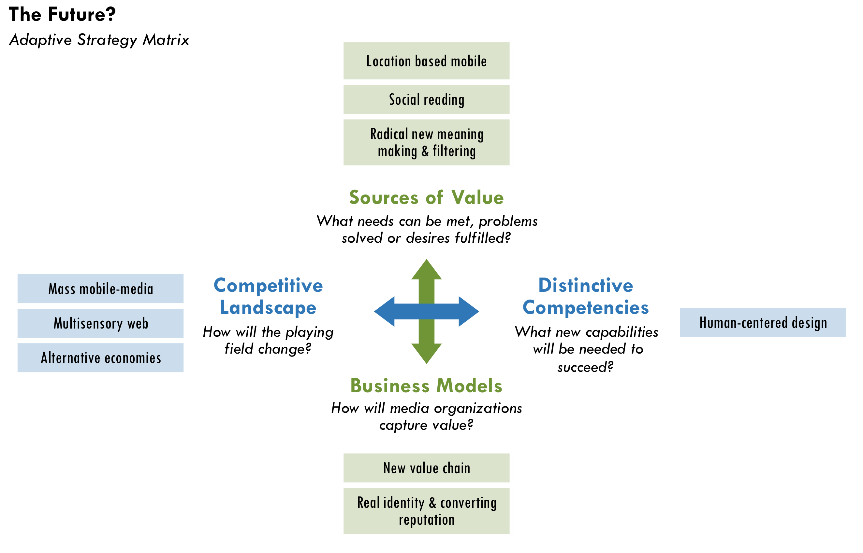

Mass mobile media
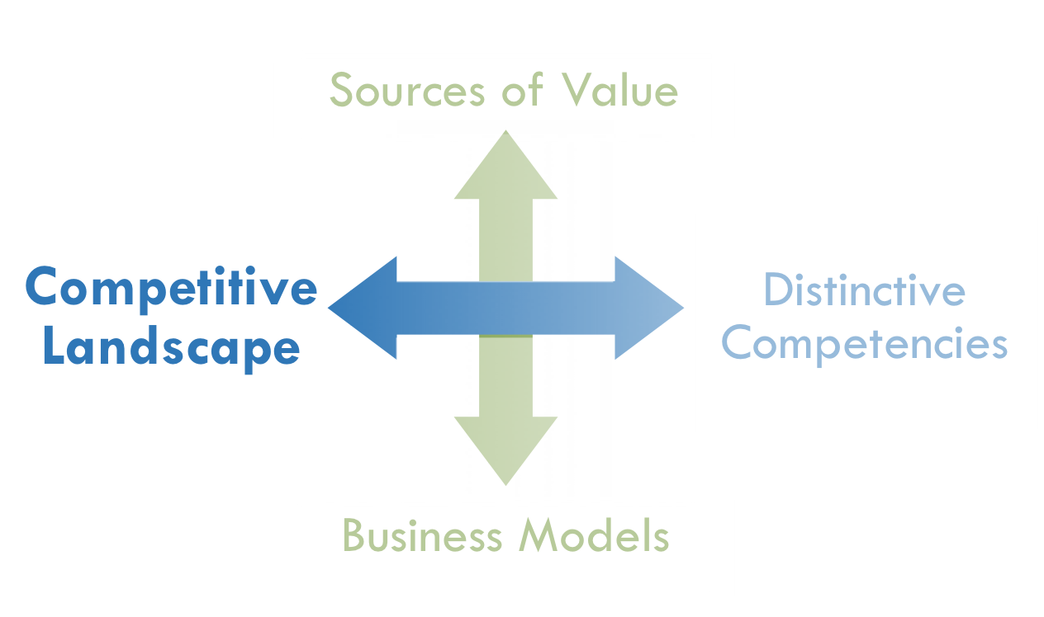
Battelle predicted that mobility would become a presumptive aspect of everything on the web by the end of 2009. Mobile phones and netbooks are just the beginning. Companies are building photography, video and audio recording into more than just phones and laptops. Apple’s iPod nano added video recording for the first time in September 2009.
Although the use of mobile phones has reached unprecedented levels worldwide, full integration with the web has barely started. Usability is still the biggest barrier for most people. BBC News reported in January 2009 that 61% of users interviewed in the UK and US said setting up a new handset is as challenging as moving bank accounts and 95% said they would try more new services if mobile technology were easier. This signals the potential explosion of mobile usage as devices become easier, faster, smaller, cheaper and more integrated with the web. Shirky believes that what he calls “ubiquitous prosthetic media devices” will be one of the biggest game changers. He recalled the Oakland BART tragedy when a policeman killed a young African-American: “Think of all the images that came from people who were there—not just one but many images—thanks to the fact that everyone had a built in camera in their coat pocket.” Iran’s 2009 presidential election is another sign of things to come. If independent media helps more people use the media-making power in their pockets, they will revolutionize journalism.

Multisensory web
We are returning to an acoustic and visual culture akin to the way most people communicated before the printing press. Video is quickly overtaking the web and will diminish the primacy of long-form, text-based journalism. Although people are consuming more information than ever before, they are reading less.
As it turns out, our brains are not wired to read. We adapt. “The act of reading is not natural,” writes Maryanne Wolf in Proust and the Squid and explains why learning to read has been critical for human development. Marti Hearst, a professor at UC Berkeley’s School of Information, goes as far as claiming, “The forms of communication that will do the cultural ‘heavy lifting’ will be audio and video, rather than text.”
The impact of text will decline further because of an emerging multisensory web. Shapes and gestures are already augmenting or replacing text input on touch screens, game consoles (e.g. Wii) and other devices, and 3-D televisions and computer displays are expected to hit the market in 2010. We will eventually have the ability to transmit smells and other data about the physical world, such as air samples to test for pollution. For instance, the Defense Sciences Office in the U.S. Department of Defense, which focuses on “mining ‘far side’ science,” is working on a way to make multi-sensory data converge in real time, just like it does in humans.
“There will be things we can’t even image when the web is more multisensory and we can smell and touch,” note Bracken. New devices of all kinds will feed this transformation.
Online users live simultaneously in a virtual and real world. The gap between them is shrinking. Facebook and Twitter are virtual worlds as much as Second Life, just without the graphical interface. As social networks evolve, they will increasingly function and look like real life. There are already names for all these realities—virtual reality, augmented reality, and even augmented viruality—but it will eventually all just be “reality.” As online media becomes more accessible, mobile and multisensory, there might not be much of a difference between real and virtual worlds. “What will the convergence of platforms mean?” asked John Gaeta, a visual effects designer for the Matrix film trilogy asked at a conference in Berkeley. “Games and films won’t look different from one another,” he said, “so you can have a transparent passage from a real piece of content to a virtual piece of content.” Convergence will be like having trap doors that lead seamlessly between different worlds. This phenomenon has come to be known as “transmedia storytelling.”
“As someone in his 40s, my generation grew up believing that we’d all end up in cyberspace with all of our heads floating in virtual worlds. Not one of my students believes this will happen. As it turns out, the Internet augments real-life and doesn’t replaces it.”
– Clay Shirky

Journalism has treated online media as a “horseless carriage” rather than reimagining a new form of journalism suitable for a multifaceted, converging web. If platform convergence is challenging today, a multisensory web, combined with mass mobile-media will make the media landscape even more complicated. The time it takes independent media organizations to participate in such innovations may not be worth the short-term benefits. However, if they do not take radical steps to keep up with early innovations, the gap between their internal competencies and how people relate to information will become even greater.

Rise in alternative economies
“We are discovering that money isn’t the only motivator,” said Chris Anderson of Wired. “Altruism has always existed, but the web gives it a platform where […] zero-cost distribution has turned sharing into an industry. In the monetary economy it all looks free—indeed, in the monetary economy it looks like unfair competition—but that says more about our shortsighted ways of measuring value than it does about the worth of what’s created.”
In many ways, traditional economic theory is insufficient; human motivations are more complicated.Many people have forecasted that the “free economy” will collapse because people are not paid. “Well, for two decades things haven’t collapsed. Clearly the theory of human motivation is wrong,” said Shirky.
The economic crisis may be fueling a larger shift. People are more willing to question capitalismpublically. Bellwethers of growing skepticism include The Daily Show and Colbert Report, which have taken major financial and media industry players to task, and Michael Moore’s latest film Capitalism: A Love Story. More than winguts are raising a voice. The Pope blasted capitalism and Heads of State in Bolivia, Cuba, Dominica, Honduras, Nicaragua and Venezuela declared “Capitalism is leading humanity and the planet to extinction.”
“Free shifts the economy from a focus on only that which can be quantified in dollars and cents to a more realistic accounting of all the things we truly value today.”
– Chris Anderson^{H}

Although a pendulum constantly swings for and against capitalism, the emergence of alternative economies and currencies are becoming more viable. This zeitgeist is redefining the traditional workforce. More Americans say that recognition, personal growth and flexibility are at least as important as money. Companies are redefining how they recruit and manage talent as a result.
“Why does Burning Man work? Why does Wikipedia work? Why does Alcoholics Anonymous work? Maybe (independent media) will be self-funded or a barter economy.”
– Katrin Verclas

Jump Forward
Will there be a new demand for quality journalism?, Vol.3, p35

Growing non-financial motivations will feed citizen journalism and professional-amateur collaborations. If the growing amateur ranks produce reporting that is “good enough,” users’ willingness to pay for higher-quality journalism may further deflate.
Independent media organizations have often operated via nonmonetary incentives in which volunteer and low-pay labor are the rule rather than the exception. This means that independent media organizations are well positioned to take advantage of a rise in alternative economies. Yet, it also means they will increasingly compete with other organizations to use this type of currency.

Human-centered design
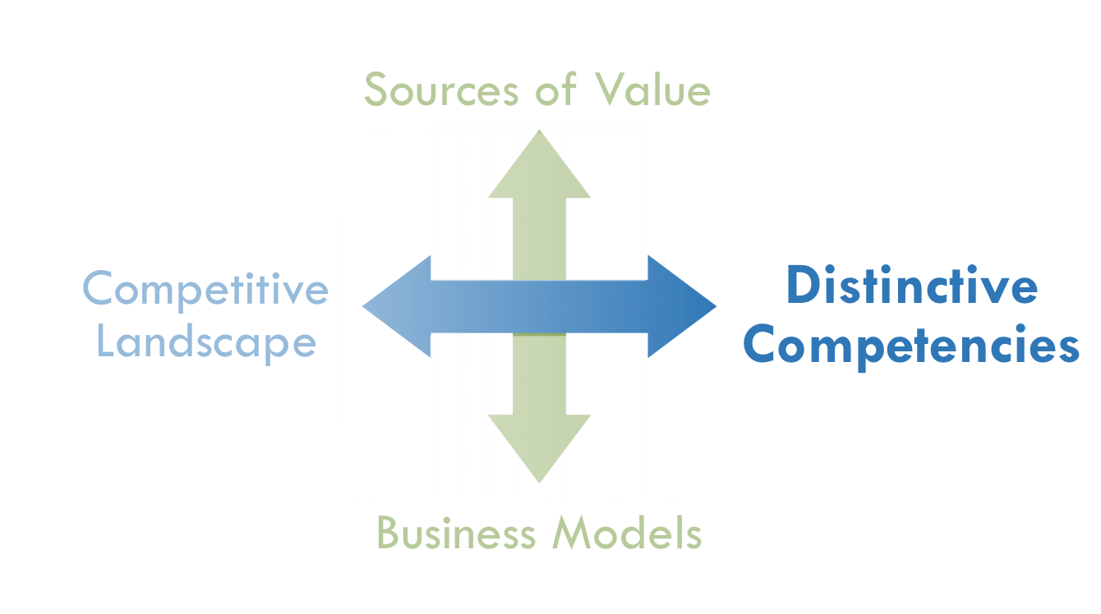
In his Atlantic article, “Is Google Making Us Stupid?” Nicholas Carr describes the many ways the Internet is shaping our minds, and admits that, “I’ve had an uncomfortable sense that someone, or something, has been tinkering with my brain, remapping the neural circuitry, reprogramming the memory.”
While technology may be changing us in profound ways, the next online frontier is how technology adapts to us. When companies are disrupted by new technologies or demographic shifts, their problems still have people at their heart wrote Tim Brown, president and CEO of the innovation and design firm IDEO. “They require a human-centered, creative, iterative, and practical approach to finding the best ideas and ultimate solutions. … By [human-centered design], I mean that innovation is powered by a thorough understanding, through direct observation, of what people want and need in their lives and what they like or dislike about the way particular products are made, packaged, marketed, sold, and supported.”
“A human-factors approach assumes that the things we’ll carry in the future are not going to be invented so much as discovered—that the answer to the question of what devices we’ll carry will become obvious as we learn more about human behavior,” explained Claire Tristram in Technology Review. Therefore, as mobile and multisensory devices proliferate and alternative economies grow, media organizations will find the best path forward by following its users.
Anthropologists are more likely than technologists to identify the next groundbreaking innovations in media. Nevertheless, technologists are still driving much of the innovation in the industry. Motorola’s Iridium satellite phone, bankrupt in 1999 after $5 billion of investment and just a year on the market, is infamous example of failure that can happen when technologists, not customers, drive a product. In this light, Battelle has questioned Google’s engineering focus, which could ultimately be its weakness in the future.
“It’s the essential human question that drives Google. I bring it up all the time. Community. Media. People. How do you make people scale?! How does Google, a company driven by algorithms and scale, find its Voice? … It can't be all algorithms.”^{II}
– John Battelle

“(Journalists) write stories that they think are important, but that’s not what the consumers want,” according to Ashish Soni of the University of Southern California’s Information Technology Program. Those journalism organizations that still have a hard time understanding their customersmay find it hard to adopt a human-centered approach. A number of progressive media projects have undergone facelifts in the past five years in an effort to appeal to a younger demographic. This is a part of human-centered design that independent media-makers sometimes ignore because they do not want to look too slick or commercial, at times to their detriment.
Media-makers cannot understand users by simply embracing new online tools and demographic realities. Amy Gahran of the Poynter Institute believes the next game changers could come from cognitive scientists such as Harvard’sSteven Pinker and others. Journalists need to “find tools to work the way the brain works and mirror how people interact in the world and with each other,”she said. For instance, there is a correlation between memory and emotional impact: The most memorable media content has the greatest emotional impact on its viewers. With a better understanding of the mind, journalism organizations could design the next generation of news distribution systems and collaboration platforms.
Social behavior makes media platforms even more complicated to design. James Surowiecki wrote in The Wisdom of Crowds that, “The solutions to coordination and cooperation problems are not like the solutions to cognition problems. They are fuzzier and less definitive…” And, researchers say there is still a long way to go in understanding how to apply offline human behavior to online media. To this end, journalists would be served by engaging in the frontiers of such research and learning from it, particularly because their central competency will increasingly be to design and build strong communities.

Location based mobile
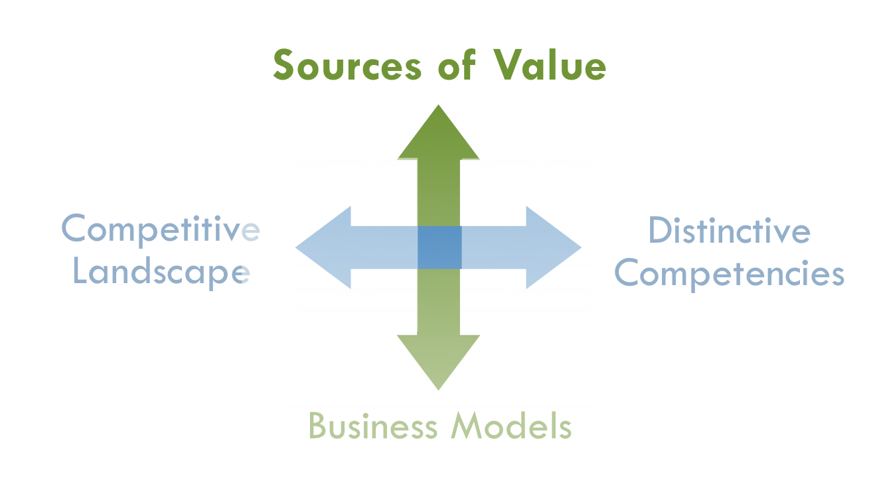
Mobile devices’ ability to detect a user’s exact location will revolutionize how we find, discover, create and interact with information.
The wave of location-based services has barely begun. Latitude on Google Maps and services from other companies such as Loopt already enable a user to broadcast their location and find friends. Location awareness will change how everyone interacts with their offline environment in even more dramatic ways.
People will not consume media primarily as a departure from their offline lives, but they will use it to enhance everything they do. Android and iPhone have augmented reality (AR) browsers that superimpose online information on its screen based on users’ physical surroundings. The devices even know if a user is sitting still or walking. Wikitude, for example, draws from Wikipedia entries when a user is near a landmark. Furthermore, shopping applications such as the iPhone’s LikeThis, G1’s Shop Savvy and some Amazon applications enable users to photograph bar codes or objects to compare prices, retrieve product information and aid mobile search based users’ location. The greatest leaps will come as satellite-positioning (GPS), tilt sensors and compasses become commonplace on most mobile devices.
“Location awareness is the single most important evolution in our data ecosystem.”
– Ben Rigby, The Extraordinaries

Location-based data opens up a new Semantic frontier of filtering information and making it more meaningful. With support from Nokia, MIT researcher Sandy Pentland is developing a “passive social graph” by collecting location-based and Bluetooth data. He conducts “reality mining” to see whose mobile phones come in proximity with each other. According to ReadWriteWeb, “Pentland predicts a future when he’ll be able to use frequency of calls, physical proximity and interruptions in conversations to determine for example who among your Facebook friends is a real life friend, who you’ve never met in person and who is your superior in a workplace hierarchy.”
Furthermore, location-based reality mining is “a new method for precise measurements of large-scale human behavior,” according to Pentland, and could be used to detect epidemics among other things. For example, if a significant portion of people do not go to school or work one day, as system might alert public health officials of a problem.
This sort of reality mining raises a whole new set of privacy and ethics issues that have to be balanced with its social benefits. Services will likely only be opt-in and analyze aggregated data to maintain anonymity. Google’s Latitude service includes a “memory leak” to remedy privacy concerns. Pentland said in an interview with MIT’s Technology Review, “The people making policies don’t know what is possible, and they don’t necessarily make policies that are in our best interest. … These capabilities are coming, but we have to come to a new deal. It doesn’t do any good to stick your head in the sand about it.”
Location awareness will help news become more relevant to users without any user input needed. Possibilities exist for journalism at many levels. Imagine:
- News alerts sent to people based on their location, for example, when an underground explosion in San Francisco’s Tenderloin caused a power outage for 8,600 residents in June 2009.
- Users scanning products for price comparison and getting news about a company, a health issue or consumer safety.
- An immediate call for volunteers that reach people who happen to be nearby.
- A network of users that enable media outlets to find a trusted source for a breaking news story in a specific area (e.g. Kansas tornado).
- The ability to send news about the Dali Lama to users who have travelled to Tibet.
- Users receiving news based on their friends’ locations? (e.g. New York on 9/11, New Orleans in August 2005).

Social reading
“The problem of how media has evolved is that it has isolated people,” said Gahran. “Your role was passive and to take it in. That damaged society in some ways.” Weinberger pointed to the early history of writing when reading became internalized. “Some people say that’s the origin of modern consciousness. The voice we heard externally, reading to us, we now hear internally.”
Cognitive scientists who study how the brain evolved say there were deep changes in our brain structures once reading and writing emerged. Marshall McLuhan famously describes how the emergence of communication technology as early as the printing press affected how we think, which had profound impact on social organization. Weinberger believes it is about to change again: “When you think of reading, you think of being by yourself, sitting quietly and reading in the hammock. Now reading may be a social act and this may change how we think.” The growing mobile, acoustic, visual and interactive web enables a new experience—social reading.
Television is already evolving into a more social experience. Just before Barack Obama’s inauguration, for example, CNN incorporated Facebook Connect. “For the first time, users could watch live TV online, invite their friends, chat with them while viewing and enjoy a social experience around Internet TV,” according to the Razorfish Digital Outlook Report.

Socratic Journalism
Now that online platforms have reached a scale for mass conversations, “social reading” may become the central metaphor for new media, which includes social editing and producing. This trend could change journalism in more significant ways than we have witnessed already.
Jump Back

Old Paradigm of Journalism, Vol.2, p2

Declarative& adaptive reporting, Vol.2, p35

How could such conversations be different from those on any social networking site? The answer might be in the role the journalist plays. Since reading and watching television was an individual act, the journalist’s role as an “educator” was paramount. People learned about current affairs privately, which equipped them to interact publicly. With social reading, people learn about current affairs and engage with others at the same time.
Journalists become conveners, facilitators and instigators in an inquiry process. They work with others to understand an issue more fully. Brave New Films (TMC member) has advanced such an approach to online documentary projects with Robert Greenwald’s “Rethink Afghanistan.” As a result, a reporter’s own skills and knowledge combine with that of users, to reach an outcome that is simultaneously more immediate, suspenseful, emotionally engaging, credible, and ultimately more comprehensive.
In the future, journalists will not simply report news for news’ sake; they will call readers to be problem solvers who think critically and iteratively with each other. Essentially, they go from declarative and adaptive reporting to being Socratic journalists.

Radical new ways of meaning-making and filtering
The next phase of filtering will center on the evolution of the “Semantic Web,” which Soni described as a step beyond aggregation that makes information more meaningful and useful. According to an article co-authored by Tim Berners-Lee, who is credited with founding the web, the semantic evolution “lets users engage in the sort of serendipitous reuse and discovery of related information that’s been a hallmark of viral web uptake.”
Jump Back
Metadata, Vol. 2, p50

“Meta tagging” as we know it today is just the beginning. The Semantic Web builds upon any metadata (e.g. hyperlinks, location, time, movement or categories) to infer greater meaning from information.
However, Berners-Lee admitted that the Semantic Web remains largely unrealized. “They’ve been working on solving this problem for 10-15 years,” Soni pointed out. “But no one is anywhere near a product or solution yet.” He said that technology is the barrier. “It turns out that (automatically) understanding the relevance and importance of documents is hard.”
Nevertheless, new ventures are making progress. For example, Wolfram Alpha, a computational knowledge engine, computes answers (in contrast to simple search) from large datasets. Although such efforts have a long way to go, each step will create new value for how we filter and make information more meaningful.

Who makes sense of the world?
The evolution of the Semantic Web depends largely on how we organize and structure information online, how pieces of information relate to one another, and how we relate to it all. This topic, called “ontology,” is a highly-debated area in technology.
“There’s this war between people who look for an algorithmic way to connect pieces and those that look for human ways,” Weinberger said. Some people believe in automated approaches to tagging, while other believe in “folksonomies,” where we can figure out the main ideas of content by analyzing people’s hand-tagging, such as you find on Flickr images. While most technologists acknowledge utility in both, Weinberger said that depending on personality, they tend to favor one and never look at the other. “It seems to go fairly deep into what we think language is, what it means to be social, how much of the world you think can be synthesized and represented.”
There are flaws in both approaches. Weinberger explained that people mostly use hand-tagging to trigger their memory, not to make sense of a topic. Although it is a bottom-up approach, he called it a flawed taxonomy. On the other hand, he noted, algorithms have not worked well either, “because people are pretty stupid about language and language is resilient against algorithmic approaches.” Nevertheless, he believes that it would be wildly foolish to think it will stay that way. “The scale of information is such that all assumptions about distilling information won’t hold.”
Shirky believes ontology itself is over-rated. “You don't really need to choose a category,” he said. “One of the great freedoms of digital data is there is ‘no shelf.’ Media outlets are very comfortable with taxonomies, but these were more for organizing careers, not content.” In a 2005 blog post on the subject, he said the debate ultimately comes down to the question, “Does the world make sense or do we make sense of the world?”
If the world makes sense, then we would have to reconcile all different points of view into one “theoretically perfect view of the world.” However, if we are the ones who make sense of the world, then an endless variety of viewpoints are possible. We do not need to place one top-level way of making sense over any other, which has been an implicit goal of traditional journalism. “The semantics here are in the users, not in the system,” he wrote. Therefore, the future of online journalism will be bottom-up approaches to making meaning.

Value of discovery
Jump Back
Old Paradigm of Journalism, Vol.2, p2

A more developed Semantic Web will certainly help users more easily find information they want, but the long-term potential for journalism will be how it helps people discover new ideas and perspectives.
“Discovery is the untapped value on the web now,” Anderson proclaimed at Nokia World 2007 and said filtering and information structuring is the solution. For example, in 2008, AlterNet received 3.3 million visits from three referral sites designed to tap the value of discovery: Digg, StumbleUpon and Reddit. Clearly, there is considerable value when new visitors—who are not predisposed to a political viewpoint—discover AlterNet’s content. Impressively, 86% of the visits from StumbleUpon and 74% from Digg were new people to AlterNet, compared to less than half of visits from other types of referral sites, such as the Huffington Post.
In comparison, only 65% of AlterNet’s visits from search engines were new readers, which shows that search is often less effective for discovery than referral sites. Interestingly, Digg and StumbleUpon depend largely on interpretation by people rather than algorithms. This indicates that systems that efficiently aggregate human interpretation at a large scale have great value. Nevertheless, AlterNet’s top 10 referral sites represented only 14% of the its 35.5 million total visits in 2008, which reveals that discovery still has unfulfilled potential in generating traffic.
Furthermore, without better discovery capabilities, online advertising’s growing focus on behavioral targeting could simply entrench users’ existing attitudes and opinions and many publishers will follow suit, which is not a good omen for democracy. “The main difference between artificial intelligence and behavioral targeting is that behavioral targeting takes past patterns and applies it to the future,” wrote Andreas Roell, Chairman and CEO of Geary Interactive. “Behavioral targeting is like a review mirror, whereas artificial intelligence constantly evolves and prioritizes behavior to make better recommendations over time.”
In order to tap discovery’s value, media organizations could take two steps:
- Share metadata more broadly. Together, such data may be more valuable than if media organizations reserved data for their own purposes. Poolingmetadata can help improve artificial intelligence, which drives the automated aspects of discovering new information on the Semantic Web.
Jump Back
Metadata, Vol. 2, p50

- Take a long-term view of users’ online experiences. However, technologists, entrepreneurs and journalists share a key limitation in this regard: They can be overly focused on short-term results. For example, a Google programmer, who asked to not be named, said that the engineers and designers at Google usually look only at the short term. “Use-case scenarios,” a central tool for software developers, are typically created for users’ first ten seconds to ten minutes of interaction. This programmer believes tremendous value is missed by not looking at longer-term use cases.
Similarly, a study on Flickr revealed potential value for developing online content with a long-term view. Researchers discovered that 20% of the pivotal first step in a “social cascade” (viral uptake) took longer than a month. Therefore, discovery that leads to eventual viral spread can include use cases of much longer than 10 minutes.
Lastly, journalists often believe that “truth telling” comes in one fell swoop and is published in one blowout article. However, as Emily Dickenson once said, “The truth dazzles gradually or else the world would be blind.” Discovery is a constantly evolving state for people, which could be an opportunity for independent media. If journalists can seek to meet people where they are, their truth telling could have a more powerful impact in users’ discovery over time.

New value chain of journalism
While media organizations are trying many different revenue models, the models that succeed in the long run will find a place in a new value chain of journalism pictured on the following page. A “value chain” is a chain of activities, each of which add value to a product or service. The financial success of any business model depends on the ability of an organization to capture value they create.
- Strategic recognition
What if… we built a new ecosystem for journalism?
Journalism’s old value chain was delineated with clear roles and exchanges of value. The new value chain reflects more roles. One organization often plays multiple roles. In the old model, advertising also had clearly defined roles. It mostly concentrated on publishing and broadcasting. In the new model, advertising is spread across more players.
Since the market is still forming the new value chain, independent media can work together to experiment with new models, promote new relationships among players and advance new standards in measuring and valuing content. Individual organizations can use the value chain to explore strategic questions for themselves, such as:
- What role do we play in the value chain now?
- Where do our strengths fit best? &Where could our role become most valuable?
- Is it best to focus primarily on one role or integrate many roles at once?

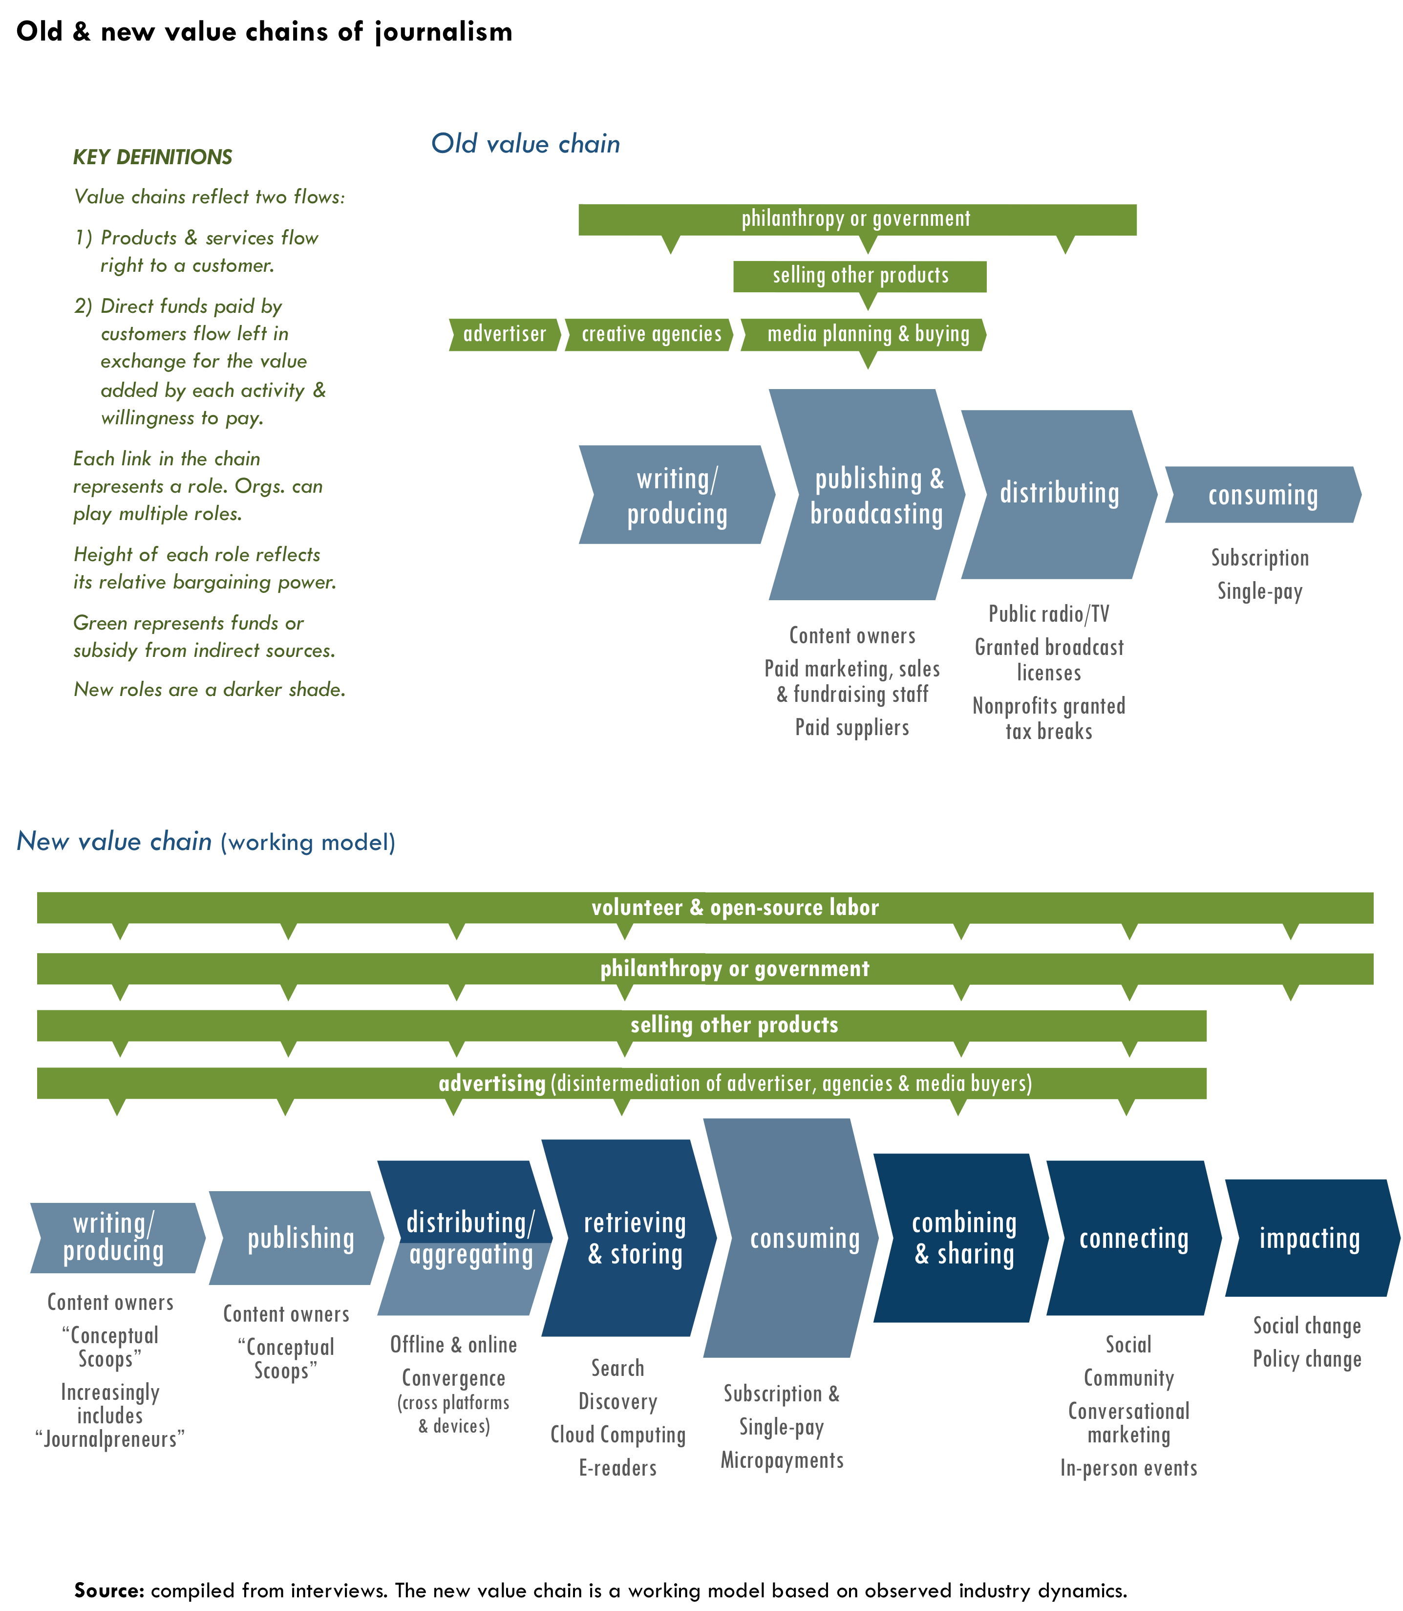

Today, some people say that advertisers are not willing to pay. Others say that readers are not willing to pay. Still others say that government or foundations are not willing to pay. Although sources of funding are more fragmented, the riddle of who pays will eventually be solved as relationships in the value chain get sorted out. Different parties will be willing to pay something, or else “we’re going to start getting what we pay for, and we may find out just how little that is,” as James Surowiecki wrote in his New Yorker article, “News You Can Lose.” This risk could easily extend beyond magazines and newspapers. The Razorfish Digital Outlook Report 09 claimed that unless television advertising evolves, it “may be at risk of losing premium content altogether.”
For many years now, there has been an oversupply of production capacity. Not only can everyone freely publish on their own, but media organizations and individuals alike can also reach the same global audiences which causes redundancy. “Now here’s what a lot of people seem to forget,” Nicholas Carr pointed out: “Excess production capacity goes away, particularly when that capacity consists not of capital but of people. Supply and demand, eventually and often painfully, come back into some sort of balance.”
As supply and demand balance out, it is still uncertain how relationships in the value chain will parse out. Will players try to cover many roles? Or will they build strength in one or two roles where they have comparative advantage?
Simplicity often wins. For example, in May 2009, Time Warner CEO Jeff Bewkes, explained in a press release that the decision to spin off AOL was so that each company could concentrate on its core competency. For similar reasons, Battelle doubted whether Facebook’s attempts to outcompete Twitter would work, because Twitter is as simple as a pencil. In contrast, he compared Facebook to Photoshop saying, “There’s so much you can do with it, the pencil function gets lost. … Back in 1997, Yahoo was a pencil to Netscape’s Photoshop. In 2000, Google was a pencil to Yahoo’s Photoshop. … Will history repeat itself?”
There are many possible ways the value in the chain could crystallize.
“Is there a way to reverse the broad expectation that information, including content assembled and produced by professionals, should be free?”
– David Carr^{X}

- Strategic recognition
What if… we collectively tested new revenue models?
“The problem is that we’ve depended on the work of the old in the new. We can all consume our news on Yahoo News or Google News or any other one of our potential news sources, but most of the stuff that we read is paid for by the print industry. … We are going to see a lot more capitulation (from the print industry before we see models arise).”
– John Battelle

- The value of simplicity could lead some media organizations to focus on creating quality investigative journalism and leave chasing eyeballs to other media organizations that are willing to share revenue with them.
- Content could become even more differentiated. For example, stories with viral potential live free online, while more specialized premium content is used to build deeper, more loyal communities willing to pay subscriptions, donate, or make other payments. However, this move may rub against an aim to make news broadly available to the public.
- Publishers could use metadata to make information they produce more useful and valuable (further defined in Vol. 2, p50).
- Non-profit media companies may win greater foundation support if quality reporting declines, especially if they can more reliably measure that they preach beyond the choir.
- A “new social contract” between the press and the public could lead to more public support for journalism, if not also a shift in consumers’ expectations of free news.
There will inevitably be different places on the value chain to capture value. If smaller players do not proactively figure out their roles, the big players will likely determine them.
Jump Back
How will the big players affect the game?”, Vol. 3, p10

The answers to two questions will affect the value chain in coming years:
“Will there be a new demand for quality journalism?” and “Will more reliable and consistent measures create greater distribution of value?”

Will there be a new demand for quality journalism?
The rise of free content will inevitably continue. However, some content could become more expensive as well. Stewart Brand, a futurist who created Whole Earth Catalog, WELL and Global Business Network, famously started a meme in 1984, “Information wants to be free. Information also wants to be expensive.”
“I think there is more of a hunger on the part of a larger segment of the public to access better and more information about the huge issues facing all of us.”
– Julie Bergman Sender, Balcony Films

Brand explained, “Information wants to be free because it has become so cheap to distribute, copy, and recombine—too cheap to meter. It wants to be expensive because it can be immeasurably valuable to the recipient. That tension will not go away. It leads to endless wrenching debate about price, copyright, ‘intellectual property,’ the moral rightness of casual distribution, because each round of new devices makes the tension worse, not better.”
Information becomes expensive when it is based on scarcities. Movie theaters can charge,in part, because a film is not available outside theaters.Attention and reputation are growing scarcities online. As users gain control of their information and identity online, the personal data could become the most expensive information of all and why the most trusted publishers will succeed.
Jump Back
New scarcities & their effects, Vol. 2, p14

Jump Forward
Real identity & converting reputation, Vol. 3, p40

There may be another scarcity emerging: the quality of investigative reporting. The price of news has dropped to zero due to information over-abundance. However, if the supply of quality news shrinks, it may create a vacuum in which the best writers and producers have renewed potential to earn money. In fact, Nicholas Carr believes a radical reduction of production capacity could actually help solve journalism’s problems. “The number of U.S. newspapers is going to collapse … and the number of reporters, editors, and other production side employees is going to continue to plummet. … As all that happens, market power begins—gasp, chuckle, and guffaw all you want—to move back to the producer. The user no longer gets to call all the shots. Substitutes dry up, the perception of fungibility dissipates, and quality becomes both visible and valuable. The value of news begins, once again, to have a dollar sign beside it.”
Conceptual Scoops
The greatest potential to capture value in journalism may be from “conceptual scoops,” a term Battelle used to describe investigative reporting that not only breaks new information, but also creates new frames for social and political issues. “Once you have a robust model for news online,” Batelle said, “that’s where conceptual scoops are going to live.” This type of reporting could spawn a new business-to-business model in journalism.
What happens when the pipeline for conceptual scoops dries up? Will aggregators have a new willingness to pay for them because they drive traffic? As a result, some journalism organizations may focus on investigative reporting and sell it to a smaller number of enterprise customers as “temporary exclusives,” rather than reaching for the broadest audience by themselves.
A consortium can help break conceptual scoops. Michel said that from her experience Huffington Post, she learned that “a network, not an individual reporter, breaks news.” Nevertheless, the “scoops” still come from individuals who lead the investigative work. Perhaps with standardized measure of influence and reach, money will flow back to the media organizations that did the hard work of unearthing the stories. Similarly, paying journalists could have renewedpotential based on stories’ performance.

Will professionals or amateurs be more valuable?
Many people believe that user generated content will continue to grow even if demand for professional content renews.Amateurs can cover more ground and often do a better job than professionals on many subjects. “(An amateur) might have passion for the school board in Methacton, NJ, for instance,” said Ben Rigby, co-founder of The Extraordinaries. “There is no way that a ‘professional’ journalist is going to care enough—or spend enough time to understand the Methacton school board the way that an amateur—who is not being paid—will. The amateur will go to every meeting, dig through documents, videotape every session, talk to every commissioner, and know all of the parents because he or she is passionate about it. A (professional) journalist simply can’t compete with this level of access and enthusiasm.”
Andrew Keen remains skeptical. InThe Cult of the Amateur: How Today's Internet is Killing Our Culture, Keen predicts that user-based information-gathering will fall apart. If YouTube’s track record is an indication, there may be some truth to Keen’s theory. YouTube has found that advertisers are not interested in user-generated content. In fact, YouTube has had to buy the rights to professionally produced content in order to attract advertisers, which will cost them $260 million in licensing in 2009, although the site’s total revenue will only reach $240 million.
Shirky disagrees with Keen, “We have all of these examples of places where groups of people are motivated by something other than money” such as the Apache Web Server and Linux. The workforce has also radically shifted;people go in and out of professions more readily. The label of “professional” has become a fluid distinction as a result. People who leave media as a vocation will continue to produce it as an avocation.
Regardless of profession, the best people will rise to the top. “This sorting out process will be good (for journalism),” noted Shirky,“because the commitment to the current business model of commercial chasing of page views has a huge overlap with the rise of mediocrity in content and media professionals.”
Journalism may thrive most in the future by motivating and supporting users to report the news more effectively—irrespective of their professional training.

Will more reliable & consistent measures create greater distribution of value?
- Strategic recognitions
What if… we standardized raw data, metadata & metrics?, p11
What if… we actively coordinated “deal-making”?, p14
Successful business modelshingetheir ability to measure value. “A well-measured medium is a more valuable medium” according to Nielsen Media Research’s website.
As more reliable and commonly accepted metrics emerge to measure content performance, the more that organizations can estimate the value they create. And, others can estimate how much they would be willing to pay for it. Money will flow to where there is value in the chain. Marketing analytics are based on this sort of reliable measurement, and deals are done based on it.
As metrics become better, publishers may be able to use new incentives for writers and producers. Also, a publisher could potentially convince aggregators to pay based on content’s performance. Aggregators could sign up freely or cheaply and pay if content spreads past a targeted threshold. If the price is low enough, and the aggregator can accurately measure the performance, it would be in their interest to share earnings in exchange for reliable content.
In particular, better ways to measure engagement and impact online will likely hold the greatest potential for independent publishers in the future.
“It is more important than ever to develop new media mix models that recognize the intricacies of channel interaction … we need to adopt new ways of measuring to account for the true complexity of media in the digital age.”
– Razorfish Digital Outlook Report 09

Metrics for engagement
For many independent publishers and aggregators, 60-70% of their online visits are for less than 10 seconds, and 50-60% of all visitors only come to the site one time. With such ratings, traffic number can often be a misleading sign of engagement.
Some people say that “page views” are becoming an irrelevant metric. In fact, many companies such as Nielson/NetRatings, Compete and Facebook are moving to “attention-based” web metrics based on time spent on site. Last July, Microsoft introduced “engagement mapping,” a way of measuring the return on investment based on how all interactions with marketing efforts lead users to take action. There is still disagreement, however, on the best way to measure engagement. Managers of projects such as Yahoo’s Buzz believe that comments, ratings, frequency of sharing and clicks are better metrics for engagement.
If measuring attention is the future of advertising, then why is there still so much emphasis on measuring page views? Muhammad Saleem, a social media consultant and contributor to open-source journalism project Newassignment.net, said the problem is a disconnection between the advertising and publishing industries. “The reason why there is an eternal quest for traffic, not only in terms of unique visitors, but also maximizing page views per visitor, is because advertising networks let you in on the basis of how much traffic you’re generating, and your eventual income is based on the number of impressions (and clicks).”
New metrics for engagement will profoundly affect all publishers, particularly smaller independent publishers who do not generate as many page views, but serve a niche that can deliver great value. Furthermore, if independent media organizations start viewing news as a “loss leader” and sell other products, engagement measures could become critical to their business.
For example, measuring the “average revenue per visit” (ARPV) based on advertising revenue is a common practice. However, people such as Benjamin Joffe, Managing Director at Asia Internet consultancy +8* and Co-Founder of MobileMonday Beijing, have called for new measures such as “average revenue from user” (ARFU). ARFU is based on non-advertising revenue directly from users such as digital goods (e.g. background music, avatars or casual games) or real-world products, which may be a better measure of a user’s engagement from a financial perspective. For independent publishers, it could include users’ donations. Joffe said that advertising has caused media companies to focus too much on generating page views, not making their services better. “Users are mere ‘eyeballs,’ while the real clients are advertisers. The revenue mix defines the service DNA.”
Jump Back
News as a loss leader, Vol. 2, p67

With stronger engagement measures a publisher can better estimate the lifetime value of a customer to make marketing and customer acquisition investments.
While advertising is making progress in measuring engagement, nonprofits also need to find better ways to measure how engagement leads to social impact in order to attract philanthropy.
Metrics of social impact
Most independent media organizations are driven by their social purpose more than business. However, measuring social impact is difficult, especially when it comes to goals that include influencing political dialogue, promoting progressive values, or launching a new meme. The complexity of factors contributing to impactonline makes it harder for organizations topinpointtheir value. Independent media organizations must simply bear witness about their ultimate social impact through anecdotes. Nevertheless, the more reliably they demonstrate impact, the more philanthropic funding they can attract.
Josh Catone wrote on ReadWriteWeb that an engagement mapping tool “will become really powerful when it can measure not only ad views that lead to a purchase, but also any other type of online or social interaction.” Imagine the value for social change that independent publishers could derive from tools that reveal exactly what online activity leads to social action.
Mother Jones examples
We can look at some examples from Mother Jones to illustrate the issues many independent media organizations face in measuring social impact.
First, there can be quite a big difference between popularity and influence. Harris said, “There are probably 10 stories where I could say, ‘here is where conventional wisdom was on an issue before a Mother Jones story, and here’s where it was after.’” An example of influence is the Mother Jones’s exposé about Exxon-Mobile’s funding of 40 different groups that were systematically denying the science of climate change. The story came out a year before the film An Inconvenient Truth, and Harris said that it put the heat on other media for giving such nay-saying groups equal treatment with the Intergovernmental Panel on Climate Change.
“If we don’t influence the public conversation, then what’s the point of having a magazine like this?”
– Monika Bauerlein, co-editor, Mother Jones

Second, impact is even harder to measure when it comes to affecting small groups of the most influential people. The Jan/Feb 2007 issue of Mother Jonesincluded a story called, “The Highwaymen,” about an Australian consortium that helped states privatize their road systems. The article was not widely read beyond people with a direct interest in highways, although Mother Jones did hand deliver the story to all members of Congress and legislators in eight states. “No big deals have gone down” since the magazine exposed the profiteering racket Harris said. In fact, the scale of impact does not necessarily correlate with size of audience.
Third, if “conceptual scoops” were easier to measure, perhaps investigative journalism outlets could capture greater value for them. For example, Google News executivesreached out to Harris in 2007 to help solve a problem. Their system determined “news” by what showed up simultaneously on sites such as nytimes.com, washingtonpost.com and wsj.com. However, the Googlers knew that Mother Jones broke important stories months ahead of these outlets, yet they could not figure out how to teach their computers to recognize the newsworthiness of such stories. If Mother Jones’s primary social value is breaking important conceptual scoops, and if Google of all companies cannot tellwhether this type of contentis news, then it is easy to see the difficultypublishers have in measuring the impact of investigative reporting.

Real identity & converting reputation
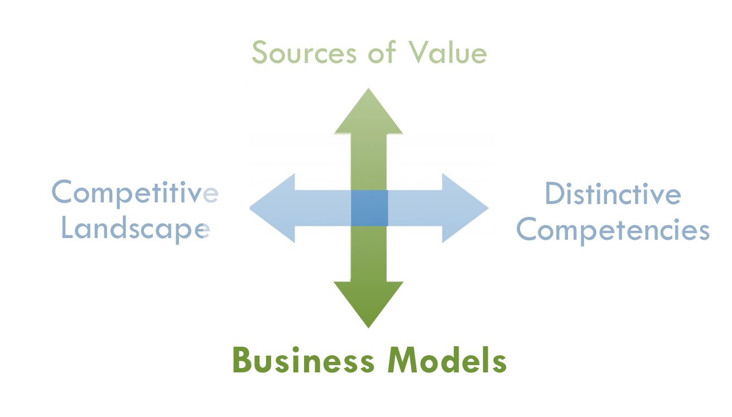
“What I want to know,” Shirky asked, “is how easy will it be 10 years from now to use my real name on the web? How easy will it be to access things without separate logins across the web? And, will my reputation and standing as a member be used? In short, will how we function and behave on the web become close to how we work in the real world? If this happens, we can see many new business models being possible.”
If this convergence happens, then qualified advertising revenue would be easier to support. Also, media outlets would be able to build communities of users who are willing to support them because those users get public credit for it. Shirky believes that so many of the problems we have right now are due to anonymity, which get disproportionately worse at scale, creating high costs in terms of usability and preventing many models from being tried. “You simply can’t have large-scale communities with anonymity. Anonymity doesn’t scale.”
“Anything you can consistently convert to cash is a form of currency itself, and Google plays the role of central banker for these new economies.”
– Chris Anderson^{H}

Virtual wealth in terms of reputation needs to be convertible to real wealth in order to be valuable. Lessons from the gaming industry indicate the potential value for media organizations of all kinds. “Players learn how to customize and to create within the online spaces, as well as how to extract this value back into the real world,” according to Cory Ondrejka, former Chief Technical Officer of Linden Labs, makers of Second Life. In fact, sometimes reputation is more valuable than time in this regard. Ondrejka learned from user behavior in games that “time-constrained users can make the rational economic decision to use real world currency to advance their character rather than time.” Citing research, Ondrejka claimed that the value of reputation has created a market in real-world currency for virtual game items, game currency and characters. While gaming has many differences with journalism, these dynamics demonstrate the potential value from reputational effects. Capturing this value will be increasingly possible as online measurement further develops and standardizes.
Lastly, the Federal Trade Commission’s (FTC) new truth-in-advertising regulations for social-media might open new windows of opportunity for media organizations to tap the value of reputation. The FTC, which has not changed its guidelines for endorsements and testimonials since 1980, plans to hold advertisers liable for false statements online. Since many marketers use bloggers and other individuals to spread information, the methods of qualifying real-life identity will become more necessary.

In summary, journalism organization could refreshtheir business models if they are prepared for five possibilities.
- If the supply of quality journalism decreases, demand for it may increase.
- If prices hit a level acceptable to consumers in relationship to the convenience and value they receive, they may be willing to pay or donate.
- If publishers can measure their value more reliably, they can capture more of that value by cutting deals with others in the value chain.
- If the value is more easily and clearly identified for engagement and impact, new value might come from sources such as foundations, government, individual donors and even consumers themselves.
- If media organizations can help users build their reputations and convert it monetarily, they will tap a new source of value.

Conclusion
PHOTO

“We’re watching hundred of billions of [bailout] dollars being spent unaccountably to support supposedly our ‘American way.’ I think at some point we have to ask whether or not the ‘American way’ includes journalism.”
— John Battelle

Do Americans view journalism as a public good that is critical to our country’s intellectual infrastructure and American exceptionalism? Do they believe that the strength of our democracy depends on a diverse and free press?
The “big thaw” of media’s old paradigm is drowning many traditional journalism outlets. If everyone—in the public, private and non-profit sectors alike—believe that journalism is part of the ‘American way,’ we need a new paradigm for it to thrive.
“So how do you change paradigms?” asks Donella Meadows in Leverage Points: Places to Intervene in a System. For an answer, she points to Thomas Kuhn, who wrote the groundbreaking book The Structure of Scientific Revolutions about science’s great paradigm shifts. “In a nutshell, you keep pointing at the anomalies and failures in the old paradigm, you keep speaking louder and with assurance from the new one, you insert people with the new paradigm in place of public visibility and power. You don’t waste time with reactionaries; rather you work with active change agents and with the vast middle ground of people who are open-minded.”
In order to succeed, The Media Consortium must speak with assurance about its strategic vision, work with those who are advocates for a new paradigm and not waste time with reactionaries who want to save media’s old paradigm. Journalism is evolving despite journalists. If journalists do not find new ground—even if it means dramatically changing their social and technological roles—they may drown.
By bringing together technologists, entrepreneurs and media-makers to increase experimentation, leverage their collective power and build audiences as communities, independent media can not only rise with technological tide, but also achieve the goals of inclusivity and fairness they espouse.

List of participants & process
The research process for this strategy project involved many different forms of input and discussion between July 2008 to July 2009. Key components included (participants listed below):
- Identified key uncertainties for the future through an online survey of TMC members and interviews with outside thinkers.
- Conducted a scenario-building workshop with TMC leadership (staff and board) based on the most relevant future uncertainties.
- Produced a “Future Scenarios Report” and “Guidelines for Game Changers” (Appendix D).
- Solicited project ideas through online survey of TMC members and several one-on-one conversations among members.
- Identified key trends and future possibilities throughoutside expert interviews.
- Evaluated early research findings to a group of outside thinkersas part of a dinnersalon/workshop.
- Held internal conversations about research findings and implications for TMC’sfuture direction, including a TMC membership meeting.
- Presented the report and project ideas to TMC membership.

Outside expert interviews
- John Battelle, author of The Search: How Google and Its Rivals Rewrote the Rules of Business and Transformed Our Culture, CEO & founder of Federated Media
- Adam Berrey, Senior Vice President of Marketing & Strategy, Brightcove
- John Bracken, Program Officer, MacArthur Foundation
- Amy Gahran, E-Media Tidbits, Poynter Institute
- Jay Harris, Publisher, Mother Jones
- Jay Heindrich, author ofThank You For Arguing& magazine consultant
- Leo Hindery, partner, Intermedia (private equity)
- Larry Irving, Vice President of Global Government Affairs for Hewlett-Packard Company and former Assistant Secretary, U.S. Department of Commerce
- Craig Newmark, Founder, Craigslist
- Vivian Schiller, CEO of National Public Radio. Former general manager of NYTimes.com
- John Schwartz, President, EBS Companies
- Clay Shirky, author of Here Comes Everybody: The Power of Organizing without Organizing; adjunct professor NYU graduate Interactive Telecommunications Program (ITP)
- Ashish Soni, Director of the Information Technology Program (ITP) at the Viterbi School of Engineering at the University of Southern California
- Alex Stefan, executive director, worldchanging.org
- Don Tapscott, author, Wikinomics
- Katrin Verclas, Co-Founder, MobileActive
- David Weinberger, author of Everything is Miscellaneous, journalist, fellow at Harvard Law School’s Berkman Center for the Internet and Society

Participants in scenario-planning meeting
- Ann Friedman, Deputy Editor, The American Prospect
- Jay Harris, Publisher, Mother Jones
- Steve Katz, Vice President for Strategy, Mother Jones
- Andrew Golis, Deputy Publisher, Talking Points Memo
- Rinku Sen, Publisher, ColorLines
- Don Hazen, Executive Director, AlterNet
- Teresa Stack, President, The Nation
- Roberto Lovato, Associate Editor, New America Media
- Tracy Van Slyke, Director, TMC
- Erin Polgreen, Program Associate, TMC
- Outside-in thinkers (external resources):
- Art Kleiner, Editor-in-Chief, Strategy+Business magazine (www.strategy-business.com)
- Mitty Owens, Senior Deputy Director, NYC Office of Financial Empowerment, former program officer at Ford Foundation
- Mike Stanton, Publisher, The Bond Buyer (leading daily newspaper of public finance)

Participants in one-on-one conversations and TMC member surveys
- Geraldine Cahill, Director of Communications and Social Media, The Real News Network
- Sandy Close, Executive Director, New American Media
- Emily Douglas, Content Editor RH Reality Check
- Frank Emspak, Executive Producer, Workers Independent News
- Jan Frel, Senior Editor, AlterNet
- Ann Friedman, Deputy Editor, The American Prospect
- Sarah van Gelder, Editor/co-founder, YES! Magazine
- Andrew Golis, Deputy Publisher, Talking Points Memo
- Jay Harris, Publisher, Mother Jones
- Linda Jue, Director/Executive Editor, G.W. Williams Center for Independent Journalism
- Steve Katz, VP Strategy and Development, Mother Jones
- Roberto Lovato, Associate Editor, New America Media
- David Michaels, Current Affairs
- Erin Polgreen, The Media Consoritum
- Lisa Rudman, Executive Director, Making Contact, National Radio Project
- Nicole Sawaya, media maven/digital agrarian
- Rinku Sen, Publisher, ColorLines
- Julie Bergman Sender, producer, Balcony Films
- Kim Spencer, President, Link TV
- Kathy Spillar, Executive Editor, Ms. Magazine
- Teresa Stack, President, The Nation
- Johanna Vondeling, Vice President, Editorial and Digital, Berrett-Kohler Publishers
- Kevin Weston, Youth Communications Director, New American Media

Participants in salon discussion
- Jen Angel, co-founder of Clamor magazine, indy media activist/writer
- Jamais Cascio, co-founder, Worldchanging.org
- Everett Harper, Director, Customer Lifecycle & Acquisition Marketing, Linden Labs (Second Life)
- Steve Katz, SVP Strategy, Mother Jones
- Peter Leyden, Founder Next Agenda; formerly Director, New Politics Institute & Managing Editor of Wired magazine
- Ben Rigby, co-founder The Extraordinaries, author, Mobilizing Generation 2.0 (Jossey-Bass)
- Ben Temchine, Senior Producer, Your Call on KALW
- Felicia Wong, SVP, Investment Services, Democracy Alliance
- Gregg Zachery, journalist and teacher at Stanford Journalism school

About the author of The Big Thaw
Tony Deifell is president of Q Media Labs, a companythat doesstrategy consulting, leadership training and project development at the intersection of media, technology and democracy. The company’s clients have included The Democracy Alliance, The Media Consortium, Google, UCLA and the Echoing Green Foundation among others. Tony created the widely successful participatory-art project wdydwyd?™, whichchallengespeople to answer, “why do you do what you do?”
Tony has spent nearly two decades as an entrepreneur in media and social enterprise. He was a founding board member of KaBOOM!, the national market leader for community-built playgrounds and skateparks. KaBOOM! generates 91% of its $20 million annual budget through major corporate clients such as The Home Depot, Sprint, and Computer Associates. He was the organization’s Chief Strategist, led a $5 million dollar investment from the founders of e-Bay and was the architect of its growth strategy and performance-measurement system, which is the subject of a Harvard Business School case study.
Prior to his work at KaBOOM!, Tony founded and headed for eight years the Institute for Public Media Arts, a company that promoted “user-generated content” before there was a label for it. His work received recognition by the White House as a national model in diversity education. Tony has served on local and national boards including the Kellogg Fellows Leadership Alliance and the Social Enterprise Alliance where he co-chaired the public policy initiative. He studied Anthropology at UNC-Chapel Hill, earned an MBA from Harvard Business School where he started a national conference aboutleadership and values, and was a fellow in the W.K. Kellogg Foundation’s National Leadership Program. In 2007,he published Seeing Beyond Sight (Chronicle Books), an award-winning book of photography by blind teenagers that wasin New York TimesBook Review and Los Angeles Timesand on KQED’s The Forum with Michael Krasny. As unusual as “blind photography” may sound, Tony draws broadly applicable lessonsfrom the stories to talk about leadership and innovation.
In 2008, the University of North Carolina at Chapel Hill selected Tony for its Distinguished Young Alumnus Award—a distinction he holds in common with former FCC Chairman Kevin Martin, Congressman Jim Cooper and sport star Michael Jordan.

TMC members’ discussion summary
As described in the introduction, the Big Thaw uses the dissonance created between old and new paradigms of media to identify the strategic importance of emerging practices and approaches. During a TMC meeting in February 2009, members discussed and debated four statements designed to surface debate.
- Discussion Worksheet follows this section that you can use with your staff or another group.

Provocative statements | Links to report analysis
- Alternative thinking no longer falls on the traditional definitions of “progressive” anymore. | - Progressive ideas, Vol. 2, p46
- The line between mainstream  & independent media is blurring. | - New abundances & their effects, Vol. 2, p13
- The source (publisher) of news  is losing relevancy. | - Declining institutional control &affiliations,  Vol. 2, p24  - Solving filter failure, Vol. 2, p49  - Radical new ways of meaning-making and filtering, Vol. 3, p28
- The role of publisher is  shifting from content creator  to communityconvener. | - Getting serious about community,  Vol. 2, p34  - Socratic Journalism, Vol. 3, p27
Members discussed three questions as they applied to each statement above. Their collective responses are listed below.
The line between mainstream and independent media is blurring.
“This is a worry because corporate media is falling apart financially, or they’re self-marginalizing by being wingnuts, so they can’t be trusted sources. So, there is a vacuum we can walk into in terms of being trusted sources of journalism.”
– Sarah van Gelder

What notions would we have to give up to move forward?
Collecitve responses from discussion | Links to report analysis
Labels. “We tend to self marginalize. We can be much more inclusive and therefore build much stronger movements, create much more opportunity for diversity among us.” | - Progressive ideas, Vol. 2, p46
Political stances. There was disagreement in the group about what exactly needs to be given up in terms of political stances, which fell in two camps. | - Progressive ideas, Vol. 2, p46  - Declarative& adaptive reporting,  Vol. 2, p35  - Socratic Journalism, Vol. 3, p27
- Giving up one-dimensional political stances. Move to more broadly inclusive values such as human rights and global perspectives in storytelling.
- Giving up articulation of political stances altogether. Move to a pragmatism of looking to what works and what people want to know, then focus on being a trusted source of quality.
Linking to external sites is a bad thing. | - Counterintuitive ways of working, p39
Publishers’ brands will sustain us forever.  It is now more complicated since writers will brand themselves as will topics. | - Journalpreneur, p42
Control. Instead, we need to be more responsive to readers. | - Declining institutional control &affiliations,  Vol. 2, p24  - “My ideas”, Vol. 2, p46  - From using users to a Conversation Economy, Vol. 2, p51
Control. “Scoop” proprietary mentality. | - Declining institutional control &affiliations,  Vol. 2, p24
Reluctance to talk to crazy people. | - From using users to a Conversation Economy, Vol. 2, p51
Old methods of getting word out. | - Physical distribution,Vol. 2, p4
What capabilities or competencies do we need in order to succeed?
The source (publisher) of news isn’t as relevant anymore.
“We decided it’s not true. But it is true that filters and validators, as in third-party sites that aggregate, imbue a link or article with their authority. This doesn’t mean the publisher is irrelevant, but it means they’re slightly less important than they used to be.”
– Ann Friedman

Collecitve responses from discussion | Links to report analysis
New language. Be both poetic and true. | - Declarative and adaptive journalism,  Vol. 2, p35
Human stories. Provide a human lens, not just the big picture. | - “My ideas”, Vol. 2, p46  - Getting serious about community, Vol. 2, p34
Cooperation. Reach beyond competitive stances.  Stronger partnering with non-profit and advocacy groups. | - Counterintuitive ways of working, Vol. 2, p39
Money. New fundraising capabilities.  Issue-based fundraising. | - Emerging revenue models, Vol. 2, p62  - Tightly integrating functions, Vol. 2, p38
Maintain brand quality and some degree of control over it, which involves community building and curatorial competency. | - Scarcity of reputation, Vol. 2, p14  - Getting serious about community, Vol. 2, p34
Open system of reporting (“to a point”). Give a certain amount of content out and ask people to engage with it. User-driven recommendations. | - Declarative and adaptive journalism,  Vol. 2, p35  The role of publisher is shifting from content creator to convener of communities.  “How do we square investigative journalism—content which builds up for long time and is vetted, tightly managed, labor intensive and embedded in a journalistic culture with a long history—with community-building activity?”  – Jessica Clark
Community organizing. Facilitating discussion, knowing skills and values of your audience. | - Getting serious about community, Vol. 2, p34  - From using users to a Conversation Economy, Vol. 2, p51
New media training. | - Strategic technology, Vol. 2, p36  - Experimentation, Vol. 2, p39

Which models & metrics are most important?
Collecitve responses from discussion | Links to report analysis
Old model: print + web.  New model: publisher (original content) + validator (curatorial). | - Solving filter failure, Vol. 2, p49  - Curation: experts + crowds, Vol. 2, p51
New model: global reach, rather than nation-state or niche groups. | - Next phase of globalization & its effects,  Vol. 2, p20
Old metrics: eyeballs and traffic.  New metrics: influence beyond eyeballs, community (How long & often reading? How often sharing, donating?). | - From using users to a Conversation Economy, Vol. 2, p51
New metrics:  - Degree of reach beyond usual suspects (mostly white audiences) + number & variety of users on site (not just young people, but also retirees).  - Brand integrity (user research to know if site is trusted).  - Number of user-community submissions.  - Degree to which media outlets collaborate. | - Dawn of a demographic revolution,  Vol. 2, p19  - New scarcities & their effects, Vol. 2 p14  - Getting serious about community, Vol. 2, p34  - Counterintuitive ways of working, Vol. 2, p39

Discussion worksheet
Break into small groups of three to eight people. Choose a person to report out.
Each group selects one of the following provocations to discuss (different one for each group).
Group 1: Alternative thinking no longer falls within the traditional definitions of “progressive.”
Group 2: The line between mainstream & independent media is blurring.
Group 3: The source (publisher) of news is losing relevancy.
Group 4: The role of publisher is shifting from content creator to community convener.

Questions for each small group
If the assumption in the statement is true…

1. What notions would we have to give up to move forward?

2. What capabilities or competencies do we need in order to succeed?

3. Which models & metrics are most important?
The Media Consortium’s history & membership
In early March 2005, two-dozen leaders from the worlds of independent print, radio, television, and Internet media answered a call from Mother Jones, The Nation, and The American Prospect to discuss “Independent Media and the Future of Democracy.” It was the first time in at least a decade that independent media content producers and distributors came together to talk about strengthening our effectiveness. We continued the conversation through 2005, expanding to include many more media organizations. We looked to diversify our membership beyond print and text-based media outlets as well as include organizations that reached specific target audiences, women, people of color, etc. Our goal: to figure out how a network of independent media could address two challenges we all face:
- How to amplify independent journalism’s voice in broader public debates over the crucial political and social issues of our times.
TMC Mission Statement:
To amplify our voices; increase our collective clout; leverage our current audiences and reach out to new ones; attract financial resources; strengthen and transform our individual businesses and our sector’s position in a rapidly changing media and political environment; and redefine ourselves and progressivism for a new century.

- How to navigate the current wave of profound technological change —change that is reshaping the media business, not to mention redefining the practice of journalism itself.
In early 2006, The Media Consortium formally coalesced. The Media Consortium’s Project Director Tracy Van Slyke calls the first few years of the network the “dating years.” TMCworked to build bridges, relationships and networks among individual organizations where none had existed before. Smaller projects were organized, mostly around business and marketing opportunities. For the first few years, there were disagreements about whether editorial collaboration should exist and if so, what it would look like.
By 2008, The Media Consortium had reached a turning point. Its staffing increased from two part-time staff in 2007 to two full-time staff in 2008. Relationships and strategies began to coalesce and fully inform the process for strategically developing projects and assessing their success.
When the consortium first formed, its members were wary of sharing information and working together. TMC provided space for developing deep professional relationships. Overall, TMC is creating the space for independent media to collectively strategize for a dynamic future. TMC’s work is ensuring growth and unity within the sector, rather than the fracturing and folding that mainstream and traditional media outlets are facing.
Members are increasingly comfortable with working together to share ideas and collaborate around projects. Joint editorial, marketing, and business projects are part of The Media Consortium’s 2009 focus. Members are confident about this work’s internal benefits—so much so that many have begun collaborating outside of TMC supported projects.
The Media Consortium’s Coordinating hasdeveloped five strategic principles that anchor TMCstrategy, initiatives and projects. They are:
- Foster Collaboration and Coordination
- Build and Diversify Media Leadership
- Focus on Audience Development
- Bring Money and Attention into the Sector
- Support Innovation in Journalism and Business models.
Membership
The Media Consortium currently has 45 members, and over half are actively engaged with TMC meetings, its listserv and TMC-sponsored projects. Members include magazines (and their websites), video producers, television networks and radio networks, book publishers, online news producers and more.
Active TMC Members
(All have online activities):
Magazines:Mother Jones,
In These Times, The Progressive, The American Prospect, The Nation, Washington Monthly, Yes! Magazine, Ms. Magazine, Texas Observer and ColorLines.
Online-only news sources:Wiretap, Grist, The Uptake (video), Talking Points Memo, RH Reality Check, OneWorld, Feministing, Center for Independent Media, AlterNet and AfroNetizen.
Television networks:
LinkTV and FreeSpeech TV.
Television Shows:
The Young Turks (with radio syndication) and GritTV (on FreeSpeech TV, hosted on blog FireDogLake and syndicated to public
access channels).
Radio:Air America, Public News Service, Democracy Now! and National
Radio Project.
Book Publishers:Chelsea Green, The New Press and Berret-Koehler.
Video:Brave New Films, Balcony Films, American News Project and Real News Network.
Other (training, syndication, production, networking organizations): G.W. Williams Center for Independent Journalism, Women’s Media Center, American Forum, The Nation Institute, NAMAC and New America Media.

More than 50% of TMC membership is made up of primarily text-based media organizations thatrange from magazines to online-only news sites. But more media outlets are moving beyond their primary platform and delivery systems due to quick industry shifts. Many now produce and distribute a mix of text, video and audio within their online operations. Within five years, many of these formats will be integrated across all our members.
Membership to The Media Consortium is based on criteria developed by our membership committee and approved by our Coordinating Committee (i.e. Board of Directors). While most of TMC’s members are “pure-play” journalism organizations, ongoing diversity goals are also considered. TMC also reviews how the changing media and political landscape impacts our ability to fulfill our mission. The Media Consortium’s membership body is a “hybrid” group of media organizations. Some examples include: advocacy and journalism, individuals, the progressive blogosphere, media distribution organizations and media outlets that have both a social justice and political focus.
Membership requirements
Members must be committed to:
- Amplifying the power of the independent media to foster a more informed, just and open society.
- Promoting the gathering and dissemination of news about current affairs in communities underserved by mainstream media.
- Supporting “mission-driven” media outlets whose missions encompass promoting the public interest in political, social and/or cultural diversity.
- Encouraging the participation of underrepresented communities in civic affairs by enhancing their connections with opinion leaders and policy makers.
- Research and development of innovative approaches to media production and distribution.
- Enhancing the practice of journalism in the public interest.
- Organizations where participation would confer a non-incidental private benefit are excluded from membership.
The Media Consortium also has multiple allies in the progressive political and media policy world, including the Center for American Progress, Media Matters, MoveOn, Free Press and more.

Collective online audience size
Online reach data was retrieved from Quantcast data on June 23, 2009 for websites of TMC members and gave an estimated online reach of 17 million website visits. Approximately 23% of these sites were measured directly, and 47% of the sites were “rough estimates” by Quantcast. Approximately 30% of the sites did not have enough data to estimate traffic, but these publishers have a relatively small impact on the cumulative number of online visits.
For consistency in comparison, Quantcast was used when available because self-reported data can vary greatly based on how metrics are defined and measured. The total collective reach includes overlapping visitors. However, research from 2006 showed that the overlap among member/subscriber lists among TMC members was just 25%.
Tracy had a bunch of stats related to diversity that she added to the Exec Summ. I think they go much better here (at least most of it).

Guidelines for generating game changing ideas
Our working definition of “game changer":Developments (projects, initiatives, strategies, new models, innovations) that “change the game” for independent media by increasing its impact and influence in the next five years. These are not incremental strategies, but rather big, bold moves that The Media Consortium could take advantage of in a rapidly changing media landscape.
Strategic moves

How can we think about game changers? To simplify, there is a continuum of strategies that might create game changers for TMC.
- REVOLUTIONARIES
These game changers tend to be über innovations. They create entirely new market spaces, categories, or social innovations that never existed before—and change the boundaries and rules of the industry or sector as a result.
- DISRUPTORS
Whereas revolutionary innovation typically comes from the “outside-in” disruptive game changers start within the boundaries of a defined industry or sector. They tend to be more “bottom-up” or lateral in their genesis. Disruptive innovations are also different because they often start out as lower cost options with inferior performance in unpromising markets, which makes them hard to spot and taken seriously at the beginning.
Examples — Airlines, motor vehicles, telephones, computing, semiconductors, internet. Note that many revolutionary innovations came about by 1) combining a range of existing technologies, e.g. Internet
2) a supportive context or "paradigm shift" that allowed them to emerge.
Examples — Encyclopedia Britannica was unable to recognize that CDs & DVDs would be a disruptive format. In addition, disruptive innovations frequently "democratize" services and enable customers to be part of the process. By this, they increase access or the ability of customers to do things that were previously done by a group of experts in a centralized fashion (For example, computing, photocopying, blogging). In any event, these strategies are called "disruptive" because they displace the incumbent players or technologies.
Examples — Personal computers, World Wide Web, FedEx, Intuit's QuickBooks, eBay, online auctions, MP3, iPods (downloadable music format) and Grameen Bank.
Examples — Minute clinics, home diagnostics, digital photography, photocopying, instant messaging technology, and microwave ovens.
Examples — Apple's "trickle down" strategy from the high-end to mainstream consumers through unique positioning and good design. Google's simple interface helped make this late entrant the market leader in internet search.
Disruptive innovations come in two forms:
- New market disruption creates new value by targeting “non-customers.” These are people with needs that were not being served by incumbents. Or there was a bottleneck in the way of their ability to consume the offering.
- Low-end market disruption creates value by targeting customers who are being over-served, or do not need the full performance required by high-end users. Often products overshoot the ability of consumers to adapt to the new features. Low-end disruptors reframe the offering by simplifying or focusing on the specific needs of these niche segments.
3. ADAPTERS
Though not as flashy and memorable, sometimes incremental innovations that are combined in novel or timely ways, can become game changers. First movers are not always successful in the end, so being a “fast follower” is often the savvy way to go. Google, for instance, was late to search.
Adapters come in two forms:
a) Design & differientiation
b) Cost reduction
Example — Wal-Mart's supply-chain approach

Characteristics |  | Impact
The following characteristics describe potentially gamechanging ideas for independent media: |  | Successful results from a game changer may include one or more of the following:
- Surprising and unexpected (reaches beyond the traditional tactics of progressive media)  - Time horizon for manifestation two years or more  - Holds potential risk that is equal to the reward/benefit that it could create (for TMC and/or its members)  - Utilizes technology that is early enough in its adoption cycle to leverage early-mover advantage  - Potential to lead to new solutions or opportunities for social impact  - Simple and intuitive |  | - Improve collective performance by 3x or more in either audience reach or influence (yet to be specifically defined)  - Significantly differentiate progressive media from competitors in news, opinion and commentary that will cut through the noise (including changing prevailing assumptions about progressive media)  - Attract new or greater funds from philanthropy or commercial sources  - Add significant value to relationships between TMC members and their customers, suppliers, funders and partners required to bring progressive content to market

Innovators to watch
Many people are experimenting with new ideas they hope will change the game for online media. We will not know for years which ones will be turning points for journalism.The Big Thaw could not include all the important innovators, although the following are some worth watching.Please add other organizations and individuals at http://themediaconsortium.com/innovators
[note: I was planning to re-order this list alphabetically, and then check the columns to the right to categorize them. It seems like it would be easier for people to find things. (??)] | Philanthropy & nonprofits | Measurement | Convergence | Adver-tising |  | Searh & filtering | Rapid programming
Philanthropy & nonprofits
Knight News Challenge (http://www.newschallenge.org), a contest awarding as much as $5 million a year for innovative ideas that develop platforms, tools and services to inform and transform community news, conversations, and information distribution and visualization. (see their winners for other ideas to list) | x
“L3C” (Low-profit Limited Liability Company) is a new type of LLC structure that better suits a mix of commercial and non-commercial revenue.
Measurement
Relay |  | x
Quantcast: http://www.quantcast.com/ |  | x
Convergence |  |  | x
Google Voice simplifies how people handle phone calls, voice mail and text messages. |  |  | x
Look under other categories such as television for convergence innovations |  |  | x
Boxee, which has a very passionate user base, pulls together multiple sources of Internet video in an easy to use interface that has caused many users to decide to cancel their cable subscriptions: “On a laptop or connected to an HDTV, boxee gives you a true entertainment experience to enjoy your movies, TV shows, music and photos, as well as streaming content from websites like Netflix, CBS, Comedy Central, Last.fm, and Flickr.” |  |  | x
Advertising
Vertical ad network platforms. E.g. Adify |  |  |  | x
Behavioral advertising |  |  |  | x
Search, contextual filters & aggregators
digg.com
StumbleUpon captures the value of discovery: http://stumbleupon.com
Medill-Brian Boyer: newsmixer.us uses Facebook connect to provide interesting functionality to news from the Cedar Rapids Gazette.
Townhall.com is a conservative aggregator. The left don’t have has anything as comprehensive. It’s very multi-platform
Visit Google Labs to learn what the company is planning next.
NewsTrustprovides a credibility filter online opinion and amateur journalism — reviewers evaluate each story against core principles of journalism, such as fairness, accuracy, context and sourcing.
Disintermediation
O’Reilly Media is way ahead of the game with XML. They’re a computer books publisher in the loosest sense. Recommended by Johanna Vondeling, Ann Friedman
Rapid programming
Symfony (PHP) (http://www.symfony-project.org)
CodeIgniter (PHP) (http://codeigniter.com)
CakePHP (http://cakephp.org)
Django (Python) http://www.djangoproject.com Missouri’s Lawrence Journal uses this platform
Microsoft PSP.net
AJAX, client-side, focuses on rich user experience, using it drives user experience and engagement
User interface
Cooliris (http://www.cooliris.com) Wall Street Journal uses for their real estate section
Apture (http://www.apture.com) Used by Washington Post. Soni called it “hyperlinked web journalism”
Zemanta (http://www.zemanta.com) Allows you to find related images as you blog (helps create links for Google search)
Naming
OpenSocial – “Friends are fun, but they’re only on some websites. OpenSocial helps these sites share their social data with the web. Applications that use the OpenSocial APIs can be embedded within a social network itself, or access a site’s social data from anywhere on the web.”
Hyper-local
Everyblock (http://www.everyblock.com)
FiveThirtyEight.com
NPR’s local affiliates. Schiller: “(I want) to work with all our member stations to create local portals so that as local newspapers die away we can step into the breach to make sure that there is not a vacuum there.”
Patch
“Tim Armstrong, Google’s president of advertising for North America and Latin America, is underwriting a new startup called Patch, which plans to put small teams of journalists in communities all over the country to produce hyper-local news content.” (http://news.muckety.com/2009/02/18/top-google-exec-funds-local-news-startup/11671)
Location-based mobile
Google Latitude lets you broadcast where you are to your friends.
Loopt (predates Latitude)
apply logic to location. can you tell me current crime stats are? what’s the average price around here. to be able to get that on your phone
Distributed sampling: “The pulse is shared, quite literally, using efforts like Stanford University’s “quake catcher” network, in which seismic activity is measured by tapping into the sensors commonly found in consumer laptops.”
Passive Social Graph (in innovations to watch)
Acrossair (http://www.acrossair.com) iPhone augmented reality app that retrieves information based on your surroundings by using the phone’s video camera.
Nokia’s MARA (mobile augmented reality applications) (http://research.nokia.com/research/projects/mara/index.html)
Wikitude (http://www.wikitude.org) Draws from Wikipedia entries based on users’ location.
Portable personal devices
Boyer: “remember Bruce Sterling, the science fiction writer and futurist, talking about the game changing impact of portable personal sensors. Once these get cheap enough, it will be possible for concerned citizens to take air quality samples in their neighborhood and then share and publish data documenting— for instance, that a company is polluting the air.” Clay Shirky’s students worked on a game like this.
TED device: SixSense, by MIT’s Pranav Mistry “‘sixthSense’ bridges this gap by augmenting the physical world around us with digital information and proposing natural hand gestures as the mechanism to interact with that information. ‘sixthSense’ brings intangible information out into the tangible world. By using a camera and a tiny projector mounted on a hat, ‘sixthSense’ sees what you see and visually augments any surfaces or objects you are interacting with. ‘sixthSense’ projects information to any surface, walls, and the objects around us, and to interact with the information through natural hand gestures, arm movements, or with the object itself. ‘sixthSense’ is having the entire world as your computer.”
Semantic tools, intelligent aggregators & meta-tagging
Silobreaker.com
Slashdot-Amazon experience is an example
Defense Sciences Office (DSO) of the Defense Advanced Research Projects Agency’s (DARPA) focuses on “mining ‘far side’ science. http://www.darpa.mil/dso/thrusts/index.htm
CALO (Cognitive Assistant that Learns and Organizes) led by SRI International and funded by Defense Advanced Research Projects Agency (DARPA). “The goal of the project is to create cognitive software systems, that is, systems that can reason, learn from experience, be told what to do, explain what they are doing, reflect on their experience, and respond robustly to surprise.”
“There is already one quiet commercial spin-off from the project. Siri Inc., based in San Jose, Calif., plans to introduce a personal assistance service in the first half of 2009. Still in “stealth” mode, with a small private test version of its service, Siri has raised $8.5 million from two venture capital firms.” (NYTime story – link) Also, Rearden Commerce (entrepreneur, Patrick W. Grady), “one of Silicon Valley’s most significantly financed but least known start-ups.” Grady, ““I set out to deliver on the longstanding ‘holy grail of user-centric computing,’ a ‘personal Internet assistant.’”
Passive Social Graph is reminiscent of the MIT researcher we wrote about last year who is collecting “passive social graph data” by watching whose cell phones come near who else’s, something he calls “reality mining.” Good how to: http://www.readwriteweb.com/archives/reality_mining.php
Wolfram Alpha (http://www.wolframalpha.com), the leading computational knowledge engine
Crowd sourcing, citizen journalism & pro-am models
The Minnesota Star-Tribune put the Coleman/Franken ballots out for readers to examine.
Ushahidi.com “Crowdsources crisis information” in Kenya Platform takes in reports from field via mobile devices. Reports are collated into web based platform/presentation and certain info is sent back via mobile, http://www.ushahidi.com
OffTheBus was a citizen-powered campaign news site co-sponsored by The Huffington Post and Jay Rosen’s NewAssignment. http://www.cjr.org/feature/get_off_the_bus.php
Help Me Investigate, http://helpmeinvestigate.com
Citizen Global Studio: “Online collaborative studio that brings individual content creators and mainstream producers together to create broadcast-quality media of any kind.” http://citizensglobalstudio.com
Social media & conversational media
Facebook Connect offers mobility of data across networks
Organizational structure & new journalists
Federated Media is blending old & new producer model http://www.mydigimedia.com
New corporation structures, such as Low-profit, limited liability companies (L3C), which function as hybrid charity/for-profit businesses.
Co-op efforts like Puerto Rico’s Daily Sun
Employee Stock Ownership Plans (ESOP), like that being attempted in Portland, Maine
Blogs & news aggregators
The Huffington Post
Daily Kos
Talking Points Memo
Boing Boing’s Xeni Jardin
AlterNet
Global Voices
Micro-blogging & micro-volunteering
Twitter has the following uses:
Sync conversations real time to find out what people are doing rightnow.
Test ideas
Managing issues/PR
Examples: air crash in Hudson
The Extraordinaries
Micropayments
The Information Valet Project is an initiative of the Reynolds Journalism Institute at the Missouri School of Journalism. http://informationvalet.wordpress.com
Journalism Online, http://www.journalismonline.com
PayChoice, http://cyber.law.harvard.edu/projectvrm/PayChoice
Intuit, the maker of QuickBooks software for small businesses, is announcing a new service called Intuit GoPayment, that will put credit-card processing technology into most cell phones.
Spot.us, community-funded reporting. Like a Donors Choose for journalism.
Video & television
Tivo “TiVo household personifies the interactive and integrated household of the future.”
Stopp|Watch rating service provides “active measurement of how viewership changes with the ability to time-shift programming.”
Live video. “Live video broadcasting service Ustream.tv (started 1 yr ago) will announce tomorrow that live feeds on the company’s website and distributed video players got a combined 10 million unique viewers last month. If those numbers are solid, it’s a major validation of live streaming video on the web.” (announced Watershed, a new white-label service, Feb 2009)
Razorfish: Companies like ZunaVision and Innovid are working on inserting Flash-based assets into video post-production, so a blank wall in a video could suddenly contain a movie poster, digitally inserted at the time of delivery.
Google TV Ads & Navic, which introduced a supply-demand model for buying and selling ads
Slingblox, HAVA, Boxee, which break down the conventions and gateways we have in place around accessing television content.
IPTV: Apple TV, Roku, Slingbox.
Translation
Global Voices’ Lingua translation project, a volunteer network of translators (from English to other languages) that focuses on Global Voices’ content. http://globalvoicesonline.org
Meedan, software-based translation project. “Meedan is bringing Arabic and English speakers together in conversation about world events using emerging machine-assisted translation technology” http://www.meedan.net
dotSUB “… View, upload, transcribe, and translate any video into and from any language.” http://dotsub.com
Research
Knight Foundation, research on networks.
Neuroscience: Steven Pinker, a linguist/neuroscientist who recently joined Harvard Psychology, researches how people communicate with each other and with themselves. Read his book The Language Instinct.
Berkman Center, Harvard
Weinberger: (at the Center at Harvard) “We’re trying to do empirical research to see how information is moving through the blogosphere and into mainstream media. This wouldn’t touch the human behavior side, though. If you want to know where a meme started – like the rumor that Sarah Palin’s daughter’s son isn’t really hers – we don’t really know where that meme started. This project would provide ways to answer these questions.”
OpenNet Initiative, www.opennet.net
Big print players
The Guardian, UK
Largest audience is in the US
Globalization of media
The New York Times
Soni: “The New York Times is doing some really great things, lots of experiments. They’ve developed a great rapid experimentation platform. They just launched something called “Times People”.
API to share data
Linking to competitors
Ask.com was their biggest profit margin
The Washington Post
The Wall Street Journal
New application to quickly link multimedia
Other experiments
DocumentCloud, a collaborative effort to create a unified database of original source documents, http://documentcloud.org (The New York Times, ProPublica, Talking Points Memo, The National Security Archive, Gotham Gazette)
E ink — Kindle (see text elsewhere in this outline).
MIT related to journalism ideas: https://www.technologyreview.com/business/20923/page
Esquire’s September issue had an electronic cover, produced by the company E Ink, which developed Amazon’s Kindle, and they have more coming in Feb & June 2009.
O’Reilly Media: http://oreilly.com/
Avate gaming (e.g. SFZero and others)

Notes & sources
Sidebarnotes & sources
^{A} In reaction to Shirky’s commentary in “Newspapers and Thinking the Unthinkable,” a member of the California Media Workers Guild wrote: “We’re supposed to just feel good that we’re living through a revolution. I guess we could have written a blog for Europe during the bubonic plague saying, ‘Get over it. It’s happening, it will trim the herd, and there’ll be more stuff for those who are left. So what if you lose a few family members.’That would have made it okay. (…) But [Shirky] insults us when he says we don’t need newspapers – suggesting that our mission has been only to pulp trees into newsprint.” See Blunz, “Brilliant Drivel,” gLOGg, March 15, 2009.
^{B}This quote is often attributed to Marshall McLuhan. While McLuhan popularized it, he repeated it as an unattributed saying. Matie Molinaro, Corinne McLuhan, William Toye, Letters of Marshall McLuhan, Oxford University Press, 1987.
^{C} Howell Raines, “On This Anniversary: Who We Are,” New York Times, November 14, 2001.
^{D} Sascha Meinrath keynote address, eComm, March 7, 2009. (transcript link)
^{E} Richard Tedlow, “Leaders in Denial,” Harvard Business Review, July/August 2008.Tedlow is the author of the forthcoming book Denial: Why Business Executives Fail to Look Facts in the Face.
^{F} Donella Meadows, “Leverage Points: Places to Intervene in a System,” The Sustainability Institute, 1999.
^{G} Richard Tedlow, "Why Bad Things Happen to Good Companies," speech, Harvard Business School, 2002.
^{H}Chris Anderson, “Free! Why $0.00 Is the Future of Business,” Wired Magazine, February 28, 2008
^{I} Martin Peers, “Future Shock for Internet Ads?” Wall Street Journal, February 17, 2009.
^{J} “Unbound,” The Economist, July 7, 2008.
^{K} Amanda Michel, “Get Off the Bus: The future of pro-am journalism,” Columbia Journalism Review, March/April 2009.
^{L}Ebony and Jet magazines’ struggles to stay afloat was a topic of news talk shows in March 2009. K. Tempest Bradford (The Angry Black Woman blog) acknowledged that part of the problem was that Ebony had not kept up with technology changes or kept their content current to young readers. “Roundtable: Can Detroit Bounce Back?” National Public Radio, March 9, 2009.
^{M} Thomas Crampton, “14 China Internet insights About.com learned launching Abang.com,” Thomas Crampton: China, Internet and new media seen from Asia (blog), January 14, 2008.
^{M} Meeyoung Cha, et al., “Characterizing Social Cascades in Flickr,” WOSN’08, August 18, 2008, Seattle, Washington.
^{N} Eric Alterman, “Out of Print: The death and life of the American newspaper,” The New Yorker, March 31, 2008.
^{O} Cass R. Sunstein, Republic.com 2.0, Princeton University Press, 2007.
^{P} Cory Ondrejka, “Escaping the Gilded Cage: User Created Content and Building the Metaverse,” New York Law School Law Review, Volume 49, Issue 1, 2004.
^{Q} David L. Altheide, Creating Reality: How TV News Distorts Events, Sage Publications, 1976, p. 17.
^{R} Jack Meyers, “Jack Myers on the Future of Television: Realities and Opportunities for Media Companies and Marketers,” Digital Outlook Report 09, Razorfish, March 9, 2009.
^{S}Behavioral Targeting: Pushing Relevance To Maximize Advertising Spending, JupiterResearch, January 26, 2009.
^{T} John Battelle, “Conversational Marketing: PGM v. CM, Part 3,” John Battelle Searchblog, March 9, 2007
^{U} Tony Deifell, “Mother Jones,” independent case study, Democracy Alliance, October 2008.
^{V}Gary Levin, “‘Simple economics': More reality TV,” USA TODAY, May 7, 2007.
^{W} Alana Conner Snibbe, “Drowning in Data,” Stanford Social Innovation Review, Fall 2006.
^{X} David Carr, “Let’s Invent an iTunes for News,” New York Times, January 11, 2009.
^{Y} Nicholas Carr, “The writing is on the paywall,” Rough Type, February 10, 2009.
^{Z} Melissa J. Perenson, “Game Economy Grows with Micropayments,” PC World, October 4, 2008.
^{AA}David Kaplan, “NYTCo Earnings Call: Citing Weakness in Display, About.com Shifts Emphasis To CPC Rev Model,” paidContent.org, January 28, 2009.
^{BB} Nicholas Carr, “Is Google Making Us Stupid?” Atlantic, July/August 2008.
^{CC} Nicholas D. Kristof, “The Daily Me,” New York Times, March 18, 2009.
^{DD} Michele Gershberg, “Citigroup sees better Amazon Kindle sales,” Reuters, August 11, 2008.
^{EE}Zachary Coile, “Pelosi goes to bat to keep Bay Area papers alive,” San Francisco Chronicle, March 17, 2009.
^{FF} Jessica Clark and Pat Aufderheide, Public Media 2.0, Center for Social Media, February 2009.
^{GG} Tracy Van Slyke, “The future of investigative journalism,” The Guardian, April 16, 2009.
^{HH} “Once the unequivocal frontrunner in information technology and telecommunications, the U.S. has fallen from 1st to between 15th and 21st in the world in terms of broadband access, adoption, speeds and prices. The most recent data from OECD underscores the fact that the U.S. broadband penetration ranking remains stagnant. Such a dramatic decline has prompted calls for a “broadband Apollo project,” a nation-wide initiative to build advanced fiber-optic communications infrastructure to connect every community, constituency, and interested individual in the country.” Benjamin Lennet, Sascha Meinrath, “Building a 21st Century Broadband Superhighway,” New America Foundation, 2009.
^{II} John Battelle, “Can Google Find Its Voice?,” John Battelle Searchblog, March 11, 2009.

Introduction| notes & sourcess

Sites that are directly measured have registered with Quantcast and added code to each page (a highly accurate measurement method).
Andy Grove was former CEO of Intel and author of “Strategic Dissonance,” a paper that is used (with modifications) to frame this report. The model is modified for this report to be more relevant for industry-wide analysis. Specifically, in the “Adaptive Strategy Matrix” in this report’s Introduction, the vertical axis between Sources of Value and Business Models replaces Grove’s axis between Corporate Strategy and Strategic Action. Grove also builds on theories of business school professors, Clayton Christensen (who coined the term “disruptive technology”) and Michael Porter. Robert A. Bergelman and Andy S. Grove, “Strategic Dissonance,” California Management Review, 1996.
“IBM’s slowness in taking advantage of the RISC microprocessor architecture (which it had invented in the mid-1970s) was, no doubt, attributable, at least in part, to top management’s perception of IBM as the leading “mainframe computer” company in the world.” (Grove, p16) “Intel’s exit from the DRAM business, for instance, was delayed by the fact that top management was still holding on to Intel’s identity as a memory company (instead of a microprocessor company), even though the company had become a non-factor in DRAMs with 2-3 percent market share by 1985.” Grove, 15, Note: DRAM was a key innovation in computer memory in 1970. Intel’s strategic shift occurred 5-6 years after their market share began to decline.
“In December 2008, the Fitch Ratings service, which monitors the health of media companies, predicted a widespread newspaper die-off: “Fitch believes more newspapers and newspaper groups will default, be shut down and be liquidated in 2009 and several cities could go without a daily print newspaper by 2010.” (Hirschorn, Atlantic.) In 2008, 525 U.S. magazines closed, and which is expected to increase in 2009. eMarketer, March 27, 2009. Vol. 1: What if? |notes & sources
In lieu of other reliable common measures of reach, the total number of website visits was used as a proxy for the total reach of TMC members. The full collective reach would include print circulation among other measurements. Growth of three times five times would mean a compound annual growth rate of 31.6% for the overall consortium, while five times would be 49.5%. As a point of reference, YouTube’s overall growth rate from 2005 to 2009 has been XX??. Moore’s Law represents a 50% annual growth rate for the capability of digital devises.
Donella Meadows, “Leverage Points: Places to Intervene in a System,” The Sustainability Institute, 1999, 19.
Clay Shirky, “Newspapers and Thinking the Unthinkable,” blog post, March 13, 2009.
Sascha Meinrath keynote address, eComm, March 7, 2009. (transcript link)
“The first BarCamp was held in Palo Alto, California, from August 19-21, 2005, in the offices of Socialtext. It was organized in less than one week, from concept to event, with 200 attendees.” From Wikipedia (http://en.wikipedia.org/wiki/BarCamp)
“The new documentary Project (Rethink Afghanistan) by Greenwald is being done in a revolutionary manner as real cinema. Instead of doing all at once, doing interviews and editing everything into one single film, he has decided to do the work in parts, and release each chapter as it becomes necessary and in ‘real time.’” Daniel Buarque, “A Military Solution in Afghanistan Will Fail, says ‘Real Time Documentary Filmmaker’,” Globo, March 31, 2009.
Ariane Sherine, “The atheist bus journey,” The Guardian, January 6, 2009. Vol. 2: Old Paradigm |notes & sources
“Among the 2,000 responses that poured in, the judge most liked ‘All the World’s News, but Not a School for Scandal.’ But even the judge did not find that preferable to Ochs’s creation, ‘All the News That’s Fit to Print.’” Clyde Haberman, “150th Anniversary: 1851-2001; Banner Headlines and Comic Strips,” New York Times, November 14, 2001.
Howell Raines, “On This Anniversary: Who We Are,” New York Times, November 14, 2001.
Studies have shown that, under the right circumstances, groups more often converge on a “correct” answer than individuals left to their own decisions. This dynamic occurs in Delphi forecasting methods (http://en.wikipedia.org/wiki/Delphi_method) and arctic survival simulations. Another example: In “Who wants to be a Millionaire?” the “ask the audience” lifeline is correct 90% of the time, whereas “phone a friend” is correct 65% of the time. (See James Surowiecki, Wisdom of Crowds, 2004.)
Clay Shirky, “The Newspaper Industry and the Arrival of the Glaciers,” Boing Boing, December 8, 2008.
Richard Tedlow, “Leaders in Denial,” Harvard Business Review, July/August 2008.
Donella Meadows, “Leverage Points: Places to Intervene in a System” (The Sustainability Institute, 1999) 19.
James Surowiecki, “News You Can Lose,” The New Yorker, December 22, 2008.
“When someone demands to know how we are going to replace newspapers, they are really demanding to be told that we are not living through a revolution. They are demanding to be told that old systems won’t break before new systems are in place. They are demanding to be told that ancient social bargains aren’t in peril, that core institutions will be spared, that new methods of spreading information will improve previous practice rather than upending it. They are demanding to be lied to.” Clay Shirky, “Newspapers and Thinking the Unthinkable,” blog post March 13, 2009.
Laurence Gonzales, Deep Survival: Who Lives, Who Dies, and Why, W.W. Norton & Company (2003), 170. Vol. 2: Chapter 1 |notes & sources
Nicholas Carr, “The writing is on the paywall,” Rough Type, February 10, 2009.
Wenda Harris Millard, “Bellies Vs. Bullion,” Mediaweek, April 14, 2008.
Chris Anderson, “Free: the past and future of radical price,” keynote address, Nokia World 2007. (http://www.nokia.com/A4705161)
“Key News Audiences Now Blend Online and Traditional Sources: Audience Segments in a Changing News Environment,” The Pew Research Center for the People & the Press, August 17, 2008.
Vanessa Grigoriadis, “Do You Own Facebook? Or Does Facebook Own You?” New York Magazine, April 5, 2009.
James Surowiecki, “News You Can Lose,” The New Yorker, December 22, 2008.
“Key News Audiences Now Blend Online and Traditional Sources: Audience Segments in a Changing News Environment,” The Pew Research Center for the People & the Press, August 17, 2008.
TNS Global (http://www.tnsglobal.com)
“In the developing world, mobile phones have revolutionized telecommunication and have reached an estimated average 49.5 per cent penetration rate at the end of 2008 – from close to zero only ten years ago.” Measuring the Information Society, International Telecommunication Union, 2009.
“I actually think that we’ve turned the corner on the digital divide—not that it’s closed but that a gap that seemed to be widening pretty relentlessly is now going to be narrowing in the coming years and I think narrowing quite quickly. We’ll find that it’s in business, it’s in emergency services, it’s in public education, it’s in primary healthcare, banking, distance learning, scientific communications, entertainment and all the rest, and this will make a very big difference. … Mobile penetration is expanding dramatically. The number given for 2007 is about 250 million subscribers in Africa and the numbers are continuing to rise very, very rapidly.” Jeffery Sachs, ”Africa: Cell Phones Could Transform North-South Cooperation,” Feb 16, 2009.
“The information users seek on a mobile device is also poised to change. Currently, the leading content categories searched by mobile users are maps/directions (69%), weather (65%), local information (62%), news (51%) and entertainment (43%).” Digital Outlook Report 09, Razorfish, March 9, 2009.
Terri Walter, Vice President, Emerging Media, “The Digitialization of Television,” Digital Outlook Report 09, Razorfish, March 9, 2009.
“Key News Audiences Now Blend Online and Traditional Sources: Audience Segments in a Changing News Environment,” The Pew Research Center for the People & the Press, August 17, 2008.
Ibid.
“While hundreds of thousands of volunteers have contributed to Wikimedia projects today, they are not fully representative of the diversity of the world.” Michael Snow, Jimmy Wales, “Letter from Michael Snow and Jimmy Wales,” letter to users, Wikimedia, September 22, 2009. (retrieved September 29, 2009).
Nicholas Carr, “The writing is on the paywall,” Rough Type, February 10, 2009.
“It becomes even more interesting when realizing all three are largely profitable. Notably, QQ had 523 million USD in revenues in 2007 and 224 million operating profit, with only 13% coming from advertising! This is more than Facebook’s total revenues.” Richard MacManus, “Facebook vs Asia’s Top Social Networks,” ReadWriteWeb, March 30, 2008.
Ronald J. Deibert, John G. Palfrey, Rafal Rohozinski and Jonathan Zittrain, Access Denied: The Practice and Policy of Global Internet Filtering, MIT Press, February 2009.
Hackers use a “botnet” (a network of compromised computers) to overwhelm a site with messages. Mike Harvey, “Russians launched Twitter attack to hit Georgian blogger Cyxymu,” Times Online, August 7, 2009.
Rick Klau, “Giving a voice to ‘digital refugees’,” Google Public Policy Blog, August 17, 2009.
“Regression analyses conducted on results from a survey of undergraduate students (N=286) suggest a strong association between use of Facebook and the three types of social capital, with the strongest relationship being to bridging social capital. In addition, Facebook usage was found to interact with measures of psychological well-being, suggesting that it might provide greater benefits for users experiencing low self-esteem and low life satisfaction. … Online social network sites may play a role different from that described in early literature on virtual communities. Online interactions do not necessarily remove people from their offline world but may indeed be used to support relationships and keep people in contact, even when life changes move them away from each other.” N.B. Ellison, C. Steinfield, and D. Lampe, “The benefits of Facebook ‘friends:’ Social capital and college students' use of online social network sites,” Journal of Computer-Mediated Communication, 12(4), article 1, 2007.
Clara Shih, The Facebook Era, Prentice Hall, March 2009.
“The State of the News Media,” Pew Project for Excellence in Journalism, 2009.
“News Consumption and Believability Study,” Pew Research Center for the People & the Press, 2008.
Michael Hirschorn, “End Times,” The Atlantic, Jan/Feb 2009.
Malcom Gladwell, “Priced to Sell: Is free the future?” The New Yorker, July 6, 2009.
Reed Hastings, CEO and founder of NetFlix, admitted that they could not figure out how to create a new distribution channel for filmmakers. NetFlix lost money every year they ran Red Envelope Productions. The Conversation: New Distribution Channels, New Tools & The Future of Visual Storytelling, Berkeley, California, October 17-18, 2008. NetFlix officially claimed that they closed Red Envelope Productions because it competed with their customers, and Hollywood insiders said that such competition was negligible. “Netflix Closing Red Envelope Entertainment Division,” Hacking NetFlix.com, July 22, 2008.
Tony Deifell, “AlterNet,” independent case study, Democracy Alliance, February 2009.
Clay Shirky, “Power Laws, Weblogs, and Inequality,” Networks, Economics, and Culture mailing list, February 8, 2003.
Cass R. Sunstein, Republic.com 2.0, Princeton University Press, 2007, p 83.
Clay Shirky, email to Tony Deifell, May 19, 2009.
Sunstein described an experimental study in 2006 comparing the music consumption of users randomly assigned to eight different, self-evolving “worlds.” Using identical inventories of previously unknown songs, the study found that the songs that appeared most popular (based on the actions of the first downloaders) were the ones that became more popular. This dynamic is similar to power law described in this report. Most notably, the songs that became most popular in the experiment varied in unpredictable ways among the eight worlds. Cass R. Sunstein, Republic.com 2.0, Princeton University Press, 2007, pp 87-88.
Meeyoung Cha, et al., “Characterizing Social Cascades in Flickr,” WOSN’08, August 18, 2008, Seattle, Washington.
Jack Meyers, “Jack Myers on the Future of Television: Realities and Opportunities for Media Companies and Marketers,” Digital Outlook Report 09, Razorfish, March 9, 2009.
Matt Richtel, “Video Game Makers Challenged by the Next Wave of Media,” New York Times, March 29, 2009. Vol. 2: Chapter 2 |notes & sources
Ariane Sherine, “The atheist bus journey,” The Guardian, January 6, 2009. http://richarddawkins.net/article,3494,Atheists-launch-bus-ad-campaign,Ariane-Sherine
“The Extraordinaries” is new smartphone software that allows millions of volunteers to perform tasks on their smartphones in just a few minutes. (http://www.theextraordinaries.org)
Amanda Michel, “Get Off the Bus: The future of pro-am journalism,” Columbia Journalism Review, March/April 2009.
Tony Deifell, “Sierra Club,” independent case study, Democracy Alliance, October 2008
Michael Hirschorn, “End Times,” The Atlantic, Jan/Feb 2009.
Charlie Beckett, “It’s 2013 - here’s the news,” POLIS, March 28, 2009.
Style Guide, The Economist.
Amanda Michel, “Get Off the Bus: The future of pro-am journalism,” Columbia Journalism Review, March/April 2009.
Eric Alterman, “Out of Print: The death and life of the American newspaper,” The New Yorker, March 31, 2008.
Tony Deifell, “Brightcove,” interview with Adam Berrey, Democracy Alliance, September 2008.
Ibid.
Clay Shirky, “Newspapers and Thinking the Unthinkable,” blog post March 13, 2009.
Adam Brandenburger and Barry Nalebuff, "Complementors in the Digital Economy,” Oracle Alliance, March-April 1997.
“News Consumption and Believability Study,” Pew Research Center for the People & the Press, 2008.
The three political knowledge questions included: 1) Do you happen to know which political party has a majority in the U.S. House of Representatives?, 2) Can you tell me the name of the current Secretary of State?, and 3) Can you tell me the name of the prime minister of Great Britain? “News Consumption and Believability Study,” Pew Research Center for the People & the Press, 2008.
“News Consumption and Believability Study,” Pew Research Center for the People & the Press, 2008.
“Google Wave Developer Preview at Google I/O 2009,” YouTube, (http://www.youtube.com/watch?v=v_UyVmITiYQ)
Jeff Jarvis, “Google Wave and news,” BuzzMachine, May 31, 2009.
“Alex Jones On 'Losing The News,' And Why It Matters,” Fresh Air, WHYY, August 18, 2009.
Amanda Michel, “Get Off the Bus: The future of pro-am journalism,” Columbia Journalism Review, March/April 2009.
Michael Hirschorn, “End Times,” The Atlantic, Jan/Feb 2009. Vol. 2: Chapter 3 |notes & sources
“The Daily Me” (http://en.wikipedia.org/wiki/Daily_Me)
Motoko Rich, “Self-Publishers Flourish as Writers Pay the Tab,” New York Times, January 27, 2009.
Hendrik Hertzbeg, “Dish Information,” The New Yorker, June 19, 2009.
Nicole Ferraro, “Twitter to Start Verifying User Accounts,” Internet Evolution, May 13, 2009.
Erick Schonfeld, “Justin.TV Is Bigger Than Hulu . . . Overseas,” TechCrunch, March 25, 2009.
Richard Szafranski, “Information overload,” Economist Debates, Tuesday, February 26, 2008.
“At Wired, for example, we ran a survey asking readers the major benefits of reading the magazine. ‘The Ads’ came up near the top.” … “a funny thing started to happen. The advertisements started to adopt the grammar and voice of the magazine.” John Battelle, “Conversational Marketing: PGM v. CM, Part 3,” John Battelle Searchblog, March 9, 2007 (http://battellemedia.com/archives/003432.php)
“The Database of Intentions is simply this: the aggregate results of every search ever entered, every result list ever tendered, and every path taken as a result. It lives in many places, but three or four places in particular—AOL, Google, MSN, Yahoo—hold a massive amount of this data. Taken together, this information represents a real-time history of post-web culture a massive clickstream database of desires, needs, wants, and preferences that can be discovered, subpoenaed, archived, tracked, and exploited for all sorts of ends.” See John Battelle, The Search, Penguin, London, England, 2005, 6.
James Surowiecki, Wisdom of Crowds, 2004.
“… Nearly as many of those responding (42%), expressed reservations, agreeing with the statement describing citizen journalism as ‘an interesting, but limited concept in which citizen input is kept to very small stories or to basic informational material ….’ Only a quarter of the survey respondents described citizen content as ‘very valuable.’ … Four in ten newspapers said they host citizen-written blogs.” Pew Research Center’s Project for Excellence in Journalism, “The Changing Newsroom,” July 21, 2008.
Tom McNichol, “The Wales Rules for Web 2.0,” Business 2.0, July 2007.
“A people business,” The Economist, September 25, 2008.
Amanda Michel, “Get Off the Bus: The future of pro-am journalism,” Columbia Journalism Review, March/April 2009.
The Pro-Am Revolution: How enthusiasts are changing our economy and society, Demos (2004)
Amanda Michel, “Get Off the Bus: The future of pro-am journalism,” Columbia Journalism Review, March/April 2009.
“Citizen journalism” is defined by the public “playing an active role in the process of collecting, reporting, analyzing and disseminating news and information.” Bowman, S. and Willis, C. “We Media: How Audiences are Shaping the Future of News and Information.” 2003, The Media Center at the American Press Institute.
iBrattleboro.com in Brattleboro, Vermont was one of the first citizen-written local news sites in the country and has 2-3K weekly visitors in a town of 12,000 people.
Amanda Michel, “Get Off the Bus: The future of pro-am journalism,” Columbia Journalism Review, March/April 2009.
John Battelle, “Conversational Marketing: PGM v. CM, Part 3,” John Battelle Searchblog, March 9, 2007.
“… The promise that better targeting will drive higher CPMs remains unfulfilled in online media, which has been offering advanced behavioral targeting capabilities but hasn’t seen commensurate increases in media values. Even with behavioral targeting, online advertising costs have declined dramatically. It’s still true that the vast majority of TV and online media buys are based on reaching audiences in the most cost-efficient manner. So, while addressable advertising theoretically has unquestioned value, marketers’ willingness to pay significant premiums for it remains unclear.” Jack Meyers, “Jack Myers on the Future of Television: Realities and Opportunities for Media Companies and Marketers,” Digital Outlook Report 09, Razorfish, March 9, 2009.
Sarah Rotman Epps, Elizabeth Stark, “Is Hyperlocal Hype Or Happening?: What US Online Consumers Want From ‘Local’ Media,” Forrester Research, January 27, 2009.
“Key News Audiences Now Blend Online and Traditional Sources: Audience Segments in a Changing News Environment,” The Pew Research Center for the People & the Press, August 17, 2008.
Bob Collins, “Behind the scenes at NPR,” News Cut, Minnesota Public Radio, March 7, 2008.
Charting Stocks, “Ning Exposed - Tech Company Scams its Clients,” March 22, 2009. Vol. 2: Chapter 4 |notes & sources
“YouTube’s revenue will jump 20 percent to $240 million, but that the increase will be offset by a staggering $710 million in costs.” Joseph Tartakoff, “Analyst: YouTube Will Lose Almost $500 Million This Year,” PaidContent.org, April 3, 2009.
The largest increases included TV Guide, Martha Stewart Living, In Touch Weekly, Life & Style and Elle (all of which increased 26% or more). The most notable example in news was the Economist, rising 14.5%. Most of the magazines on the list decreased and seven are no longer in print. Graham Roberts and Hannah Fairfield, “Mostly Gloom for Glossies,” New York Times, February 1, 2009. Original sources: Magazine Publishers of America; Audit Bureau of Circulations and includes Publishers Information Bureau members with the highest circulation in 2005.
Collectively, New York Times print and online has 213M readers monthly. Print editions have a 1.1M weekday circulation and 1.4M Sunday circulation multiplied times four readers per copy (estimate based on various Audit Bureau of Circulations) totals 128M. NYTimes.com monthly visits averaged 85M (10/08-3/09). Note: many online metrics measure unique visitors, rather than visits, which is used here to compare to readers (as in the times a paper was read). For example, the Huffington Post averaged 5.5 visits per unique visitor in March 2009 (data from Quantcast).
Eric Alterman, “Out of Print: The death and life of the American newspaper,” The New Yorker, March 31, 2008.
Clay Shirky, “What Newspapers and Journalism Need Now: Experimentation, Not Nostalgia,” Britannica Blog, April 7th, 2008.
Max Chafkin, “And the Money Comes Rolling In,” Inc. Magazine, January 2009.
Gary Levin, “‘Simple economics': More reality TV,” USA TODAY, May 7, 2007.
Michael Hirschorn, “The Case for Reality TV,” The Atlantic, May 2007.
Stephanie Lowell, Brian Trelstad, & Bill Meehan, “The Ratings Game,” Stanford Social Innovation Review, Summer 2005.
Eric Pfanner, “European Newspapers Find Creative Ways to Thrive in the Internet Age,” New York Times, March 30, 2009.
David Carr, “Let’s Invent an iTunes for News,” New York Times, January 11, 2009.
Matthew Flamm, “New York Times waffles on free Website,” Crain’s New York Business, March 13, 2009.
“The State of the News Media,” Pew Project for Excellence in Journalism, 2009.
Clay Shirky, “Newspapers and Thinking the Unthinkable,” blog post March 13, 2009.
Nicholas Carr, “The writing is on the paywall,” Rough Type, February 10, 2009.
Melissa J. Perenson, “Game Economy Grows with Micropayments,” PC World, October 4, 2008.
Doc Searls, “Saving the Globe From its World of Hurt,” Doc Searls Weblog, April 9, 2009.
Tony Deifell, “AlterNet,” independent case study, Democracy Alliance, February 2009.
Tony Deifell, “Mother Jones,” independent case study, Democracy Alliance, October 2008.
Clay Shirky, “Why iTunes is not a workable model for the newspaper business,” Clay Shirky’s blog, March 3, 2009.
Eric Pfanner, “European Newspapers Find Creative Ways to Thrive in the Internet Age,” New York Times, March 30, 2009.
Richard MacManus, “Facebook vs Asia's Top Social Networks,” ReadWriteWeb, March 30, 2008.
“The State of the News Media,” Pew Project for Excellence in Journalism, 2009.
Ibid.
According to a research firm cited, local online advertising shows, “no sign of improving quickly, irrespective of upward movement in the nation’s economy.” Sarah Lacy, “Local Advertising Isn't Jumping Online,” BusinessWeek, February 17, 2009.
eMarketer, “The Shrinking World of Newspapers,” January 8, 2009.
Jeffrey F. Rayport, “Why Online Ads Are Weathering the Recession,” BusinessWeek, December 24, 2008.
IAB Internet Advertising Revenue Report conducted by PricewaterhouseCoopers (http://www.iab.net/AdRevenueReport)
Microsoft website: http://advertising.microsoft.com/go-live/content-guidelines (8/7/09)
Quantcast, March 2009.
About.com’s writers earn an undisclosed page rate based on page views and topic area, which has been reduced by 7.5% along with their monthly guarantees from $725 to $675, which is based on at least four articles plus four blog posts per month. Dan Frommer, “About.com Cutting 10% Of Staff, Pay Cuts For Guides (NYT),” Silicon Valley Insider, February 5, 2009. Similar to a book publisher’s model, the guarantee works like an “advance,” which must be hurdled in order to earn additional “royalties.” Writers own their content, but they are obligated to provide it exclusively via About.com until they leave. The company’s website claims that an average writer earns $1,000/month in the first two years, but some can make as much as $100,000. Vanessa, the owner of Treesandshrubs.about.com said that she “sometimes” makes more than the monthly minimum of $675, which seems to be beyond 12K monthly unique visitors (Quantast estimated).
About.com’s annual revenue shrunk by $1.1M in 2008 ($29.8M total) while costs rose by $700K ($19.8M total). They reduced their staff by 10% in 2009. David Kaplan, “Earnings: NYTCo Swung To Loss In ‘08; Q4 Profit Drops 47 Percent,” paidContent.org, January 28, 2009.
Quantcast, March 2009.
Mark Glaser, “CBS Considers ‘Loyalty Index’ Over Pay for Page Views,” MediaShift, April 21, 2008. Vol. 3: Future Uncertainties & Possibilities |notes & sources
Donella H. Meadows, The global citizen, Island Press, 1991, p4.
Cutting-edge researchers also recognize this point. When Meeyoung Cha with colleagues from Germany published research of social networks in August 2008, they wrote: “Despite the excitement, the precise mechanisms by which information is exchanged over (social networking sites) are not well understood.” Meeyoung Cha, et al., “Characterizing Social Cascades in Flickr,” WOSN’08, August 18, 2008, Seattle, Washington.
Michael Hirschorn, “End Times,” The Atlantic, Jan/Feb 2009.
Brian Stelter, “Finding Political News Online, the Young Pass It On,” New York Times, March 27, 2008.
Nicholas Carr, “Is Google Making Us Stupid?” Atlantic, July/August 2008.
Cass R. Sunstein, Republic.com 2.0, Princeton University Press, 2007, p 61-62.
Economists contend that consumer audiences tend to concentrate in their tastes and buying habits. Anita Elberse, “Should You Invest in the Long Tail?” Harvard Business Review, July 1, 2008.
Cass R. Sunstein, Republic.com 2.0, Princeton University Press, 2007.
Ibid.
“The State of the News Media,” Pew Project for Excellence in Journalism, 2009.
“The Cincinnati Post published its last edition on New Year’s Eve 2007, leaving the Cincinnati Enquirer as the only daily newspaper in the market. The next year, fewer candidates ran for municipal office in the suburbs most reliant on the Post, incumbents became more likely to win re-election, and voter turnout fell. We exploit a difference-in-differences strategy—comparing changes in outcomes before and after the Post’s closure in suburbs where the newspaper offered more or less intensive coverage—and the fact that the Post’s closing date was fixed 30 years in advance to rule out some non-causal explanations for these results. Although our findings are statistically imprecise, they demonstrate that newspapers—even underdogs such as the Post, which had a circulation of just 27,000 when it closed—can have a substantial and measurable impact on public life.” Sam Schulhofer-Wohl and Miguel Garrido, “Do Newspapers Matter? Evidence from the Closure of The Cincinnati Post,” NBER Working Paper No. 14817, National Bureau of Economic Research, March 2009.
Clay Shirky, “What Newspapers and Journalism Need Now: Experimentation, Not Nostalgia,” Britannica Blog, April 7, 2008.
Eric Alterman, “Out of Print: The death and life of the American newspaper,” The New Yorker, March 31, 2008
Kit Eaton, “Should The New York Times Ditch Paper, Distribute Kindle E-readers?” FastCompany.com, February 2009.
Lynnette Luna, “Amazon: Kindle EV-DO e-book best selling electronic device,” Silicon Investor, January 4, 2009.
Staci D. Kramer, “Google Promises Publishers (And Amazon) Will Sell E-Books In 2009,” PaidContent.com, July 1, 2009.
John Battelle, “(Credit, Oil, IT, and) Paper Ain't Free, So Don't Waste It,” John Battelle’s Searchblog, March 27, 2009.
Stephanie Clifford, “In Switch, Magazines Think About Raising Prices,” The New York Times, April 12, 2009.
Eric Pfanner, “European Newspapers Find Creative Ways to Thrive in the Internet Age,” New York Times, March 30, 2009.
Nokia’s worldwide marketshare is 39%. Mark Borden, “Nokia’s Plan To Rule The World,” Fast Company, September 2009.
Nicholas Carr, “The writing is on the paywall,” Rough Type, February 10, 2009.
Nat Ives, “Media Giants Want to Top Google Results: Argue That Professional Sources Should Be More Recognized Than Blogs,” Advertising Age, March 23, 2009.
Richard Pérez-Peña and Tim Arango, “They Pay for Cable, Music and Extra Bags. How About News?” New York Times, April 7, 2009.
“Arthur Sulzberger, Jr. told an audience at Stony Brook University that he would consider charging consumers for web content, again.” Matthew Flamm, “New York Times waffles on free Website,” Crain’s New York Business, March 13, 2009.
Richard Pérez-Peña and Tim Arango, “They Pay for Cable, Music and Extra Bags. How About News?” New York Times, April 7, 2009.
Brad Stone and Brian Stelter, “Why Pay for Cable?” New York Times, March 30, 2009.
Mike Shields, “ESPN Turns Off Ad Nets,” MediaWeek, March 24, 2008.
Richard Pérez-Peña and Tim Arango, “They Pay for Cable, Music and Extra Bags. How About News?” New York Times, April 7, 2009.
Thomas Crampton, “Exclusive: Matt Roberts on About.com’s launch in China as Abang.com,” Thomas Crampton: China, Internet and new media seen from Asia (blog), January 14, 2008.
Zachary Coile, “Pelosi goes to bat to keep Bay Area papers alive,” San Francisco Chronicle, March 17, 2009.
Dana Milbank, “In Congress, No Love Lost for Newspapers,” Washington Post, April 22, 2009.
Sascha Meinrath keynote address, eComm, March 7, 2009. (transcript link)
Robin van der Velden, “MEDIA: Public Broadcasting Faces Political Pressure,” IPS, May 12, 2009. (http://www.ipsnews.net/interna.asp?idnews=28649)
Tracy Van Slyke, “The future of investigative journalism,” The Guardian, April 16, 2009.
Meadows used the thermostat illustration to explain the importance of the relative strength of negative (corrective) feedback loops in systems. Donella Meadows, “Leverage Points: Places to Intervene in a System,” The Sustainability Institute, 1999, 19.
This report focused mostly on video-related media, but touched on other areas. Andrew Blau, Deep Impact: A Report on the Future of Independent Media, National Alliance for Media Arts and Culture, 2004.
Tony Deifell, “AlterNet,” independent case study, Democracy Alliance, February 2009.
Tony Deifell, “Mother Jones,” independent case study, Democracy Alliance, October 2008.
“New phone features ‘baffle users’” BBC News, January 19, 2009.
Although a 2009 National Endowment for the Arts study showed that 26 years of decline in “literary” reading (plays, poetry, novels, or short stories has reversed), nearly half of Americans still do not read literature or books. The study found a 7% increase in literary reading since 2002, but book-reading (offline or online) declined by 4%. The study does not consider increases in the total amount of information people consume on average since 2002. (“Reading on the Rise,” National Endowment for the Arts, January 2009.) Other studies have shown a decline in overall reading and the fact that young people watch TV over 13 times more than reading. (Alexandra Beggs, “U.S.: Gen Y Reads - But Only for Nine Minutes a Day,” IPS, Feb. 25, 2009.)
Marti Hearst, “The Decline of Text,” Edge.org, 2009.
“3-D: It's nearly there,” The Economist, September 3, 2009.
Defense Sciences Office in the U.S. Department of Defense website: http://www.darpa.mil/dso/thrusts/index.htm
The Conversation: New Distribution Channels, New Tools & The Future of Visual Storytelling, Berkeley, California, October 17-18, 2008.
Henry Jenkins coined the term in Convergence Culture (2006) and examples include The Matrix films, Lost (ABC) and Heroes (NBC).
When the automobile was first invented, it was shortsightedly viewed as a carriage without a horse. “It was, thus, no accident that early customer decisions about automobiles were framed in terms of a choice between a ‘horseless carriage’ and a ‘carriage with a horse.’ …[A] set of subordinate concepts … gave further definition [to the concept of automobile]: speed, mobility, endurance, payload and so forth. … These were distinctions and categorizations that rested on years of customer experience, on new habits of transportation and of course, on the development of the product itself. Kim B. Clark, “The Interaction of Design Hierarchies and Market Concepts in Technological Evolution,” Research Policy, 1985.
Chris Anderson, “Free! Why $0.00 Is the Future of Business,” Wired Magazine, February 28, 2008.
Traditional economics has focused on using rational incentives (self-interest) to explain behavior of economic agents. Social, cognitive and emotional factor have pushed these boundaries. Dan Ariely’s 2009 book, Predictably Irrational, is an example. http://www.predictablyirrational.com/?page_id=5. Retrieved 2008-04-25.
“Pope blasts capitalism ahead of G-8 meeting,” CNN.com/Europe, July 8, 2009.
“The Declaration of Cumaná: Capitalism ‘threatens life on the planet’”, Rabble.ca, April 24, 2009.
Sylvia Ann Hewlett, Maggie Jackson, Laura Sherbin, Peggy Shiller, Eytan Sosnovich, Karen Sumberg, Bookend Generations: Leveraging Talent and Finding Common Ground, Center for Work-Life Policy, September 2009.
Nicholas Carr, “Is Google Making Us Stupid?” Atlantic, July/August 2008.
Tim Brown, “Design Thinking,” Harvard Business Review, June 2008.
Claire Tristram, “Hand-Helds of Tomorrow,” Technology Review, April 2002.
Paul B. Carroll and Chunka Mui, “Seven Ways to Fail Big,” Harvard Business Review, September 2008.
James Surowiecki, The Wisdom of Crowds, Anchor, August 16, 2005, pps. 270-271.
A 2008 study of Flickr stated that the field still needs much more research to understand the similarities between online and offline human behavior and information dissemination. Meeyoung Cha, et al., “Characterizing Social Cascades in Flickr,” WOSN’08, August 18, 2008, Seattle, Washington.
Marshall Kirkpatrick, “MIT Researcher Collecting Passive Social Graph Data From Cellphone Activity, Bluetooth,” ReadWriteWeb, December 21, 2007.
Kate Greene, “What Your Phone Knows About You,” Technology Review, December 20, 2007.
Digital Outlook Report 09, Razorfish, March 9, 2009.
“The new documentary Project (Rethink Afghanistan) by Greenwald is being done in a revolutionary manner as real cinema. Instead of doing all at once, doing interviews and editing everything into one single film, he has decided to do the work in parts, and release each chapter as it becomes necessary and in ‘real time.’” Daniel Buarque, “A Military Solution in Afghanistan Will Fail, says ‘Real Time Documentary Filmmaker’,” Globo, March 31, 2009.
Nigel Shadbolt, Wendy Hall, Tim Berners-Lee, "The Semantic Web Revisited". IEEE Intelligent Systems, May/June 2006.
Clay Shirky, “Ontology is Overrated: Categories, Links, and Tags,” Clay Shirky's Writings About the Internet, 2005.
Chris Anderson, “Free: the past and future of radical price,” keynote address, Nokia World 2007.
Tony Deifell, “AlterNet,” independent case study, Democracy Alliance, February 2009.
Case Studies on Independent Media for Democracy Alliance, Fall 2008.
Andreas Roell, “The marketing implications of artificial intelligence,” iMediaConnection, March 16, 2009.
Meeyoung Cha, et al., “Characterizing Social Cascades in Flickr,” WOSN’08, August 18, 2008, Seattle, Washington.
James Surowiecki, “News You Can Lose,” The New Yorker, December 22, 2008.
Terri Walter, Vice President, Emerging Media, Digital Outlook Report 09, Razorfish, March 9, 2009.
Nicholas Carr, “The writing is on the paywall,” Rough Type, February 10, 2009.
“Time Warner Inc. Announces Plan to Separate AOL,” press release, AOL, May 28, 2009.
John Battelle, “Search Is A Pencil,” John Battelle’s Searchblog, March 9, 2009.
Steward Brand, The Media Lab: Inventing the Future at MIT, Viking Penguin, 1987 p202.
Nicholas Carr, “The writing is on the paywall,” Rough Type, February 10, 2009.
Amanda Michel, “Get Off the Bus: The future of pro-am journalism,” Columbia Journalism Review, March/April 2009.
Joseph Tartakoff, “Analyst: YouTube Will Lose Almost $500 Million This Year,” PaidContent.org, April 3, 2009.
Case Studies on Independent Media for Democracy Alliance, Fall 2008.
Josh Catone, “Microsoft: ROI Measurement is Broken; We'll Fix It,” ReadWriteWeb, February 25, 2008.
Muhammad Saleem, “Page View Metric Dying - But What Will Replace It?” ReadWriteWeb, February 28, 2008.
Ibid.
Richard MacManus, “Facebook vs Asia's Top Social Networks,” ReadWriteWeb, March 30, 2008.
Josh Catone, “Microsoft: ROI Measurement is Broken; We'll Fix It,” ReadWriteWeb, February 25, 2008.
Tony Deifell, “Mother Jones,” independent case study, Democracy Alliance, October 2008.
Cory Ondrejka, “Escaping the Gilded Cage: User Created Content and Building the Metaverse,” New York Law School Law Review, Volume 49, Issue 1 (2004).
Ibid., p81
David Gelles, “Advertisers brace for online viral marketing curbs,” Financial Times, April 2, 2009. Conclusion |notes & sources
Donella Meadows, “Leverage Points: Places to Intervene in a System” (The Sustainability Institute, 1999) 19.

