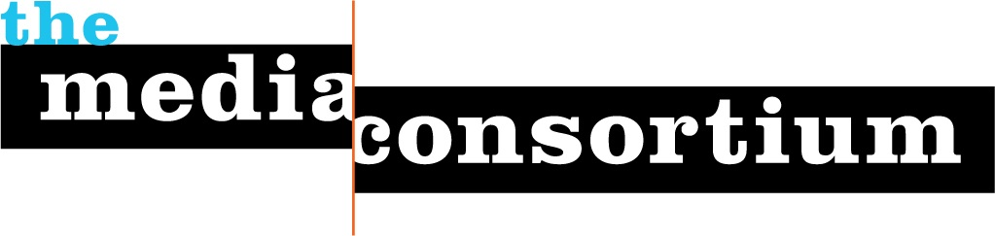
The Media Consortium
Discussion on Current and Future Structure

Current Structure
- Initially set up as democratic structure with knowledge that structure may or may not work. Idea was to be a member driven-network with much work done by volunteers from member organizations.
- CC committee set up as representative board. CC members represent similar organizations in the mc network (size, platform, focus)
- Relatively flat, little hierarchy, power concentrated in elected CC

Current Roles:
Coordinating Committee
- Budget approval
- Strategy approval
- Project concept approval
- Project build out approval
- Supporting the concept and work of network publicly and among MC members

TMC Staff
- Technically contractors
- Run day-to-day and long-term planning/organizing, project implementation, relationship building, and fundraising
- Coordinate/Organize CC members in the decision-making and shaping of MC and its projects.
- Recruit MC members to be advisers in project development and implementation.
- Represent TMC and progressive media sector publicly to increase public knowledge and impact of sector

A Developing Future Structural Framework
Suggested ideas to work off of:
The TMC will be organized around supporting strategies, projects and actions that will a) benefit the sector as a whole through external relations, research, networking and more or b) drive projects that directly benefit, educate and connect members. The CC still needs to prioritize where TMC staff spends that time in balancing these two issues.

TMC strategic focus and subsequent related projects are largely driven by the needs/areas of interest of its members. Communication and ongoing conversations between members and TMC staff/leadership is critical to shaping and implementing strategy and subsequent projects. TMC leadership must use its knowledge of the changing media and political landscape to integrate and inform conversations and feedback with members and outside allies.

TMC leadership should regularly assess these needs/shared interests and communicate them back to the membership at large. In organizing and synthesizing these conversations, it will help TMC leadership deepen strategic priorities and projects as well as focus on short and long-term opportunities to support both the membership and the entire sector.

In the past, there have been little to no enforceable requirements for members to participate and low barriers for project entry. To make certain projects successful and that TMC is creating higher-level opportunities/benefits for members; there will be a higher level of member accountability. "BIG" projects will require clear participation requirements including: staff time and energy, applications, and potentially a little money investment. If these are not met, members will no longer be able to benefit/participate in that particular project.

Internal Structure opportunities and questions
In order to further deepen the effectiveness of The Media Consortium, we should discuss how and if we:
- Get rid of failed notion that this will be largely volunteer driven
- Develop more efficient decision-making by staff
- Reorient membership roles, benefits and responsibilities

Internal Question's
- What should become role and responsibilities of CC?
- What should become role and responsibilities of staff?
- How should membership shift or evolve? Who decides?
- How does this impact our mission statement?

