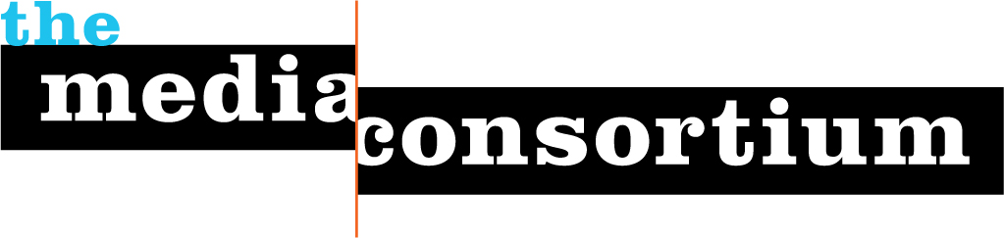

Current Media Consortium Members

Afro-Netizen
Air America Radio
AlterNet
American News Project
The American Prospect
Balcony Films
Brave New Films
Berrett-Koehler Publishers
Center for Independent Media
Chelsea Green Publishers
ColorLines
Democracy Now
Free Speech TV
GlobalVision/Media Channel
GoLeftTV
Grist.org
Hightower Lowdown
In These Times
LinkTV
Media Venture Collective
Mother Jones
Ms. Magazine
The Nation
Nation Institute
National Alliance for Media
Arts and Culture (NAMAC)
National Radio Project
New America Media
New Press
New Voices in Independent Journalism
The Progressive
Public News Service
Raw Story
RealTV/IWT
Regional News Network
Salon Media Group, Inc.
Sojourners
South End Press
Talking Points Memo
Texas Observer
Truthdig
Warandpiece
The Washington Monthly
Women's Media Center
Workers Independent News
YES! Magazine
The Young Turks

