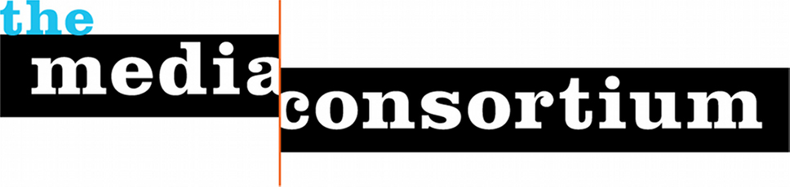

Who is the Media Consortium?

The Media Consortium is a non-profit North American network of over 80 independent news outlets, collectively reaching over 100 million people a day. Our member outlets are multiplatform—online, in print, and on the air. Prominent members include Mother Jones, The Nation, Democracy Now!, Orion, Ms. Magazine, AlterNet and Grist.

Why Sponsor the 2017 Transformative Media Conference?

For many of our outlets, the Media Consortium’s annual conference is the only trade conference they attend. We expect 150 attendees, all decision makers—either Executive Directors, CEOs, Publishers, Producers or Editors. Make sure your company gets out in front of them while supporting the independent news media.

This year, our conference will be held open-space style, with the goal of responding to the Trump era by transforming our media system.
We believe there is an opportunity with the failure of corporate media to create a new media system that is mission-based and values-driven. Among the values this new media system will share will be the journalistic values of accuracy and accountability, and the social values of inclusivity and equity. It will be a news media that puts communities (rather than journalists or politicians, etc,) at its center.
The specific objectives of this conference are:
1) Develop concrete ways to further editorial collaboration between news media working with and within different communities;

2) Develop concrete ways to for news outlets to collaborate on new means for distribution, marketing, and promoting content;

3) Renew Media Consortium members’ commitment to racial, geographic and class equity within our organizations.

Sponsorship Opportunities
Lunch: $7500 (2)
Host lunch on Thursday March 2 or Friday March 3, 2017
- Opportunity to make a brief announcement before 125 attendees
- Opportunity to distribute branded materials on tables
- Opportunity to host a table in our exhibit area
- 2 full conference registrations
- Onsite signage
- Logo and link prominently placed on conference website

Badges and Registration Desk: $3,000
Dedicated branding and handouts (provided by Sponsor) at registration area.
- Sponsor Logo on all attendee badges
- Opportunity to host a table in our exhibit area
- 2 full conference registrations
- Onsite signage
- Logo and link prominently placed on conference website

Snack and Coffee Break: $2,500 (2)
Host a refreshment break in the afternoon. Sponsor logo displayed on refreshment table.
- Opportunity to host a table in our exhibit area
- 2 full conference registrations
- Onsite signage
- Logo and link prominently placed on conference website

AM Coffee Break : $750 (2)
Host a coffee break in the morning. Sponsor logo displayed on refreshment table.
- Opportunity to host a table in our exhibit area
- 2 full conference registrations
- Onsite signage
- Logo and link prominently placed on conference website

Ask us also about sponsoring our opening reception Wednesday evening, March 1.

Contact:

Jo Ellen Green Kaiser
Executive Director, The Media Consortium
joellen@themediaconsortium.org
415.878.3862 | @tmcmedia
Main site: https://themediaconsortium.org
Conference: http://tmcmedia.org

