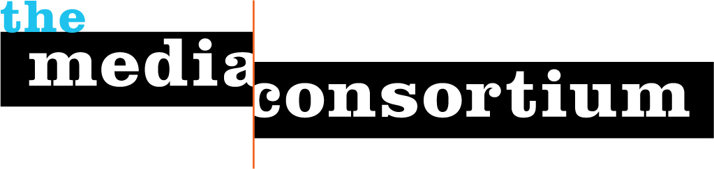

For Immediate Release: May 27 2014
Contact: Jo Ellen Green Kaiser, Executive Director
joellen@themediaconsortium.com/ 415-878-3862

Press Background Briefing on June 17, 3pm ET:
Communities Broadband Networks:
Has the Time Come?

The digital content Americans currently receive takes a long and winding path before reaching their devices. Packets of information are transferred via deep infrastructure providers, then travel via copper or fiber optic wires or wireless waves to our devices. Each packet is pushed along this infrastructure by an internet service provider (ISP).

In most of America, the ISPs own the wires that carry these packets from the internet to your device, as well as the right of way to carry the content. But should this infrascture be owned by a few companies? Or should it be a community-created utility like highways, sewers, and water pipes? That’s what we will discuss today.

Registration for this briefing is now open at
We expect lively discussion from the experts on this call:
Christopher Mitchell is the Director of the Community Broadband Networks Initiative at the Institute for Local Self-Reliance. Christopher’s work focuses on telecommunications — helping communities ensure the networks upon which they depend are accountable to the community. He is a leading national expert on community broadband networks and speaks at conferences across the United States on the subject, occasionally to directly debate opponents of public ownership.

Wayne Pyle is the City Manager and CEO of West Valley City, Utah’s second largest municipality. He will be speaking to us about Utopia, a community-build fiber optic infrastructure that provides open access to all internet service providers. Instead of the ISPs owning the infrastructure, they lease it from the community.

As associate director of technology studies at the Competitive Enterprise Institute, Ryan Radia focuses on adapting law and public policy to the unique challenges of the information age. His research areas include information privacy, intellectual property, electronic speech, competition policy, telecommunications, media regulation, and Internet freedom.

The Media Consortium is a national network of leading, progressive independent media. Our members include magazines, web sites, television networks, radio, and film producers. www.themediaconsortium.org Our thanks to the Media Democracy Fund for making this policy briefing and MPREP program possible.

