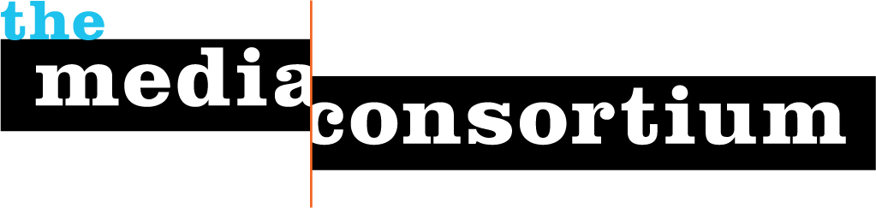

For Immediate Release: April 20, 2012
Contact: Jo Ellen Green Kaiser, Executive Director
joellen@themediaconsortium.com/ 415-878-3862

Press Background Briefing on April 24, 5 pm ET:
SOPA Redux: The Problem with CISPA
With Rainey Reitman (EFF) and Josh Levy (Free Press)
There's a new piece of legislation moving through Congress that experts are calling just as dangerous to online freedom as SOPA and PIPA - the Cyber Intelligence Sharing and Protection Act (HR 3523) or CISPA. Civil liberties experts worry that the language in CISPA, like SOPA, is so broad that it may spur unintended and undemocratic side effects. Concerns are that CISPA will allow widespread Internet monitoring and more extensive surveillance of personal communications and lacks information-sharing restrictions. Groups like EFF and Free Press argue that alternatives exist.
As part of its Media Policy Reporting and Education Project, The Media Consortium, a national network of over 60 leading independent media outlets, has assembled an in-depth press briefing on CISPA. This briefing will help reporters understand the specifics of CISPA, including where it differs from SOPA. Reporters will also get an update on where the bill is in Congress, who is supporting and opposing the bill, and what actions are being taken. All journalists are invited to attend.
Registration for this briefing is now open at http://www.anymeeting.com/PIID=ED57DB80824F
The briefing will begin with expert Rainey Reitman, Activism Director at the Electronic Frontier Foundation, who will provide background, explain how CISPA differes from SOPA, and where Congress is in the legisltative process. After she speaks, we will hear comments from Josh Levy, Internet Campaign Director at Free Press, who will talk about the campaign against CISPA. Journalists will have ample opportunity to ask questions. The briefing will last one hour.
Rainey Reitman leads the activism team at the Electronic Frontier Foundation, a nonprofit civil liberties law firm and advocacy organization focused on free speech, privacy and innovation in the digital world. Prior to joining EFF, she served as Director of Communications for the Privacy Rights Clearinghouse, a nonprofit advocacy and education organization promoting consumer privacy.
Josh Levy develops and implements Internet-based campaigns, programs and projects to encourage online activism, advocacy and fundraising at Free Press. Before joining Free Press, Josh was managing editor of Change.org, a social action network where he supervised the launch of more than a dozen issue-based blogs.

The Media Consortium is a national network of leading, progressive independent media. Our members include magazines, web sites, television networks, radio, and film producers. www.themediaconsortium.org Our thanks to the Media Democracy Fund for making this policy briefing and MPREP program possible.

