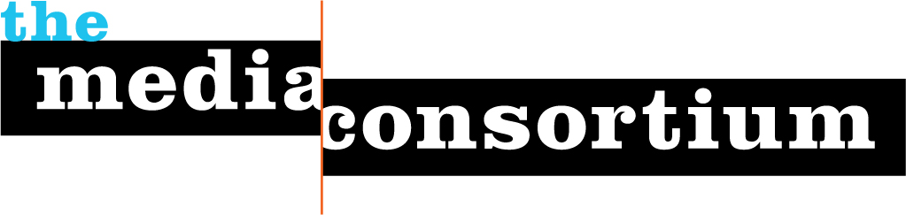

October 23, 2012

Dear Ben,

This is the time of year when we ask Media Consortium members to renew their membership in the Consortium. I’m afraid the Membership Committee has decided to ask Change.org not to renew your membership.

The recent news about the change in Change.org’s policies is not the source of the Committee’s decision. When Change.org stopped publishing original content in 2011, your organization technically became disqualified from membership. All Media Consortium members must publish original journalistic content. It was an oversight on our part that we did not write to you then to let you know that your membership would not be renewed.

I hope you understand this decision. Please let me know if you have any questions.

Sincerely,

Jo Ellen Green Kaiser
Executive Director, The Media Consortium
415.878.3862
joellen@themediaconsortium.com
www.themediaconsortium.org

