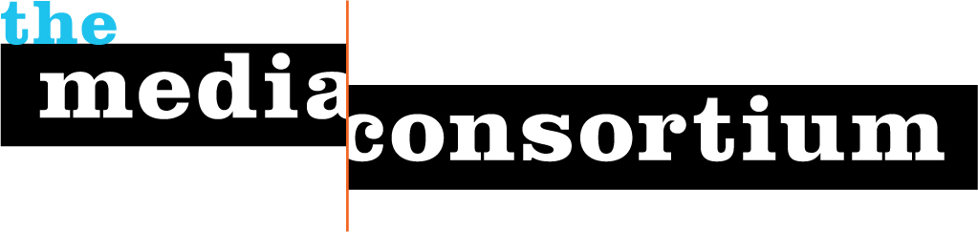

TO: Media Consortium Coordinating Committee
FR: Steve Katz and Tracy Van Slyke
DT: 1 May 2007
RE: Update on The Media Consortium activities

Here is a quick summary of what’s been going on with the Consortium since our last conference call.

- Progressive media list development and joint marketing project
Teresa introduced Steve Dunn and Jonathan Pogact from Mal Dunn & Associates to Steve for follow up and next steps. Dunn and Pogact will be attending the 5/19 general meeting to talk about the next round of list development and marketing. They have submitted a simple contract – still in review – to cover their management of the list and their role as brokers to interested parties.
I DON’T KNOW THE NEXT STEPS ON THIS, BUT WHAT ARE THE MAIN OBJECTIVES ON THE THIRD PHASE? LONG TERM GOALS/CONSIDERATIONS CONTINUE TO BE XXX AND XXX.

- Washington DC pooled reporting project:
Tracy and I interviewed six candidates for the reporting position, and have scheduled a second round with two finalists, Brian Beutler (former Washington Correspondent for The Raw Story) and Marcy Wheeler (blogger for The Next Hurrah and Firedoglake) for this coming Monday. Starting in early to mid-June, the reporter will begin by work by focusing on Waxman’s House Oversight Committee, and Conyers’ House Judiciary Committee. It is also likely that we will recruit a field producer to provide audio and video content along with written reporting. We expect the reporter to join us in NYC on 5/19 to meet with the working group. Several organizational and budget issues remain to be worked through – we’ll be talking about this on the conference call.

- Washington DC progressive linkages
Tracy and I met with the communications director from Rep. Conyers’ Judiciary committee, along with the staff director of the Congressional Progressive Caucus and the communications directors for CPC co-chairs Reps. Woolsey and Lee to work out arrangements for better coordination with and through the Consortium. The overall objective for the meetings were to develop regular “pipelines of communication and coordination.”
Ideas that came out of the meetings include: an in-person “getting to know you and why the progressive media” meeting b/w Democratic communicators directors and MC members; regular (and informative) conf. calls b/w MC members and committee staffers; and the development of a media contact list for congressional communication directors and a congressional staffer list for MC members. Other collaboration ideas are in the works.

- Consortium polling project
Tracy and I also met with Celinda Lake, principal at the polling firm of Lake Research Partners, to discuss commissioning her firm to do a signature poll for The Media Consortium later this year. They are very interested. It looks like their pricing could fit our budget ($27,000 direct cost for a telephone survey, 10 minutes, 1000 contacts). I’ve contacted Peter Leyden at NPI to see about the possibility of a jointly sponsored survey on Millenials and/or Latino voters.
National polling sets up some exciting opportunities for The MC, including: publicly branding The MC, informing and planning MC members editorial content, driving the larger news cycle, and becoming players in the ’08 election cycle. Considerations of poll topics and strategic next steps for roll out and publicity will be discussed at the May MC meeting.

- Survey of Consortium members
We are conducting an online survey of Media Consortium members to acquire self-reported data on organizational estimates of audience size, use of digital technology, advertising practices, and media relations practices. So far, 12 of the Consortium’s 36 organizations have completed the survey. We’ll be sending out a reminder email soon.
The results from this survey will help inform projects as ad barter that were in the works but frozen as we waited to compile this information.

- Campaign to halt US Postal Service rate increases affecting small, independent magazines
We are collaborating with Free Press and independent conservative magazine publishers to challenge recent changes in postal rates approved by the US Postal Service Board of Governors, the burden of which disproportionately falls upon small, independent magazines. So far, some 60,000 comments and emails have been generated by the campaign, calling for a delay in implementation of the new rates pending congressional hearings. Tracy, Teresa, Jay and I will be talking with the Free Press staff right after our committee call, to discuss strategy and next steps. It seems likely that this campaign will run well into 2008. The MC must decide both the staff and financial allocation that will be dedicated to this project as it ebbs and flows throughout the next year.

- www.TheMediaConsortium.org

We launched www.TheMediaConsortium.org. Deanna is cleaning up some of the content on the crosslink website in time for the 5/19 meeting.

WHERE ARE WE ON ROLLING OUT THE CROSS-LINK PROJECT?

- Expanded staffing

I’m devoting substantial time to Consortium matters. Tracy Van Slyke is working 50% time on Media Consortium projects and carrying primary responsibility for our DC-oriented projects. Deanna Zandt continues on contract for technology-related matters. DO WE WANT TO FLOAT THE IDEA THAT MY HOURS MAY GO UP A SMALL BIT? OR HOLD ON THAT?

- Meetings and relationship building

I’ve sent you the draft agenda for the 5/19/07 general meeting in NYC. We’ve got about 50 people confirmed, from 30 or so organizations. This meeting will be much more of a working meeting than our LA session, with much more time spent in small groups.

We’ve also been asked to host a social networking event as a “kick-off” to the Take Back America conference in Washington DC June 18-20; we’ll be talking about this on the call. Budget questions and ideas for location venues will be discussed.

COMPUTMENTOR POSSIBLE COLLABORATION? DO YOU WANT TO BRING THAT UP?

