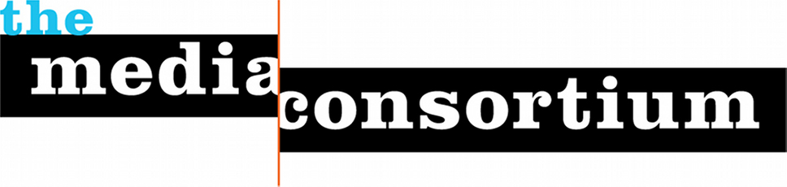

Contact: Jo Ellen Green Kaiser Erin Polgreen
Executive Director, The Media Consortium Managing Director, The Media Consortium
joellen@themediaconsortium.com erin@themediaconsortium.com
www.themediaconsortium.org Twitter: tmcmedia

Who We Are
The Media Consortium is a national network of independent media outlets. We support smart, powerful, passionate journalism that redefines American political and cultural debate.

Our Mission
Our mission is to amplify independent media’s voice, increase our collective clout, leverage our current audience and reach new ones. We believe it is possible and necessary to seize the current moment and change the debate in this country.

Our Strategic Principles
- Foster Collaboration and Coordination
- Build and Diversify Media Leadership
- Focus on Audience Development
- Bring Money and Attention into the Sector
- Support Innovation in Journalism and Business Models

Our Members
A participating member of The Media Consortium must have:
- A journalism-driven mission
- Staff and organizational capacity to participate in projects that benefit the organization and the Consortium
- The commitment of senior leadership to personally participate in Media Consortium activities, projects, and meetings
- A mission that promotes progressive ideals
Current Members

AlterNet
American Forum
American Independent News Network
Berrett-Koehler
Brave New Films
Campus Progress
Care2
Change.org
Chelsea Green
Chicago Reporter
City Limits
Colorlines.com
David Pakman Show
Democracy Now!
Earth Island Journal
Feministing
Feet in 2 Worlds
Free Speech Radio News
Free Speech TV
Globalvision
Grist
GWW Center
Inter Press Service
In These Times
Laura Flanders Show
LinkTV
Mother Jones
Ms. Magazine
NAMAC
The Nation
The Nation Institute
National Radio Project
New America Media
The New Press
Oakland Local
Orion
The Progressive
Public News Service
Race, Poverty, and the Environment
Real News Network
RH Reality Check
The Texas Observer
Truthdig
Truthout
The Uptake
Utne Reader
Washington Monthly
The Women’s Media Center
Workers Independent News
YES! Magazine
The Young Turks

