

Restaurants
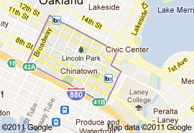

Oakland’s Chinatown
Stretches from 12th to 7th, and from Broadway to Harrison.
(map at right) Explore the restaurant options yourself—
They are cheap and don’t require reservations.

Here are a few places we recommend:

Golden Lotus Vegetarian Vietnamese Restaurant
1301 Franklin Street @ 13th, goldenlotusvege.com

Battmabang Cambodian
850 Broadway @ 9th

Shan Dong Restaurant (home made noodles and dumplings!)
328 10th St @ Webster

Silver Dragon (Banquet Hall Chinese)
835 Webster St. @ 9th, silverdragonrestaurant.com

Not into Chinese/SE Asian? Then Go to Jack London Square!
Note that this is a tourist area, so we are only recommending places the locals like.

Yoshi’s Jazz Club and Japanese Restaurant (pricey but worth it!)
444 Embarcadero West @ 1st yoshis.com

Everett & Jones Barbeque (the real deal)
126 Broadway @ 2nd eandjbbq.com

Souley Vegan (vegan food non-vegans will eat)
301 Broadway @ 3rd, souleyvegan.com

In the Other Direction, a Taste of High-End CA Cuisine
Flora Restaurant (white tablecloth, $10 cocktails, lotsa atmosphere)
1900 Telegraph Ave, floraoakland.com

