DRAFT – PLEASE DO NOT DISTRIBUTE – final version will be available at www.themediaconsortium.org/future

The Future of Independent Media

Game Changer Box Set

Vol. 1 | What if?
Vol. 2 | Dissonance & Opportunity
Vol. 3 | The Future?

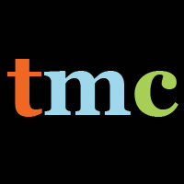

The Media Consortium

By Tony Deifell, Q Media Labs

How to use this report
The results of the Game Changer Strategy Project are presented as a “box set” with three volumes that can be used separately.
- Vol. 1: What if?
This volume focuses on our research’s implications, plus project ideas for The Media Consortium (TMC), collected from people from both inside and outside the consortium. The volume can be viewed as a compendium of potential solutions, a dynamic roadmap for going forward or a tool for strategic conversations as TMC builds a shared vision for the future.
- Vol. 2: Dissonance & Opportunity
This volume focuses on in-depth analysis that compares journalism’s old paradigm to its emerging realities. Vol. 2’s analysis is intended to benefit individual TMC members and other media organizations as they adapt to the changes around them.
- Vol. 3: Future Uncertainties & Possibilities
This volume surfaces some key uncertainties and future possibilities that are important to consider and may change the game further in coming years.
While much of the analysis focuses on journalism, the implications span all types of content and forms of media.
You could use this report in the following ways:
- Tool for internal planning and strategy
The New Competencies chapter in Vol. 2 and its summary of shifting roles on page 30 can be used to assess your organizational structure and the human resources needed to succeed in the new competitive landscape. The New Sources of Value chapter can help you prioritize the products and services you provide and the New Business Models chapter to structure your organization financially.
- Conversation starter among staff, board or other key stakeholders
Appendix B includes a worksheet for facilitating group discussions. The worksheet includes four provocative statements, based on our research, to spark debate—feel free to add others. Use this process to identify the implications of the new industry dynamic on your organization’s future strategies.
- Tool for innovation
Use Vol. 3, Future Possibilities to help identify new business models, product strategies and operating tactics. This volume only begins to identify potential game changers, but it can be used as a starting point for you to find others.
- Knowledge development
Share selections of this report with staff members who want to learn more about the changing media industry. You could also conduct further research on areas of particular interest to your organization.
- Partnership development
Use the Competitive Landscape chapter in Vol. 2 to explore the types of partnerships you could build to succeed.
- Funder conversations
Share this report with funders that are interested in learning about new media’s emerging and may want to explore your organization’s role in the new media environment.
- Online discussion
Share portions of the report with your users to engage them with the industry’s shifting dynamics and solicit comments and discussion to further your strategic thinking.

This report is also available online at www.themediaconsortium.org/future

Table of Contents
The Future of Independent Journalism
Game Changer Box Set

Executive Summary i
Introduction: Strategic Dissonance v
Box Set Vol. 1
What if?
New Strategic Intent & Actions Ideas 1-17
Box Set Vol. 2
Dissonance & Opportunity
Old Paradigm of Journalism 1
New & Emerging Realities 6
CHAPTER 1
NEW COMPETITIVE LANDSCAPE:
How is the playing field changing? 8
New abundances & their effects 10
New scarcities & their effects 11
Device proliferation, convergence & their effects 13
Dawn of a demographic revolution 14
Next phase of globalization & its effects 15
Declining institutional control & affiliations 17
Myth of The Long Tail 19
CHAPTER 2
NEW COMPETENCIES:
What new capabilities are needed to succeed? 23
Getting serious about community 24
Strategic technology 26
Being multiplatform 26
Tightly integrating functions 27
Experimentation 27
Counter-intuitive ways of working 28
Shifting roles 30
CHAPTER 3
NEW SOURCES OF VALUE:
What needs can be met, problems solved or desires met? 32
Progressive ideas 34
“My ideas” 34
Metadata 35
Now is the time for immediacy 35
Solving filter failure 36
From using users to a Conversation Economy 37
From audiences to communities 38
CHAPTER 4
NEW BUSINESS MODELS:
How are media organizations structured to capture value? 41
Emerging operation models & cost structures 42
Emerging revenue models 43
Diversification & tension 49
Emerging value chain of journalism 50
Will there be a new demand for quality journalism?
Will more reliable & consistent measures create greater distribution of value?
Box Set Vol. 3
The Future? Key Uncertainties & Possibilities
What don’t we know? 1
How will consumers act? 1
What trends will last?
What will happen to serious news?
Will online media broaden or narrow perspectives?
Will online media help or hurt democracy?
What will happen with paper? 5
How will the big players affect the game? 6
What will commercial media & technology companies do?
What role will government play?
Will philanthropy adjust its role?
Will we decide that the American Way includes investing in journalism?
Future Possibilities 11
Ubiquitous prosthetic media devices
Multisensory convergence
Rise in alternatives economies
Human-centered design
Radical new ways of solving filter failure & making meaning
Location based mobile
Social reading
Real identity & converting reputation
Conclusion 20
Appendices
A. List of participants & process
B. TMC members’ discussion summary
C. The Media Consortium's history & membership
D. Guidelines for generating game changing ideas
E. Innovations & innovators to watch
F. Most popular versus most influential content
G. Notes & sources

Executive Summary

“No society in history has ever existed without storytelling. The job of storytelling is to tell stories that are true and important. Sure, there may be many distinctions between professionals and amateurs, between breaking news and follow up pieces, between long or short, and so forth. But these are just artifacts of production methods rather than deep truths. And we have to have truth tellers.”
– Clay Shirky

Journalists and independent media makers will continue to be some of society’s most important truth tellers. However, the organizations that have supported them over the past century are reconciling their historical role with the online media landscape. This report focuses on how to navigate this profound transition.
In 2008-09 The Media Consortium (TMC), a network of 45 of the country’s leading independent media organizations, conducted a Game Changer Strategy Project. Its goal was to enable TMC and its members to make bold moves that increase their impact and influence—and reach five times its current collective audience within the next five years. A proxy for TMC’s collective online reach as of June 2009 was 17 million website visits.
The major implications for TMC and the independent media sector are framed as “What ifs?” that fall in four areas of potential systemic change. They are summarized below and outlined in volume one of the Game Changer Box Set.
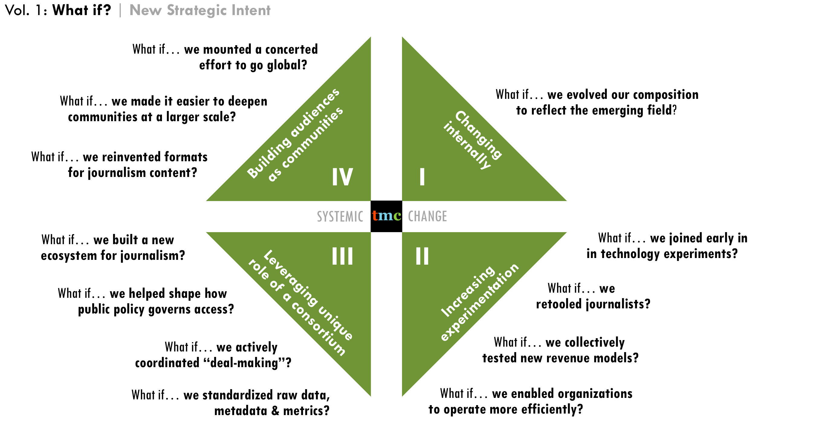

The Media Consortium
Mission Statement:
To amplify our voices; increase our collective clout; leverage our current audiences and reach out to new ones; attract financial resources; strengthen and transform our individual businesses and our sector’s position in a rapidly changing media and political environment; and redefine ourselves and progressivism for a new century.

A broad array of information was collected via scenario building, member surveys, interviews with outside thought-leaders and a scan of current reporting and commentary. The most important new realities of the changing media landscape are outlined in volume two of this box set. We analyzed these new realities across two overlapping axes (pictured below) and used them to indentify the greatest opportunities for strategic change.
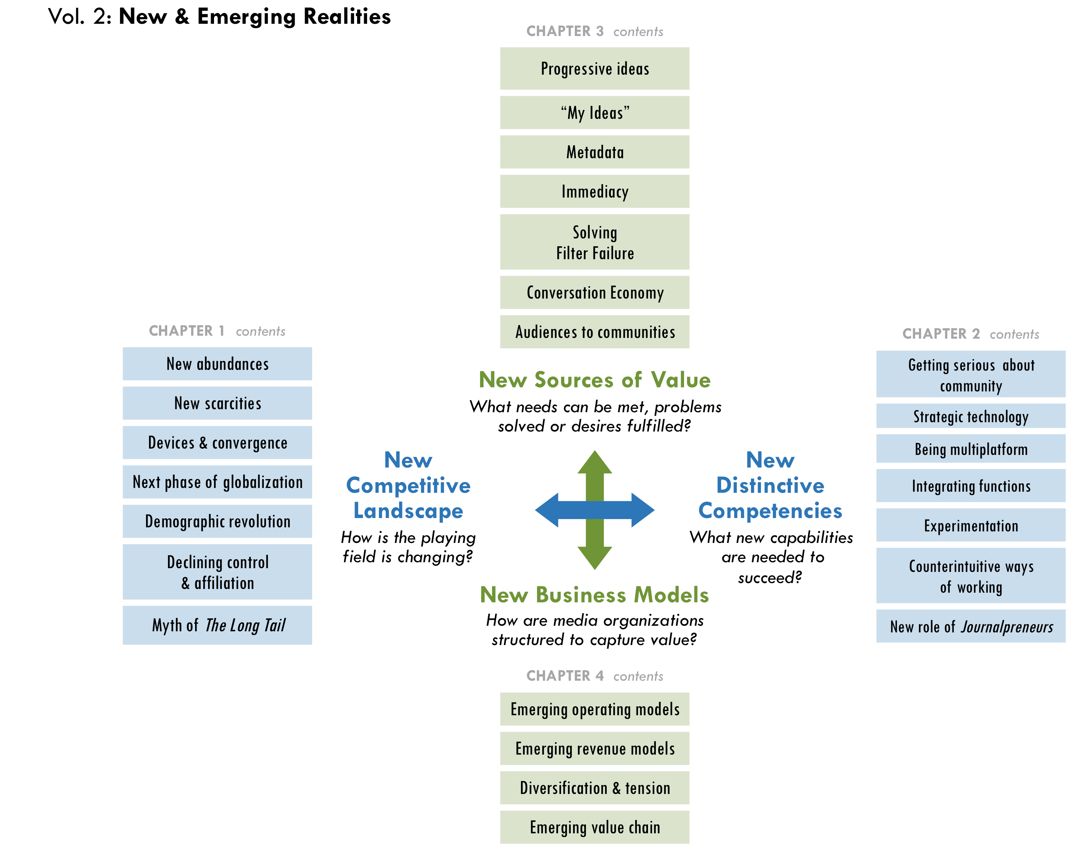
- Appendix A
List of Participants

Traditional business models, which were based on old sources of value between publishers and readers, have been in flux for the past ten years. They have recently come into sharp focus as the world economic crisis accelerated the collapse of newspapers and other media outlets. However, new sources of value are leading to new business models.
The new competitive landscape in media (commercial and non-commercial) requires new distinctive competencies for organizations to survive, let alone thrive. Collective action by a consortium of organizations has great potential to amplify the power of independent media, yet any bold steps will depend on developing a shared perspective on the shifting landscape and its implications for the future.
Volume three of this box set highlights current uncertainties, including how consumers will act, what trends will last, whether online media is helping or hurting our democracy and how the biggest players will affect the game.
Those interviewed also highlighted possible game changers to come, which are pictured below in the report’s analytical framework. Most of these trends are underway. While they have yet to reach game changing scale, many of them will.
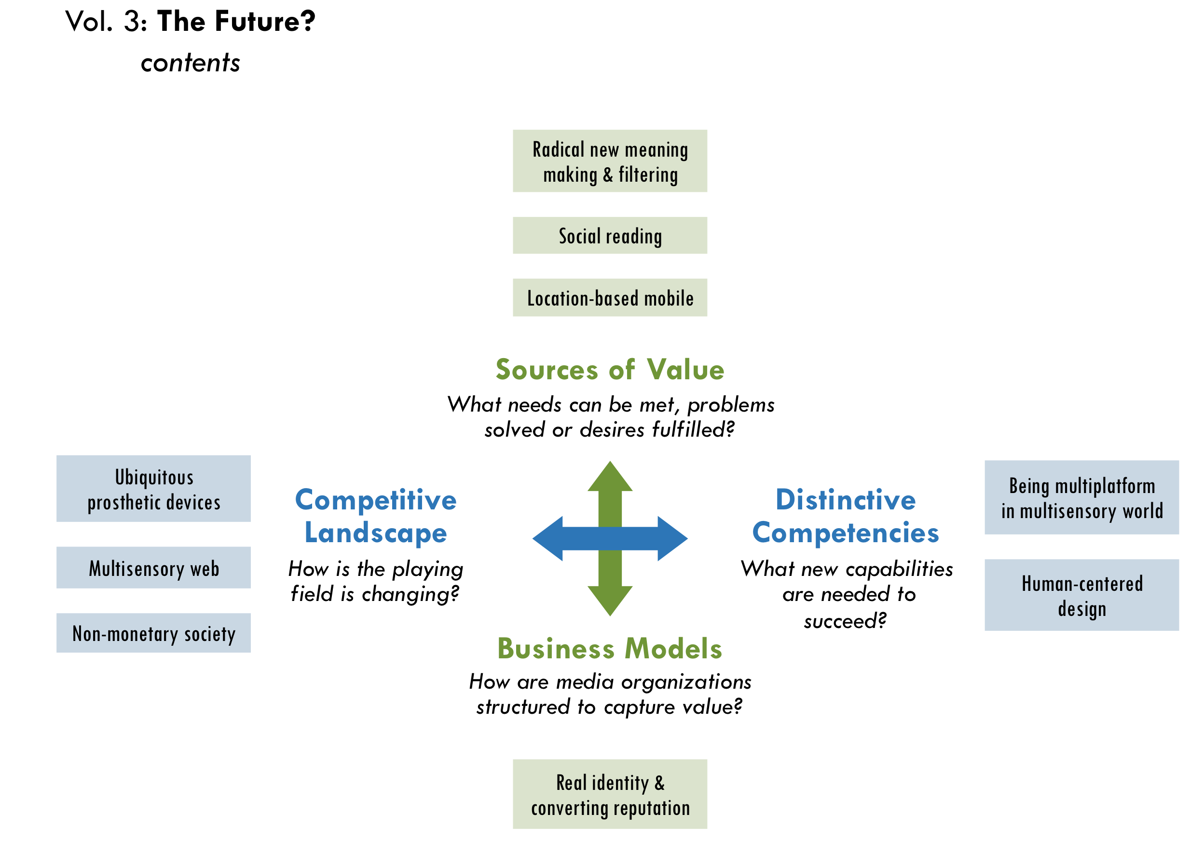

The one thing we know for sure is that change will continue. The bad news is that TMC cannot do everything. The good news is that some things are more worth doing than others. The success of TMC’s strategy depends on making hard choices that have the greatest potential to move the independent media field forward.
Recommendations
TMC and its members can take advantage of emerging and future industry conditions by making four decisive moves:
- Change internally
New models will most likely come from new players. The first and deepest change TMC could make is to redesign its membership to more actively include the emerging field of technologists, entrepreneurs and independent media makers, thus amplifying the power of its current members.
- Increase experimentation
Greater experimentation will win. TMC can increase the capacity of its members to innovate with new technology, journalistic practices and business models. Beginning with a broader membership, TMC can systematically increase experimentation in the independent media field.
- Leverage unique role of a consortium
Standing together will be more valuable than working alone. Since independent media will continue to grow more diverse and fragmented, TMC must actively leverage the collective power of its membership to negotiate deals, influence public policy and build journalism’ new ecosystem to benefit all members.
- Building audiences as communities
Decentralized communities will create the greatest impact. Media consumers have more power than ever before, and they will be attracted to the most user-focused media ventures. Media organizations will grow their audiences by simultaneously building broader reach and deeper communities. People today are less tied to formal institutions, and they increasingly affiliate with decentralized networks of individuals and groups. To this end, TMC members can not only better reach global audiences by working together, but also engage those audiences in more efficient and valuable ways, which tap their full potential as producers, community builders and agents of social change.

Introduction: Strategic Dissonance
TMC began this strategy project by looking for what “game changers” it could create (working definition at right). During the research process, we realized that the most effective aim was not to introduce new game changers, but to identify strategic responses to a game that has already changed considerably.
“Game Changers are developments (projects, initiatives, strategies, new models, innovations) that can ‘change the game’ for independent media by increasing their impact
and influence in the next five years.
These are not incremental strategies, but rather big bold moves that The Media Consortium could develop to take advantage of a rapidly changing media landscape.”
– TMC’s working definition, Appendix D
“How much more of the game needs to change, really?” asked David Weinberger, a journalist, author of Everything is Miscellaneous and fellow at Harvard Law School’s Berkman Center for the Internet and Society. “There’s a lot of handwringing about the future of media,” Katrin Verclas, co-founder of MobileActive, told us, “but look around, it’s kind of happening.”
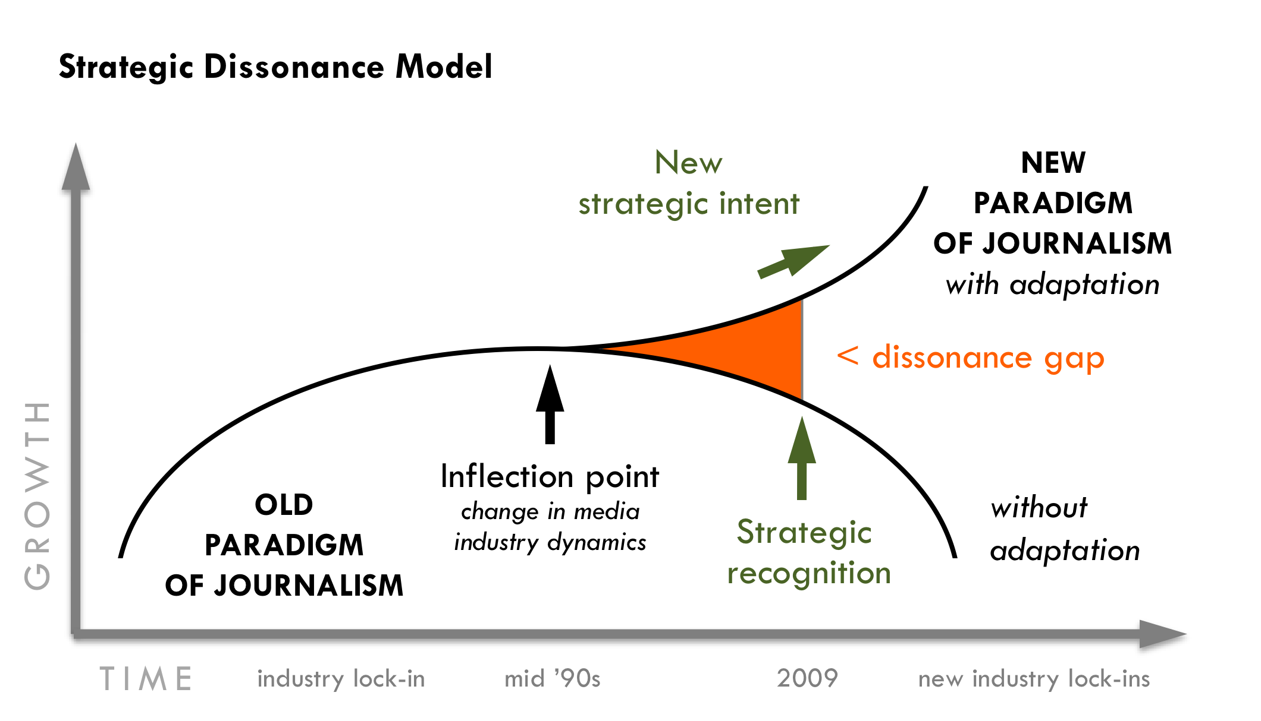
To make sense of these new realities, we have modified a model from Andy Grove’s work as the former CEO of Intel. Terms are defined in the right margin.

Explaining the model:
Inflection point: The starting point when one type of industry dynamic or existing paradigm gives way to a new one.
Strategic recognition: Identifying the importance of emerging practices and approaches after they arise but before unequivocal environmental feedback is available to make their significance obvious.
Dissonance gap: The gap between the inflection point and strategic recognition when diverging ideas, practices and approaches cause conflicting opinions.
New strategic intent:
Leaders’ ability to make sense of conflicting information generated by dissonance to create a new strategic direction that fully takes advantage of new industry conditions.
Source: Andy Grove

A ten-year gap before incumbent players recognize the strategic importance of an inflection point is not unusual. Other industries have taken similar time to adapt. Grove calls this gap “strategic dissonance,” where changing dynamics cause tension with many conflicting opinions about how best to react. Yet, this very tension helps create a new strategic intent. In this time of strategic dissonance, independent media have an opportunity to establish a new operational approach to the new paradigm rather than be ruled by a tyranny of how they believe things still “should be.”
Two causes of dissonance
In order to turn dissonance into action, we must identify its causes. This can be done by analyzing the changing dynamics across the two overlapping axes of what we call the “Adaptive Strategy Matrix” on the following page.
Vol. 2 of the Game Changer Box Set analyzes these areas in depth.
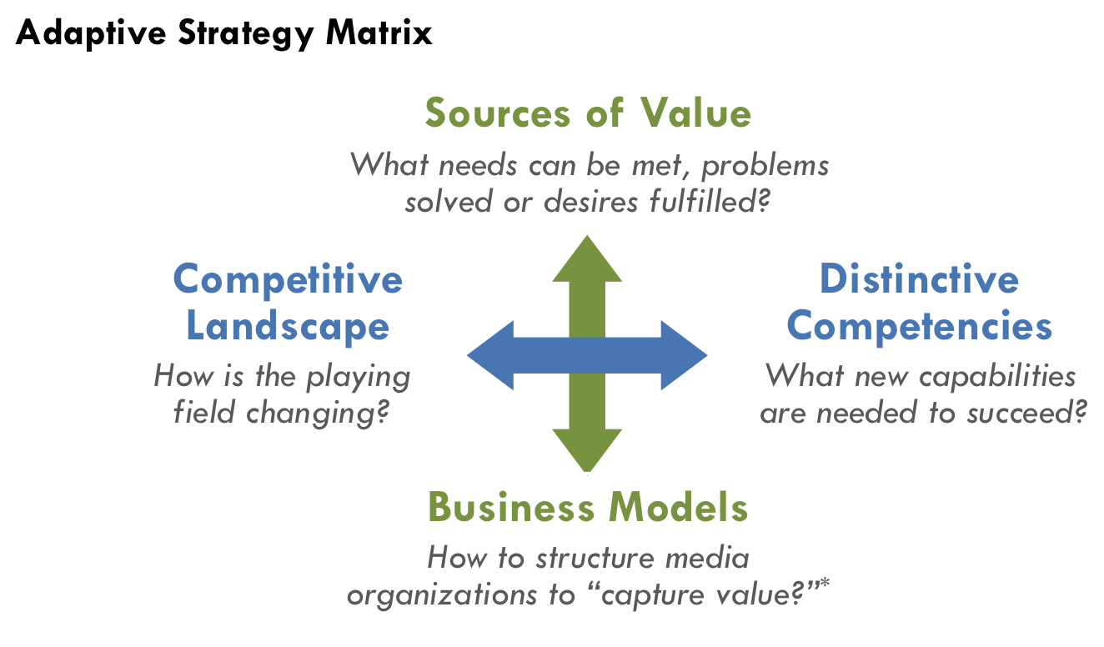

The first cause of dissonance is the divergence between the industry’s new competitive landscape and an organization’s distinctive competencies to succeed in it. For example, as the amount of information and number of voices have become more abundant online, a news organization’s ability to “cover” the news with a deep bench of staff or freelance reporters has become less of a competitive advantage. News outlets have gained ground by aggregating stories from many sources (including users) for targeted audiences. This divergence between the new competitive landscape and old competencies has occurred in many areas described further in Vol. 2. The good news, however, is that where there is dissonance, there are also new strategies to discover.
“The 18th century was messy with newspaper wars, so it will shake out again.”
– John Bracken, MacArthur Foundation

* “Capturing value” is
the ability to convert the value of products and services into resources (commercial or philanthropic) while retaining enough to cover costs and grow.
Competitive forces and organizational competencies often evolve on independent paths and can be a major challenge for leaders to keep aligned. As a result, Grove describes this divergence as not easily visible, yet most fundamental. While the inertia of existing business models can cause competencies to lag, new competencies can also emerge in the margins of the organization and make surprising new opportunities possible.
“We’re in a transition and there is so much opportunity in transition but there is also so much loss and so much fear.”
– John Battelle, Federated Media & author of
The Search

The second cause of dissonance is the divergence between what customers value the most and old business models. Existing structures often reflect current leaders’ beliefs about historical success in their organizations or field. Grove points out that career tracks, emotional attachment and corporate identity deeply influence current leaders’ perceptions, as well as hesitation to change strategies when the consequence are not completely clear. This is why inertia is a major driver of dissonance and inaction.
The people interviewed in this report believe the media industry has crossed a critical threshold and is moving out of the current stage of dissonance. Some predict that a major industry restructuring will settle out in the next two years. The financial crisis accelerated this shift and has caused so many newspapers and magazines to close in 2008-09. “While people in media were starting to realize this,” NYU adjunct professor Clay Shirky noted, “they were suddenly robbed of the four to five years they thought they had to respond.” Andrew Golis, deputy publisher of Talking Points Memo (TMC member) noted a key casualty: “I think many of the best publications haven’t been ready for the transition and so the sharpest minds have lost prominence in the debate as a result.”
“The stakes are very high for independent media. Will it change? Or, will it atrophy? Independent media can become the dominant media in society. Who would have dreamed that 30 years ago?”
– Don Tapscott, author of Wikinomics

DRAFT
Please do not distribute

What if?
New Strategic Intent & Action Ideas

Game Changer Box Set
Vol. 1

What if?
TMC’s historical underpinnings create opportunities to lead the field, as well as potential challenges to making bold game changing moves. TMC’s strategic decisions must take into account its current realities, as summarized below.
- Appendix C
TMC history & members

- Historical underpinnings: TMC began in 2005, and its founding members originated in print publishing. Three quarters of its 45 current members originated offline and approximately one quarter are “net native” (designed from the start for the Web).
- Content: Most members are “pure-play” journalism organizations with an emphasis on underserved and underrepresented communities.
“You just take the word ‘progressive’ out, and the substantive question is, ‘How do you build a successful media company?’”
– Adam Berrey, Senior Vice President, Brightcove

- Primary medium: 49% text (magazines, books and online), 19% TV/video, 12% radio (includes overlap), 12% other (training, syndication, production, networking organizations). All members have online distribution and most are increasingly becoming multi-platform publishers.
- Membership composition is biased towards non-profits (84% of membership).
- Current definitions of “independent” and “progressive” are ambiguous among TMC members. Furthermore, all outside experts interviewed for this report asked what TMC means by the two terms and questioned their continued relevance.
This report indentifies four broad areas for strategic renewal and innovation, which include 16 project ideas that serve as a compendium of potential solutions. Each idea is not necessarily a game changer alone since these are rare and often emerge in combination. Nevertheless, the “What ifs?” can serve as a dynamic map for going forward and help TMC identify the most important projects now and in the future.
“The platform shift is real. We get it. … But let’s please get to the solutions.”
– Member of CA Media Workers Guild^{A}

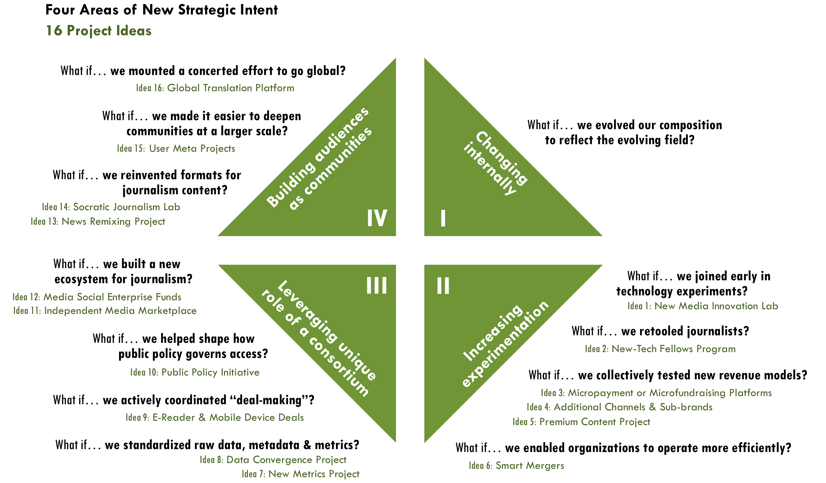

Strategic way of changing internally
TMC began this Game Changer Strategy Project to strengthen the power of independent media. Specifically, TMC wanted to grow the collective reach of its members to an audience of three to five times beyond its existing scale. A proxy for TMC’s collective online reach as of June 2009 was 17 million website visits (Appendix C). However, as we consider the shift away from the old paradigm of journalism where the ability to “cover” the news rested on centralized media outlets, the field-building strategy to improve individual media organizations’ reach may no longer sufficiently strengthen the independent media field. There may be a more powerful, decentralized strategy.
- Analysis in Vol. 2
Media as watchtower, p1
Abundance of independent voices, p10
Dawn of a demographic revolution, p14
Declining institutional control & affiliations, p17
“Journalpreneurs,” p30

What if… we evolved our composition to reflect the emerging field?
Perhaps the most radical game changer TMC could tackle is to change itself from the inside out. One of independent media’s primary purposes is to be a corrective feedback loop for excess and corruption in our economy, government and society. However, its strength must be relative to what it is trying to correct. For example, a thermostat may work fine on a cold winter day, but open all the windows and its corrective power will fail. As a result, TMC may have to reexamine whether the work of its 45 members alone is strong enough relative to the impact it was originally intended to correct. Would TMC’s larger purpose of strengthening independent media be better served by building a stronger corrective feedback loop? That is to say, could TMC and its field-leading members support a broader, more diverse ecosystem of journalists that produce content in non-traditional and entrepreneurial ways, including citizen-journalists, technologists and an emerging segment of “Journalpreneurs,” as described on p30 of Vol. 2?
“We do not know who discovered water, but we are fairly sure that it was not a fish.”
– Marshall McLuhan^{B}
Many efforts are emerging to help both amateurs and professionals take digital journalism on full force. TMC’s unique strength is the leverage of current members’ brands, strong journalistic traditions and credibility. As a result, TMC is well positioned to integrate new entrepreneurial efforts that both build the field and benefit its members via tighter affiliation with emerging players.
“Some of the recent hires by companies or deans of journalism, they are still the old guard, they don’t truly understand the technology piece.”
– Ashish Soni, USC Viterbi School of Engineering

This area of strategic intent does not include specific projects. Rather, it is an internal shift that underpins many of the following 16 project ideas and would take full advantage of new industry conditions. Such a shift would require a deliberate recruitment strategy to achieve.

Strategic ways of increasing experimentation
“No one experiment is going to replace what we are now losing with the demise of news on paper, but over time, the collection of new experiments that do work might give us the journalism we need,” wrote Shirky.
- Analysis in Vol. 3
What don’t we know?, p1
What trends will last?, p1

What if… we joined early in technology experiments?
First-mover advantage can be critical to reach the largest scale. Quickly adopting technologies and platform as they emerge would enable TMC members to build large audiences before others can do so. A potential leverage point for TMC is to help its members get ahead of the curve on testing and adopting innovations, particularly involving mobile technology. In fact, as described below, the consortium could use its collective power to be included in technology innovations early-on.
Idea 1: New Media Innovation Lab
Goal: Create a sub-group of opt-in members who agree to terms of participation, assign staff to participate in trainings and manage mini-experiments in their organizations.
- Analysis in Vol. 2
Power Law & the Myth of the “Long Tail” p19
Experimentation, p27
“Mostly companies aren’t set up for rapid innovation. By contrast, big media companies only know how to do big money projects that take six months or more to complete. So they are not set up to move fast. Companies have traditionally been set up with huge profit/revenue streams so they could get 20 people to do an experiment. So in this day and age, rapid low cost experimentation skills are lacking, to execute and to even think in that way.”
– Ashish Soni

- “This sort of TMC innovation sub-group would develop viable new distribution mechanisms and other technologies to reach wider market and bypass problems with current distribution systems,” wrote Linda Jue, Director and Executive Editor of New Voices in Independent Journalism (TMC member).
- “Classic independent media outlets are slow to adapt to changes in audience composition, preferences, styles, platforms (thinking of younger audiences and of people of color audiences that currently are not served by us),” wrote Steve Katz, Vice President of Strategy & Development for Mother Jones (TMC member).
Key TMC-led activities
- Organize small-scale experimentation in a relatively contained cluster, suggested TMC members Johanna Vondeling of Berrett-Kohler Publishers and Ann Friedman of The American Prospect.
- Support experimentation with opt-in members through an ongoing series of TMC-organized workshops. Members can compare results of experimentation, learn from experts in new technology, multi-platform content development and human-centered design, take learning journeys to technology companies and agree on subsequent collective experiments.
- Analysis in Vol. 2
Rapid, low-cost innovation, p26
Being multiplatform, p26
- Help members conduct rapid prototyping as a low-cost way to test which new business models, technology and content development work without hurting their bottom lines and at a scale they would not be able to achieve alone.
- Broker deals between the consortium and new technology ventures (see idea #9) to learn about forthcoming opportunities.
- Facilitate agreements with commonly-used tech vendors to enable greater coordination and learning.
- Analysis in Vol. 3
Multisensory convergence, p11
Human-centered design, p13
- Coordinate low-cost marketing experiments, such as using search technology to understand user behavior, interests and desires. Hire outside marketing experts to define customers’ motivations, suggested Vondeling and Friedman.
- Work with members and outside experts to choose first phase of lab-based experimentation and implementation. Initial focus could be on mobile technology and explore the following questions:
- Analysis in Vol. 2
Mobile revolution, p13

- Analysis in Vol. 3
Location based mobile, p17
  - What do mobile users most want and need?
  - What are the most effective ways journalists are using mobile devices?
  - What future developments are coming (new apps & devices), particularly related to location-based capabilities?
  - What deals are happening (especially in advertising), how do they work and who are the key deal-makers?
Key benefits to members
- Learn from information, reports, lessons learned from the smaller group of opt-in participants in the innovation lab.
- Identify new opportunities to self-organize, expand test pilots and manage entrepreneurial spin-off projects.
- Identify cutting-edge stories at the intersection of technology, online-journalism and community organizing.

What if… we retooled journalists?
“As with any trade, you have to learn the craft. And the craft now includes tools like Twitter and Google and telling your stories in ways that are native to these environments. Getting some fluency in these tools will open up amazing vistas,” suggested John Battelle, journalist and author of The Search: How Google and Its Rivals Rewrote the Rules of Business and Transformed Our Culture.
Idea 2: New-Tech Fellows Program
Goal: Create a fellowship program to train and retool journalists as technologists and technologists as journalists.
- Analysis in Vol. 2
Merging roles of journalist and technologist, p26
Being multiplatform, p26
- The fellowship program could be designed to overlap, in part, with the New Media Innovations Lab (idea #1) and provide stipends to offset the time required to participate.
- Fellowships are attractive programs to some foundations.
Key TMC-led activities
- Select annual classes of fellows who build strong professional ties.
- Organize a series of gatherings over the period of a year for fellows to hone their skills in latest technology, take learning journeys to technology companies; and design action projects to build their host organizations’ capabilities.
- Focus on using the newest technology for maximum impact.
  - Create greater interactivity, feedback and horizontal communication, suggested TMC members Frank Emspak, Executive Producer of Workers Independent News, and David Michaels, Senior Editor of Current Affairs.
  - Harness social networking/news convergence, suggested TMC member Emily Douglas, Content Editor of RH Reality Check.
  - Simplify, enhance and lower the costs of research and
content output.
- Develop selection criteria and measurable program goals.
Key benefit to members
- Bring new capabilities into member organizations, which would be the primary focus for the fellows.
- Increase the speed and agility with which independent media organizations can innovate—a potential competitive advantage over big media companies that typically move slowly.

What if… we collectively tested new revenue models?
Idea 3: Micropayment or Microfundraising Platforms
Goal: Build a micropayment and/or microfundraising platform for reader-supported journalism to span TMC members’ sites.
- Analysis in Vol. 2
Micropayment & micro-fundraising from users, p45
- Analysis in Vol. 3
Real identity & converting reputation, p18
- Readers would show their support for certain types of reporting by using an “electronic wallet” and making micro-donations. For example, just as a reader would tag an article on Digg, they could easily donate a few cents for a story they like or larger amounts for publishers to investigative a topic or sponsor a reporter.
- Micropayments have been tried before, and many new experiments are emerging as described in Vol. 2, p45. Although there is much debate on the viability of such platforms, a collective effort by a consortium has potential to coordinate the large-scale participation that could be necessary for such a project to work.
Key TMC-led activities
- Facilitate coordinated campaigns to sign up members’ users on one common platform and familiarize users with the new payment tool.
- Develop standardized revenue-share agreements.
- Explore critical questions like: Does the consortium build its own platform or form a deal with an emerging platform?
Key benefits to members
- Reduce one of the primary barriers to widespread user adoption by sharing an easier and more intuitive user-interface across multiple publishers.
- Leverage a key user motivation (e.g. reputational value) via real-time recognition of highest donors to specific reporters, issues and the overall publication. If recognition were reflected across multiple member sites, the reputational value could be even higher.
- Analysis in Vol. 2
Scarcity of reputation, p11
- Utilize micropayments to enable a more valuable supplementary rating system for content. With “skin in the game,” users would put more thought into their ratings than they do with no-cost “thumbs up” ratings.
Idea 4: Additional Channels & Sub-Brands
Goal: Create additional channels and sub-brands to reach greater scale.
- “Additional channel,” in this case, means entering a new market with a new product to reach greater scale, such as making an MSNBC-type channel in partnership with current TMC members, as Jay Harris, publisher of Mother Jones, suggested.
- Analysis in Vol. 2
Counterintuitive ways of doing business, p28
News as a loss leader, p46
- Analysis in Vol. 2
Adding distribution channels & sub-brands, p44
- Some possibilities include:
  - Ten-minute weekly online talk show that could include reporter roundtables, interviews, TMC members’ stories and Bill Maher-style debates integrated with pop culture guests.
  - Daily one-minute video roundup that delivers headlines in a hip-hop or comedic style with links to full stories by TMC members.
- Harris suggested some key factors to consider.
  - As resources get tighter, funders will be looking for ways to do more with the same or fewer resources.
  - TMC members may have come to the party identified with one particular medium, but “We are all multi-media now.”
  - There is obvious resource duplication of resources in some areas and perhaps not enough market-development talent in general.
Key TMC-led activities
- Facilitate partnerships among members to create new channels.
- Support and advise members in creating or acquiring additional sub-brands to distribute the same content to different audiences.
Key benefits to members
- Drive more traffic, create greater impact and potentially earn more revenue from the same content.
Idea 5: Premium Content Project
Goal: Create a new tier of premium content from specialized data, possibly through partnerships among members.
- TMC members have highly skilled journalists who often collect and synthesize more information than is published or relevant to core users/readers.
- Analysis in Vol. 2
Free + premium content, p45
- Specialized synthesis of surplus reporting, which is not of general interest to readers, could be packaged and sold. For example, overall findings from an investigative piece could be free to the public, but detailed financial analysis of a company or industry could cost extra.
- A publication might choose to pay freelance economists or other specialists to create premium reports to sell or provide as a benefit to paid subscribers.
Key TMC-led activities
- Develop pricing, revenue-sharing, metrics and distribution strategies.
- Promote “temporary exclusives” as premium content that could emerge with improved metrics, where bloggers and aggregators could calculate the value of such content and pay for its use.
- Define “conceptual scoops” as a potential area to capture value.
- Analysis in Vol. 2
Will there be a new demand for quality journalism?, p53
Conceptual Scoops, p53
  - Battelle said that the stories that really break are “conceptual scoops”—that is, stories that not only break new information, but also create new frames and understandings of social and political issues. Such radical new ideas, insights or news usually come from investigative reporting and could capture additional value. For example, what happens when the pipeline for conceptual scoops dries up with so many journalism outlets closing? Will there be an emerging willingness to pay for content if there is such a scarcity (regardless of whether it comes from an organization or individual)? Could there be a potential new business-to-business model, where publishers or writers sell investigative content as temporary exclusives to other sites that chase eyeballs?
Key benefits to members
- Capture additional revenue by synthesizing data from multiple publishers.
- Create greater impact due to higher perceived value of paid content, especially for publishers trying to reach influential audiences.

What if… we collectively enabled organizations operate more efficiently?
Incremental innovations that significantly reduce costs can become game changers, particularly when they are combined with other innovations. For example, Dell changed the PC industry by using a new “just in time” inventory process to under price other manufacturers. A new collaborative venture among The New York Times, ProPublica, TMC member Talking Points Memo and others, will build a unified database of original source documents called “DocumentCloud” that will make it significantly more efficient to examine large sets of documents.
To reduce costs, TMC members have expressed interest in using online collaborative tools such as DocumentCloud or creating new platforms to “eliminate the middleman” (intermediaries such as publishers, sales reps and vendors), which can have the added benefit of putting publishers in direct communication with users. Yet disintermediation also has drawbacks because it shifts mediation to new areas of control such as filtering and search. Opportunities to reduce costs significantly will continue to emerge and could include taking dramatic steps such as “smart mergers,” which Harris suggested.
Idea 6: Smart Mergers
Goal: Facilitate smart mergers among TMC members who may be stronger together.
- Analysis in Vol. 2
New scarcities & their effects, p11
Lean and mean, p42
- “By [smart mergers] I mean really understanding, beyond what a deal looks like on paper, what it takes to pull off a successful merger and bringing that knowledge into the sector,” wrote Harris.
- Sufficient willingness to merge would be necessary, which may be greater if the alternative is folding or losing influence.
- When asked if non-profit mergers would work, John Bracken of the MacArthur Foundation told us, “A lot depends on personalities.”
- Different levels of merging could include sharing databases or technology platforms and consolidating back-office functions.
Key TMC-led activities
- Conduct feasibility study by interviewing thought leaders or hiring business-school interns who have been part of mergers and acquisitions or academics who have studied them.
- Analysis in Vol. 2
Adding distribution channels & sub-brands, p44
- Hire an expert who has managed corporate mergers to advise the process and evaluate the opportunities and consequences of merging within the sector.
- Distribute the results and identify opportunities for TMC members who want to explore this idea.
Key benefits to members
- Gain power and influence, increase impact and build stronger multiplatform capacity. However, the potential benefit would need to be sufficient to compel such a difficult process as merging.
- Tap the value of keeping separate co-existing sub-brands in merged organizations as described in idea #4.

Strategic ways of leveraging the unique role of a network
An ongoing question since TMC’s inception has been “How can the sum be greater than its parts?” While many ideas in this report are relevant to individual TMC members, the question of broader purpose remains: What can TMC do as a consortium to affect the larger independent media system and lift the tide for everyone?
The consortium structure has already helped facilitate greater scale in advertising across members’ sites. Four TMC members (Air America, AlterNet, Mother Jones and The Nation) have come together to start an online vertical ad network on the Adify platform. The “Ad Progress Network” launched Spring 2009. This venture is a smart strategic move, given the continually increasing competition online. Although TMC members’ sites are growing in traffic, they still may be challenged to keep ahead of overall audience growth and fragmentation online. Many progressive media companies—even the larger ones—have relatively small audiences compared to major media companies such as the New York Times. An ad network enables publishers to leverage a greater scale of ad impressions to attract ad buyers that may not otherwise spend the time to buy ads on a single publisher’s site. The unique role of a consortium is ideal for other projects like this, some of which are listed below.
- Analysis in Vol. 2
Getting more from advertising, p47

What if… we standardized raw data, metadata & metrics?
Media consumption is increasingly dictated by how people pull many fragmented pieces of content together, which means that new models of content distribution are more important than developing content itself. Partnerships related to information structuring, filtering, bundling and mash-ups are critical for content to reach users anywhere, anytime, on any device. Metadata, which is simply data about data, is a pivotal piece of the online distribution equation and described in more detail in Vol. 2, p35.
Idea 7: New Metrics Project
Goal: Standardize practices that would more reliably measure the value of TMC members’ social impact (e.g. diversity & community engagement), possibly designed in collaboration with investors.
- Nielsen Media Research explains on their website, “a well-measured medium is a more valuable medium.” Online commercial media is making progress in technology and standards for measurement, which independent media can influence as it codifies.
- Independent media have even greater challenges in measuring the less tangible goal of impact. Non-profit media organizations are primarily driven by social purpose rather than financial goals, which are based on commercial-focused metrics. Yet, measuring social impact is difficult, especially when it comes to goals such as influencing the political dialogue, promoting progressive values or launching a new meme into public consciousness. Most independent media organizations still demonstrate their ultimate social impact via anecdotes. There is no agreed-upon system of reliable impact measurement to help inform business models (commercial or philanthropic). However, the more reliably that media outlets can demonstrate impact, the more funding they can secure.
- Analysis in Vol. 2
Non-profit, philanthropy model, p44
Emerging value chain of journalism, p50
Will more reliable & consistent measures create greater distribution of value?, p54
- Although performance-pay models like Gawker’s are not popular with journalists, they may still grow more prevalent. A New Metrics Project could help shape the changing incentive structures, including rewarding reporters for investigative stories that break. The incentive structure could mirror performance pay, but would adapt performance metrics to “conceptual scoops” and social impact in addition to traditional traffic measure.
Key TMC-led activities
- Standardize new measures for impact, both quantitative and qualitative, that can be used across TMC members.
- Experiment with new types of metrics (e.g. reputation) that incentivize long-term connection and community.
Key benefits to members
- Provide funders and investors with new rationales for funding projects by measuring impact more reliably.
- Promote commonly-accepted metrics that will help TMC members better communicate the value they create for their users.
- More clearly measure the value created by content producers in order to capture that value for the organization and reward producers’ work.
- Enable more distribution deals by promoting reliable and standardized measurement for use beyond TMC members.
- Improve members’ products and services with more sophisticated data about their impact.
- Link revenue more closely to activities and outcomes.
Idea 8: Data Convergence Project
Goal: Standardize raw data and metadata to enable greater re-bundling, linking filtering and information collection.
- Raw data (i.e. data such as date, time or location that has not been processed for use) and related metadata could be standardized through a structured protocol for TMC members to use to code all finished content and data from investigative research.
- Analysis in Vol. 2
Device proliferation, convergence & their effects, p13
Metadata, p35
Relevancy is king, p36
- Analysis in Vol. 3
Radical new ways of solving filter failure & making meaning, p14
Real identity & converting reputation, p18
- “There might be a financial model that comes from the standardization of raw data, together with mash-up client services,” suggested Shirky, “there might be the creation of novel value for no additional costs required, which also binds users to the service, because once they have the service they go back over and over again. It’s getting this kind of combinatorial power that lends itself to the work of consortia. Just sharing of data, this makes so much sense, even though it’s often hard to do.”
- TMC is beginning to experiment with re-bundling data through its Media Wire project.
Key TMC-led activities
- Facilitate a TMC-wide process of determining standards and protocols.
- Standardize issue-based tags to help create vertically integrated content streams that match activist and political campaigns.
- Negotiate partnerships to plug TMC members’ content into emerging “semantic web” models for search and user interaction such as Wolfram Alpha, an engine developed by Stephen Wolfram that computes answers (in contrast to search) from large datasets.
- Lead research on trends in metadata, SEO optimization, and other emerging technologies/platforms for members to use.
- Hire a technologist to help advise members in developing their IT systems and commonly-shared protocols.
- Provide trainings and initial investment in platform for metadata management.
Key benefits to members
- Increase relevancy of content for search and discovery by users.
- Build a new core asset: databases of accurate, verified raw data and metadata. This would only be valuable if it reached a large enough scale, which could only be achieved by collaborating across many publications.
- Create new revenue streams from datasets through revenue-sharing agreements within the consortium.
- Enable TMC members to prepare their content for republication across multiple platforms (e.g. online, mobile and gaming)

What if… we actively coordinated “deal-making”?
Leveraging the power of a consortium is not just about partnering in a traditional sense, but also brokering “deals” that are clear transactional relationships that help TMC members expand their work. For example, in June 2009, Associated Press announced a deal to distribute content from four non-profit journalism organizations. TMC could collectively facilitate such deals.
- Analysis in Vol. 2
Micropayment & micro-fundraising from users, p45
News as a loss leader, p46
- Analysis in Vol. 3
What will happen with paper?, p5
Idea 9: E-Reader & Mobile Device Deals
Goal: Negotiate a deal with Amazon, Apple, Sony or others to distribute TMC members’ content on E-Readers and other mobile devices.
- With the decline of paper, e-readers could increasingly replace print news and also save in distribution costs.
- The driving business model in e-paper comes from selling the device and using content as a loss leader, as Apple did with iTunes. While TMC could not become a device manufacturer, it may be able to use its collective news-production capacity to cut deals with those companies that do have such capacity. Many companies are coming out with new e-readers in 2009 and 2010.
Key TMC-led activities
- Coordinate agreement among members for distribution standards and processes to enable collective deal-making.
- Hire business development consultant or staff with deal-making experience in mobile technology.
- Link to Micropayments & Microfundraising Platform (idea #3), if it catches on substantially.
Key benefits to members
- Leverage collective negotiating power to build distribution opportunities.

What if… we helped shape how public policy governs access?
- Analysis in Vol. 3
What role will government play?, p7
While TMC can view public policy as a topic for reporting, it can also view policy as a business area and leverage its network role to mobilize broader change. Many trade associations work to affect public policy on behalf of members, which ensures that they can thrive in a competitive environment.
Idea 10: Public Policy Initiative
Goal: Wield TMC’s collective influence to shape media policy, reform and support.
“Media Consortium itself is a good example of the power of collaboration. (An Obama Presidency will) swing the balance in the FCC, freeing up Copps and Edelman to make some major changes in the media landscape around consolidation and access to bandwidth.”
– Kim Spencer, Link TV

- “There is this massive behind-the-scenes, epic, political battle being waged inside the beltway right now,” said Sascha Meinrath, Research Director for the New America Foundation. The battle is between an open, decentralized telecommunications future and one that is command-and-control.
Key TMC-led activities
- Hire lobbyists to represent TMC interests in Washington, D.C. and weigh in on current battles about many critical issues.
- Collaborate with other organizations involved in public policy work.
- Conduct policy-related research and analysis to inform TMC’s organizational activities.
Key benefits to members
- Promote the sharpest progressive minds that have lost prominence in shaping the discourse about new media policy because “many of the best publications haven’t been ready for the transition” as Golis pointed out.
- Influence policymakers’ agendas in a more powerful way.

What if… we built a new ecosystem for journalism?
“The best scenario for the future of media is this: The largest possible variety of writers and creators are working. There’s an ecosystem that supports many, many different types of productions,” said Weinberger. However, a new ecosystem that benefits the independent media field will not happen on its own. Vivian Schiller, CEO of National Public Radio predicted that “There will be more partnerships among quality news organizations so that we can support each other.”
- Analysis in Vol. 2
Emerging value chain of journalism, p50
Counterintuitive ways of doing business, p28
TMC members, together with users, can help shape a new ecosystem for journalism. To do this, TMC needs a value-chain road map—a vision for how the value chain of journalism could emerge. Such a systemic view of all the players and how value is exchanged would enable TMC members to discover where new value could be created; determine where market gaps exist that require government or philanthropic subsidy; build new types of business relationships among all players in the field; advance models that work; and shape the new marketplace for independent media outlets.
- A value-chain map would help differentiate the activities around which TMC members believe they are competing and where they can compliment each other and benefit everyone.
- A value-chain map would constantly evolve to clarify how value flows across the field. The map would be a living document and used to structure conferences and other TMC projects.
- A working group of TMC members could create this vision. It would help inform the strategy for other project ideas listed in the report, such as:
“(TMC needs to) break down the entire life cycle, the ecosystem, the whole puzzle and look for changes they can make across the ecosystem and look at how other parts would respond to such changes.”
– Ashish Soni
  - Testing new business models and technology platforms
(see New Media Innovation Lab, idea # 1),
  - Standardizing new measurements to enable new value chain to emerge (see New Metrics Project, idea # 8),
  - Facilitating deals with big companies (see E-Reader & Mobile Device Deals, idea # 9),
  - Advocating for public policy that supports the new ecosystem
(see Public Policy Initiative, idea # 10), and
  - Building a marketplace for new players (see Independent Media Marketplace, idea # 11).
Idea 11: Independent Media Marketplace
Goal: Host gatherings that build a marketplace for both “net native” entrepreneurial journalists (“Journalpreneurs”) and established progressive media organizations.
- Analysis in Vol. 2
“Journalpreneur,” p30
- Gatherings would be a mix between blogger and technology conferences with a focus on entrepreneurial approaches to journalism.
Key TMC-led activities
- Initiate two types of gatherings that support and compliment each other: Informal “BarCamp” gatherings and a formal national conference.
- Launch & promote BarCamps as decentralized, informal gatherings.
  - BarCamps are a popular model of user-generated conference, use a format similar to Open Space Technology and are cheaper and more replicable than a traditional conference.
  - TMC could create a BarCamp template that would facilitate regional caucuses/meetings and would allow its members and interested parties to self-organize and potentially piggyback on other conferences.
  - TMC would be able to reach localized media organizations efficiently and include them in its network.
- Host an annual national “Journalpreneur” Conference.
  - Primary purpose would be to build a marketplace for the field by structuring the conference around pitching new ideas, deal-making between organizations and continually developing and promoting the BarCamp template.
  - Secondary purpose would be for training in new approaches to reporting, strategic technology, marketing and business skills.
  - TMC members could invite their leading users who want to mount Meta User Shared Projects (idea #15) and sign on other TMC members to participate.
Key benefits for TMC members
- While there are already many formal journalism conferences, such a gathering creates strategic advantages for a consortium, especially in combination with the informal networked-approach of BarCamps.
- Benefits of a national conference would include:
  - Identifying TMC as a field-building leader and influence the field’s evolving definitions and standards,
  - Disseminating TMC field-building knowledge such as the value-chain map, Socratic Journalism Lab methods (idea #14), case studies from New Media Innovation Lab (idea #1),
  - Enabling TMC members to more easily identify and recruit talent, form new content-supplier partnerships and nurture existing relationships,
  - Continually identifying further innovations for the field, the likes of which we cannot yet anticipate,
  - Attracting funders and thought-leaders who are important to the field, but less likely to come to informal BarCamp gatherings,
  - Create a financially self-sustaining TMC event that could potentially earn money to support other TMC programs.
Idea 12: Media Social Enterprise Funds
Goal: Create or encourage foundations to start funds specializing in low-cost debt financing for earned-revenue strategies that improve the long-term sustainability of independent media organizations.
- Analysis in Vol. 2
Non-profit, philanthropy model, p44
- Analysis in Vol. 3
Will philanthropy adjust its role?, p8
- This fund would not simply grant money. Rather, it would help media organizations with set-up and working-capital costs to build earned-revenue strategies. Examples of fundable projects might include direct-mail campaigns and starting new online advertising program.
- TMC members echoed the need for this sort of fund. Jue wrote: “micro-financing operations like revolving loans to help indies with biz operations, especially with marketing and promotions.”
- Revolving loan funds have been tried before, by organizations such as the Independent Press Association (IPA). Although some no longer exist, the need is still substantial. Social capital markets are fragmented and insufficient, particularly related to debt financing. For example, since the IPA loan fund’s total assets were $500K, it could not accommodate the full request of some organizations without limiting the financing available to others. There are few other funds currently available for such financing.
Key TMC-led activities
- Encourage foundations to start many such funds.
- Enable funders to converse with each other outside pressures from grant seekers (a key to a successful implementation). For example, TMC could work through the Council on Foundation’s affinity group, “Grantmakers in Film + Electronic Media,” or start a new group. Another possible tactic could be hosting a funders-only gathering to work on ways to capitalize the field.
- Explore whether TMC should take a more active role by starting a fund, finding investors or partnering with other organizations, such as EBS Companies, Democracy Alliance, Calvert Foundation or others.
- Explore other types of funds, including one for start-up ventures similar to what the Echoing Green Foundation provides for social entrepreneurs.

Key benefits for TMC members
- Attract significantly more capital to the field to support the sustainability and growth of independent media.
- Strengthen members’ business practices, help them become more responsive to customers and diversify their revenue beyond big philanthropic sources.

Strategic ways of building audiences
Building audiences as communities was the biggest new source of value noted by everyone who participated in this project. Some viewed the term “audience” as an anachronism because it still puts too much emphasis on content as the primary product. Today, journalism is more of a process that also involves users in content generation and dialogue that reflects the emerging value of “co-meaning making.”
- Analysis in Vol. 2
From audiences to communities, p38
Co-meaning making, p38

What if… we reinvented formats for journalism content?
Idea 13: News Remixing Project
Goal: Remix the news with other entertainment and cultural formats to engage new audiences.
- Analysis in Vol. 2
Counterintuitive ways of reporting news, p28
- “There is value to creating echo-chambers. But there is potential to find common ground in unexpected places,” Vondeling and Friedman reported from their conversation.
- Examples of other possible formats include comedy, rapping the news (e.g. InFiNiTe-1 on E! and “The Week in Rap” on Channel One) and reality TV (e.g. Michael Moore meets The Apprentice).
Key TMC-led activities
- Facilitate new relationships among unlikely partners that share common interests such as driving traffic or reaching new audiences.
- Utilize formal and informal gatherings (idea #11) to promote news remixing and experiment with formats through the Socratic Journalism Lab (idea #14).
- Integrate successful remixing models with members’ efforts to create Additional Channels & Sub-brands (idea # 4).
Key benefits for TMC members
- Reach diverse new audiences, especially young people.
- Cross-promote content with entertainment media outlets.
- Create new kinds of conversation-generating events.
Idea 14: Socratic Journalism Lab
Goal: Experiment with an open system of reporting that engages users as story develops and promotes the best emerging new practices.
- Old physical limits required full stories to be formed before publishing. Now, story development and publishing occur simultaneously, which enables a “Socratic reporting” process, an open method of systematically questioning an issue or news event with users. A reporter uses his or her own skills and knowledge, combined with that of users, to reach an outcome that is simultaneously more immediate, suspenseful, engaging, credible, and ultimately more comprehensive.
  - Brave New Films (TMC member) has advanced such an approach to online documentary projects with Robert Greenwald’s “Rethink Afghanistan.”
- Analysis in Vol. 2
Declarative & adaptive reporting, p25
Counterintuitive ways of reporting news, p28
- Analysis in Vol. 3
Social reading & Socratic journalism, p18
- Publishers would use the lab to develop more sophisticated ways of engaging users in content development via user-driven recommendations, ratings and other mechanisms.
Example
  - Media outlet(s) announce that they are planning a story/product/series/issue that they want to cover over period of time, which could be framed as a “journalistic mission.” Invite community to be part of process in specific ways such as voting on key issues, sourcing information and creating derivative products (mashups). A “community organizer/editor” works with users and reporters throughout the process as a conduit for information, facilitating and coaching. (Many other tactics and processes like this could be explored.)
  - Promote the final outcome (completed missions) that includes reporting, auxiliary info created by users and the resources that users had contributed to the process.
Key TMC-led activities
- Create a test bed for identifying the best content development models and new reporting processes based upon the major trends in the future of journalism, which include community-building, co-creation, co-meaning making and transparency. This lab is distinct from the New Media Innovation Lab (idea # 1), which focuses primarily on building technology capabilities rather than content development.
- Produce case studies and methodologies to disseminate through the Independent Media Marketplace (idea # 11).
- Develop a wiki platform for users to post source materials that could add to the overall story (e.g. interviews, photos, articles, personal anecdotes) and help reporters distill large documents (e.g. databases, government reports).
  - Build a rating system to identify best, verifiable resources contributed by users. Over time, this would establish their reputations as credible sources and help both editors and users sift through resources by knowing the trustworthiness of information.
  - Allow users to pull data from open wiki to create extra auxiliary products that could be built around a story. Users get the opportunity to interact with raw data and produce “extras” that media outlets do not have time, money or expertise to produce.
  - Design incentives for users, such as contribution bylines, top-users awards, opportunities to be featured/promoted broadly or small financial rewards.
  - Explore the possibility of using Google Wave (coming fall 2009), a new open-source software platform for integrating content and conversation across the Web. TMC can customize it as a shared TMC platform by hiring a programmer.
- Build buzz about “journalistic missions” that are underway to report a story. Ask participating users to spread stories through their networks and target media outlets, politicians, corporate executives and other decision makers. TMC could track such distribution online to measure its value.
- Incorporate Micropayments or Microfundraising Platform (idea #3) and User Meta Projects (idea # 15), which would enable users who participate in story development to support it financially. For example, a subscription model could be tested for a sub-group of users who participate in story development and get a user-contribution byline.
Key benefits for TMC members
- Develop new ways to tap the storytelling benefit of drama, which now unfolds real-time on the Web.
- Enable rapid iteration in designing new content-development processes.
- Build a more loyal community of users by enabling them to feel part of the solution if stories result in real impact (e.g. policy change).
- Build members’ brands through the guerilla activities of its user community.
- Develop new journalism standards of quality and ethics commensurate with new media practices.
- Create new business models and fundraising opportunities such as:
  - Putting wiki-source content behind a wall after a month or two.
  - Fundraising for community supported journalism from foundations (e.g. Knight Foundation).
  - Building a platform TMC can sell to other journalists.

What if… we made it easier to deepen communities at a larger scale?
Idea 15: User Meta Projects
Goal: Enable shared projects among a broad cross-section of users from multiple publishers’ communities.
- Analysis in Vol. 2
Real membership equals shared projects, p24
- For example, the Atheist Bus Campaign mounted a widely successful shared project in the United Kingdom that raised £135,000 to put “There is no God” messages on 800 buses across the country.
- Other examples could include collective petitions, user-generated content, flash mobs or coordinated simultaneous events such as Fox’s “Tea Parties.”
Key TMC-led activities
- Create opportunities for users across TMC members’ sites to self-organize and recruit collaborators, such as at a National Journalpreneur Conference (idea #11).
- Piggyback on existing platforms such as Change.org, Gather.com or Obama’s emerging volunteer project (Serve.gov).

Key benefits for TMC members
- Create greater scale for action and unity in the progressive community.
- Build deeper communities of users at lower cost by sharing costs of coordination and promotion.

What if… we mounted a concerted effort to go global?
“How can we help make the world smaller?” asked Bracken. Katz predicted, “International audiences will be looking for high quality info about U.S. politics. We can do this, by deciding that our audience isn’t just domestic, but global, and then organizing ourselves to serve that audience.” This effort could begin simply with better marketing of U.S. English-language content overseas through partnerships with independent media in other countries and expand to efforts such as a global translation network.
- Analysis in Vol. 2
Next phase of globalization & its effects, p15
Breadth of network, p41
Idea 16: Global Translation Platform
Goal: Build volunteer-run, human-powered translation service for TMC members to reach broader global audiences.
- Automated translation services on the Web are inadequate, and there is a need for human interpretation, especially for journalistic content.
“A potential game changing project is universal translation services/software.”
– John Bracken

- This effort would be similar to Global Voices’s Lingua translation project, but for a broad set of publishers. TMC can learn from Lingua’s trial and error and possibly collaborate with them.
- TMC could reach global audiences in many ways, and a tangible, simple translation service could be a useful first step to lead to other relationships and ideas for global reach.
- Translation also has great potential domestically, thanks to the growth of Spanish-language media in the U.S.
Key TMC-led activities
- Begin with one or two languages to ensure high quality and cultural relevance.
- Send top stories from TMC members to a broadly distributed volunteer network for non-English translation.
- Test the idea with simple, off-the-shelf wiki software to post stories that need translation. Eventually, build in recognition and other incentives to reward people for volume and quality.
- Explore the potential of paying people for translations if the pay rate is both attractive locally and cost effective for independent publishers.
- Establish a network of global and non-English domestic partners that want to publish translated stories.
- Select top stories from global partners to translate into English for TMC members to publish, which increases international coverae.
- Host an international gathering with partners to build working relationships and broaden collaborations (long term possibility).
- Incorporate international reporting from partners into TMC’s Data Convergence Project (idea #7), which would expand the value of the datasets it collects.
- Explore key questions such as:
  - How would monetary value flow, if at all? Would partners pay, or would there be a quid pro quo exchange?
  - Where would translated stories live? What content-sharing models would generate the most new traffic?
  - How actively would TMC need to maintain quality control?
Key benefit to members
- Broaden social impact (“make the world smaller”) and leverage greater political power.
- Reach new audiences, both inside and outside the U.S.
- Connect current users to global users more directly. Google Wave has ground-breaking live chat translation that could be used
(see Socratic Journalism Lab, idea #14).
- Build supplier relationships with more publishers worldwide.
- Tap into global social networking sites (e.g. Orkut in Brazil)

Vol. 1 Conclusion
Game changers are often thought of only as revolutionary and disruptive innovations. However, incremental innovations—though not as memorable and flashy—can change the game, particularly when they are combined in novel and timely ways.
The above set of 16 project ideas above offers possible steps for TMC to build the field of independent media. Since the greatest potential value of these ideas comes in combination, their interrelationships should be considered when mapping TMC’s strategy.
- Appendix D
Guidelines for generating game changing ideas
Two examples of these synergistic groupings are highlighted in the graphic below.
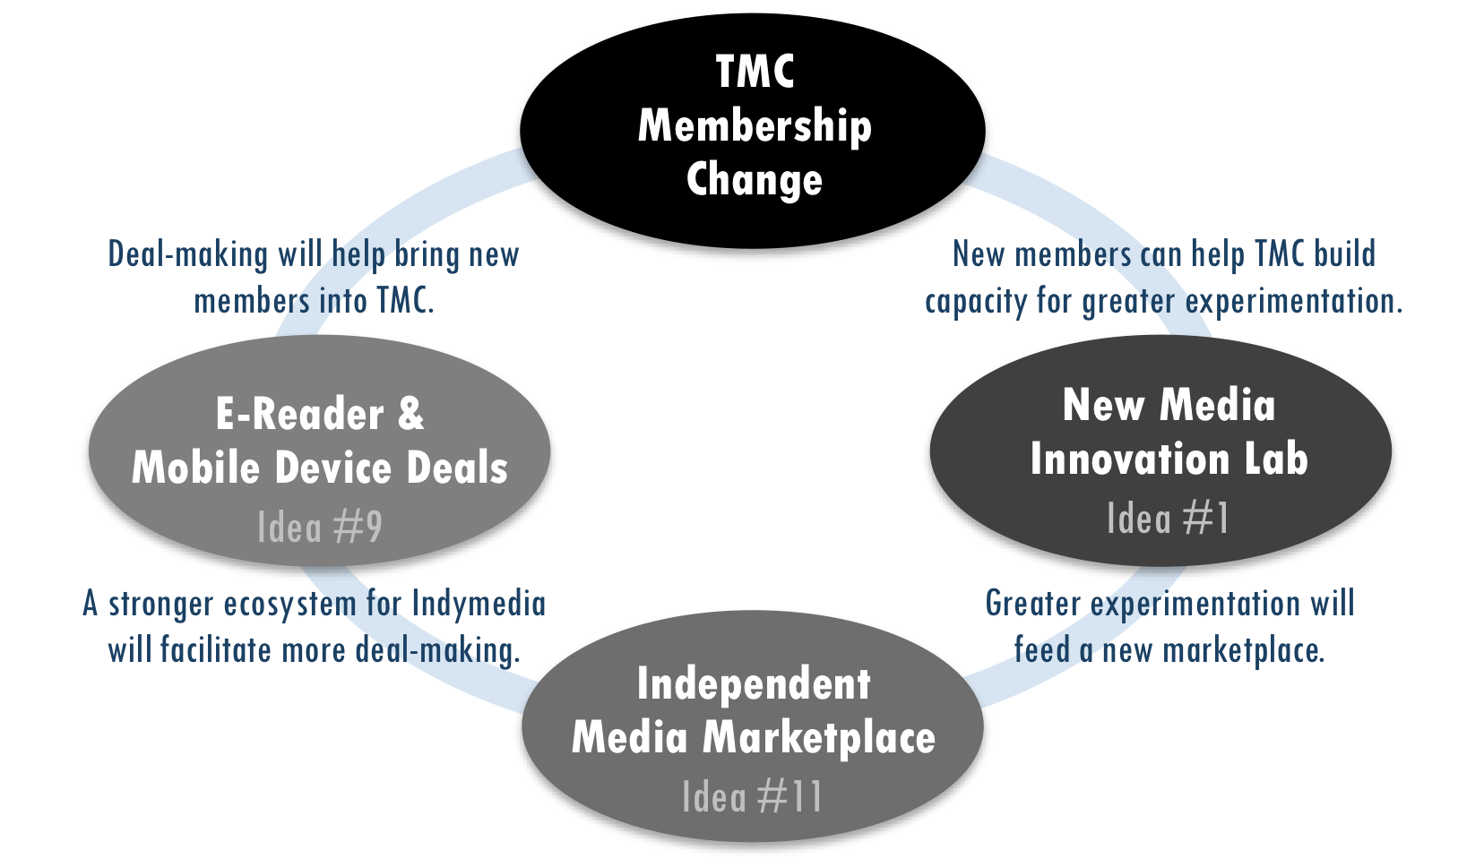
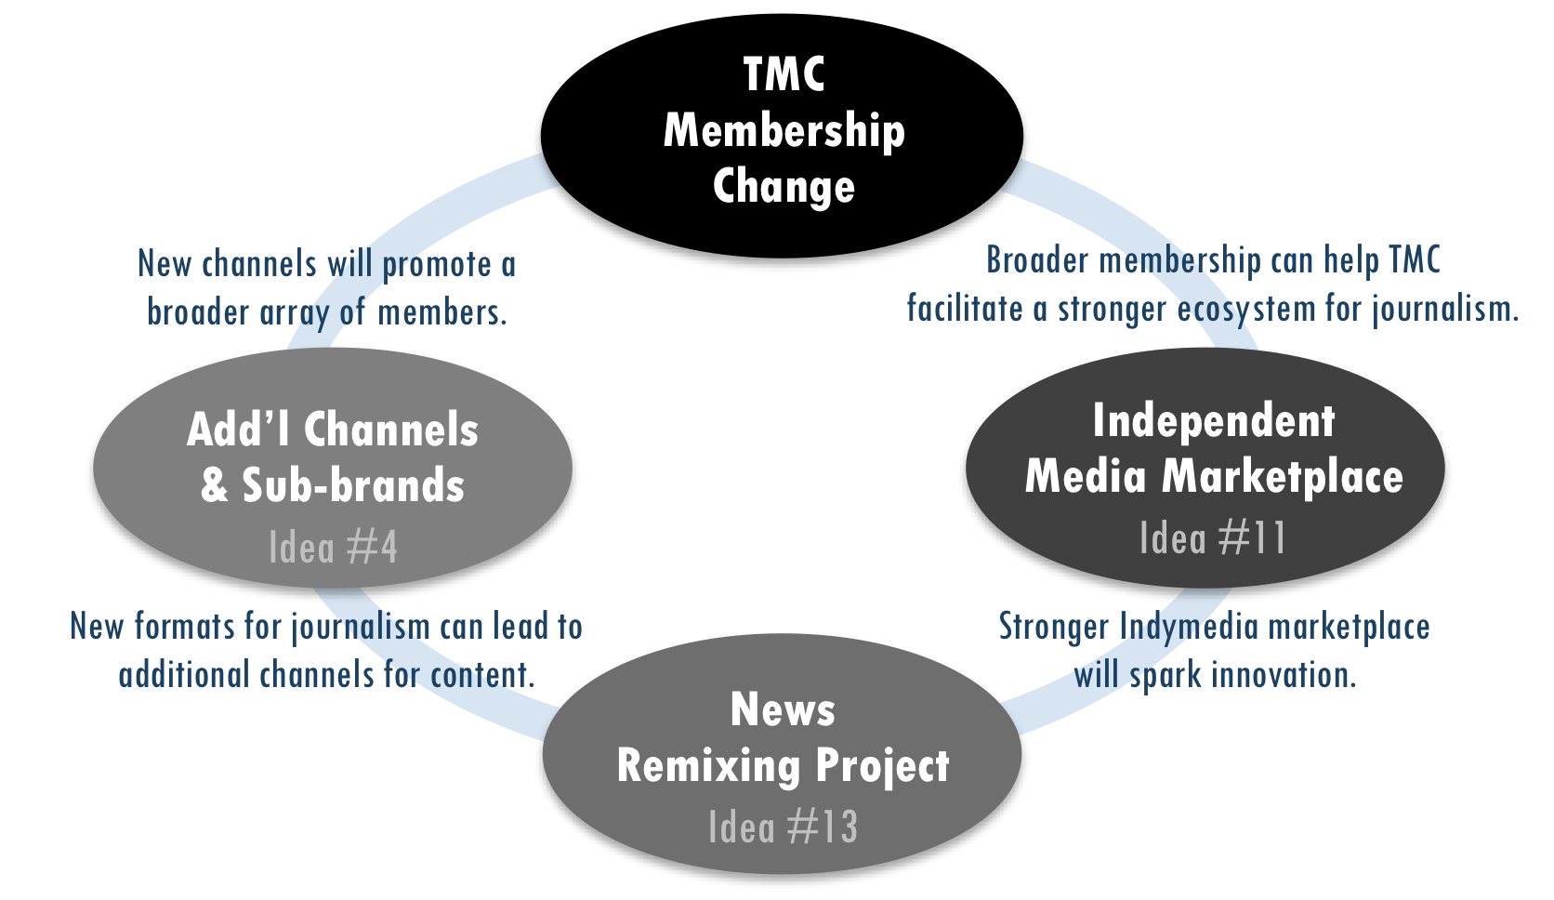

DRAFT
Please do not distribute

Dissonance & Opportunity

Game Changer Box Set
Vol. 2

Old Paradigm of Journalism
Media as watchtower 1
Independent media as watchdog 2
Physical distribution 2
Resistance and denial 3
Tyranny of should 4
Are we facing a glacier or flood? 5

New & Emerging Realities
CHAPTER 1
NEW COMPETITIVE LANDSCAPE:
How is the playing field changing? 8
CHAPTER 2
NEW COMPETENCIES:
What new capabilities are needed to succeed? 23
CHAPTER 3
NEW SOURCES OF VALUE:
What needs can be met, problems solved or desires met? 32
CHAPTER 4
NEW BUSINESS MODELS:
How are media organizations structured to capture value? 41

Old Paradigm of Journalism
Long-time media professionals are tired of hearing about the old paradigm of journalism and how so much is changing. They are well aware of the historical underpinnings of their industry’s structure, and emerging trends have been discussed extensively on blogs, in print commentary, on radio talk shows and at industry conferences.
Fast Forward
Old Supply Chain, Vol. 2, p48
The bulk of this report’s analysis focuses on emerging realities and future possibilities. However, for context, it is useful to summarize a few key points about journalism’s old paradigm and why adaptation is so difficult.
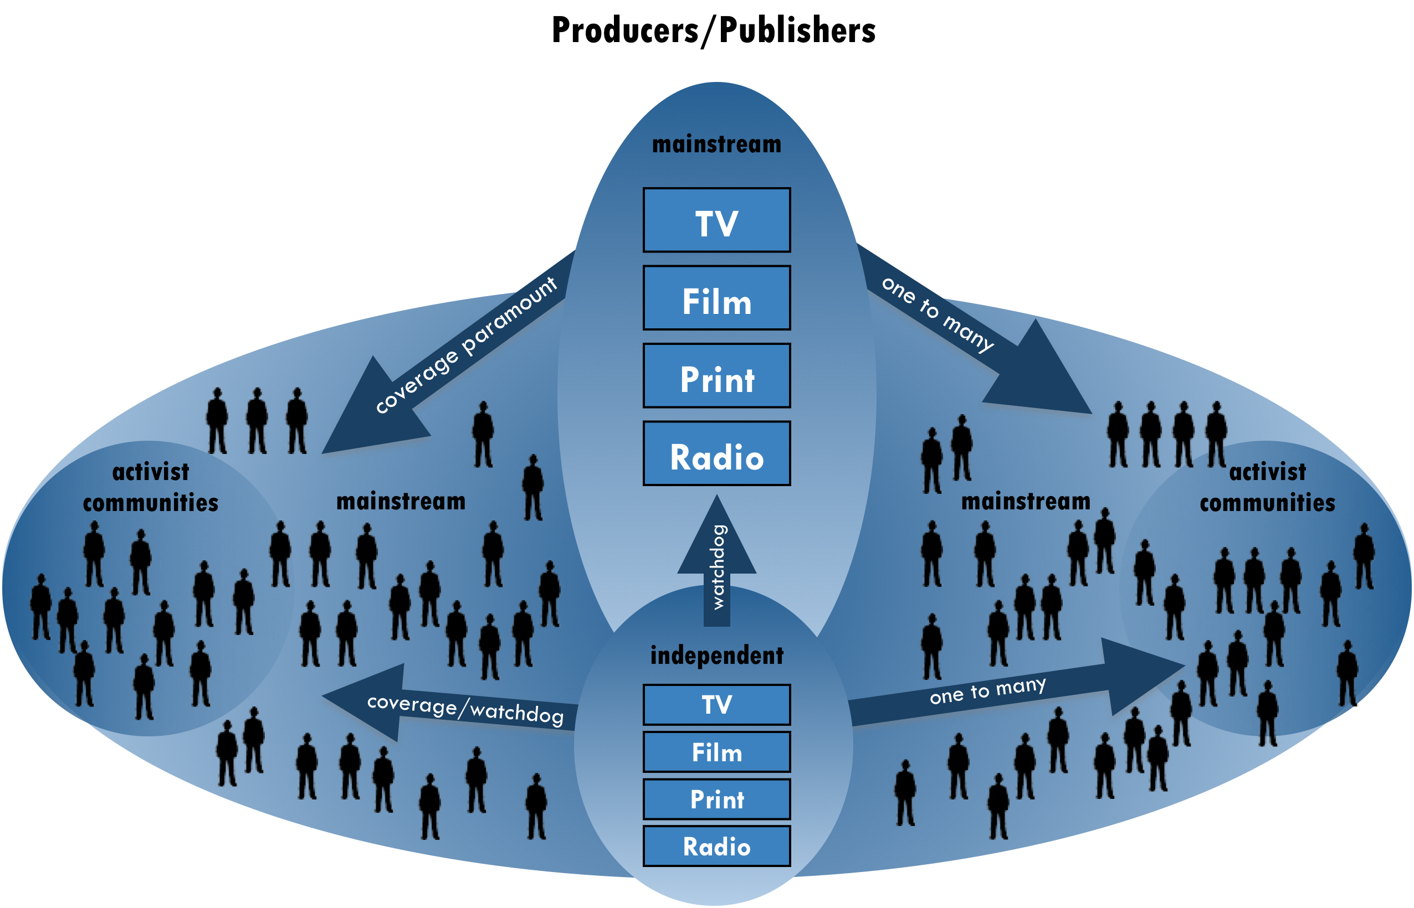

Media as watchtower
Weinberger used a watchtower as the central metaphor for the old paradigm of journalism (pictured above), where journalists assume responsibility for covering all that is important, which is also their source of perceived authority. “If you don’t notice all the signal flares going off below the watchtower, you’ve missed something. But it makes no sense now—there’s too much to cover,” he said.
“And what about the next 50 or 100 years? … “Will newsprint (or something like it) survive? Will the digital world finally transform the physical presence of newspapers in some way as yet unforeseen? Who’s to say? In any event, we'll be here—one way or another—with the same values embodied in the same seven words Adolph Ochs put atop the front page more than a century ago.”
– Howell Raines, New York Times Executive Editor, 2001^{C}

“The notion that there is news ‘coverage’ is historically a result of the assumption of scarcity,” Weinberger explained. “The world only looks like that if you’re looking at it from a point of view with a finite amount of space and centralized structure for filling that space, like in a newspaper.” Today, lack of coverage is no longer the primary problem for news-seekers. In fact, the amount of information online reveals how much news coverage was missing before the Web. For example, Twitter users blindsided CNN for insufficient coverage of Iranian elections in July 2009.
In 1896, the New York Times offered $100 prize to the reader who submitted a better slogan than “All the news that’s fit to print.” After receiving over 2,000 entries, it kept the original. Although the slogan is the subject of endless debate and parody, Times executive editor Howell Raines explained in 2001: “…We cling to it not because it’s charmingly archaic but because it’s our beacon, the beacon of the values that have guided us for all of the 150 years.” Raines acknowledged the slogan’s flaw in a literal sense, as did a Times editor over 105 years earlier. Although Raines admitted, “Every day, the paper misses a great deal,” the intent act as a watchtower for the news is still central to their value system.
Stemming from the watchtower role, journalists have historically had the authority of an expert or educator, with “beats” to cover and accumulated knowledge in subject areas. Readers often grant this perceived authority to journalists unconsciously, partly due to their role as trained professionals and partly due to the didactic one-to-many information flow from a central tower. These dynamics perpetuate, even if unintended, the myth that “experts know best.” While society needs experts, they do not always know best. Often crowds know better, especially if it is the right crowd. Nevertheless, the perceived authority of journalists is reinforced by the conventional goal of objectivity, where the responsibility of “coverage” includes balancing diverging viewpoints, assuming the journalist knows enough to strike the right balance. However, as the problem of missing coverage declined with the breadth of voices online, people increasingly question the goal of objectivity in reporting, a notion that many people in independent media have seen as an illusion for some time.
“Indymedia and media activists everywhere, from the commie-pinko left, all the way to the completely reactionary wacko right, have been waging a war to establish platforms for telling their stories and narratives, for years now. The goal of all of this work has been to impact mainstream culture and to shift the very foundations of civil discourse.”
– Sascha Meinrath, New America Foundation^{D}

“The media thinks its job is to make us well informed.”
– David Weinberger

Independent media as watchdog
If a watchtower describes media organizations’ historical role, the extension of this metaphor for independent journalism as an alternative watchtower or, more frequently, as a watchdog is useful. Watchdogs provide a corrective feedback mechanism to mainstream watchtowers, including corporations and government.
Watchdogs from an array of political perspectives will always be important to a healthy democracy. However, if independent media outlets see themselves primarily as watchdogs or alternative watchtowers, they will perpetuate the myth that “experts know best”—even if they believe their experts are more enlightened than mainstream powerbrokers.
Weinberger pointed out the tension that arises if journalists cling too tightly to these traditional sources of authority: “The motivation of media is not the same as that of the readers/viewers of the media. … We’re reading because it’s interesting to us in some way, not because we want to be well informed.” Nevertheless, most journalism organizations still include informing readers as a central idea in their mission statements.

Physical distribution
Physical distribution limits enabled media companies to create and maintain a competitive advantage in the old model. High costs gave outlets greater control of their publication’s distribution channels and lowered competition. For example, the elimination of these limits today has considerably lowered the barriers to entry for new players. In July 2008, Teresa Stack, president of The Nation, wrote in a TMC members’ survey that all the new entrants, and the breakout success of the Huffington Post, were big surprises in the past few years.
- Moore’s Law
An observation by Intel co-founder Gordon Moore that processing speed, memory capacity and other capabilities of digital devices doubles approximately every two years.

Even in the digital world, hardware is no longer a physical limitation in terms of both processing power and data storage due to Moore’s Law (definition in right column). In fact, Google designed its Gmail service based on the idea that a user never needs to delete data. Similarly, Yahoo! Mail offered unlimited storage in 2007. “It’s more expensive now to get rid of things than to keep them,” Shirky pointed out. “If you remove files from your hard drive, using a minimum wage, it’s cheaper to just buy more data storage.”
The historical physicality of media has determined its form. Traditional publishing organizations have found it appealing to think that they might only need digital facelifts of their physical selves, rather than develop entirely new incarnations. But interpreting new forms based on old models does not remove old limitations. For example, homepages are shrinking assets since users increasingly interact with sites through paths other than homepages.

Resistance and denial
“No one has been ‘caught up in this great upheaval’ about the fall of print business model. This change has been more like seeing oncoming glaciers ten miles off, and then deciding not to move.”
– Clay Shirky
Technological innovations have been changing the game for over a decade. The current monumental shift is nothing new. However, there is a difference between knowing that significant change is coming and recognizing how to best react, which is a process that can take many years.
Leverage points are
“places within a complex system (e.g. corporation, city, ecosystem) where a small shift in one thing can produce big changes in everything. … We not only want to believe that there are leverage points, we want to know where they are and how to get our hands on them. Leverage points are points of power.”
– Donella Meadows^{F}

“Sigmund Freud described denial as a state of ‘knowing-but-not-knowing.’ …Freud saw denial… as ‘a state of rational apprehension that does not result in appropriate action.’”
– Richard Tedlow^{E}

First of all, it is difficult to anticipate the total consequences of a system that needs to change, until well after the changes happen. Before the levees broke in New Orleans, it was obvious to many people that a flood was inevitable. It was not as clear, until the city flooded, what the many complex effects would be: The convention center debacle, the city’s population drain and the fact that some wards are still ghost towns five years after Hurricane Katrina.
Second, TMC members, as with other media outlets’ leaders, still have very rational apprehensions about changing their practices and are uncertain about how significant any changes would need to be. For example, in response to utilizing crowdsourcing (see definition p37) in reporting, one TMC member wrote: “I’m not sure I like this idea because it takes away from individual ownership (both outlet and writer) for a story. But it might be the way things are going.”
Business historian Richard Tedlow has studied the role of denial in undermining leaders’ ability to steer their companies through industry shifts. He points to the U.S. automobile industry as one of the best examples. He explains denial has involved many issues, “From ignoring external forces such as technological innovation and demographic change to overestimating a company’s own capabilities and resources.”
One of the biggest barriers to changing an organization or field is leaders’ inability to shed the paradigm from which it arose, which are often deeply held sets of shared beliefs and practices about how the world works. Donella Meadows, a pioneering environmental scientist and respected systems thinker, ranked the twelve most effective “leverage points” to change any system. Her second most powerful lever was changing “the mindset or paradigm out of which the system—its goals, structure, rules, parameters—arises.” Interestingly, Meadows notes that the greater the leverage point, the more the current system will resist changing it. Therefore, those who face a completely new paradigm may have the strongest denial.
The history of failure in the railroad industry illustrates the significance of this paradigm-shifting leverage point for journalism. James Surowiecki described the parallel in his New Yorker article, “News You Can Lose.” If railroad owners had focused on customers instead of products, they may have recognized that they were in the transportation business, not the railroad business, which was quickly losing customers to automobiles and airplanes. Surowiecki wrote, “By extension, many argue that if newspapers had understood they were in the information business, rather than the print business, they would have adapted more quickly and more successfully to the Net.”
Perhaps we are denying a paradigm shift that runs even deeper than Surowiecki suggests. If journalism organizations view themselves as part of the community-building or conversation business, not just the information business, they might rise with their customers to higher ground instead of drowning with an old paradigm they believe “should” still work.
Business historian Richard Tedlow says there are two reasons businesses have failed over the last century: either the business leaves the market, or the market leaves the business.^{G}

Tyranny of should
An underlying goal of the progressive movement is to change the world as it is into the world as it should be. Certainly, this is the underlying goal of anyone seeking any sort of change, although for many media organizations this might be secondary to the aim of creating quality journalism. Nevertheless, the rub comes from differing perspectives of what the world should be.
Bettering the world is likely tied to goals that include women should vote, everyone should reduce their carbon footprint, people should support local public media. However, people and organizations can also limit themselves by clinging to “shoulds” that undercut their ability to gain the resources (e.g. financial, social, cultural) to do their work. Sometimes, organizations can even create greater positive change by first meeting people where they are, especially in an online world that is characterized by empowerment of individual users and relevancy of information.
“Progressives would rather be right than win.”
– Larry Irving

Non-profit and advocacy organizations face a particular challenge with the tyranny of should, as they are driven primarily by social missions. That’s the paradox for progressives. “There is an anti-democratic smugness in the Democratic community,” observed Larry Irving, a technology and media strategist, and former Assistant Secretary for Communications and Information at the U.S. Department of Commerce.
For any type of organization, strategic action depends recognizing shifting trends that are beyond control. John Bracken, program officer at the MacArthur Foundation said, “I feel like ‘shoulds’ are uncontrollable. People have been concerned about newspapers, but there are waves of trends going on that we can’t control.”
“Shoulds” come from deeply held beliefs about how the world can be better, which often seed the transformation of complex systems such as capitalism and democracy. However, “shoulds” are also trapped within an existing paradigm or worldview. The power to transcend paradigms themselves is the number one most effective lever in Meadows’ ranking of twelve leverage points to change complex systems. That is, “to keep oneself unattached in the arena of paradigms, to stay flexible, to realize that no paradigm is ‘true.’”
“If no paradigm is right,” Meadows points out, “you can choose whatever one will help to achieve your purpose.” Amy Gahran of the Poynter Institute recommended that TMC’s strategy stem from asking: “So, what? What will media do for people?” By strengthening its members’ agreement regarding TMC’s purpose, the consortium can shift paradigms more easily, choose the most game changers and better weather any industry changes to come.
“When we shift our attention from ‘save newspapers’ to ‘save society’, the imperative changes from ‘preserve the current institutions’ to ‘do whatever works.’ And what works today isn’t the same as what used to work.”
– Clay Shirky

Are we facing a glacier or flood?
While changes to the news industry advanced at a glacial pace for many years, as Shirky claimed, transitions can come as quickly as the levees that broke in New Orleans. Trigger events can cause sudden floods before new a system is in place to prevent it.
News organizations are facing flash floods and many are in a mode akin to sudden-death, wilderness survival. Laurence Gonzales, in his book Deep Survival: Who Lives, Who Dies, and Why, explained that those people who most quickly surrender to their new circumstances, take decisive action, and believe anything is possible are the ones most likely to survive. Each independent media organization must answer two questions in order to survive: “What will you be standing on when the water reaches you?” and “How will you boldly move to higher ground?”
The collective insights from this project’s participants warn that old ways of thinking can limit transition. This is especially true for media organizations that only make incremental changes. Small moves prevent them from choosing entirely new strategies and developing new competencies quickly enough to remain relevant. However, participants suggested many avenues for making bold moves—outlined in the following four chapters—which can collectively lead independent media to higher ground.

New & Emerging Realities
The dissonance between journalism’s historical role and its new realities can help media organizations identify ideas, practices and approaches for the future.
The following four chapters begin with a brief chart comparing the old and new paradigms, followed by a detailed analysis of the new paradigm’s opportunities.

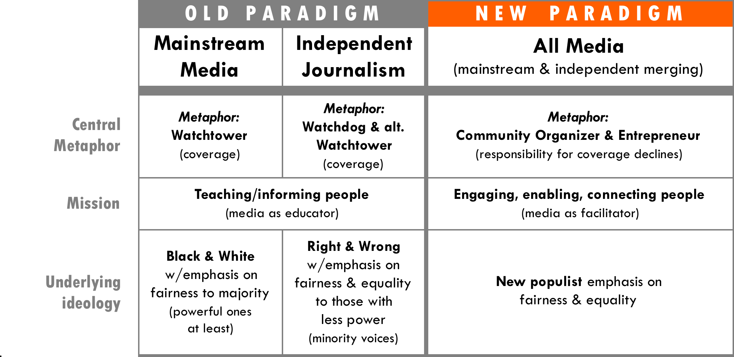

The new competitive landscape requires media organizations to develop new competencies to succeed. Finding new ways to meet users’ needs, solve their problems and fulfill their desires will be the sources of value that drive new business models. The four chapters (outlined below) describe the key trends identified through our research. The framework centers on four questions that can help media organizations align their strategy and operations with the emerging trends that it sees as most important.

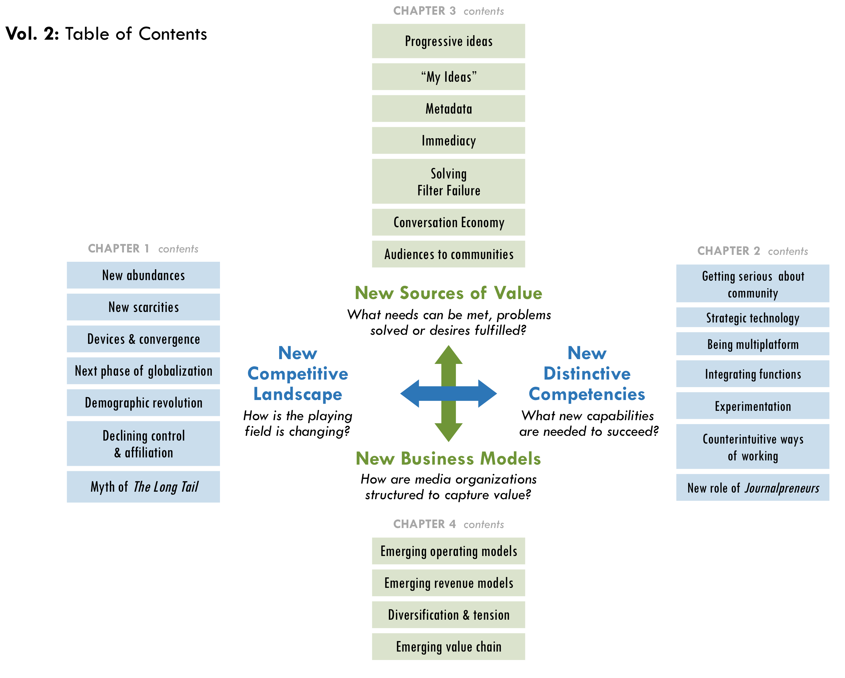

CHAPTER 1
NEW COMPETITIVE LANDSCAPE: How is the playing field changing?
When the media industry was more stable, the primary risks for media organizations were clearer. For mainstream media, risk centers primarily on rivalry among existing commercial competitors. The risks for independent media centered on competing against the mainstream as controlled by corporate conglomerates and government powerbrokers.
“Independent media will be part of normal everyday media, integrated as mainstream media, part of the usual.”
– Craig Newmark, Craigslist

Today, the media industry faces considerable instability, causing the mainstream and independent media’s competitive forces to overlap almost indistinguishably. The basis for competitive advantage also evaporated. As Weinberger put it, “There is no more mainstream.” An important aim of progressive media could be to fight to keep it that way.
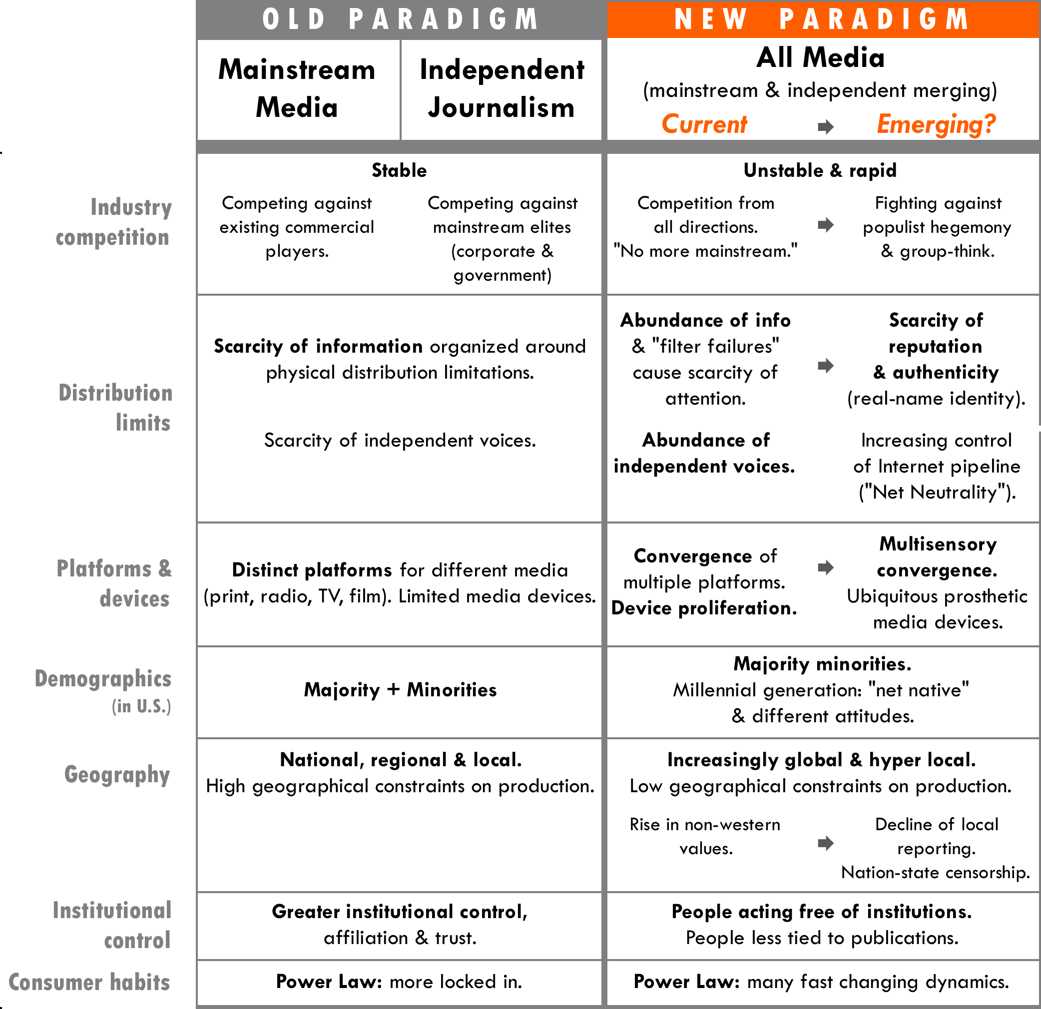

The basis for competition has changed due to significant shifts in abundances and scarcities, which underlie the basic principles of supply and demand. These dynamics are exacerbated by the proliferation of devices and convergence of content on them. Globalization and demographic shifts have made reaching audiences more complex, yet consumption habits still fall into familiar patterns described by “power law” (defined below). This chapter covers the following topic areas in analyzing the competitive landscape.

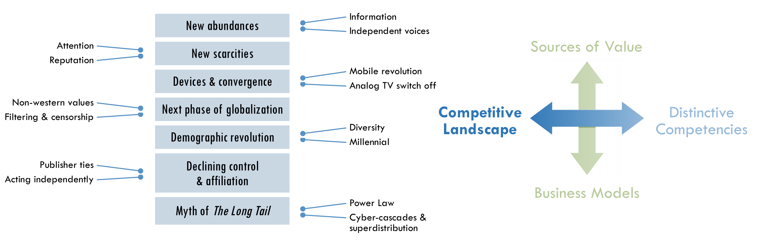

New abundances & their effects
As physical limitations decline, the competitive landscape changes fundamentally: New abundances generated by the disappearing costs of information sharing have turned the economics of distribution on its head.
Fast Forward
News as a loss leader, p48

For example, “loss-leader strategies” are inverted. Companies used to give away one percent of a product, such as perfume, to get the samplers to buy the other ninety-nine percent. Now, companies such as Flickr or Skype give away ninety-nine percent (often called a “freemium”) to sell one percent in the form of premium purchases. For example, Flickr Pro costs $25 per year. This flip has generated new abundances of products.
This inversion has fundamentally shifted systems of distribution by creating a new, self-reinforcing positive feedback loop. In this loop, the more you give away for free, the more you have to give away for free in order to compete. Meadows said that such loops, if unchecked, can be a “race to the bottom,” where a system will ultimately destroy itself. In the old paradigm, the price of creating and sharing information served as a useful corrective feedback loop. A photographer, for example, limited the number of images she or he shot due to the cost of film, processing and printing.

Abundance of information
The media-as-watchtower role worked well in a world of information scarcity. “Now there’s an abundance of everything—content, reporters reporting on it, commentators to make sense of it, and lots of ways to put it together, such as emailing links, doing a ‘Digg.’ It’s entirely about abundance,” Weinberger explained. “The only thing that scales is the massive effort of readers doing it for themselves.” However, this abundance has another effect, according to writer Nicholas Carr: “What the Internet has done is broken the geographical constraints on news distribution and flooded the market with stories, with product. Supply so far exceeds demand that the price of the news has dropped to zero.”
“What does the Internet display-ad market have in common with Zimbabwe? Both are printing nearly-limitless amounts of their main currency, vastly diminishing its value and undermining their future. (This) isn't just about a cyclical downturn caused by the recession.”
– Martin Peers^{I}

“Forty years ago, the principal nutritional problem in America was hunger; now it’s obesity.”
– Chris Anderson^{H}

Of course, an abundance of content inventory also leads to an oversupply of available advertising real estate, which causes ad prices to decline. At any given time, 50 to 70% of available advertising impressions can go unsold on a site, even with the help of advertising networks that efficiently reach more advertisers. Although Wenda Harris Millard, president of Martha Stewart Living Omnimedia, warned in early 2008 that companies should not sell their Web inventory like “pork bellies”, publishers often need to lower their prices to compete.
Content oversupply can have similar effects on philanthropy, making it harder for content producers to raise funds. More producers are competing for limited grants, and funders can find producers who are willing to develop content for less money. Like advertisers, foundations now have more options than ever before to direct their funds in support of the content they want to reach people, diluting both investment in—and possibly impact of—media projects.

Abundance of independent voices
The good and bad news are now one and the same: there are more independent voices than ever before. Within the old media structure, there were too few independent voices, but that is no longer the biggest problem. Shirky said, “Empirically there are so many, many, many, ways for alternative voices to emerge. For instance, the Al Jazeera Twitter feed is going strong with the war in Gaza with a fairly large following.”
Despite talk of reaching niche audiences, it would be silly to believe that independent media (whether it is from an individual or organization) wants to reach just twelve people, unless the group is the President’s cabinet. The growing ease of “few-to-few” communication is valuable in many ways, but information must reach a greater audience scale to have power. Scale is hard to control with many fragmented voices, which makes it more challenging for any one content-producing organization to sustain itself. While the emergence of many new, independent voices may be the future we have been waiting for, it also might threaten the existence of organizations whose value was largely based on their “independence” from large commercial media companies. Verclas went as far as to say that in 10 years, “I don’t think there will be such a thing as independent media anymore in terms of organizational structure.” Even if such organizations do not disappear altogether, the abundance of independent voices will inevitably change the form they take.

New scarcities & their effects
Some people have viewed the new media paradigm as a perpetual rise in disintermediation, where publishers go directly to readers for funding. Nevertheless, mediation—and the organizations that benefit from it—may simply be shifting from one place of control to another. New forms of mediation will be based on new scarcities that are growing, and there will be a fight to control them.
“Publishing has only two indispensable participants: authors and readers. As with music, any technology that brings these two groups closer makes the whole industry more efficient–but hurts those who benefited from the distance between them.”
– The Economist^{J}

In a keynote at Nokia World 2007 about the “taxonomy of free,” Chris Anderson of Wired Magazine said that time and money are no longer the chief scarcities for people. The new scarcities include time, money, attention and reputation. He asked the audience, “Which economy are you playing in?”

Scarcity of attention
Anderson views total attention as a fixed sum; you can gain share or lose shares. Media companies not only compete with each other for attention, but also have to compete with the time someone takes to attend their child’s soccer game, for example. The value of solving filter failure online is largely determined by scarcity of attention.
Fast Forward
Now is the time for immediacy, p37
Solving filter failure, p38
Depth of community, p41
Fast Forward
Will more reliable & consistent measures create greater distribution of value?, p55

Furthermore, just as the fractional costs of sharing information approach zero, so can the switching costs for users to find another information source. This makes it paramount for publishers to find other ways to maintain users’ attention online. Partly, media organizations can achieve this by the amount of connection they build with and among users.
- Strategic recognition
What if… we made it easier to deepen communities at a larger scale?, p16
Media companies can also find more ways to capture value based on the scarcity of attention. With the growing value of immediacy and ability to access live video, online events could help independent media compete for attention.

Scarcity of reputation
Google search built its PageRank on sites’ reputations; eBay built auctions on sellers’ reputations; Prosper.com and Kiva.org are building microfinancing sites on lenders’ and borrowers’ reputations. Digg and StumbleUpon have done the same in filtering news and information. NewsTrust, started in 2005, aims to provide use reputational value as a credibility filter for online opinion and amateur journalism, thus building greater trust and accuracy. Furthermore, many companies are increasingly focusing on “mindshare” (a type of reputation) as the ways to measure degree of attention and loyalty online grow more reliable.
- For journalism organizations, building a stronger reputation could be particularly valuable. According to a 2008 Pew study, “Believability ratings for national news organizations remain very low. If anything, believability ratings for major online news outlets—including news aggregators such as Google News and AOL News—are lower than for major print, cable and broadcast outlets.”
“A stronger rapport with the public won’t solve journalism’s crisis by itself, but it could be a central component of the solution.”
– Amanda Michel^{K}

Reputation is fragile, however, and perhaps more fragile than time, money and attention. Like organizational culture, reputation is hard to build and easy to destroy, and it can falter with a single act that sparks mistrust. In a New York magazine article, Vanessa Grigoriadis asked, “Why has the number of MySpace visitors remained essentially flat in the past year? Why do social networks fail?” The fragility of users’ trust is a big reason, she explained.
Furthermore, reputation can be inextricably linked with privacy issues, which Battelle has written about for years, including a “Data Bill of Rights” in 2007. Even though stronger government regulation needs to protect privacy, consumers are already uneasy about it and have shown that they want greater control of their personal information. As a result, the relationship between privacy and reputation could be a differentiating factor for media organizations that manage it well. Publishers can serve as a trusted broker between advertisers who want to reach people and users who do not trust advertisers with their personal information but would still like to get ads that are relevant and useful.
Battelle has been a proponent of “Conversational Marketing” that depends upon players’ reputations. As he put it, “conversational marketing is simply the tip of a very large iceberg, representative of a sea change in how all businesses converse with their constituents—be they customers, partners, or employees.” Of course, the conversation involves many more players (both commercial and non-commercial) and hinges on reputation created through greater transparency and dialogue across the board.
“To follow the money, you have to shift from a basic view of a market as a matching of two parties—buyers and sellers—to a broader sense of an ecosystem with many parties, only some of which exchange cash.”
– Chris Anderson^{H}

As we consider the abundances and scarcities described above, we must also consider the long-term effects of shuttering news organizations on these dynamics. For example, Surowiecki claimed, “we’re almost sure to see a sharp decline in the volume and variety of content that newspapers collectively produce.”
Journalism’s human capital drain will seep into other sectors. The Pew Project of Excellence in Journalism found that “nearly one out of every five journalists working for newspapers in 2001 is now gone, and 2009 may be the worst year yet.” Where will all the journalists go? Some will go into public relations work, while others will enter entirely new careers and take their journalistic skills into other sectors. For example, Douglas Frantz, former managing editor of The Los Angeles Times, now serves as chief investigator of the Senate Foreign Relations Committee, where he said that he acts much like an investigative reporter, “but with two potential tools he could only dream about having previously: subpoena power and, should his application be accepted, security clearance to review classified data.”
Many former journalists are turning into social entrepreneurs—working independently or starting their own ventures—and they could benefit from new, networked support systems such as a consortium could provide. The increasing number of career shifts among journalists has even spawned consulting services. For example, Amy Webb conducts trainings for “newspaper refugees” to build post-mainstream journalism careers. Wherever journalists go, they are not likely to be absorbed back into traditional news organizations that once supported them, yet they could be organized to shape a new future for journalism.
- Strategic recognition
What if… we retooled journalists?, p4

Device proliferation, convergence & their effects
“The future of media for me would be the type of content that I want anytime, anywhere, on any device,” said Ashish Soni, who directs the Information Technology Program at the University of Southern California. One trend that has become very clear in the last few years: consumers want complete control of the content they consume, access to it on all their devices and platforms and services that allow this. As a result, media content no longer falls neatly along the lines that used to separate print, radio, TV or film.
“The device that wins will seamlessly integrate Web content with content from other sources, such as cable, onto the TV, since consumers will undoubtedly want to put their large, flat-panel HDTVs to good use.”
– Razorfish Digital Outlook Report 09

All media organizations will have to reckon with two major game changers that may have the greatest impact on media convergence going forward: mobile and the analog switch-off in television.

Mobile revolution
“The big game changer over the next short term is mobility,” said Don Tapscott, author of Wikinomics. “Media is coming into our pocket and is with us at all times on a device that knows where we are.” The mobile revolution will likely have the greatest impact on media convergence, as laptops are becoming more mobile (e.g. netbooks & cloud computing) and mobile phones become more powerful computing devices. In the United States, 15% of the population has smart phones (e.g. iPhone or Blackbery) according to a 2008 Pew study, and 37% of those who own these devices say they get news on them.
“Mobile is the primary means of communications for the majority of the world. If you care about freedom, this is about freedom of location and time.”
– Katrin Verclas
Already, three quarters of the world’s messages are sent via mobile. In developing countries, nine out of 10 messages are from mobile devices, which have “leapfrogged” other technologies and reached an estimated 61% penetration rate by the end of 2008—from nearly zero ten years earlier. In fact, Jeffery Sachs, a renowned economist who has focused on the developing world, points to mobile devices as part of the reason we might be turning the corner on the digital divide.
Verclas asked, “What do people actually want on the content side—in particular, mobile content? What is needed? What is necessary? What is provided? What is available?” Razorfish’s Digital Outlook Report 09 claimed that growing mobile usage will cause some consumption habits to converge: “As the mobile search experience begins to mirror that of the PC, so too do the expectations for types of content. This means users will increasingly begin to see the mobile device not only as a source of localized information on the go, but as an aid to many of their everyday tasks.”

Analog TV switch off
Jessica Clark believes that the switch-off of the analog signal in summer 2009 may be a more significant game changer than people in independent media realize. Clark, who directs the Future of Public Media Project at American University’s Center for Social Media and is former executive editor of In These Times, said, “Lots of lefties don’t subscribe to cable or satellite because they disdain television; now they’ll either need to do that or to buy a set-top box, or buy a new set. It’s a moment of decision that might move some definitively to consuming programs and films only on their computers—kind of like the younger set of consumers who no longer have land lines.”
Clark notes that the switch-off will also generate many new broadcast channels, offering an opportunity for progressive and independent media makers to generate fresh broadcast content that could also be streamed online.
- Strategic recognition
What if… we helped shape how public policy governs access?, p11
The challenge now comes from the tremendous number of devices that people use, and the fact that consumers increasingly want to access any content, anytime on any device. To that extent, convergence is not only about creating content that optimizes multiple platforms at once, but also about enabling people to find and access any type of content easily using any platform.
- Strategic recognition
What if… we built a new ecosystem for journalism?, p11
To make matters worse, different platforms inevitably have different strengths for different types of content. People often want to check email on a more private device than their TV, for example. Schiller explained that radio has some built-in advantages over a newspaper or website, which makes radio a complimentary rather than competing form of media. “You can listen to NPR getting dressed in the morning,” she said. “But when you sit down to read a newspaper, you could be going online.”
Nearly all media technology companies, large incumbents and startups alike, have made plays in platform convergence, which will change the competitive landscape in significant ways. “In fact, the word ‘television’ will eventually mean something new—it will need to move beyond the platform itself,” wrote Terri Walter in the Razorfish Digital Outlook Report 09. Convergence technology is quickly improving, and media organizations that make it easiest for consumers to mix platforms will succeed. The whole ecosystem of content creation, ad buying, philanthropic funding and audience building will have to adapt as well, which is where TMC can play a role.
- Strategic recognition
What if… we standardized raw data, metadata & metrics?, p8
We are heading into a post-platform economy, where media organizations that can think beyond platforms in overall technology strategy, yet can also efficiently differentiate content form by device, may win.
“(Game changers in the media space) may be in the innovative ways that digital media interacts with legacy media whether it’s print, radio or television. … The opportunity is that we have layers of different kinds of media, each with its own strength. Figuring out a way to interconnect them is the real opportunity.”
– Vivian Schiller

Dawn of a demographic revolution
“My bottom line [is] that demographics are changing in this country dramatically. Technology is changing dramatically. Willingness to hear progressive media is increasing dramatically,” said Irving “There is a certain window of time to make something long-lasting.”

Effects of diversity
“Independent, progressive journalism doesn’t understand that progressives are speaking past Black and Brown audiences but are dependent on Black and Brown votes,” Irving said. “They are condescending to these communities, afraid of these communities, and are not supporting and building in these communities. The reality is that five to ten years from now Browns and Blacks are going to make up more than 50% of the vote. Progressive media just doesn’t hear it, won’t make the investment and has insular naval gazing. But I think part of the blame is that Blacks and Browns give their votes to people who don’t pay attention to them.”
Over one third of the nation is now made up of non-white populations. Hispanic and Asian populations grew ten times faster than whites, and Black population four times faster.
U.S. Census Bureau 2007

“I think of Ebony, I think of it as the kind of magazine that my mother would read, not necessarily the kind of magazine that I would run out and read.”
K. Tempest Bradford, The Angry Black Woman blog^{L}

The United States rapidly becoming more diverse and attitudes about diversity are changing. “There is a lot less concern among the younger generation about the racial divide,” said Irving. “For some Black Americans it’s important that the media they access is Black. But for younger people who want Black perspectives, it doesn’t have to be from Black people all the time. Black is one of the things they are—they have grown up in a diverse world. Some of the walls we’re seeing now are crumbling.”
Shifting demographics create both challenges and opportunities for content producers since different groups use media in different ways. Irving noted that for Latinos, Facebook, MySpace and SMS texting drove greater adoption of technology. Furthermore, according to a 2008 Pew study, African-American Internet users are 18% more likely to watch online video than white internet users and 15% more likely to have a profile page on a social networking site such as MySpace or Facebook. In terms of gender differences, for instance, women tend to watch network TV news (particularly morning programs such as the Today show), while more men watch cable TV shows. It is insufficient for a publisher to simply make content available anytime, anywhere on any device. They must also sophisticatedly customize their content to reach different audiences.

Effects of Millennial Generation
“I’m concerned that independent media organizations are not figuring out how to tap into the next generation of news consumers,” worried Erin Polgreen of TMC. Young people (born between mid 1980s to early 1990s) are leaving print and television news, and for a long time incumbent organizations believed that they might eventually come back. “In spite of the increasing variety of ways to get the news, the proportion of young people getting no news on a typical day has increased substantially over the past decade,” a 2008 Pew study said. “About a third of those younger than 25 (34%) say they get no news on a typical day, up from 25% in 1998.”
Nevertheless, the Millennial Generation’s members are world-changers with strong democratic values, which indicates that they are interested in information about the world around them. Tapscott, who authored the 2008 book, Grown Up Digital: How the Net Generation is Changing the World, explained: “This is the first generation to come of age in digital age. They have enormously strong values—they care a lot. It’s not true about this being the ‘narcissistic me’ generation. Civic engagement in U.S. has been growing decade to decade and is currently at an all time high, and it has turned into political action. This generation is going to change the world.”
“The engagement of young people that Obama has generated seems cause for optimism. How can we translate that engagement into support for our type of journalism and our values?”
– Teresa Stack, The Nation

If independent media can experiment with bold new ways to engage audiences, they may tap a new generation of users that will transform the world and how its news is reported. “In the progressive community, (young) people will have the more universal POV, and also be the ambassadors for their communities,” Irving says. “Don’t expect progressive media to have a direct path initially. They need to find trusted voices inside the community that can help create the echo chamber.”
- Strategic Recognition
What if… we joined early in technology experiments?, p2
What if… we reinvented formats for journalism content?, p14

Next phase of globalization & its effects
“The idea that you can have a native political audience that is tied to a publication—like how African-Americans were traditionally Democrats because they had no other place to go—is no longer true,” said Shirky. The same goes for native geographical audiences. For example, The Guardian now has more readers in the United States than in the United Kingdom. While expanding to global audiences is an opportunity for individual publishers, it poses a threat of further media fragmentation and redundant production capacity. “When the geographical constraints went away,” Nicholas Carr wrote, “all that fragmented (and redundant) capacity suddenly merged together into (in effect) a single production pool serving (in effect) a single market.”
In addition to the economic implications, two key challenges in the next phase of globalization include a reckoning with non-Western values and the growth of filtering and censorship by other countries.

Non-Western values
Publishers cannot simply extrapolate from American experiences alone: The future will be shaped by non-Western cultural drivers. For example, according to long time Asian correspondent Thomas Crampton, “While U.S. users tend to trust a professionally put-together [website], Chinese users have the opposite reaction and are highly skeptical. Chinese users presume that a professional-looking site was put together to promote a product or service.” Matt Roberts, general manager for About.com’s China operation said, “Chinese have suffered from propaganda and soft content for so long that they are very savvy. Instead of believing what a professional site says, users in China prefer to ask a bulletin board to hear what anonymous users post in reply.” Furthermore, Richard MacManus, founder and Editor of ReadWriteWeb explained that one of the main reasons Facebook had almost no presence in three of the markets they cover—China, South Korea and Japan—is the persistent bias from Americans that everything from the U.S. is great, while Asia just copies. If independent media made a concerted effort to go global, it may take careful work to avoid this trap.
- The ambiguity surrounding the definition of “progressive” could be further complicated when non-Western values enter the mix. How will that, in turn, affect content production from U.S. sources that seek to be relevant to global audiences? What content do global audiences want and for what purpose? Do their wants align with what independent media wants to cover?
Connecting to a global audience must be a two-way street. Media organizations cannot simply impose stories users in other countries: They must also pull stories into the U.S. and explain why they are relevant—a task that may be made possible by our country’s demographic revolution and through partnerships with growing Spanish-language media. Also, learning about media habits from other countries is an important part of the reciprocal equation. Already, the Western world has a lot to gain from learning how users in Asian markets use mobile media and other technologies.
“Sometimes the most direct route to innovation is to look abroad and translate what you find.”
– Tom Kelley, IDEO^{M}

U.S. media organizations can also build reciprocal relationships by deliberately facilitating connections between their current users—particularly those who are involved in co-creating content—and international writers, producers and consumers. This would be particularly effective when dealing with global issues such as climate change, trade or public health. Google plans to introduce a new product called “Google Wave” in fall 2009, which has groundbreaking translation capabilities for live chat, and could open new possibilities for international user engagement. However, a concerted community organizing effort would need to accompany such a tool.

Global filtering & censorship
Government censorship is increasingly threatening independent voices around the world, as we saw with Iran’s elections. “A simple correlation between the Internet environment and the expansion of global civil society can no longer be taken for granted,” according to Ronald Deibert and Rafal Rohozinski, co-founders of the OpenNet Initiative. A new book they edited, Access Denied: The Practice and Policy of Global Internet Filtering, found growing filtering, censorship and surveillance in 40 countries they studied—a sharp rise in the number of countries and the extent of control compared to similar research in 2006. Independent media is often the only source of free expression in many states that tightly regulate and control major media outlets. Access Denied reported that 17 countries blocked at least one Website that was in the category of “independent media.”
Most alarmingly, filtering and censorship activities are no longer confined to non-democratic countries. Deibert and Rohozinski found that, over the past five years, arrests and intimidation of bloggers by authorities have progressively increased. Governments are also using denial-of-service tactics to proactively block them, especially in election periods, as demonstrated by Iran’s contested 2009 election.
Government and big corporate players, such as Google, will need to become more active in fighting the rise of censorship and monitoring. But how can TMC and its members contribute to this fight? For one, TMC could join the formidable international movement for Internet protection by using tools and publishing information that undermines global filtering measures. Also, TMC could begin projects that build relationships with foreign journalists, translators and organizers.
Furthermore, since news organizations have been shutting down their international bureaus to cut costs, users in the United States may need to get more of their news directly from users in other countries. Shirky pointed out that a video of the 2008 Sichuan earthquake in China was online before authorities knew about it. “Compare this with the big quake in the 1970s, when it took three months for the Chinese to confirm that it had even happened. The censorship of the Chinese government is facing the wrong direction,” he said. “They have the in-bound media covered, but they have much less focused on their own people. So their firewall is facing the wrong way.” This could be an opportunity in disguise for independent media, which could source international news more actively from users and outlets in other countries and, in turn, build a reciprocal relationship with global audiences to support greater content distribution.
“A sprawling, distributed, and highly potent sphere of global civic networks has been unleashed that moves in and around sovereign states,” wrote Deibert and Rohozinski. “These networks of autonomous agents are highly creative and can be technologically sophisticated.” This global movement of change-makers is a powerful potential audience, which Paul Hawken, in his 2007 book Blessed Unrest, calls “humanity’s immune response” to the toxins of injustice, corruption and pollution. Hawken says the movement involves people from many different professions, has no charismatic leader or unifying ideology, and that most people have not fully recognized its potential—especially media outlets.
- Strategic recognition
What if… we mounted a concerted effort to go global?, p17
“There is one thing (TMC) should be examining—their political assumptions in a global era.”
– Clay Shirky
“The world is in precarious situation and stakes are high. The combination of youth, new media communications and power of organizing, moves us towards first global movement of change.”
– Don Tapscott

Declining institutional control & affiliations
Many people today, especially young people, no longer depend on institutions in the same way, which has forced media organizations to compete in a more decentralized, open environment. “There is this weird state of disconnect between existing structures and openness,” said Katrin Verclas, co-founder of MobileActive. “Open networks are where things are evolving; yet media organizations are not. There’s not a lot of pro-activeness but a lot of reactiveness.”

Acting free of institutions
“People are increasingly acting on their own, free of institutions. They are taking distinct actions on distinct issues online,” Bracken said. “If I was concerned about an issue in the past, I’d start an organization, open an office, get a bank account in order to organize letter-writing campaigns, do outreach to Congress. But, today, I might start a Facebook group and draw awareness without ever opening an office or a bank account.”
Civic engagement, for example, can no longer be measured by formal affiliations, a basis for past research. Bowling Alone, Robert Putnam’s well-known book claimed a decline in “social capital” by pointing to declining participation in civic organizations. Today, however, affiliations may even be higher, but they are simply happening in more informal and decentralized ways. In fact, some research has shown that online social networks have actually increased social capital in many new ways.
“Terrorists get it. They work in these small decentralized cells.”
– Katrin Verclas

The implications for institutions are significant: their relationship with constituents is more casual than what was previously acceptable, traditional organizational hierarchies are flattening, and network effects are amplified independently of institutions.
Tapscott predicted that every institution in society faces a fundamental transformation. “People can now self-organize like never before. Young people have at their fingertips the most powerful tools, to find out what’s going on, to organize collective responses. Every institution in society is going to be naked and if you’re going to be naked you better be buff."

Readers not tied to publishers
Much of media today is still like a bookstore, which organizes books by publisher, explained Weinberger, because that is what the industry values. “For the reader, though, it makes no difference,” he said. “This is not entirely true. I do care that it came from a place where I recognize their commitment; there’s credibility that it came from that particular site—but that’s precious little to build a business from. The credential that matters is person X who sends me an email saying ‘you have to look at this,’ not that Mother Jones produced it.” Today, online users, particularly casual newsreaders, increasingly receive news from direct referrals and links from their social networks.
“We want quality content, but the trend is against going to a single place to find it.”
– David Weinberger

Only approximately one quarter of casual newsreaders, who comprise most of Americans, say they trust a few news sources more than others. In contrast, two-thirds of hard-core newsreaders feel that way, which indicates the value of trustworthy sources remains high for at least a small segment of consumers. Furthermore, people increasingly consume news from multiple sources. A survey in mid-2008 by the Pew Research Center for People & the Press asked news consumers to list their most frequented news sites. The results mostly included portals and TV news sites, yet revealed considerable fragmentation across the board. Only eight sites were mentioned by more than 2% of respondents. Only Google and Yahoo! increased as news sources, compared to center’s 2006 survey.
As a result, publication-centered news may continue to face greater challenges in turning readers’ fragmenting attention into a steady return of visitors. Michael Hirschorn went as far as saying that, “The Internet has done much to encourage lazy news consumption, while virtually eradicating the meaningful distinctions among newspaper brands.”
The new rules of online engagement, according to Verclas, mean that there will be no central control. “It mutates and adapts; it’s flexible and agile,” she said. “We have no idea in the media how to do this. With the principles of decentralization, profits go away.”

Myth of The Long Tail
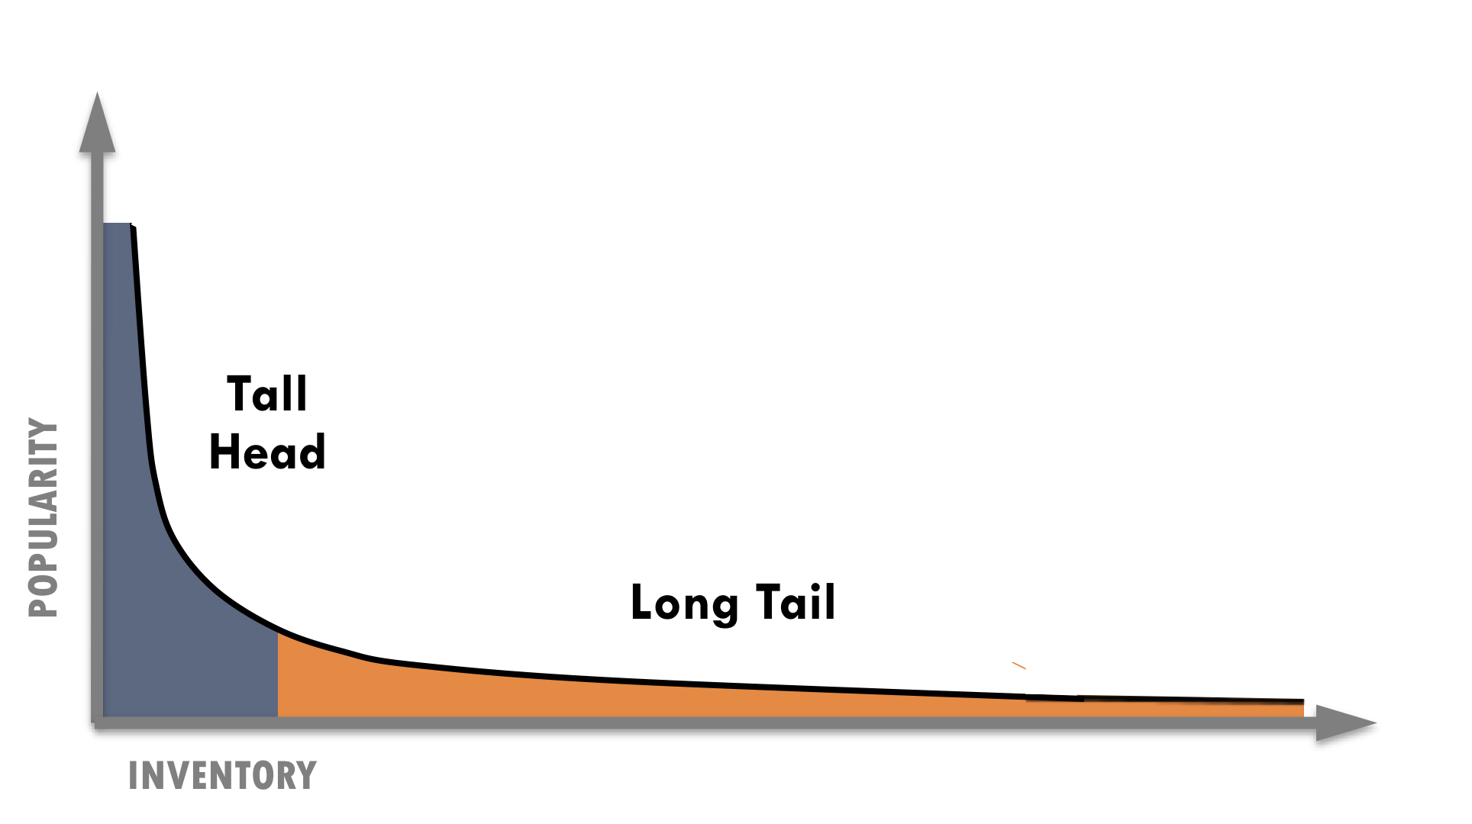
While many consumption patterns are at play in the online environment, two are particularly important to the new competitive landscape: power law distributions and social cascades. Both of these are more volatile and less predictable online, potentially creating opportunities for independent media.
Since Chris Anderson popularized the term “The Long Tail” in a 2004 Wired magazine article, the concept has become the basis for countless business models. Before the term was prevalent, Amazon had already grown from the effects of a Long Tail—which essentially describes the graphical representation of the demand curve for all books available in the world, 80% or more of which are not sufficiently in-demand to justify the expense of stocking them in a bookstore. The economics of combining broadly eclectic tastes with efficient distribution is what make it work.
The Long Tail flips the conventional business logic of “power law” on its head by capturing value online from the Long Tail of the less popular, less profitable content. In recent years, the promise of The Long Tail has become the predominant myth for the future of online business. People believe it can work for most online business models. However, the success of a long-tail model hinges on being able to provide a large scale of niche products at little to no marginal distribution costs. If the collective number of products in the tail is not large enough, it will not work. In other words, it serves the interests of big corporations, not independent producers. In fact, in his critique of Anderson in The New Yorker, Malcolm Gladwell asked, “Why are the self-interested motives of powerful companies being elevated to a philosophical principle?”
Power Law (aka “rich get richer effect”) is a self-reinforcing positive feedback loop. For example, the more babies are born, the more people grow up to have babies, or the more money you have in the bank, the more money you earn to put in the bank. This dynamic shows up in nature, social systems, financial markets and many other places.

To make matters worse, since news goes out of date quickly, the Long Tail is limited for journalistic organizations. Furthermore, since many types of media production often require considerable expense (e.g. investigative journalism, television dramas or console video games) the Long Tail may often be insufficient to recoup costs. For example, Netflix’s long-tail model worked for distributing other producers’ films, but when it came to their own films, production costs were prohibitive. NetFlix closed its Red Envelope Entertainment division in 2008 after investing in more than 100 film productions and losing money every year.

The power of “power law”
The Long Tail certainly still has value for many businesses, but it does not serve everyone. Despite its myth as the secret to online business, considerable power still remains in the tall head of the curve, where most of the action happens.
The significance of the tall head has been reinforced in studies of online media with sites such as YouTube and Flickr. For example, those sites that have a large number of links due to length of existence are the ones that get more new links. Don Hazen, Executive Director of AlterNet (TMC member), described the site’s historical success in terms of power law. Since AlterNet was one of the first news portals, it has far more backlinks than their peer progressive sites (over 2M on Yahoo! alone), which helps maintain sizable traffic (3.2M visits/month in late 2008).
“Should You Invest in the Long Tail?” Anita Elberse asked in her 2008 Harvard Business Review article. She wrote: “Although no one disputes the lengthening of the (long) tail, the tail is likely to be extremely flat and populated by titles that are mostly a diversion for consumers whose appetite for true blockbusters continues to grow.” In fact, Shirky claims the more that diversity and freedom of choice increases, the more extreme the inequality becomes. Power law is a counter-intuitive notion that can offend many people’s sense of fairness, but a phenomenon that can be denied, ignored or leveraged. The trick for independent media organizations is not to force fit the Long Tail to their business models, but make strategic moves to leverage unstable power law dynamics of online media.
When media outlets could manufacture popularity by pushing content on consumers, journalism’s power law was locked in and stable. Now that there are many fast-changing dynamics and new windows of opportunity exist. Shirky said, “There will be some places that get very large audiences every day. In the space that the independents will preserve are the spaces where people are looking for alternative views that are harder to scale.”
As we have seen with YouTube and Twitter, new platforms create new stars, usually those who are first on the scene. Industry volatility and lower competitive barriers mean that new players can establish a beachhead on a new platform and leave incumbents behind. Yet today, more than ever, independent media has the chance to break through since dominant companies no longer have power law locked in. If independent media can strategically innovate, they can leverage their existing audience to become first movers with new technologies and platforms that will inevitably continue to emerge.

Cyber-cascades & superdistribution
The Web’s viral dynamics cannot be fully understood without considering social cascades—how information spreads socially. Cascades have been studied in many fields since the 1950’s, including sociology, economics and psychology. They reinforce or oppose conventional thinking, depending on their source. Cass Sunstein, who recently became President Obama’s new head of the White House Office of Information and Regulatory Affairs, described this phenomenon in his book, Republic.com 2.0. He explained that cascades either lead people to conform to a crowd in order to protect their reputation, or form an opinion based only on opinions from others (instead of their own judgment). In either case, the “behavior of the first few people can, in theory, produce similar behavior from countless followers.”
A 2008 study comparing dissemination of popular photos on Flickr to epidemiology found that social networks caused popular content to be as much as 38 times as infectious as HIV and 10 times that of measles.^{N}

“One freak-out that is just getting started is superdistribution,” Shirky noted, which is largely based on the effects of social cascades. Wikipedia defines superdistribution as products entirely free of copy protection and made publicly available. In other words, they are free of physical distribution’s limitations. Since information sharing no longer has transactional costs and has risen to warp speeds, the social cascades that have always existed are now on steroids—which Sunstein calls “cyber-cascades.” As a result, online social networks have simultaneously ratcheted up both amplification and filtering of information. Shirky said, “Superdistribution’s remarkable property is that content can spread widely without being sent to people who don’t care about it.”
“The transformation of newspapers from enterprises devoted to objective reporting to a cluster of communities, each engaged in its own kind of ‘news’––and each with its own set of ‘truths’ upon which to base debate and discussion––will mean the loss of a single national narrative and agreed-upon set of ‘facts’ by which to conduct our politics.
– Eric Alterman^{O}

People have been talking about viral spread for a long time, but superdistribution takes it beyond an important threshold: a single story can now hurdle the readership of its original publication. “For instance,” Shirky explained, “when the Boston Globe printed an article about the priest abuse scandal, that single article had a bigger distribution than the entire nominal circulation of the newspaper. It used to be that an article was a subset of a newspaper, but that’s not the case anymore.”

Superdistribution: the new mainstream
Superdistribution also has potential value to create social good. Old mainstream media had value in its ability, as a “solidarity product,” to generate a widely shared experience. In Republic.com 2.0, Sunstein wrote, “General-interest intermediaries (such as newspapers or TV), if they are operating properly, give many people, all at once, a clear sense of social problems and tasks.” The scale of their reach, he claimed, can help ease social interactions and promote shared hopes, goals, and concerns.
In contrast, independent media’s value comes from promoting alternative conversations that challenge the mainstream media’s conventional shared experience. A popular metaphor in progressive circles is the “echo chamber,” in which a message is repeated so many times that it pushes the larger public or the mainstream media to acknowledge, respond, and give air time to progressive ideas. If done well, the message within the echo chamber can become the accepted meme. Many media organizations and think tanks have used the echo chamber effectively for advocacy purposes by repeating memes across several platforms in order to build buzz, impact political dynamics, share public opinion and change public policy. If the messages in the echo chamber are not done well, they simply remain insular and preach to the choir.
“As a result of the increased options, the most highly rated show on current network television has far fewer viewers than the fifteen most highly rated shows in a typical year in the 1970s.”
– Cass Sunstein

Today, however, alternative and mainstream conversations less clearly differentiated. Since superdistribution’s mega-hits can far surpass a single publication’s circulation, the story itself drives shared experiences more than a media outlet. It’s much more unpredictable. In many ways, superdistribution may be the new “mainstream,” whether or not it is caused intentionally.
Superdistribution’s very uncertainty is a key opportunity for independent media. Sunstein wrote that “the Internet greatly increases the likelihood of diverse but inconsistent (social) cascades.” He recounted an experimental 2006 study about inequality and unpredictability, which compared user’s music consumption. Interestingly, the experiment’s most popular songs varied in unpredictable ways. The researchers claimed that “When individual decisions are subject to social influence, markets do not simply aggregate pre-existing individual preferences.” As a result, although individuals and organizations may fail to predict success, they can help create it. This is how an echo chamber can spark social cascades and be most effective. Yet, echoing messages is not the only solution; technology and community design are equally important. For example, early studies have shown that webpage design and community features can have a strong correlation to surges in social cascades that underpin superdistribution.
Superdistribution has made one-hit wonders possible without a standing publishing platform, yet publishers can still tap it in clever ways. For example, the proponents of the “free economy” say that if the unit cost of something approaches zero, you should treat it as zero and use it to sell something else. Superdistribution can enable publishers to do just that, especially since they no longer have as much control of capturing value from their content.
The major implication for independent media is that they can still promote shared conversations that challenge conventional ways of thinking. However, instead of fighting for mainstream media companies’ attention, independent media organizations have greater opportunity than ever before to bypass them altogether, if they focus on understanding their customers and mastering new social media. In fact, the new target of independent media might now be more of an ephemeral one: the crowd. While the problem of oversimplifying complex issues is nothing new, online media has enabled a decentralized populism that blunts nuanced thinking more than the powerbrokers and gatekeepers did in the centralized mainstream institutions of the past.

Tidal waves for all types of media
Just as all forms of media are converging, so are all the competitive pressures described in this chapter—every type of media from television to video games face tidal waves. “While these crashing waves have been most deeply felt by the print media, they are also lapping at the foundation of television, the medium that, for decades, has been the most popular advertising medium of all,” wrote Jack Myer in March 2009. In terms of video games, which are often lifted up as hallmarks for the possibilities of new media, Matt Richtel wrote: “Booming video game sales are masking a serious concern for game makers: their economic model is in peril. Game companies are taking in more money, but, in many cases, not profits. … The problem is a marked shift in the economics surrounding the PlayStation and Xbox consoles. Makers cannot charge enough or sell enough games to cover the cost of producing most titles. As with the Hollywood movie studios, video game makers have to hope for a blockbuster.” Richtel also pointed out a dynamic that is already so familiar to newspapers: “Cheap or free games on the Web and for smartphones are winning gamers’ time.” The video-game market has expanded with more women and older gamers, yet there are more devices (consoles, computers, cell phones), cheaper games and more consumer choice.
“Over the past few years, broadcast networks have profited from the economics of a supply-demand model by raising their CPMs as gross ratings points declined and ad inventory decreased. The changes afoot, while challenging, are long overdue.”
– RazorFish Digital Outlook Report 09

CHAPTER 2
NEW COMPETENCIES: What new capabilities are needed to succeed?
Media organizations are developing new competencies as they shift from the old to new paradigm highlighted in the chart below.
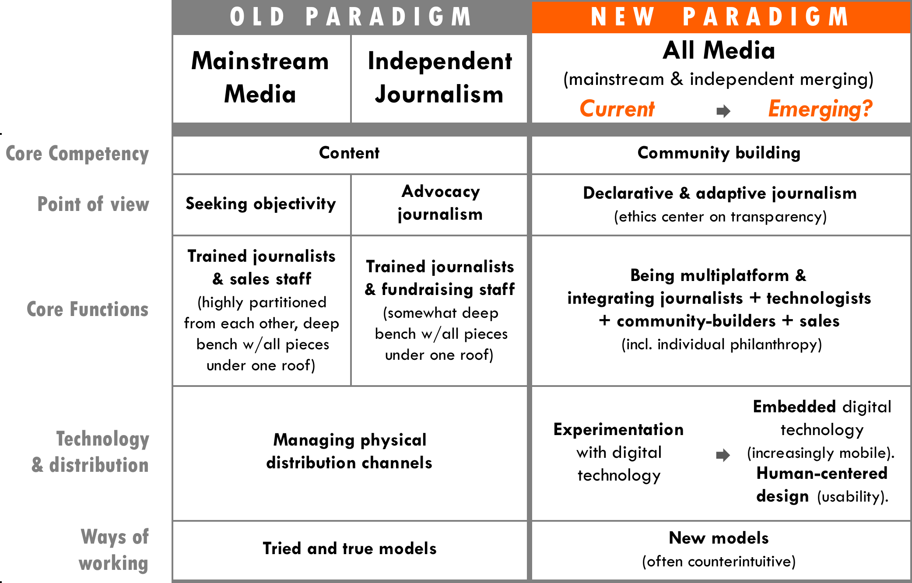

The new competitive landscape requires publishers to build many new competencies from community building to strategic use of technology, multi-platform agility, greater integrated organizational functions and an ability to experiment, which many require counterintuitive ways of working. This chapter covers the following topic areas in emerging competencies.

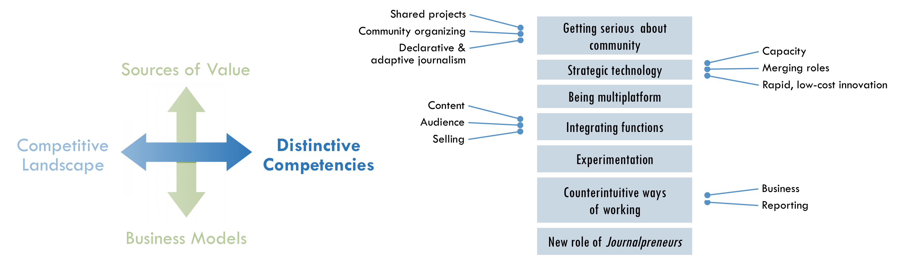

Getting serious about community
Many people in the media industry are talking about building community, but what does that really look like? “It’s not just enough to have a place where readers talk back—or the classic letters to the editors pattern,” Shirky said. “Rather it’s about providing a platform for readers to coordinate with one another. That’s a really radical shift because in part because it means you have to take community seriously.” In the past, journalism organizations had a deep bench with all the pieces under one roof, but a key competency for the new environment is having deep engagement with users and communities in a way that can also grow to scale. For TMC, scale could be achieved through a shared platform among members.
“Publishers can fight it and cling to old, crumbling distribution models, or they can get in the game themselves by offering content producers sophisticated ways to reach/observe/respond to reader behavior, directly.”
– Johanna Vondeling,
Berrett-Kohler

Real membership equals shared projects
“The word ‘membership’ has a nice feeling, but what media outlets usually mean by this is: give me money and we’ll give a product or access. But real membership is about coming together on shared projects, and this is extremely rare.” Shirky claimed, “The convening power of media organizations is a power they haven’t used because of their model, but the potential is huge.”
“The Metaverse needs to be built differently. It will be so enormous that only distributed approaches to creation have any hope of generating its content, thus users must build the world they live it.”
– Cory Ondrejka,
co-founder Second Life^{P}

Shared projects are a point on the continuum of user-generated content from crowdsourcing to co-meaning making (p38). An interesting example in the United Kingdom has been the Atheist Bus Campaign, in which a spontaneous campaign to raise £135 to put “There is no God” messages on 800 buses went global. Online gaming has led innovation in shared projects, particularly “avante-gaming,” which mixes real-world interaction with online communities. Similarly, “micro-volunteering,” simple tasks done on mobile phones, has great potential for journalism and is being developed by organizations such as The Extraordinaries. For example, news stories could spark a coordinated micro-volunteering effort, which is reflected in real time below stories and rolled up to reveal all actions taken by the site’s users. Ranking the most active members could build community members’ reputations and sense of loyalty to the site.

Role: community organizing
Publishers and journalists alike will take on the role of a classic community organizer. Amanda Michel, one of the founders of Huffington Post’s OffTheBus who now works for ProPublica, said, “I’m not a journalist by training and I directed the project using the online organizing tactics I learned on the campaigns of Howard Dean and John Kerry. Unlike traditional organizers, Web organizers communicate and organize using online tools.”
Traditional journalists often do not like to mix community organizing with journalism because it can contaminate the credibility of the reporting. However, as the competitive landscape shifts from scarcity to abundance of information and voices, the ability to “cover” the news in an objective way is no longer the key competency needed. An interesting comparison can be made to the Sierra Club, an environmental nonprofit that emerged from traditional community organizing. The Club has its own bimonthly magazine, Sierra, which is a benefit given to all its members for no additional payment. Although the magazine’s reporting may have less influence in some circles because of the issue-bias of the organization, the club has had considerable social and environmental impact because of their strong organizing tactics with 716,000 dues-paying members. At the same time, these members supported the club to the tune of $40.6M annually in 2007. Although Sierra magazine may never have the credibility of independent journalism, and TMC members’ may never surpass the community-organizing competency of a fully-fledged membership club, there are many things independent media could learn in order to tap the value of community and compete for attention in new ways. Care2 and Change.org are already mobilizing communities around blogging and journalistic content. What if TMC members became news organizations with more robust membership programs that they can activate for social action?

Declarative & adaptive reporting
If community building becomes a new competitive advantage, then declaring a perspective may become more valuable than seeking objectivity. Hirschorn wrote that if journalism was no longer weighed down by the need to create an omnibus news product, then “reportage could make the case for why it matters, and why it might even be worth paying for.”
Jonathan Krim of the Washington Post called for “declarative journalism,” where reporters are able to be more honest about their own views. The Economist, a bright spot in the magazine business these days, could be growing partly because of its distinctive style and perspective. Similarly, readers often value progressive publishers for their strong point of view. For example, AlterNet (a TMC member) aims to counter right-wing media and sees its mission as promoting a progressive vision through what it calls “strategic journalism”—a deliberate step away from objectivity.
With a declarative approach, journalists may increasingly become instigators, who are the subject of news in addition to reporting it. For example, Jon Stewart’s very public hard-nosed debate on The Daily Show with CNBC’s Bill Cramer made news itself. Similarly, cable news hosts Chris Matthews of MSNBC and Larry Kudlow of CNBC made news when they seriously considered running for political office. Conversely, via outlets like the Huffington Post and Air America, celebrities are increasingly venturing into political commentary and even reporting.
Getting serious about community could require reporters to go one step further to adaptive journalism, where reporters declare a point of view and adapt it based on engagement with a community of readers. As a result, journalists may need to adapt the ethical framework of their profession in order to build communities. Based on her experience with OffTheBus, Michel wrote, “Transparency and disclosure, rather than neutrality—often tainted if not patently false—must become critical fourth-estate virtues.” Battelle believes that transparency and integrity can be as simple as “telling people what you’re doing, telling people why you’re doing it and letting them make their own decisions. If they think you’re crossing a line, they tell you and then listen to them.”
- Strategic recognition
What if… we made it easier to deepen communities at a larger scale?, p16
"Our reporters do not cover stories from their point of view. They are presenting them from nobody’s point of view.”²
– Richard Salant, President of CBS News (1976)

“If you’re a journalist in traditional environment that is either allergic to or has an immune response against the approach of openness and transparency in how you do your work it’s a terrible, terrible time to be in the media world because you know you just aren’t going to succeed in that new environment.”
– John Battelle

Journalism that declares a perspective and adapts in response to user engagement may even hold promise for democracy in our country. In his New Yorker article, Eric Alterman drew a contrast between the news cultures in the United States and those in Europe, which “long ago embraced the notion of competing narratives for different political communities, with individual newspapers reflecting the views of each faction. It may not be entirely coincidental that these nations enjoy a level of political engagement that dwarfs that of the United States.”

Strategic technology
Taking community seriously requires a greater allocation of resources toward both technology and the personnel who can use it effectively. “Many organizations only see one piece of the puzzle and want to do small experiments—hire an intern and a few people here and there—without seeing how that impacts the rest of the media,” said Soni. “People who do have knowledge of the other pieces of the puzzle can do real systemic innovation, and this is the highest area to impact.”
“Most companies and organizations that I see don’t have the ability to use technology strategically.”
– Ashish Soni

- Investing in capacity. “Publishers still see journalists as the core and that budget should go to editors/writers,” Soni noted. “You hear media companies talk about the importance of technology, but pay attention to what they actually do and not what they say. In my experience, they talk about tech but aren’t willing to pay for it.” At a large scale, particularly when it comes to content generation, it is often not enough to increase technology investment alone, but also the personnel that make it strategically useful. For example, Sierra Club made significant investments in software such as Care2, a service to acquire emails, and Convio, a new constituent relationship management system (eCRM) that synchronizes communication touch points and membership status across all their databases and 63 chapters. However, the new strategies they developed are equally important for using that technology to increase online fundraising and advocacy effectiveness. Similarly, when OffTheBus crowd-sourced fact checking through a database, it was their strategy to pair anecdotes with users’ information and sort by zip code that made the difference. Many people in media talk about the importance of building “lists” (i.e., databases of constituencies, donors or subscribers), but it is equally important to use those lists to build meaningful connections.
“The problem wasn’t getting content; hundreds of submissions came in daily. But the scope of our collaborative-reporting assignments frequently outstripped our writers’ capacity to turn all those data into cogent stories.”
– Amanda Michel, OffTheBusK

- Merging roles of journalist and technologist. Reflecting on her biggest lessons as general manager for NYTimes.com, Schiller (now CEO of NPR) said, “Don’t think about technology as the end of the process but as integrated into the process. Developers should be part of the journalistic process, and depending on their training, the right developers are journalists. What the web is doing is not just converting news into an online experience, but it’s creating a whole new journalistic experience.”
- Rapid, low-cost innovation. At a time when companies are cutting back and laying off employees, it’s hard for organizations to innovate. However, Soni said, “There is often an inability to do what I call rapid, low-cost innovation. This kind of innovation is important because in these times we don’t know what’ll work and what won’t, all we can do is rapid experimentation and see how the consumer responds.” In this regard, Soni said that using search to understand customers is more valuable than running traditional focus groups. “Search is an active process—not passive—me actively going in looking for something that demonstrates an intention. That’s what makes it real.”
“The number one challenge is that the definition of your list changes in a multi-media environment. Once upon a time, it was simple: you have your subscriber list from which you derive your donor list, list rental revenue, advertising sales, etc., but what do you do if 70% of your traffic comes to read a story on the website and leaves?”
– Jay Harris, Mother Jones

Being multiplatform
The lines separating print, radio, TV or film can still largely define the core competencies of publishers and producers. They have historical roots in these separate forms, each with its own set of business models, distribution systems, practices and professional fields.
Platform convergence can be as much of a cultural and organizational challenge, as it can be a technical one. It can require media organizations to retrain or replace staff who are unable to manage multiplatform production. Adam Berrey, Senior Vice President at Brightcove, a leading online video platform said that one of the mistakes he sees companies make is “underestimating what it means to be in more than one platform and how each platform is actually distinct, even if you’re carrying a brand across them, and even if you’re leveraging content assets in both places.” For example, selling to advertisers when a publisher goes multi-platform is more complex. “It’s not like, ‘here is my rate card for my website and here is my rate card for print.’ And, even worse, the print staff is selling separately from the web staff, or the print staff is trying to sell the web when they don’t really understand the web.”
“To be a multi-platform media company,” Berrey explained, “means you have a great sales organization on the advertising side that knows how to build products, that knows how to construct sponsorships, that can work with editorial in really, really smart ways, and that can speak to advertisers on these different levels.” This level of multiplatform integration is what Battelle calls “Conversational Marketing,” which in a blog post he said meant more than simply putting Twitter search results on your website. “It means taking your core assets—the data that drives value and knowledge inside your enterprise—and offering it as fuel for the collective intelligence of all your partners—your channel, your vendors, and, ultimately, your customers.”

Tightly integrating functions
“When you’re dealing with small organizations (e.g. independent media) and you have one weak link—one or two mediocre people—suddenly that whole part of the organization isn’t nearly what it needs to be.”
– Adam Berrey

Historically, the central competencies for traditional media organizations were divided between highly trained journalists and business expertise. This structure works when the benefits of specializing in a functional area are greater than the benefits of being responsive to the market. In today’s rapidly changing market, media organizations increasingly need to integrate multiple functions to succeed, sometimes using the same employee to do so.
Berrey has worked with many online publishers at Brightcove and believes that a successful media company must integrate three fundamental pillars. “First, can you create and put together content and service that are valuable? Second, can you market this content and service in a way that an audience of consumers is really engaged with and invested in? Lastly, can you turn the attention of that audience into viable advertising products and have a sales team that can really move those products with the advertisers that want to reach your audience?” Berrey went on to explain, “Often times, you’ll see people who might be good at one or two but rarely do you see folks that are really executing all three with excellence.”
Furthermore, since content, advertising, and the entire online experience are perpetually evolving, the best way to be market-focused with Berrey’s three pillars is to tightly integrate the functional areas in an organization as Schiller did at The New York Times. “Integrating the print and the online newsrooms was essential,” she said.

Experimentation
“Those that focus their attention on innovative business models and optimized services in the next several years, and who offer vision, expertise and leadership will discover a marketplace that is far more receptive to them than to their competitors who continue to depend on the ‘tried and true.’”
– Jack Meyers??

In Eric Alterman’s New Yorker article in March 2008, “Out of Print: The death and life of the American newspaper,” he said that the Huffington Post, almost by accident, discovered the right formula for online journalism. On Colbert Report, Twitter co-founder Biz Stone said that the service started simply as a side project.
“There is such a dearth of models, people try to grasp at straws,” Bracken said. “People need to get out on a limb try new things for where there isn’t a model yet.” However, Bracken also acknowledged that new models are a “hard sell” to funders since they are unproven. Often experiments have to be funded internally at first as AlterNet did to start their online advertising business and Sierra Club did to build their online membership program.
“If the old model is broken, what will take its place?” Answering his own question in a blog post, Shirky answered, “Nothing will work, but everything might. Now is the time for experiments, lots and lots of experiments, each of which will seem as minor at launch as Craigslist did, as Wikipedia did, as octavo volumes did.”
Publishers cannot underestimate the role of serendipity, yet luck is certainly not enough to build a business upon. However, TMC could help support “rapid, low-cost innovation” among its members, reducing the risk for any one organization, and helping the field adapt and change faster.

Counter-intuitive ways of working
Experimentation includes trying counterintuitive ways of thinking about doing business and producing content. The challenge is that they can often fail and it is often hard to convince funders and investors to take risks on unproven models as Bracken noted in the section above.

Counterintuitive ways of doing business
Many organizations in both the for-profit and non-profit world view competition for resources as a “zero sum” game. While competition is inevitable, many people have embraced the idea of “co-opetition,” which hinges on a separation between the areas that organizations have competitive advantage and where they believe that they can compliment each other in a way that lifts the tide for everyone. For example, Hollywood studios believed that VCRs would keep people from going to the movies and were so threatened that they fought to tax blank cassettes, which in the long run, they were fortunate to lose. By 1997, VCR movie rentals became a $12 billion business, effectively tripled the potential revenue sources for Hollywood.
While the VCR example may now seem intuitive, competitive stances based on conventional business intuition are still commonplace. For example, for a long time, publishers avoided including hyperlinks to other websites for fear that they would simply lead readers away. However, publishers now realize how important these links are to improving search engine optimization.
These are just a few well-known examples, yet new ways of working that now seem counter-intuitive will emerge. The key to co-opetition is for organizations to define very clearly where they are competing and where they should work together.

Counterintuitive ways of reporting news
Fast Forward
Emerging value chain of journalism, p49
- Strategic recognition
What if… we actively coordinated “deal-making”?, p10
Some of the potential implications for journalists in the new environment of cyber-cascades and superdistribution may be to report the news in ways that run counter to traditional journalism.
For example, journalism organizations could find new ways of making news more entertaining and enjoyable. According to a 2008 survey in by the Pew Research Center for People & the Press, “Enjoyment of the news has consistently been associated with higher levels of both news interest and news consumption.” In fact, the report claims that no single attitude is more important.
It is no surprise that The Daily Show and Colbert Report are so popular, particularly with young people. Despite the fact that many people would debate whether these shows are journalism, Stewart often asks questions tough-minded as you would see on any serious TV news show. It is arguably harder to make people laugh than it is just to give them the facts and surely even more difficult to do both. In addition, Stewart makes people think too and, as a result, attracts a well-informed audience. In the Pew Research Center’s survey, 30% of The Daily Show viewers answered three political-knowledge questions correctly, compared to 18% of the general public. In fact, The Daily Show viewers are more well-informed than those who watch CNN, even though a larger proportion of CNN viewers are college graduates and the cable channel has double the portion of viewers over age 50.
Rapping news headlines has proven successful for entertainment news and has begun to catch on for broader topics. Chicago hip-hop artist, InFiNiTe-1 condenses celebrity news in a segment on the E! network’s “The Daily 10,” and Flocabulary produces a broader news recap with The Week in Rap for teens and students online and for Channel One. YouTube users such as MCMrNapkins and BretterDays have also begun to rap the news.
The definition of “quality” news could incorporate a greater focus on entertainment value. Of course entertainment is not limited to comedy or rapping; new online platforms could find ways to make news more enjoyable in other ways. The definition of quality journalism could also be served by incorporating an even greater emphasis on entertainment value.
Furthermore, the metaphor of “gossip” is another notion that runs counter to traditional journalism. Some reporters and editors may view this approach as too low-brow for serious news, yet they will lose ground to those who master the social dynamics of gossip to break important stories. Shows such as The Soup, The Dish, and Tosh 2.0, as well as sites like The Daily Beast, Drudge Report and Wonkette demonstrate an appetite for cheeky, gossip-driven coverage salted with political and social commentary.
By the end of 2009, Google will launch “Google Wave,” a new approach to online communication and collaboration that could be a promising tool for journalists. Its founders say, Google Wave would be how email would work if it were invented today rather than 40 years ago. Jeff Jarvis, journalist and creator of BuzzMachine claimed, “Wave is what news can be if we invent it today, as we must.”

Shifting roles
The new competencies outlined above are some of the key ones needed to succeed in the new competitive landscape described in the previous chapter. As a result, traditional roles in journalism are shifting. In fact, many different roles are merging, which reflects how journalism is now more of a process than a product. The central challenge of shifting roles is that they threaten many people’s jobs, pensions and familiar ways of working.
“Publishers need to think of themselves not as publishers, but as community builders.”
– Don Tapscott

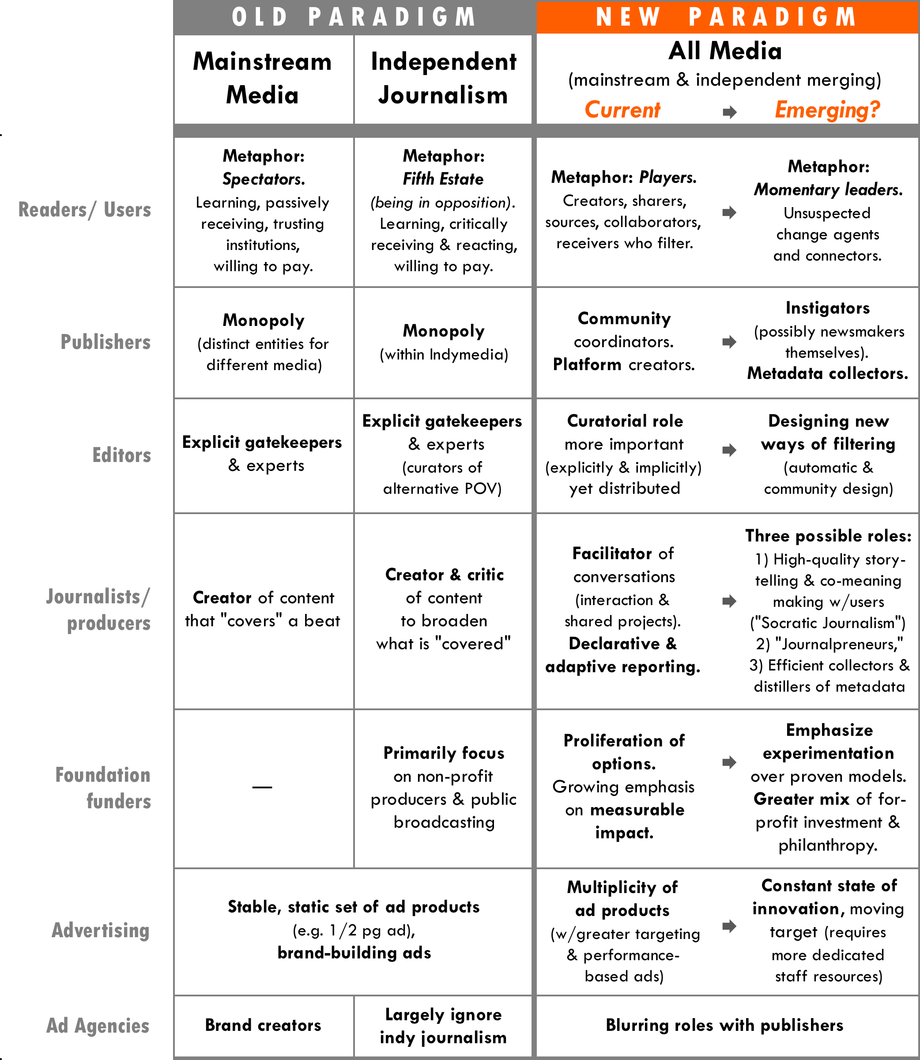

New role of Journalpreneurs
As journalists master the key new competencies, many are becoming “Journalpreneurs,” which are taking the best practices from business and integrating them with their traditional work to improve the world.
The success of citizen-journalism efforts have demonstrated that a market demand exists for individual citizens who want to be involved in the journalistic process in some way or another. For example, more than twelve thousand people signed up to participate in OffTheBus leading up to the Presidential elections, seventeen hundred of whom were writers. Many organizations offer journalistic training to citizen media makers, such as J-Lab’s Knight Citizen News Network and the Center for Independent Media.
“I think the winners are going to be the entrepreneurs. I think the entrepreneurs who start companies like Huffington Post and Twitter and others are going to be the ones around ten years from now.”
– John Battelle

On the professional media-maker side, Hirschorn suggested in an Atlantic article that writers such as Thomas Friedman, Paul Krugman, and Andrew Ross Sorkin could be “worth a great deal on the open market” by becoming a brand-of-one and “perhaps more profitable than fighting as part of a union for an extra percentage-point raise in their next contract.”
While roles in traditional journalism organizations have been shifting and professional-amateur collaborations have been growing more than ever, a growing segment of “Journalpreneurs” (journalist-entrepreneurs) have emerged as well. Journalpreneurs are a slightly different shade of journalist than citizen-writers or well-known professional writers. They could be characterized more by the entrepreneurship of Amanda Michel than the thousands of citizens she coordinated through OffTheBus (already the fourth organization she had launched) or Chris Dykstra and Jason Barnett, who started The UpTake, a Minnesota-based citizen journalism venture that helped feed mainstream reporting of the Coleman-Franken race. The UpTake has utilized low-cost technology such as live broadcasts from cell phone cameras.
“The media world needs to act and think more like tech entrepreneurs.”
– Ashish Soni
“Federated Media, the company that I run, works with about 170 different authors and publishers and of those I’d say the top 20% of those are not only making very good money, they have staff.”
– John Battelle

Battelle described Xeni Jardin as an example of someone who had come from professional ranks. Jardin has traveled the world for NPR, Wired, and CNN shedding light on stories to which no one was paying attention. She works only for Boing Boing now, where Battelle said, “She’s actually more like publisher as well as a reporter because in this world you need those skills.”
There are many serial entrepreneurs like Michel, Dykstra, Barnett and Jardin, who come from a wide array of disciplines such as technology, community organizing, online media and even traditional journalism. Furthermore, journalism students are emerging with a greater mix of technology, writing, marketing, new media and entrepreneurial skills. This emerging segment of Journalpreneurs could be a key opportunity for TMC in supporting the field of independent journalism.
- Strategic recognition
What if… we evolved our composition to reflect the emerging field?, p2
By evolving its membership to integrate this emerging segment of Journalpreneurs with its current members, TMC can build a broader, more diverse ecosystem of people who produce content in many kinds of non-traditional and entrepreneurial ways, as well as stay at the forefront of the shifting new media landscape.

CHAPTER 3
NEW SOURCES OF VALUE: What needs can be met, problems solved or desires fulfilled?
In the old paradigm, the content that created the greatest value for mainstream media had centered primarily on the most popular ideas. For independent media, the value had been based on alternative ideas. Today, a greater mix of the two are creating value, increasingly determined by what reflects “my ideas”—a combination of greater personal expression, remixing and filtering.
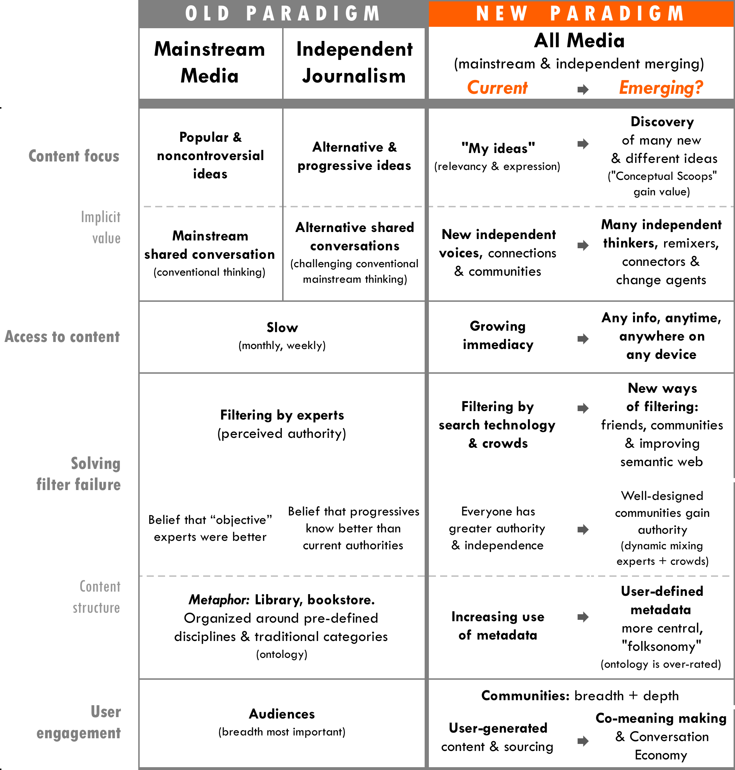

This chapter covers the following topic areas in the emerging sources of value a media organization can capture.
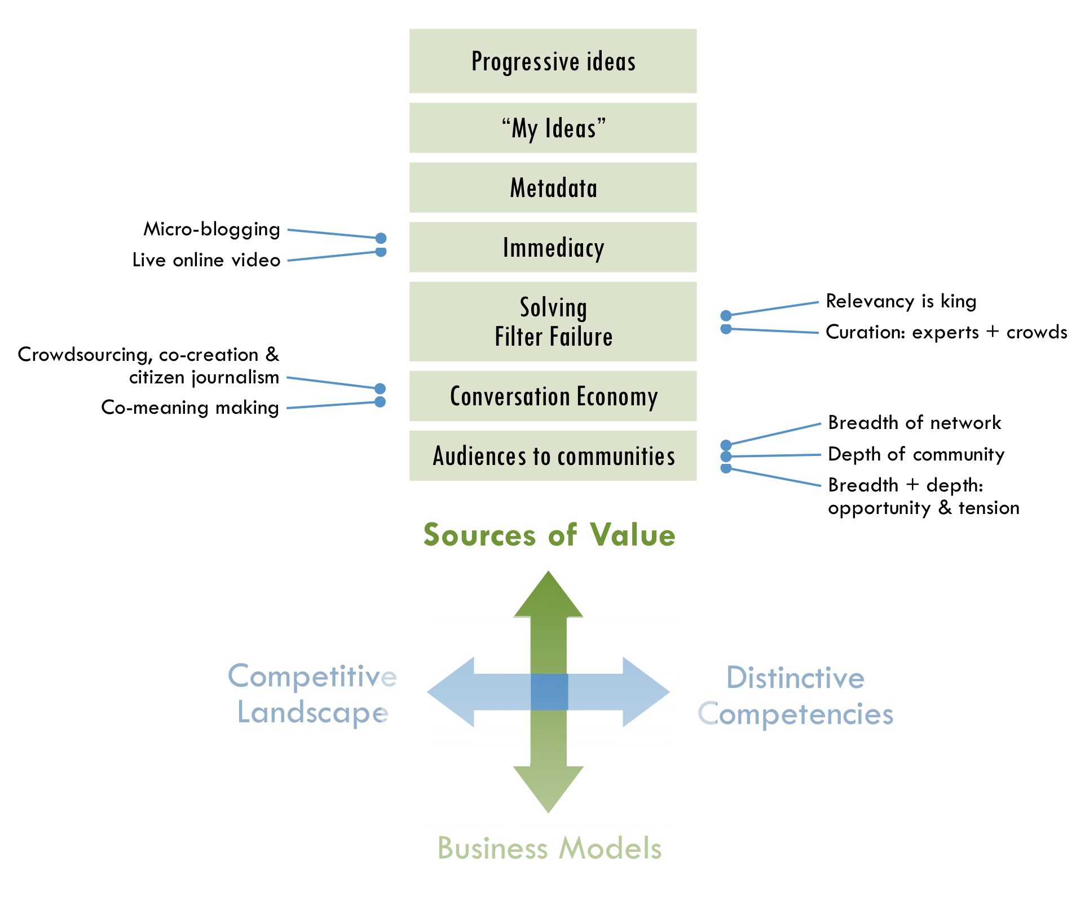

Progressive ideas
Progressive publishers have shed light on many important recent issues, such as the implosion of the housing market long before the economic crisis and premature predictions about the Iraq War leading up to the invasion. A significant value of independent media is to help underserved communities address unmet needs.
The new political environment has shifted the context in which progressive publishers operate. In the Bush era, being in opposition had a large effect on the identity and tactics of “progressives.” Despite the euphoria about Barack Obama’s presidency, the new administration will inevitably have its share of disappointments for the progressive community, making the role of watchdog still important. However, the political shift also affects how progressive publishers generate value. For example, Jay Harris believed that interest in Mother Jones (a TMC member) may have been strengthened because of readers’ concerns about the Bush administration. This is a belief that others in progressive media have expressed as well. A clear enemy can help build funders’ and audiences’ perceived value for editorial content with a strong oppositional point of view. In this new political context, publishers may be able to generate as much value by facilitating politically diverse conversations that promote the underlying progressive values of inclusivity and fairness, as they can in the traditional role of a watchdog. As a result, the definition of “progressive” may broaden, and the label itself may become an anachronism.
“We tend to self marginalize. We can be much more inclusive and therefore build much stronger movements, create much more opportunity for diversity among us.”
– Sarah van Gelder

“A broader cross section of people generally, and liberals specifically, have figured out that media was a problem, and say ‘I have doubts about whether preemptive war is a good idea, but I can’t really find out what is going on.’”
– Jay Harris

The new political and media environment has caused progressive media organizations to reevaluate their identity and tactics. For example, at TMC annual meeting in February 2009, members discussed whether alternative thinking falls on the traditional definitions of “progressive” anymore. There was debate among members about what notions would need to be given up in order for independent media to move forward. One group believed independent media needed to give up one-dimensional political stances and move to more broadly inclusive values such as human rights and global perspectives in storytelling. Another group believed that independent media must go even farther by giving up the need to articulate political stances altogether. They believed publishers should look more pragmatically at what works and what people want to know and focus more on being a trusted source of quality journalism. Identifying where the greatest value lies will help independent media resolve this debate and move forward powerfully.

“My ideas”
Whether it is popular or alternative, all content is increasingly valuable as it relates to “my ideas”—a mélange of concepts and interests that an individual develops throughout the course of his or her life. The personal expression of my ideas, mixing of other people’s content to fit my ideas, filtering content to reflect my ideas—all are an evolution of what Nicholas Negroponte of MIT’s Media Lab coined, “The Daily Me.”
“It’s not that there are new sources of content, which is how the media first tried to understand it, but rather it’s about the complete disaggregation of content and our increasing ability to pull together what’s interesting to us. And we do it socially—to others and for others. There is very little relationship to traditional media—both of them have content, but that’s about it.”
– David Weinberger

The proliferation of blogs and user-generated content are already a clichéd example of people’s demand for personal expressions, but Motoko Rich of the New York Times predicted a more interesting sea change: “The point may soon come when there are more people who want to write books than there are people who want to read them.” To be sure, many forms of media could pass this threshold of a greater demand for expression than consumption, and this dynamic creates opportunities that publishers are beginning to tap as well. For example, Hewlett-Packard’s MagCloud makes it easy for anyone to make their own slick print magazines, produced on-demand.

Metadata
- [Note: Based on initial feedback from reviews, this section is being further developed since there is so much confusion about metadata]
Simply put, metadata is “data about data,” and it has become more valuable than stories.

Now is the time for immediacy
Everything about the web is becoming more “live,” from activity feeds, micro blogging, live streaming video to real-time analytics. Consumers’ demand for accessing news, in particular, has become both more immediate and granular. Publishers work hard at adapting to this demand while also maintaining the value of content that requires more time and synthesis to create—trying not to get exhausted by the increasingly demanding 24/7 news cycle.
For example, although Mother Jones had been online since 1993, they began an initiative in 2007 called “Mother Jones 2.0” to move more aggressively into publishing content on a daily or hourly basis. This content was intended to supplement their bimonthly, long-form reporting. As a result, their online traffic doubled month-to-month from 2007 to 2008 (surpassing one millions unique visitors in September 2008), and they began to break news in a more immediate way. For example, motherjones.com was the first news source to report John McCain’s infamous “100 years in Iraq” comment during the 2008 Presidential election.
While many other independent publishers have tapped greater value with shorter cycles of reporting, much of today’s digital media is still prepackaged. In the future, demand for immediacy will become greater and push the limits of reporting and analysis even further. Micro-blogging and live online video are leading this trend.

Micro-blogging
Many people are turning to news that is even more direct and immediate, such as the micro-blogging pioneered by Twitter. An evolution of instant messaging in many ways, micro-blogging is asynchronous, hyper-short and enables one-to-many communication. To be sure, Twitter’s driving question—“What are you doing?”—has produced inane granularity such as, “rowell23: Wiping my dog’s butt!” However, individuals have also broken important news on Twitter. For example, the first published image of the Hudson River US Airways crash came from a mobile phone via Twitter (right) and content from Twitter has led the coverage of the Iranian election.

Live online video
In late 2008, live streaming video began taking off. Justin.tv has more unique visitors globally (22 million per month in March 2009) than the pre-packaged video site Hulu, and their users are as just as engaged, watching on average just over an hour of video per month. Traffic seems to be largely driven by live sports, although musical artists, churches and politician are also gaining traction as Justin.tv claims 428,000 do-it-yourself channels. Ustream.tv is the closest competitor with 1.4 million visitors per month. Seesmic is an example of real-time video conversation and Qik.com is leading live video for mobile devices. Despite the fact that the quality of video can be low in live video and illegal content proliferates, the value of immediacy is still clear and will increasingly be tapped for online news.

Solving filter failure
People have been increasingly concerned about “information overload,” and some believe that technology has made this worse. In an Economist.com Oxford-style debate, Richard Szafranski argued that technology has created “over-choice,” which he describes as a “human response to alternatives and variations so numerous, so potentially satisfying and so complex that humans can no longer decide easily.” Our time is limited and the more choices we have, the more time it takes to choose.
However, Shirky claims that information overload has been a problem long before the digital age, as anyone has experienced entering a library or bookshop. Ever since the amount of available books exceeded a person’s ability to read them in their lifetime, overload has not been the central problem to solve—it has been filter failure. “We had a set of filters that we were used to, but are now broken,” Shirky pointed out. The media organizations that help solve filter failure with greater relevancy, used of metadata and curation, will control the new decentralized distribution channels online.

Relevancy is king
Making information relevant to users has become the most important source of value. Even when it comes to advertisements, as it turns out, many customers want them when they are relevant and interesting.
“The real change has happened around meta-data, not content. It’s not about generating content, because content is cheap (and I say this as a content creator) but rather about which content pieces go together and how we present them.”
– David Weinberger

For search, the Holy Grail is to tap the “Database of Intentions” of every user online, which enables a user’s search to match his or her intentions. Yet, the perfect such database will never be fully realized. In fact, Battelle described this as one of the central challenges of the search business. “Search as a problem is about five percent solved,” Udi Manber claimed when he was CEO of Amazon’s A9.com search engine. Manber is now responsible for core search at Google.
The clear-cut ways of categorizing content based on a library/bookstore metaphor are disappearing, and a more complex, decentralized system of structuring and accessing content has emerged based on metadata derived from link relationships, contextual content, tagging, user behavior among other inputs.
At first, relevancy was largely achieved by contextual filters (the text on the page, a user’s search term and link information). Much of the metadata was an afterthought for publishers and search took care of itself. Today, publishers have successfully adopted strategies for Search Engine Optimization (SEO) to leverage contextual and link metadata. However, filtering based on metadata is becoming increasingly complex and important, including link history, social connections and now location information. Sophisticated ways of using metadata to achieve relevancy across multiple platforms is becoming the greatest source of value in solving filter failure and worthy of a corresponding level of effort on the part of independent media companies.
Consumers have become more receptive to behavioral targeting than contextual ads in recent years.
– Jupiter Research^{Q}

Curation: experts + crowds
“I think on the contrary what the blogosphere has proved to us that we need editors now more than ever.”
– Vivian Schiller

While any system creates many implicit filtering effects, curators also play an explicit filtering role. Their perceived authority is built upon a combination of a person’s faith in a curator’s access to content, judgment of quality and attention paid by others. However, this authority is fragmenting across a variety of sources (individuals, informal groups and organizations) and publishers are not able to capture the same amount of value they once commanded as curators.
The wisdom of crowds versus that of expert curators is slowly finding a balance. Each has its share of criticism. Crowds can lead to mediocrity, noise and groupthink. Individual experts can be limited in variety/scope and are more often than crowds, wrong. Together they can improve each other. Experiments that bring together these two sources of authority have begun to tap this value. For example, rules for self-organizing communities, which Wikipedia has executed so effectively, as well as “curating the crowd” are gaining traction.
News will likely become even more fragmented and granular than it is now. People are already pulling together many tiny pieces of information from lots of sources to form a picture of what is going on. As content further proliferates and converges across devices, users will increasingly turn to curators, whether it’s friends, friends of friends, trusted outsiders, publishers, automated filters, or more likely, a combination of them all. The media organizations that develop capabilities to help solve filter failure—equal to their expertise in content production—will most likely succeed in the future.
- Strategic recognition
What if… we standardized raw data, metadata & metrics?, p8
“This wisdom of crowds idea, it’s true, but you still have to have the right crowd. You can have stupid crowds.”
– Ashish Soni

From using users to a Conversation Economy
“I think the idea that (journalism) organizations can go away because now everybody is a journalist is ridiculous. It takes time, it takes investment, and it adheres to certain standards for it to be credible.”
– Vivian Schiller

With the proliferation of inexpensive production and publishing tools and do-it-yourself movements, everyone can consider themselves an expert. This trend gets mixed reactions from professionals, yet it will have increasing value as “net native” platforms evolve.

Crowdsourcing, co-creation & citizen journalism
Media organizations have used the growing market of amateur user-generated content as a way to reduce costs by “outsourcing” content production and sometimes aiming to tap distributed problem-solving. There are many terms to describe user participation in content production, which often overlap.
- “Crowdsourcing” is typically a broad or targeted “open call,” in contrast to the more integrated cooperative activity of the “open source” movement, and it has drawn skepticism from both traditional journalists and online innovators. For example, 42% of U.S. newspaper editors surveyed in early 2008 had reservations about the role of citizens beyond providing very small stories or basic information, while Jimmy Wales, founder of Wikipedia, called “crowdsourcing” an “incredibly irritating” term. “Any company that thinks it’s going to build a site by outsourcing all the work to its users,” he said, “not only disrespects the users but completely misunderstands what it should be doing. Your job is to provide a structure for your users to collaborate, and that takes a lot of work.”
“We discovered that politically involved people make great sources, especially en masse. They almost always disclosed more information, because they knew more.”
– Amanda Michel

On the other hand, crowdsourcing has proven to be valuable for source-finding and fact-checking for many journalistic organizations such as Talking Points Memo (TMC member). As another example, OffTheBus on the Huffington Post used 227 contributors to find out everything they could about Superdelegates in the Presidential election. Also, after news broke of that Hilary Clinton’s New Hampshire campaign office had been taken hostage, OffTheBus found a nearby member in its database and sent him to the home of Fox News’s alleged hostage taker, only to discover he was not involved.” New efforts such as Help Me Investigate are creating broader platforms for any journalist to use crowdsourcing in investigative journalism.
- New “pro-am” strategies to co-create content have begun to take root, in which people work together across traditional professional-amateur lines. For example, Jay Rosen, a New York University journalism professor, started NewAssignment.Net in 2006 to link professional journalists and amateur contributors. Some organizations have found pro-am projects to be expensive to manage, risky and journalistically uneven.
- “Citizen journalism” trains non-professionals in new technology and journalism to do the reporting themselves, which often does not involve professional journalists at all. Critics have said that this form of reporting often abandons “objectivity” and also has uneven quality. Citizen journalism has shown promise for hyper-local sites, including small towns that may no longer be able to support a traditional newspaper.

Co-meaning making
The larger story of the many experiments in user participation is the evolution of co-meaning making. Shirky pointed to developments in the scientific world as an example of the co-meaning making that is beginning to happen more in journalism. “The number of papers with multiple co-authors is increasing dramatically. It’s just simply harder and harder to do science as one. That’s because the problems are more combinatorial in nature.”
“… publications are conversations between three core parties—the author, the audience, and the advertiser. The best of these have a robust shared grammar, a voice that all three parties understand and respect.”
– John Battelle^{R}

“There is nothing greater than running through a story with a community that cares about it as well and makes it better.”
– John Battelle

Fast Forward
Getting more from advertising, p46
Media organizations can no longer afford to view users only as sources or DIY journalists, but rather need to engage them as participants and actors in unfolding stories. More sophisticated models are developing, and the nature of storytelling itself is changing. In a recent Columbia Journalism Review article, Amanda Michel of OffTheBus said, “There was a palpable joy among participants who transcended the role of spectator and created new narratives beyond those they were seeing in their daily newspapers day after day.”
Battelle calls co-meaning making the “conversation economy,” and it ultimately involves all players in the media ecosystem in a more transparent and adaptive way than every before. This particularly goes for marketers and advertisers who can often be walled off by journalists.

From audiences to communities
Since communities are formed in multiple and co-existing ways, people interviewed for this project varied in their opinions about how best to build communities and capture value from them to run a media organization. Trends in audience building can grow in two different directions simultaneously: broader and deeper.

Breadth of network
The goal of scaling up independent media projects is largely a question of breadth, whether it is geographical reach, aggregating many local or “niche” communities, size of members or the number of links to a site. AlterNet, for example, found that the breadth of links to their site, which has accumulated over years, is one of their primary reasons for success because these links generate tremendous traffic. “PageRank” which is the central measure of Google’s search algorithms is based on the breadth of links to a site. And, when it comes to viral marketing, it is the breadth of a network (formal or informal) that amplifies content. In online advertising, it is the breadth of reach that enables “ad exchanges” to reach large enough segments through contextual and behavioral filters.

Depth of community
Communities are often defined by depth—a measure of participation, identity, interest and expertise—all of which build a sense of loyalty and shared ownership. In many ways, depth is an extension of “my ideas” described above with the added value of meaningful connection. Targeted segments (“niches”) of broader audiences can be as valuable for community organizing as they are for advertising. Evidence has shown, however, that the price of advertising has not remained commensurate with the value it creates in targeting. Instead it has been more closely tied to how efficiently ad buyers can reach breadth.
“People deeply hunger for the opportunity to get together with the people who care about the same stuff.”
– Johanna Vondeling &
Ann Friedman

Examples of building community depth include hyper-local “micro news” that targets geographic-focused communities, and many sites are seeking to become their communities’ new digital town squares. However, a recent Forrester Research report showed that customers care less about what happens in their neighborhoods than across the country and also rely on different sources of information for local news compared to local business listings, which cause problems for business models in local media. For many progressive sites such as Daily Kos, deepening of community happens around ideology or perceived charisma and runs as deep as geographic ties. Offline events such as many sites’ user conferences have helped online users connect in person. In advertising, “vertical ad networks” take the idea of an “ad exchanges” into deeper communities of interest (e.g. SustainLane, which works the “green” category, Gay Ad Network and the new “Ad Progress Network,” created by TMC members).
One would think that since word of mouth is one of the oldest forms of news, that journalism could find a natural home in the growing social aspects of the web. Seventy-five percent of the online population in the United States is now engaged in online social behavior according to Forrester Research, and overall consumption habits are becoming more social through FriendFeed and many other social tools. However, forming more connected social networks does not necessarily correlate to consuming news. “Just 10% of (young people) with social networking profiles say they regularly get news from these sites,” according to a 2008 Pew study.
Publishers and advertisers are learning that “social news” does not mean just distributing news socially, but it actually means building audiences as communities that engage with news in ways that are social by design. For example, user-generated content can be used as a shared project to form deeper communities across various interest areas, a value beyond providing free content. Other examples are described on p24.

Breadth + depth: opportunity and tension
Most organizations strive to build their community in both directions. National Public Radio has been particularly successful, with a structure of 860 local affiliate stations that provide approximately half of NPR’s annual revenue from affiliate fees as well as a flourishing weekly audience of 32.7 million at a time when audiences are fragmenting for other news organizations. Larger affiliate stations are able to report local stories while NPR also maintains 18 foreign bureaus (more than any of the major broadcast TV networks).
“I get very excited about the combining the power of NPR’s national, international news gathering operation with the power of the local communities—NPR stations in over 800 places across America.”
– Vivian Schiller

Several online ventures provide create-your-own social network platforms that go broad and deep simultaneously. One such platform called “Ning” has claimed that users have built over one million such social networking sites for professions (e.g. firefighters), tastes (e.g. hip-hop music), high schools, cities and many other niches. Jive Software, Pluck and KickApps are providing similar community platforms, but focused more on enterprises such as HBO, Fox and USA Today. In advertising, Adify (bought by Cox Enterprises in April 2008) is a build-your-own vertical ad network platform, which powers SustainLane, Ad Progress Network, Washingtonpost.Newsweek Interactive, and Martha Stewart among others. Vertical ad networks sell advertising for a collection of sites that all relate to a particular category such as “gaming” or “men’s fashion.” DoubleClick announced in March 2009 that it plans to make this type of platform available as well.
“Scale still matters, but the choices available that deliver depth and breadth outside of the portals continue to rise.”
– Razorfish Digital Outlook Report 09

The challenge with combining breadth and depth, is that they often are at odds with each other. For example, NPR has faced tension from the disaffections of local affiliates, as well as criticism of bias from both liberals and conservatives. Also, Ning created significant controversy in March 2009 by combining all the members of their customers’ social networks into one Ning membership—a tactic that some have suggested is to reach more breadth in order to compete with Facebook and MySpace. Google has built its business by viewing the old model of media as dozens of networks of millions, rather than a new model of millions of networks of dozens. However, their ability to target advertising has still required the breadth of millions of networks to reach sufficient scale. Now, they are receiving mounting criticism, just as Microsoft did, because of their concentrated power. The puzzle for TMC is how to harness the breadth of the sector and the depth of individual communities.
- Strategic recognition
What if… we made it easier to deepen communities at a larger scale?, p16

CHAPTER 4
NEW BUSINESS MODELS: How to structure media organizations to capture value?
As the sources of value and the competitive landscape have changed, so have the business models that will mostly likely succeed. Underpinning the dissonance between old and new media is the growing imbalance between traditional revenue models and their ability to cover the high costs of original content production. The current financial crisis has accelerated this shift, forcing quicker adaptation and shortening the runway for new models to take off—particularly for investigative reporting.
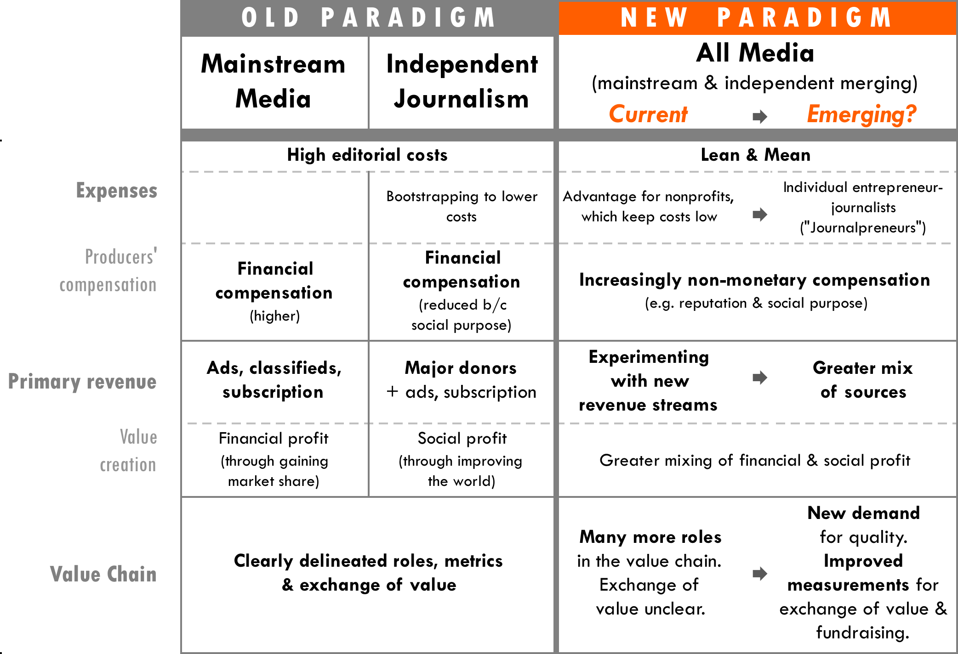

For business models to work they cannot merely create value; they must eventually capture enough value to sustain themselves, whether it is directly from those who benefit or from third parties such as philanthropists. Ventures—such as Twitter and YouTube—that make a play for audience first, must eventually capture value. In fact, YouTube is still far short of making enough money, with its costs nearly three times more than its revenue as one analyst reported in April 2009. Furthermore, the collapse of the print industry and economic crisis cannot be blamed as the sole cause of magazines’ troubles—some have continued to grow due to their ability to capture value. Of the 100 magazines with the highest circulations in 2005, 21 were able to increase their print advertising pages from 2005 to 2008.
“For Mother Jones, it’s becoming more and more obvious that the marketplace on its own will not support investigative reporting.”
– Monika Bauerlein^{S}

“The best-case scenario,” according to Shirky, “is where (traditional media organizations) give up on the idea of ‘Plan B’—that is, we’re going to move from one business model to this other business model, because it’s not going to happen this way. In this future you can do news in a much cheaper way with a dramatic range of outlets.”
Business models will change in significant ways, beginning with more efficient operations. Many organizations are testing new revenue models and will likely mix of several of them. As this happens, a new value chain of journalism is coming into focus, which TMC and its members can influence in proactive ways. This chapter covers the following topic areas in emerging business models.
“We have never seen investigative journalism thrive in print form to be honest—and we have to be honest with ourselves. The New Yorker is not a success as an economic play. It’s only profitable maybe 12 of the last 50 years.”
– John Battelle

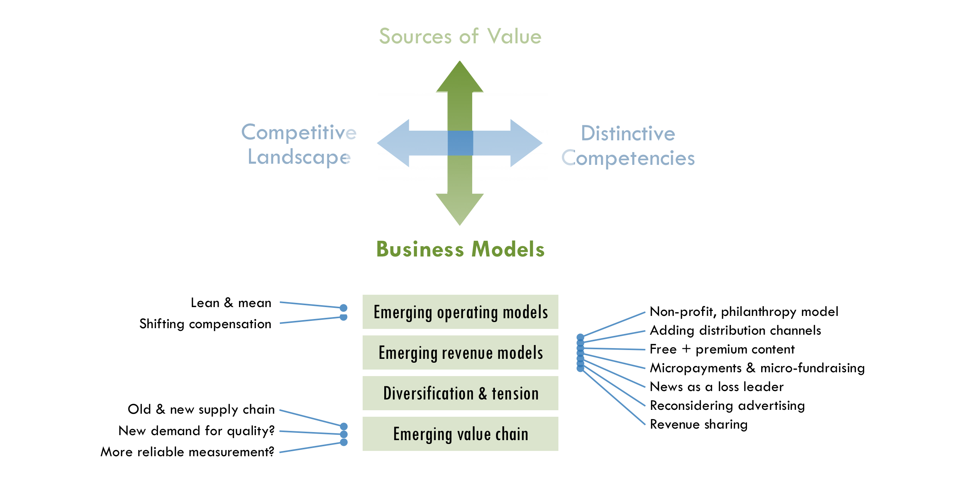

Emerging operation models & cost structures
The traditional journalism business has been built on enormous cost structures with publishers maintaining deep benches of reporters, partly due to their effort to “cover” all the news as watchtowers. The New York Times newsroom of twelve hundred employees was fifty times more than the Huffington Post in 2008, while the Washington Post and the Los Angeles Times had approximately 850 editorial employees. In contrast, the direct print-plus-online reach of the New York Times was just a little over three times that of the Huffington Post in late 2008.
While many prophets of the new era preach about the great potential of online technology for creating media more efficiently, original investigative reporting still takes time, resources and a little shoe leather to do well. “What’s worth saving, as a critical function, is investigative journalism. We need someone, many someones, to do long, deep, boring research, for stories that may not even pan out,” Shirky wrote in a blog post. The online environment has caused some publishers to increase editorial staff rather than cut it. Sometimes they hire additional editors to prevent burnout in a 24/7 news environment. Other times, they discover that they can no longer depend on freelancers to provide timely responses necessary to weigh in on fast-moving issue while also meeting standards for quality investigative reporting.
“Having all the pieces of the puzzle assembled under one roof, with one group—Watergate journalism if you will—is getting rarer and rarer.”
– Clay Shirky

Lean and mean
A perception still exists that it takes a big organization to be a viable media company. In recent years, lean and mean entrepreneurial approaches have taken off. Boing Boing only has eight staffers and others, such as Tech Crunch and Talking Points Memo, have a small staff as well.
A lesser-known, more dramatic example of running lean and mean is Plenty of Fish, a dating site. Although the site’s content is not news, neither were personal classified ads in a newspaper, which have historically contributed a great deal to newspaper revenue. Plenty of Fish has become one of the top-10 in the US by monthly page views (1.6 billion in late 2008) with only three employees besides the founder Markus Frind—and he has claimed to work only 10-20 hours per week. By comparison, dating pioneer Match has hundreds of employees and one quarter of the traffic. In 2006, Frind posted his blueprint: “Pick a market in which the competition charges money for its service, build a lean operation with a ‘dead simple’ free website, and pay for it using Google AdSense.”
“I’m spending a lot of my time talking to organizations about mergers and consolidating back offices. This will challenge folks to innovate, but will more than challenge organizations on many fronts. I don’t think it is a good thing overall, although the organizations left standing will be stronger.”
– John Bracken

With the decline of large organization, salaries will inevitably shrink and journalists will also have to be more productive and multifaceted. Media organizations that figure out how to do more with less will likely win. As a result, the lean and mean cost structure that nonprofits have built may have an advantage in the current news industry shakeout.

Shifting compensation
“We get that (news) can be delivered in different ways. That’s not the problem. You need a critical mass, a large enough news organization, a way to pay writers and editors…”
– Member of CA Media Workers Guild^{A}

People create content for many reasons other than earning money, and there are increasingly operation models that tap a broader array of human motivation to reduce costs. Experiments in crowdsourcing and co-creation have proven successful in journalism, although they require greater investment in editors and staff skilled in community organizing.
Reality television in 2000 provides an interesting parallel. The explosion of this genre can be tied to the cost advantages of “unscripted” shows that sidestep the need for high-paid actors. These lower costs—combined with the greater odds that reality series have of becoming a breakout hit compared to sitcoms and dramas—fueled this genre of TV.
"Some of the biggest game changers tend to be on the alternative side.”
– Ghen Maynard, head of reality programming at CBS

Hard-core journalists may be quick to criticize the quality of citizen journalism as people did with reality television, but they should not overlook its potential either. For example, filmmakers claimed that reality television made documentaries more mainstream. Also, Michael Hirschorn points out that the genre has “engaged hot-button cultural issues—class, sex, race—that respectable television, including the august CBS Evening News, rarely touches.” While non-monetary compensation will enable journalism to run lean and mean, it could also be an opportunity to adapt the form journalism takes in the future.

Emerging revenue models
Despite the rise of lean and mean operations and shifting compensations, media organizations are still searching for new ways of generating revenue. The most prevalent model for TMC members has been philanthropy, although this source of revenue alone is often insufficient for sustainability and growing to scale. Some other possible models include creating additional channels of distribution, combining free and premium content, tapping user subsidies, utilizing news as a “loss leader” to generate funds and sharing revenue content producers. Increasingly, for-profit and non-profit publishers alike will grow strongest with a greater mix of these revenue streams.
“Journalism has been thought of as business for some years, now by some people are starting to think about it as a charity.”
– John Schwartz,
EBS Companies

Non-profit, philanthropy model
“All journalism is finding themselves in the gap (between philanthropy and earned revenue). Commercial media is having as hard a time now. Philanthropy won’t pick all that up.”
– John Bracken

For many years, non-profit publishers, such as many of those in TMC, have required 50 to 75% of their revenue from philanthropy in order to meet the high costs of their editorial missions. While this dependence on philanthropy could be seen as a market failure just a year ago, it is now viewed as a potential advantage in diversifying revenue. In fact, experts such as Charles Lewis, Geneva Overholser and Bob McChesney have started to suggest non-profit structures as a potential solution for news. Although many people have called for philanthropy to make up the difference between the cost of journalism and what the market can bear, many in the non-profit world say that there is already not enough philanthropic funding available to sustain independent media as it is.
In 2008, ProPublica started a new non-profit investigative newsroom with a grant of $10 million a year from the Sandler Foundation, a move criticized by some in progressive media because it was seen as a duplicative organization that used philanthropic funds that could have gone to help strengthen existing journalism organizations. ProPublica does not currently accept advertising, although according to its website, it hopes to build a “brand” to capture other sources of funds. Many non-profit publishers survive largely based on a few major donors such as the Sandlers, and they also compete with each other for a limited pool of additional philanthropy.
It is often difficult to measure the ultimate impact of media production beyond number of viewers, which has discouraged funders from this area of investment. In fact, donors have increasingly become concerned with measuring the social impact of all types of nonprofits. Investors with sufficient resources and inclination often want to ensure that their investments leverage the greatest possible impact, and they have pushed social enterprises to measure results more rigorously.
“Despite the ire it has raised (among nonprofits), the demand for evaluation shows no signs of slowing. This is probably for the best. Trusted with other people’s cash and absolved of taxation, nonprofits and foundations should evaluate themselves and their programs to reassure the paying public that their money is actually making a difference.”
– Stanford Social Innovation Review^{T}

Groups such as Charity Navigator, American Institute of Philanthropy’s CharityWatch.org and Better Business Bureau’s Wise Giving Alliance have also used online technologies to create greater transparency for nonprofit performance, although these services have been criticized for their methodologies and emphasizing the wrong measures. The problem is that different types of organizations often require different types of metrics to demonstrate their impact. Within a group of similar organizations, such as independent media, standardized measure could possibly work. This could be more powerful if such a group proactively determined the most suitable metrics. (See “Will more reliable & consistent measures create greater distribution of value?”, p54)
- Strategic recognition
What if… we standardized raw data, metadata & metrics?, p8

Adding distribution channels & sub-brands
Axel Springer, which owns the biggest newspaper in Europe, made its highest profit ever in 2008 with 14% of its revenue generated online. The company’s chief executive said one reason for its success is that it has created or acquired new publications, which enables the same content to be delivered to different audiences. The company’s Berlin newsroom, for instance, produces content for six publications.
“Our books are sold not because of bookstore, but because authors are creating an immersive experience for the reader, who is buying it as a souvenir.”
– Johanna Vondeling,
Berrett-Kohler

By creating sub-brands, media companies could reach a new market segments and influence the public dialogue new ways—all with the same content. This strategy has been successful in other industries. For example, Black & Decker bought a small tools manufacturer called "DeWalt" and decided to maintain it as a sub-brand, rather than folding it in to the overall company brand. The DeWalt colors (yellow) spoke to a professional market segment, while the Black & Decker's red & black were considered to be for consumers. Similarly, Google took this strategy after acquiring YouTube. They decided to keep their existing "Google Video" in a separate brand because they believed it would reach an older segment and ultimately expanded their reach. Harris wants to take this idea a step further with Mother Jones by taking its content into other channels of distribution, such as an MSNBC-type cable show.
Although the book-publishing industry is waning, some online news publishers, such as AlterNet, have found value other than revenue from an additional distribution channel. A book can support the personal motivations of writers and editors and raise their credibility in leading thought circles, catapulting them into mainstream media and policy discussions. Books also have the added benefit of providing content for their website, building relationships with grassroots groups and advancing their social mission.

Free + premium content
“I also subscribe to The Wall Street Journal, one of the few pay newspaper sites. I could cobble together a free version … but I chose to pay the freight. To me, paying for content I want online is not all that different from paying for a DropSend account, which allows me to send and receive large files: the paid option outweighs the hassle and time of the free ones.”
– David Carr⁵¹

Many publications have experimented with offering free plus premium content, through subscription or single-pay models.
- Cook’s Illustrated has 260,000 digital subscribers who pay $35 a year primarily to access their complete database of recipes. One reason that users are willing to pay a subscription fee for full access to Consumer Reports is to get the irreproachability that can come from not accepting advertising.
- Wall Street Journal mixes free content with access to premium content at $1.99 per week. This works because financial news is one type of information that users are more likely to hoard than share.
- New York Times does not currently charge for content, although Arthur Sulzberger, Jr. said in March 2009 that he would consider charging again. The Times has tried this before (QPass and TimesSelect), so it is uncertain whether it will work.
Subscriptions have been a saving grace for cable television providing half of its revenue—one reason the three major news cable channels grew by a third in 2008 and are expected to be as strong in 2009 when all other forms of news are struggling. While newspapers do not control distribution channels in the same way that cable companies do, subscriptions in some form helps insulate fluctuations in advertising.
Berret-Koehler (TMC member) is experimenting with a model of offering free portions of books, which include the introduction plus one chapter, as a way to sell a full book. They have also begun to break their books into lower priced article-length sizes that users can find through a graphic navigator tool on their website designed to search more intuitively by business challenge and potential solution in addition to a more conventional general-topic structure.
“In this environment (of content oversupply), you're about as like to be able to charge for an online news story as you are to charge for air.”
– Nicholas Carr⁵⁶

Micropayment & micro-fundraising from users
People have predicted the rise of micropayments (small low-cost online transactions by users) since the late 1990’s, including Nicholas Negroponte of MIT’s Media Lab and Jakob Nielsen, a leading web usability consultant. Micropayments for news content have also had skeptics, including the Project for Excellence in Journalism and Shirky, who said, “Micropayments work only where the provider can avoid competitive business models.”
“No one is seriously suggesting that the New York Times could pull out of ads in favor of direct user subsidies, but over time the balance might shift. And while this may not make sense for mainstream media, this certainly does for independents.”
– Clay Shirky

Some detractors have argued that users do not like micropayments because they are too inconvenient and there is a big psychological gap between free and almost free. However, Nicholas Carr pointed to a classic example of ATM machines that charge small amounts for every withdrawal to prove that if small payments are easy enough and provide value, users are not annoyed. Carr expressed reservations about how valuable it could be for news content.
Over the past year, online and iPhone applications have begun to increase users’ familiarity with micropayments. Also, the gaming world has had success with in-game micropayments, which may indicate the potential of motivations other than convenience—namely, reputation. Potentially, if micropayments were linked to other motivations such as reputation, they might become more valuable for users and publishers alike. For example, a “thumbs up” vote for a story tied to a small user cost could increase the quality of ratings.
"Most people playing in these persistent world environments are building their character … are happy to spend some money there.”
– Joseph Olin, Academy of Interactive Arts & Sciences⁵⁷

Many new ventures are planning to test micropayments in journalism across a wide array of news sites, although nothing has proven to work yet. The Missouri School of Journalism has been promoting The Information Valet Project. Steven Brill, Gordon Crovitz (former Wall Street Journal publisher, and Leo Hindery have started Journalism Online. PayChoice is a type of Vendor Relationship Management (the reciprocal of Customer Relationship Management) that enables micropayments across a wide array of news sites.
Non-profit publishers have also utilized micro-fundraising from small individual donors, who believe in their social mission. Both Mother Jones and AlterNet saw a rise in small individual donations in 2008, which represented 11 and 14% respectively of their overall revenue. For Mother Jones, 9% of their paid print subscribers donated last year, which indicates that there was a large group of readers who recognize the value of Mother Jones’s work beyond what they paid for the content itself.
- Strategic recognition
What if… we collectively tested new revenue models?, p5
As technology makes user subsidies easier (at any amount), news organizations may find value to capture, especially as other motivations come into play.

News as a loss leader
For a long time, publishers have used news as a “loss leader,” a product sold below costs to create other sales. Using free content to sell premium content is just one example. For most of their history, newspapers have provided the paper at a loss in order to sell ads. In the computer industry, printers have been a loss leader to sell ink cartridges. In the gaming industry, Second Life by Linden Labs has provided a free virtual online world, paid for almost entirely by selling virtual real estate that user buy and trade.
“If print wants to perform a cashectomy on users, it should probably look to what happened with music, an industry in which people once paid handsomely for records, then tapes, then CDs, that was overtaken by the expectation that the same product should be free.”
– David Carr⁵²

What are all the possible loss leaders that can cross subsidize media content in the new environment? The music industry shakeout has revealed a successful model. Steve Jobs saw music as a loss leader that would sell iPods and iPhones, which is partly what allowed Apple to price songs at 99 cents by not taking enough of a cut to pay for developing the platform itself.
Many people have criticized the iTunes-for-news idea. Shirky pointed out what is so different about the music industry from journalism: people consume the same content many times, four companies control most of the popular content and their control has limited alternative models through regulation and legalities (e.g. Napster). However, journalism should not be so quick to dismiss the iTunes example. One aspect is still fundamental: news can be a loss leader to get users to pay for something else.
While independent media organizations do not have the capacity to become a broad device manufacturer, TMC may be able to use its collective news-production capacity to cut deals with those companies that do have this capacity. Publishers do not need manufacturing capabilities to take advantage of using news as a loss leader. Some newspapers have simply looked beyond news as its only product. For example, VG Nett, offshoot of Norway’s largest newspaper, runs a weight-loss club that has 150,000 users paying $90 a year. Furthermore, in Asia, social networking market leaders QQ and Cyworld make most of their money from digital goods such as background music to avatars and casual games. And, according to a ReadWriteWeb interview, “The introduction of an online currency supported by a variety of payment systems has helped lower the payment and monetization barriers dramatically.” Could digital goods be a potential loss leader for news too?
“Turns out the Kindle is becoming the iPod of the book world.”
– Mark Mahaney, Citigroup^{U}

Getting more from advertising
Most publishers have had high hopes for online advertising. Months before the financial crisis was in full swing, Ann Friedman, Deputy Editor of The American Prospect wrote: “In terms of advertising, I think we did expect web revenues to be far higher than they are now. Yeah, we all expected print circulation to continue to decline. But we thought we’d have figured out how to ‘monetize the web’ by this point. Not so.” As it turns out, online advertising has not been enough to cover the cost structure of traditional news gathering, amounting to just one tenth of newspapers’ overall ad revenue, and not growing fast enough to replace losses in offline advertising.
“The Web is likely heading for a shakeout on a scale unseen since the dot.com bust.”
Martin Peers, Wall Street Journal^{I}

In the long run, ads alone may be insufficient to sustain online journalism. The average CPM price (cost per thousands) dropped in half from 2007 to 2008 to just 26 cents for newspapers’ online ads, an average that includes both high-priced display ads as well as low-end text ads. Although many publishers (including TMC members) earned six to eight times that amount on average, the trend is still declining. While niche-targeted ads can command a higher price, the real problem is that 40-50% of ad impressions often go unsold. Publishers simply have too much advertising real estate on their sites to fill at reasonable prices. To make matters worse, local advertising is not necessarily going online. In early 2009, BusinessWeek reported a big slowdown in local online advertising that they do not expect to rebound when the economy recovers.
Nevertheless, Schiller is optimistic. “I fully believe that advertising will bounce back online,” she said. Despite current challenges, online advertising still has historic potential. Every year, the growth of online advertising has far outpaced cable and broadcast TV when comparing each industry’s first fourteen years.
“In a year in which we had a historic election and the Olympics, news as a category was down.” Razorfish’s “news” vertical declined from 2006 to 2008 by 36%.
– Razorfish Digital Outlook Report 09

One answer that Golis wants to know if he could see into the future is “What happens to the ad money leaving newspapers?” eMarketer reported in early 2009 that $7.5 billion in advertising left newspapers in 2008, and estimates another $6 billion in 2009. While some of this is due to the financial crisis, the spending levels will return, and marketing research shows that much of it will move online. In fact, Jeffrey Rayport, founder and chairman of Marketspace believes the advertising business may emerge from this recession altered in dramatic ways. As a result of sustained growth of in online advertising while ad spending in all other media is declining, a new and different advertising equilibrium will emerge as the economy recovers. He said, “it will represent a radical shift from anything we’ve known before.”
Three opportunities stand out for getting more from online advertising.
- Build the capacity for constant innovation. Online ad products are not static; there is always a new type of ad that will attract advertisers. As a result, Berrey explained that the most successful online media companies have ad product managers who focus on creating new ad products rather than just selling them. “It's like a magazine saying, 'We’ve got the back cover. We’ve got a full page, a half page’,” he explained. “But when you move online, there is infinite number of different combinations."
- Experiment with “performance-based” ads. Performance ads now represent the largest portion of online advertising, yet independent publishers primarily use “display” ads based on number of impressions. Although many advertisers still prefer display ads, the market is shifting to performance ads, which are based on the measurable results of users’ actions. From 2006 to 2008, the proportion of total online ad revenue for display ads declined from 48 to 39%, while performance ads increased from 47 to 57%. Advertising experts expect this trend to grow, and independent media organizations that innovate with these types of ads may leverage greater value in the future.
When the New York Times Company redesigns About.com in 2009, they plan to take advantage of cost-per-click performance ads to reduce their dependence on display ads.^{V}

- Multiplatform sponsorship. As independent media companies become multiplatform, they have greater opportunity attract advertisers with broader sponsorships than simply giving them a rate card. Publishers can give an advertiser access to their audience in a multi-faceted way that creates a deeper relationship with an advertiser’s brand. By combining online, print, TV, radio, co-sponsored events and online advertising in a packaged deal, media organizations can build advertising relationships that will contribute more to their bottom line.
- Strategic recognition
What if… we joined early in technology experiments?, p2
These sorts of efforts usually take specialized staff that focus on designing new ad products, putting together creative sponsorship packages and making deals. For smaller media organizations that do not have this capacity, a consortium-led collaborative effort could provide a valuable solution.
Some TMC members may be skeptical of advertising, especially if they might not generated significant income, yet still risk their independence or political voice. Advertising has not historically covered the costs of political content on the left or the right the way it has been for more mainstream, commercial content. Teresa Stack, president of The Nation (TMC member) wrote, “Yes, we get some money from ads, but most advertisers remain skittish about partisan political content.”
Political content has been funded mostly through subscribers and donors, but business models on the Internet have been based mostly on free content supported by ads. Before the advertising market collapsed, Stack had questioned the implications of ad supported content for TMC. “How do we transition to ad-supported content for the first time in history, or is there another way?” Stack’s caution may return to the forefront if the advertising market recovers and other business models are not found. As a result, progressive publishers may still have to figure out a way to get more from advertising than they have in the past, which may include more aggressive marketing efforts.
When Battelle started working with Boing Boing, he said they “were not anti-marketing per se, but they were deeply skeptical.” The company founders worried that readers would revolt, that they would not be able to find ads that understood the voice of their site, or that they would not make money if they avoided obnoxious ads. As it turns out, Boing Boing’s users did not revolt and the company has become one of Federated Media’s largest clients.
“Brands are not evil. Brands are human beings who work at places who want the opportunity to have a conversation with an audience saying hey we have something you might want. And if you can have that conversation in a way that doesn’t violate the integrity of the community, then you should.”
– John Battelle
Battelle believes that many journalists still need to overcome a deeply rooted skepticism toward marketing as a way to reach audiences. “I think that we got really comfortable as journalists saying, ‘We’re an ivory tower and nobody can talk to us and those evil advertisers over there that pay our salaries—they have to stay far away.’ … One of the greatest faults of the traditional press is to presume that the readers just don’t know what’s good for them.”
In the end, advertising still has great potential to generate the resources that independent media makers need to have a much greater impact, as well as reach new audiences. Many publishers of political content will increasingly need to tap advertising to support their missions, even if they do not depend primarily on it.

Revenue sharing
About.com, owned by the New York Times, has been a leading revenue-share model for writers. About.com was in the top 15 trafficked websites in the US with 47M monthly visitors as of March 2009, compared to 14M to NYtimes.com according to Quantcast, although its profit margins shrunk in 2008 leading them to make cuts. Many other sites have also utilized revenue-sharing models successfully, such as Associated Content and the Gawker family of blogs.
As an example of revenue-sharing structures, About.com contracts with a pre-screened group of 750 writers (called “Guides”) and shares advertising revenue with them in a way much like a book publisher (advance & royalties). The site claims that they have Guides who make as much as $100,000 a year, which is a strong incentive for producing content as well as promoting it. In reality, most Guides make far less, which has been further reduced in 2009.
While revenue sharing may create a broader network, it does not necessarily create a deeper, more loyal connection for audiences. One quarter of visits to NYTimes.com comes from people visiting the site over 30 times per month, while only 2% of visits to About.com come to their affiliate sites as often. (Quantcast)
“I worry that there is not a robust enough understanding or trust in what media is and can do from all of those sources that fund independent media—and I am always trying to think of ways for independent media to become more autonomous.”
– Julie Bergman Sender, Balcony Films

Other sites are testing new revenue sharing models. For example, CBSSports.com is trying a “loyalty index” as a way of judging the work of their writers that may lead to more return visitors, breaking news or original ideas and promoting greater interaction with readers.

Diversification & tension
No emerging model listed above is the panacea for journalism, yet together they might be. A diversity of revenue sources not only makes independent media more stable and sustainable, but can also make it more independent.
In fact, deliberately mixing for-profit and non-profit strategies could have great promise for the future of journalism. Advertising revenue increases by publishing popular stories, which are by definition relevant to many users. Yet, publishers can also push other important stories with foundation and major-donor funds. The right balance enables publishers to stay highly relevant to online audiences, achieve their social agenda and scale their organization at the same time—a feat that could surely be a solution for journalism.
“Leveraging what you have, and having multiple source of income, is the key to future sustainability.”
– Ashish Soni

Emerging value chain of journalism
While media organizations are trying many different revenue models, the models that succeed in the long run will carve out their place in the new value chain of journalism pictured on the following page. “Value chains” are a chain of activities that progressively add value to a product or service. The financial success of any business model depends on the ability of an organization to capture the value they create.
- Strategic recognition
What if… we built a new ecosystem for journalism?, p11
The old value chain of journalism was delineated with clear roles and exchanges of value. The new value chain reflects more activities, and one organization often serves multiple roles. Similarly, advertising had delineated roles in the old model and mostly concentrated on publishing and broadcasting, but in the new model, it is distributed across more players.
Since the new value chain is in flux, TMC can use its network to influence the structure by collectively experimenting with new models, promoting new relationships among players and advancing new standards in measuring and valuing content. Independent media organizations can also use the value chain to explore strategic questions for themselves, such as:
- What role do you play in the value chain now?
- Where do your strengths fit best? & What could your role become?
- Is it best to focus primarily on one role or integrate many roles at once?
- How would you modify the value chain based on your understanding of new industry dynamics? & Where does the most value exist?
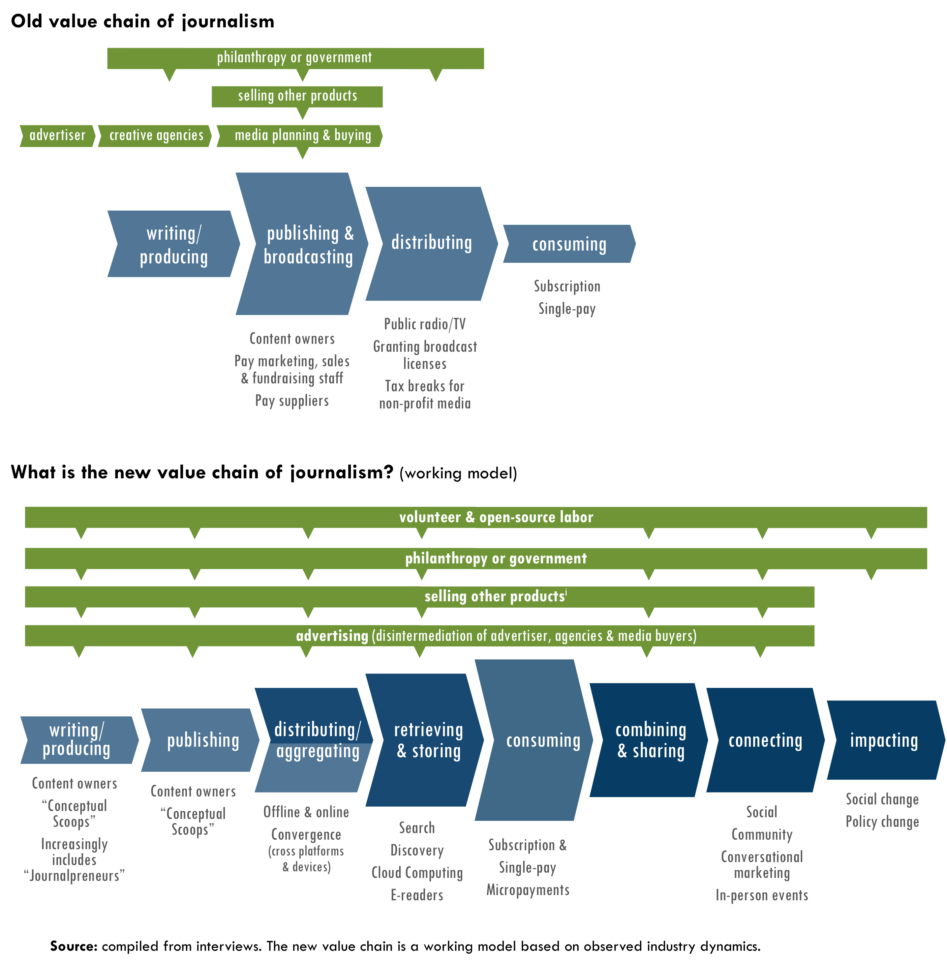

KEY DEFINITIONS
Value chains reflect two flows:
1) Products & services flow right to a customer.
2) Direct funds paid by customers flow left in exchange for the value added by each activity & willingness to pay.
Each link in the chain represents a role. Orgs. can play multiple roles.
Height of each role reflects
its relative bargaining power.
Green represents funds or subsidy from indirect sources.
New roles are a darker shade.

Today, some people are saying that advertisers are not willing to pay. Others say that readers are not willing to pay. Still others say that government or foundations are not willing to pay. Although the sources of funds are becoming more fragmented, the riddle of who pays will eventually be solved as relationships in the value chain get sorted out. Different parties in the chain will be willing to pay something—or else “we’re going to start getting what we pay for, and we may find out just how little that is,” as Surowiecki said in his New Yorker article, “News You Can Lose.” This risk could easily extend beyond magazines and newspapers. The Razorfish Digital Outlook Report 09 claimed that unless television advertising evolves, “we may be at risk of losing premium content altogether.”
For many years now, there has been an oversupply of production capacity. Not only can everyone freely publish on their own, but media organizations and individuals alike can also reach the same global audiences, which causes redundancy. “Now here’s what a lot of people seem to forget,” Nicholas Carr pointed out: “Excess production capacity goes away, particularly when that capacity consists not of capital but of people. Supply and demand, eventually and often painfully, come back into some sort of balance.”
As supply and demand balance out, it is still uncertain how the relationships in the value chain will parse out. Will players try to cover many roles? Or, will they build strength in one or two roles where they have comparative advantage or where simplicity may win? For example, in May 2009, Time Warner CEO Jeff Bewkes, explained in a press release that the decision to spin off AOL was so that each company could concentrate on its core competency. For similar reasons, Battelle doubted whether Facebook’s attempts to outcompete Twitter would work, because Twitter is as simple as a pencil. In contrast, he compared Facebook to Photoshop saying, “There’s so much you can do with it, the pencil function gets lost. … Back in 1997, Yahoo was a pencil to Netscape’s Photoshop. In 2000, Google was a pencil to Yahoo’s Photoshop. … Will history repeat itself?”
There are many possible ways the value in the chain could crystallize.
“Is there a way to reverse the broad expectation that information, including content assembled and produced by professionals, should be free?”
– David Carr ^{zz}

- The value of simplicity could lead some media organizations to focus on creating quality investigative journalism and leave chasing eyeballs to other media organizations that are willing to share revenue with them.
- Strategic recognition
What if… we collectively tested new revenue models?, p5
- Content could become even more differentiated. For example, stories with viral potential live free online, while more specialized premium content is used to build deeper, more loyal communities willing to pay subscription, donate or make other payments. However, this move may rub against an aim to make news broadly available to the public.
- Metadata that publishers’ collect could become a core asset for generating revenue (further defined on p35).
- Non-profit media companies may win greater foundation support if quality reporting declines, especially if they can more reliably measure that they preach beyond the choir.
- A “new social contract” between the press and the public could lead to more public support for journalism, if not also a shift in consumers’ expectations of free news.
- Internet Service Providers could collect a fee to access news websites, a move that would only succeed if news organizations worked together.
“The problem is that we’ve depended on the work of the old in the new. We can all consume our news on Yahoo News or Google News or any other one of our potential news sources, but most of the stuff that we read is paid for by the print industry. … We are going to see a lot more capitulation (from the print industry before we see models arise).”
– John Battelle

There will inevitably be different places on the value chain to capture value. If smaller players do not proactively figure out their roles, the moves of big players will likely determine them (see “How will the big players affect the game?”, p6).
The answers to two questions will affect the value chain in coming years:
“Will there be a new demand for quality journalism?” and “Will more reliable and consistent measures create greater distribution of value?”

Will there be a new demand for quality journalism?
The rise of free content will inevitably continue. However, some content could become more expensive as well. Stewart Brand, a futurist who created Whole Earth Catalog, WELL and Global Business Network, famously started a meme in 1984, “Information wants to be free. Information also wants to be expensive.”
“I think there is more of a hunger on the part of a larger segment of the public to access better and more information about the huge issues facing all of us.”
– Julie Bergman Sender, Balcony Films

Brand explained, “Information wants to be free because it has become so cheap to distribute, copy, and recombine—too cheap to meter. It wants to be expensive because it can be immeasurably valuable to the recipient. That tension will not go away. It leads to endless wrenching debate about price, copyright, ‘intellectual property,’ the moral rightness of casual distribution, because each round of new devices makes the tension worse, not better.”
Information wants to be expensive when it is based on scarcities, which Anderson claims are attention and reputation. As users gain control of their information and identity online, the personal data that users want to control could become the most expensive information of all and the reason why the publishers most trusted by users will succeed.
Rewind
New scarcities & their effects, Vol. 2, p11

Fast Forward
Real identity & converting reputation, Vol. 3, p18
There may be another scarcity emerging: the quality of investigative reporting. The price of news has dropped to zero due to the abundance of information produced. However, if the supply of quality news shrinks it may create a vacuum where the best writers and producers could have renewed potential to earn money. In fact, Nicholas Carr believes a radical reduction of production capacity could actually help solve journalism’s problems. “The number of U.S. newspapers is going to collapse … and the number of reporters, editors, and other production side employees is going to continue to plummet. … As all that happens, market power begins—gasp, chuckle, and guffaw all you want—to move back to the producer. The user no longer gets to call all the shots. Substitutes dry up, the perception of fungibility dissipates, and quality becomes both visible and valuable. The value of news begins, once again, to have a dollar sign beside it.”
Many people believe that user generated content such as citizen journalism will continue to grow despite the dearth of money to pay people. However, Andrew Keen is skeptical. Keen, author of The Cult of the Amateur: How Today's Internet is Killing Our Culture, predicts that user-based information gathering will fall apart. And, if YouTube’s track record is any indication, this may be true. YouTube has found that advertisers are not interested in user-generated content. In fact, YouTube has had to buy the rights to professionally produced content in order to attract advertisers, which will cost them $260 million in licensing in 2009, although the site’s total revenue will only reach $240 million.
Shirky disagrees with Keen and said that the best writers and producers will rise to the top. “This sorting out process will be good, because the commitment to the current business model of commercial chasing of page views has a huge overlap with the rise of mediocrity in content and media professionals.” Schiller also believes the highest quality enterprises will survive and predicted, “I think you’ll see a separating of the wheat from the chaff.”
Conceptual Scoops
The greatest potential to capture value in journalism may be from “conceptual scoops,” a term Battelle used to describe investigative reporting that not only breaks new information, but also creates new frames and understandings of social and political issues. “Once you have a robust model for news online,” he said, “that’s where conceptual scoops are going to live.” This type of reporting could spawn a new business-to-business model in journalism. What happens when the pipeline for conceptual scoops dries up? Will aggregators have a new willingness to pay for them because it drives traffic? As a result, some journalism organizations may focus on investigative reporting and sell it to a smaller number of enterprise customers as “temporary exclusives,” rather than reaching for the broadest number of eyeballs by themselves.
Breaking conceptual scoops is where the role of a consortium can come into play. Michel said that from her experience with OffTheBus, she learned that “a network, not an individual reporter, breaks news.” Nevertheless, the “scoops” still come from individuals who do the investigative work. Perhaps with standardized measure of influence and reach, TMC could use its collective network to break these scoops and help money flow back to the media organizations that did the hard work of unearthing them. Similarly, journalists could receive additional incentive pay based on the performance of their stories.

Will more reliable & consistent measures create greater distribution of value?
The potential of new business models to capture value hinges on being able to measure it. As more reliable and commonly accepted metrics emerge to measure the performance of content, the more that players in the value chain can estimate the value they can create with it, and how much the would be willing to pay for it. As a result, money will flow where there is value in the chain. Marketing analytics are based on this sort of reliable measurement, and deals are done based on it.
“It is more important than ever to develop new media mix models that recognize the intricacies of channel interaction … we need to adopt new ways of measuring to account for the true complexity of media in the digital age.”
– Razorfish Digital Outlook Report 09

As metrics become better, publishers may be able to use new incentives for writers and producers. Also, a publisher could potentially sign up aggregators to pay based on performance of content. Aggregators could sign up freely or cheaply and pay if content spreads past a targeted threshold. If the price is low enough, and the aggregator can accurately measure the performance, it would be in their interest to share earnings in exchange for reliable content.
In particular, better ways to measure engagement and impact online will likely hold the greatest potential for independent publishers in the future.
Metrics for engagement
For many independent publishers and aggregators, 60-70% of their online visits are for less than 10 seconds, and 50-60% of all visitors only come to the site one time. With such ratings, traffic number can often be a misleading sign of engagement.
Some people say that “page views” are becoming an irrelevant metric. In fact, many companies such as Nielson/NetRatings, Compete and Facebook are moving to “attention-based” web metrics based on time spent on site. Last July, Microsoft introduced “engagement mapping,” a way of measuring the return on investment based on how all interactions with marketing efforts lead users to take action. There is still disagreement, however, on the best way to measure engagement. Projects such as Yahoo’s Buzz, believe that comments, ratings, frequency of sharing and clicks are better metrics for engagement.
If measuring attention is the future of advertising, then why is there still so much emphasis on measuring page views? Muhammad Saleem, a social media consultant and contributor to open-source journalism project newassignment.net, said the problem is a disconnection between the advertising and publishing industries. “The reason why there is an eternal quest for traffic, not only in terms of unique visitors, but also maximizing page views per visitor, is because advertising networks let you in on the basis of how much traffic you’re generating, and your eventual income is based on the number of impressions (and clicks).”
New metrics for engagement will profoundly affect all publishers, but particularly smaller independent publishers who do not generate as many page views, but serve a niche that can deliver great value. Furthermore, if independent media organizations start viewing news as a “loss leader” and sell other products to support their reporting, then other engagement measures could become critical to their business.
For example, measuring the “average revenue per visit” (ARPV) based on advertising revenue is a common practice. However, people such as Benjamin Joffe, Managing Director at Asia Internet consultancy +8* and Co-Founder of MobileMonday Beijing, have called for new measures such as “average revenue from user” (ARFU). ARFU is based on non-advertising revenue directly from users such as digital goods (e.g. background music, avatars or casual games) or real-world products, which may be a better measure of a user’s engagement from a financial perspective. For independent publishers, it could include users’ donations. Joffe said that advertising has caused media companies to focus too much on generating page views, not making their services better. “Users are mere ‘eyeballs,’ while the real clients are advertisers. The revenue mix defines the service DNA.”
With new measures such as ARFU, a publisher can better estimate the lifetime value of a customer, which would enable it to invest more effectively in marketing and customer acquisition. Measurement notwithstanding, independent publishers must still find ways to increase the level of engagement from its current levels.
While advertising is making progress in measuring engagement, in order to attract philanthropy nonprofits also need to find better ways to measure how engagement leads to social impact.
Metrics of social impact
Most independent media organizations are driven by their social purpose more than their business. However, measuring their social impact is difficult, especially when it comes to goals such as influencing the political dialogue, promoting progressive values or launching a new meme into public consciousness. Also, when it comes to impact online, the complexity of contributing factors is even higher, which makes it hard to isolate the value of one organization’s work. Mostly independent media organizations are left with simply bearing witness through anecdotes about their ultimate social impact. Nevertheless, the more reliably they demonstrate impact, the more philanthropic funding they can secure.
Josh Catone wrote on ReadWriteWeb, that an engagement mapping tool “will become really powerful when it can measure not only ad views that lead to a purchase, but also any other type of online or social interaction.” Imagine the value for social change that independent publishers could derive from tools that reveal exactly what online activity leads to social action.
Mother Jones example
We can look at some examples from Mother Jones to illustrate the issues many independent media organizations face in measuring social impact.
First, there can be quite a big difference between popularity and influence. Harris said, “There are probably 10 stories where I could say, ‘here is where conventional wisdom was on an issue before a Mother Jones story, and here’s where it was after.’” Appendix F compares the top 10 most popular stories (by number of unique page views) to the top 10 most influential stories ranked by Harris. An example of influence is the Mother Jones’s exposé about Exxon-Mobile’s funding of 40 different groups that were systematically denying the science of climate change. The story came out a year before the film An Inconvenient Truth, and Harris said that it put the heat on other media for giving such nay-saying groups equal treatment with the Intergovernmental Panel on Climate Change.
Monika Bauerlein posed a key question to her colleagues at Mother Jones: “If we don’t influence the public conversation, then what’s the point of having a magazine like this?”

Second, impact is even harder to measure when it comes to affecting a small group of influential people. A Mother Jones strategy document says that they aim to “shift how elites and the public understand an issue.” Although some Mother Jones staff take issue using with the word “elite,” reaching a very small audience segment of influentials can have a disproportionate amount of impact. For example, the Jan/Feb 2007 issue of the magazine included a story called, “The Highwaymen,” about an Australian consortium that helped states privatize their road systems. The article was not widely read beyond people with a direct interest in highways, although Mother Jones did hand deliver the story to all members of Congress and legislators in eight states. Since the time Mother Jones exposed their profiteering racket “no big deals have gone down,” Harris said, which shows that scale of impact does not necessarily correlate with size of audience.
Third, if “conceptual scoops” were easier to measure, perhaps Mother Jones and other investigative journalism outlets could capture greater value for them. For example, Harris recounted an interesting story about the challenges of tracking such scoops. In summer 2007, he was invited to Google by executives at Google News. They wanted to talk about Mother Jones’s editorial work so that they could adjust their search algorithms. Their system could tell that something was “news” if it showed up simultaneously on sites such as nytimes.com, washingtonpost.com and wsj.com. However, the Googlers knew that Mother Jones often broke important stories months ahead of these other papers, and they could not figure out how to teach their computers to recognize such stories. If the primary value created by Mother Jones is breaking important conceptual scoops, and if Google of all companies cannot track whether Mother Jones’s stories are news, then it is easy to see the challenge for all investigative reporting in measuring impact.

Vol. 2 Conclusion
In summary, five key possibilities could bring relief to the crisis in the industry.
- As the supply of quality journalism decreases, the demand may increase.
- Strategic recognitions
What if… we standardized raw data, metadata & metrics?, p8
What if… we actively coordinated “deal-making”?, p10
- If the price hits a level acceptable to consumers for the convenience and value they receive, they may be willing to pay or donate.
- If the value created by content producers becomes more clearly identified at every level, they may be able to capture more of that value.
- If measures across the value chain increase in reliability and standardization, more deals can be done among players in chain.
- If the value is more easily and clearly identified for engagement and impact, new value might enter the value chain from sources such as foundations, individual donors and even consumers themselves.
In the end, the new value chain will parse itself out. Innovative and agile independent media organizations will find the business models to sustain themselves—especially if they work together. It might even be worth considering whether TMC members will be prepared to measure and capture value if a growing demand for quality journalism emerges.

DRAFT
Please do not distribute

The Future?
Key Uncertainties & Possibilities

Game Changer Box Set
Vol. 3

Future uncertainties
This report began with Weinberger’s question: “How much more of the game needs to change, really?” However, is now the future we’ve been waiting for? In many ways, it is not. Independent media has worked hard to lift independent voices and empower communities, which the online world has made possible more than ever before. People interviewed for this project felt hopeful, but they were also worried about the quality and availability of investigative journalism, uncertain how consumers will behave, curious how the biggest players in the game will act and unsure about which new strategies and business models will most likely solve the economic problems facing journalism. The strategic recognitions in this report address these uncertainties in a way that is intended to be useful in moving us forward.
[add graphical representation]

What don’t we know?
“We’re essentially clueless,” Weinberger said, when it comes to how information flows on the Web, which cutting-edge researchers also point out.
There is so much we do not know, yet this is exactly what creates opportunity—especially when we let go of what we do know. For example, Bracken warned against too quickly drawing parallels to popular models, which have more often than not succeeded due to a perfect storm. “If I had a dollar for every time people mention Wikipedia, I’d be rich,” he said. “People try to draw lessons from open source software and building online communities, but the types of skills needed are different from those needed for journalism. There is often more different than similar in comparisons people make.”
“One of the things we need to learn is that we don’t actually know what’s going on. We don’t know how information moves through the Internet, because we haven’t done the studies. To a large degree this information hasn’t been available, because we need a lot of cooperation to get this data, including from the government.”
– David Weinberger

“We all talk about a set of things that have worked,” Shirky said, “but we wave big caveats over them because the failure rates are so high. For instance, Yahoo Groups, one of the most successful examples in history, easily suffered a failure rate of 50%. Many groups just failed to launch. And for many open source projects, about 75% of the time stuff never happens.”
While the game has already changed in dramatic ways, we still face many uncertainties in how it will look in coming years. The rule of thumb is expect the unexpected. Radical changes in technology will continue to affect the basis for competition and new competencies will become even more important. Keeping the following questions at the forefront will help independent media sector shape the future it wants to see.

How will consumers act?
In an era when consumer choice and control continue to increase, many of the uncertainties center on questions about how customers will behave in the long run.

What trends will last?
“‘Are Weblogs and Facebook the new normal?’ Shirky asked rhetorically. “In 2009 this seems clear, but before 2005 we wouldn’t even know to ask the question.”
“There are lots of strategies you use when it’s revolutionary change, and different strategies when it’s about cohorts changing. But it’s hard to see this when you’re in the middle of it, when things are growing so fast.”
– Clay Shirky

Anticipating what trends will catch fire may be hard enough already. Ann Friedman of The American Prospect said in a 2008 TMC member survey: “I’m surprised web video seems to have caught on in a way, say, podcasting never really did. And because doing it well does require a few more resources, I think a lot of publications are still catching up.”
A much more challenging uncertainty is which trends might also become tectonic shifts that fundamentally change society. “We don’t know how much of a change in the current landscape is a one-way racket, or how much of it is a particular cohort living through something,” Shirky noted. “Everyone talks about how the younger cohorts only text (SMS) and never use email. But once they got into office environments, then they started using email because it was appropriate to the context. Short texts of 8-18 lines is great for kids, but it turns out young adults need a higher form of communication, which email facilitates. Is this a big one-way change?”
“Now that we’re living our lives online more with Facebook, Twitter, will they these trends fade, or are they significant changes in how we conceive of ourselves and society?
I tend think it is a significant change, it will increasingly become cross generational and cross cultural.”
– John Bracken

Media companies are “constantly climbing down the ladder of youth” noted Shirky. Nevertheless, opportunities still exist with audiences, potentially quite large, where publishers can still provide value to readers who are lagging adopters of new trends and to the advertisers who want to reach them. Often, such audiences may even be underserved because other content providers have left them behind.
Shirky explained that as Rolling Stone’s readers grew older, the publication had to choose between reaching a younger audience or moving with their demographic, which is why you find ads for American Express Platinum cards in its pages now. Yet, Shirky claimed, “When this cohort dies, so does Rolling Stone.” It is not necessarily bad news to focus on a declining market segment, especially if they are underserved by existing media companies.
In the end, Shirky asked, “Are these changes definitely going to last, or not going to last? The answer is somewhere in the middle. We’re going to answer this by looking at human behavior rather than technological capability.”

What will happen to serious news?
Customers’ ability to pull content together on their own terms has surely become a stronger force than publishers’ ability to push it out to them. Some people question how actively people will pull in serious news in the future, particularly casual newsreaders. In his Atlantic article, Hirschorn went as far as saying, “The Internet has done much to encourage lazy news consumption.” For example, one young person was quoted in a New York Times story about online consumption habits saying, “If the news is that important, it will find me.” This dynamic underpins one of Bracken’s biggest worries going forward: “Will people looking for serious news be able to find it? What happens to news that is unpopular, long or complex, will such reports be passed along as well?” If you have read this far in this long report, you must at least know the answer as it applies to yourself.
“My mind now expects to take in information the way the Net distributes it: in a swiftly moving stream of particles. Once I was a scuba diver in the sea of words. Now I zip along the surface like a guy on a Jet Ski.”
– Nicholas Carr^{W}

Other people have confidence that they can still find a depth of knowledge from the blogsphere when they want it, even though the news may first reach them in other more immediate and social ways. Weinberger explained that he first found out from Twitter that Julius Genachowski became the new chair of the FCC, but said he turned to bloggers to read more deeply about it rather than get further reports from a news source such as CNN. To be sure, Weinberger is a more avid news consumer than most Americans, which still leaves the question: How often will casual newsreaders seek more in-depth content when left to their own devices?
Greater uncertainty remains about how demand-centric online consumption will affect the production of news in the long run. Partly, Bracken was concerned that content itself might be shifting. For example, he pointed out that James Fallows, Andrew Sullivan, Jeffrey Goldberg’s blogs for the Atlantic are quite different from long form articles. Sullivan even admitted that the online environment has changed the way he writes. This should come as no surprise. For instance, Nicholas Carr described in his article, “Is Google Making Us Stupid?” that after Nietzsche moved from writing longhand to using a typewriter his writing went from “arguments to aphorisms.” Therefore, in the long term, we must wonder how much complexity and nuanced thinking could diminish in serious news and how that may affect society.

Will online media broaden or narrow perspectives?
Will the Internet ultimately make people more self-focused and fragmented than ever before—with only like-minded people talking to each other—or will it broaden our experience and understanding?
“The web serves us a lot better in many ways, but there is a tendency to think that we’re getting access to everything, when we’re really maintaining our own niches of ideas.”
– John Bracken

“As the rest of the world becomes more represented online, we’ll have access to them, and different conversations will arise out of that. The corollary is that we could stay in our own little niches,” Bracken said. “Partly it’s a question of technology and partly it’s cultural.” An offline experiment by Sunstein illustrates the dynamic. In 2005, after convening small groups batched together by similar political views to discuss controversial issues, he found that each group’s conversation made them more homogeneous and extreme in their point of view.
“One argument is that the Internet is making us more self-involved, rather than what we’d hope and even expect: that everyone reads everything and are becoming more part of the world,” Weinberger said. “We don’t actually know that that’s happening.” He noted “the terrible and seemingly inescapable tendency of humans to prefer the familiar to the unfamiliar. There’s always a risk that we’re going to get caught up in self-reinforcing circles where we don’t learn enough about what we don’t know about the rest of the world.” Irving feared that we are heading towards a point where a person’s pre-existing position determines the content they consume online whether or not it is based on bias or truth. “Now you can read your point of view and that’s all you read,” he said.
“In short, those who want to find support for what they already think, and to insulate themselves from disturbing topics and contrary points of view, can do that far more easily than they can if they skim through a decent newspaper or weekly newsmagazine.”
– Cass Sunstein

What perspective do newsreaders want?
While it may be the case that a user can personalize news to their individual interests, a 2008 Pew study found that 62% of Americans say they would rather get an overview of news than news about topics of particular interest to them. However, less than half of 18 to 24 year olds feel this way, which highlights the growing tension between broad “coverage” and specific “relevancy.”
The Pew study also found that most Americans (66%) want political news with no point of view rather than just sites that share their views—a percentage that has remained roughly the same since their 2004 survey. However, the study does not ask newsreaders whether they might prefer news sites that include content with strong viewpoints that might diverge from one another.
Even if consumers are presented with multiple perspectives, they will likely still follow Power Law and social cascade dynamics, p19-20. Some economists contend that consumers tend to converge in their tastes and buying habits, which could suggest that a site’s perceived bias for a particular political viewpoint could simply be perpetuated by what appears to be most popular among its users.
Godwin’s Law
As an online discussion grows longer, the probability of a comparison to Nazis or Hitler approaches one, at which point it ends.

Are balkanized communities an Internet or human problem?
Sunstein suggested that our online lives could amplify this phenomenon. He wrote that “as a result of the Internet, we live increasingly in an era of enclaves and niches—much of it voluntary, much of it produced by those who think they know, and often do know, what we’re likely to like.”
Many examples exist of how the Internet has improved civic discourse. However, Weinberger said, “The notion that the only sign of success for new media/internet is that people will always be talking with an open mind with people with whom they deeply disagree in order to hash out differences and come to agreement is bull-crap. Where do you ever see that in the real world? In that view, all human conversation has failed except maybe one you have had in your life. I take that back. Guess what?—you’ve never had it. You’ve never sat down with a Nazi and tried to take his perspective seriously.”
“This is not an Internet problem, but a human problem,” Weinberger claimed. “We do prefer to hang out with people with whom we have something in common.” To be sure, many business models will continue to capitalize on this tendency as they increase the relevancy of information and affiliations of users. However, the benefit of connecting divergent points of view may also make new business models possible.
“If we don’t take steps (interpersonally), we will hang out with people who are like us— culturally ethnically, gender, race, and all the normal divisions. We’ll just be total sheep hanging out with other sheep just like us.
– David Weinberger

While Weinberger, Bracken, Sunstein and others top concerns were about the future were about growing homogeneity, they felt that, at the end of the day, benefit of the Internet is positive. “My hunch, with no data, is that on the whole the net benefit is positive: that the Internet is generally bringing us into contact with more and more diversity than before,” Weinberger believed. “But we constantly have to be working on keeping ourselves open, trying to be more and more sympathetic, to expand our range of interests, and not falling back into reptilian brain patterns. That’s a never-ending challenge for us.”

Will online media help or hurt democracy?
After noting that the Internet may cause people to sort themselves into enclaves and niches, Sunstein asked, “What will happen to their views? What are the eventual effects on democracy?” It is useful to question who is most served most by the combination of increasingly fragmented news and balkanized communities: independent voices who have greater opportunity to challenge people and organizations currently in power or existing power brokers who could also be served by an illusion of democracy that actually keeps people splintered. Bracken pointed to the example of Iran where evidence has shown that the Internet does not always deliver people’s high hopes for advancing democracy: “Reports have claimed that kids are using the Internet more for culture (music, dating) rather than political engagement. It’s a pressure release valve, and useful to the government because it’s a distraction. In fact, some claim that civic discourse that could happen online, doesn’t because of government monitoring.” In the case of China, the state of their democracy has not changed significantly despite the rise of the Internet.
“(Bill Bishop) argues that Americans increasingly are segregating themselves into communities, clubs and churches where they are surrounded by people who think the way they do. Almost half of Americans now live in counties that vote in landslides either for Democrats or for Republicans, he said. In the 1960s and 1970s, in similarly competitive national elections, only about one-third lived in landslide counties.”
– Nicholas Kristof^{X}

“Overall, the Internet is a good thing, but I don’t think it’s always the panacea that some people think it is.”
– John Bracken

In an article for the New Yorker, Eric Alterman claimed that in the United States, “News will become increasingly ‘red’ or ‘blue’.” He said that this is nothing new since brazen partisan newspapers dominated journalism in the first century of the country, which led, in part, to Adolph Ochs’ famous “without fear or favor” declaration when he took over the New York Times. Today, one of the greatest risks to our democracy in an online world may now come less from partisan news, but from a populist group-think behavior of consumers that creates a stronger cultural hegemony. Roberto Lovato of New America Media wrote in a TMC members’ survey that one of his biggest concerns is the “degree of falsity, myth and lying the populace has now been conditioned to consume.”
We cannot depend on the potential of the Web to enable open expression and engagement. “Just as we’ve worked against (homogeneity) successfully so far, in the sciences especially, we have to work against it in the media too,” suggested Weinberger. In this regard, independent media could be the greatest potential antidote, if they can avoid the elitism that has turned off many news consumers in the past. While journalists could more easily attempt to balance points of view “objectively” in the old watchtower role, this dynamic has changed. Since media organizations can no longer control the flow of information, they can no longer present different points of view that readers should consider, especially when readers can simply filter it out. Independent media makers can give newsreaders reasons to want to do this by appealing to a broader array of interests such as making news more entertaining, giving readers reasons for wanting to be challenged or meeting their interests to discover something new.

What will happen with paper?
“The biggest challenge to progressive media is being honest, intellectually embracing, and not walling ourselves off from the millions of people who worry that progressive elites look down on them.”
– Larry Irving

The decline of paper is evident, but much less certainty exists in the extent of the decline, how fast it will happen and whether it could create a new source of value for content—despite that it kills trees.

Will paper disappear?
One of the biggest answers Weinberger would want to know about media 10 years from now: “How much paper is there going to be? Have we managed to replace books and magazines yet? That’s the shoe that’s waiting to drop on multiple industries from publishing, to education, and when it happens, it’ll happen very, very rapidly.” In a February 2009 Fast Company blog post, Kit Eaton even asked whether the New York Times should ditch paper altogether claiming (in oversimplified math) that if the Times bought every subscriber a Kindle e-reader and delivered the content electronically, it would be cheaper by 50%.
Citigroup analyst Mark Mahaney told his clients in the middle of 2008, that he expected Amazon to sell 380,000 Kindles by the end of 2008—twice his original projections. Lots of companies are now jumping on the bandwagon and plan to provide much larger screens, which could work better than Kindle as an alternative to newspapers and magazines. Heart Corporation is launching an 8.5x11-inch e-reader in 2009 and Plastic Logic plans to make a large-screen e-reader available in 2010. TechCrunch reported in December 2008, that Apple will release a 7-9-inch iPod touch device within nine months. By the end of 2009, Google will begin selling device agnostic e-books—a different approach that could threaten businesses models based on controlling the device.
“Turns out the Kindle is becoming the iPod of the book world.”
– Mark Mahaney, Citigroup

Katz suggested, “If it’s cheap enough, e-paper could be the new technical basis for media. In the future, the user owns the appliance, and the media outlet delivers the content. That frees up the outlet from the overhead burden, drops costs way down, and distributes those costs in manageable bite-size chunks to consumers. At the same time, it gives us a platform with more flexibility and utility than an LED screen.”

Will paper raise the value of content?
Paper may have potential renewed value in differentiating some content in the future, and in a rush towards e-paper, publishers might be smart not to leave it in the dust entirely. Battelle wrote in a 2009 blog post, “The era of print as the presumptive delivery vehicle for information was over. From now on, if you’re going to consign something to paper, you can’t presume to waste it. In fact, you have to do the opposite: You have to add value to it to the point of it becoming an object people want to literally touch (hence, our approach to design).”
“If you're going to create something using paper, you have to justify it.”
– John Battelle

With this logic, publishers might be able to raise the price of print publications, partly because it could raise the perceived value of content. Recently, Marvel Entertainment and DC Comics have successfully raised the price of their more popular comics. And in the face of slumping advertising, Axel Springer has been able to raise prices of publications such as German newspaper, Blid, which sells three million copies.

How will the big players affect the game?
The media industry is not shaped by consumer habits alone, but also by the actions of its biggest private and public players. To be sure, big players face similar uncertainties as smaller ones in the new media game, but their moves will have a disproportionate affect on the overall landscape. The research for this project surfaced a few of the key issues.

What will commercial media & technology companies do?
Battelle is curious about impact of two companies in particular: Google and Twitter. Battelle has argued from the very beginning that Google is good for the news business. One of his primary questions about the future is whether Google will go into the content business full force. “I think that would make a lot of people think very hard about a lot of issues,” he said. Furthermore, for his 2009 predictions, Battelle wrote that newcomer Twitter “has a tiger by the tail” and that “Twitter’s community and content will become commonplace in well-executed marketing on third party sites.”
Will we see a smaller number of bigger media companies when industry turmoil pans out? Nicholas Carr thinks we will: “We’ll likely end up with a handful of mega-journalistic-entities, probably spanning both text and video, and hence fewer choices. This is what happens on the commercial web: power and money consolidate. But we’ll probably also end up with a supply of good reporting and solid news, and we’ll probably pay for it.”
The fight for controlling content has heated up. Currently, many big media companies are starting to use their bargaining power to try to regain the value of their content. For example, Advertising Age reported, “Publishers on both sides of the Atlantic are increasingly adopting the Automated Content Access Protocol, which intends to tell search engines what they can use and how. It’s focused on copyright, but widespread adoption might give publishers new clout with Google” In 2008, ESPN stopped using ad networks to have greater control of their audience and ad inventory. Several major companies that have just indicated plans in March and April 2009 to leverage more control:
- Rupert Murdoch is suddenly a born-again evangelist in charging for content after once believing that The Wall Street Journal’s Web site should be free.
- New York Times is considering charging for content again.
- Associated Press plans to police the use of its content.
- TV networks are starting to limit access to full shows online to cable subscribers.
- Even Google announced this spring that it will start to include ads on Google News for the first time, and the company still claim it can use “snippets” under fair-use copyright provisions.
People have their doubts about whether companies will ultimately succeed at efforts to control content. MediaWeek quoted Tim Vanderhook, co-founder of ad network Specific Media, saying: “If several, or even all, big name publishers stopped working with us (in order to have greater control), it would hurt the publishers themselves more than us…The online advertising business is all about targeting and publishers can’t do it on their own because they don’t have enough data.” Some people also say that many companies’ flip-flopping about charging for content has simply confused readers. For example, Encyclopedia Britannica attracted 70,000 paid subscribers in 1995, then reversed course in 1999 to leverage advertising. Two years later, after the dot-com bust, the company returned to charging for online access.
If companies succeed at controlling content this time, it may be an opportunity for independent media one way or another. Companies that capture greater value from their content may ultimately feed more money into the supply chain of media that could spread to other players. On the other hand, paywalls that curb the consumption of content could create an opportunity for independent media to attract many users who have grown accustomed to free content.
Many online users and independent media-makers have taken for granted that big companies have done a lot to enable independent voices through investment innovation in free tools, sophisticated platforms and much more. These companies will continue to enable many new voices to emerge if they find profitable business models in doing so. If they pull back, it could ultimately hurt independent media.
Big companies implicitly minimize contrary voices as well. For example, publishers’ search engine optimization is essentially an effort manipulate search results, which can indirectly drown out smaller, independent voices. Also, companies can self-censor whether it is intentional or not. For example, Abang.com (About.com’s China venture owned by the New York Times Company) sidesteps censorship issues in China by focusing on lifestyle issues and avoiding topics that alarm the government such as politics and religion—topics that are featured on About.com’s U.S. sites. Furthermore, for-profit companies that invest in hosting public domain information are at more risk to pull back when profit pressures arise, which begs the question if it is always wise to entrust for-profit companies with information that is in the public good—a fear that some had about Flickr’s The Commons, which is a public photography archives with partners such as Library of Congress.

What role will government play?
Lawmakers have begun stepping up to help save journalism. Congresswoman Nancy Pelosi wrote a letter in March 2009 to U.S. Attorney General Eric Holder urging the Justice Department to weigh its concern about anti-competitive behavior with the public benefit of saving newspapers. Pelosi said that the House Judiciary Subcommittee on Courts and Competition Policy would soon hold hearings to investigate these issues further. In Connecticut, among other places, lawmakers are also intervening to keep newspapers alive.
“Public media 2.0 can develop on the basis of the platforms that are the winners of the consolidation taking place today and with the help of policy that supports it within that environment. But it won’t happen by accident.”
– Public Media 2.0^{Y}

"We must ensure that our policies enable our news organizations to survive and to engage in the news gathering and analysis that the American people expect.”
– Nancy Pelosi’s letter to U.S. Attorney General, 3/16/09

The government can tackle many issues that would support the public value of media besides loosening up anti-trust regulations for failing newspapers. However, it remains to be seen what role the government will ultimately play. “There is this massive behind-the-scenes, epic, political battle being waged inside the beltway, right now, between the forces that want to create this more open, distributed, participatory media and telecommunications future and those who favor a centralized, command and control regime, a reinstitution of command and control in all of these new media in telecommunications systems,” said Sascha Meinrath, Research Director for the New America Foundation, during a speech at eComm in March 2009.
In a February 2009 white paper, Public Media 2.0, the Center for Social Media at American University called for the government to play a major role in the new public media landscape through policy and funding that support new platforms, standards and practices. In the white paper, Jessica Clark and Pat Aufderheide called for government to fund content production as well. Bruce Ackerman, Ian Ayres and David Sasaki have also suggested a national endowment or foundation to support journalism in a similar way to the National Endowment for the Arts or the National Science Foundation.
While government could fund content production, there are questions about whether this is the most appropriate role. For one, conjuring old government funding models might not fit the emerging online environment for producers and consumers. As Tracy Van Slyke, director of The Media Consortium, pointed out in an article for the Guardian, such models rely on an institution-based model of investigative journalism when the online ecosystem is now much more distributed across individuals and organizations. Furthermore, since one of the pillars of independent media is to be a watchdog for government, will it be willing to bite the hand that feeds it? Journalists can certainly resist the influence of funding as Mother Jones did when they investigated tobacco companies in the 1970s and lost Carlton Cigarettes as an advertiser, but it can often be difficult. Partly, the greater the diversity of funding sources, the more power an organization has to risk losing one of them.
“While there is still a critical need for highly trained investigative reporters, investigative journalism is evolving into a more complicated and splendid model.”
– Tracy Van Slyke ¹⁴³

The effects of funding on content begs the question about whether government support is more suitable for increasing access and building platforms than it is for content production. Government pays for highways, not the cars that people use to drive on them. Granted, cities usually pay for buses and trains as well as people to police them or drive them. Similarly, creating the information superhighway is not enough; the need for government involvement grows as online systems become larger and more complex. Copyright issues, “net neutrality” (see glossary), rural broadband access, foreign relations related to global censorship and monitoring are just a few of the major issues that need greater government leadership.
“What if there was significant rural broadband? It would open up the ability to be living in the woods yet remain connected to the world. Also, native and land-based people would soar.”
– Nicole Sawaya

The balance between the role of the private and public sectors is a perpetual subject of debate on many fronts, but it has especially heated up in media. “The reason why you need private industry and government in these spaces is because private industry helps push the envelope and government helps prevent the worst excesses of private industry,” Meinrath explained in his eComm speech. He said that we are living through a failure of government to play a sufficient role in protecting the public’s access to media.
“… the U.S. has fallen from 1st to between 15th and 21st in the world in terms of broadband access, adoption, speeds and prices. … U.S. broadband penetration ranking remains stagnant.”
– New America Foundation^{Z}

Government regulation is an important corrective feedback loop for excess in our economy, but recall Meadows point, p2, that the strength of a negative feedback loop is only relative to the impact it is designed to correct. Repeating her illustration: “If the impact increases in strength, the feedbacks have to be strengthened. A thermostat system may work fine on a cold winter day, but open all the windows and its corrective power will fail.” Meinrath applied the same logic to commercial media: government regulations have become insufficient relative to the excesses that they are trying to correct. “If you don’t have government intervention to set parameters for how (media) systems operate,” Meinrath said, “you have far more massive government intervention down the road because of our failure to be responsible for preventing these excesses.”

Will philanthropy adjust its role?
(Note: This section is being modified based on initial feedback from reviewers.)
- With urging from the Knight Foundation, community-based foundations are turning their attention to funding local media projects that support civic engagement and the information needs of underserved populations.
- The J-Lab recently produced a very useful database of funders supporting various journalism projects: http://www.j-lab.org/about/press_releases/new_media_makers_release
- Worth noting that many funders were hit by economic crisis and are being hit up hard by both traditional newspapers and public broadcasting, also suffering from the crisis. Independent media makers might do well to pursue partnerships with such entities—as well as universities—in order to reap the benefits of funders’ investments in those institutions.
- There’s a new breed of philanthropists—Fledgling Fund, Omidyar, Google.org, Skoll, etc.—very invested in triple bottom line strategies and media infrastructure investment.
Many independent media organizations should be able to raise debt capital. For example, Mother Jones projected it would send 1.75 million pieces of direct mail in FY08. Harris said that if they had sufficient cash flow, they could mail up to 50% more volume with attractive response rates and pay back the investment in 18 months to two years. After this point, the new subscriptions would be a profit center for the organization and increase the proportion of their overall business supported by earned revenue. Nevertheless, Harris reports that Mother Jones has faced challenges in helping potential lenders to understand their business enough to commit capital. This is partly a reflection of inefficient and insufficient capital markets for nonprofit organizational growth.

Will we decide that the American Way includes investing in journalism?
“We’re watching hundred of billions of dollars being spent unaccountably to support supposedly our American way,” said Battelle about the bailouts of banks, auto makers. “I think at some point we have to ask the question as to whether or not the American way includes journalism.”
This is not a question just to get government to pony up funding, although the areas it invests bailout money reflect what it views as most important. This question is also one for all commercial and non-commercial players as well. While these players do not see eye-to-eye on many things, they can sometimes align on broader, more long-term interests. For example, public-private partnerships have worked to improve K-12 education so that we have a talented, skilled and globally competitive workforce ten or twenty years from now. As with the issue of education, every player in our country (big or small) needs to consider the long-term value our country receives with a strong journalism field.
First, will most people view journalism as a public good that contributes to our country’s intellectual infrastructure and American exceptionalism? Second, how much do people believe the health of our democracy depends on a strong and free press? Many people are worried that the loss of investigative reporting will lead to less civic and corporate accountability. The Pew Project for Excellence in Journalism discovered that the Washington Post produced only three major investigative profiles of the eventual winner of the race in 2008, while it had 13 such pieces in 1992. According to the report, “In its campaign coverage, the press was more reactive and passive and less of an enterprising investigator of the candidates than it once was.” Partly this is due to staff reduction, but also to other factors. Furthermore, new evidence has shown a dire impact on political participation when local news outlets close. Research by Princeton economists found a correlation between the closing of the Cincinnati Post and the fact that fewer candidates ran for local office in the local districts most reliant on the Post. They also found that “incumbents became more likely to win re-election, and voter turnout fell.” Shirky believes the problem could be even more widespread: “Without (investigative journalism), government at all levels will simply slide back into the nepotism and corruption of the 19th century. … That is the challenge we need to take on, it’s not one currently being met well on the Internet.”
As the big corporate players, the government and voters continue to watch news organizations fail, will they decide that journalism is an important part of the American way?

Future Possibilities
People interviewed for this project anticipated several possibilities for the future that fall within the Adaptive Strategy Matrix below. These future possibilities add weight and complexity to the new realities described in the previous chapters.
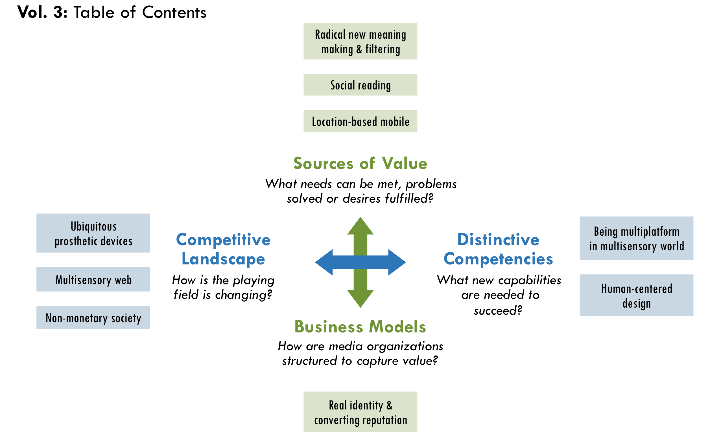

Ubiquitous prosthetic media devices
Although penetration of mobile phones is at unprecedented levels worldwide, full integration with the Web has barely begun. Usability is still the biggest barrier for most people. BBC News reported in January 2009 that 61% of users interviewed in the UK and US said setting up a new handset is as challenging as moving bank accounts and 95% said they would try more new services if mobile technology were easier, which signals the potential explosion of mobile usage as the technology improves in the coming years.
One of Battelle’s predictions for 2009 was that mobility would become presumptive in every aspect of the Web. And, mobile phones are just the beginning. Shirky believes one of the biggest game changers will be that “ubiquitous prosthetic media devices”—cameras, video, audio—will be built into everything. “Take what happened on Oakland BART (on New Year’s Eve when a transit policeman killed a young African-American man]. Think of all the images that came from people who were there—not just one but many images—thanks to the fact that everyone had a built in camera in their coat pocket.”

Multisensory convergence
Many people claim that we are moving back into an acoustic culture and visual culture akin to the way most people communicated before the printing press. Video is quickly overtaking the Web and will diminish the primacy of text-based journalism, particularly when it becomes easier to watch video on mobile devices.
The impact of text could be marginalized further by the emergence of a multisensory web. We will likely have the ability to transmit smells and other data about physical world such as air samples for pollution. For instance, the Defense Sciences Office in the U.S. Department of Defense, which focuses on “mining ‘far side’ science,” is working on a way to make multi-sensory data converge in real time, just like it does in humans.
“There will be things we can’t even image when the web is more multisensory and we can smell and touch,” note Bracken. For example, a surprising portion of the population who would be willing to have brain implants that enable them to use their mind to access the Internet. According to a survey by Zogby International, 11% of respondents said they were very or somewhat likely to do so if it could be done safely.
Journalism organizations are still trying to figure out how to tap social networks, yet they are chasing a moving target. As social networks evolve, they will increasingly function and look like real life. Moreover, virtual gaming worlds, such as Second Life, are already social networks. As they become easier and more accessible, there might not be much of a difference between real and virtual worlds. John Gaeta, a visual effects designer in the Matrix film trilogy asked at a conference in Berkeley, “What will the convergence of platforms mean?” He said we will see “interactive realism” where online and offline become a mixed reality. “Games and films won’t look different,” he said, “so you can have a transparent passage from a real piece of content to a virtual piece of content.” Convergence will be like having trap doors that lead seamlessly between different worlds.
If platform convergence is a challenge today, the multisensory web combined with ubiquitous prosthetic devices will make the competitive landscape even more complicated. The time it takes for independent media organizations to participate in such innovations today may not be worth the scale of reach. However, if they do not take radical steps to keep up with early innovations, the gap between their internal competencies and the emerging online environment will become even greater.

Rise in alternatives economies
Human motivations are much more complex than a drive for money or other rational incentives might explain, which has pushed the boundaries of traditional economics and will continue to shape the competitive landscape of the media industry.
“We are discovering that money isn’t the only motivator,” said Anderson. “Altruism has always existed, but the Web gives it a platform where the actions of individuals can have global impact. In a sense, zero-cost distribution has turned sharing into an industry. In the monetary economy it all looks free—indeed, in the monetary economy it looks like unfair competition—but that says more about our shortsighted ways of measuring value than it does about the worth of what’s created.”
“Why does Burning Man work? Why does Wikipedia work? Why does Alcoholics Anonymous work? Maybe (independent media) will be self-funded or a barter economy.”
– Katrin Verclas

Some people have pointed to alternative economies that have risen up in large scale, such as the Burning Man Festival. Over 50,000 people create the third largest city in Nevada the week before Labor Day, which runs almost entirely by a “gift economy,” in which transactional relationships of any kind are shunned.
“We have all of these examples of places where groups of people are motivated by something other than money, like the Apache Web Server,” Shirky said. “We’ve had many people forecasting that because people aren’t getting paid, because things are free, that everything will collapse. Well, for two decades things haven’t collapsed. Clearly the theory of human motivation is wrong. But we don’t know what the alternative theories are either. Almost everybody— myself included—does a lot of hand waving around this issue. Folks like myself, Don Tapscott, and Jeff Howe say people do it because it’s fun, that they like it, but the truth is we don’t really know. We know how to set up a business, for instance, but it’s hard to figure out the human motivations behind why and what works.”
Many people have pointed out a rise in skepticism about capitalism. Shirky noted that “giving readers a point of view free from the distorting effects of ads and commercial interests is something increasingly important given recent financial scandals.” Possible bellwethers of growing zeitgeist include The Daily Show and Colbert Report, which have taken major financial and media industry players to task, especially Jon Stewart’s debate on March 12, 2009 with Jim Cramer, host of CNBC’s “Mad Money.” Furthermore, Heads of State in Bolivia, Cuba, Dominica, Honduras, Nicaragua and Venezuela declared “Capitalism is leading humanity and the planet to extinction.”
“Free shifts the economy from a focus on only that which can be quantified in dollars and cents to a more realistic accounting of all the things we truly value today.”⁸⁸
– Chris Anderson

“There’s a democratization in some ways of wealth—we’re in the early days. It’s not easy to see it because overall in the world the rich are getting richer and the poor are getting poorer. But that power is shifting to the vernacular: consumers, employees, citizens are getting unprecedented access to knowledge. And knowledge is power.”
– Don Tapscott

- These alternative motivations will inevitably do wonders in feeding the growth of citizen journalism and pro-am collaborations. However, if society becomes less focused on financial profit, it may also have a lasting effect on whether any journalists get paid sufficiently for their work. If the growing amateur ranks produce reporting that is “good enough,” a demand for higher quality journalism may not materialize sufficiently to increase people’s willingness to pay for it. Meanwhile, the abundance of information online would continue to increase, and the need to solve filter failure would become more pressing.
Independent media organizations have often operated via a form of gift economy, in which volunteer and low-pay labor are the rule rather than the exception. Perhaps this means independent media will be well positioned if this trend increases in the future?

Human-centered design
In his article, “Is Google Making Us Stupid?” Nicholas Carr describes many ways the Internet is shaping our minds, and admits himself that, “I’ve had an uncomfortable sense that someone, or something, has been tinkering with my brain, remapping the neural circuitry, reprogramming the memory.”
While technology may be changing us in profound ways, the next online frontier will be how technology adapts to us. Tim Brown, president and CEO of innovation and design firm IDEO, wrote that when companies are disrupted by new technologies or demographic shifts, the problems still have people at their heart. “They require a human-centered, creative, iterative, and practical approach to finding the best ideas and ultimate solutions. … By (human-centered design) I mean that innovation is powered by a thorough understanding, through direct observation, of what people want and need in their lives and what they like or dislike about the way particular products are made, packaged, marketed, sold, and supported.”
Claire Tristram explained in Technology Review, “as computing power seeps from the desktop further into our daily lives, it’s becoming all the more important to make products that are both easy to use and improvements on what we’re using today. A human-factors approach assumes that the things we’ll carry in the future are not going to be invented so much as discovered—that the answer to the question of what devices we’ll carry will become obvious as we learn more about human behavior.” For example, people became good at memorizing 10-digit phone numbers for the past century. But, that habit all but disappeared overnight. Shirky said, “the trick is to look case-by-case at the changes in human behavior versus technology.” In this regard, anthropologists are more likely than technologists to identify the next groundbreaking innovations in media.
Nevertheless, technologists are still driving much of the innovation in the industry. Motorola’s Iridium satellite phone, bankrupt after $5 billion of investment and just a year on the market, is often held up as an example of failure that can happen when technology, not customers, drives a product. Battelle has also questioned Google’s engineering focus, which could ultimately be its weakness in some products in the future. “It’s the essential human question that drives Google. I bring it up all the time. Community. Media. People. How do you make people scale?! How does Google, a company driven by algorithms and scale, find its Voice? … It can't be all algorithms.”
When something becomes commoditized such as technology or information, other differentiating factors increase in value. For example, computers have sunk to very low prices while at the same time overshooting most customers’ need for speed and memory. In many ways, they are becoming commoditized. As a result, Apple has captured more market share by differentiating computers through innovative human-centered design. The parallel to journalism could reveal one potential solution for the future: How can journalism differentiate how it designs the production and delivery of news in such a way that it becomes more valuable?
Human-centered design of news delivery may be a particular challenge for journalism in the future if it does not understand their customer today, which Soni claims is a problem. “They write stories that they think are important, but that’s not what the consumers want.” In the future, journalists will not only need to develop a better understanding of customers by embracing new tools and demographic realities, but also understand how the mind works. Gahran believes journalists need to “hack around trying to find tools to work the way the brain works and mirrors how people interact in the world and with each other.” She suggested the next game changers could come from cognitive scientists such as Steven Pinker and others. For example, there is a correlation between memory and emotional impact. The most memorable elements of a media product are the ones that have the greatest emotional impact on its viewers. A better understanding of how the mind works could be considerably valuable for journalists in designing news products in the future.
However, when it comes to human-centered design, social behavior can be even more complicated. Surowiecki wrote in The Wisdom of Crowds, “the solutions to coordination and cooperation problems are not like the solutions to cognition problems. They are fuzzier and less definitive…” And, there is still a long way to go in understanding how to apply such offline human behavior to new media. Research in 2008 on social cascades in Flickr said that they still need to go much further in understanding the similarities between online and offline dissemination. Nevertheless, journalism needs to stay at the cutting edge of such research. Human-centered design will become even more important as the central competency for media organizations increasingly becomes building strong, well-designed communities.

Radical new ways of solving filter failure & making meaning
The next phase of linking, tagging and other metadata will be determined by the evolution of the “Semantic Web,” which Soni described as “one level beyond aggregation” that aims to make information more meaningful and useful. According to an article co-authored by Tim Berners-Lee, who is credited with founding the Web, “It lets users engage in the sort of serendipitous reuse and discovery of related information that’s been a hallmark of viral Web uptake.”
Tagging as we know it today is just the beginning. The Semantic Web will depend on any data that enables inferences of meaning from human behavior, personal preferences, trustworthiness, provenance (the when, where, and how information originated) and many other elements. However, Berners-Lee said the Semantic Web remains largely unrealized. “They’ve been working on solving this problem for 10-15 years,” Soni pointed out. “But no one is anywhere near a product or solution yet.”
“The technology itself is a barrier,” Soni explain. “It turns out that understanding the relevance and importance of documents is hard. For example, say I have a story that has a certain keyword ten times. Automatically the artificial intelligence tool might rate it as very important for that topic, but it could be that those ten mentions aren’t really relevant. Trying to understand the real meaning of a document… the science isn’t there yet.”

New ontology
The evolution of the Semantic Web depends largely on how we organize and structure information online and how pieces of information relate to one another. This topic, called “ontology,” is a highly debated area in technology.
“There’s this war between people who look for an algorithmic way to connect pieces and those that look for human ways,” Weinberger said. Some people believe in automated approaches to tagging, while other believe in “folksonomies,” where we can figure out the main ideas of content by analyzing people’s hand-tagging, such as you find on Flickr images. While most people acknowledge utility in both, Weinberger said that people, by personality, tend to favor one and never look at the other. “It seems to go fairly deep into what we think language is, what it means to be social, how much of the world you think can be synthesized and represented.”
There are flaws in both approaches. Weinberger explained that people mostly use hand tagging to trigger their memory, not to make sense of a topic. Although it is a bottom-up approach, he called it a flawed taxonomy. On the other hand, algorithms have not worked well either he noted, “because people are pretty stupid about language and language is resilient against algorithmic approaches.” Nevertheless, he believes that it would be wildly foolish to think it will stay that way. “The scale of information is such that all assumptions about distilling information won’t hold.” For instance, IBM is making progress in this area. Instead of using rules to translate semantics into standardized language, they simply analyze a large corpus of data that shows which words are closely related, which works much better and more quickly than rule-based methods.
Shirky believes ontology itself is over-rated. “You don't really need choose a category,” he said. “One of the great freedoms of digital data is there is ‘no shelf.’ Now media outlets are very comfortable with taxonomies, but these were more for organizing careers not content.” In a 2005 blog post on the subject, he said the debate ultimately comes down to the question, “Does the world make sense or do we make sense of the world?” If the world makes sense, then we would have to reconcile all different points of view into one “theoretically perfect view of the world.” However, if we are the ones who make sense of the world from an endless variety of viewpoints then, “What you do instead is you try to find ways that the individual sense-making can roll up to something which is of value in the aggregate, but you do it without an ontological goal.” That is, we do not place one top-level way of making sense over any other. “The semantics here are in the users, not in the system,” he wrote.

Value of discovery
While a more developed Semantic Web will certainly help users find information easier, the long-term potential for independent journalism could rest more in how it helps people discover new ideas and perspectives.
“Discovery is the untapped value on the web now,” Anderson proclaimed at Nokia World 2007 and said filtering and information structuring is the solution. For example, in 2008, AlterNet received 3.3 million visits from three referral sites designed to tap the value of discovery: Digg, Reddit and StumbleUpon. Clearly, there is considerable value when new visitors—who are not predisposed to a political viewpoint—discover AlterNet’s content. Impressively, 86% of the visits from StumbleUpon and 74% from Digg and were people new to AlterNet, compared to less than half of visits from other types of referral sites, such as the Huffington Post.
Furthermore, 65% of visits from search engines were new to AlterNet, which shows that search is currently less effective in tapping discovery than referral sites. Interestingly, Digg and StumbleUpon depend largely on interpretation by people rather than algorithms. This indicates the discovery value created by systems that can efficiently aggregate human interpretation at a large scale. Nevertheless, AlterNet’s top 10 referral sites represented only 14% of the its 35.5 million total visits in 2008, which reveals that discovery still has unfulfilled potential in generating traffic.
In order to promote greater discovery in the future, independent media could coordinate the collection of metadata. Such data may be more valuable for organizations if it was pooled with larger amounts of data over time, than if they protected it for their own purposes. The data can help improve artificial intelligence, which drives the automated aspects of the Semantic Web and will be critical to enable greater discovery.
In lieu of new discovery capabilities, online advertising may grow more focused on behavioral targeting, which can simply entrench people’s existing attitudes and opinions. Andreas Roell, Chairman and CEO of Geary Interactive wrote, “The main difference between artificial intelligence and behavioral targeting is that behavioral targeting takes past patterns and applies it to the future. Behavioral targeting is like a review mirror, whereas artificial intelligence constantly evolves and prioritizes behavior to make better recommendations over time.”
Software developers and progressives may share one limitation in how they approach data: both are overly focused on short-term impact. However, the long-term view of user’s online experience is an underdeveloped area in terms of discovery value.
For example, a Google programmer, who asked to not be named, said that the engineers and designers at Google usually look only at the short term. “Use-case scenarios,” a central tool for software developers, are typically created for only ten seconds to ten minutes of a user’s experience. He believes tremendous value is missed by not looking at use case with a long-term view.
The potential value for online product development can be seen in a study of social cascades in Flickr. Researchers discovered that 20% of the pivotal first step in a social cascade took longer than a month, which shows that discovery leading to superdistribution includes use cases of much longer than 10 minutes.
Similarly, independent media-makers can tend to believe that “truth telling” comes in one fell swoop. However, as Emily Dickenson once said, “The truth dazzles gradually or else the world would be blind.” Discovery is a constantly evolving state for people, which could be an opportunity for independent media. If journalists can seek to meet people where they are, their truth telling could have a more powerful impact in users’ discovery over time.
Weinberger said part of the best-case scenario for independent media 10 years from now is that “there will be structures in place that challenge me in ways that I want to be challenged, but that ten years ago I didn’t think I wanted to be challenged.”

Location based mobile
The ability to detect a user’s exact location will revolutionize the use of mobile devices in the future. Already, Latitude on Google Maps and services from other companies such as Loopt enable a user to broadcast where they are to friends.
The future of location-based services has barely begun, and it will dramatically change how we interact with our offline environment. For example, shopping applications such as the iPhone’s LikeThis, G1’s Shop Savvy and some Amazon applications enable users to scan bar codes or take pictures of products to retrieve price comparisons and other information as well as aid mobile search. The revolutionary leap will come as these services add GPS ability to compare prices and find products by location.
With support from Nokia, MIT researcher Sandy Pentland is developing a “passive social graph” by collecting location-based and Bluetooth data. He can conduct what he calls “reality mining” to see whose mobile phones come in proximity with each other. According to ReadWriteWeb, “Pentland predicts a future when he’ll be able to use frequency of calls, physical proximity and interruptions in conversations to determine for example who among your Facebook friends is a real life friend, who you’ve never met in person and who is your superior in a workplace hierarchy.” The iPhone even has the capability to tell if you are sitting and walking. This location-based reality mining is “a new method for precise measurements of large-scale human behavior” and could be used to detect epidemics among other things. For example, a significant portion of people not going to school or work one day might alert health officials.
This sort of reality mining will raise a whole new set of privacy and ethics issues that will have to be balance with its social benefits. Services will likely only be opt-in and analyze aggregated data to maintain anonymity. For example, Google’s Latitude service includes a “memory leak” to remedy privacy concerns. Pentland said in an interview with MIT’s Technology Review, “The people making policies don’t know what is possible, and they don’t necessarily make policies that are in our best interest. … These capabilities are coming, but we have to come to a new deal. It doesn’t do any good to stick your head in the sand about it.”
The potential for news is great, particularly local news, and particularly in helping news become more relevant to users based on their location without any user input needed. A Forrester 2009 research report found that hyper-local media that succeeds will have to master the mobile channel and connect it to low-cost, user-generated content as well as a smart ad sales automation. Imagine news alerts to people based on their location, such as when an underground explosion in San Francisco’s Tenderloin caused a power outage for 8,600 residents. Imagine news about a company, health issues or consumer safety that could be available when a user scans a product for price comparison. Imagine nearby micro-volunteering opportunities reaching people based on where they are.

Social reading
“The problem of how media has evolved is that it has isolated people,” said Gahran. “Your role was passive and to take it in. That damaged society in some ways.” Weinberger pointed to the early history of writing when reading became internalized. “Some people say that’s the origin of modern consciousness. The voice we heard externally, reading to us, we now hear internally.”
Cognitive scientists studying how the brain evolved say there were deep changes in our brain structures once reading and writing emerged. Marshall McLuhan famously describes how the emergence of communication technology as early as the printing press affected how we think, which had profound impact on social organization. Weinberger believes it is about to change again: “When you think of reading, you think of being by yourself, sitting quietly and reading in the hammock. Now reading may be a social act and this may change how we think.”
Television is evolving into a more social experience as well. Just before Barack Obama’s inauguration, for example, CNN incorporated Facebook Connect. “For the first time, users could watch live TV online, invite their friends, chat with them while viewing and enjoy a social experience around Internet TV,” according to Razorfish.

Socratic journalism
Since online tools have now reached a scale for mass conversations, “social reading” may become the central metaphor for new media, which could change journalism in more significant ways than we have seen so far.
Media is far from one-way communication anymore, but only recently has it begun to move beyond a bidirectional model. Commenting on news sites is interactive, but no less bidirectional since comments are published and funnel through the publisher. So, what would multidirectional communication look like in journalism? If it were truly multidirectional, it would have to include horizontal conversations among groups of users that by pass the publisher altogether—like conversations among friends during a sports event, concert or political rally. Yet, how would that be any different from all-purpose social networking?
The answer might be in the role the journalist plays. Since reading and watching television was an individual act, the journalist’s role as educator was suitable. People learned about current affairs privately, which equipped them to interact publicly. In a social-reading metaphor, people learn about current affairs and engage with others simultaneously. As a result, journalists become conveners, facilitators and instigators in an inquiry process. They work with others to understand an issue more fully. They do not simply report news for news’ sake; they create problem solvers who can think critically and iteratively. Essentially, they become Socratic journalists.

Real identity & converting reputation
“What I want to know,” Shirky said, “is how easy will it be 10 years from now to use my real name on the Web, how easy will it be to access things without separate logins across the web, and will my reputation and standing as a member be used. In short, will how we function and behave on the web become close to how we work in the real world? If this happens, we can see many new business models being possible.”
Shirky said that if this convergence happens, then qualified advertising revenue would be easier to support. Also, media outlets would be able to build communities of users who are willing to support them because those users get public credit for it. He believed that so many of the problems we have right now are due to anonymity, which get disproportionately worse at scale, creating high costs in terms of usability and preventing many models from being tried. “You simply can’t have large-scale communities with anonymity. Anonymity doesn’t scale.”
“Anything you can consistently convert to cash is a form of currency itself, and Google plays the role of central banker for these new economies.”
– Chris Anderson^{H}

Virtual wealth in terms of reputation needs to be convertible to real wealth in some way in order to be valuable. Lessons from the gaming industry indicate the potential value for media organizations of all kinds. “Players learn how to customize and to create within the online spaces, as well as how to extract this value back into the real world,” according to Cory Ondrejka, former Chief Technical Officer of Linden Labs, makers of Second Life. In fact, sometimes reputation is more valuable than time in this regard. Ondrejka learned from user behavior in games that “time-constrained users can make the rational economic decision to use real world currency to advance their character rather than time.” Citing research, Ondrejka claimed that the value of reputation has created a market in real-world currency for game items, game currency and characters. While gaming has many differences with journalism, these dynamics suggest there is value to be captured from reputational effects, which will be increasingly possible as online measurement is developed and standardized further.
New Federal Trade Commission (FTC) truth-in-advertising regulations for social-media could make reputational conversion more likely. The FTC, which has not changed its guidelines endorsements and testimonials since 1980, plans to hold advertisers liable for false statements online. Since many marketers use bloggers and other individuals to spread information, the methods of qualifying real-life identity will become more necessary.
“As someone in his 40s, my generation grew up believing that we’d all end up in cyberspace with all of our heads floating in virtual worlds. Not one of my students believes this will happen. As it turns out, the Internet augments real-life and doesn’t replaces it.”
– Clay Shirky

Conclusion
(Note: this section is being changed based on initial feedback from reviewers. A few notes remain, but they are not yet polished.)
In the end, the future of media is all about power. Those with power will continue to accrue it until they have too much, and those without will fight to correct it. The future of media leadership will be an ebb and flow as it has always been, but two primary questions have surfaced: Will the ebb and flow of an organization’s power be more volatile and offer more opportunity for independent voices—both organizations and individuals—to grow within the new system? Or will it continue to be race to the bottom?
In her seminal paper, Leverage Points: Places to Intervene in a System, Donella Meadows asked, “So how do you change paradigms?” She points to Thomas Kuhn, who wrote the ground-breaking book about science’s great paradigm shifts: “In a nutshell, you keep pointing at the anomalies and failures in the old paradigm, you keep speaking louder and with assurance from the new one, you insert people with the new paradigm in place of public visibility and power. You don’t waste time with reactionaries; rather you work with active change agents with the vast middle ground of people who are open-minded.”
In order to succeed on the new playing field of journalism, TMC needs to speak with assurance about its strategic direction and work with the people and organizations that will be change agents in this new paradigm.
- The process of considering change, as the TMC done since its inception, is part of change itself. By actively engaging and encouraging experimentation, brainstorming, and questioning, progressive media makers will build a sector that not only mirrors the progress of the times, but also achieves the progressive goals they espouse.
List of participants & process
Outside interviews
- John Battelle, author of The Search: How Google and Its Rivals Rewrote the Rules of Business and Transformed Our Culture, CEO & founder of Federated Media
- Adam Berrey, Senior Vice President of Marketing & Strategy, Brightcove
- John Bracken, Program Officer, MacArthur Foundation
- Amy Gahran, E-Media Tidbits, Poynter Institute
- Jay Harris, Publisher, Mother Jones
- Jay Heindrich, author Thank You For Arguing & magazine consultant
- Leo Hindery, partner, Intermedia (private equity)
- Larry Irving, former Assistant Secretary, U.S. Department of Commerce, technology strategist & futurist
- Craig Newmark, Founder, Craigslist
- Vivian Schiller, CEO of National Public Radio. Former general manager of NYTimes.com
- John Schwartz, President, EBS Companies
- Clay Shirky, author of Here Comes Everybody: The Power of Organizing without Organizing; professor NYU graduate Interactive Telecommunications Program (ITP)
- Ashish Soni, Director of the Information Technology Program (ITP) at the Viterbi School of Engineering at the University of Southern California
- Alex Stefan, executive director, worldchanging.org
- Don Tapscott, author, Wikinomics
- Katrin Verclas, Co-Founder, MobileActive
- David Weinberger, author of Everything is Miscellaneous, journalist, fellow at Harvard Law School’s Berkman Center for the Internet and Society

Participants in scenario planning meeting
- Ann Friedman, Deputy Editor, The American Prospect
- Jay Harris, Publisher, Mother Jones
- Steve Katz, Vice President for Strategy, Mother Jones
- Andrew Golis, Deputy Publisher, Talking Points Memo
- Rinku Sen, Publisher, ColorLines
- Don Hazen, Executive Director, AlterNet
- Teresa Stack, President, The Nation
- Roberto Lovato, Associate Editor, New America Media
- Tracy Van Slyke, Director, TMC
- Erin Polgreen, Program Associate, TMC
Outside-in thinkers (external resources):
- Art Kleiner, Editor-in-Chief, Strategy+Business magazine (www.strategy-business.com)
- Mitty Owens, Senior Deputy Director, NYC Office of Financial Empowerment, former program officer at Ford Foundation
- Mike Stanton, Publisher, The Bond Buyer (leading daily newspaper of public finance)

Credits:
Report was written by Tony Deifell, Q Media Labs
Review and editing: Nicole Anne Boyer, Jessica Clark, Steve Moss, Erin Polgreen, Ben Rigby and Tracy Van Slyke.

TMC members’ discussion summary
As described in the introduction, this report uses the dissonance created between old and new paradigms of media to identify the strategic importance of emerging practices and approaches. During TMC meeting in February 2009, members discussed and debated four statements designed to surface debate.
- Discussion Worksheet follows this section that you can use with your staff or another group.

Provocative statements | References to analysis in Vol. 2
- Alternative thinking no longer falls on the traditional definitions of “progressive” anymore. | - Progressive ideas, p34
- The line between mainstream & independent media is blurring. | - New abundances & their effects, p10
- The source (publisher) of news is losing relevancy. | - Declining institutional control & , p17  - Solving filter failure, p36
- The role of publisher is shifting from content creator to community convener. | - Getting serious about community, p24
Members discussed three questions as they applied to each statement above. Their collective responses are listed below.
The line between mainstream and independent media is blurring.
“This is a worry because corporate media is falling apart financially, or they’re self-marginalizing by being wingnuts, so they can’t be trusted sources. So, there is a vacuum we can walk into in terms of being trusted sources of journalism.”
– Sarah van Gelder

What notions would we have to give up to move forward?
Collecitve responses from discussion | References to analysis in Vol. 2
Labels. “We tend to self marginalize. We can be much more inclusive and therefore build much stronger movements, create much more opportunity for diversity among us.” | - Progressive ideas, p34
Political stances. There was disagreement in the group about what exactly needs to be given up in terms of political stances, which fell in two camps. | - Progressive ideas, p34  - Declarative & adaptive reporting, p25
- Giving up one-dimensional political stances. Move to more broadly inclusive values such as human rights and global perspectives in storytelling.  - Giving up articulation of political stances altogether. Move to a pragmatism of looking to what works and what people want to know, then focus on being a trusted source of quality. | The source (publisher) of news isn’t as relevant anymore.  “We decided it’s not true. But it is true that filters and validators, as in third-party sites that aggregate, imbue a link or article with their authority. This doesn’t mean the publisher is irrelevant, but it means they’re slightly less important than they used to be.”  – Ann Friedman
Linking to external sites is a bad thing. | - Counter-intuitive ways of working, p28
Publishers’ brands will sustain us forever. It is now more complicated since writers will brand themselves as will topics. | - Journalpreneur, p30
Control. Instead, we need to be more responsive to readers. | - Declining institutional control & , p17  - “My ideas”, p34  - From using users to a Conversation Economy, p37  - Solving filter failure, p36
Control. “Scoop” proprietary mentality.
Reluctance to talk to crazy people. | - From using users to a Conversation Economy, p37
Old methods of getting word out. | - Physical distribution, p2

What capabilities or competencies do we need in order to succeed?
Collecitve responses from discussion | References to analysis in Vol. 2
New language. Be both poetic and true. | - Declarative and adaptive journalism, p25
Human stories. Provide a human lens, not just the big picture. | - “My ideas”, p34  - Getting serious about community, p24
Cooperation. Reach beyond competitive stances.  Stronger partnering with non-profit and advocacy groups. | - Counter-intuitive ways of working, p28
Money. New fundraising capabilities.  Issue-based fundraising. | - Emerging revenue models, p43  - Tightly integrating functions, p27
Maintain brand quality and some degree of control over it, which involves community building and curatorial competency. | - Scarcity of reputation, p11  - Getting serious about community, p24
Open system of reporting (“to a point”). Give a certain amount of content out and ask people to engage with it. User-driven recommendations. | - Declarative and adaptive journalism, p25
Community organizing. Facilitating discussion, knowing skills and values of your audience. | - Getting serious about community, p24  - From using users to a Conversation Economy, p37
New media training. | - Strategic technology, p26  The role of publisher is shifting from content creator to convener of communities.  “How do we square investigative journalism —content which builds up for long time and is vetted, tightly managed, labor intensive and embedded in a journalistic culture with a long history— with community-building activity?”  – Jessica Clark  - Experimentation, p27

Which models & metrics are most important?
Collecitve responses from discussion | References to analysis in Vol. 2
Old model: print + web.  New model: publisher (original content) + validator (curatorial). | - Solving filter failure, p36
New model: global reach, rather than nation-state or niche groups. | - Next phase of globalization & its effects, p15
Old metrics: eyeballs and traffic.  New metrics: influence beyond eyeballs, community (How long & often reading? How often sharing, donating?). | - From using users to a Conversation Economy, p37
New metrics:  - Degree of reach beyond usual suspects (mostly white audiences) + number & variety of users on site (not just young people, but also retirees).  - Brand integrity (user research to know if site is trusted).  - Number of user-community submissions.  - Degree to which media outlets collaborate. | - Dawn of a demographic revolution, p14  - New scarcities & their effects, p11  - Getting serious about community, p24  - Counter-intuitive ways of working, p28

Discussion worksheet
Break into small groups of three to eight people. Choose a person to report out.
Each group selects one of the following provocations to discuss (different one for each group).
Group 1: Alternative thinking no longer falls within the traditional definitions of “progressive”.
Group 2: The line between mainstream & independent media is blurring.
Group 3: The source (publisher) of news is losing relevancy.
Group 4: The role of publisher is shifting from content creator to community convener.

Questions for each small group
If the assumption in the statement is true…

1. What notions would we have to give up to move forward?

2. What capabilities or competencies do we need in order to succeed?

3. Which models & metrics are most important?

The Media Consortium’s history & membership
In early March 2005, two-dozen leaders from the worlds of independent print, radio, television, and Internet media answered a call from Mother Jones, The Nation, and The American Prospect to discuss “Independent Media and the Future of Democracy.” It was the first time in at least a decade that independent media content producers and distributors came together to talk about strengthening our effectiveness. We continued the conversation through 2005, expanding to include many more media organizations. We looked to diversify our membership beyond print and text-based media outlets as well as include organizations that reached specific target audiences, women, people of color, etc. Our goal: to figure out how a network of independent media could address two challenges we all face:
- How to amplify independent journalism’s voice in broader public debates over the crucial political and social issues of our times.
TMC Mission Statement:
To amplify our voices; increase our collective clout; leverage our current audiences and reach out to new ones; attract financial resources; strengthen and transform our individual businesses and our sector’s position in a rapidly changing media and political environment; and redefine ourselves and progressivism for a new century.

- How to navigate the current wave of profound technological change —change that is reshaping the media business, not to mention redefining the practice of journalism itself.
In early 2006, The Media Consortium formally coalesced. The Media Consortium’s Project Director Tracy Van Slyke calls the first few years of the network the “dating years.” TMC worked to build bridges, relationships and networks among individual organizations where none had existed before. Smaller projects were organized, mostly around business and marketing opportunities. For the first few years, there were disagreements about whether editorial collaboration should exist and if so, what it would look like.
By 2008, The Media Consortium had reached a turning point. Its staffing increased from two part-time staff in 2007 to two full-time staff in 2008. Relationships and strategies began to coalesce and fully inform the process for strategically developing projects and assessing their success.
When the consortium first formed, its members were wary of sharing information and working together. TMC provided space for developing deep professional relationships. Overall, TMC is creating the space for independent media to collectively strategize for a dynamic future. TMC’s work is ensuring growth and unity within the sector, rather than the fracturing and folding that mainstream and traditional media outlets are facing.
Members are increasingly comfortable with working together to share ideas and collaborate around projects. Joint editorial, marketing, and business projects are part of The Media Consortium’s 2009 focus. Members are confident about this work’s internal benefits—so much so that many have begun collaborating outside of TMC supported projects.
In July 2008, The Media Consortium’s Coordinating Committee came together for a two-day strategy retreat in New York and developed four strategic principles for Media Consortium initiatives and projects in 2009-10, including:
- Build and diversify the media leadership pipeline
- Bring money into the sector
- Foster collaboration among TMC members and like-minded organizations
- Focus on audience development through demographic research and strategic outreach.

Membership composition
The Media Consortium currently has 45 members, and over half are actively engaged in TMC meetings, its listserv and TMC-sponsored projects. Members include magazines (and their websites), video producers, television networks and radio networks, book publishers, online news producers and more.
- Active TMC Members
- (all have online activities):
Magazines: Mother Jones,
In These Times, The Progressive, The American Prospect, The Nation, Washington Monthly, Yes! Magazine, Ms. Magazine, Texas Observer and ColorLines.
Online-only news sources: Wiretap, Grist, The Uptake (video), Talking Points Memo, RH Reality Check, OneWorld, Feministing, Center for Independent Media, AlterNet and AfroNetizen.
Television networks:
LinkTV and FreeSpeech TV.
Television Shows:
The Young Turks (with radio syndication) and GritTV (on FreeSpeech TV, hosted on blog FireDogLake and syndicated to public
access channels).
Radio: Air America, Public News Service, Democracy Now! and National
Radio Project.
Book Publishers: Chelsea Green, The New Press and Berret-Koehler.
Video: Brave New Films, Balcony Films, American News Project and Real News Network.
Other (training, syndication, production, networking organizations): G.W. Williams Center for Independent Journalism, Women’s Media Center, American Forum, The Nation Institute, NAMAC and New America Media.
More than 50% of TMC membership is made up of primarily text-based media organizations that range from magazines to online-only news sites. But more media outlets are moving beyond their primary platform and delivery systems due to quick industry shifts. Many now produce and distribute a mix of text, video and audio within their online operations. Within five years, many of these formats will be integrated across all our members.
Membership to The Media Consortium is based on criteria developed by our membership committee and approved by our Coordinating Committee (i.e. Board of Directors). While most of TMC’s members are “pure-play” journalism organizations, ongoing diversity goals are also considered. TMC also reviews how the changing media and political landscape impacts our ability to fulfill our mission. The Media Consortium’s membership body is a “hybrid” group of media organizations. Some examples include: advocacy and journalism, individuals, the progressive blogosphere, media distribution organizations and media outlets that have both a social justice and political focus.

Membership requirements
Members must be committed to:
- Amplifying the power of the independent media to foster a more informed, just and open society.
- Promoting the gathering and dissemination of news about current affairs in communities underserved by mainstream media.
- Supporting “mission-driven” media outlets whose missions encompass promoting the public interest in political, social and/or cultural diversity.
- Encouraging the participation of underrepresented communities in civic affairs by enhancing their connections with opinion leaders and policy makers.
- Research and development of innovative approaches to media production and distribution.
- Enhancing the practice of journalism in the public interest.
- Organizations where participation would confer a non-incidental private benefit are excluded from membership.
The Media Consortium also has multiple allies in the progressive political and media policy world, including the Center for American Progress, Media Matters, MoveOn, Free Press and more.

Collective online audience size
Online reach data was retrieved from Quantcast data on June 23, 2009 for websites of TMC members and gave an estimated online reach of 17 million website visits. Approximately 23% of these sites were measured directly, and 47% of the sites were “rough estimates” by Quantcast. Approximately 30% of the sites did not have enough data to estimate traffic, but these publishers have a relatively small impact on the cumulative number of online visits.
For consistency in comparison, Quantcast was used when available because self-reported data can vary greatly based on how metrics are defined and measured. The total collective reach includes overlapping visitors. However, research from 2006 showed that the overlap among member/subscriber lists among TMC members was just 25%.

- Table delineating traffic sources TK

Guidelines for generating game changing ideas
Our working definition of “game changer"
Developments (projects, initiatives, strategies, new models, innovations) that “change the game” for independent media by increasing its impact and influence in the next five years. These are not incremental strategies, but rather big bold moves that The Media Consortium could take advantage of in a rapidly changing media landscape.
Strategic moves

How can we think about game changers? To simplify, there is a continuum of strategies that might create game changers for TMC.
- REVOLUTIONARIES
These game changers tend to be über innovations. They create entirely new market spaces, categories, or social innovations that never existed before—and change the boundaries and rules of the industry or sector as a result.
- DISRUPTORS
Whereas revolutionary innovation typically comes from the “outside-in” disruptive game changers start within the boundaries of a defined industry or sector. They tend to be more “bottom-up” or lateral in their genesis. Disruptive innovations are also different because they often start out as lower cost options with inferior performance in unpromising markets — which makes them hard to spot and taken seriously at the beginning.
Examples — Encyclopedia Britannica was unable to recognize that CDs & DVDs would be a disruptive format. In addition, disruptive innovations frequently "democratize" services and enable customers to be part of the value creation process. By this, they increase access or the ability of customers to do things that were previously done by a group of experts in a centralized fashion (For example, computing, photocopying, blogging). In any event, these strategies are called "disruptive" because they displace the incumbent players or technologies.
Examples — Airlines, motor vehicles, telephones, computing, semiconductors, internet. Note that many revolutionary innovations came about by 1) combining a range of existing technologies, e.g. Internet
2) a supportive context or "paradigm shift" that allowed them to emerge.
Examples — Personal computers, World Wide Web, FedEx, Intuit's QuickBooks, eBay, online auctions, MP3, iPods (downloadable music format) and Grameen Bank.
Examples — Minute clinics, home diagnostics, digital photography, photocopying, instant messaging technology, and microwave ovens.
Examples — Apple's "trickle down" strategy from the high-end to mainstream consumers through unique positioning and good design. Google's simple interface helped make this late entrant the market leader in internet search.
Disruptive innovations come in two forms:
- New market disruption creates new value by targeting “non-customers.” These are people with needs that were not being served by incumbents. Or there was a bottleneck in the way of their ability to consume the offering.
- Low-end market disruption creates value by targeting customers who are being over-served, or do not need the full performance required by high-end users. Often products overshoot the ability of consumers to adapt to the new features. Low-end disruptors reframe the offering by simplifying or focusing on the specific needs of these niche segments.
3. ADAPTERS
Though not as flashy and memorable, sometimes incremental innovations that are combined in novel or timely ways, can become game changers. First movers are not always successful in the end, so being a “fast follower” is often the savvy way to go. Google, for instance, was late to search.
Adapters come in two forms:
a) Design & differientiation
b) Cost reduction
Example — Wal-Mart's supply-chain approach

Characteristics |  | Impact
The following characteristics describe potentially gamechanging ideas for independent media: |  | Successful results from a game changer may include one or more of the following:
- Surprising and unexpected (reaches beyond the traditional tactics of progressive media)  - Time horizon for manifestation two years or more  - Holds potential risk that is equal to the reward/benefit that it could create (for TMC and/or its members)  - Utilizes technology that is early enough in its adoption cycle to leverage early-mover advantage  - Potential to lead to new solutions or opportunities for social impact  - Simple and intuitive |  | - Improve collective performance by 3x or more in either audience reach or influence (yet to be specifically defined)  - Significantly differentiate progressive media from competitors in news, opinion and commentary that will cut through the noise (including changing prevailing assumptions about progressive media)  - Attract new or greater funds from philanthropy or commercial sources  - Add significant value to relationships between TMC members and their customers, suppliers, funders and partners required to bring progressive content to market

Innovations & innovators to watch Still being developed, please excuse rough copy

- Key innovations:

MIT related to journalism ideas: https://www.technologyreview.com/business/20923/page

Knight News Challenge http://www.newschallenge.org
- Caution:

Shirky (blog post): “Experiments are only revealed in retrospect to be turning points.”

Therefore, it might also be more agile to watch individual thinkers.

Shirky: “We don’t know who the Aldus Manutius of the current age is. It could be Craig Newmark, or Caterina Fake. It could be Martin Nisenholtz, or Emily Bell. It could be some 19 year old kid few of us have heard of.”
People

Tim O’Reilly, founder of O’Reilly Media
Measurement

Relay

Quantcast
Convergence

Google Voice simplifies how people handle phone calls, voice mail and text messages.

Also look under other categories such as television for convergence innovations

Boxee, which has a very passionate user base, pulls together multiple sources of Internet video in an easy to use interface that has caused many users to decide to cancel their cable subscriptions: “On a laptop or connected to an HDTV, boxee gives you a true entertainment experience to enjoy your movies, TV shows, music and photos, as well as streaming content from websites like Netflix, CBS, Comedy Central, Last.fm, and Flickr.”
Advertising

Vertical ad network platforms. E.g. Adify

Behavioral advertising
Search & contextual filters & aggregators

digg.com

StumbleUpon (value of discovery)

Medill-Brian Boyer: newsmixer.us uses Facebook connect to provide interestingly functionality to news with permission from Cedar Rapids Gazette.

Townhall.com is a conservative aggregator. The left don’t have has anything as comprehensive. It’s very multi-platform

Visit Google Labs to learn what the company is planning next

NewsTrust — provides a credibility filter online opinion and amateur journalism — reviewers evaluate each story against core principles of journalism, such as fairness, accuracy, context and sourcing.

Disintermediation

O’Reilly Media is way ahead of the game with XML. They’re a computer books publisher in the loosest sense. Recommended by Johanna Vondeling, Ann Friedman
Rapid programming

Symfony (PHP) (http://www.symfony-project.org)

CodeIgniter (PHP) (http://codeigniter.com)

CakePHP (http://cakephp.org)

Django (Python) http://www.djangoproject.com Missouri’s Lawrence Journal uses this platform

Microsoft PSP.net

AJAX, client-side, focuses on rich user experience, using it drives user experience and engagement
User interface

Cooliris (http://www.cooliris.com) Wall Street Journal uses for their real estate section

Apture (http://www.apture.com) Used by Washington Post. Soni called it “hyperlinked web journalism”

Zemanta (http://www.zemanta.com) Allows you to find related images as you blog (helps create links for Google search)
Naming

OpenSocial – “Friends are fun, but they’re only on some websites. OpenSocial helps these sites share their social data with the web. Applications that use the OpenSocial APIs can be embedded within a social network itself, or access a site’s social data from anywhere on the web.”
Hyper-local

Everyblock (http://www.everyblock.com) Newmark: (on next game changers) “Networks of hyper-local news starting. student-focused, done by journalism students.”

FiveThirtyEight.com

NPR’s local affiliates. Schiller: “(I want) to work with all our member stations to create local portals so that as local newspapers die away we can step into the breach to make sure that there is not a vacuum there.”

Patch

“Tim Armstrong, Google’s president of advertising for North America and Latin America, is underwriting a new startup called Patch, which plans to put small teams of journalists in communities all over the country to produce hyper-local news content.” (http://news.muckety.com/2009/02/18/top-google-exec-funds-local-news-startup/11671)
Location-based mobile

Google Latitude lets you broadcast where you are to your friends.

Loopt (predates Latitude)

apply logic to location. can you tell me current crime stats are? what’s the average price around here. to be able to get that on your phone

Distributed sampling: “The pulse is shared, quite literally, using efforts like Stanford University’s “quake catcher” network, in which seismic activity is measured by tapping into the sensors commonly found in consumer laptops.”

Passive Social Graph (in innovations to watch)
Portable personal sensors & prosthetic media devices

Boyer: “remember Bruce Sterling, the science fiction writer and futurist, talking about the game changing impact of portable personal sensors. Once these get cheap enough, it will be possible for concerned citizens to take air quality samples in their neighborhood and then share and publish data documenting— for instance, that a company is polluting the air.” Clay Shirky’s students worked on a game like this.

TED device: SixSense, by MIT’s Pranav Mistry “‘sixthSense’ bridges this gap by augmenting the physical world around us with digital information and proposing natural hand gestures as the mechanism to interact with that information. ‘sixthSense’ brings intangible information out into the tangible world. By using a camera and a tiny projector mounted on a hat, ‘sixthSense’ sees what you see and visually augments any surfaces or objects you are interacting with. ‘sixthSense’ projects information to any surface, walls, and the objects around us, and to interact with the information through natural hand gestures, arm movements, or with the object itself. ‘sixthSense’ is having the entire world as your computer.”
News mashup

http://www.newsmixer.net

Semantic tools, intelligent aggregators & meta tagging

Silobreaker.com

Slashdot-Amazon experience is an example

Defense Sciences Office (DSO) of the Defense Advanced Research Projects Agency’s (DARPA) focuses on “mining ‘far side’ science. http://www.darpa.mil/dso/thrusts/index.htm

CALO (Cognitive Assistant that Learns and Organizes) led by SRI International and funded by Defense Advanced Research Projects Agency (DARPA). “The goal of the project is to create cognitive software systems, that is, systems that can reason, learn from experience, be told what to do, explain what they are doing, reflect on their experience, and respond robustly to surprise.”

“There is already one quiet commercial spin-off from the project. Siri Inc., based in San Jose, Calif., plans to introduce a personal assistance service in the first half of 2009. Still in “stealth” mode, with a small private test version of its service, Siri has raised $8.5 million from two venture capital firms.” (NYTime story – link) Also, Rearden Commerce (entrepreneur, Patrick W. Grady), “one of Silicon Valley’s most significantly financed but least known start-ups.” Grady, ““I set out to deliver on the longstanding ‘holy grail of user-centric computing,’ a ‘personal Internet assistant.’”

Passive Social Graph is reminiscent of the MIT researcher we wrote about last year who is collecting “passive social graph data” by watching whose cell phones come near who else’s, something he calls “reality mining.” Good how to: http://www.readwriteweb.com/archives/reality_mining.php
Crowd sourcing, citizen journalism & pro-am models

The Minnesota Star-Tribune put the Coleman/Franken ballots out for readers to examine.

Ushahidi.com (http://www.ushahidi.com ) “Crowdsources crisis information” in Kenya Platform takes in reports from field via mobile devices. Reports are collated into web based platform/presentation and certain info is sent back via mobile.

OffTheBus was a citizen-powered campaign news site co-sponsored by The Huffington Post and Jay Rosen’s NewAssignment. (http://www.cjr.org/feature/get_off_the_bus.php)

Help Me Investigate, http://helpmeinvestigate.com

DocumentCloud, a new unified database of original source documents

Citizen Global Studio http://citizensglobalstudio.com, “Online collaborative studio that brings individual content creators and mainstream producers together to create broadcast-quality media of any kind.”
Social media & conversational media

Facebook Connect offers mobility of data across networks
Organizational structure & New journalists

Federated Media is blending old & new producer model http://www.mydigimedia.com

New corporations, like L3C’s

co-op efforts like the new Puerto Rico Daily Sun

ESOP efforts like that being attempted in Portland, Maine
Blogs & news aggregators

The Huffington Post

Daily Kos

Talking Points Memo

Boing Boing’s Xeni Jardin

AlterNet

Global Voices
Micro-blogging & micro-volunteering

Twitter

Syncing conversations real time (Tim O’Reilly retweeting), find out what people are doing right now

testing ideas

managing issues/ PR (Ford)

examples: air crash in Hudson, Al Zazerra in Gaza)

The Extraordinaries
Micropayments

The Information Valet Project is an initiative of the Reynolds Journalism Institute at the Missouri School of Journalism. http://informationvalet.wordpress.com

Journalism Online, http://www.journalismonline.com

PayChoice, http://cyber.law.harvard.edu/projectvrm/PayChoice

Intuit, the maker of QuickBooks software for small businesses, is announcing a new service called Intuit GoPayment, that will put credit-card processing technology into most cell phones.

Spot.us, community-funded reporting. Like a Donors Choose for journalism.
Video & television

Tivo “TiVo household personifies the interactive and integrated household of the future.”

Stopp||Watch rating service provides “active measurement of how viewership changes with the ability to time-shift programming.”

Live video. “Live video broadcasting service Ustream.tv (started 1 yr ago) will announce tomorrow that live feeds on the company’s website and distributed video players got a combined 10 million unique viewers last month. If those numbers are solid, it’s a major validation of live streaming video on the web.” (announced Watershed, a new white-label service, Feb 2009)

Razorfish: Companies like ZunaVision and Innovid are working on inserting Flash-based assets into video post-production, so a blank wall in a video could suddenly contain a movie poster, digitally inserted at the time of delivery.

Google TV Ads & Navic, which introduced a supply-demand model for buying and selling ads

Slingblox, HAVA, Boxee, which break down the conventions and gateways we have in place around accessing television content.

IPTV: Apple TV, Roku, Slingbox.
Translation

Global Voices’ Lingua translation project (http://globalvoicesonline.org), a volunteer network of translators (from English to other languages) that focuses on Global Voices’ content.

Meedan (http://www.meedan.net) software-based translation project. “Meedan is bringing Arabic and English speakers together in conversation about world events using emerging machine-assisted translation technology”

dotSUB.com (http://dotsub.co) “On dotSUB you can view, upload, transcribe, and translate any video into and from any language.”
Research

Knight foundation

research on networks

Neuroscience: Steven Pinker recently joined Harvard Psychology (He’s a linguist/neuroscience. research into how people communicate with each other and with themselves--processing. read his books: the language instinct)

Berkeman Center, Harvard

Weinberger: (at the Center at Harvard) “We’re trying to do empirical research to see how information is moving through the blogosphere and into mainstream media. This wouldn’t touch the human behavior side, though. If you want to know where a meme started – like the rumor that Sarah Palin’s daughter’s son isn’t really hers – we don’t really know where that meme started. This project would provide ways to answer these questions.”

OpenNet Initiative www.opennet.net
Big print players

The Guardian, UK

largest audience is in the US

globalization of media

The New York Times

Soni: “The New York Times is doing some really great things, lots of experiments. They’ve developed a great rapid experimentation platform. They just launched something called “Times People”. Time People??

API to share data

linking to competitors

Ask.com was their biggest profit margin

The Washington Post

The Wall Street Journal

new application to quickly link multimedia

CNN (FB Connect)
Other experiments

DocumentCloud, a collaborative effort to create a unified database of original source documents, http://documentcloud.org (The New York Times, ProPublica, Talking Points Memo, The National Security Archive, Gotham Gazette)

E ink — Kindle (see text elsewhere in this outline).

Esquire’s September issue had an electronic cover, produced by the company E Ink, which developed Amazon’s Kindle, and they have more coming in Feb & June 2009.

“The Printed Blog”

Knight News Challenge (http://www.newschallenge.org), a contest awarding as much as $5 million a year for innovative ideas that develop platforms, tools and services to inform and transform community news, conversations, and information distribution and visualization. (see their winners for other ideas to list)

Avate gaming (e.g. SFZero and others)
Other innovations & possibilities
- Personalized news
- Consumer generated Associated Press
- “Let’s Invent an iTunes for News” (David Carr’s NYTimes article)

Most popular vs. most influential content
The difference between the most popular content and the most influential content highlights a key to the value proposition for independent media. In the case of Mother Jones, for example, Harris identified a different top 10 list for their most influential stories from 2008, which are compared to 2008’s most popular stories.
Total unique page views
Jan-Aug 2008
[popularity rank]
- "Foreclosure Phil" and the subprime meltdown timeline, by David Corn, Nomi Prins, James Galbraith et al. As noted in the Columbia Journalism Review, Mother Jones’s July issue about the housing mess (on sale June), led the rest of the press in connecting McCain advisor Phil Gramm to the deregulation of "credit default swaps" in late 2008. Many other news outlets also picked up this story. | 43K  [not in top 10  most popular stories]
- "There’s Something about Mary: Unmasking a Gun Lobby Mole," by James Ridgeway. This late-July story, revealing that the NRA paid a spy, Mary Lou Sapone (aka Mary McFate), to infiltrate three separate gun-control organizations (including the Brady Center) was picked up widely, including by the Washington Post and the Associated Press (which ran several stories on the subject). Senator Frank Lautenberg of New Jersey, one of the principal proponents of sensible gun regulation in Congress, wrote a public letter to the NRA, demanding an explanation. The story also garnered coverage on ABC’s Good Morning America, MSNBC’s Countdown (where Sapone/McFate made the Worst Person List), NPR and other news outlets. | 77K  #7  most popular story
- It’s "fine" with John McCain if American troops are in Iraq "for a hundred years." David Corn, while John McCain was in New Hampshire on the night of the Iowa caucuses, first reported McCain’s statement (made to a town hall meeting in Derry, New Hampshire). Within hours, the story had been picked up by a range of political sites and blogs, including the Huffington Post, Talking Points Memo, Politico and Real Clear Politics. The comment quickly became part of the primary season rap about McCain. | 35K  [not in top 10  most popular stories]
- "McCain’s Spiritual Guide: Destroy Islam" and "John McCain’s Pastor Problem: The Video," by David Corn. Days after the Ohio presidential primary, for which John McCain had sought and received the endorsement of influential Ohio televangelist Rev. Rod Parsley, David Corn blew the whistle on Parsley’s rabidly anti-Islam sermons. (A small sample: Islam is a "false religion," Allah was really Satan speaking to Mohammed in "demon voices," America was founded in part "to destroy Islam.") The first story was circulated widely within the progressive web, but it popped broadly in April after Mother Jones released a follow-up piece showing video of Parsley’s sermons juxtaposed with McCain’s appearance praising Parsley as a "moral compass" and a "spiritual guide." The video, which was produced in association with Brave New Films, led to a raft of stories, including pieces on ABC’s Good Morning America and Keith Olbermann’s Countdown, and was viewed 500,000 times on YouTube. McCain was forced to renounce Parsley and his endorsement. A subsequent piece in the New York Times mentions this story prominently. | 138K  #2  most popular story

- "The Torture Playlist." In March, Mother Jones published a special issue of the print magazine featuring a range of exhaustively reported stories related to Bush Administration policies on torture, detention, civil and human rights. The package itself was very well received, especially by the NGOs working to keep these issues alive in an election year, but the most interesting "impact" anecdote may be the story of the "Torture Playlist." After reporting a superb profile of a former soldier whose job at Abu Ghriab prison was to "soften up" prisoners, Mother Jones reporter Justine Sharrock complied a downloadable playlist of the songs that had been blared at Iraqi prisoners. | 134K  #3  most popular story
- "Civil Rights Groups Defending Predatory Lenders: Priceless," by Stephanie Mencimer. This summer, the president of the Southern Christian Leadership Conference (SCLC) wrote an op-ed in the Washington Post attacking proposed measures to regulate the practices of sub-prime lenders. The problem was, as exposed in this story on motherjones.com, the SCLC had only recently entered into a business deal with an issuer of sub-prime credit cards, a company called CompuCredit. The story noted that, in the previous month, the Federal Trade Commission (FTC) had sued CompuCredit for unfair and deceptive trade practices, as well as violating the Fair Debt Collection Practices Act. The FTC alleged that CompuCredit bilked consumers out of at least $217 million through a scheme in which consumers paid so much in fees that they rarely had any credit available on the company's Visa cards. | 11K  [not in top 10  most popular stories]
- "Sarah Palin’s Secret Emails," by David Corn. The story on Palin's email was linked very widely: the Huffington Post, Real Clear Politics, Raw Story, Talking Points Memo, Wonkette, Politico, ProPublica, ABC News, Propeller.com and other sites. It received over 200 "Diggs." Mother Jones has now filed a request under the Freedom of Information Act for an additional trove of emails that have been uncovered during research for this story. | 115K  [occurred Sept. 2008, after time period  for top 10 list]
- "Cops and Former Secret Service Agents Ran ‘Black Ops’ on Green Groups," by James Ridgeway and Mother Jones's Washington D.C. bureau. Multiple media outlets followed this story, including Democracy Now, New York Times, Washington Post, International Herald Tribune, Grist, Corporate Crime Reporter, USA Today and many blogs. Greenpeace, one of the targets, issued a press statement and was exploring possible litigation avenues with their lawyers. | 38K  [not in top 10  most popular stories]
- "John Lewis: John McCain’s Wise Man?," by Jonathan Stein. When John McCain told megachurch pastor Rick Warren that civil rights veteran and Democratic Congressman John Lewis was one of the "three wisest people" he would "rely heavily on" in a McCain presidency, it was news to Lewis. | 28K  [not in top 10  most popular stories]
- "McCain Attacks Wall Street Greed — While 83 Wall Street Lobbyists Work for His Campaign," by David Corn, Jonathan Stein and Nick Baumann. | 18K  [occurred Sept. 2008, after time period  for top 10 list]

Notes & sources
References
^{A} Blunz, “Brilliant Drivel,” gLOGg, March 15, 2009 (http://glogg.org/log/?p=24)
^{B} This quote is often attributed to Marshall McLuhan. While McLuhan popularized it, he repeated it as a an unattributed saying. Matie Molinaro, Corinne McLuhan, William Toye, Letters of Marshall McLuhan, Oxford University Press, 1987.
^{C} Howell Raines, “On This Anniversary: Who We Are,” New York Times, 11/14/01 (http://travel.nytimes.com/2001/11/14/specials/onefifty/20FROM.html)
^{D} Sascha Meinrath keynote address, eComm, March 7, 2009. Transcript: http://ecommmedia.com/blog/2009/03/sascha-meinrath-keynote-transcript.html
^{E} Richard Tedlow, “Leaders in Denial,” Harvard Business Review, July/August 2008. http://hbr.harvardbusiness.org/2008/07/leaders-in-denial (Tedlow is the author of the forthcoming book Denial: Why Business Executives Fail to Look Facts in the Face)
^{F} Donella Meadows, “Leverage Points: Places to Intervene in a System,” The Sustainability Institute, 1999.
^{G} Richard Tedlow, "Why Bad Things Happen to Good Companies," speech, Harvard Business School, 2002.
- ^{I} Martin Peers, “Future Shock for Internet Ads?” Wall Street Journal, February 17, 2009. (http://online.wsj.com/article/SB123483323444195983.html)
- ^{J} “Unbound,” The Economist, July 7, 2008.
- ^{N} Meeyoung Cha, et al., “Characterizing Social Cascades in Flickr,” WOSN’08, August 18, 2008, Seattle, Washington.
- ^{O} Eric Alterman, “Out of Print: The death and life of the American newspaper,” The New Yorker, March 31, 2008.
- ^{T} Alana Conner Snibbe, “Drowning in Data,” Stanford Social Innovation Review, Fall 2006.
- ^{U} Michele Gershberg, “Citigroup sees better Amazon Kindle sales,” Reuters, August 11, 2008.
- ^{V} David Kaplan, “NYTCo Earnings Call: Citing Weakness in Display, About.com Shifts Emphasis To CPC Rev Model,” paidContent.org, January 28, 2009. (http://www.paidcontent.org/entry/419-nytco-earnings-call-president-ceo-robinson-as-competitors-pullback-well)
- ^{X} Nicholas D. Kristof, “The Daily Me,” New York Times, March 18, 2009. (http://www.nytimes.com/2009/03/19/opinion/19kristof.html?ref=opinion)
- ^{Z} “U.S. technological leadership is in a state of decline. Once the unequivocal frontrunner in information technology and telecommunications, the U.S. has fallen from 1st to between 15th and 21st in the world in terms of broadband access, adoption, speeds and prices. The most recent data from OECD (through June 2008) underscores the fact that the U.S. broadband penetration ranking remains stagnant. Such a dramatic decline has prompted calls for a “broadband Apollo project,” a nation-wide initiative to build advanced fiber-optic communications infrastructure to connect every community, constituency, and interested individual in the country.” Benjamin Lennet, Sascha Meinrath, “Building a 21st Century Broadband Superhighway”, New America Foundation, 2009. (http://www.newamerica.net/publications/policy/building_21st_century_broadband_superhighway)
- These Footnotes need to be matched:
^{??2} David L. Altheide, Creating Reality: How TV News Distorts Events, Sage Publications, 1976, p. 17.
?? An online debate illustrates the tension between fear and opportunity in industry transition. In reaction to Shirky’s commentary in “Newspapers and Thinking the Unthinkable,” a member of the California Media Workers Guild wrote: “We’re supposed to just feel good that we’re living through a revolution. I guess we could have written a blog for Europe during the bubonic plague saying, “Get over it. It’s happening, it will trim the herd, and there’ll be more stuff for those who are left. So what if you lose a few family members.” That would have made it okay.” “But (Shirky) insults us when he says we don’t need newspapers – suggesting that our mission has been only to pulp trees into newsprint.” See Blunz, “Brilliant Drivel,” gLOGg, March 15, 2009 (http://glogg.org/log/?p=24)
^{xxx} Bill Grossman, “The general election and the rise of behavioral targeting,” iMedia Connection, October 9, 2007. (http://www.imediaconnection.com/content/16929.asp)

^{xxxxxxxxx} Martin Peers, “Future Shock for Internet Ads?” Wall Street Journal, February 17, 2009.

^{y} Michael Estrin, “Millard: ‘My space is your space’,” iMediaConnection, February 13, 2008.
^{yy} Clay Shirky, “Newspapers and Thinking the Unthinkable,” blog post March 13, 2009. (http://www.shirky.com/weblog/2009/03/newspapers-and-thinking-the-unthinkable)

^{zz} David Carr, “Let’s Invent an iTunes for News,” New York Times, January 11, 2009. (http://www.nytimes.com/2009/01/12/business/media/12carr.html)

Sites that are directly measured have registered with Quantcast and added code to each page (a highly accurate measurement method).
“Unique page views” excludes additional pages (e.g. page 2+) of a story that were viewed. Source: Google Analytics.
"Political Freelancers Use Web to Join the Attack" by Jim Rutenberg on the New York Times June 29, 2008.
Andy Grove was former CEO of Intel and author of “Strategic Dissonance,” a paper that is used (with modifications) to frame this report. The model is modified for this report to be more relevant for industry-wide analysis. Specifically, in the “Adaptive Strategy Matrix” in this report’s Introduction, the vertical axis between Sources of Value and Business Models replaces Grove’s axis between Corporate Strategy and Strategic Action. Robert A. Bergelman and Andy S. Grove, “Strategic Dissonance,” California Management Review, 1996.
“IBM’s slowness in taking advantage of the RISC microprocessor architecture (which it had invented in the mid-1970s) was, no doubt, attributable, at least in part, to top management’s perception of IBM as the leading “mainframe computer” company in the world.” (Grove, p16) “Intel’s exit from the DRAM business, for instance, was delayed by the fact that top management was still holding on to Intel’s identity as a memory company (instead of a microprocessor company), even though the company had become a non-factor in DRAMs with 2-3 percent market share by 1985.” Grove, 15, Note: DRAM was a key innovation in computer memory in 1970. Intel’s strategic shift occurred 5-6 years after their market share began to decline.
“In December 2008, the Fitch Ratings service, which monitors the health of media companies, predicted a widespread newspaper die-off: “Fitch believes more newspapers and newspaper groups will default, be shut down and be liquidated in 2009 and several cities could go without a daily print newspaper by 2010.” (Hirschorn, Atlantic.) In 2008, 525 U.S. magazines closed, and which is expected to increase in 2009. eMarketer, March 27, 2009 (http://www.emarketer.com/Article.aspx?id=1006994)
In lieu of other reliable common measures of reach, the total number of website visits was used as a proxy for the total reach of TMC members. The full collective reach would include print circulation among other measurements. Growth of three times five times would mean a compound annual growth rate of 31.6% for the overall consortium, while five times would be 49.5%. As a point of reference, YouTube’s overall from 2005 to 2009 has been XX??. Moore’s Law represents a 50% annual growth rate for the capability of digital devises.
Meadows used the thermostat illustration to explain the importance of the relative strength of negative feedback loops in systems. Donella Meadows, “Leverage Points: Places to Intervene in a System,” The Sustainability Institute, 1999, 19.
Clay Shirky, “Newspapers and Thinking the Unthinkable,” blog post, March 13, 2009. (http://www.shirky.com/weblog/2009/03/newspapers-and-thinking-the-unthinkable)
Sascha Meinrath keynote address, eComm, March 7, 2009. Transcript: (http://ecommmedia.com/blog/2009/03/sascha-meinrath-keynote-transcript.html)
“The first BarCamp was held in Palo Alto, California, from August 19-21, 2005, in the offices of Socialtext. It was organized in less than one week, from concept to event, with 200 attendees.” From Wikipedia (http://en.wikipedia.org/wiki/BarCamp)
“The new documentary Project (Rethink Afghanistan) by Greenwald is being done in a revolutionary manner as real cinema. Instead of doing all at once, doing interviews and editing everything into one single film, he has decided to do the work in parts, and release each chapter as it becomes necessary and in ‘real time.’” Daniel Buarque, “A Military Solution in Afghanistan Will Fail, says “Real Time Documentary Filmmaker,” Globo, March 31, 2009. (http://bravenewfilms.org/press/?p=175)
http://richarddawkins.net/article,3494,Atheists-launch-bus-ad-campaign,Ariane-Sherine
“Among the 2,000 responses that poured in, the judge most liked ‘All the World’s News, but Not a School for Scandal.’ But even the judge did not find that preferable to Ochs’s creation, ‘All the News That’s Fit to Print.’” Clyde Haberman, “150th Anniversary: 1851-2001; Banner Headlines and Comic Strips,” New York Times, November 14, 2001.
Howell Raines, “On This Anniversary: Who We Are,” New York Times, 11/14/01 (http://travel.nytimes.com/2001/11/14/specials/onefifty/20FROM.html)
Studies have shown that, under the right circumstances, groups more often converge on a “correct” answer than individuals left to their own decisions. This dynamic occurs in Delphi forecasting methods (http://en.wikipedia.org/wiki/Delphi_method) and arctic survival simulations. Another example: In “Who wants to be a Millionaire?” the “ask the audience” lifeline is correct 90% of the time, whereas “phone a friend” is correct 65% of the time. (See James Surowiecki, Wisdom of Crowds, 2004.)
Clay Shirky, “The Newspaper Industry and the Arrival of the Glaciers,” Boing Boing, December 8, 2008 (http://www.boingboing.net/2008/12/08/the-newspaper-indust.html)
Richard Tedlow, “Leaders in Denial,” Harvard Business Review, July/August 2008. (http://hbr.harvardbusiness.org/2008/07/leaders-in-denial)
Donella Meadows, “Leverage Points: Places to Intervene in a System” (The Sustainability Institute, 1999) 19.
James Surowiecki, “News You Can Lose,” The New Yorker, December 22, 2008 (http://www.newyorker.com/talk/financial/2008/12/22/081222ta_talk_surowiecki)
“When someone demands to know how we are going to replace newspapers, they are really demanding to be told that we are not living through a revolution. They are demanding to be told that old systems won’t break before new systems are in place. They are demanding to be told that ancient social bargains aren’t in peril, that core institutions will be spared, that new methods of spreading information will improve previous practice rather than upending it. They are demanding to be lied to.” Clay Shirky, “Newspapers and Thinking the Unthinkable,” blog post March 13, 2009. (http://www.shirky.com/weblog/2009/03/newspapers-and-thinking-the-unthinkable)
Laurence Gonzales, Deep Survival: Who Lives, Who Dies, and Why, W.W. Norton & Company (2003), 170.
Nicholas Carr, “The writing is on the paywall,” Rough Type, February 10, 2009. (http://www.roughtype.com/archives/2009/02/misreading_news.php)
Wenda Harris Millard, “Bellies Vs. Bullion,” Mediaweek, April 14, 2008.
Chris Anderson, “Free: the past and future of radical price,” keynote address, Nokia World 2007. (http://www.nokia.com/A4705161)
“Key News Audiences Now Blend Online and Traditional Sources: Audience Segments in a Changing News Environment,” The Pew Research Center for the People & the Press, August 17, 2008. (http://people-press.org/report/444/news-media)
Vanessa Grigoriadis, “Do You Own Facebook? Or Does Facebook Own You?” New York Magazine, April 5, 2009.
James Surowiecki, “News You Can Lose,” The New Yorker, December 22, 2008 (http://www.newyorker.com/talk/financial/2008/12/22/081222ta_talk_surowiecki)
“The State of the News Media,” Pew Project for Excellence in Journalism, 2009. (http://www.stateofthenewsmedia.org/2009/index.htm)
Jim Rutenberg, “Ex-Journalists’ New Jobs Fuel Debate on Favoritism,” The New York Times, February 2, 2009.
“Key News Audiences Now Blend Online and Traditional Sources: Audience Segments in a Changing News Environment,” The Pew Research Center for the People & the Press, August 17, 2008. (http://people-press.org/report/444/news-media)
TNS Global (http://www.tnsglobal.com)
http://www.itu.int/ITU-D/ict/publications/idi/2009/index.html
“I actually think that we’ve turned the corner on the digital divide—not that it’s closed but that a gap that seemed to be widening pretty relentlessly is now going to be narrowing in the coming years and I think narrowing quite quickly. We’ll find that it’s in business, it’s in emergency services, it’s in public education, it’s in primary healthcare, banking, distance learning, scientific communications, entertainment and all the rest, and this will make a very big difference. … Mobile penetration is expanding dramatically. The number given for 2007 is about 250 million subscribers in Africa and the numbers are continuing to rise very, very rapidly.” Jeffery Sachs, ”Africa: Cell Phones Could Transform North-South Cooperation” Feb 16, 2009. (http://allafrica.com/stories/200902161504.html)
“The information users seek on a mobile device is also poised to change. Currently, the leading content categories searched by mobile users are maps/directions (69%), weather (65%), local information (62%), news (51%) and entertainment (43%).” Digital Outlook Report 09, Razorfish, March 9, 2009.
Terri Walter, Vice President, Emerging Media, “The Digitialization of Television,” Digital Outlook Report 09, Razorfish, March 9, 2009.
“Key News Audiences Now Blend Online and Traditional Sources: Audience Segments in a Changing News Environment,” The Pew Research Center for the People & the Press, August 17, 2008. (http://people-press.org/report/444/news-media)
“Key News Audiences Now Blend Online and Traditional Sources: Audience Segments in a Changing News Environment,” The Pew Research Center for the People & the Press, August 17, 2008. (http://people-press.org/report/444/news-media)
Nicholas Carr, “The writing is on the paywall,” Rough Type, February 10, 2009. (http://www.roughtype.com/archives/2009/02/misreading_news.php)
Thomas Crampton, “14 China Internet insights About.com learned launching Abang.com,” Thomas Crampton: China, Internet and new media seen from Asia (blog), January 14, 2008. (http://www.thomascrampton.com/2008/01/14/14-china-internet-insights-aboutcom-learned-launching-abangcom)
“It becomes even more interesting when realizing all three are largely profitable. Notably, QQ had 523 million USD in revenues in 2007 and 224 million operating profit, with only 13% coming from advertising! This is more than Facebook’s total revenues.” Richard MacManus, “Facebook vs Asia’s Top Social Networks,” ReadWriteWeb, March 30, 2008 (http://www.readwriteweb.com/archives/facebook_vs_asia_top_social_networks.php)
Ronald J. Deibert, John G. Palfrey, Rafal Rohozinski and Jonathan Zittrain, Access Denied: The Practice and Policy of Global Internet Filtering, MIT Press, February 2009.
“Regression analyses conducted on results from a survey of undergraduate students (N=286) suggest a strong association between use of Facebook and the three types of social capital, with the strongest relationship being to bridging social capital. In addition, Facebook usage was found to interact with measures of psychological well-being, suggesting that it might provide greater benefits for users experiencing low self-esteem and low life satisfaction. … Online social network sites may play a role different from that described in early literature on virtual communities. Online interactions do not necessarily remove people from their offline world but may indeed be used to support relationships and keep people in contact, even when life changes move them away from each other.” Ellison, N. B., Steinfield, C., & Lampe, C. (2007). The benefits of Facebook "friends:" Social capital and college students' use of online social network sites. Journal of Computer-Mediated Communication, 12(4), article 1. (http://jcmc.indiana.edu/vol12/issue4/ellison.html)
Clara Shih, Facebook Era, The: Tapping Online Social Networks to Build Better Products, Reach New Audiences, and Sell More Stuff, Prentice Hall, March 12, 2009.
“The State of the News Media,” Pew Project for Excellence in Journalism, 2009. (http://www.stateofthenewsmedia.org/2009/index.htm)
“News Consumption and Believability Study,” Pew Research Center for the People & the Press, 2008.
Michael Hirschorn, “End Times,” The Atlantic, Jan/Feb 2009. (http://www.theatlantic.com/doc/200901/new-york-times)
Malcom Gladwell, “Priced to Sell: Is free the future?” The New Yorker, July 6, 2009. (http://www.newyorker.com/arts/critics/books/2009/07/06/090706crbo_books_gladwell)
Reed Hastings, CEO and founder of NetFlix, admitted that they couldn’t create a new distribution channel for filmmakers and that NetFlix lost money every year they ran Red Envelope Productions. The Conversation: New Distribution Channels, New Tools & The Future of Visual Storytelling, Berkeley, California, October 17-18, 2008. (http://www.theconversationspot.com). NetFlix officially claimed that they closed Red Envelope Productions because it competed with their customers, and Hollywood insiders said that such competition was negligible. “Netflix Closing Red Envelope Entertainment Division,” Hacking NetFlix.com, July 22, 2008. (http://www.hackingnetflix.com/2008/07/netflix-closing.html).
Clay Shirky, “Power Laws, Weblogs, and Inequality,” Networks, Economics, and Culture mailing list, February 8, 2003. (http://www.shirky.com/writings/powerlaw_weblog.html)
Cass R. Sunstein, Republic.com 2.0, Princeton University Press, 2007, p 83.
Clay Shirky, email to Tony Deifell, May 19, 2009.
Sunstein described an experimental study in 2006 comparing the music consumption of users randomly assigned to eight different, self-evolving “worlds.” Using identical inventories of previously unknown songs, the study found that the songs that appeared most popular (based on the actions of the first downloaders) were the ones that became more popular. This dynamic is similar to power law described in this report. Most notably, the songs that became most popular in the experiment varied in unpredictable ways among the eight worlds. Cass R. Sunstein, Republic.com 2.0, Princeton University Press, 2007, pp 87-88.
Meeyoung Cha, et al., “Characterizing Social Cascades in Flickr,” WOSN’08, August 18, 2008, Seattle, Washington.
Jack Meyers, “Jack Myers on the Future of Television: Realities and Opportunities for Media Companies and Marketers,” Digital Outlook Report 09, Razorfish, March 9, 2009.
Matt Richtel, “Video Game Makers Challenged by the Next Wave of Media,” New York Times, March 29, 2009. (http://www.nytimes.com/2009/03/30/technology/30game.html)
http://richarddawkins.net/article,3494,Atheists-launch-bus-ad-campaign,Ariane-Sherine
“The Extraordinaries” is new smartphone software that allows millions of volunteers to perform tasks on their smartphones in just a few minutes. (http://www.theextraordinaries.org)
Amanda Michel, “Get Off the Bus: The future of pro-am journalism,” Columbia Journalism Review, March/April 2009. (http://www.cjr.org/feature/get_off_the_bus.php)
Michael Hirschorn, “End Times,” The Atlantic, Jan/Feb 2009. (http://www.theatlantic.com/doc/200901/new-york-times)
Charlie Beckett, “It’s 2013 - here’s the news,” POLIS, March 28, 2009. (http://www.charliebeckett.org/?p=533)
Amanda Michel, “Get Off the Bus: The future of pro-am journalism,” Columbia Journalism Review, March/April 2009. (http://www.cjr.org/feature/get_off_the_bus.php)
Eric Alterman, “Out of Print: The death and life of the American newspaper,” The New Yorker, March 31, 2008.
Clay Shirky, “Newspapers and Thinking the Unthinkable,” blog post March 13, 2009. (http://www.shirky.com/weblog/2009/03/newspapers-and-thinking-the-unthinkable)
Adam Brandenburger and Barry Nalebuff, "Complementors in the Digital Economy,” Oracle Alliance, March-April 1997. (http://mayet.som.yale.edu/coopetition/news/oracle.html)
“News Consumption and Believability Study,” Pew Research Center for the People & the Press, 2008.
The three political knowledge questions included: 1) Do you happen to know which political party has a majority in the U.S. House of Representatives?, 2) Can you tell me the name of the current Secretary of State?, and 3) Can you tell me the name of the prime minister of Great Britain? “News Consumption and Believability Study,” Pew Research Center for the People & the Press, 2008.
“News Consumption and Believability Study,” Pew Research Center for the People & the Press, 2008.
“Google Wave Developer Preview at Google I/O 2009,” YouTube, (http://www.youtube.com/watch?v=v_UyVmITiYQ)
Jeff Jarvis, “Google Wave and news,” BuzzMachine, May 31, 2009.
Amanda Michel, “Get Off the Bus: The future of pro-am journalism,” Columbia Journalism Review, March/April 2009. (http://www.cjr.org/feature/get_off_the_bus.php)
Michael Hirschorn, “End Times,” The Atlantic, Jan/Feb 2009. (http://www.theatlantic.com/doc/200901/new-york-times)
“The Daily Me” (http://en.wikipedia.org/wiki/Daily_Me)
Motoko Rich, “Self-Publishers Flourish as Writers Pay the Tab,” New York Times, January 27, 2009. (http://www.nytimes.com/2009/01/28/books/28selfpub.html)
Erick Schonfeld, “Justin.TV Is Bigger Than Hulu . . . Overseas,” TechCrunch, March 25, 2009. (http://www.techcrunch.com/2009/03/25/justintv-is-bigger-than-hulu-overseas)
Richard Szafranski, “Information overload,” Economist Debates, Tuesday, February 26, 2008.
“At Wired, for example, we ran a survey asking readers the major benefits of reading the magazine. ‘The Ads’ came up near the top.” … “a funny thing started to happen. The advertisements started to adopt the grammar and voice of the magazine.” John Battelle, “Conversational Marketing: PGM v. CM, Part 3,” John Battelle Searchblog, March 9, 2007 (http://battellemedia.com/archives/003432.php)
“The Database of Intentions is simply this: the aggregate results of every search ever entered, every result list ever tendered, and every path taken as a result. It lives in many places, but three or four places in particular—AOL, Google, MSN, Yahoo—hold a massive amount of this data. Taken together, this information represents a real-time history of post-Web culture a massive clickstream database of desires, needs, wants, and preferences that can be discovered, subpoenaed, archived, tracked, and exploited for all sorts of ends.” See John Battelle, The Search, Penguin, London, England, 2005, 6.
James Surowiecki, Wisdom of Crowds, 2004.)
“… Nearly as many of those responding (42%), expressed reservations, agreeing with the statement describing citizen journalism as ‘an interesting, but limited concept in which citizen input is kept to very small stories or to basic informational material ….’ Only a quarter of the survey respondents described citizen content as ‘very valuable.’ … Four in ten newspapers said they host citizen-written blogs.” Pew Research Center’s Project for Excellence in Journalism, “The Changing Newsroom,” July 21, 2008 (http://journalism.org/node/11975)
Tom McNichol, “The Wales Rules for Web 2.0,” Business 2.0, July 2007.
“A people business,” The Economist, September 25, 2008.
Amanda Michel, “Get Off the Bus: The future of pro-am journalism,” Columbia Journalism Review, March/April 2009. (http://www.cjr.org/feature/get_off_the_bus.php)
The Pro-Am Revolution: How enthusiasts are changing our economy and society, Demos (2004)
Amanda Michel, “Get Off the Bus: The future of pro-am journalism,” Columbia Journalism Review, March/April 2009. (http://www.cjr.org/feature/get_off_the_bus.php)
“Citizen journalism” is defined by the public “playing an active role in the process of collecting, reporting, analyzing and disseminating news and information.” Bowman, S. and Willis, C. “We Media: How Audiences are Shaping the Future of News and Information.” 2003, The Media Center at the American Press Institute.
iBrattleboro.com in Brattleboro, Vermont was one of the first citizen-written local news sites in the country and has 2-3K weekly visitors in a town of 12,000 people.
Amanda Michel, “Get Off the Bus: The future of pro-am journalism,” Columbia Journalism Review, March/April 2009. (http://www.cjr.org/feature/get_off_the_bus.php)
John Battelle, “Conversational Marketing: PGM v. CM, Part 3,” John Battelle Searchblog, March 9, 2007 (http://battellemedia.com/archives/003432.php)
“… The promise that better targeting will drive higher CPMs remains unfulfilled in online media, which has been offering advanced behavioral targeting capabilities but hasn’t seen commensurate increases in media values. Even with behavioral targeting, online advertising costs have declined dramatically. It’s still true that the vast majority of TV and online media buys are based on reaching audiences in the most cost-efficient manner. So, while addressable advertising theoretically has unquestioned value, marketers’ willingness to pay significant premiums for it remains unclear.” Jack Meyers, “Jack Myers on the Future of Television: Realities and Opportunities for Media Companies and Marketers,” Digital Outlook Report 09, Razorfish, March 9, 2009.
Sarah Rotman Epps, Elizabeth Stark, “Is Hyperlocal Hype Or Happening?: What US Online Consumers Want From ‘Local’ Media,” Forrester Research, January 27, 2009.
“Key News Audiences Now Blend Online and Traditional Sources: Audience Segments in a Changing News Environment,” The Pew Research Center for the People & the Press, August 17, 2008. (http://people-press.org/report/444/news-media)
Bob Collins, “Behind the scenes at NPR,” News Cut, Minnesota Public Radio, March 7, 2008. (http://minnesota.publicradio.org/collections/special/columns/news_cut/archive/2008/03/behind_the_scenes_of_npr_1.shtml)
Charting Stocks, “Ning Exposed - Tech Company Scams its Clients,” March 22, 2009. (http://www.chartingstocks.net/2009/03/ning-exposed-tech-company-ning-scams-its-clients)
“YouTube’s revenue will jump 20 percent to $240 million, but that the increase will be offset by a staggering $710 million in costs.” Joseph Tartakoff, “Analyst: YouTube Will Lose Almost $500 Million This Year,” PaidContent.org, April 3, 2009. (http://www.paidcontent.org/entry/419-youtube-profits)
The largest increases included TV Guide, Martha Stewart Living, In Touch Weekly, Life & Style and Elle (all of which increased 26% or more). The most notable example in news was the Economist, rising 14.5%. Most of the magazines on the list decreased and seven are no longer in print. Graham Roberts and Hannah Fairfield, “Mostly Gloom for Glossies,” New York Times, February 1, 2009. Original sources: Magazine Publishers of America; Audit Bureau of Circulations and includes Publishers Information Bureau members with the highest circulation in 2005. (http://www.nytimes.com/interactive/2009/01/30/business/20090201_metrics.html)
Eric Alterman, “Out of Print: The death and life of the American newspaper,” The New Yorker, March 31, 2008.
Collectively, New York Times print and online has 213M readers monthly. Print editions have a 1.1M weekday circulation and 1.4M Sunday circulation multiplied times four readers per copy (estimate based on various Audit Bureau of Circulations) totals 128M. NYTimes.com monthly visits averaged 85M (10/08-3/09). Note: many online metrics measure unique visitors, rather than visits, which is used here to compare to readers (as in the times a paper was read). For example, the Huffington Post averaged 5.5 visits per unique visitor in March 2009 (data from Quantcast).
Clay Shirky, “What Newspapers and Journalism Need Now: Experimentation, Not Nostalgia,” Britannica Blog, April 7th, 2008. (http://www.britannica.com/blogs/2008/04/what-newspapers-and-journalism-need-now-experimentation-not-nostalgia)
Max Chafkin, “And the Money Comes Rolling In,” Inc. Magazine, January 2009.
Gary Levin, “‘simple economics': More reality TV,” USA TODAY, May 7, 2007.
Michael Hirschorn, “The Case for Reality TV,” The Atlantic, May 2007.
Stephanie Lowell, Brian Trelstad, & Bill Meehan, “The Ratings Game,” Stanford Social Innovation Review, Summer 2005.
Eric Pfanner, “European Newspapers Find Creative Ways to Thrive in the Internet Age,” New York Times, March 30, 2009.
David Carr, “Let’s Invent an iTunes for News,” New York Times, January 11, 2009. (http://www.nytimes.com/2009/01/12/business/media/12carr.html)
Matthew Flamm, “New York Times waffles on free Web site,” Crain’s New York Business, March 13, 2009. (http://www.crainsnewyork.com/article/20090313/FREE/903139973)
“The State of the News Media,” Pew Project for Excellence in Journalism, 2009. (http://www.stateofthenewsmedia.org/2009/index.htm)
Clay Shirky, “Newspapers and Thinking the Unthinkable,” blog post March 13, 2009. (http://www.shirky.com/weblog/2009/03/newspapers-and-thinking-the-unthinkable)
Nicholas Carr, “The writing is on the paywall,” Rough Type, February 10, 2009. (http://www.roughtype.com/archives/2009/02/misreading_news.php)
Melissa J. Perenson, “Game Economy Grows with Micropayments,” PC World, October 4, 2008. (http://www.pcworld.com/article/151891/game_economy_grows_with_micropayments.html)
Doc Searls, “Saving the Globe From its World of Hurt,” Doc Searls Weblog, April 9, 2009. (http://blogs.law.harvard.edu/doc/2009/04/09/saving-the-globe-from-its-world-of-hurt)
Clay Shirky, “Why iTunes is not a workable model for the newspaper business,” Clay Shirky’s blog, March 3, 2009. (http://www.shirky.com/weblog/2009/03/why-itunes-is-not-a-workable-model-for-the-news-business)
Eric Pfanner, “European Newspapers Find Creative Ways to Thrive in the Internet Age,” New York Times, March 30, 2009.
Richard MacManus, “Facebook vs Asia's Top Social Networks,” ReadWriteWeb, March 30, 2008. (http://www.readwriteweb.com/archives/facebook_vs_asia_top_social_networks.php)
“The State of the News Media,” Pew Project for Excellence in Journalism, 2009. (http://www.stateofthenewsmedia.org/2009/index.htm)
“The State of the News Media,” Pew Project for Excellence in Journalism, 2009. (http://www.stateofthenewsmedia.org/2009/index.htm)
According to a research firm cited, local online advertising shows, “no sign of improving quickly, irrespective of upward movement in the nation’s economy.” Sarah Lacy, “Local Advertising Isn't Jumping Online,” BusinessWeek, February 17, 2009. ( http://www.businessweek.com/print/technology/content/feb2009/tc20090213_028329.htm)
Comparison was made in inflation-adjusted dollars. IAB Internet Advertising Revenue Report conducted by PricewaterhouseCoopers (http://www.iab.net/AdRevenueReport)
eMarketer, “The Shrinking World of Newspapers,” January 8, 2009. (http://www.emarketer.com/Article.aspx?id=1006843)
Jeffrey F. Rayport, “Why Online Ads Are Weathering the Recession,” BusinessWeek, December 24, 2008. (http://www.businessweek.com/print/technology/content/dec2008/tc20081224_411499.htm)
IAB Internet Advertising Revenue Report conducted by PricewaterhouseCoopers (http://www.iab.net/AdRevenueReport)
About.com’s annual revenue shrunk by $1.1M 2008 ($29.8M total) while costs rose by $700K ($19.8M total) with 220 staff, which they reduced by 10% in 2009. David Kaplan, “Earnings: NYTCo Swung To Loss In ‘08; Q4 Profit Drops 47 Percent,” paidContent.org, January 28, 2009. (http://www.paidcontent.org/entry/419-earnings-nytco-swung-to-loss-in-08-q4-profit-drops-47-percent)
About.com’s writers earn an undisclosed page rate based on page views and topic area, which has been reduced by 7.5% along with their monthly guarantees from $725 to $675, which is based on at least four articles plus four blog posts per month (http://www.businessinsider.com/2009/2/aboutcom-cuts). Similar to a book publisher’s model, the guarantee works like an “advance,” which must be hurdled in order to earn additional “royalties.” Writers own their content, but they are obligated to provide it exclusively via About.com until they leave. The company claims that an average writer earns $1,000/month in the first two years, but some can make as much as $100,000 (http://beaguide.about.com/compensation.htm). Vanessa, the owner of Treesandshrubs.about.com said that she “sometimes” makes more than the monthly minimum of $675, which seems to be beyond 12K monthly unique visitors (Quantast estimated).
Mark Glaser, “CBS Considers ‘Loyalty Index’ Over Pay for Page Views,” MediaShift, April 21, 2008. (http://www.pbs.org/mediashift/2008/04/cbs-considers-loyalty-index-over-pay-for-page-views112.html)
James Surowiecki, “News You Can Lose,” The New Yorker, December 22, 2008 (http://www.newyorker.com/talk/financial/2008/12/22/081222ta_talk_surowiecki)
Terri Walter, Vice President, Emerging Media, Digital Outlook Report 09, Razorfish, March 9, 2009.
Nicholas Carr, “The writing is on the paywall,” Rough Type, February 10, 2009. (http://www.roughtype.com/archives/2009/02/misreading_news.php)
“Time Warner Inc. Announces Plan to Separate AOL,” press release, AOL, May 28, 2009. (http://corp.aol.com/press-releases/2009/05/time-warner-inc-announces-plan-separate-aol)
John Battelle, “Search Is A Pencil,” John Battelle’s Searchblog, March 9, 2009. (http://battellemedia.com/archives/004862.php)
The Project for Excellence in Journalism suggested this idea. Bundling content that consumers are unwilling to pay for directly has worked in Europe. “Few Europeans willing to pay for music directly, through services like iTunes, so the industry is instead bundling music costs into a broadband subscription, like basic cable channels do in the United States.” Eric Pfanner, “European Newspapers Find Creative Ways to Thrive in the Internet Age,” New York Times, March 30, 2009.
Steward Brand, The Media Lab: Inventing the Future at MIT, Viking Penguin, 1987 p202.
Nicholas Carr, “The writing is on the paywall,” Rough Type, February 10, 2009. (http://www.roughtype.com/archives/2009/02/misreading_news.php)
Joseph Tartakoff, “Analyst: YouTube Will Lose Almost $500 Million This Year,” PaidContent.org, April 3, 2009. (http://www.paidcontent.org/entry/419-youtube-profits)
Amanda Michel, “Get Off the Bus: The future of pro-am journalism,” Columbia Journalism Review, March/April 2009. (http://www.cjr.org/feature/get_off_the_bus.php)
Case Studies on Independent Media for Democracy Alliance, Fall 2008.
Josh Catone, “Microsoft: ROI Measurement is Broken; We'll Fix It,” ReadWriteWeb, February 25, 2008. (http://www.readwriteweb.com/archives/microsoft_engagement_mapping_roi_tool.php)
Muhammad Saleem, “Page View Metric Dying - But What Will Replace It?” ReadWriteWeb, February 28, 2008. (http://www.readwriteweb.com/archives/page_view_metric_dying.php)
Muhammad Saleem, “Page View Metric Dying - But What Will Replace It?” ReadWriteWeb, February 28, 2008. (http://www.readwriteweb.com/archives/page_view_metric_dying.php)
Richard MacManus, “Facebook vs Asia's Top Social Networks,” ReadWriteWeb, March 30, 2008. (http://www.readwriteweb.com/archives/facebook_vs_asia_top_social_networks.php)
Josh Catone, “Microsoft: ROI Measurement is Broken; We'll Fix It,” ReadWriteWeb, February 25, 2008. (http://www.readwriteweb.com/archives/microsoft_engagement_mapping_roi_tool.php)
When Meeyoung Cha with colleagues from Germany published research of social networks in August 2008, they wrote: “Despite the excitement, the precise mechanisms by which information is exchanged over (social networking sites) are not well understood.” Meeyoung Cha, et al., “Characterizing Social Cascades in Flickr,” WOSN’08, August 18, 2008, Seattle, Washington.
Michael Hirschorn, “End Times,” The Atlantic, Jan/Feb 2009. (http://www.theatlantic.com/doc/200901/new-york-times)
Brian Stelter, “Finding Political News Online, the Young Pass It On,” New York Times, March 27, 2008. (http://www.nytimes.com/2008/03/27/us/politics/27voters.html)
Nicholas Carr, “Is Google Making Us Stupid?” Atlantic, July/August 2008.
Cass R. Sunstein, Republic.com 2.0, Princeton University Press, 2007, p 61-62.
Anita Elberse, “Should You Invest in the Long Tail?” Harvard Business Review, July 1, 2008.
Cass R. Sunstein, Republic.com 2.0, Princeton University Press, 2007.
Cass R. Sunstein, Republic.com 2.0, Princeton University Press, 2007.
Eric Alterman, “Out of Print: The death and life of the American newspaper,” The New Yorker, March 31, 2008
Kit Eaton, “Should The New York Times Ditch Paper, Distribute Kindle E-readers?” FastCompany.com, February 2009.
Lynnette Luna, “Amazon: Kindle EV-DO e-book best selling electronic device,” Silicon Investor, January 4, 2009.
Staci D. Kramer, “Google Promises Publishers (And Amazon) Will Sell E-Books In 2009,” PaidContent.com, July 1, 2009. (http://paidcontent.org/article/419-google-promises-publishers-and-amazon-will-sell-e-books-in-2009)
John Battelle, “(Credit, Oil, IT, and) Paper Ain't Free, So Don't Waste It,” John Battelle’s Searchblog, March 27, 2009. (http://battellemedia.com/archives/004809.php)
Eric Pfanner, “European Newspapers Find Creative Ways to Thrive in the Internet Age,” New York Times, March 30, 2009.
Nicholas Carr, “The writing is on the paywall,” Rough Type, February 10, 2009. (http://www.roughtype.com/archives/2009/02/misreading_news.php)
Nat Ives, “Media Giants Want to Top Google Results: Argue That Professional Sources Should Be More Recognized Than Blogs,” Advertising Age, March 23, 2009. (http://adage.com/mediaworks/article?article_id=135433)
Richard Pérez-Peña and Tim Arango, “They Pay for Cable, Music and Extra Bags. How About News?” New York Times, April 7, 2009.
“Arthur Sulzberger, Jr. told an audience at Stony Brook University that he would consider charging consumers for Web content, again.” Matthew Flamm, “New York Times waffles on free Web site,” Crain’s New York Business, March 13, 2009. (http://www.crainsnewyork.com/article/20090313/FREE/903139973)
Richard Pérez-Peña and Tim Arango, “They Pay for Cable, Music and Extra Bags. How About News?” New York Times, April 7, 2009.
Brad Stone and Brian Stelter, “Why Pay for Cable?” New York Times, March 30, 2009.
Mike Shields, “ESPN Turns Off Ad Nets,” MediaWeek, March 24, 2008. (http://www.mediaweek.com/mw/esearch/article_display.jsp?vnu_content_id=1003729063)
Richard Pérez-Peña and Tim Arango, “They Pay for Cable, Music and Extra Bags. How About News?” New York Times, April 7, 2009.
Thomas Crampton, “Exclusive: Matt Roberts on About.com’s launch in China as Abang.com,” Thomas Crampton: China, Internet and new media seen from Asia (blog), January 14, 2008. (http://www.thomascrampton.com/2008/01/14/exclusive-matt-roberts-on-aboutcoms-launch-in-china-as-abangcom)
Zachary Coile, “Pelosi goes to bat to keep Bay Area papers alive,” San Francisco Chronicle, March 17, 2009.
Sascha Meinrath keynote address, eComm, March 7, 2009. Transcript: http://ecommmedia.com/blog/2009/03/sascha-meinrath-keynote-transcript.html
Tracy Van Slyke, “The future of investigative journalism,” The Guardian, April 16, 2009.
“The State of the News Media,” Pew Project for Excellence in Journalism, 2009. (http://www.stateofthenewsmedia.org/2009/index.htm)
“The Cincinnati Post published its last edition on New Year’s Eve 2007, leaving the Cincinnati Enquirer as the only daily newspaper in the market. The next year, fewer candidates ran for municipal office in the suburbs most reliant on the Post, incumbents became more likely to win re-election, and voter turnout fell. We exploit a difference-in-differences strategy—comparing changes in outcomes before and after the Post’s closure in suburbs where the newspaper offered more or less intensive coverage—and the fact that the Post’s closing date was fixed 30 years in advance to rule out some non-causal explanations for these results. Although our findings are statistically imprecise, they demonstrate that newspapers—even underdogs such as the Post, which had a circulation of just 27,000 when it closed—can have a substantial and measurable impact on public life.” Sam Schulhofer-Wohl and Miguel Garrido, “Do Newspapers Matter? Evidence from the Closure of The Cincinnati Post,” NBER Working Paper No. 14817, National Bureau of Economic Research, March 2009.
Clay Shirky, “What Newspapers and Journalism Need Now: Experimentation, Not Nostalgia,” Britannica Blog, April 7, 2008.
“New phone features ‘baffle users’” BBC News, January 19, 2009. (http://news.bbc.co.uk/2/hi/technology/7833944.stm)
http://www.darpa.mil/dso/thrusts/index.htm
Marshall Kirkpatrick, “The Internet Brain Implant: Why We Should Say No,” ReadWriteWeb, December 25, 2007. (http://www.readwriteweb.com/archives/the_internet_brain_implant.php)
The Conversation: New Distribution Channels, New Tools & The Future of Visual Storytelling, Berkeley, California, October 17-18, 2008. (http://www.theconversationspot.com)
“Free! Why $0.00 Is the Future of Business,” Wired Magazine, February 28, 2008.
“The Declaration of Cumaná: Capitalism ‘threatens life on the planet’”, Rabble.ca, April 24, 2009. (http://rabble.ca/news/2009/04/declaration-cuman%C3%A1-capitalism-threatens-life-planet)
Nicholas Carr, “Is Google Making Us Stupid?” Atlantic, July/August 2008.
Tim Brown, “Design Thinking,” Harvard Business Review, June 2008.
Claire Tristram, “Hand-Helds of Tomorrow,” Technology Review, April 2002.
Paul B. Carroll and Chunka Mui, “Seven Ways to Fail Big,” Harvard Business Review, September 2008.
John Battelle, “Can Google Find Its Voice?,” John Battelle Searchblog, March 11, 2009, (http://battellemedia.com/archives/004865.php)
James Surowiecki, The Wisdom of Crowds, Anchor, August 16, 2005, pps. 270-271.
Meeyoung Cha, et al., “Characterizing Social Cascades in Flickr,” WOSN’08, August 18, 2008, Seattle, Washington.
Nigel Shadbolt, Wendy Hall, Tim Berners-Lee, "The Semantic Web Revisited". IEEE Intelligent Systems, May/June 2006. (http://eprints.ecs.soton.ac.uk/12614/1/Semantic_Web_Revisted.pdf)
Clay Shirky, “Ontology is Overrated: Categories, Links, and Tags,” Clay Shirky's Writings About the Internet, 2005. (http://www.shirky.com/writings/ontology_overrated.html)
Chris Anderson, “Free: the past and future of radical price,” keynote address, Nokia World 2007. (http://www.nokia.com/A4705161)
Case Studies on Independent Media for Democracy Alliance, Fall 2008.
Andreas Roell, “The marketing implications of artificial intelligence,” iMediaConnection, March 16, 2009. (http://www.imediaconnection.com/content/consumer-strategies-targeting-the-marketing-implications-of-artificial-intelligence_22336.html)
Meeyoung Cha, et al., “Characterizing Social Cascades in Flickr,” WOSN’08, August 18, 2008, Seattle, Washington.
Marshall Kirkpatrick, “MIT Researcher Collecting Passive Social Graph Data From Cellphone Activity, Bluetooth,” ReadWriteWeb, December 21, 2007. (http://www.readwriteweb.com/archives/reality_mining.php)
Kate Greene, “What Your Phone Knows About You,” Technology Review, December 20, 2007.
Sarah Rotman Epps, Elizabeth Stark, “Is Hyperlocal Hype Or Happening?: What US Online Consumers Want From ‘Local’ Media,” Forrester Research, January 27, 2009.
Cory Ondrejka, “Escaping the Gilded Cage: User Created Content and Building the Metaverse,” New York Law School Law Review, Volume 49, Issue 1 (2004).
Cory Ondrejka, “Escaping the Gilded Cage: User Created Content and Building the Metaverse,” New York Law School Law Review, Volume 49, Issue 1 (2004), p81
David Gelles, “Advertisers brace for online viral marketing curbs,” Financial Times, April 2, 2009.
Clay Shirky, “Newspapers and Thinking the Unthinkable,” blog post March 13, 2009. (http://www.shirky.com/weblog/2009/03/newspapers-and-thinking-the-unthinkable)
Jack Meyers, “Jack Myers on the Future of Television: Realities and Opportunities for Media Companies and Marketers,” Digital Outlook Report 09, Razorfish, March 9, 2009.

