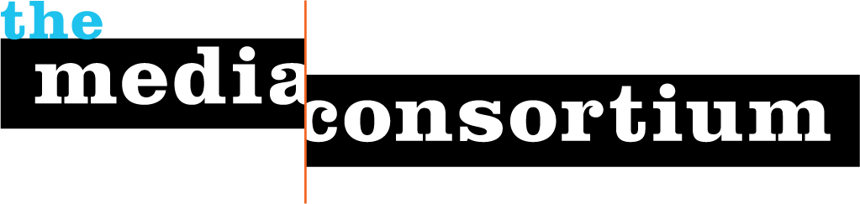

TO: Members of The Media Consortium
FR: Jo Ellen Green Kaiser, Executive Director
DT: December 10, 2015
RE: Member dues

Dear [ Column D ],

It’s December, which means it’s time to renew your dues to the Media Consortium!

This year has seen the rise of the #BlackLivesMatter movement, an international push to fight climate change and a real recognition of economic inequality. At the same time, the political right has countered with hate speech and violence against immigrants and abortion clinics, and continues to support climate deniers. Progressive news continues to be vital to provide the public with the real story.

The Media Consortium is your support in this effort. Look to us to promote your work via our innovative social feeds, to provide you with discounted services (like Chartbeat and Cision), to offer free one-on-one consulting, to organize high-impact collaborations, and to bring you information on the newest developments via our annual conference and webinars. In all these ways, the Media Consortium is here for you. Be sure to pay your dues now to continue as a member in good standing!

Dues are based on a sliding scale. You are being invoiced either at the same rate you had last year, or, if you are new, at the rate suggested by the Membership Committee. If your financial situation has changed, please let me know.

Make your checks payable to the Foundation for National Progress, with “Dues for the Media Consortium” in the subject line. Mail to: Foundation for National Progress attn. Mitch Grummon, 222 Sutter St. Suite 600, San Francisco CA 94108. If you need to pay by credit card, please contact Mitch at mgrummon@motherjones.com (By next year, you will be able to pay online).

I’m always available if you have any questions, comments or concerns.

Sincerely,

Jo Ellen Green Kaiser
joellen@themediaconsortium.com

Dues for [ Column B ] are [ $ Column AB] for 2016.

