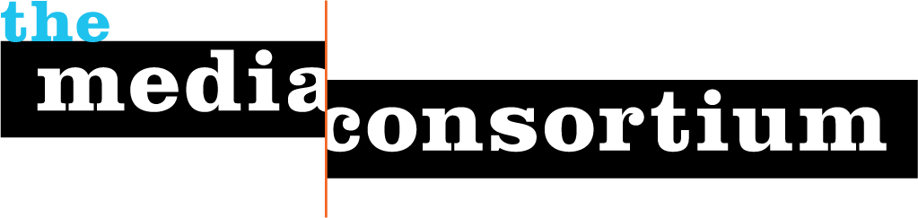
Membership Screening Questionnaire
Any information gathered during this process is for private consideration by the Media Consortium's membership committee and will not be released without the permission of the organization applying for membership.
These questions help us determine suitability for membership, and help us set dues:
- What is your organization’s mission and vision?
Newsdesk.org was founded to serve as a home for commercial-free, nonprofit, independent journalism covering "important but overlooked news from around the world."
Some background:
Newsdesk operated from 2000 to 2010, publishing long-form enterprise and investigative coverage of the energy industry, public health, human rights, elections, and other public-interest topics, as well as systematic aggregation around the same. We received an SPJ SDX award in 2010, but that same year our grant from the Ethics & Excellence in Journalism Foundation was not renewed. Newsdesk had only ever been powered by freelancers, stipends and lots of volunteering, a formula that was not sustainable after the funder walked.
- Why do you want to join The Media Consortium?
I'm looking for an environment where alternative discourse about journalism practice and sustainability is possible. There is solidifying status quo focused on enterpreneurship and innovation that tends to suck all the air out of the room. As valuable as that work is, there needs to be more going on.
What I saw at the Media Consortium/AAN conference was a bunch of folks who really want to interact and co-create news structures, and to directly apply their experience as news producers and publishers to the creation of a horizontal network of peers. These are qualities I deeply value, and the sort of environment I feel most positively productive in.
(I was also really knocked out by the Impact Award winners, and want to hang out with folks who produce that sort of coverage.)
The funny thing about Newsdesk is that it really is done as an enterprise — done as in kaput, completed, over. But it has this weird afterlife. It has a premium URL and a ton of coverage. It still gets traffic, the social media still gets followers. All this has made me think back about why Newsdesk.org was started in the first place.
The point was not to start a business, though that was in fact necessary, but the actual point was to serve as a home for commercial-free, nonprofit, independent journalism covering important but overlooked news.
Perhaps, in that regard, Newdesk shouldn't even try to be a journalism enterprise, but rather a platform, an incubator, a sandbox, a space for professionals to do fundraising and publish in the company of peers. Etc.
All this is pure speculation, but it's thought-provoking. TMC seems like an interesting and indeed hopeful place to offer this conversation.
- Does your organization have any areas of expertise that could be helpful to The Media Consortium and its members?
Newsdesk itself is available as a platform to news producers of all sorts. As far as expertise, I can personally offer is a big plate of lateral thinking about confronting journalism's shortcomings in public trust and sustainability.
Beyond Newsdesk, I have expertise in fiscal sponsorship for media as co-founder and a former staffer and boardmember of Independent Arts & Media. I also have done a bunch of event production for the Expo for the Artist & Musician, an IAM project that ran from 2000-2010, and produced the ambitious, lively and fecund 2012 NAMAC conference on a shoestring budget after institutional funding fell through.
- What is your operating budget?
<$1k
- How many staff do you have?
Zero. The project is on hiatus. I consider myself a steward or a trustee at this point rather than a staffer.
- Would you like to join as an associate or full member?
Jo Ellen suggested associate, and looking at the membership info, I agree.

Answering the following questions will help us better serve you as members:
- Are you organized as a non-profit or a for-profit?
Nonprofit, fiscally sponsored.
- How would you describe your primary audience in terms of size, diversity/demographics, lifestyle and geography?
Topic-driven, Engligh-language news seekers from around the world, and, Fourth Estate and civil-society advocates, both from the journalism world and from the general public. Email list was about 3,000 and site traffic was around 30,000/month by the end of things. Currently Newsdesk's FB page has 868 followers. The Twitter account has 212 followers.
- What are your primary platforms? (e.g., print, radio, online, video, tv, books, social networks, etc.)
Website.
- What infrastructure is your organization looking to build? (e.g., advertising, web strategies, technological innovations, editorial planning, etc.)
Collaborative fundraising and article development.
- Who will be the primary TMC contacts for your organization? (We recommend one editorial contact and one business contact.) These representatives will be expected to attend TMC meetings, convey pertinent information regarding our projects to your staff, and ensure that your organization is involved in TMC-related projects and conversations.
Josh Wilson
Please return this questionnaire to Jo Ellen Green Kaiser at joellen@themediaconsortium.com.

