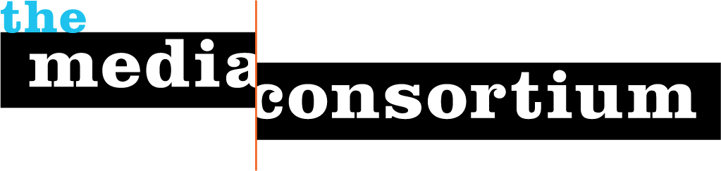

Membership Screening Questionnaire
Any information gathered during this process is for private consideration by the Media Consortium's membership committee and will not be released without the permission of the organization applying for membership.

These questions help us determine suitability for membership, and help us set dues:
- What is your organization’s mission and vision?
The stated mission of the National Catholic Reporter Publishing Co. is to connect Catholics to church, faith and the common good with independent news, analysis and spiritual reflection. We aim to be the best and most comprehensive source of intelligent and objective news about the Catholic Church and the issues that surround it, and to provide an analytical perspective that consistently focuses on the social mission of the church, especially regarding the values that were the foundation of the Second Vatican Council. These values include a recognition of human dignity throughout the world, the obligation to serve the poor and the marginalized and the elevation of the role of lay Catholics within the church and its community. And, because of our adherence to these values, we focus much of our reporting on social policy, endorsing concepts such as equal access to health care; compassion for immigrants and the imprisoned; equality for women, people of color and members of the LGBT community; that climate change is a pro-life issue, and that justification for war rarely exists.

- Why do you want to join The Media Consortium?
Our interest in joining TMC is two-fold. First, we are a small, independent non-profit based out of Kansas City, Mo. While we interact often with members of the Catholic press, we have little opportunity to share ideas and innovations with publishing organizations that have structures and goals similar to ours. We can envision ourselves in the membership of TMC and think we would benefit greatly from the experiences of others working through the same challenges and trends in this ever-shifting business.
Second, we are drawn to the idea of collaborating with other organizations whose social philosophies are similar to our own.
- Does your organization have any areas of expertise that could be helpful to The Media Consortium and its members?
We are considered the go-to news organization for intelligent perspective and analysis of news out of the Vatican and elsewhere in the Catholic Church. Our reporters and editors are steeped in church history as well as religious theologies and social policies worldwide. We have a small staff of full-time reporters, but an extensive cadre of freelance writers around the world. We also currently have a grant-funded project to cover and write for Catholic sisters who are working in communities around the world, with a focus on Africa and Asia. This gives us a good insight into issues of poverty and global development.
Many of our freelancers have been contributing to NCR for years and have first-hand knowledge of the progressive movements of the last 50 years. Our younger staff members and correspondents are not as well-versed in that history, but represent the socially minded journalists of today and the future.

- What is your operating budget?
About $4.5 million
- How many staff do you have?
39
- Would you like to join as an associate or full member?
We would like to be a full member.

Answering the following questions will help us better serve you as members:
- Are you organized as a non-profit or a for-profit?
We are a non-profit.
- How would you describe your primary audience in terms of size, diversity/demographics, lifestyle and geography?
NCR’s audience is highly educated, often with multiple degrees and often from Catholic universities. We have a mix of religious and clergy (priests, brothers, nuns), former clergy, and lay people active in the church, often in some ministry. They are knowledgeable on issues of theology and religious history. They are especially interested in serving others, and often work with homeless, in schools, and in social organizations.
Our numbers:
- 31,000 print subscribers
- 100,000 readers
- half a million unique visitors to our website and 2 million page views each month
- 115,000 likes on Facebook
- 19,000 Twitter followers.

- What are your primary platforms? (e.g., print, radio, online, video, tv, books, social networks, etc.)
- Two print products: National Catholic Reporter is a newspaper that publishes every other week, and Celebration is a monthly guide for parish liturgy ministers. Late this spring, we plan to launch an electronic version of the newspaper. We also have a Kindle edition of the newspaper.
- Three websites: ncronline.org is the main, news-driven website; celebrationpublications.org is the website for Celebration and globalsistersreport.org is an online site for stories about, for and by Catholic sisters around the globe.
- About a dozen email alert products that have as many as 43,000 subscribers.

- What infrastructure is your organization looking to build? (e.g., advertising, web strategies, technological innovations, editorial planning, etc.)
All of the above! Specifically, we would like in the next year to establish a mobile presence, strengthen our development capabilities and possibly move to a membership-based business model.

- Who will be the primary TMC contacts for your organization? (We recommend one editorial contact and one business contact.) These representatives will be expected to attend TMC meetings, convey pertinent information regarding our projects to your staff, and ensure that your organization is involved in TMC-related projects and conversations.

Caitlin Hendel, CEO/President, chendel@ncronline.org
Dennis Coday, Editor, dcoday@ncronline.org

Please return this questionnaire to Jo Ellen Green Kaiser at joellen@themediaconsortium.com.

