2013 Meeting Survey

Attended:
Wednesday Pre-Meeting 43.8%
Thursday 9-lunch 87.5%
Thursday lunch-5:30 84.4%
Friday 9-lunch* 65.6%
Friday Business Meeting* 50%

Opening Reception 59.4%
Party 59.4%

*Many left early due to snowstorm

What was the highlight of the meeting for you? What was the lowpoint?

I'm afraid I ended up missing much of the conference because I was afraid of the storm and decided to leave early

The panels were informative, and it was particularly interesting to hear how Bob Cohn, with a deep background in print, approached his publication as editor of Atlantic Digital. Bhaskar Sunkara was especially impressive and the story of his journey from digital to print was both counterintuitive and instructive. Mostly, though, I benefited from the casual discussions in between panels and the continued contact after the one day I attended.

networking 1-on-1 at lunch, etc. I also liked the presentations from Upworthy, the Atlantic and the PEW.
The music at the party was so loud I couldn't hear anything anyone was saying...would have been nice to have some informal networking time like that where you could chat without tons of distractions.

Highlights were the energy and enthusiasm shown by so many members. RJ break out session, Willingness of members to attend biz mtng and problem solve. Face-time with so many colleagues

The High Points - the networking opportunities, the break out meetings during the "open space" time, and the price of the conference. Low Point - I wasn't able to connect one on one with as many people as i had hoped too...
Highlight: meeting so many people who wanted to collaborate and strategize about framing of issues. Lowpoint: very tiring, intensive meetings, limited progress on collaborative projects.
Best part of these meetings is getting to see everyone and hang out. Worst part of this trip was having to leave early because of the storm.
The sense of community and shared purpose. [lowpoint:] Bo Sacks talk. Had expected more than a rah-rah slideshow.

Networking with all the people doing similar things as we're trying to do. Making connections. Hearing about the projects people are trying.
In my very limited exposure, I really liked the informal "peer exchange" session that Rod and Steve facilitated. I thought that they did a very good job. If capacity exists in the future I think it would be helpful if we could get some "thinking ahead" questions so that we could be best prepared for that session.
The highlight was the working group meetings. It was a great way to network.
Solutions -oriented journalism speaker & woman from Pew, good TMC biz mtg
The database session! Also having time to connect with people
Several high points - networking, meeting new people, presentations by Upworthy, Michael Copps. Also affinity group meeting on immigration. No real lowpoint.
Mother Jones video, Up Worthy and Mulit-platform media discussion. No real "lowpoint"
HiLier=lots of personal interaction and discussion w other attendees; also informative panels. LoLite? None comes to mind
Meeting everyone and going to the panels, which were all good, were the high points. I didn't really care for Bo Sacks's presentation, which seemed too glib. Having to leave early was also a low point.
Highlight, the mobile media presentation ties with the opportunity to reconnect with what has, through the Media Consortium's ongoing work, become a real community. Lowpoint was the crazy elevator.
I loved the schedule; good balance of presentations; casual networking time during coffee/lunch; & break-out discussions. The cozy size of rooms facilitated networking. Lowpoint: Not getting a room in time and having to stay down the street. I would have had more time to network if I stayed at the hotel.
The highlight was the networking.The lowpoint was taking a wrong turn while walking to the party, and realizing I'd walked on to the set of The Wire (there's that moment when you realize that not only are you in the wrong place, everyone else has noticed that you are in the wrong place).
Thurs. afternoon affinity groups/networking
Highlight: Pre-meeting for print, opening panel/discussion.
Chris Rabb's presentation was great!
Highlight - breakout sessions with independent media makers. Lowpoint - wish I could have stayed for the whole thing.
The whole thing was very well done-- it was well paced, full of information across a breadth of issues, and allowed for networking.
High point: Wednesday's panel discussion and presentations about print media and the relevancy of print media.
Low point: (with a grain of salt!) the largely American focus was expected, but made it difficult for some points and activities to transcend to international borders and media, particularly Canadian media.
Highlights were Steve Michelson's presentation, the networking meetings - anything to do with cross-collaboration.The low point may have been Comm. Copps (hate to say it, because I think very highly of him), but I understand the reason for bringing him and making him aware of TMC.
The F2F connections made and deepened. So valuable at the nuts and bolts level for those who lead their organizations in staying relevant and profitable. No low point for me.
I wish I could have attended more than one session.

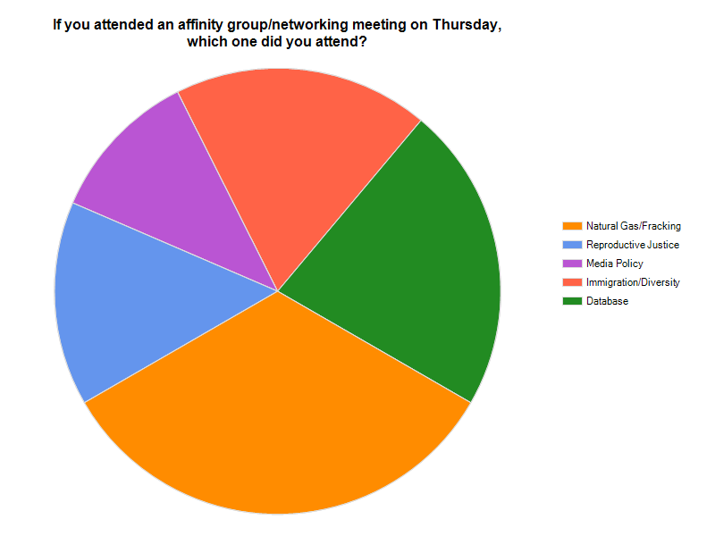

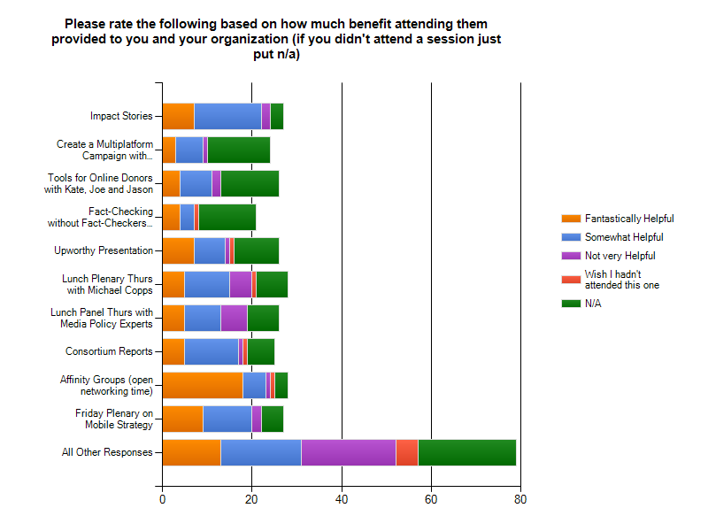

Please evaluate the split between TMC-based and non-TMC presentered. Did we get the ratio right?

Just right: 92.9%

Friday Business Meeting

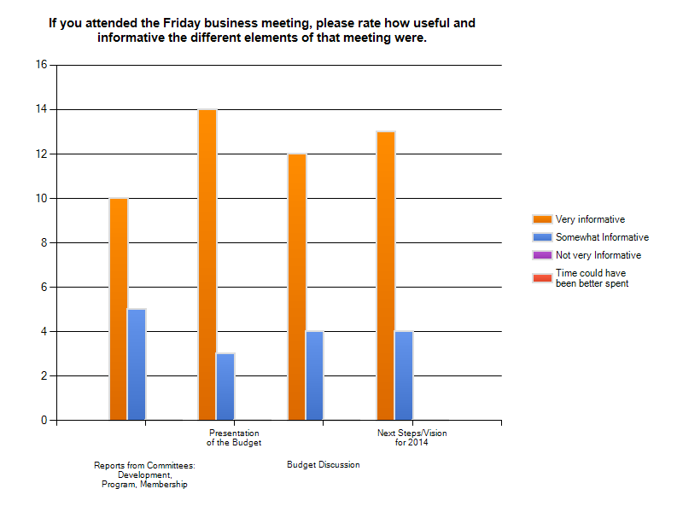

Had you hoped for a session or activity in Baltimore that we did not provide? Please explain what you wanted so we can provide it next year!

more time to just network with others and talk shop. More discussions of the large societal /political themes coming up and what each outlet is thinking editorially 9in addition to affinity groups)

I wish for more time with just the book publishers.

I would like to get to more detailed planning on how the various outlets can collaborate to cover news across the country.

A hotel with a better business center.

Case study of TMC collaboration

The affinity group/networking breakouts are a good idea, but more choices (and smaller groups) would have been better. Such means for participants to learn from each other in areas of interest are among the most useful features of the meeting.

More involvement from funding community and panels etc geared toward funding specifics

I would love to see a session that focuses more on social media for more traditional news outlets. While the Upworthy presentation was interesting, their type of pure-activisty viral campaigning does not apply one-on-one to more traditional news outlets who may want to use social media to expand their audience, build partnerships with other outlets etc. The Atlantic presentation began to touch on this a little in the Q&A round, but I would love to get a closer look into the nitty gritty of how fellow news outlets run their social media: anything from staffing levels and structures to how they prepare, scheduled and execute special campaigns.

Non-profit media strategies for financial sustainability; video based content both developed as feature material and to augment media content that's primarily "radio" or "print"

It might be helpful to have presenters from non-profits that are not focused on journalism or for-profits (where appropriate). For example, perhaps have a social media/digital content presentation with someone from a political campaign or a large company. Hearing from a top-notch development/major gifts/foundation relations specialist from any non-profit might help in the area of fundraising and development.

