PIEC Logo (centered)
Environmental Coverage in the News – 1st Annual Ranking Report
December 2012
-or-
Environmental Coverage in the News: Room for Innovation
1st Annual Ranking Report – December 2012

Environmental Coverage in the News: A 2012 Ranking Report
This ranking report was completed by the Project for Improved Environmental Coverage (PIEC) - a nonprofit initiative dedicated to improving environmental news coverage in the mainstream media. The PIEC is a program of SEE Innovation; an organization whose mission is to build awareness, capacity, and structures for social and environmental transformation. Principal authors are Tyson Miller and Todd Pollak.
Contact: tyson@environmentalcoverage.org / 828-333-5426
Acknowledgements (Kelly – can you put the content from this page onto the last page of the executive summary as well (p.9) of this word doc – if it will fit?)
Thank you to our program supporters: the Cornell Douglas Foundation, Lisa and Douglas Goldman Fund, the Giles and Elise Mead Foundation, New Visions Foundation, Park Foundation, and anonymous supporters. This report relies on key outlet-by-outlet tracking data that is maintained and was provided to the PIEC by the Pew Research Center’s Project for Excellence in Journalism (www. journalism.org). The Project for Excellence in Journalism’s commitment to tracking this data is invaluable and greatly appreciated. A special thank you to Paul Hitlin, Senior Researcher at the Project for Excellence in Journalism, for your time and guidance. Thank you also to Curtis Brainard of the Columbia Journalism Review and Jo Ellen Kaiser of the Media Consortium for your review and feedback and to Kelly Spitzner for designing the report.

Table Contents:
Executive Summary

Why Improved Environmental Coverage Matters

Americans Want Improved Environmental Coverage

Ranking

Environmental Coverage Methodology
Quality of Environmental Journalism
Examples of Excellent Structure to Foster Quality Environmental Journalism
Vision for Improved Environmental News Coverage
Resources

Environmental News Coverage Ranking
Inaugural Annual Ranking December 2012

"We must go through a natural revolution if we are to survive on earth. We need to change people's perceptions. If there's no environment, there's no human race. We are in a state of global denial." - Ted Turner, CNN Founder

Executive Summary

News coverage of the environment has a significant impact on public opinion, policy-making, and whether we, as a society, expand and deepen our stewardship ethic. Recent polling shows that nearly 80% of Americans want improved environmental coverage in the news. Despite its value, however, headline coverage of the environment represented just 1.2% of nationally prominent news headlines in the US during a 17⁻month period (Jan 2011 – May 2012) for the 30 nationally recognized news organizations ranked in this report. Meanwhile,
entertainment and crime garner 20 times and 60 times more coverage, respectively, than environment-related reporting.

Using data provided by the Pew Research Center’s Project for Excellence in Journalism for a wide range of national and local news organizations across platforms, this report compares and ranks news organizations among their peers according to how they are prioritizing environmental headlines. This report also examines coverage ratios, a critical factor of quality of reporting, and also looks at success models for replication, citizen attitudinal data, and a host of other topics.

An Industry Snapshot:
The figure below illustrates how varying news media types are prioritizing environmental coverage. Local newspapers are the only news format that prioritizes environmental over entertainment headlines on average.

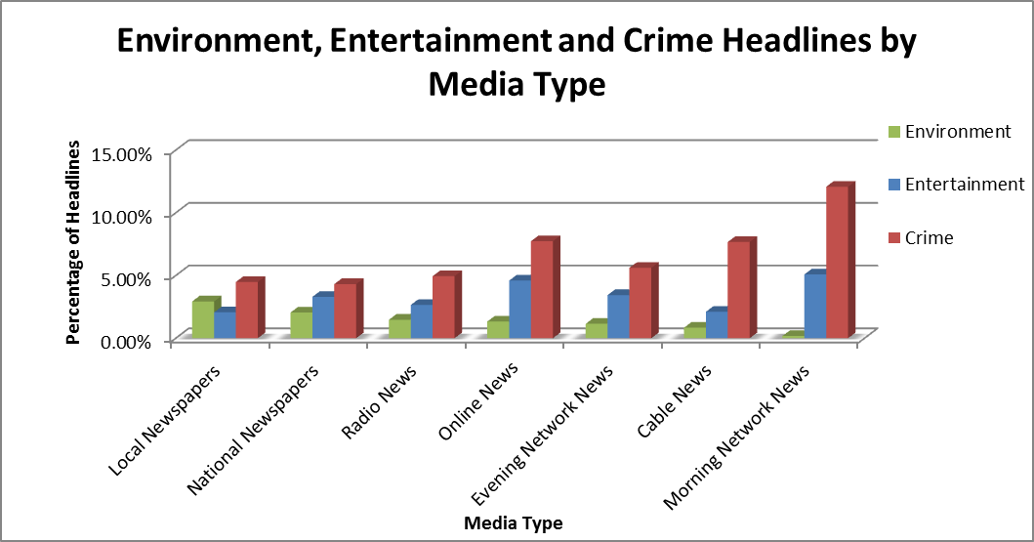

Key Findings

- On average, entertainment-related stories get over three times as much coverage as environmental stories for nationally prominent news organizations.

- Some news organizations prioritize entertainment headline stories at least five times more than environment-related stories including: CNN, USAtoday.com, CNN.com, ABC Nightly News, and Google News and all morning network news outlets (which average at least 30 times more entertainment coverage).

- Out of all media types, local newspapers have the lowest crime-to-environment ratios—1.5-to-1 on average despite the fact that crime coverage can be viewed as being locally relevant.

- In contrast, most national news media categories have very high crime-to-environment ratios despite the fact that many of the crime stories are local in nature and can be classified as not nationally relevant, as evidenced by the following average crime-to-environmental coverage ratios:

- Morning network news: 69-to-1
- Cable news: 9-to-1
- Online news: 6-to-1
- Evening network news: 5-to-1

- Fox News had the highest percentage of headline environmental stories (1.57%) among cable and network news outlets, even beating out PBS (1.43%); with CNN having the lowest (0.36%).

- Local newspapers ranked highest in terms of the quantity of environmental headlines with the Daily Herald (WA) at 7.3% and the platform averaging 2.9%, which is nearly 2.5 times the average for the outlets ranked in this report.

- Network morning news ranked lowest in terms of environmental news coverage with the platform averaging just 0.18%.

- With the Huffingtonpost.com at 3% and Google News at 0.25% of headlines, online news as a platform had the widest variance of environmental headline coverage.

- ABCnews.com had one of the highest crime-to-environment story ratios at 51.1-to-1 and Google News had one of the highest entertainment -to-environment story ratios at 55-to-1.

- Snapshot tracking shows independent news aggregator Commondreams.org to be a potential model for replication for online news platforms with environmental news stories representing over 15% of the story mix during varying months.

Nationally Prominent News Outlets Ranked by Percentage of Environmental Headlines
Rank | News Organization | Environmental Coverage | Entertainment Coverage | Crime Coverage | Crime to Environment Ratio | Entertainment to Environment Ratio
1 | huffingtonpost.com | 3.00% | 1.72% | 3.36% | 1.12 | 0.57
2 | LA Times | 2.66% | 3.08% | 4.82% | 1.81 | 1.16
3 | NY Times | 2.50% | 2.55% | 3.60% | 1.44 | 1.02
4 | NYTimes.com | 2.43% | 1.16% | 5.21% | 2.14 | 0.48
5 | NPR | 2.15% | 2.31% | 2.80% | 1.31 | 1.08
6 | foxnews.com | 2.13% | 2.81% | 12.62% | 5.92 | 1.32
7 | Wall Street Journal | 1.89% | 1.48% | 3.76% | 1.99 | 0.78
8 | USA Today | 1.64% | 7.55% | 6.00% | 3.67 | 4.61
9 | Fox News Total | 1.57% | 1.68% | 8.07% | 5.15 | 1.07
10 | Washington Post | 1.55% | 1.82% | 3.38% | 2.18 | 1.17
11 | PBS Evening | 1.43% | 2.02% | 2.61% | 1.82 | 1.41
12 | MSNBC.com | 1.42% | 3.46% | 10.54% | 7.41 | 2.43
13 | usatoday.com | 1.38% | 14.02% | 7.87% | 5.72 | 10.20
14 | latimes.com | 1.37% | 4.97% | 7.40% | 5.40 | 3.62
15 | NBC Evening | 1.36% | 4.45% | 6.01% | 4.42 | 3.28
16 | washingtonpost.com | 1.32% | 1.76% | 2.97% | 2.26 | 1.34
17 | wsj.com | 1.03% | 0.92% | 4.44% | 4.32 | 0.90
18 | CBS Evening | 1.02% | 3.10% | 6.57% | 6.42 | 3.03
19 | CNN.com | 0.90% | 6.68% | 8.03% | 8.92 | 7.42
20 | ABC Evening | 0.77% | 4.17% | 7.25% | 9.39 | 5.40
21 | CBS Radio Headlines | 0.63% | 4.08% | 7.09% | 11.22 | 6.46
22 | MSNBC Total | 0.59% | 1.39% | 5.11% | 8.63 | 2.35
23 | ABC Radio Headlines | 0.57% | 3.88% | 11.53% | 20.26 | 6.82
24 | Yahoo.com | 0.42% | 1.52% | 6.77% | 16.01 | 3.59
25 | CNN Total | 0.36% | 3.25% | 9.83% | 27.51 | 9.09
26 | abcnews.com | 0.31% | 3.28% | 16.06% | 51.12 | 10.44
27 | Google news | 0.25% | 12.84% | 7.57% | 30.09 | 51.04
28 | ABC Morning | 0.25% | 7.85% | 14.07% | 55.97 | 31.21
29 | CBS Morning | 0.24% | 3.40% | 8.26% | 35.09 | 14.45
30 | NBC Morning | 0.04% | 3.99% | 13.89% | 340.69 | 97.81
 | Average | 1.24% | 3.91% | 7.25% | 5.85 | 3.15

Top Three Local Newspapers
Rank | News Organization | Environmental Coverage | Entertainment Coverage | Crime Coverage | Crime to Environment Ratio | Entertainment to Environment Ratio
1 | Daily Herald (WA) † | 7.33% | 2.80% | 5.22% | 0.71 | 0.38
2 | Traverse City Record† | 6.37% | 0.00% | 1.09% | 0.17 | 0.00
3 | Spokesman Review* | 5.81% | 1.95% | 4.28% | 0.74 | 0.34

As is evident from the charts above, most nationally recognized news organizations have ample room to improve environmental reporting, especially when compared to crime and entertainment reporting. In contrast, local newspapers, tracked by the Pew Research Center, perform much better in this area and can be looked to as a model for replication.
The two contrasting charts below represent both the problem and the spectrum of opportunity.
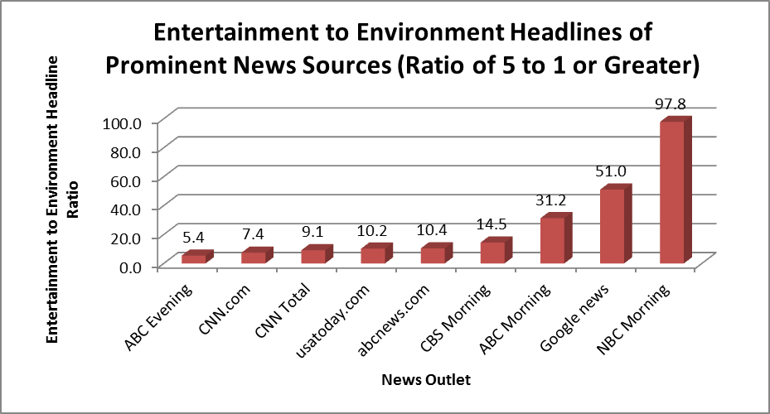
The chart above highlights nationally recognized news sources that average at least 5 times as many entertainment headlines as environmental headlines. NBC Morning News has the highest ratio with nearly 100 times more entertainment than environmental coverage.

The chart below highlights which news organizations have an entertainment–to-environmental headline ratio of 1-to-1 or less (meaning they report on the environment as much as or more frequently than entertainment headlines). The leader in the regard is NYtimes.com, which publishes environmental headlines twice as frequently as entertainment headlines (entertainment-to-environmental coverage ratio is 0.5-to-1). It should be noted that this chart only demonstrates the leaders among prominent nationally recognized news outlets, and there are several local newspapers that have entertainment-to-environment headline ratios below that of NYtimes.com (8 out of 13 local newspapers evaluated had a entertainment headline ratio of 0.5 or less).

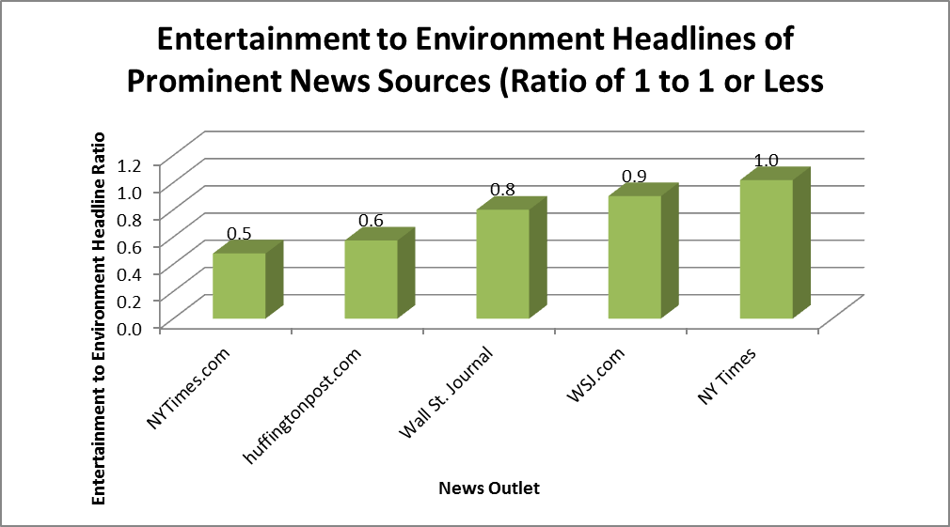

Quality vs. Quantity
To be certain, quantity of environmental coverage is not a proxy for quality of coverage and it can be said that if one had to choose, quality is better than quantity. Case in point: running a plethora of headline stories that deny climate change and criticizing renewable energy is irresponsible in the face of facts, as Fox News has been criticized by the Union of Concerned Scientists. In contrast, if a news outlet has produced quality environmental stories, but neglects to prioritize these stories and place them in high visibility locations, then these stories aren’t reaching as wide an audience as they could or should. In other words, improved environmental coverage is dependent upon both better quality of coverage, a greater quantity, and higher visibility of that coverage. While it is possible that future reports will incorporate quality of reporting as a measurement metric, for now owing to the limited data on this topic, this report ranks media outlets solely according to quantity of headline environmental stories as a measure of how environmental reporting is being prioritized. The report also looks at coverage ratios—comparing how entertainment and crime are covered in relation to the environment—a variable that is representative of both quantity and quality. A robust discussion of factors that determine quality begins on page X.

Citizen Attitudinal Data Speaks for Itself
An overwhelming majority of Americans (79%) feel that environmental coverage should be improved and, interestingly, this preference spans political and demographic lines. The April 2012 citizen poll, commissioned through Opinion Research Corporation, queried over 1,000 random individuals throughout the country, and the net results are compelling:

- 79% of both young people 18–24 and those over 65 want better environmental coverage. The sentiment is nearly equally shared in every region in the country.

- Minority groups have a stronger interest in this issue than whites—88% to 77% respectively.

- Level of education has little impact on Americans’ views—83% of those with a high school diploma or less and 76% of college graduates believe coverage should be improved.

While many news organizations claim that individuals are more likely to click on or tune in to a crime or entertainment story, this is simply human nature. It doesn’t mean that people actually want the quantity of those types of stories or that they want those types of stories instead of critical information about local, national, or international environmental issues. Progress on this front need not be an either-or proposition. Regardless of the reaction to the data, the poll results clearly show that a large majority of citizens want better environmental coverage and the news media industry has a unique opportunity meet this need. Detailed representation of the demographic data and a more robust discussion begins on page X.

Opportunities for Innovation
While there are clearly news organizations that are leaders when it comes to prioritizing environmental reporting, the findings of this report demonstrate that there is much room for innovation within the mainstream news media at-large and a strong public desire to see this happen. To this end, a group of journalism professionals crafted the Vision for Improved Environmental Reporting (http://environmentalcoverage.org/vision) and defined four core pillars and varying strategies for improving environmental coverage including:

I Integrate the environmental angle into other stories and make that connection explicit.
II Make environmental stories appealing to a larger cross section of society.
III Focus more on solutions.
IV Increase the visibility of environmental stories.

Whether news organizations formally endorse this vision or develop their own internal goals for improved environmental coverage, the net effect is likely that this goal setting will lead to enhanced coverage. Fortunately, there are more resources on this topic than ever before such as environmental news services, academic institutions, science-based research organizations, and others that are able to support news organizations in deepening coverage and making it more visible without incurring additional costs. What is more, the environment is connected to hundreds of topic areas from health and security to food, community issues and human interest.

Environmental Coverage Ranking Methodology
The data used in this report was provided by the Pew Research Center’s Project for Excellence in Journalism (PEJ, www.journalism.org), which maintains a news coverage index that classifies mainstream news headlines by topic. This ranking report utilizes news coverage index data tracked and provided by the Pew Research Center’s Project for Excellence in Journalism for 30 nationally recognized and a range of local news organizations for all of 2011 and January through May of 2012. The report also presents coverage ratios that compare the quantity of environmental news headlines to entertainment and crime headlines. It should be noted that the Pew Research Center’s Project for Excellence in Journalism categorizes “sports” and ”celebrities and entertainment” as two separate categories. However in our analysis and presentation of the data, we have combined these categories into one given that sports is an entertainment-related topic. The methodology used by the Project for Excellence in Journalism to collect this data is summarized below and on page x and the full methodology published by PEJ is available at: http://www.journalism.org/about_news_index/methodology.

Read On
The full scope of this report presents ranking data for nearly 50 news organizations throughout the country, in-depth information on citizen attitudes, success models for innovation, a robust exploration related to the issue of quality in environmental reporting, resources, and much more. We encourage you to read further and share your thoughts with us for improving the scope of this report next year and in future years. Contact us at info@environmentalcoverage.org with questions or feedback.

Grab some wrap –up content from conclusion page on pg. 35.

Why Improved Environmental Coverage Matters

"We must go through a natural revolution if we are to survive on earth. We need to change people's perceptions. If there's no environment, there's no human race. We are in a state of global denial."
- Ted Turner, CNN Founder

As CNN founder Ted Turner so aptly conveys in his quote above, we need environmental understanding and concern to be a more integral part of our collective mind-set. We are inextricably linked with the environment and our prosperity, health, security and well-being are intimately tied to it. Ironically, as is presented in the ranking section of this report, both CNN and CNN.com are in the bottom half of environmental coverage when compared to their peers—even falling below the 1.2% average during our study period at 0.9% and 0.4% of headlines respectively. Perhaps if Ted Turner were still at the helm, this would be different. Regardless, as a pioneer and news media visionary, Mr. Turner’s guidance is worth paying attention to especially given the important role of the news media in affecting environmental understanding and policy.

So, where do adult Americans typically acquire their environmental knowledge? According to the National Environmental Education Foundation (NEEF), for most adults, particularly those older than 35, the media is by far the leading source of environmental information for adults. A NEEF/Roeper Report found that about 80% of Americans are heavily influenced by incorrect or outdated environmental myths and there is little difference in environmental knowledge levels between the average American and those who sit on governing bodies, town councils, and in corporate board rooms, and whose decisions often have wider ramifications on the environment. Their conclusion is that low levels of knowledge about the environment is a signal that members of the public will be unprepared for increasing environmental responsibilities in the coming years.

In a recent study conducted by the Yale Project on Climate Change Communication, researchers, found that 63 percent of Americans believe that global warming is happening, but many do not understand why. In this assessment, only 8 percent of Americans have knowledge equivalent to an A or B grade, 40 percent would receive a C or D, and 52 percent would get an F. The study also found important gaps in knowledge and common misconceptions about climate change and the earth systems. According to the study “these misconceptions lead some people to doubt that climate change is happening or that human activities are a major contributor, to misunderstand the causes and therefore the solutions, and to be unaware of the risks. Thus many Americans lack some of the knowledge needed for informed decision-making in a democratic society.” For example, only:

• 57% know that the greenhouse effect refers to gases in the atmosphere that trap heat;
• 50% of Americans understand that global warming is caused mostly by human activities;
• 45% understand that carbon dioxide traps heat from the Earth’s surface;
• 25% have ever heard of coral bleaching or ocean acidification.

In addition, the study also found that Americans also recognize their own limited understanding of the issue. Only 1 in 10 say that they are “very well informed” about climate change, and 75 percent say they would like to know more. Likewise, 75 percent say that schools should teach our children about climate change and 68 percent would welcome a national program to teach Americans about the issue. Perhaps the news media can be the engine for such a “national program.”

Americans Want Improved Environmental Coverage

Nearly 80% of Americans Believe News Coverage of the Environment Should Be Improved

According to a 2012 national poll commissioned by the Project for Improved Environmental Coverage and conducted by the Opinion Research Corporation over the weekend of April 14–15, 79% of Americans believe news coverage of the environment should be improved. Taken together, the results of the poll confirm that regardless of age, race, income or region of the country, an overwhelming majority of Americans believe news coverage of our environment should be improved.

Summary of Findings:

The difference between men and women was minor with slightly more women (82%) than men (76%) believing the news media should improve coverage.

- By race, 88% of African-Americans polled shared this view, versus 79% of Hispanics and 77% of whites, suggesting that concern over environmental issues may actually be slightly higher for nonwhites than whites.

- Regionally there was very little variation with 77% of those polled in the Northeast, Midwest, and West feeling news coverage could be improved while 83% of those in the South felt this way

- As household income increased, belief in the need for better coverage decreased slightly: 84% of those with incomes below $35,000/year and 74% of those whose incomes exceed $100K/year felt coverage should be improved.

- Level of education also had little impact on Americans’ views with 83% of those who have a high school diploma or less and 76% of college graduates believing coverage should be improved.

- Somewhat surprisingly, age made no difference. In fact, 79% of 18–24 year-olds and 79% of those over 65 felt coverage should be improved.

The poll also asked Americans about how they felt news coverage of the environment could be improved and several choices were provided. Over half (51%) felt all of the following would help improve coverage:

- Making the relationship between the environment and other issues more clear
- Focusing more on solutions
- Making environmental stories more appealing to a larger cross section of society
- Making environmental news more visible by including in top headlines

Of these four ways, “making the relationship between the environment and other issues more clear” (chosen by 22%) was viewed as the best single way to improve coverage followed closely behind by “focusing more on solutions” (chosen by 20%). Each of these four strategies is included in the national Vision for Improved Environmental Coverage

Methodology
Approximately 1,000 individuals responded to a question posed over the phone by Opinion Research Corporation staff. The question provided was “Do you think news coverage of the environment should be improved?” Here is a link to the summary.
Ranking
While many people get their news from a variety of media types, it is reasonable to assume that more than 100 million individuals in the U.S. are “news consumers” via print, television, online, and radio news formats combined. This number represents a huge cross-section of society and a critical mass of individuals whose knowledge base about environmental issues can ultimately translate to improved policy-making at local and national levels, collective actions that reduce impacts, and the cultivation of an expanded national stewardship ethic. It should be noted that this ranking is based upon the data averages over a 17-month period (all of 2011 and Jan–May 2012) provided by the Pew Research Center’s Project for Excellence in Journalism. While this data is representative of a wide range of news organizations, it is merely a representative sampling that is focused almost entirely on mainstream (and not independent) news organizations. The Pew Research Center’s data is also guided by their methodology.

Key Findings

- On average, entertainment-related stories get over three times the coverage as environmental stories and much more for many news outlets

- Some news organizations prioritize entertainment headline stories at least five times more than environmental stories including: CNN, USAtoday.com, CNN.com, ABC Nightly News, and Google News and all Morning Network News Outlets (which have 30 times more entertainment coverage)

- Out of all media types, local newspapers have the lowest crime to environment ratios of 1.5-to-1 on average despite the fact that crime coverage can be viewed as being locally relevant.

- In contrast, most national news media categories have very high crime-to-environment ratios despite the fact that many of the crime stories are local in nature and are not nationally relevant, as evidenced by the following average crime to environmental coverage ratios:

- Morning Network News: 69-to-1
- Cable News: 9-to-1
- Online News: 6-to-1
- Evening Network News: 5-to-1

- Fox News had the highest percentage of headline environmental stories (1.57%) among cable and network news outlets, even beating PBS (1.43%); with CNN having the lowest (0.36%).

- Local newspapers ranked highest in terms of the quantity of environmental headlines with the Daily Herald (WA) at 7.3% and the platform averaging 2.9%—nearly 2.5 times the national average.

- Network morning news ranked lowest in terms of environmental news coverage- averaging just 0.18%.

- With the Huffingtonpost.com at 3% and Google News at 0.25% of headlines, online news as a platform had the widest variance of environmental headline coverage.

- ABCnews.com had one of the highest crime-to-environment story ratios at 51-to-1 and Google News had one of the highest entertainment/sports to environment story ratios at 551-to-1

- Snapshot tracking showed independent news aggregator Commondreams.org as a potential model for replication for online news platforms with environmental news stories representing over 15% of the story mix during varying months
Table 1: Nationally Recognized News Organizations: Environmental Coverage Ranking

Rank | News Organization | Environmental Coverage | Entertainment Coverage | Crime Coverage | Crime to Environment Ratio | Entertainment to Environment Ratio
1 | huffingtonpost.com | 3.00% | 1.72% | 3.36% | 1.12 | 0.57
2 | LA Times | 2.66% | 3.08% | 4.82% | 1.81 | 1.16
3 | NY Times | 2.50% | 2.55% | 3.60% | 1.44 | 1.02
4 | NYTimes.com | 2.43% | 1.16% | 5.21% | 2.14 | 0.48
5 | NPR | 2.15% | 2.31% | 2.80% | 1.31 | 1.08
6 | foxnews.com | 2.13% | 2.81% | 12.62% | 5.92 | 1.32
7 | Wall Street Journal | 1.89% | 1.48% | 3.76% | 1.99 | 0.78
8 | USA Today | 1.64% | 7.55% | 6.00% | 3.67 | 4.61
9 | Fox News Total | 1.57% | 1.68% | 8.07% | 5.15 | 1.07
10 | Washington Post | 1.55% | 1.82% | 3.38% | 2.18 | 1.17
11 | PBS Evening | 1.43% | 2.02% | 2.61% | 1.82 | 1.41
12 | MSNBC.com | 1.42% | 3.46% | 10.54% | 7.41 | 2.43
13 | usatoday.com | 1.38% | 14.02% | 7.87% | 5.72 | 10.20
14 | latimes.com | 1.37% | 4.97% | 7.40% | 5.40 | 3.62
15 | NBC Evening | 1.36% | 4.45% | 6.01% | 4.42 | 3.28
16 | washingtonpost.com | 1.32% | 1.76% | 2.97% | 2.26 | 1.34
17 | wsj.com | 1.03% | 0.92% | 4.44% | 4.32 | 0.90
18 | CBS Evening | 1.02% | 3.10% | 6.57% | 6.42 | 3.03
19 | CNN.com | 0.90% | 6.68% | 8.03% | 8.92 | 7.42
20 | ABC Evening | 0.77% | 4.17% | 7.25% | 9.39 | 5.40
21 | CBS Radio Headlines | 0.63% | 4.08% | 7.09% | 11.22 | 6.46
22 | MSNBC Total | 0.59% | 1.39% | 5.11% | 8.63 | 2.35
23 | ABC Radio Headlines | 0.57% | 3.88% | 11.53% | 20.26 | 6.82
24 | Yahoo.com | 0.42% | 1.52% | 6.77% | 16.01 | 3.59
25 | CNN Total | 0.36% | 3.25% | 9.83% | 27.51 | 9.09
26 | abcnews.com | 0.31% | 3.28% | 16.06% | 51.12 | 10.44
27 | Google news | 0.25% | 12.84% | 7.57% | 30.09 | 51.04
28 | ABC Morning | 0.25% | 7.85% | 14.07% | 55.97 | 31.21
29 | CBS Morning | 0.24% | 3.40% | 8.26% | 35.09 | 14.45
30 | NBC Morning | 0.04% | 3.99% | 13.89% | 340.69 | 97.81
 | Average | 1.24% | 3.91% | 7.25% | 5.85 | 3.15

As is evident in Table 1 above, with the variance between first and last place differing by a factor of 75, there is a wide spectrum of performance when it comes to focusing on environmental news and in a sense, the numbers speak for themselves. Even though there are leaders, overall, the quantity of environmental headlines across the news industry should be much higher, provided that the coverage is constructive.

Table 2: Local Newspapers Environmental Coverage Ranking
Rank
News Organization | Environmental Coverage | Entertainment Coverage | Crime Coverage | Crime to Environment Ratio | Entertainment to Environment Ratio
1 | Daily Herald (WA) † | 7.33% | 2.80% | 5.22% | 0.71 | 0.38
2 | Traverse City Record† | 6.37% | 0.00% | 1.09% | 0.17 | 0.00
3 | Spokesman Review* | 5.81% | 1.95% | 4.28% | 0.74 | 0.34
4 | Houston Chronicle† | 4.12% | 4.94% | 7.10% | 1.72 | 1.20
5 | Arizona Republic* | 2.63% | 4.46% | 5.34% | 2.03 | 1.70
6 | St. Augustine Record* | 2.54% | 0.32% | 1.57% | 0.62 | 0.13
7 | The Hour (CT)* | 1.98% | 0.00% | 1.94% | 0.98 | 0.00
8 | Denver Post† | 1.84% | 1.91% | 0.76% | 0.41 | 1.04
9 | Toledo Blade* | 1.67% | 1.53% | 2.50% | 1.50 | 0.92
10 | Atlanta Journal Const.* | 1.30% | 0.22% | 2.98% | 2.30 | 0.17
11 | Joplin Globe* | 1.20% | 0.66% | 1.59% | 1.33 | 0.55
12 | Orlando Sentinel† | 0.67% | 1.56% | 17.48% | 26.23 | 2.34
13 | Eagle Tribune (MA) † | 0.65% | 6.43% | 6.43% | 9.91 | 9.91
 | Average | 2.93% | 2.06% | 4.48% | 3.74 | 1.44

*Data collected Jan.-Dec. 2011
†Data collected Jan.-May 2012
Local newspapers were not included in the table of nationally recognized news organizations because this report primarily focuses on news media sources that receive national attention. However local newspapers seem to prioritize environmental coverage more than other news sources. The average percentage of environmental headlines for local papers reviewed by PEJ is 2.93% nearly two and a half times higher than the average for nationally prominent media sources. Had local papers been included in the table above, they would have occupied 6 of the top 10 slots in the ranking. It is also interesting to note that local newspapers focus on crime considerably less than nationally prominent news sources. Stories about crime rarely affect people living far from location where the crime occurred and one could assume that most crime stories would be of most importance to people living in the immediate vicinity. Given that crime is more likely to be a local issue it is surprising that national news media sources tend to report on crime so much more frequently than local newspapers.

Figure 1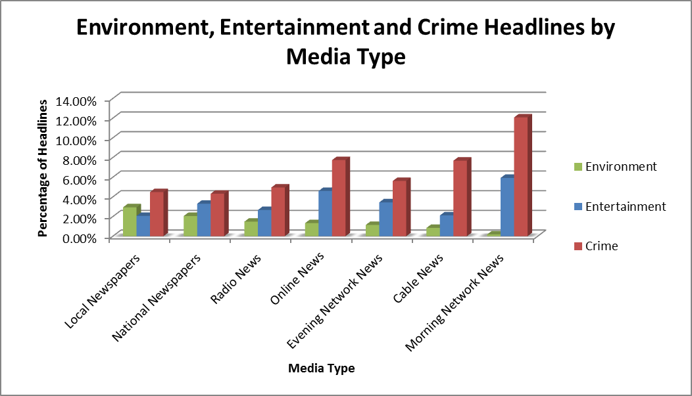

What is interesting to note in Figure 1 above, with 2.93% of headlines on average, local newspapers prioritize environmental news nearly two and a half times more than the sample of 30 nationally recognized news organizations and 16.3 times more than morning network news. Additionally, local newspapers on average tend to keep headlines focused less on entertainment and crime than any other news format. This may be a key driver for their ability to place a higher priority on environmental stories.

Figure 2
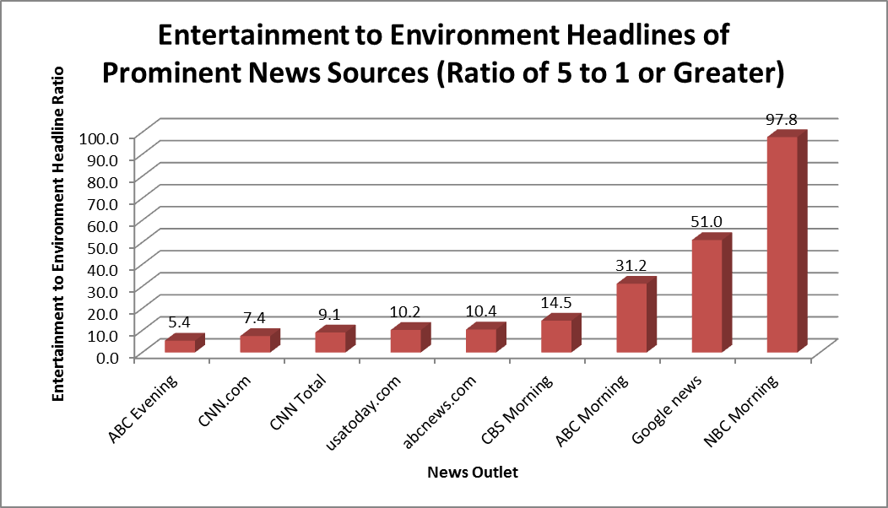
Kelly: Can u make charts on prior page smaller so that this analysis can fit under figure 2? As is evident in Figure 2 above, a wide range of news organizations are placing a much higher priority on entertainment-related headlines (including sports) than environment-related headlines. In the chart above, all news outlets with a 5-to-1 ratio or above are listed with some credible institutions much higher than that.

Figure 3
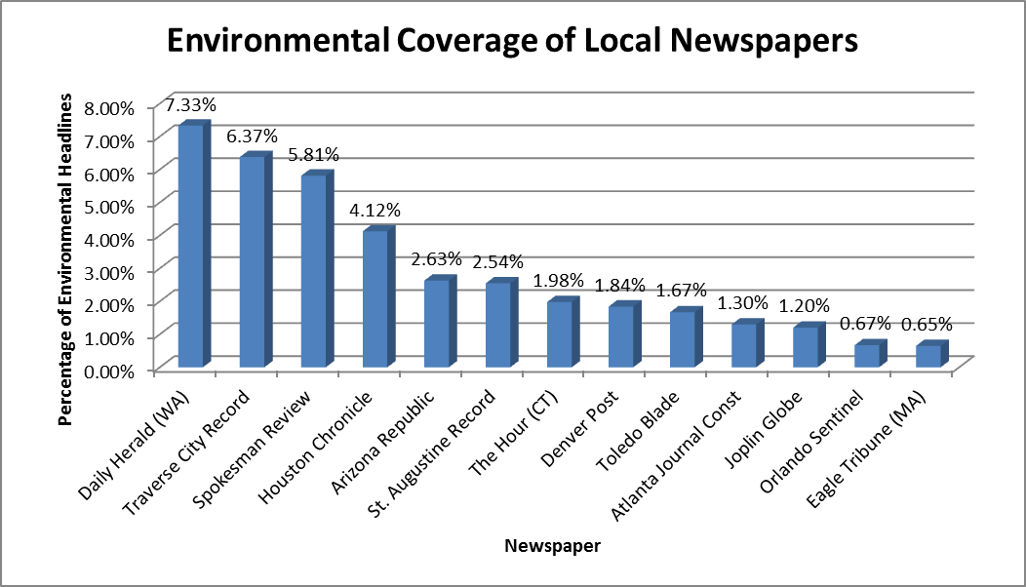
As is evident in Figure 3 above, environmental headlines at the Daily Herald in Washington (7.33%) are prioritized nearly six times more than the average for nationally recognized news organizations over 17 months and have the highest ranking of any news portal tracked by the Pew Research Center’s Project for Excellence in Journalism.

Figure 4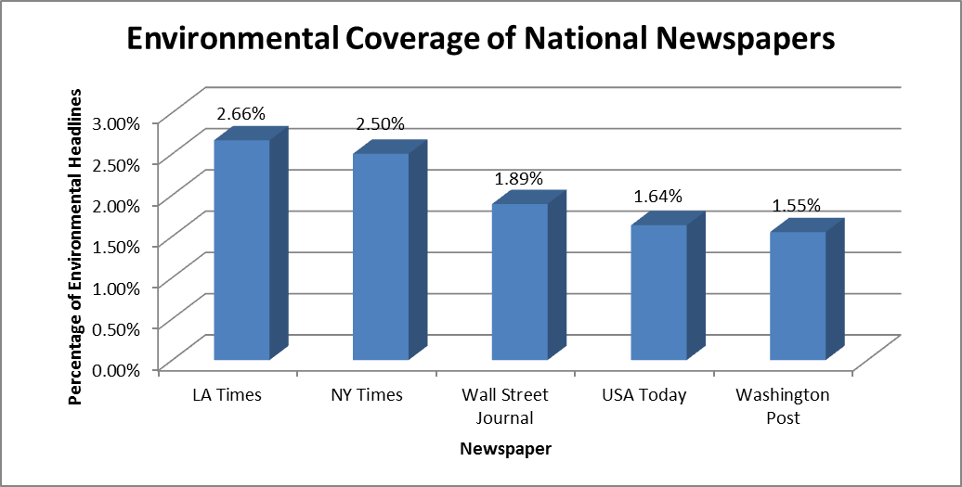

Kelly: Shrink charts above so that these 3 sentences can fit. While nationally recognized newspapers as a whole are somewhat closely grouped together when it comes to environmental reporting, it should be noted that the LA Times features environmental headlines 72% more than the Washington Post.

Figure 5
. 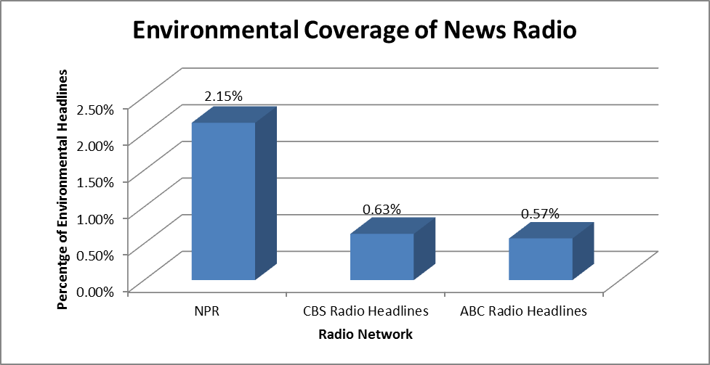

While NPR’s environmental headline average is still quite small for a public-interest news organization, their average is over three times more than ABC news radio. In contrast, that National Radio Project maintains a coverage mix of approximately 15% for environmental stories (see success model section on page X for more).

Figure 6
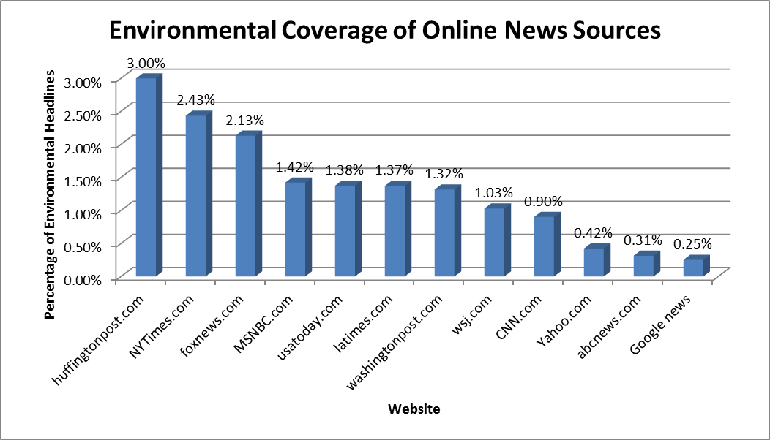
Kelly: Ditto re: shrinking charts. As a news media format, online news sources come in fourth compared to other formats. With the Huffington Post leading the pack in this category at 3%, prioritizing environmental stories more than 12 times that of Google News, which is in last place at 0.25%. It should also be noted that CNN.com, Yahoo News, ABCnews.com, and Google News are all less than the 1.2% average for the study period.

Figure 7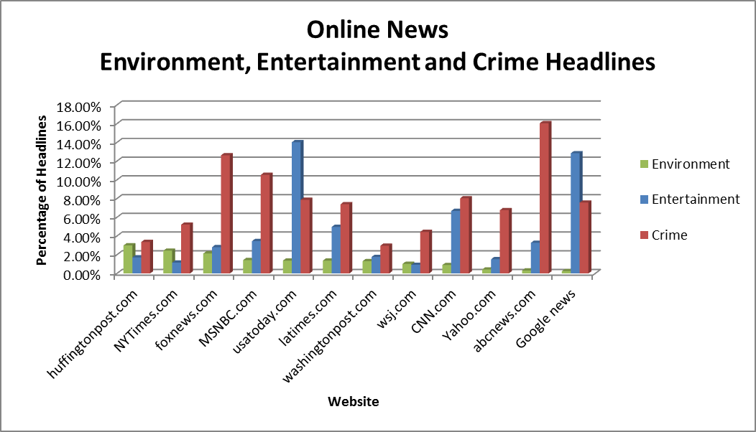

Figure 7 above provides a glimpse of how environmental headlines stack up against entertainment and crime for online news portals.

Figure 8
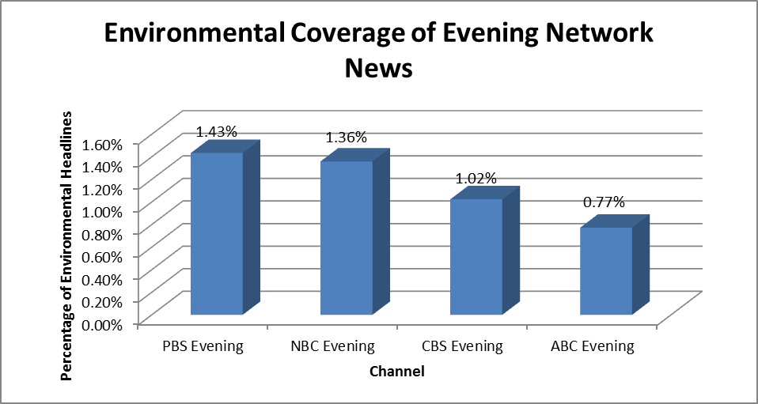
Kelly – Ditto: Given the audience reach, nearly 50 million nightly viewers of evening network news, it is surprising to see how PBS and the networks compare to the national average of 1.2% for the study period. Unlike other news formats, the networks are grouped somewhat close together with PBS Evening (1.43%) just over twice the environmental headline coverage of ABC Evening (0.77%).

Figure 9
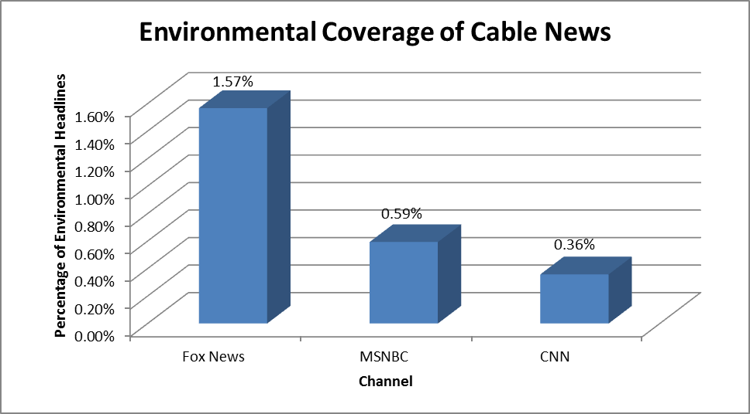
While there are a fewer number of news organizations to compare in the cable news format category, it is interesting to note that Fox News covers environmental headlines nearly four times more than CNN and approximately 2.5 times more than MSNBC. As stated above, Fox News is often criticized for having a blatant anti-environment bias and accordingly quantity is not a proxy for quality of coverage on this issue. It does, however, lead one to ask why Fox might be covering environmental topics so much more than its counterparts and conversely why environmental headlines on CNN and MSNBC seem to garner so little visibility at 0.59% and 0.36% of headlines respectively.

Figure 10
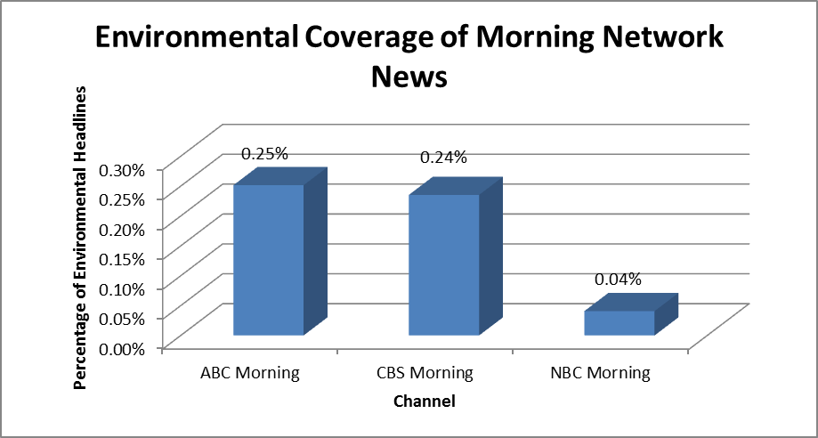
As is evidenced in Figure 10 above, morning network news as a format is devoting very little coverage to environmental news with the three networks averaging 0.18%—nearly seven times less than the national average of 1.24% during the 17-month study period. With an entertainment and crime to environment ratios of 27-to-1 and 69-to-1 respectively, there are certainly opportunities for a few less stories in these topic areas and a few more environmental headline stories.

Trivial News vs. Environmental News
It is easy to argue that the mainstream news media’s coverage of environmental news is so low because there are simply so many stories on other topics that are critical to the public interest. Part of this argument is certainly true—stories about politics, business, the economy, education, science, technology and many other issues are critical to informing the public about issues that are central to their lives. However, a significant amount of stories actually covered by varying mainstream news organizations can easily be categorized as trivial and offering little other than entertainment value to the news consumer.

When the frequency of reporting on environmental issues is compared to reporting on celebrities or entertainment-related topics, it becomes clear that there is a need for many mainstream news sources to reconsider what issues they prioritize. One study by Media Matters found that between January 1, 2011 and June 26, 2012 prominent newspapers and television news from major network and cable stations mentioned the family of reality TV stars, the Kardashians a combined 2,133 times while ocean acidification was only mentioned 45 times over the same period. Newspapers reported on the Kardashians 26 times more frequently than ocean acidification while television news reported on the Kardashians 270 times more frequently.

The project for Improved Environmental Coverage completed a search using Vanderbilt University’s television news archive that included the names of several celebrities as well as other entertainment related phrases and compared the number of results to searches for terms related to important environmental issues. Vanderbilt’s collection consists of regularly scheduled newscasts from ABC, CBS, NBC, CNN and Fox News. The time period searched was the same 17-month period for which PEJ data was analyzed, January 1, 2011 to May 31, 2012.

Search Results from the Vanderbilt University Television News Archives
January 1, 2011 to May 31, 2012
Search Term | Number of Television News Stories
Entertainment Phrases Searched
LeBron James | 348
Tiger Woods | 152
Casey Anthony | 149
Dancing With the Stars | 124
Donald Trump | 111
Environmental Phrases Searched
Deforestation | 0
Invasive Species | 0
Green Jobs/Green Economy | 1
Extinction | 2
Pesticides | 3
Fracking/Hydraulic Fracturing | 6
Environmental Health | 28
Climate Change | 244
Table 2. Source: http://tvnews.vanderbilt.edu/

The fact that the celebrity/entertainment searches consistently turn up over 100 news stories while many searches for many critical environmental issues turn up 5 or fewer stories highlights the lack of environmental coverage compared to more trivial issues. It is particularly surprising that the searches for two critical environmental problems—green jobs and extinction—both resulted in only one match across more than 5 major television stations over a 17-month period. Climate change appears to be the only environmental issue to result in more than 100 searches, and despite being what many would consider to be the most important and most challenging environmental issue it still addressed 30% less frequently than basketball player LeBron James by television news. A closer look at one major news source, CNN.com further emphasizes the imbalance between entertainment/trivial news and environmental news in the following section.

A Closer Look at CNN.com
The CNN brand and news platforms are viewed by many as a source for unbiased news coverage. CNN’s leadership in this area and quality of coverage is deserving of praise. But, it is also worth drawing attention to how CNN.com prioritizes environmental stories with a finer scale of detail. Below is a snapshot of CNN.com’s headlines as tracked and categorized by the Project for Improved Environmental Coverage over the course of four weeks in Spring 2012. This is merely a month of data, but it aptly captures the scope of opportunity for CNN.com.

CNN.com News Headlines from 4/18/12 - 5/23/12
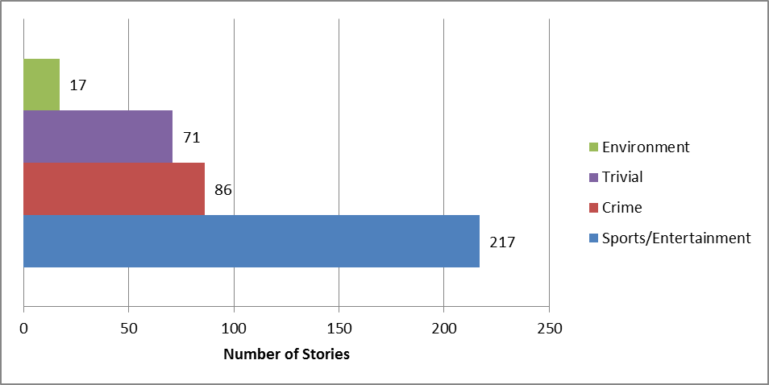

3 Environmental Stories Unreported by CNN.com in this Time Period (4/18/12 - 5/23/12)

Mayors group pledges big greenhouse gas reduction effort
Changing sea conditions threaten a major world food source -- U.N. report
Report warns of pesticide residue in conventionally grown produce

Eight Non-Sensical Stories Covered as News Headlines by CNN.com During this Time Period (4/18/12 - 5/23/12)

Cat weighs almost 40 pounds Being a porn star saved my life
Photos: A home made of beer cans Charlie Sheen sues strip club
The RidicuList: Drunk friends steal penguin Hot dog stripper goes back to work
Mom denies taking 6-year-old for tan Grad Gift Trend: Breast Implants?

After examining environmental coverage levels across 30 nationally recognized news organizations, it is clear that the mainstream news industry as a whole can and should be doing a much better job prioritizing environment-related stories. It should be noted that “environmental stories” according to the Pew methodology don’t just have to be about climate change or threatened species. In fact, stories can be classified as “environment” if they are connected to jobs, the economy, security, politics and a range of other topics as long as the primary angle is environmentally oriented.
Much of the sector-by-sector analysis accompanies the charts earlier on in the report, but the most important finding is that the industry has a huge opportunity to improve how it covers and prioritizes environmental stories. Many would say that the opportunity is also a responsibility. Of course, with headlines representing a narrow slice of “real estate” above the fold and newsroom budgets decreasing, the question becomes what gets covered less and what is the budget for improving coverage. These topics will be explored more in-depth in the success-model section, but the short answer is that it could be as simple as covering entertainment and crime less and environment more and without any significant impact to the bottom-line. Additionally, there are more resources to support robust environmental reporting than ever before in the form of news services, academic institutions, journalism training organizations and science-based civil society organizations and making use of these resources enables a news organization to increase coverage of environmental stories without necessarily having to incur additional costs.

Local Newspapers: A Model for Replication?
On the whole, local newspapers perform better than any other news platform when it comes to prioritizing environmental coverage—with average story headlines nearly three times the average compared to nationally focused news organizations. With environmental stories representing 7.3% of headlines, the leading local news organization (Daily Herald WA) covered environmental stories nearly six times the national average. Granted, this level of performance varied quite a bit; with an eleven-fold spread between the leader (Daily Herald WA) and the last place finisher. Influencing factors for the leader title include:

- The sector had the lowest entertainment-to-environment ratio and the second lowest crime-to-environment ratio (leaving more room and resources for better environmental coverage).

- Environmental stories work best when citizens can connect as individuals to the content and local environmental coverage is in line with this approach.

If, at some point in the near future, the news industry covered the environment at 7% of headlines, it would actually be close to what citizens are looking for in regards to attitudinal data that shows that citizens would like to see environment-related stories representing 18% of headlines according to our 2010 poll conducted through the Opinion Research Corporation.

Environmental Coverage Methodology
This ranking report utilizes news outlet content analysis data provided by the Pew Research Center’s Project for Excellence in Journalism (www.journalism.org) for 46 news and related organizations for all of 2011 and January through May of 2012. The report also presents coverage ratios that compare the quantity of environmental news headlines to entertainment and crime headlines. It should be noted that the Pew Research Center’s Project for Excellence in Journalism categorizes “sports” and ”celebrities and entertainment” as two separate categories. However in our analysis and presentation of the data, we have combined these categories into one given that they are both entertainment-related. It should also be noted that, for clarity, we have segmented ranking data into nationally recognized news organizations (30) and local news organizations (13) and left out several outlets that don’t fit the mold as a “news organization” in the traditional sense including Ed Shulz Radio, Sean Hannity Radio, and Rush Limbaugh. The methodology used by the Project for Excellence in Journalism to collect this data is summarized below however, the full methodology published by Pew is available at: http://www.journalism.org/about_news_index/methodology.

Other than the primary topic of the story, the index created by PEJ does not address other issues such as tone, sourcing, or quality. For the purposes of this index, the PEJ has identified five sectors of “mainstream news”: Network TV news, newspapers, online news sites, cable news and radio news. PEJ archived and reviewed news media from a sample of news outlets from each of the five sectors of mainstream news. Due to time constraints, PEJ does not review the entirety of every news source but instead codes and classifies the most prominent news stories (i.e. those in the first 30 minutes of a radio, cable or network news program, the top five headlines on a news website or the first page of a newspaper). The PEJ acknowledges that this may skew the data towards the more serious stories, but they state that it should include the main stories from each news source each day. The news sources sampled by the Project for Excellence in Journalism are regularly updated based on a variety of factors including “audience ratings, sector reach and assessments of [the project’s] coding processes.” The methodology used by PEJ was developed with assistance from a team of academic advisors.

Using the data collected by PEJ, the Project for Improved Environmental Coverage conducted an analysis of the quantity of environmental headlines for each sector of the mainstream news identified by PEJ and for each of the news outlets included in PEJ’s sample. For the purposes of this report the percentage of total news headlines that were classified as “environmental” were calculated, as well as the ratios of crime headlines to environmental headlines and sports/celebrity/entertainment to environmental headlines. As mentioned previously PEJ counts sports as its own category and celebrity/entertainment as a separate category.

The data used for this report includes all data from PEJ for the 2011 calendar year as well as PEJ data for the first five months of 2012. Because only 5 months of 2012 were included in the dataset it would be inaccurate to compare that data to the full year of data obtained for 2011. To create a weighted average, the averages for environmental coverage and the crime to environmental headlines and the sports/celebrity/entertainment to environmental headlines ratios for each year were weight by the percentage of the total 17-month timeframe they represent. Thus the averages and ratios from 2011 were given a weighting of 70.59% (equivalent to 12/17) and the averages and ratios for January through May 2012 were given a weighting of 29.41% (equivalent to 5/17). The weighting was used to create averages and ratios that were representative of the entire 17-month period which covered January 2011 through May 2012. It is these weighted averages and ratios that are presented and discussed in this report.

About the Project for Excellence in Journalism
The Pew Research Center’s Project for Excellence in Journalism focuses on collecting empirical data to inform the media and the public about “what the press is delivering, how the media are changing, and what forces are shaping those changes” more information about the PEJ is available at http://www.journalism.org/about_pej/about_us

Quality of Environmental Journalism
As mentioned previously, ranking news organizations according to the quantity of environmental headlines says nothing about the quality of the environmental coverage presented to the public. Elements of quality such as the tone of the news story, scientific accuracy, types of sources relied upon and the balance of perspectives presented were not considered in this analysis. There are several factors that may cause journalists to intentionally or unintentionally misinform the public when it comes to reporting on the environment or any other topic involving science.

First many environmental issues are extremely complex and reporters, who, by the nature of their jobs, cannot be experts on every topic, may unintentionally include factual errors in a report resulting from a lack of understanding of the topic. In some cases, it appears that some news organizations may intentionally misinform the public about certain issues relating to the environment. One study by the Union of Concerned Scientists found that representations of climate change on Fox News were “misleading” 93% of the time (source: http://www.ucsusa.org/assets/documents/global_warming/Is-News-Corp-Failing-Science.pdf)

There is also a tendency in journalism to focus more on human interest stories than scientific data which may place more weight on anecdotal evidence from a single event or individual’s personal account than on broad data or scientific consensus. The news media’s efforts to appear objective and provide balanced coverage, while important, may also misinform the public by creating the appearance of controversy when there is in fact consensus among scientists. As Stephen Schneider, Professor of Environmental Biology and Global Change at Stanford University stated, “a mainstream, well-established consensus may be ‘balanced’ against the opposing views of a few extremists, and to the uninformed, each position seems equally credible.” Boyce Rensberger, the director of the MIT Knight Center for Science in Journalism, suggested that “balanced coverage of science does not mean giving equal weight to both sides of an argument. It means apportioning weight according to the balance of evidence:” something that could be better integrated when it comes to reporting on climate change.

A study in 2005 reviewed mass media coverage of climate change between 1988 and 2004.The study concluded that nearly 53% of “prestige-press” articles provided “roughly equal attention to the views that humans were contributing to global warming and that exclusively natural fluctuations could explain the earth's temperature increase."

It is also evident that this so-called balanced reporting which provides equal time to opposing viewpoints despite a clear consensus among scientist is influencing public opinion which in turn influences policy. A recent Gallup poll found that 48% of Americans believe that the seriousness on global warming is generally exaggerated.

Additionally, as noted previously, reporting frequently on environmental issues is by no means a guarantee that news consumers are presented information that will help them better understand an issue or promote solutions to environmental issues. In fact there are studies that indicate that in some instances, news outlets such as Fox News that cover environmental issues with a relatively high frequency are often dismissing environmental concerns and offering a negatively biased environmental perspective.

For example, Media Matters conducted an analysis of media coverage of the Keystone XL pipeline between August 1 and December 31, 2011. At the time there was a great deal of controversy surrounding a proposal to extend the pipeline. Supporters of extending the pipeline viewed the project as one that would create jobs and help spur the economy while opponents of the extension feared it would pose an undue environmental risk. According to data from the Project for Excellence in Journalism, Fox News had more environmental headlines than the other cable news channels in 2011 and the first 5 months of 2012 (a timeframe that overlaps with the Media Matters study). Similarly Media Matters found in its study that Fox News also mentioned environmental issues the most frequently of any cable news channel when discussing the Keystone XL pipeline. However the Media Matters study found that in Fox News stories about the pipeline 66% of those quoted or hosting shows favored the pipeline extension compared to only 13% who opposed it. Media Matters further states that, “while Fox News mentioned environmental factors in a third (33%) of its coverage, it was often to dismiss these concerns.” The Media Matters report also noted that Fox News along with The Wall Street Journal (both are owned by the same parent company, Newscorp) mentioned protests of the pipeline extension less than other news outlets.

Corporate influence and profit motives are possible factors to the relatively low percentage of time that is devoted to environmental issues among mainstream national news outlets. As FAIR (Fairness and Accuracy in Reporting), a media watch group, states, “Almost all media that reach a large audience in the United States are owned by for-profit corporations—institutions that by law are obligated to put the profits of their investors ahead of all other considerations. The goal of maximizing profits is often in conflict with the practice of responsible journalism.“

Numerous surveys and studies have shown that this focus on maximizing profits combined with a reliance on corporate advertisers has caused some in the news media to put a greater emphasis on maximizing ratings and providing the greatest entertainment value, rather than emphasizing issues that are of the greatest interest of the public.

As Ron Smith writes in his book Ethics in Journalism, “Advertising constitutes as much as 80 percent of a newspaper’s revenue and nearly all of a television station’s. Some advertisers use the clout of their advertising dollars to directly influence news coverage.” This is supported by a study that appeared in Editor and Publisher which found that nearly 90% of newspapers surveyed had been pressured by advertisers to either modify or kill a news story that the advertiser found unfavorable and that about a third of editors admitted to complying with the advertisers request. The degree of this problem is illustrated by a study completed by Extra! (published by FAIR) which analyzed the time news programs on variety of television stations (ABC, CBS, NBC, CNN and Fox News Channel) devoted to the controversial process of hydraulic fracturing or “fracking”). The study analyzed news transcripts from these channels between January 2009 and November 2011—nearly three years—and found that combined these news outlets devoted less than an hour of news to fracking over the entire period. Meanwhile over four and a half hours of advertisements for “America’s Oil and Gas Industry” or “America’s Natural Gas” were broadcast on these networks over the same period.)

Structural Aspects of a News Organization Affecting Environmental Journalism:
Some elements of quality environmental journalism have more to do with how a news organization is structured than how a story is written or the choices of the reporters and editors involved in a specific story. Structural elements that engender strong environmental reporting may focus on how a newspapers, websites, and television/radio broadcast are organized and how news organizations prioritize environmental issues.
How a news organization integrates environmental news into the spectrum of other issues it covers has significant implications with regards to how visible these stories are to a typical reader who may be scanning headlines for a story of interest. Some websites and newspapers have a separate environment section which, if done right, can increase the prominence of environmental stories and allow interested readers to view several stories on the topic all in one place. Similarly, some radio broadcast periodically includes special segments on the environment.
Having special segments or sections for environmental issues can, however, be counterproductive if it is done in a way that makes it less likely for such stories to be included among the most prominent headlines. Ideally the most important environmental stories would be included with the most prominent headlines and environmental stories deemed less important would be included in an environment section or segment. With online news sources it is possible to do both by including a link to an important environmental story with the most prominent headlines and including a link to the same story in the environment section on the web and likewise prioritizing the story towards the major sections of a newspaper.
It is also possible for a television or radio program to broadcast a recurring segment on environmental issues immediately before or after the most prominent headlines. For example, NPR affiliate Michigan Radio airs approximately 2 episodes of The Environment Report each week, and times the broadcast to occur when many listeners are commuting and listening to the radio in their cars. The stories are generally in close proximity to general news shows that cover the top headlines of the day. Each episode of The Environment Report is only three or four minutes long, but since it only focuses on one story per episode there is enough time to go into sufficient detail and educate listeners about two environmental issues affecting the state each week.
Environmental Reporters:
As Joe Romm stated in an article for ThinkProgress.org, “Sadly, the environmental reporter has become an endangered species.”
Environmental correspondents help ensure the quality of environmental journalism because by nature of their position, they have experience with a broad range of environmental issues and are more likely than a general assignment reporter to accurately report science-based environmental issues in a way that is appealing and understandable to a broad audience. Because of this specialized knowledge and experience, logic would dictate that these reporters would be more likely to adequately assess claims from industry and have better access to scientists at government agencies and academic institutions.
Unfortunately research from 2003 to 2005 indicates that among daily newspapers only about 37% have some kind of environmental reporter. Televisions stations that report news have even fewer environmental reporters with only 10% having some kind of environmental reporter. Additionally, environmental reporters responding to a survey reported on average that just 43% of their time was dedicated to environmental stories, and only 26% of reporters that greater than two thirds of their time was dedicated to environmental stories.
Quantity: While frequently reporting on environmental issues does not imply quality environmental journalism, it is impossible for a news outlet to adequately inform the public about key environmental issues if few stories are dedicated to environmental concerns and solutions. While there is no clearly defined threshold that would constitute the “right” amount of environmental news, certainly 1.2% of headlines—the average for the national news sources tracked by the Project for Excellence in Journalism during the 2011–12 study period, is not adequate to fully inform the public about this important topic area.
Prioritizing Environmental Coverage:
Many of the structural elements discussed above come down to the degree to which reporting on the environment is a priority for a given news organization. A news organization that places a high value on quality will dedicate a relatively large percentage of the “news hole” to environmental issues, employ at least one environmental reporter, and/or will make environmental stories highly prominent. There may be a separate section or segment for environmental stories, but this section/segment will be prominent and will not prevent important environmental stories from being covered among other top headlines.
Examples of News organizations with Excellent Structure to Foster Quality Environmental Journalism
Commondreams.org is a nonprofit online news aggregator that both curates stories from other sources and also conducts original reporting. Common Dreams prioritizes environmental coverage, often integrating environmental stories with other prominent news headlines. An assessment by the Project for Improved Environmental Coverage during varying reporting periods demonstrated that 15% of Common Dreams’ news stories have an environmental focus. Common Dreams is an nonprofit organization that receives no advertising, corporate underwriting or government funding.
YES! Magazine and Mother Jones are two other news sources that also appear to be structured to prioritize environmental coverage. Each is a magazine published several times per year (MotherJones is published 6 times per year and YES! Magazine is published 4 times per year) but they both have website that are updated daily with news stories and posts. This is a slightly different format than the other media types discussed previously in this report but the focus each places on environmental coverage is worth noting. Both have a separate environmental section but almost always include environmental stories among the most prominent headlines on their respective homepages. As Susan Gleason, Media and Outreach Manager for Yes! stated, “Online, we have five categories of coverage: Planet, People Power, Peace and Justice, Happiness, and the New Economy. Once again, we find that environmental solutions show up in categories beyond the ‘Planet’ category…So, to us, the environment is not a separate category—it is embedded in almost everything we do.”

Both Yes! Magazine and Mother Jones also appear to have staff writers with in-depth knowledge of environmental issues and rely on freelance writers who are experts on specific topics. Many of the environmental stories are in-depth investigative reports. Both are also nonprofits that rely largely on donations and subscriptions from readers, private foundations, and some advertising. In its guidelines for freelance writes, Mother Jones specifically lists the environment as one of the major topics they tend to focus on stating, “We're interested in just about anything that will raise our readers' eyebrows, but we focus especially on these areas: national politics, environmental issues, corporate wrongdoing, human rights, and political influence in all spheres.” In the writer’s guidelines for Yes! Magazine, not only are environmental issues highlighted as a key area of interest, but the magazine’s focus on solutions to social and environmental issues are also highlighted: “YES! is not interested in simply bemoaning the problems that face our society. Instead, we highlight solutions in action that address the roots of our deepest ecological, social, and political problems. We emphasize engaging storytelling and factual accuracy. We are especially interested in authentic stories of positive change from the grassroots that can serve as models and inspiration for others.”
In discussing this with the Project for Improved Environmental Coverage, Susan Gleason, from Yes! Magazine said, “Frankly, in our reporting, we don't have to pull any punches. We don't have to keep quiet about Shell Oil's plans to drill for oil in the Arctic or Monsanto's impact on farmers and environmental health, or the ways in which big banks and Wall Street financiers deplete the social and natural capital that are our real forms of wealth. Instead of selling our readers' attention to advertisers, we exist to serve them.”

The New York Times also appears to prioritize environmental coverage which could help explain the relatively high coverage of environmental issues in both it’s newspaper and the nytimes.com website. On it’s website discussing corporate responsibility, the New York Times states “the Company's primary business is journalism, and global warming and greenhouse gas emissions are topics that it covers extensively. The New York Times spotlights these issues on both its editorial and op-ed pages and throughout its news coverage.” While the New York Times is a leader in integrating environmental coverage in with other top stories, it also maintains separate sections and websites specifically dedicated to environmental issues including an energy and environment subsection in the business section of the website, and an environment subsection of it’s science section on the website. The New York Times also maintains the dot earth environment blog and a Green Blog.
Though not a U.S. newspaper The Guardian in the U.K. is also a news outlet that has a structure that is notable in terms of promoting quality environmental coverage. The company has a sustainability vision, which specifically highlights their commitment to informing the public about environmental issues and solutions. “Through our editorial coverage and business activities, we will demonstrate to readers, staff, advertisers, suppliers and our communities that Guardian News and Media is committed to enhancing society's ability to build a sustainable future . . . . Clearly, our greatest impact comes from informing and influencing our global audience. We will therefore build on our position as a recognised leader in the reporting of environmental and social justice issues, by providing the most comprehensive news coverage on subjects such as climate change, environmental degradation and social inequality . . . . We will promote public debate and harness the power of our readers and users by creating online tools and projects that give them the opportunity to share knowledge and ideas, as well as encouraging them to make a difference, both as individuals and within their communities.”
Story-Specific Elements of Quality Environmental Journalism
The structural elements of quality environmental journalism discussed above have more to do with how the company is setup than the decisions made by a writer or editor. While these structural issues certainly influence decisions on the part of writers and editors, the following story-specific elements of environmental journalism are more within the control of journalists and editors
Visibility: The visibility and the prominence of news stories are absolutely critical. Even the best environmental coverage will do little to inform the public and motivate positive change if only a small percentage of news consumers read, watch or listen to report in the first place. All too often high quality environmental news stories are relegated to a back section of a newspaper or obscure section of a website. High quality environmental journalism would not only have a higher quantity of stories focusing on environmental issues, but those stories would be visible, appearing at the beginning of news broadcasts, the most prominent sections of websites and the front page of newspapers. Clearly the structure of a news organization can either enhance or reduce the visibility of a given story, but it this is also an area where en editor can make a decision about where to place a particular story.
Integrate the environmental angle into other stories and make that connection explicit: The environment is, by definition, our surroundings, and we interact with it through a wide range of complex processes. Many choices by governments, corporations and individuals have environmental impacts that affect people and communities around the world, though in many instances they are not thought of primarily as environmental decisions. Examples include a policy decision that, among other things, cuts funding for enforcement of environmental laws, and the decision of a company to manufacture a new product. In the former example, a story could simply be classified as a political story and only note that environmental enforcement was one issue that lost funding. Contrarily the story could explain in much more detail the implications of that decision and connect the cut in funding to ways it will affect the air we breathe and the water we drink. In the example of a business manufacturing a new product, a news outlet could classify it as a business story and only focus on how the new product will affect shareholders. Alternatively a story may assess the lifecycle of the new product and look at how it either increases or reduces environmental impacts compared to a competitor’s product or an earlier model of a similar product.
The more the news media links the decisions of individuals, corporations and governments to the environmental consequences, the less society will view the environment as a separate issue and the more it will be seen as intertwined with politics, economics, education, business, and virtually every other topic that the news media reports on.
Making Environmental News Appealing to a Larger Cross Section of Society: By nature environmental issues often involve complex scientific processes. While it is critical that environmental stories are based on scientific data and studies as discussed below, stories that are too dry or technical will discourage some readers/viewers/listeners. Conversely a story that is able to successfully take what may be complex or technical information and break it down into plain English in a way that helps the reader/viewer/listener understand the issue and make the connection to how it has relevance to his/her life will attract more individuals and bring more attention to important environmental issues.
Ensuring Scientific Accuracy: While it is important to explain scientific information in plain language, it is also critical that all information reported is scientifically accurate. Often stories about environmental issues will involve varying perspectives and different interpretations of the facts, but quality environmental journalism will ensure that doing so does not misrepresent scientific studies or take certain conclusions out of context.
Focusing on Solutions: Informing the public of environmental problems is important, but high quality environmental journalism also focuses on the solutions to environmental issues. The very reason there is a need for more, high quality environmental news coverage is so that the public not only understands important environmental issues, but can act to solve these problems by either changing their behavior, taking action within their communities or by electing public officials who will be thoughtful and progress-oriented. For example, a story about rainforest destruction in Indonesia may adequately inform the public about the nature and scale of the problem, but a more helpful story would include information about what an individual can do to reduce the problem such as buying recycled paper products, or purchasing paper and furniture that are certified to be sourced from well managed forests. Tying environmental problems to the decisions made by individuals, politicians and corporations that reduce environmental impacts is a key element of quality environmental journalism that empowers the public to implement solutions.
Relying on Credible Sources and Fully Identifying the Nature of Sources: Research has shown that when it comes to news stories about the environment, government agencies are the most frequent source of information. There is no denying that government agencies have a wealth of data and expertise about a broad range of environmental issues and in many cases representatives from such agencies are the most appropriate source of information. However journalists and editors should keep in mind that many positions in government agencies are political appointees and in some cases may not be the most objective sources of information. Academic institutions and scientists should perhaps be viewed as the most credible and objective sources of information. In many cases, credible NGOs that specialize on a particular issue may also be an excellent source of information. While the perspective of representatives of corporations or industry trade groups should certainly be included in a story, it should be balanced by information from academic sources, independent scientists or NGOs. Additionally the nature of an industry group or association should be fully disclosed. For example a story about the environmental impacts of oil drilling or hydraulic fracturing may quote a spokesperson from Vote4Energy, but doing so would fail to fully inform the public if it was not also disclosed that Vote4Energy is a project of the American Petroleum Institute representing more than 490 oil and natural gas companies. Failing to disclose the nature of the organization may leave some readers with the false impression that a citizen-based group concerned about energy issues is behind the claim.
Examples of Quality Environmental Journalism
Below are examples of several environmental news stories from a variety of platforms that include many of the elements of quality environmental journalism discussed above. These stories were identified by browsing various news sources and reviewing winners of various environmental journalism awards (including the Society of Environmental Journalists and the Grantham Prize for Environmental Reporting).

Newspaper Articles:

Headline: After Three Decades, We’re Still Dumping in the Lake
News Source: Chicago Tribune
Media Type: Local Newspaper
Date Published: March 20, 2011

The article discusses the “Deep Tunnel” started in 1975 to prevent sewage and other waste from being dumped into lake Michigan when there is excess storm water. Despite the fact that the project was started over 35 years ago, it is not expected to be fully completed until 2029 and water contaminated with sewage and other pollutants is still being dumped into the lake—19 billion gallons between 2007 and 2010. PEJ did not track the Chicago Tribune, so the percentage of prominent headlines focusing on environmental issues is not known. However, this particular story is extremely prominent. It appears on the front page of the paper and is second only to a headline about the start of airstrikes by the U.S. and allies against pro-Gadhafi Libyan forces. The article is also accompanied by several large photographs and diagrams, which help draw attention to it.

The story explains the problem in plain English without the use of technical terms or jargon. Although the article does not address many scientific topics, it appears to rely on government records in reporting the amount of wastewater runoff that is dumped into Lake Michigan. The article can be viewed at http://www.sej.org/sites/default/files/webform/AwardsEntries2012/StillDumpingInTheLake.pdf
The article also includes some solutions and identifies other steps that both Chicago and other cities have taken to minimize storm water runoff such as building “green roofs” and modifying vacant lots so that they soak up as much water as possible. The story relies on information from credible sources and includes quotes both city government officials and the EPA.

Headline: Gas Drilling Jitters Unsettle Catskills Sales
News Source: New York Times
Media Type: National Newspaper
Date Published: September 29, 2012

The article discusses how proposed hydraulic fracturing in the Catskills region of New York is depressing home values in the region. The region overlaps with the Marcellus Shale, though New York State has not yet decided if and where fracking will be allowed. However the potential for the controversial method of extracting natural gas has caused many potential buyers to fear that the picturesque environment could become more industrial and that water in the area could become polluted. The result is that real estate prices in the area have been depressed even beyond what would be expected given the poor state of the national real estate market. The article highlights one seller of a home on 14-acre wooded lot near prime trout fishing that is having trouble selling at a reduced price of $107,000. This article does an excellent job of connecting the environmental issue of fracking to home values, another issue that is important to many people. The full article is available at: http://www.nytimes.com/2012/09/30/realestate/fracking-fears-hurt-second-home-sales-in-catskills.html?pagewanted=all&_r=0

Radio:

Headline: As Arctic Ice Melts, So Does The Snow, And Quickly
News Source: NPR-All Things Considered
Media Type: Radio News
Date Published: September 24, 2012

The broadcast discusses a study that found that not only is Arctic Sea ice melting, but that snow in the arctic is also melting considerably more rapidly than previously expected. The implications of this discovery, including the effect of melting snow accelerating global warming through reduced reflectivity of sunlight and carbon releases from melting permafrost are also discussed. Among the radio news sources evaluated by the Project for Excellence in Journalism, NPR is has the highest percentage of prominent environmental headlines (2.15%). This particular story was moderately prominent. It was the fourth out of 17 headlines covered on the show, and it began approximately 16 minutes into the broadcast. The story also did a good job of taking complex scientific information and explaining it in plain English. “Springtime snowmelt matters a lot: It determines when spring runoff comes out of the mountain to fill our rivers. And Chris Derksen at Environment Canada in Toronto says snow also reflects sunlight back into space, helping to keep the Earth from heating up too fast . . . . It also hastens melting of the permafrost, a layer of frozen soil that contains a lot of carbon. And when permafrost melts, it releases those greenhouse gases into the atmosphere.” The article relies of credible sources for information and quotes from government sources (Environment Canada) that published the study in a peer reviewed journal. The story also quotes a biologist from the University of Alaska, Fairbanks. The broadcast can be streamed at
http://www.npr.org/2012/09/24/161701420/as-arctic-ice-melts-so-does-the-snow-and-quickly

Online:

Headline: Caribbean coral reefs face collapse
News Source: guardian.co.uk
Media Type: U.K. online news
Date Published: September 10, 2012
A recent study by the International Union of Concerned Scientist is discussed which highlights multiple factors that are causing a rapid decline in coral reefs in the Caribbean, as well as the implications of the rapid decline.
The article makes connections between declining coral reefs and the implications it will have on people who depend on them for their livelihood stating, “This decline is likely to have severe impacts on coastal villages, particularly in developing countries, where many people depend on the reefs for fishing and tourism. Globally, about 275 million people live within 19 miles of a reef.” The article does not go into detail about the threats facing coral reefs in the Caribbean, but does discuss them generally and in plain English with a quote from a scientist from the International Union for Conservation of Nature (IUCN) who said, "The major causes of coral decline are well known and include overfishing, pollution, disease and bleaching caused by rising temperatures resulting from the burning of fossil fuels.” The article also has some discussion of solution: “IUCN, which is holding its quadrennial World Conservation Congress on Jeju island in South Korea this week, said swift action was vital. The organization called for catch quotas to limit fishing, more marine-protected areas where fishing would be banned, and measures that would halt the run-off of fertilizers from farmland around the coast. To save reefs around the world, moves to stave off global warming would also be needed, the group said.” The article can be viewed at:
http://www.guardian.co.uk/environment/2012/sep/10/caribbean-coral-reefs-collapse-environment

Magazine:

Headline: Global Warming’s Terrifying New Math
News Source: Rolling Stone
Media Type: Magazine
Date Publisher: July 19, 2012

This article details over 30 years of failure in efforts to get a meaningful worldwide agreement to limit greenhouse gas emissions. The article notes that most nations have signed on to the Copenhagen accord which sets a target of limiting the increase in the earth’s temperature to 2 degrees Celsius, but describes how even if that target is achieved, it will likely be catastrophic and goes on to highlight how challenging it will be to even achieve that target. According to the article, scientists estimate that releasing 565 gigatons of carbon would result in a 2-degree increase in temperature, but there are currently 2,795 gigatons in the proven reserves of oil companies—5 times the amount needed to reach a 2-degree increase. While the article takes data from a variety of scientific organizations including the intergovernmental panel on climate change (IPCC), it does an excellent job of presenting the information in a way that is easy to understand. At one point the article compares the 2 degrees Celsius to a legal drinking limit, “Think of two degrees Celsius as the legal drinking limit – equivalent to the 0.08 blood-alcohol level below which you might get away with driving home. The 565 gigatons is how many drinks you could have and still stay below that limit – the six beers, say, you might consume in an evening. And the 2,795 gigatons? That's the three 12-packs the fossil-fuel industry has on the table, already opened and ready to pour.”
The full article is available at: http://www.rollingstone.com/politics/news/global-warmings-terrifying-new-math-20120719

Television

Headline: Forest In Oregon At Risk From Timber Industry and Chemicals
News Source: PBS Newshour
Media Type: Television
Date Publisher: September 12, 2012

The segment describes a community near Triangle Lake in Oregon that is frustrated by aerial spraying of private timberland near homes and farms. Studies of the urine of residents in the area found that all of the subjects tested had pesticides in their urine and the potential health impacts of these pesticides were discussed. The information in the segment appears to be scientifically accurate, and credible sources from a variety of nonprofit, government and academic organizations were quoted. Industry representatives were also quoted, but they were clearly identified as representing the timber industry or the chemical company manufacturing the pesticide in questions. This article also does an excellent job of making the connection between an environmental issue and the potential human health impacts. The full segment is available at http://video.pbs.org/video/2278535290

Headline: Girl Scout Cookies: An Environmental Threat?
News Source: CBS The Early Show
Media Type: Television
Date Publisher: May 24, 2011

The segment covers two girl scouts who have been campaigning to have palm oil removed from Girl Scout Cookies. The girls became concerned about the issue while researching orangutan and have spent 5 years bringing attention to the issue. The clip provides information about the impacts of palm plantations on rainforests in Indonesia and Malaysia. The girl scouts featured in the clip admit that they are not food scientists, but that they know it is possible to make the cookies without palm oil because the ingredient was added just five years ago. The two teenagers were profiled in the clip immediately before a meeting that the Girl Scouts organization had finally agreed to hear their concerns. This clip was included in part because it demonstrates that anyone who has enough passion and determination can help bring about positive change. The full clip is available at http://www.cbsnews.com/video/watch/?id=7367161n&tag=mncol;lst;1
Vision for Improved Environmental News Coverage
In an effort to chart a path forward for their industry on this issue, a range of journalism professionals participated in a process to envision core principles for improving environmental coverage. These goals are contained within the Vision for Improved Environmental News Coverage (view at http://environmentalcoverage.org/vision ).

An advisory group of environmental journalism professionals from the following organizations were involved in the development of the Vision during 2011-12:

Bryan Walsh, TIME Magazine Beth Parke, Society of Environmental Journalists
Jennifer Grayson, Huffington Post Dave Poulson, Knight Center for Environmental Journalism
Peter Fimrite, San Francisco Chronicle Libby Waldo, Grist Magazine
Rebecca Williams, Michigan Radio Tess Croner, Solutions Journal

The stakeholder group affirmed that:

As news organizations, professionals and other interested parties, we understand the critical role of the news media. We recognize that public environmental literacy is important now and will be increasingly more so given the challenges we face. We believe that:

- Journalism has a tremendous influence on the public’s environmental literacy. The nature and level of environmental news reporting is one of the most important influences on the perception and understanding of the environment, according to numerous studies.

- The public wants better and more environmental news. Seventy-nine percent of Americans think news coverage of the environment should be improved, according to an April 2012 poll conducted by Opinion Research Corp.

- The news media bridges the political divide on environmental issues. With the divisiveness that often occurs in politics, there is a danger of distorting and marginalizing environmental issues that are critical to our economy, health and quality of life. The news media can hold a bright spotlight on such issues and provide an unbiased analysis.

Industry Goals

I Integrate the environmental angle into other stories and make that connection explicit. The environment affects or is affected by many areas of public interest including the economy, health, social issues and national security. Illuminating these connections dispels the belief that the environment can be separated from other issues or simply ignored.

II Make environmental stories appealing to a larger cross section of society. The technical or scientific nature of some environmental stories challenges understanding. Making the content accessible by relating it to other issues and reporting with clarity overcomes these barriers.

III Focus more on solutions. Including potential solutions makes environmental news stories more useful. Reporting them adds to the momentum for solving the environmental challenges we face.

IV Increase the visibility of environmental stories. Limiting environmental stories to a special section or program suggests that the environment is a special interest rather than a public concern. This limits the likelihood of the consumption of important news. In fact, stories with an environmental focus comprise just 1 percent of the top stories, according to the Pew Center. Featuring environment-related headlines on front or home pages or as one of the top stories of a broadcast gives them greater visibility and helps to increase public awareness.
The Wrap Up: There’s A Lot of Room for Innovation and Improvement

The News Affects Environmental Understanding, Policy, and More

Thomas Jefferson wrote, “Were it left to me to decide whether we should have a government without newspapers or newspapers without a government, I should not hesitate a moment to prefer the latter.” He understood the powerful role of the news media in shaping our society and, alas, this importance still reigns today. Our level of environmental understanding directly impacts the policies we establish, the daily choices we make, and the extent to which we deepen a national ethic of stewardship. And similar to the way feedback loops work in nature, this stewardship ethic ultimately reinforces our ability to thrive as a species and will enable future generations to enjoy the same comforts and stability that we have.

The news media is a critical conduit that can engender better environmental understanding and a corresponding national stewardship ethic.

A Public Interest Priority
Undoubtedly, news organizations face a daunting challenge when it comes to determining which stories reach the public. There are so many competing topics that are important and deserve coverage. With entertainment and crime headlines receiving over three and five times more headline coverage than environmental ones, however, there is a real opportunity for nationally prominent news organizations to do a much better job in this arena. In fact, environmental coverage could likely improve across the full spectrum of news organizations – from local to independent news outlets. Fortunately there are ways to track and measure quantitative shifts in headline priorities and it will be a great day when we see less entertainment and crime coverage and more coverage of topics like the environment that are in the public interest and affect our shared common good. It is important to note that there are more resources than ever for strong environmental coverage and that it can be connected to so many varying topics from health and economy to jobs and security.

Americans Want More Environmental Coverage
As was referenced earlier in this report, 79% of Americans want improved environmental coverage and this desire cuts across all demographic and geographic lines. This data shouldn’t come as a surprise because it can be argued that most Americans have an intrinsic inclination to recognize that the environment isn’t some external thing. It is core to the foundation for our existence and well-being and connected to virtually every aspect of our lives.

Follow the Leaders
As the data reveals and as explored in the section on quality, there are leading news organizations that are at the front-end of prioritizing environmental coverage from both a quantity and quality standpoint. For example, environmental headlines at the Daily Herald in Washington (7.33%) are prioritized nearly six times more than the 1.2% average for nationally recognized news organizations. It is possible that a key factor in this leadership can be connected to the fact that they and other leading local news outlets prioritize environmental coverage much more than entertainment and even crime coverage. A range of other more prominent news organizations such as the New York Times, NPR, Huffingtonpost.com and independent news organizations such as Commondreams.org, Grist.com, Mother Jones, Yes! Magazine, and others can be looked to as leaders in this area. It will be a good thing when, at some point in the near future, our future ranking analysis is able to point to an industry average where environment receives three times more coverage than entertainment instead of it being the other way around. Fortunately there are news organizations that are already there and whose leadership in this area can be replicated.

News organizations are a vital part of the health and functioning of any society. At the Project for Improved Environmental Coverage, we recognize this verity and look forward to continuing to work with news outlets and other stakeholders to support and report on positive progress in this area.

Resources

Environmental News Services
Bloomberg Environmental News: http://www.bloomberg.com/news/environment/
ClimateWire: (www.eenews.net/cw )
Earth Gauge: (http://www.earthgauge.net/environment )
Environment News Service (ENS): (www.ens-newswire.com )
Environmental Health News: http://www.environmentalhealthnews.org/
Environmental News Network (ENN): (www.enn.com )
Greenwire: (www.eenews.net/gw )
Environment & Energy Daily: (www.eenews.net/eed )
Inside EPA: (www.insideepa.com )
National Science Foundation Environmental News: http://www.nsf.gov/news/index.jsp?prio_area=6
NPR Environmental News: http://www.npr.org/sections/environment/
Reuters Environmental News: http://www.reuters.com/news/archive/environmentNews?date=today
Scientific American Environmental News: http://www.scientificamerican.com/earth-and-environment

Professional Development and Other Organizations

Society of Environmental Journalists, www.sej.org

Knight Center For Environmental Journalism, http://ej.msu.edu

Metcalf Institute for Marine and Environmental Reporting, www.metcalfinstitute.org

Pew Research Center’s Project for Excellence in Journalism, www.journalism.org

Yale Project on Climate Change Communication, http://environment.yale.edu/climate/

National Environmental Education Foundation, www.neefusa.org

Columbia Journalism Review – The Observatory, http://www.cjr.org/the_observatory/

Project for Improved Environmental Coverage, http://environmentalcoverage.org

Union of Concerned Scientists, www.ucsusa.org

Poll conducted by the Opinion Research Corporation April 2012: http://environmentalcoverage.org/docs/Environmental%20News%202012%20Study%20--%20Standard%20Banners.docx
According to source data provided to the PIEC by the Pew Project for Excellence in Journalism www.journalism.org
http://www.ucsusa.org/assets/documents/global_warming/Is-News-Corp-Failing-Science.pdf
Environmental Literacy in America: http://www.neefusa.org/pdf/ELR2005.pdf
American’s Knowledge of Climate Change: http://environment.yale.edu/climate/publications/knowledge-of-climate-change/
http://environmentalcoverage.org/docs/Summary%20of%20Citizen%20Attitudinal%20Poll%20April%202012.docx
http://www.journalism.org/about_news_index/methodology
http://mediamatters.org/blog/2012/06/27/study-kardashians-get-40-times-more-news-covera/186703
http://www.eci.ox.ac.uk/publications/downloads/boykoff07-geoforum.pdf
http://www.ucsusa.org/assets/documents/global_warming/Is-News-Corp-Failing-Science.pdf
http://mediamatters.org/research/2012/01/26/study-the-press-and-the-pipeline/186559
http://www.questia.com/library/1G1-13531531/advertiser-pressure-on-newspapers-is-common-survey
http://www.fair.org/index.php?page=4477
http://thinkprogress.org/climate/2010/01/19/205368/science-journalism-the-environmental-reporter/?mobile=nc
http://www.slideshare.net/thaothucsg/environmental-journalists-in-the-21st-century-a-study-of-us-environment-reporters-vs-us-journalists-in-general
http://www.nytco.com/social_responsibility/index.html

