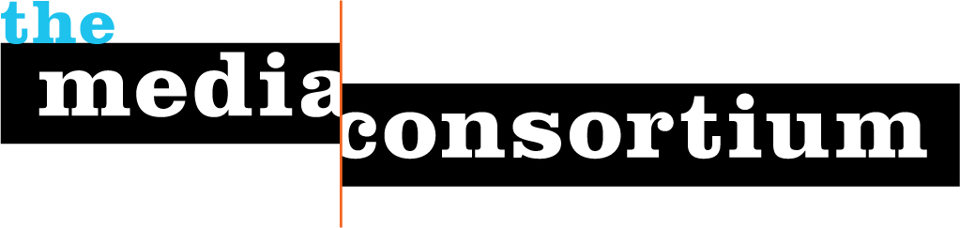
New 2009 Projects
*For information on the 2008/2009 GameChangers and MediaWire projects, please see separate documents in this packet.
Getting our Future Journalists Started
The right has been investing time and money in their future leaders for years--and the results are the likes of Bill O'Reilly, and many other, untold conservative reporters and pundits. If progressive media were to show the same initiative and dedication to developing talent, we could attract dedicated workers and visionaries from a young age, thus helping ensure the longevity of our respective organizations and foster the kinds of innovative thinking necessary to building a successful media sphere.
With the right initiative we could help develop the next generation of media leaders and journalists, specifically looking to focus on diversity, including women, people of color, and varying income backgrounds. As part of its strategy to build and diversify the media leadership pipeline in 2009, TMC is inititating a beta "journalism internship" project for its members.
What does the beta program look like?
- MC staff will place 12 interns with member organizations in 2009 (4 interns/quarter over 3 quarters)
- MC provides $2k stipend to intern
- Host organizations provide regular reports on intern performance
Next steps:
- Fine tune criteria participation for both TMC members and interns (see below)
- Create application process for both MC members and interns. Potential form would include: Experience, Aspirations, Relationship/Knowledge of independent media,
Sample criteria for interns and MC members:
Criteria for MC members
All organizations participating in this project must be able to provide the following:
- Provide intern with fact-checking/reporting duties on a weekly basis.
- Give intern one to two major reporting or editorial projects to complete during internship.
- Organize Bi-monthly check-ins b/w intern and top editors/reporters to discuss skills and project development.
- Final written and one-on-one assessment of intern at end of internship program.
- Work with MC staff to develop next iteration of internship program.
Criteria for Interns
- Must be able to work at least four, eight-hour days a week
- Interns create/write monthly "experience" reports to MC
- Interns will be recruited with the utmost attention to economic, geographic, gender and ethnic diversity.
For more information or to help with the next stages of development and launch, contact Tracy Van Slyke at tracy@themediaconsortium.com.
Making the Media Darlings
What is a media darling? Rachel Maddow. Amy Goodmn. Josh Marshall. Arianna Huffington. In addition to their amazing talents, these individuals have broken through the mainstream media system due to the support and platforms provided by progressive media outlets and allies. As public faces of the progressive media they have helped to coalesce, diversify, and legitimize progressive media analysis and journalism to a broader audience. It's our long-term strategy to help our members support and launch the high-impact journalists of today and tomorrow.
If we want to make the media darlings, we need to put in the effort to promote, publicize, and connect them to establishment media, additional progressive media, targeted audiences, and allies--even unlikely ones. These journalists can act as bridges to targeted, diverse audiences for individual outlets and the sector as a whole.
The Media Consortium will help create and implement a plan that embraces traditional and innovative communication strategies to actively push out and brand these journalists as critical voices in today and tomorrow's democracy. Overarching goals include:
- Make the next generation of media darlings.
- Create a sustainable and scalable program to increase the influence and impact of the reporting/analysis of a diverse set of progressive journalists (and media outlets) on the political and public dialogue by undertaking concentrated efforts to increase their presence on MSM, reach new targeted audiences and employing new media/journalism tools.
- Legitimize and expand the overall audience of the progressive media to new and established audiences.
2009 Plan
Launch a beta program focused on 4-5 individuals over the next 8-10 months. This test run will give us a chance to refine a high-impact program using ready-to-be established personalities that are already affiliated with MC members. The beta program will be organized around one issue (i.e. economy) and participants will be recruited with special attention paid to diversity. The beta run will allow us to track impact, focus on one issue as baseline for a more comprehensive program in the future, and adjust/evaluate as needed.
Project Details Include:
- Hire a Part or Full-time booker for Mainstrea Media placement
- Media Trainings for journalists
- Identify beats/regions to impact
- Pitch/Promote to targeted audiences via online and offline events
- Work on getting weekly radio/television spots in targeted markets
- Partner with organizational allies who can help support, market, and promote media darlings
Networking/Support for MC Members
MC staff will continue to build out networking opportunities for MC members, including small group work and potential retreats related to communications, collaborations around coverage, and possibly fundraising. Staff will also continue to organized two annual meetings and manage the listserv.
Ongoing MC member promotion and partnership development
In 2009, The Media Consortium will continue brokering relationships that can feed news stories to its members as well as promote progressive media institutions at key events and to key audiences. These efforts include:
Editor's Tip Sheet: The Media Consortium has created a weekly "tip sheet" form to be distributed on a weekly basis to an approved list of organizations and individuals. This tip sheet will help feed stories and information to MC reporters and editors that will help them break stories around specific issues/events, identify future trends around specific issues and build their database of sources and contacts.
Conferences: The Media Consortium will continue its efforts to identify opportunities for progressive media organizations to showcase, discuss and promote their organizations and journalism at political and media conferences throughout the year.
Other promotion opportunities include brokering relationships between progressive media and non-profits, funders, political leaders and like-minded organizations using the progressive media impact presentation and editor/reporter database.

