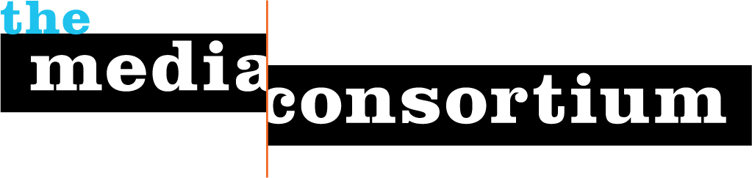

Contact: Erin Polgreen
Erin@themediaconsortium.com
312.841.0553
www.themediaconsortium.org

Connect your community to the latest headlines from independent media
The Media Consortium has created an easy web 2.0 toolkit to connect your audience to news and information on the issues they care about. We believe that the more people have access to strong, independent reporting, the more we can positively impact the public and political dialogue. This project is highly beneficial to organizations looking to inform, engage and activate their constituencies.
Our tools are free and can provide your community with up-to-date news and opinion on the economy, healthcare, immigration and sustainability/environment from the country’s leading independent media outlets, including Mother Jones, New America Media, LinkTV, Air America, Wiretap and Democracy Now.
Quality Reporting + Your Organization = Informed and Active Communities.





How you can benefit:
1) Access the best independent reporting and opinion in the country at these one-stop shops:

- Economy.NewsLadder.net
- Healthcare.NewsLadder.net
- Immigration.NewsLadder.net
- Sustain.NewsLadder.net

Sign up for an account at http://newsladder.net/register to join the NewsLadder community and post/share your organization’s latest news. Encourage your readers to vote on their favorite articles.
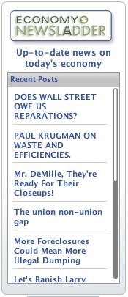
2) Publish the blogs: The MC’s weekly blogs round up the best and most interesting journalism by leading independent media and are free for anyone who wants to post. The Weekly Audit (economy) is published on Tuesdays, The Weekly Pulse (healthcare) on Wednesdays, and The Weekly Immigration Wire on Thursdays. View sample blogs at http://is.gd/t1yW, then contact us to join the blog email list to receive the fully coded blogs.
3.) Post the Widgets: It’s simple to host the latest news and headlines on your website. Widgets are available for: economy, healthcare, immigration, sustain and top political news. (Sample widget on right) For instructions and coding, visit: http://is.gd/kQzZ. We can also customize a widget for you! We can help design and distribute a widget to help get the word out about a campaign or cause.

4.) Host XML/RSS feeds: RSS feeds are a great way to offer the latest news without disrupting the look and feel of your site. To see a sample of the feeds in action, visit the following link: http://is.gd/t1DQ. The feed is in the middle, under the heading "news and opinion."
5.) Follow us on Twitter: @Economynewsladr, @Healthcareladr, @Immigrationladr and @Sustainnewsladr.

