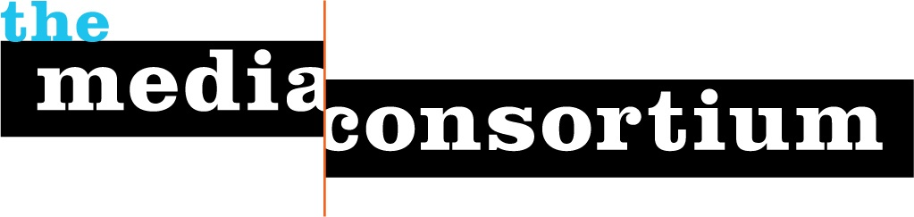
Submitted by The Media Consortium, a project of the Foundation for National Progress
Date: December 15, 2010
To: Instructional Telecommunications Foundation
Re: Letter of Intent
The Media Consortium is pleased to submit a Letter of Intent for Zingr, a mobile application, to the Instructional Telecommunications Foundation. In October 2010, with the support of Chicago ITF, TMC brought over 50 journalists and hackers together in Chicago for the Independent Media Mobile Hackathon, which was dedicated to building prototype apps that merged news content delivery with community engagement, gaming mechanics, and fun. Over six prototype applications were developed at this event, and we are excited to be moving forward on Zingr, a top-placing prototype.
Zingr is a mobile web-based application that provides sassy, accurate, and well-sourced rebuttals to conservative talking points. Zingr represents a scalable opportunity for many progressive media organizations and allies to engage with and benefit from a wide array of progressive audiences. It also represents a smart entry point for engaging the next generation of young, tech-savvy progressives with leading issues of the day. Zingr is an excellent fit with ITF’s mission and goals of innovatively reaching and engaging the public around progressive issues and educating citizens through technology and media distribution. With the support of ITF and other funders, The Media Consortium and Zingr’s creators will pursue the in-depth research and development necessary to successfully launch this application.
Zingr: Soundbytes for Sound Arguments
Picture this: You’re at a family gathering and your uncle complains that illegal immigrants are stealing jobs—he even saw a piece about it on Fox News! It’s the heat of the moment–how can you quickly riposte? With Zingr, a rational (and hilarious) rebuttal is simple. Just whip out your phone, type in a query, and pull up a Zingr that includes links to reporting that supports the statement. For more Zingr in action, watch this video presentation of the Zingr prototype from the Independent Media Mobile Hackathon.
Zingr fulfills the progressive community’s need for smart, funny rebuttals to the tight, top-down messaging of the conservative movement. Even better, as a mobile web-based application, Zingr offers key tools for progressives wherever there’s a cellular signal, thus increasing the reach and potential impact of key issues. Brad Flora, founder of the Windy Citizen, Knight News Challenge and a judge at the hackathon, loved the prototype and dubbed it “a practical field guide for progressives.”
For the last decade, conservative messaging guru Frank Luntz has set a top-down agenda with yearly “playbooks” and frequent memos that dictate careful, near-Orwellian use of language. Republican party and the right-wing media, including Fox News, follow it slavishly. In the meantime, progressives have spent the last ten years bemoaning their lack of a corollary system.
Yet, a top-down approach doesn’t sit quite right with progressive values. We want to be able to voice many opinions and create consensus around a sound, meaningful argument, not regurgitate a slick, manipulative soundbyte. Zingr neatly sidesteps this game by tapping into the wisdom of the crowd, then letting the smartest, savviest, and overall best messaging bubble to the top.
The application offers a fresh approach and new modes of engagement with progressive issues. First, the joy of the Zinger, a one-liner that packs a punch. A great “Zingr” condenses an entire, well-reasoned argument into a pithy, humorous sentence. Need an example? Think “Ginger Rogers did everything Fred Astaire did, but backwards and in high heels”—as a handy metaphor for the ways in which women are hindered by diffuse sexist forces and a reminder that women’s continuing success in the face of these odds is remarkable. Secondly, via gaming mechanics and other community engagement strategy, Zingr is a platform that will keep users coming back for more. Furthermore, all Zingrs will be sourced by existing content from progressive media and allies to provide context and nuance to back up and further conversation.
Seeking a Sustainable Model—and Sharing it with Others
Zingr represents a new opportunity for independent media—and mobile apps that generate revenue are uncharted territory for the sector. To successfully develop Zingr, we need to extensively investigate potential business models and promotional opportunities for the app, including sponsored Zingrs, advertising, community-based funding and more. We are quite intrigued by the possibilities inherent in sponsored content, in which advocacy media, advocacy groups, and interest organizations such as unions could develop Zingr verticals around various topics.
ITF’s support would allow TMC to conduct in-depth research in the first half of 2011 to move Zingr from prototype to a tool that is in development and has a smart business and launch plan. TMC would be able to accomplish work on three key fronts:
- Develop a solid business plan for Zingr that taps into the emerging application economy of the mobile web.
- Conduct additional research into audience development and delineate the roles of media organizations within the app
- Further develop the Zingr prototype to present to future investors and stakeholders
Findings from each of these three areas would also be made available to other TMC member organizations to assist in their efforts to diversify revenue streams, expand their audiences, and move into mobile. As the technological landscape continues to change, it will be vital for media organizations to have ongoing access to these kinds of peer-to-peer findings and experiences. This kind of research and shared best practices will be of vital importance.
TMC is the ideal launch manager for the Zingr application. Not only do we have key connections with progressive media institutions, we know how to build lasting collaborative infrastructure that supports ongoing development of programs and platforms. TMC will work with Zingr’s developers to create a sustainable business model for the application, identify target audiences and partners, research the legal requirements for the platform, and further strategize how Zingr can work with progressive, independent media organizations to increase the reach of their work and reporting. TMC staff have also have built up a network of mobile tech allies and potential advisers in the Chicago region, including lead staff at Chicago Android, the Metro Chicago Information Center and Syncubator, a hub for startup tech enterprises.
Key Stakeholders and Partners
The Media Consortium is a network of 50 leading independent media outlets that work in print, online, television, and radio. We support smart, powerful and passionate journalism that redefines American political and cultural debate. As millions of people are looking for powerful and accurate journalism, TMC has created a solid cooperative infrastructure that helps our members serve a 21st-century audience. Please visit www.themediaconsortium.org for a list of our current members.
Zingr’s creators and ongoing program advisors include Jessica Stites, Associate Editor of Ms. Magazine, Maya Schenwar, Executive Editor of Truthout, and Chicago-based mobile developer Marek Gibiec.
Big Door Media, a web startup from Seattle, WA, has made an in-kind donation ongoing technical support and access to Big Door's gamification API for Zingr’s future development.

