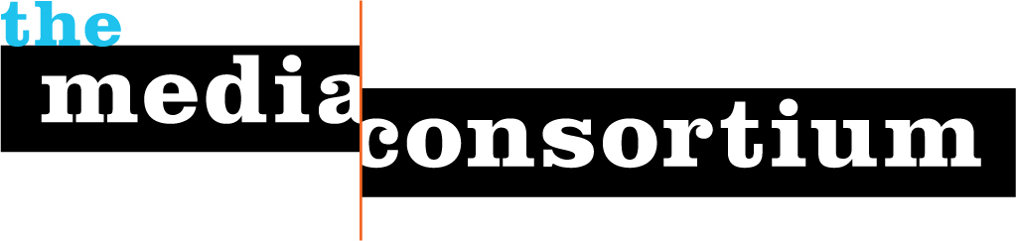

25 January 2008

Iris Krieg
Executive Director
Leo S. Guthman Fund
203 N Wabash Ave, Suite #1800
Chciago, IL 60601

Dear Ms. Krieg,

This letter is to confirm that the Foundation for National Progress has received the Leo S. Guthman Fund’s contribution of $5,000 to The Media Consortium’s Live from Main Street project via your check #5913 dated 1 November 2007.

On behalf of The Media Consortium, I thank you.

Sincerely,
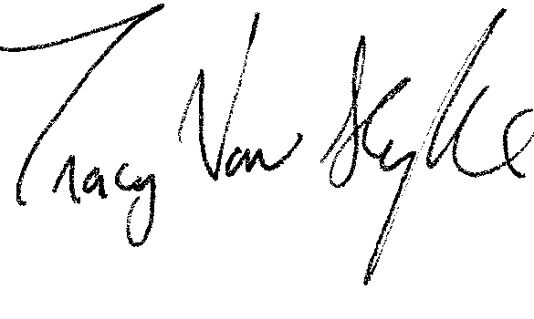
Tracy Van Slyke
Project Director/The Media Consortium

