Lobbying Expenditure Certification

The Arca Foundation does not earmark grant funds to be used to influence legislation. However, grantees of the Arca Foundation may use grant funds for advocacy efforts, including direct and grassroots lobbying activities, if they elect to do so. In such a case, a project-specific grant may not exceed the amount budgeted by the grantee for non-lobbying project expenses for the year of the grant. In order to satisfy IRS requirements applicable to private foundations, a grantee officer must certify the amount of the project that has been budgeted for lobbying activities. Alternatively, the grantee may provide a statement that it does not intend to use any project funds for lobbying activities.

Total project budget for the year of the grant: $_________________

Total amount budgeted for lobbying activities: $______________

Alternative statement:
No funds provided for the project are intended to be used to carry on propaganda or otherwise to attempt to influence legislation, including direct and grassroots lobbying communications as defined in §56-4911-2 of the Internal Revenue Regulations.

_TVS (officer initials)

Signature: _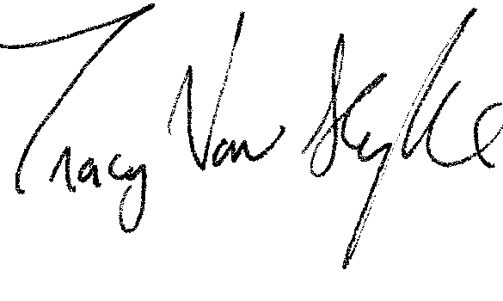____________ Date: _02/21/10____

Print Name: _Tracy Van Slyke_______________

Title: __Program Director_______________

