May 25, 2011

Herb Block Foundation
Encouraging Citizen Involvement
1730 M. Street NW Ste 901
Washington DC 20036

Dear Marcela Brane,

Thanks to social networking tools and portable devices, headline news is more abundant than ever. Yet, beyond the headlines, there are fewer and fewer entry points for citizens to understand and engage with complex issues that impact their lives—issues like the debt ceiling, the U.S.-Pakistan relationship, and the health care crisis. And if you don’t understand a problem, you are unlikely to get involved in solving it.

What we need are better ways to tell the story. And here’s the good news. A new generation of reporters is drawing on comic art forms (from editorial cartooning to graphic novels) and innovative interactive software to create a new kind of graphic journalism that makes the most difficult issues engaging and accessible. Highly portable across multiple platforms, technologies, and languages, the work of today’s graphic journalists can inform and activate millions of citizens.

Graphic journalists can’t work alone, however. They need media organizations to partner with them. A few media outlets, including the The New York Times, American Prospect and Truthout are beginning to experiment with graphic journalism, but most media organizations don’t know where to start. Realizing the full potential of graphic journalism requires building a new editorial infrastructure to incubate, produce, and distribute such work.

The Media Consortium, a nonprofit national network of independent media organizations including The Nation, Yes! Magazine, LinkTV, and AlterNet, is well-equipped to facilitate the building of such an infrastructure. Founded in 2006, The Media Consortium’s mission is to amplify independent media's voice in order to impact public discourse. We achieve this mission by fostering editorial collaborations and supporting innovation among our membership body. In the past year, The Media Consortium has successfully executed three innovation labs designed to help members engage their constituencies in the production and dissemination of news. We seek a grant of $25,000 from the Herb Block foundation for a four-month long Graphic Journalism Incubator.

The Graphic Journalism Lab will enable 5-7 media organizations to experiment with graphic journalism via hands-on trainings and a partnership with a graphics journalism fellow. Each organization will be required to produce at least 3 pieces designed to engage and empower citizens around policy issues during the grant period. The organizations will also be required to work jointly with Media Consortium staff to develop guidelines that can be used by other media organizations in working with graphic journalists in order to enable media to better inform, educate and involve citizens around pressing policy issues.

Anticipated Impact and Outcomes
- 15-21 new pieces of graphic journalism that will collectively reach over 3 million people
- Written guidelines to increase the capacity of news organizations to use graphic journalism
- Increased engagement of citizens in complex, data-driven news stories

Media Consortium members include both national and regional organizations from around the United States, and we will encourage outlets to produce a mixture of content that is designed to reach audiences on a local and national level.

The Media Consortium brings special expertise to this new field. Our Managing Director, Erin Polgreen, has written about graphic journalism and spoken about the emerging field at the National Conference for Media Reform and other venues. She has relationships with many of the best graphic journalists working today. Erin will manage this project, ensuring that content produced by the lab will be specifically designed to empower citizens to understand complex policy data so that they can better engage in the democratic process.

We are excited to report that a collective of graphic journalists, Graphic Journos, has agreed to be a strategic partner for this program. They will help craft trainings and partner with media outlets to produce content. We are also incredibly excited to count Cartoon Movement, an international publishing house for political comics and graphic journalism, as a partner and sponsor. Cartoon Movement will financially sponsor one fellow in the production of three works for this incubator. CM will also make content produced via this partnership available for international syndication, massively increasing its reach. The cash value of this partnership is $5,000 and the in-kind is at least another $5,000 of additional promotion and distribution assistance.

This project requires $30,000 to fully fund 7 organizations. We are requesting $25,000 from the Herb Block Foundation, and have $5000 in support committed from Cartoon Movement, in addition to in-kind support from both the Cartoon Movement and Graphic Journos. We are able to begin this lab as soon as we receive funding, with an anticipated start date of October 1, 2011. A copy of the Foundation for National Progress’ 501c3 letter is attached. I’ve also attached our operating budget and the FNP’s audited financial statement for 2009.

Thank you for the opportunity to submit a full proposal to the Herb Block Foundation.

Sincerely,
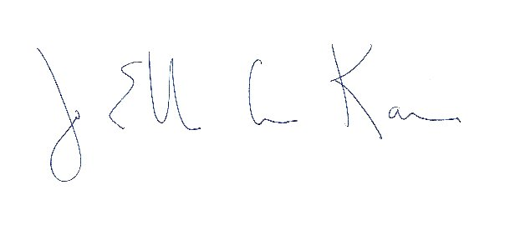
Jo Ellen Green Kaiser
Executive Director, The Media Consortium
joellen@themediaconsortium.com

