,
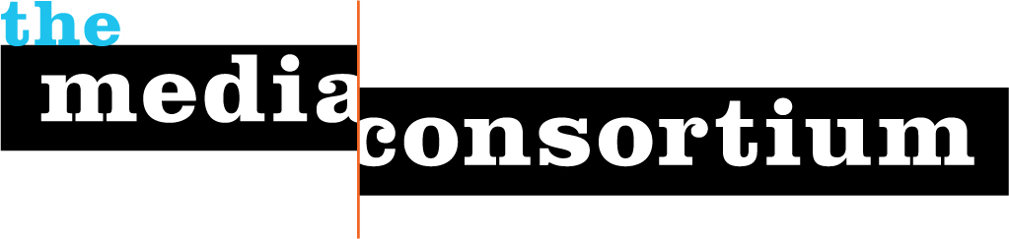
LOI: Media Policy Reporting and Education Project

For: The Media Consortium, a Project of the Foundation for National Progress

Date: September 1, 2011

To: The Funding Exchange

By: Jo Ellen Green Kaiser, Executive Director, The Media Consortium

415-878-3862 / joellen@themediaconsortium.com

Democracy depends on public access to information, which in our society is delivered primarily through the media. The digital revolution promised that media would become more open and accessible; instead, even as information technologies have proliferated, an increasingly unequal distribution of wealth, monopolistic corporate interests, and poor policy decisions have combined to threaten the public’s access to information.

To preserve the free and open flow of information, members of the public must advocate for a more just media policy that fosters community and engages citizens. Net neutrality, universal broadband access, low-power FM licenses, and anti-trust measures against media consolidation are just some of the policies that can ensure the public has access to the free flow of information. The Center for Media Justice works at the grasrroots level through its Media Action Grassroots Network (MAG-Net)to ensure that these progressive policies are adopted and enforced. In 2012, MAG-Net will focus their activism on XXXX.

Activists need media coverage to amplify their work—media coverage enables activists to reach new audiences, inform and educate citizens, and build momentum for a more just media policy. However, activists working on the local level often do not have the know-how to translate their technical expertise into easily comprehensible soundbites, or the communications training to bring the stories of their community to media attention. Meanwhile, journalists in the media policy arena often lack a deep understanding of media policy and don’t know how to translate media policy issues to the local level. In short, organizers need to learn how to work with media to amplify their message; journalists need to learn how to work with organizers to produce stories that will inform and engage the public.

A The independent press will get these stories out. Independent media outlets care deeply about access and media policy, because media policy impacts how well they are able to transmit their content and connect with their audiences; when media policy supports corporate interests, independent publishers and producers can be left in the dark. The organizing work of the Prometheus Radio Project around low power FM station licensing illustrates that independent media outlets can have a significant impact.

To make that impact, independent media outlets require support. Such outlets lack the resources to pay for a media policy “beat,” and their reporters can not always keep up with the highly technical nature of the field.
To respond to this need, The Media Consortium launched its Media Policy Reporting and Education Pilot Project (MPREPP) in April 2011. Supported primarily by the Media Democracy Fund with additional funding from the Benton and the William Penn Foundations, this 4-month project enabled Media Consortium staff to educate reporters on media policy, from mobile regulation to the Universal Service Fund. It also provided seed money to independent media outlets to support the production of high-impact reporting on media policy. The aim was to increase the capacity of independent media to report on media policy issues and see if the project would raise media policy to a new level of public awareness by supporting quality reporting and efficient content delivery to a diverse set of constituencies.

The pilot program, just concluded, has been a success. The nine participating media outlets—AlterNet, New American Media, the New York Community Media Alliance, The G.W. Williams Center for Independent Journalism, Mother Jones, Truthout, GritTV, Feet in Two Worlds and Public News Service—have produced over 80 pieces on media policy, along with a biweekly roundup blog, “The Wavelength,” which put this work in context and presented an overarching narrative for media policy issues. These original researched and reported stories include the following highlights:

- Feet in 2 Worlds produced a segment for NPR’s The World on how young immigrants are using social media to organize around the DREAM Act.

- The G.W. Williams Center for Independent Journalism, in partnership with New America Media, published a two-part investigation into how Low Power TV stations provide vital services to ethnic communities—but are being given short shrift by the FCC.

- AlterNet is running a 5-part series on how corporate media consolidation has directly impacted citizens and consumers. The series is authored by former telecom industry insiders Bruce Kushnick and David Rosen.

The stories created for this pilot project have already created real change:

“Joseph Orozco of KIDE … contacted us about the low-power TV story, and [Wavelength blogger and author] Eric Arnold put him in touch with Ravi Kapur of KAXT-TV. Just the kind of connection a New America Media story should make.” –Paul Kleyman, Editor, New America Media.

The real promise of the Media Policy Reporting and Education Project has been the way it has helped build connections between independent media outlets and media policy experts. Every three weeks, TMC staff arranged content-rich conference calls for MPREPP participants with experts from organizations including Free Press, the New American Foundation, the Benton Foundation, Native Public Media, and the Center for Media Justice on a variety of issues.

The Media Consortium is requesting $25,000 to in order to launch the Media Policy Reporting and Education Project as a full-fledged program, to run through 2012. With media consolidation continuing, broadband and low-power FM access challenged, and new threats to net neutrality, this reporting program is needed more than ever.

One year MREP Budget:

Amount Requested: $125,000

Expenses:
Personnel Expense: $25,000 50% time associate to run program
(includes tax, benefits)
$10,000 Social Media Curator/blogger to push content out

Seed Money for Media $40,000 @$4K per text-based media outlet @10 outlets
$28,000 @$14K per video-based media outlet@2 outlets
$7,000 @$7K per radio-based media outlet @1 outlet

Experts for Calls 0 In-kind donation

Overhead $6,250 5% (will cover telephone/webinar expense)

Fiscal Sponsor Fee $8,750 7%

Total Expenses: $125,000

