

28 February 2008

Executive Director
The Arca Foundation
1308 19th Street, NW
Washington, DC 20036

To Whom It May Concern,

We’d like to thank the Arca Foundation for its $35,000 contribution to The Media Consortium in 2007. Arca’s support was integral to our success last year.

This is an important year for both the country and the progressive, independent media. The Media Consortium has several projects in the works that will, in the words of our mission statement:
“amplify our voices; increase our collective clout; leverage our current audiences and reach out to new ones; attract financial resources; strengthen and transform our individual businesses and our sector’s position in a rapidly changing media and political environment; and redefine ourselves and progressivism for a new century.”

On behalf of The Media Consortium and its 45 member organizations, we are requesting a grant of $50,000 to fund initiatives that will continue to build connections, strengthen the infrastructure and amplify the voices of progressive media outlets.

Thank you,

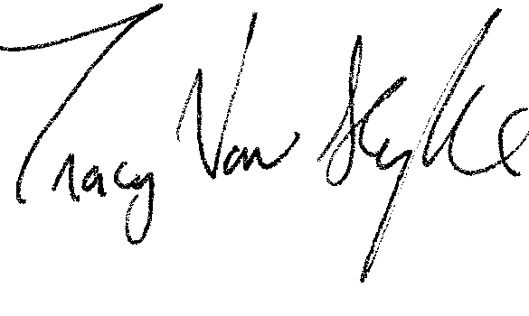
Tracy Van Slyke
Project Director/The Media Consortium
tracy@themediaconsortium.com/312-315-1127

