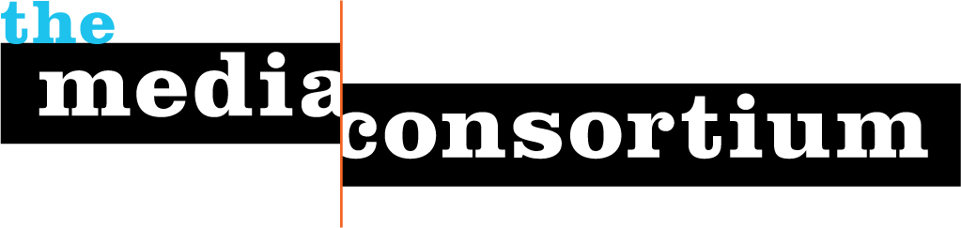
Diversity Statement 2014

The Media Consortium is committed to diversity among our members, among our staff, among our governance team, and within our projects

Diversity Policy
All members of the Media Consortium agree to adhere to the following set of core values in their organizational mission and day-to-day operations. The Media Consortium staff and governing bodies also commit to the below values in regards to recruiting staff, member organizations, and governing committee members.

- Member organizations are Equal Opportunity Employers who do not discriminate on the basis of race, gender, or sexuality.
- Member organizations promote social, racial, and economic justice; they commit to pursing these values as they apply to hiring practices, audience outreach, editorial policies, and ownership.

TMC membership is not extended to organizations that publish content that is counter to the core values of our organizational mission and vision.

Member Diversity

Total number of member outlets: 65
Member outlets organized around a race/ethnic lens 9 14%
Member outlets organized around a gender/sex lens 5 8%

Total number of member outlets: 65
Member outlets with a woman leader* 36 55%
Member outlets with a LGBT leader* n/a**
Member outlets with a person of color as a leader* 11 17%

*leader=executive director, publisher, president or editor-in-chief
** we don’t ask about the sexual identification of staff at member publications

Staff/Board Diversity

Total number of individuals on Coordinating Committee 9
Number of CC members who are women 5 55%
Number of CC members who are people of color 2 22%

