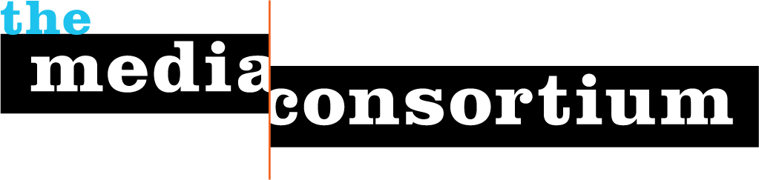
A Proposal for General Support
Submitted by: The Media Consortium,
a project of the Foundation for National Progress
Date: September 14, 2012
Contact: Jo Ellen Green Kaiser, Executive Director 415.878.3862 / joellen@themediaconsortium.com

In this election year, the need for independent media has never been more evident, as a flood of campaign money drowns out the journalistic values of accuracy and transparency.
Independent media outlets have responded. Outlets such as Colorlines, In These Times, Truthout, New America Media, and Free Speech Radio News tell stories that educate the public about the need for more equitable and just policies. Reporters like David Corn at Mother Jones, Allison Kilkenny at the Nation, Linda Jue at the G.W. Williams Center, and Laura Flanders at GRITtv, reveal the hypocrisy of bought-and-paid-for politicians. Outlets like Yes! magazine, Orion, LinkTV, Dissent, and Earth Island Journal propose new solutions for long-standing social problems.
These and the other 50+ members of the Media Consortium know, however, that they can’t fight this battle alone. They need to work together in order for their voices to be heard. That’s the role played by The Media Consortium.
The Media Consortium is a network of the country’s leading progressive independent media. Our mission is to support and grow the impact of the independent media sector. Our vision is to build a progressive infrastructure of independent media and advocacy organizations with real power to inform, educate and engage the public on matters of public policy. The Media Consortium accomplishes this mission and vision by fulfilling four strategic principles:
- Foster Collaboration and Coordination
- Build and Diversify Media Leadership
- Bring Money and Attention into the Sector
- Support Innovation in Journalism and Business Models
Since our founding in 2005, the Media Consortium has become the leading forum for building partnerships and collaborations among independent media outlets and external allies. In 2012 we tackled some of the country’s most pressing issues:

- Citizens United. We organized a collaborative effort (#campaigncash) to help independent outlets fight against this anti-democratic decision. This fall, we are working with Free Press and Common Cause to show how campaign cash is limiting citizen access to electoral news.
- Climate Change. The Media Consortium is working with Future 500 to report on the possible benefits of a carbon tax, and we’re planning a 2 year, multimedia investigation of fracking.
- Occupy. Since September 17, 2011, the Media Consortium has supported this grassroots movement by organizing weekly briefing calls between the press and Occupiers. On May Day 2012, we produced a 32-outlet collaboration to tell the real story about the May Day protests. With over 25,000 views just on our pop-up website, a CNBC interview, and mentions by over 65 outlets, we became the official news source for the day.

In 2013, we plan to build on these projects to pursue three core objectives closely related to our strategic principles:

- Foster Multimedia Collaboration
- Give Voice to the Grassroots
- Create Network of Networks

These efforts are all designed to amplify the impact of progressive media coverage and to drive progressive voices into the mainstream.

I. Who is the Media Consortium?

The Media Consortium is a national network of 59 independent progressive news media outlets. Our current members are:

AlterNet | Globalvision | Orion
American Forum | GregPalast.com | The Progressive
The American Independent News Network | GritTV | Public Eye/ PRA
The American Prospect | Grist | Public News Service
Berrett-Koehler Publishers | The G.W. Williams Center | Rabble.ca
Brave New Films | The Hightower Lowdown | Race, Poverty and Environment
Campus Progress | Interpress Service | The Real News Network
Care2 | In These Times | RH Reality Check
Change.org | LA Progressive | Specialty Studios
The Chicago Reporter | Link TV | The Texas Observer
Chelsea Green | Mother Jones | The Thom Hartmann Show
City Limits | Ms. Magazine | Truthout
Colorlines | NAMAC | Truthdig
The David Pakman Show | The Nation | The Uptake
Dissent | The Nation Institute | Utne
Earth Island Journal | National Radio Project/Making Contact | Washington Monthly
Feet in 2 Worlds | New America Media | Women’s Media Center
Feministing | The New Press | Yes! Magazine
Free Speech Radio News | News Taco | The Young Turks
Free Speech TV | Oakland Local

The Media Consortium prizes diversity, and continues to seek outlets as members that serve the needs of the entire progressive community. New members in 2012 include: LA Progressive, GregPalast.com, Dissent, News Taco, and the Public Eye.

Support
The Media Consortium runs an array of programs to support our members. We focus on providing members with opportunities for face-to-face and digital interaction.

- Member Meetings. We host an annual meeting for our members each year—in 2013, the annual meeting will be held on February 6-8 in Baltimore. We also organize regional meetings to create ongoing interpersonal relationships between member organizations. In 2012, we held regional meetings in Denver, San Francisco, Providence (at Netroots Nation), New York, and Chicago.
- Monthly Newsletter. Each month, the TMC staff puts out a newsletter summing up our projects and giving members a heads-up about new initiatives, in addition to maintaining an on open listserv for member comments.
- Google Groups. In addition to the TMC listserv, TMC has set up a listserv just for social media staff at member outlets so they can better publicize each other’s content. We also run separate google groups for each editorial collaboration.
- Social Media Curator. We have hired a part-time social media curator, Debi Mason, to tweet and facebook member content daily. Our handle, @tmcmedia, now has close to 2500 followers. It serves as an important resource for media watchers, and a tool to encourage members to crosspromote their content.
- Innovation and Incubation Labs. The labs take an in-depth dive into a business or technology problem. Our 2012 lab focuses on long form journalism, with a series of guest lectures by experts including Prof. Hayasaki of UC Irvine, Richard Tofel of ProPublica, and staff from the Atavist. 2013 will feature the Metric Impact Lab (discussed below) and an Advanced Mobile Lab (in partnership with sister organization, INN).
- “How it Works” Monthly Webinars. These monthly webinars around editorial strategy and technology innovations supplement the in-depth work we do in editorial collaborations and Innovation and Incubation labs. Webinar topics in 2012 included Open Source HTML for Interactive Maps, IRS Rules for Nonprofits, Introduction to HTML5, The Future of Facebook, What is NewsJunkie, How to Conduct a GoogleLess Search, and Donor Development.
- Collaborative Fundraiser. In 2012, the Media Consortium launched what will become our annual Support Your Media Day fundraiser on Razoo.com. On this one day, each media outlet promotes this joint fundraiser to their donors. On our first Support Your Media day, 23 member outlets participated. Fourteen outlets met their fundraising goals for the day, as 1,408 unique donors gave $69,925. Of these, 279 donors or more than 20% gave to more than one outlet. The Media Consortium itself raised $1,885 from 291 donors who gave us a “tip” after giving to their favorite outlet.

We run as many programs as organizations twice our size. Much of what we do, however, is behind the scenes. Here are just a few examples:

- When the Young Turks realized they were short a DNC press pass for their camera operator, they came to us. We connected them with LinkTV, which had an extra pass. That made possible the coverage you can see here: http://tinyurl.com/9vlc6nj.
- Berrett-Koehler’s publisher came to our annual conference looking for ideas—he came away with This Changes Everything! the very first book on Occupy (written by the editor of Yes! magazine).
- Both Free Speech Radio News and the American Prospect faced serious cash shortfalls this summer. The Media Consortium network came through for them, crosspromoting their story via twitter and facebook and, in several case, actually asking their own donors to give to these two organizations. Both survive.

When asked to name the main benefit of being a Consortium member, respondents answered it was the opportunity to network with each other. Media Consortium staff provide the infrastructure that supports those powerful relationships.

Grow
Every member of the Media Consortium has joined because they want to grow their own impact and the impact of the entire sector. We know that we are stronger together. To that end, the Media Consortium organizes collaborations that change the how the American public understands the world. A great example of our impact in 2012 was our May Day collaboration.

May Day 2012
Since the Occupations began, corporate media had not covered Occupy adequately or fairly. That’s why, when Occupiers, unionizers, and immigrant rights workers declared they were organizing May Day protests, the Media Consortium mobilized 32 of our outlets to cover the story. Working together, our outlets put together an interactive map that would highlight every single May Day protest, along with accompanying stories. Our goal was to demonstrate how widespread these actions were, and how much the issues of the day were middle class, mainstream issues.

On May Day itself, Free Speech TV provided 4 hours of live coverage, interviewing TMC reporters across the country. That video feed, along with the interactive map and a storify blog pulling in tweets from TMC reporters, were available for viewing or download on our pop-up website, www.mediaforthe99percent.org (see Appendix B).

This coverage worked. Reuters began the day dismissing the May Day protests as “a dud.” By midday, they were reporting on the broad extent of the protests. Fox News and Red State Blog began the day by covering the Ohio bridge bombing story, suggesting that all Occupiers were terrorists. By midday, coverage had changed to show Occupiers as “regular” folks—as picnickers in Poughkeepsie and families in Phoenix. Our coverage was picked up by 65 outlets; TMC director Jo Ellen Kaiser was interviewed by CNBC.com; and the popup site got over 25,000 hits—which in turn was a mere fraction of the total hits from all sites carrying the content. (A report on May Day 2012 is available)

May Day 2012 took an extraordinary effort, but proved that when we work together as a network, we can change the national conversation.

II. Next Steps

Our successes this year have led to our next steps. Our objectives are to foster multimedia collaboration, give voice to the grassroots, and build networks of networks.

Foster Multimedia Collaboration

In 2012, the Media Consortium successfully implemented an infrastructure for editorial collaboration across our own internal network (see Appendix A). Our next step is to leverage the diversity of our members’ platforms and audiences to create more impact.

A Multimedia Strategy—a Progressive Topic: Fracking
In 2013, we will create a truly multimedia project around fracking. We chose fracking because we know that natural gas is not the cheap solution to our energy problem—its costs are measured in harm to the water supply, the air, and human health. Both Republicans and Democrats have embraced fracking, however, and Big Oil is pumping dollars into its promotion. We need progressive independent media to tell the American public what is truly at stake if we begin to rely on natural gas.

Partners in this collaboration include Earth Island Journal (print/digital), Truthout (digital only), Making Contact (radio), Link TV (TV), Specialty Studios (film), Chelsea Green (books) and Care2 (the petition site). Together, they reach over 55 million Americans.

The value of the collaboration is not just this large additive reach, but what we believe will be an exponential impact. Usually, a media outlet will publish on just one media platform (a magazine article, a blog, a video) that reaches just one type of audience. The idea behind this collaboration is to tell the truth about fracking via stories that cross many different media platforms, reach different audiences, and roll out over a period of several years.

Partners will share content, so that Earth Island Journal will feature a video from LinkTV; LinkTV will feature audio from Making Contact’s radio show; Making Contact will invite a reporter from Truthout on their show; Truthout will publish a petition from Care2; and so forth. Working together, they will engage audiences in a way they could not do on their own. The ultimate goal is to change public discourse about the value of fracking.

We have requested funding for this project from the Park Foundation, 11th Hour, and the Fledgling Fund. The collaboration will also be wrapped into our Metrics Lab and our Media Policy Project.

Measuring Impact

The goal of large-scale social media collaborations like May Day 2012 and multimedia collaborations like the Natural Gas Group is to create a greater impact on public discourse than any outlet could manage on its own. Impact means much more than simply reaching an audience—a story with impact leads an audience to a new understanding of their world, and, if very successful, engages that audience to act upon their new understanding.

Up until now, media organizations have had no way of quantifying impact. This year, thanks to the generous assistance of John Schwartz, the Media Consortium has embarked upon an 18-month experiment to develop tools to measure this impact. During this period, Harvard Professor and Crimson Hexagon founder Gary King will use his cutting-edge lab to track Media Consortium members’ memes through digital space. His goal is to develop tools to measure how much our stories change prevailing memes, and to ascertain whether and how our editorial collaborations build impact.

The Metrics Lab includes funding from the Deutsch Foundation, two major donors who prefer to remain anonymous, and the EBS companies. Funding will underwrite the cost of the research as well as provide mini-grants to Media Consortium members to incentivize their participation. These mini-grants—which must be for collaborative activity—will be deployed in conjunction with the Media Consortium’s Natural Gas and Media Policy Projects. (The proposal outlining the purpose and goals of the Metrics Lab is available).

Benchmarks for Collaboration:
- Implement the metrics project: develop a tool for measuring impact; create a full report by December 2014.
- Implement the natural gas multimedia project: produce a special issue of Earth Island Journal; three radio shows; two TV shows; several short “viral-style” videos; and a book. Via these media, create a shift in public discourse around fracking, measurable via the metrics tools the Consortium is developing.
- Experiment with at least one more large-scale breaking-news social media-driven collaboration like May Day 2012; evaluate different social media tools.

Give Voice to the Grassroots
In 2011, the Media Consortium conducted an Innovation and Incubation lab to experiment with crowd-sourced reporting. The lab led us to realize that we were missing an opportunity to develop stories that originate with the community, rather than with our outlets.

In response, the Media Consortium plans to establish a Community Journalism Training Institute. The CJTI will focus first on volunteers with advocacy organizations. These volunteers already act as witnesses—as activist eyes and ears--at legislative and court hearings. CJTI will teach these progressive activists how to see the world as a journalist and how to use the tools they already possess (cell phone, camera) to make professional quality recordings of their stories. Trainings will be in-person, and will feature journalists from Media Consortium outlets as well as professional trainers.

CJTI fulfills several of the Media Consortium’s key strategic principles.
- Build and Diversify Media Leadership. Our efforts with Occupy demonstrated to us the opportunity to develop media leaders among community members.
- Bring Attention to the Sector. There is no better way to engage the public in independent media, or to educate the public about current issues than to ask the public to see the world like a journalist.
- Support the Independent Media Sector. As local independent newspapers, radio stations, and TV stations disappear, journalists no longer have access to the beat reporters that used to provide local news. They need the kind of access to local news that increasingly only community members can provide.

The benefits of the CJTI will be:

- Empower community members to tell their own stories
- Support advocacy organizations by training their volunteers
- Provide advocacy organizations with a rich fund of stories to support their efforts, all told by their own volunteer activists
- Provide reporters with local sources for local stories
- Support independent media by developing an audience for their work among advocacy organizations and activists

Additionally, the Media Consortium aims to construct this program to provide external revenue for the Media Consortium to make us less reliant on general support funding. Planning for CJTI is underway, and a pilot project will launch this fall.

Benchmarks for CJTI:

- Prepare and vet a business plan
- Create a series of pilots to test the plan
- Roll out CJTI in 1-2 urban areas in 2013, training 200 community journalists

Create a Network of Networks

The Media Consortium’s most ambitious goal for 2013 is to begin creating a network of networks. As former TMC Director Tracy van Slyke argued in Beyond the Echo Chamber, the key to amplifying progressive voices is not to create an echo chamber but to create a network-powered media. To build a progressive movement, we must harness together the research of policy think tanks, the people power of advocacy organizations, and the storytelling power of media (see Appendix D).

The Media Consortium is uniquely placed to create a network of networks. Unlike any other U.S. media organization, the Media Consortium is not a trade association—we are fundamentally mission-driven to leverage the collective power of our members to impact public discourse.

Networking with Activists I: MPREP
In 2011, the Media Consortium launched the Media Policy Reporting and Education Project. Funded by the Media Democracy Fund, the aim of this project is to inform, educate and engage the public about media policy by recruiting and training a corps of reporters to write a significant number of media policy stories.

Now in its second year, this project is a proven success. Fifteen journalists have been trained in the media policy beat. Over 130 stories have been produced. The briefings created by Media Consortium staff as part of this project have been attended by a wide array of journalists, including several from sister organization AAN. A list of the 2012 briefings can be found in Appendix C.

As part of this project, Media Consortium staff created a roundtable of media policy experts from 11 different organizations. As trust grew between these experts and TMC staff, they began providing embargoed materials and consulting with us about media rollouts. We had created a new network.

Our grant proposal to MDF for 2013 is based on building this network out from media policy experts to policy advocates in other fields. We have proposed focusing our media policy reporting on three non-media policy issues, in order to bring together media policy advocates, issue advocates, and independent media. These issues are campaign cash, criminal justice, and environmental justice.

This fall, we have already begun working closely with Free Press and Common Cause to track the media policy implications of the Citizens United ruling. The Media Consortium has worked with both these organizations before, but this is the first time these advocacy organizations have worked with each other. It’s a first step towards building a larger network.

Networking with Activists II: Occupy
The Occupy movement blew the top off politics as we know it for a few short months in 2011. Suddenly, student debt, home foreclosures, and the economy–real policy issues, affecting real people--took center stage. The Media Consortium leapt into action, setting up a weekly briefing call every Thursday so that members of Occupations around the country could inform the media about their actions. And on May Day 2012, the Consortium created the most intense one-day coverage ever of Occupy through our pop-up site, www.mediaforthe99percent.org

The Media Consortium and its members gained the trust of Occupiers because we also are non-partisan, independent, and seek positive, progressive change. As Occupy transformed from physical encampments to working groups, Media Consortium members stayed with the story. It was Occupiers, with their livestream feeds and twitter updates that prompted the Media Consortium to first begin thinking about setting up a Community Journalism Training Institute. Our ability to work with Occupiers has demonstrated that not only can we, but we must, work with activists in the community as well as with established advocacy and policy organizations if we are to embrace real change.

Networking with Other Media Associations
As the news economy has collapsed, news associations have proliferated—every outlet seeks support as we go through this time of turmoil in the sector. Following this boom, a period of consolidation is likely.

The Media Consortium differs from the other news organizations because we are not a trade association—we are mission-focused on creating progressive infrastructure. That mission gives us all the more reason to find ways to partner with these organizations in our sector. What follows is a brief list of partnerships the Media Consortium is currently pursuing:

- Technology and Business Training. Media Consortium members need to update their skills to keep up with a wildly changing innovation sector. While our mission includes supporting the sector, too much focus on training takes away from our collaborative work. So we have turned to our colleagues at the Investigative News Network to pursue joint trainings, and we encourage our members to become members of the Online News Association.
- Community Journalism Training. As the Media Consortium launches CJTI, we have begun talks with our colleagues at the Alliance for Community Media and the National Federation of Community Broadcasters –trade associations for community TV and radio stations-- about providing advanced training to community journalists who may wish to start their own radio or TV programs. Such advanced training will probably phase into the Institute’s work in 2015.
- Editorial Collaborations—the Local Story. Many Media Consortium collaborations would benefit from a local angle. We have begun talks with the Alliance for Community Media, the National Federation of Community Broadcasters, and the Association of Alternative Newsmedia about participating in our collaborations. We look forward to having the same discussions with LION, the new association for hyperlocal news websites.

Benchmarks for Network of Networks
- Continue with core Media Consortium support: hold an annual meeting February 5-8 in Baltimore; put on the annual Support Your Media fundraiser on March 5; create a new Innovation and Incubation lab around mobile; put on monthly “how it works” webinars.
- Implement the new Media Policy Project: Organize advocacy, media policy, and media outlets around the areas of campaign finance reform, environmental justice and criminal justice; put out twenty media policy stories in each area, for a total of 60 media policy pieces.
- Build new alliances with advocacy and policy organizations
- Create joint programs with other media associations.

Conclusion

At a time when our country is facing serious challenges, independent media are committed to working together to inform, educate and engage the public to make real change. The Media Consortium plays a key role in this independent media sector, providing the infrastructure necessary to promote collaboration and increase impact.

In 2013, our media policy project, natural gas collaboration, metrics lab and community journalism training institute will enable us to develop our mission to support and grow the impact of our sector. We seek a general support grant of $30,000 from the Wallace Global Fund to power the invisible work that makes those other projects possible—the behind the scenes efforts of our staff to link networks to networks, to grow the progressive infrastructure.
Appendix A
What’s Necessary for Editorial Collaboration: An Infrastructure Map

This infrastructure was implemented for TMC editorial collaborations in 2012.

Networking Infrastructure
- A dedicated listserv for participants in a collaboration to share story ideas and breaking news
- Regular conference calls with participants and allies to share information and plan next steps
- Sharing editorial calendars so that stories can be timed for greatest impact

Content-Provision Infrastructure
- A series of conference calls/webinars with experts/sources for collaborative stories
- Partnerships between members on different platforms in order to multiply audiences
- Seed money to fund content creation, with amounts based on the different expenses of different platforms (i.e. digital, print, radio, video)

Marketing Infrastructure
- A listserv for social media curators at all member outlets to push collaborative stories out
- A TMC-based social media curator to tweet, fb, etc. the content of collaborative stories
- When appropriate, a dedicated Tumblr blog to aggregate the collaborative content
- When appropriate, a topic-driven url to bring together the Tumblr, twitter/fb feeds, and headline widgets
- A professional publicist to set up mainstream media interviews (if news is breaking)
- Intense networking with allies to bring content to the attention of advocacy organizations

Evaluation Infrastructure
- Insert a pixel ping into all stories so TMC can directly track metrics related to those stories
- TMC social media curator uses a social media dashboard in order to track social media metrics
- Publicist maintains file of all media interviews including audience numbers if available
- Qualitative evaluation surveys given to participants at end of a collaboration

Key Infrastructure Requirement:
- Dedicated TMC staffer to create and manage collaboration infrastructure
Appendix B
May Day 2012 Website
www.mediaforthe99percent.com

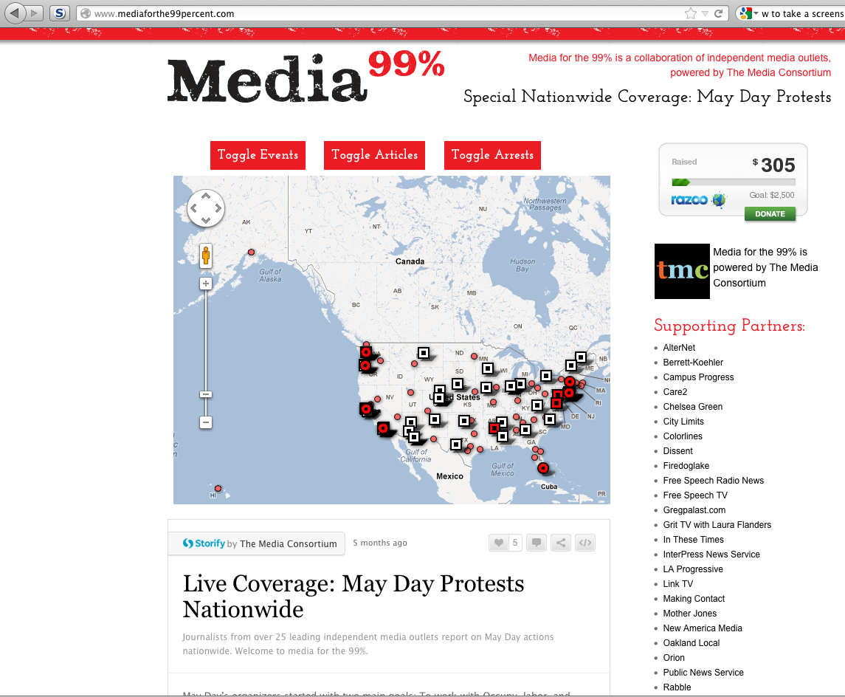
Appendix C
Media Policy Reporting and Education Project Briefings

DATE | TOPIC | PRIMARY SPEAKER | SECOND SPEAKER
1/10/12 | SOPA/PIPA | Josh Levy, Free Press
3/7/12 | Broadcast TV Disclosure | Corie Wright, Free Press | Andy Schwartzman, Media Access
3/29/12 | Verizon/cable deal | Parul Desai, Consumers Union | Edyael Casperalta
4/11/12 | LPFM sale | Brandy Doyle, Prometheus | Luis Avila, El Break Radio
April | CISPA | Rebecca Jeschke, EFF | Josh Levy, Free Press
5/7/12 | Prison Phone Monopolies | Amalia Deloney, Center Media Justice | Lee Petro, Biddle
7/2/12 | Internet Freedom | Josh Levy, Free Press
7/25/12 | Mobile Data Caps
  Michael Weinberg, Public Knowledge
8/15/12 | Warrantless Searches | Hanni Fakhoury, EFF | Lieutenant Raymond E. Foster, LAPD
9/11/12 | Broadcast TV Disclosure | Tim Karr, Free Press

Appendix D
Developing a Theory of Change for a Network of Networks

TMC staff are in the process of developing a theory of change to describe how journalists can best work with advocacy and policy organizations to impact public discourse while remaining true to journalistic values. The slide below is oversimplified, but shows the direction in which we are moving.

The idea is that progressive infrastructure starts with the grassroots. Advocacy organizations responding to grassroots concerns research issues then develop policies to solve those issues. They report on their research and their proposed policies to journalists. Journalists independently evaluate the organization’s research, proposed policies, and framing of the issue, then produce their own stories. Advocacy organizations then promote those stories to create change. The critical elements of this model are:

1) transparency—the exchange of information between NGOs and journalists is public and open.
2) accuracy—journalists are charged with ensuring accuracy of material, no matter what the source.
3) independence—every party is free to participate or not, to publish or not, to promote or not.

The outcome is not an echo chamber but a dialogic partnership that first tests and then amplifies issues and policies.

