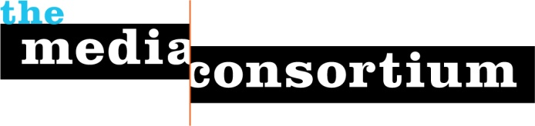

Staff Biographies

Jo Ellen Green Kaiser is the executive director of The Media Consortium. She is responsible for strategic direction, development, member recruitment and program management, working closely with TMC’s Coordinating Committee.
Passionate about mission-driven independent media, Jo Ellen has worked for a succession of independent magazines, including stints as Managing Editor and Associate Publisher of Tikkun, Publisher of LiP: Informed Revolt, and Executive Director and Editor-in-Chief of Zeek. She is driven by a belief that democratic societies thrive only when their members have access to accurate information and informed opinion.
A leading figure in Jewish media, Jo Ellen is an expert on the Jewish social justice movement. She is the co-editor of Righteous Indignation: A Jewish Response to Justice (Jewish Lights) and co-led the Righteous Indignation Project. She has written about Jewish social justice for a number of publications, including The Jewish Daily Forward, Sojourners, Tikkun and Interfaithfamily.com.

