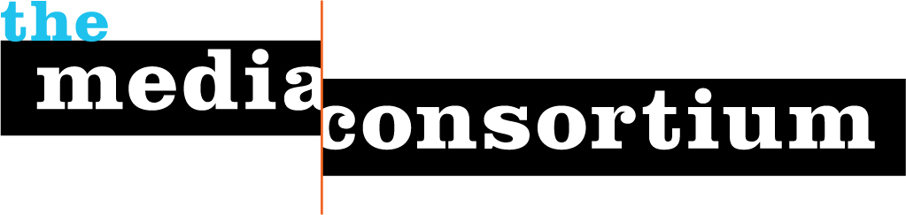
Submitted by: The Media Consortium, a project of the Foundation for National Progress
Submitted to: Media Democracy Fund
Date: September 7, 2011
Contact: Jo Ellen Green Kaiser, Director
415-878-3862/joellen@themediaconsortium.com
After a successful four-month pilot, completed in July 2011 with the support of the Media Democracy Fund, The Media Consortium, a network of over 50 independent media outlets, is ready to launch an ongoing project designed to raise media policy issues to a new level of pubic awareness. The Media Policy Reporting and Education Project (MPREP) proposes to build a lasting infrastructure that supports the production of quality media policy coverage that informs and engages citizens.

The vision of The Media Consortium—and our members—is to leverage our reporting to create real change. MPREP offers an innovative pathway to creating change by developing closer partnerships among independent media outlets and between media and our allies in the advocacy world. This project will educate reporters, inform the public, and engage citizens in creating a more just media policy.

To achieve its goals, the program will work on the following three fronts:
- Educate Reporters on Media Policy
- Increase the Volume and Visibility of Media Policy Reporting
- Increase Collaboration Between Media Outlets and Media Policy Advocates

Takeaways:
- 200+ pieces of high quality reporting produced by of 12 educational sessions with reporters from our 12-13 participating outlets.
- Ongoing, updatable database of expert sources from advocacy groups and activists in the media policy space.
- Spread media policy stories via syndication, interviews with MPREP reporters, Facebook and Twitter updates and retweets, and a Tumblr focused on media policy’s impact on citizens.
- Link media outlets to over 20 different media policy groups as resources, including the Benton Foundation, the Center for Media Justice, Free Press, and Native Public Media.

As a representative of the independent media, it is part of the Media Consortium’s mission to ensure media access to all Americans. Our proven track record in supporting collaborative reporting, and our successful MPREP pilot, demonstrate that we can amplify the many voices speaking up today for a more just media policy. We seek the Media Democracy Fund’s support in the form of a $75,000 grant towards this $215,000 project.

