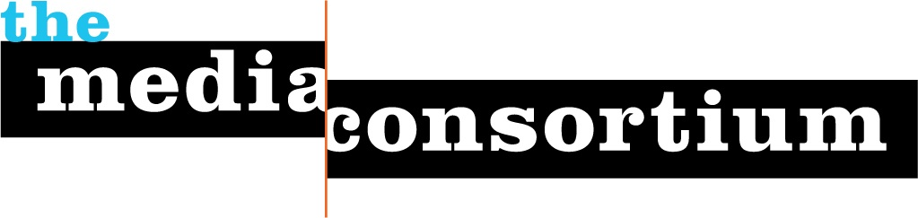

Submitted by The Media Consortium, a project of the Foundation for National Progress
Date: September 30, 2009
To: Instructional Telecommunications Foundation
Re: Letter of Intent

The Media Consortium (TMC) is pleased to submit a Letter of Intent to the Instructional Telecommunications Foundation. In 2010, TMC will launch its Innovation and Incubation Lab (II Lab) program, which focuses on helping progressive, independent media overcome technological barriers, reach out to new audiences, and deepen the impact of progressive reporting on political debate. The II Lab is an excellent match with ITF's mission of engaging and educating citizens through technology and media distribution.

Founded in 2005, The Media Consortium is a network of 45 leading independent journalism organizations that work in print, online, television, and radio. We support smart, powerful and passionate journalism that redefines American political and cultural debate. As millions of people are looking for powerful and accurate journalism, TMC has created a solid cooperative infrastructure that helps our members serve a 21st-century audience. Please visit www.themediaconsortium.org for a list of our current members.

The digital revolution creates unprecedented opportunities for independent media outlets to reach and engage new audiences. But many journalism outlets are having trouble bridging the gap between yesterday and tomorrow's media landscape. As detailed in our report on the current and future media landscape, The Big Thaw: Charting a New Future for Journalism (Sept. 2009), portable mobile devices represent the next wave of information distribution and audience engagement. If independent media is to thrive, it must invest in research and development of mobile applications, distribution strategies, revenue development and audience expansion.

That's why The Media Consortium is launching its II Lab in 2010. The program will coordinate one-on-one consulting, expertise, and strategic small group lab space to help its members understand, navigate and experiment in this new media environment. TMC has the infrastructure, reach, and network to implement this project differently than any other network. Through the II Lab, members will develop strategies and produce products that will allow them to delve into new revenue models, produce transformative journalism and create cutting edge products to increase audience reach and impact. The program will consist of two specific components: One-on-One Consulting and Small Group Labs.

TMC will hire a consultant to provide one-on-one consulting for up to 12 members over 12 months. By the end of the consulting period, each member organization will have a full overview of the current and future media landscape, determined their five-year goals for growth and laid out a one-year plan to kickstart those goals. The results of the consultation sessions will be shared with other consortium members, providing invaluable case studies and lessons for the sector. In a recent member survey, 88% of members said that they were very interested in this program.

While some members receive intense one-on-one consulting, Media Consortium staff will concurrently organize small group labs that facilitate research and experimentation. With these small-group labs, The Media Consortium will help its members develop new models of revenue generation, audience development and editorial opportunities with a specific focus on mobile media. Cumulatively, these labs will catalyze a broad shift in how independent media outlets operate, survive and thrive in a 21st century landscape. The debut small group lab will zero in on moving our members into mobile.

In a recent survey, our members indicated an overwhelming interested in strategically investing in mobile media distribution, developing e-reader and e-book applications and experimenting with new models for distributing stories that are vital to public debate and civic engagement. What's more, mobile devices are critical to expanding audiences and ultimately informing and impacting the public debate. Media Consortium members can take advantage of mobile —but only if they understand the best opportunities that play into mobile distribution and have the resources to support them making this strategic move. The II Labs can make this happen.

The lab will start in the first quarter of 2010 and will follow the following steps over four months:
Step 1: Identify members to participate in lab
Step 2: Resource Gathering and Research
Step 3: Experiment Idea Generation and Decision-Making
Step 4: Design and Implement Experiment
Step 5: Assess and Move Forward

The resource and research phase will provide opportunity and space for self-education, peer knowledge sharing, access to outside experts, and the development of collaborations and products that can scale up and improve the long-term sustainability and impact of members’ outlets. In addition to organizing the small group lab, The Media Consortium will provide seed money of $20,000 to help incubate new mobile products. If costs go over $20,000, TMC members will decide how to pool resources to cover the difference. The end goal is for members to develop and release one or more cutting edge mobile applications that that could include models for content distribution, communication with users, and revenue generation.

In addition to actual incubation of products, participating members will share experiences and lessons learned at the end of the lab cycle with MC members and allies, creating a ripple effect in which education, deployment of practices and evolution of experiments moves outward to benefit the whole independent media sector.

II Lab Key Staff
TMC Project Director Tracy Van Slyke has dedicated much of her career as a journalist, communications professional and media producer to building a strong progressive, independent media infrastructure. Her first book, Beyond the Echo Chamber: How a Networked Progressive Media Can Reshape American Politics (The New Press) will be released in December 2009. Van Slyke has frequently spoken and written about the role and impact of the progressive, independent media and how progressive, independent media must transform for the current and future media landscape. Van Slyke is also the former publisher of In These Times magazine, a national, award-winning magazine.

TMC II Labs consultant Andrew Golis is the Deputy Publisher of TalkingPointsMemo.com. Golis will be the lead in providing one-on-one consulting for members and particpate in the development and outside expertise for the the small-group lab. As Deputy Publisher, Andrew is in charge of audience growth and engagement, business development and technology and has played an integral part in scaling up the operation editorially and financially. He speaks at venues like Columbia Journalism School and Netroots Nation about new media practices and business models and does consulting focused on the same issues.

The Media Consortium is seeking to put in a full proposal for $35,000 from ITF for its debut small group lab that will focus on moving progressive media outlets into mobile. This includes support for TMC staff facilitation and organizing an in-person meeting among participating members and outside experts, and seed money for members to experiment and build mobile tools and applications. Please let us know if you have any questions or need more information.

Sincerely,
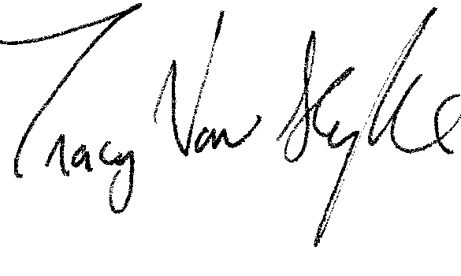
Tracy Van Slyke
Project Director, The Media Consortium
312-315-1127
tracy@themediaconsortium.com

