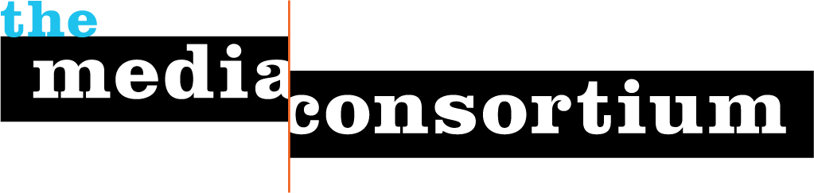
A Proposal for General Support
Submitted by: The Media Consortium,
a project of the Foundation for National Progress
Date: September 29, 2011
Contact: Jo Ellen Green Kaiser, Executive Director
415.878.3862 / joellen@themediaconsortium.com

As the courts and Congress give corporations increasing power over the levers of democracy, Americans need a media that is independent of corporate control more than ever. And the independent media need The Media Consortium (TMC), the only national organization dedicated to supporting and growing the independent media sector.

Since our founding in 2006, The Media Consortium has built a powerful network of over 50 independent, news-driven media outlets. Consortium members directly reach over 30 million Americans through video, radio, digital and print platforms. Member outlets such as Democracy Now!, Mother Jones, LinkTV, Yes! Magazine, AlterNet, Grist.org, Colorlines, and Brave New Films challenge mainstream infotainment media to do more by informing, educating, and engaging the public.

The Media Consortium supports this independent media sector by providing internal and external networking opportunities, offering monthly webinars with media experts, and establishing an Innovation and Incubation Lab series to help outlets to keep pace with new technology and to develop sustainable business models. We grow the power of the independent media sector by facilitating collaborations between members in order to leverage our collective power, bringing multiple perspectives and reports together to create a megaphone that mainstream media cannot ignore.

When TMC members published multiple stories around Citizens United and the corporate financing of elections, our #campaigncash hashtag forced mainstream media to pay attention to the story. When 9 TMC outlets joined together on TMC’s Media Policy Reporting and Education Project, they produced over 80 pieces on media policy in just four months. When 15 TMC outlets collaborated to cover the Wisconsin protests in early 2011, they succeeded in keeping the spotlight on a story the mainstream was planning to cover (and dismiss) in one 24-hour news cycle.

We are looking forward to a bold future, in which a diverse array of independent media organizations, armed with the most useful technological innovations, collaborate with each other and allies to put out stories that will educate, inform, and engage the widest possible audience. We want to tell the story of corporate power in elections; we want to tell the story of our decade-long wars in the Middle East; we want to tell the stories of union-busting and environmental inaction, of media consolidation and racial injustice—and we want those stories, coming from a wide range of media outlets, across digital, print, audio and video platforms, to be amplified until they cannot be ignored.

We seek and are grateful for the Wallace Global and Proteus Fund’s continued general support for our project. For 2012, we request a general support grant of $30,000 from the Wallace Global Fund.

