Strategic Planning Report:Survey Results
Submitted by Jo Ellen Green Kaiser
February 12, 2014

OVERVIEW:
Founded in 2005, the Media Consortium has entered a strategic planning process to answer a fundamental question: What is the unique value that the Media Consortium provides to its stakeholders?

On January 6, 2014, the Strategic Planning Committee sent a survey consisting of 5 questions to the Media Consortium list, which includes former and current Media Consortium members, former and current funders, as well as some allies. Of 422 members on the list, we have 63 respondents, or a 15% overall response.

SURVEY RESULTS-Executive Summary

Survey respondents were largely current Media Consortium members. Their overwhelming consensus is that the Media Consortium has a unique value to them and should not sunset.

Respondents define the Media Consortium as a network of peers. They define their peers as members of the independent and progressive media.

While respondents clearly indicate that they need technical training and assistance with business practices, they don’t see skills or training as core to the purpose of the Media Consortium.

Respondents strongly agree that the Media Consortium’s purpose is creating impact for and fostering collaboration among these peer organizations.

NEXT STEPS

Based on the survey data, the Media Consortium’s strategic planning team is conducting focus groups to drill down into the relationship between achieving impact and fostering collaboration, and how these goals relate to the definition of the Media Consortium as a peer network.

The Focus Groups will conclude on February 19; the TMC director will issue a focus group report by February 24, and that will form the stepping stone for our planning event on March 1-2.

SURVEY RESULTS—Details
The survey asked 5 questions, all designed to get at the question of the value of the Media Consortium to respondents. The first question asked respondents how they were related to the Media Consortium.

1. Demographics:

Please indicate how you are connected to the Media Consortium
(you can check more than one)

When numbers were adjusted so that anyone who indicated funder was put only in the funder category, and then anyone indicating current member was put only in the current member category, the breakdown was as follows:
54 Current TMC
5 Former TMC
3 Funders
3 Allies

14 respondents currently serve on TMC committees; 7 respondents were at the TMC founding event at Pocantico.

Demographics Analysis: Respondents reflect the current state of the Media Consortium, and the interests of current members.

2. Point of View

When asked to select one word to describe the typical Media Consortium outlet,
- 27 respondents chose “independent,”
- 28 respondents chose “progressive,” and
- 7 respondents chose another answer (news, non-profit, journalism, non-partisan, muckracking).

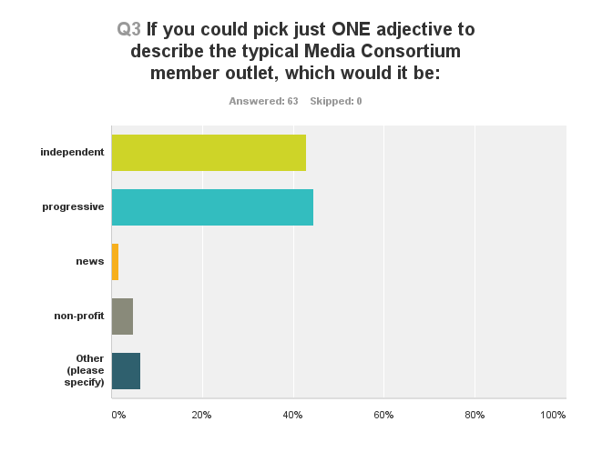

Point of View Analysis: Members feel comfortable using the term “progressive” to describe themselves. This strongly differentiates TMC members from those of other associations, for example, INN.

3. Purpose
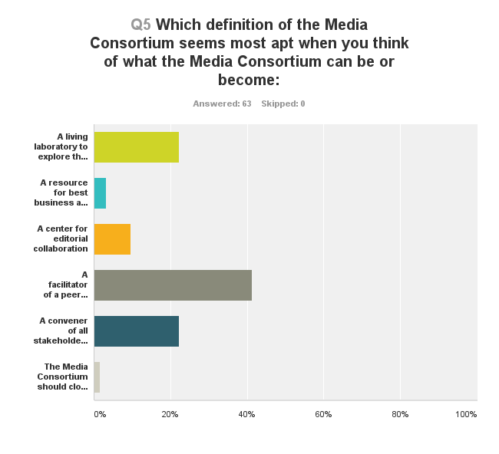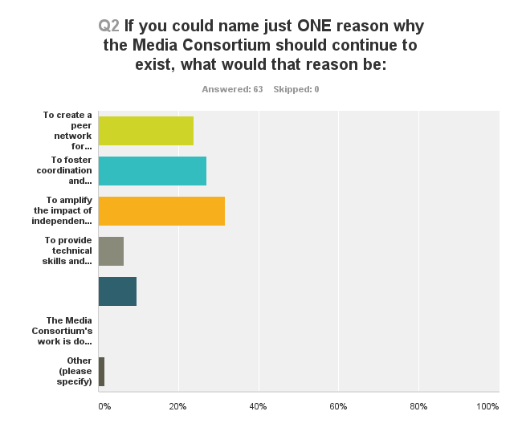

Here is another way to look at this data, using just key words

Key Word | Purpose | Definition
Peer Network | 24% | 42%
Editorial Collaboration | 27% | 9%
Impact | 32% | 22%
Technical | 6% | 3%
Conventor/Consortium | 9% | 22%
Shut Down/Sunset | 0 | .1%
Other | .1% | 0

Purpose Analysis: What is most striking about the survey results is that they show what the Media Consoritum is NOT: it is not primarily the place members look for technology advice or best business practices. The other clear message is that the respondents did not see a reason to sunset the organization—they feel it is still vital.

When respondents thought about the purpose of the Media Consortium—what it is meant to do—they emphasized impact and collaboration (59%). The survey did not ask about the relationship between impact and collaboration.

When they thought most about the definition of the Media Consortium—what it is—they stressed the peer network and were even willing to extend the notion of that network beyond news outlets to allies and funders (64%).

4. Mission-Related Activities

This survey was not designed to drill down into specifics, but to give a better understanding of the purpose/definitiion questions respondents were asked whether five different activities were core to the mission of the Consortium. These activities were designed to reflect the purpose/definition questions.

Please rate these current and future activities of the Media Consortium. Please base your rating on your vision of what the Media Consortium could be at its best.

Purpose | Activity | Core | Important | Unimportant | Off Mission
Peer Network | Listserv | 44% | 52% | 1% | 0
Convenor | Conference | 28% | 65% | 5% | 0
Peer Network | Regional Meetings | 6% | 56% | 32% | 1%
Collaboration | Collaborations | 35% | 48% | 13% | 0
Technical | Tech Training | 21% | 65% | 11% | 1%

Mission-Related Activities Analysis: Once again, the peer network and collaboration are clearly seen as core to the mission of the Media Consortium. Perhaps reflective of the national (and international) aspirations of members, or possibly only of their limited time, regional meetings were not seen as important as national and digital means of networking.

What stands out from this question is that members underscored that technical training is in fact important to them, even if they don’t see it as core to the Media Consortium’s mission or purpose. This indicates that many members require this kind of training, and might suggest the Media Consortium partner with other associations or organizations that can provide it for members.

