Strategic Planning Report:
Survey and Focus Group Results
Submitted by Jo Ellen Green Kaiser
February 8, 2014

Overview
I. Background
II. Planning Process
III. Survey Results
IV. Focus Group Results

OVERVIEW:
Founded in 2005, the Media Consortium has entered a strategic planning process to answer a fundamental question: What is the unique value that the Media Consortium provides to its stakeholders?

The answer to that question will provide direction for planning the next phase of the Media Consortium’s work.

I. BACKGROUND:
The Media Consortium entered a strategic planning process in September 2013 to address a number of critical questions:
- Since TMC’s founding in 2005, several new associations have entered the sector including: ONA, INN, and LION—are they competitors for members or dollars or are they partners (or both)?
- TMC has faced a critical shortage of general support funding since 2011, a reduced level which does not seem tied to the economy but to the willingness of TMC’s stakeholders to fund the organization. What is TMC’s path to sustainable funding?
- The digital revolution has led to a convergence of platforms, which could create opportunities for mergers in the news association space. Should TMC take advantage of these opportunities?

Because these questions pose existential questions for the Media Consortium, the Coordinating Committee chose to focus strategic planning on asking a core existential question: why does the Media Consortium exist? What unique value does the Media Consortium provide for its stakeholders?

We ask this question out of a feeling of confidence, primed by the important successes the organization has had in fulfilling its core mission of supporting and growing the impact of its members:
- The Media Consortium’s membership has doubled in the past three years from 35 to 70 member outlets.
- Once a member, always a member; the Media Consortium has a very high retention rate (over 95%) and even more surprising for the field, a very high rate of member survival (over 97% of members survive year to year).
- Media Consortium members have increasingly had an impact on public conversations. Mother Jones’ 47% video; the Washingon Monthly’s alternative College Guide, and Colorlines’ I-word campaign are some of the most prominent examples.
- Media Consortium members have learned to collaborate to increase impact: from the Wisconsin effort in 2011 to Occupy May Day in 2012 members have learned to work together to create and crosspromote content.
- The Media Consortium has become a center of national attention within its sector for our Metrics Impact Lab—we are farther along on measuring impact than any of our peers.
And these are only the most prominent of our successes over the past three years.

Coming from this position of strength allows us to take the bold step of asking a question few organizations dare to ask—what is at our core? What is our purpose?
What is the unique value that the Media Consortium provides to its stakeholders?

II. PLANNING PROCESS

The Media Consortium is a horizontal organization—we exist for our members, and are governed by members. This horizontal quality has governed the planning process we have implemented.

9/13-12/13 Coordinating Committee and Executive Director form strategic planning committee, create focus question and planning process.

12/13-1/14 Survey of members

1/14-2/14 Focus groups with stakeholders:
- Outlets w/budgets over $2 million/year
- Funders
- Former TMC Directors
- Executive Directors of Peer Associations
- Media “Experts”
- Self-selected group of members

2/12/14 Report to members on process to date

3/1-3/2/14 In person planning event at TMC annual conference

3/15/14 Report to members on event outcomes

3/14-5/14 Planning Committee to implement event outcomes including wordsmithing, further research, etc.

5/14-8/14 Retreat if necessary to operationalize outcomes

9/14 Final report to members

III. SURVEY RESULTS-Executive Summary

On January 6, 2014, the Strategic Planning Committee sent a survey to the Media Consortium list, which includes former and current Media Consortium members, former and current funders, as well as some allies. Of 422 members on the list, we have 63 respondents, or a 15% overall response.

The survey asked five questions, all designed to determine what stakeholders saw as the unique role and value of the Media Consortium within the independent media sector. It began by asking what relationship the respondent currently has with TMC:

Survey respondents were largely current Media Consortium members. Their overwhelming consensus is that the Media Consortium has a unique value to them and should not sunset.

Respondents define the Media Consortium as a network of peers. They define their peers as members of the independent and progressive media.

While respondents clearly indicate that they need technical training and assistance with business practices, they don’t see skills or training as core to the purpose of the Media Consortium.

Respondents strongly agree that the Media Consortium’s purpose is creating impact for and fostering collaboration among these peer organizations.

SURVEY RESULTS-Details
The survey asked 5 questions, all designed to get at the question of the value of the Media Consortium to respondents. The first question asked respondents how they were related to the Media Consortium.

1. Demographics:

Please indicate how you are connected to the Media Consortium
(you can check more than one)

When numbers were adjusted so that anyone who indicated funder was put only in the funder category, and then anyone indicating current member was put only in the current member category, the breakdown was as follows:
54 Current TMC
5 Former TMC
3 Funders
3 Allies

14 respondents currently serve on TMC committees; 7 respondents were at the TMC founding event at Pocantico.

Demographics ANALYSIS: Respondents reflect the current state of the Media Consortium, and the interests of current members.

2. Point of View
When asked to select one word to describe the typical Media Consortium outlet,
- 27 respondents chose “independent,”
- 28 respondents chose “progressive,” and
- 7 respondents chose another answer (news, non-profit, journalism, non-partisan, muckracking).

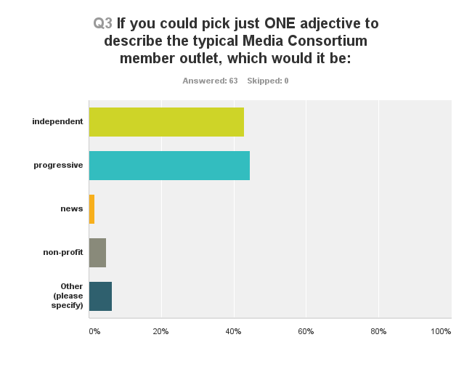

Point of View Analysis: Members feel comfortable using the term “progressive” to describe themselves. This strongly differentiates TMC members from those of other associations, for example, INN.

3. Purpose
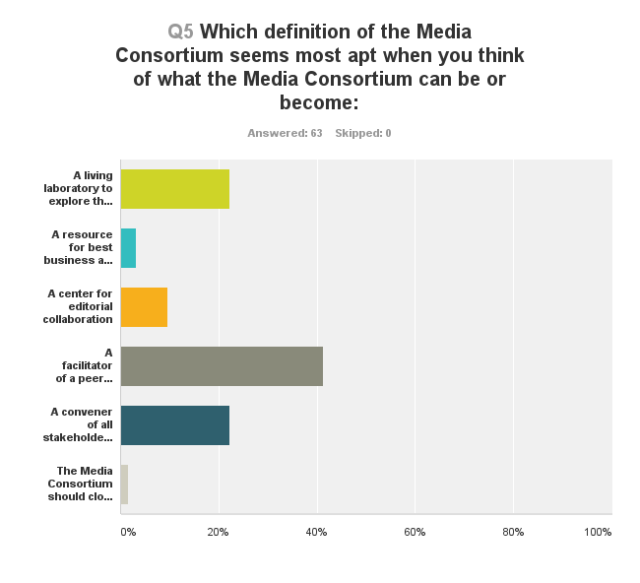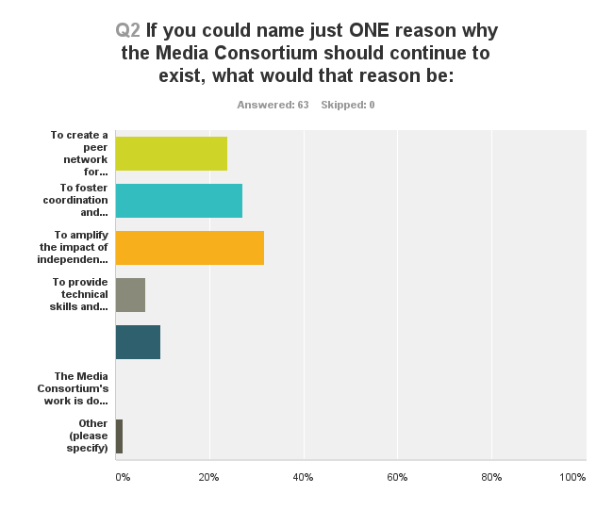

Here is another way to look at this data, using just key words

Key Word | Purpose | Definition
Peer Network | 24% | 42%
Editorial Collaboration | 27% | 9%
Impact | 32% | 22%
Technical | 6% | 3%
Conventor/Consortium | 9% | 22%
Shut Down/Sunset | 0 | .1%
Other | .1% | 0

Purpose Analysis: What is most striking about the survey results is that they show what the Media Consoritum is NOT: it is not primarily the place members look for technology advice or best business practices. The other clear message is that the respondents did not see a reason to sunset the organization—they feel it is still vital.

When respondents thought about the purpose of the Media Consortium—what it is meant to do—they emphasized impact and collaboration (59%). The survey did not ask about the relationship between impact and collaboration.

When they thought most about the definition of the Media Consortium—what it is—they stressed the peer network and were even willing to extend the notion of that network beyond news outlets to allies and funders (64%).

Mission-Related Activities

This survey was not designed to drill down into specifics, but to give a better understanding of the purpose/definitiion questions respondents were asked whether five different activities were core to the mission of the Consortium. These activities were designed to reflect the purpose/definition questions.

Purpose | Activity | Core | Important | Unimportant | Off Mission
Peer Network | Listserv | 44% | 52% | 1% | 0
Convenor | Conference | 28% | 65% | 5% | 0
Peer Network | Regional Meetings | 6% | 56% | 32% | 1%
Collaboration | Collaborations | 35% | 48% | 13% | 0
Technical | Tech Training | 21% | 65% | 11% | 1%

Mission-Related Activities Analysis: Once again, the peer network and collaboration are clearly seen as core to the mission of the Media Consortium. Perhaps reflective of the national (and international) aspirations of members, or possibly only of their limited time, regional meetings were not seen as important as national and digital means of networking.

What stands out from this question is that members underscored that technical training is in fact important to them, even if they don’t see it as core to the Media Consortium’s mission or purpose. This indicates that many members require this kind of training, and might suggest the Media Consortium partner with other associations or organizations that can provide it for members.

IV. FOCUS GROUP RESULTS

Between January 15, 2014 and February 19, 2014, the strategic planning committee is conducting focus groups and interviews with key stakeholders.

Focus Groups:

- TMC Funders Past and Present
- TMC Members with Budgets > $2 million
- TMC Members, self-selected
- Indy Media Pundits/Observers

Interviews:
- Tracy Van Slyke, former TMC Director*
- Kevin Davis, E.D., INN
- Tiffany Shackleford, E.D., AAN
- Chip Giller (TMC Member with Budget > $2 million)
- Josh Stearns (Indy Media Observer)

*Erin has been unavailable for interview due to a death in the family

TMC Funders

TMC Large Members (Focus Group + Interview)

Competitive Landscape:
Surprisingly, most of TMC’s larger members do not belong to any other media association. The print publications have an on-again/off-again relationship with the Magazine Publishing Association’s Independent Magazine division (MPA-IMAG). Several members have joined the Social Venture Network, but do so in order to harvest donors/advertisers, not to bolster their own businesses. Mother Jones joined INN but feels more at home with TMC.

Digging deeper, it turns out that individual staffers at these outlets are members of ONA. They look to ONA to provide updates on technology but they don’t name ONA as an association to which they belong—they see the association’s annual meeting as a training ground and hiring arena for employees.

Interviews w/staff

Interviews w/peer association leaders

