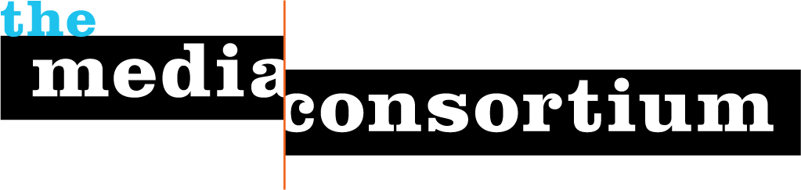
Submitted by The Media Consortium, a project of the Foundation for National Progress
Date: April 10, 2009
To: The Rappaport Family Foundation

Thank you for emailing The Media Consortium about the Rappaport Family Foundation’s LOI process. We are debuting a unique, national media internship program this summer that we think is an excellent match with the foundation’s stated goals of engaging young people in the political process.
2009 promises to be a year of extremes, filled with great opportunity and deep struggle. Today’s youth will play a critical role in the development of new policies and government infrastructure. They will also communicate their ideals using new technologies and engage new communities in the democratic process—but only if we invest in them.
As a part of The Media Consortium’s commitment to supporting media outlets that inform and shape our democracy, as well as our dedication to cultivating the next generation of media leaders, we are proud to debut the Independent Media Internship program in summer 2009. We believe this program will be a perfect fit for a seed grant because, as founding father Thomas Jefferson believed, an independent, informed press is critical to a healthy democracy. The Independent Media Internship program has an operating budget of $24,000 for 2009. With additional support from the Rappaport Foundation, we would be able to greatly increase our capacity to recruit and place a diverse group of budding journalists at leading, independent media outlets across the country.
This program will have a domino-style impact: One young journalist who has the connections and drive to tell a story well has the power to inform and engage thousands of individuals. By engaging passionate voices at an early age and providing them with a tool kit for success, The Media Consortium is fostering a generation of media leaders committed to telling key stories, asking hard questions and inciting debate around vital political issues.
The Independent Media Internships are for politically active, civically engaged, undergrad and graduate students who are passionate about independent media. Using hands-on learning, mentorship, and career-training workshops in a variety of media fields (audio, video, print, online), we hope to develop the next generation of thinkers, writers and reporters that will give voice to issues impacting every day Americans. Their work is critical to informing and engaging communities in the political process.
With this program, we will foster young writers’ knowledge of key political and social issues, including: immigration, healthcare, economics, the political process, civil rights and international relations. Investing in young media makers is beneficial for journalism as an institution, government, and American citizens.
We have partnered with universities and other internship placement programs to recruit a diverse group of students committed to the practice and future of journalism as a means of strengthening democracy and public dialogue. To date, over 70 students from a variety of economic, cultural, educational and gendered backgrounds have applied for 2009. These applicants are smart, engaged, global citizens who are passionate about the power of journalism to transform democracy.
With current funds, Media Consortium staff are identifying and place 12 interns with member organizations over two four-month periods in 2009—six interns/quarter—and providing a stipend of $2,000 for twelve 32-hour workweeks. Over this four-month period, interns will complete one or more major editorial projects, complete weekly duties (including fact-checking, research, writing and multimedia production) and meet with top editors and reporters for mentoring sessions. They will also participate in monthly skill-development conference calls organized by Media Consortium staff.
We will place interns across the spectrum of media platforms—participating organizations in 2009 include: Air America, The American Prospect, GritTV, RH Reality Check, ColorLines, LinkTV, Talking Points Memo, Mother Jones, and more. All participating organizations must meet rigorous criteria and be committed to investing in the education and career development of the intern.
The Independent Media Internship program is, in many ways, a natural outgrowth of The Media Consortium’s core mission and vision: Not only does is allow us to shore up and support our members, but is a necessary investment in the future of journalism that informs and shapes a vital democracy.
Most media internships are unpaid and offer little support to young journalists—this program ensures that passionate young people have the financial support and mentorship necessary to build a vibrant career in the media. Paid internships are also crucial to ensuring that the next generation of media leaders come from a diversity of economic and cultural backgrounds. By recruiting young people from a variety of communities, we are helping create the megaphone with which our future journalists will make the issues important to their communities heard.
We already have more applicants than we could hope to place in two years. A $25,000 grant from the Rappaport Family Foundation would make it possible for The Media Consortium to place an additional 10 young people in 2009 and the beginning of 2010 with independent media institutions around the country. The requested amount includes Media Consortium staff time to manage monthly calls with interns, recruit applicants and work with members to ensure that the program is successfully implemented.
About The Media Consortium
Founded in 2005, The Media Consortium is a network of almost 50 leading independent journalism organizations that work in print, online, on television, and on the radio. We support smart, powerful and passionate journalism that redefines American political and cultural debate. The Media Consortium is creating a solid cooperative infrastructure that will serve a 21st-century audience and offer a sustainable future for independent media. Millions of Americans are looking for honest, fair, and accurate journalism. We’re finding new ways to reach them. Our current members are:

Afro-Netizen
Air America Radio
AlterNet
American Forum
American News Project
The American Prospect
Balcony Films
Brave New Films
Berrett-Koehler Publishers
Center for Independent Media
ColorLines
Democracy Now
Feministing.com
Free Speech TV
G. W. Williams Center for
Independent Journalism
GlobalVision/Media Channel
GoLeftTV
Grist.org
High Country News
Hightower Lowdown
In These Times
LinkTV
Mother Jones
Ms. Magazine
The Nation
The Nation Institute
National Alliance for Media Arts
and Culture (NAMAC)
National Radio Project
New America Media
The New Press
OneWorld US
The Progressive
Public News Service
RealTV/IWT
Regional News Network
Talking Points Memo
Texas Observer
Truthdig
The Uptake
The Washington Monthly
WireTap
Women’s Media Center
Workers Independent News
YES! Magazine
The Young Turks

Thank you again for your interest in The Media Consortium. We look forward to your consideration of this request and the opportunity to submit a formal proposal for your review. Please do not hesitate to contact us with any questions, or if you would like additional information about the Independent Media Internships program.
Sincerely,

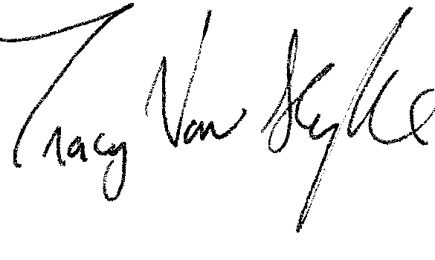
Tracy Van Slyke
Program Director
312-315-1127
tracy@themediaconsortium.com

