
December 3, 2008

Dear Gladys and Perry,

Happy Holidays!

When we all last touched base, the two of us were at In These Times (Tracy as Publisher and Erin as Associate Publisher). We departed from the magazine with a pledge to continue building and strengthening the impact of independent journalism created by media outlets such as In These Times, The Nation, Mother Jones, Free Speech TV, AlterNet and many more.

Like you, we know that the cornerstone of a healthy democracy is a vibrant and flourishing independent press. That is why we now run The Media Consortium--a network of the country’s leading, independent media outlets.
Each of The Media Consortium’s 51 member outlets is committed to producing journalism that informs and engages Americans. Our members believe that we can create a larger impact by working together through The Media Consortium, rather than working alone.

In 2006, a Media Consortium-sponsored project discovered that the progressive media reaches millions of people. Our collective audience comprises a powerful block of the American population that is voting, donating and engaging in democratic and social justice activities everyday. Through this and other projects, The Media Consortium exists to help the independent media expand their audiences, increase their impact on the political dialogue, and create long-term sustainability for the sector.

We are engaging in cutting-edge editorial support, marketing research, and revenue generating projects, to fulfill these goals. The attached packet contains an overview of The Media Consortium’s history, mission and recent initiatives.

We would love to talk to you more about The Media Consortium and our plans for its future. Please let us know if there’s a good time to set up a phone call or in-person meeting to talk. And please don’t hesitate to contact us with any questions.

In solidarity,

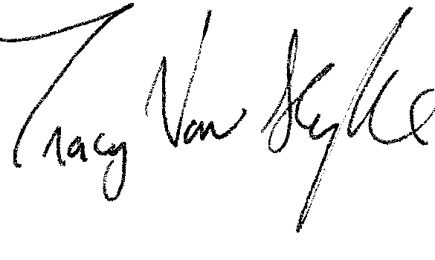
Tracy Van Slyke
Project Director
tracy@themediaconsortium.com


Erin Polgreen
Program Associate
erin@themediaconsortium.com

1.312.315.1127
www.themediaconsortium.org

