THE OPEN SOCIETY INSTITUTE

Proposal Title Page

Please complete and attach to the front of your proposal

Formal organization name as stated on IRS letter of tax determination:

The Media Consortium, a project of The Foundation for National Progress

One-sentence description of the proposed initiative:

The purpose of this project is: to amplify the voices of the progressive, independent media; increase our collective clout; leverage our current audiences and reach out to new ones; attract financial resources; strengthen and transform our individual businesses and our sector’s position in a rapidly changing media and political environment; and redefine ourselves and progressivism for a new century.

Amount Requested: Project Organizational Budget:
$ 125,000 $ 502,000

Proposed Grant Period: From: January, 2009 To: December, 2009
(Month/Year) (Month/Year)

Proposal/Project Contact (Principal Investigator):
Tracy Van Slyke, Project Director
(name) (title)

Address: 2825 W. Logan Blvd. #2b, Chicago, IL 60647

Telephone: 312-315-1127
Fax:
E-mail: tracy@themediaconsortium.com
Web address: www.themediaconsortium.com

Tax Contact (Organization or fiscal agent officer authorized to sign grant agreement):
Madeline Buckingham, CFO, Foundation for National Progress
(name) (title)

Address: 222 Sutter Street, 6th Floor, San Francisco, CA 94108

Telephone: 415-321-1700 x.229
Fax:
E-mail: mbuckingham@motherjones.com
Web address: www.motherjones.com

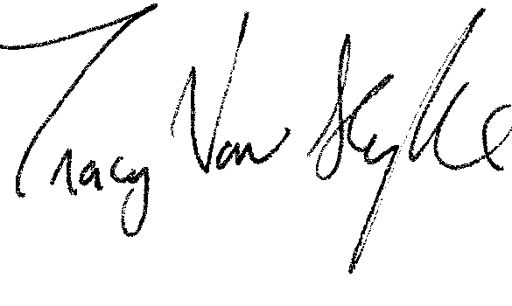 September 26, 2008

Signature of Proposal Contact Date

