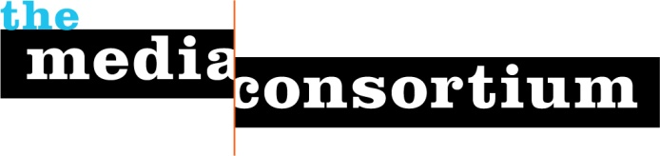

The Media Consortium Staff
2010

Tracy Van Slyke has dedicated much of her career as a journalist, communications professional and media producer to building a strong independent media infrastructure. As the Project Director of The Media Consortium, she works to organize effective partnerships and innovative projects that will change the terms of the American political and cultural debate as well as create a cooperative infrastructure that supports a sustainable future for independent media. She is also co-author of the book, Beyond the Echo Chamber: Reshaping Politics Through Networked Progressive Media (February 2010, The New Press). In October 2009, Van Slyke was named one of the Heeb Hundred-one of the top hundred Jews in the country to watch out for.

Van Slyke is the former publisher of In These Times magazine, a national, award-winning monthly magazine of progressive news, analysis and cultural reporting. In 2005 and 2006, she and Jessica Clark co-authored the landmark articles on strengthening the progressive media landscape including, “Making Connections: Why is the news so bad? What can progressives do to fix it?” and “Welcome to the Media Revolution: How today’s media makers are shaping tomorrow’s news.“

Prior to joining In These Times, she was the Communications Director for the National Training and Information Center. In 2000 she was a fellow at Knight Ridder’s Washington D.C. bureau during the 2000 presidential campaign and covered national politics and events. She is also the co-editor of Build the Echo. Van Slyke also serves on the board of the National Training Information Center.

Erin Polgreen is the Associate Director of The Media Consortium. She manages the Consortium’s MediaWires project, which connects an aggregate audience of 7.5 million people to top content from Media Consortium members via blogs, socNET engagement strategies, and RSS-based widgets. As the staff representative on TMC’s membership committee, Erin also oversees membership engagement and recruitment for the Media Consortium.

From 2005-2007, she was the Associate Publisher for In These Times, where she managed advertising, marketing, event planning, and other outreach initiatives. Prior to working at In These Times, Erin served with City Year Chicago, an Americorps program, where she co-led a team of literacy tutors at an elementary school on the West side of Chicago. Erin has written about media, politics, comic books and Feminism for Attackerman, In These Times, Campus Progress and Care2, among other publications. She is an active member of Chicago’s cycling community.

Jeanne Brooks is the Program Associate for The Media Consortium. As the former Outreach Coordinator at the Center for Public Integrity, she managed the Center’s outreach efforts and the online marketing/donor campaigns. Prior to that she was the Managing Director of the Fund for Independence in Journalism, a support organization to the Center that was created to foster independent, high-quality public service journalism in the United States and around the world. While at the Fund she also assisted the research and editing of Iraq: The War Card, an online searchable database of false statements made by the Bush administration in the lead-up to the war. Jeanne began her career at the New Hampshire Commission on the Status of Women.

