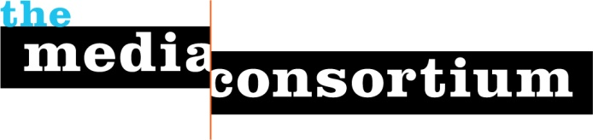
List of 2010 Funders/Commitments for The Media Consortium

2010 Projected Revenue (Gen Ops) |  | Status of funds
Open Society Institute | $100,000 | Confirmed
The Surdna Foundation | $100,000 | Confirmed
2008 grant balance carry forward | $38,000 | Confirmed
Member Dues | $16,000 | Confirmed
Incubation and Innovation Lab Fees | $9,000 | Pending
Arca Foundation | $50,000 | Pending
Haas Foundation | $25,000 | Pending
Other | $70,000 | Pending

