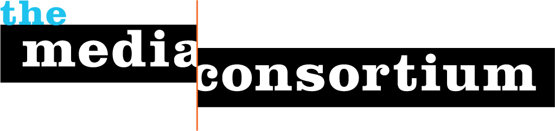
LOI: Media Policy Reporting and Education Project

For: The Media Consortium, a Project of the Foundation for National Progress

Date: July 5, 2011

To: The Ford Foundation

By: Jo Ellen Green Kaiser, Executive Director, The Media Consortium

415-878-3862 / joellen@themediaconsortium.com

As new communication technologies emerge at a breakneck pace, media policy has become a vital, yet often overlooked, element of our democracy. Citizens rely on broadband, cell phones, and radio to access information that informs and enriches their lives. In an ideal world, access to these utilities would be unfettered and available to all.

But in reality, Americans’ access to and consumption of media is mired in byzantine policy and techno-jargon. This disconnect between people and policy results in poorly informed policy decisions that are often held to corporate, rather that public, interests. There is an enormous information gap between the policymakers and lobbyists who regulate media policy and the everyday citizens who use and depend on media, from broadband to smartphone. Americans need to know how changes to media policy will impact them; they need accessible, easy-to-understand reporting about the policy that shapes their lives.

We cannot look to the mainstream media to put out these stories. Mainstream media is corporate-owned, and often has a conflict of interest around media policy issues. Despite the much-vaunted journalistic “firewall,” mainstream media too often buries the lede. Even the left can be swayed by corporate cash. Only the independent press can be relied upon for the real story, as in AlterNet’s recent expose of AT&T’s use of grants to persuade nonprofits to back the T-Mobile merger: http://bit.ly/iYSvRj

Independent press will get these stories out. Independent media outlets care deeply about access and media policy, in part because they also have a stake in the game—on the side of the consumer. Media policy impacts how media outlets are able to transmit their content and connect with their audiences. The organizing work of the Prometheus Radio Project around low power FM station licensing illustrates that independent press outlets can have a significant impact. However, independent press outlets lack the resources to pay for a media policy “beat,” and their reporters can not always keep up with the highly technical nature of the field. Thus independent media outlets require support—both financial and educational—in order to continue to put out these stories.

To respond to that need, The Media Consortium launched its Media Policy Reporting and Education Pilot Project (MPREPP) in April 2011. Supported primarily by the Media Democracy Fund with additional funding from the Benton Foundation, this 4-month project enabled TMC staff to educate reporters on media policy, from mobile regulation to the Universal Service Fund. It also provided seed money to independent press media outlets to support the production of high-impact reporting on media policy. The aim was to see if the project would raise media policy to a new level of public awareness by supporting quality reporting and efficient content delivery to a diverse set of constituencies.

The pilot program, nearing its conclusion, has been a success. The nine participating media outlets—AlterNet, New American Media, the New York Community Media Alliance, The G.W. Williams Center for Independent Journalism, Mother Jones, Truthout, GritTV, Feet in Two Worlds and Public News Service—have produced over 50 pieces on media policy, along with a biweekly roundup blog, “The Wavelength.” These original researched and reported stories include:

- Feet in 2 Worlds is producing a segment for NPR’s The World on how young immigrants are using social media to organize around the DREAM Act. The story will air in late July.

- The G.W. Williams Center for Independent Journalism, in partnership with New America Media, published a two-part investigation into how Low Power TV stations provide vital services to ethnic communities—but are being given short shrift by the FCC. As reporter Eric Arnold writes: “LPTV has been around for decades, although largely under the media radar. But its 2009 conversion to digital technology, which permits a station to ‘multiplex’--or clone--its signal, increased LPTV’s programming possibilities and therefore its profile in communities nationwide. … Yet advocates have had to fight for LPTV’s life—often against mega-media corporations and in the halls of lawmakers and regulatory agencies such as the Federal Communications Commission (FCC).”

- AlterNet is running a 5-part series on how corporate media consolidation has directly impacted citizens and consumers. The series is authored by former telecom industry insiders Bruce Kushnick and David Rosen.

The stories created for this pilot project have already created real change:

“Joseph Orozco of KIDE … contacted us about the low-power TV story, and [Wavelength blogger and author] Eric Arnold put him in touch with Ravi Kapur of KAXT-TV. Just the kind of connection a New America Media story should make.” –Paul Kleyman, Editor, New America Media.

In addition to the actual stories produced, the Media Policy Reporting and Education Project has helped build connections between independent media outlets and media policy experts. Every three weeks, TMC staff arranged content-rich conference calls for MPREPP participants with experts from Free Press, the New American Foundation, the Benton Foundation, Native Public Media, and the Center for Media Justice. These organizations are eager to continue the project, as they appreciate this ongoing means to communicate with the independent press.

“One of the most challenging aspects of working to reform the media is that it’s often very hard to get the media to cover itself. When media policy issues are covered it’s usually in the business section and the perspectives of local people and communities are left out of the picture. That’s why it is so vital to have journalists from independent outlets digging into these issues. Briefing reporters on complex media policy issues helps advocates work to translate and hone our messaging, and is a constant reminder to tie events in DC back to people’s daily lives.”—Josh Stearns, Free Press

The Media Consortium is requesting $125,000 in order to launch the Media Policy Reporting and Education Project as a full-fledged program, to run through 2012. With media consolidation continuing, broadband and low-power FM access challenged, and new threats to net neutrality, this reporting program is needed more than ever.

One year MREP Budget:

Amount Requested: $125,000

Expenses:
Personnel Expense: $25,000 50% time associate to run program
(includes tax, benefits)
$10,000 Social Media Curator/blogger to push content out

Seed Money for Media $40,000 @$4K per text-based media outlet @10 outlets
$28,000 @$14K per video-based media outlet@2 outlets
$7,000 @$7K per radio-based media outlet @1 outlet

Experts for Calls 0 In-kind donation

Overhead $6,250 5% (will cover telephone/webinar expense)

Fiscal Sponsor Fee $8,750 7%

Total Expenses: $125,000

