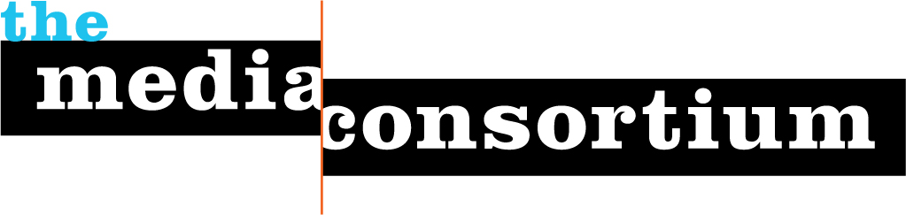
Jo Ellen Green Kaiser
Executive Director
415-878-3862
joellen@themediaconsortium.com

Progressive initiatives require an infrastructure linking media with advocacy organizations in order to inform, educate and engage the public. That is the vision of the Media Consortium, a national network of 58 independent news media outlets.

To that end, the Media Consortium has played a significant role in helping to connect reporters from our member outlets to advocacy groups around policy campaigns. Most recently, we hosted a briefing by Free Press to announce its Declaration of Internet Freedom campaign. We also have worked with a coalition of groups, including Common Cause, People for the American Way, and Public Citizen, to educate the public about possible responses to the Citizens United ruling, including amending the constitutions to declare that corporations are not people.

This fall, the Media Consortium proposes working closely with Future 500 to inform, educate, and engage the public around the issues being discussed at Unconvention 2012, a key element of the Commit! Forum hosted by CR magazine.

Why the Media Consortium?

The aim of the Unconvention is to bring together corporate leaders with policy advocates and activists in the interest of examining how corporatins can “do well by doing good.”

The members of the Media Consortium are perfectly positioned to publish stories on the topics that are the focus of the Unconvention. A number of our members, including Mother Jones, the Nation, Truthout, Alternet, and In These Times have focused throughout 2012 on crony capitalism or what we call “dark money,” the story of secret money funding poor government policies. The Media Consortium represents a number of environmentally-focused outlets, including Grist, Care2, Earth Island Journal and Yes! magazine that have focused specifically on energy security and the carbon tax in the recent past. Finally, the Consortium’s Media Policy Reporting and Education Project has trained reporters at 12 outlets on how to report in a meaningful way about digital freedom.

What Will We Do?

Editors at independent news outlets, by their nature, are resistant to suggestions from the outside about what they should cover. Yet, if offered the opportunity to dig deeper into issues they already cover, most reporters leap at the opportunity. The Media Consortium has had considerable success with the following format:

- Publicity for the Unconvention. We will use our private listserv of journalists and editors to urge reporters to follow the story of the Unconvention. We will also publicize it via our social media and email newsletter. This publicity will be designed primarily to promote press access, the travel fund, and the background briefing.
- Press Access. Working with Future 500, we will offer access to the Unconvention to Media Consortium journalists. We will work with Future 500 to create a smooth process for vetting these journalists and supplying them with passes. Likewise, we will work with Future 500 staff to create a process for forwarding interview requests and arranging interview logistics. The aim of this effort is to encourage journalists to attend the Unconvention and to write stories about it in advance of the event.
- Travel Fund. We will set up a small fund to cover travel costs for journalists who wish to attend the Unconvention but require financial aid.
- Background Briefing. Two weeks before the Unconvention, we will host a background briefing for reporters with Bill Shireman of Future 500 and with 2 or 3 of the more progressive participants in the Unconvention. The focus will be on asking them why they are participating in a convention on Wall Street, why they believe in working with corporations, and what they hope to gain from this effort. The aim of this briefing is to generate stories in advance of the Unconvention.
- Mini-Press Conference. The Media Consortium will work with Future 500 staff to arrange a mini-press conference at the event. The Consortium will use social media to send out a copy of this press conference to our 2500+ followers. The aim of this conference is to generate stories during the Unconvention.

Benchmarks

Success for this effort will be measured in several different ways:
1) the number and type of efforts made by the Media Consortium to get out the word about the Unconvention to members of the media;
2) the number of speaking opportunities afforded Bill and Erik as a result of Media Consortium efforts;
3) the quantity and quality of stories written as a result of this media outreach; and 4) specifically the quantity and quality of stories written about the carbon tax initiative.

Request
To fulfill the terms of this proposal, the Media Consortium requests $3000 from Future 500.

Budget

Requested Grant
Future 500 | $3000 | Requested
Expenses
Project Manager | $2200 | 7 hrs/wk * 6 wks @ $50/hr
Social Media Curator | $90 | 10% time* 6 wks
Travel Fund | $500 | Partial scholarships
Administrative Costs | $210 | Fiscal Sponsor requires 7%

