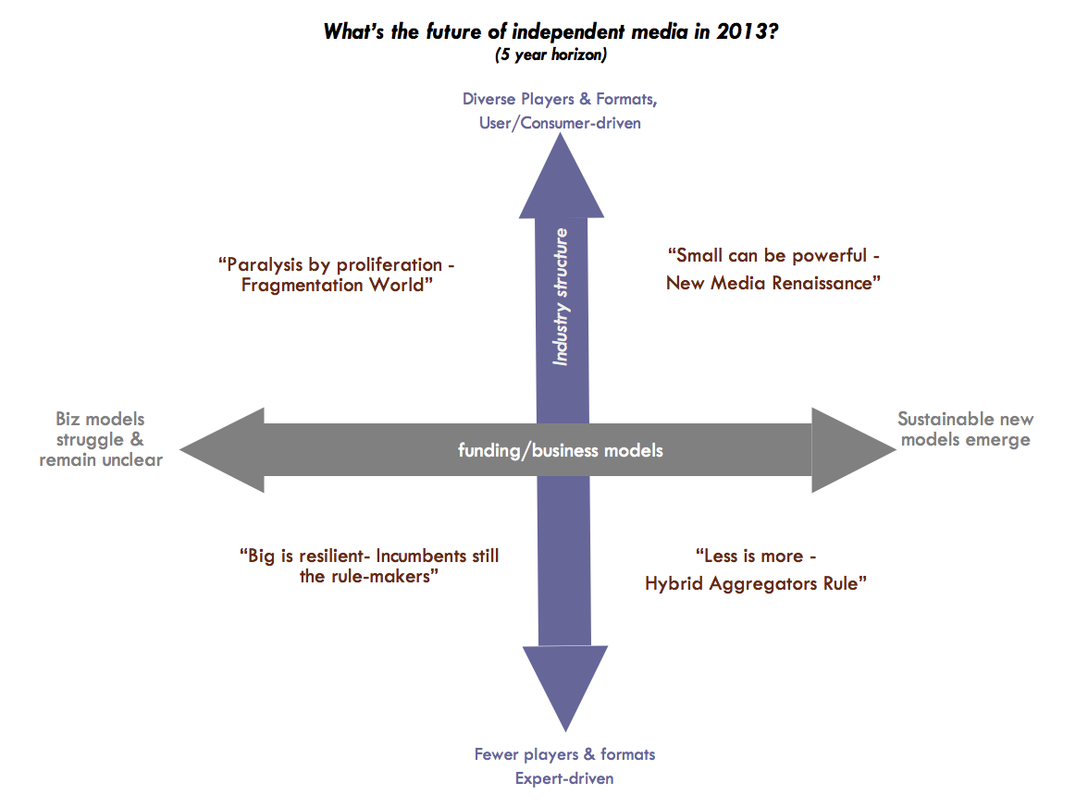

Scenario 1 — “Big is Resilience - Incumbents Still Dominate"

The Story
This is a world in which the recessionary economy worsens and is longer and deeper than most people were prepared for. In the political scene, things weren’t that much better. Despite a change in administration, all of the problems facing the nation forced a more status quo approach to governance and policy-making. Moreover, the US becomes even more isolationist, perhaps a predictable legacy of Iraq. But this signals strongly to the rest of the world that the US is on a fast track to losing its global superpower status, something that seemed unthinkable even five years ago.

This had a crippling impact on the media landscape. With consumers ‘cocooning’ both in spirit and spending, advertising revenues plummet early on and are slow to recover. And for some channels and segments they never do bounce back, going the way of the newspaper classified ad. Investment in anything new and untried also dries up. Even the once hip “social media "startups suffer. Back-to-basics is the new mantra. With struggling business models across the media spectrum, this puts many organizations in an untenable position. Many smaller and middle-sized organizations either go out of business, or take drastic measures — like partner with unlikely allies, even “selling out" to corporations, or switching to lower cost “survival" options.

Clearly, the winners in this scenario are the large corporate media organizations, since they had the resources and deep pockets to weather out the storm. And while some new media and independent voices are still around— albeit treading water— the larger brands remain the gatekeepers in terms of content production and distribution channels. As a result, the level of innovation slows in this scenario. Consumers also get less choice, but don’t seem too bothered by this; their concerns and priorities are elsewhere — like their smaller pocketbook .

By 2010, things start turning around. Economic growth is resuming. Some of the new players that were pushed under start to reemerge. And while a longer view would say they would eventually be a threat to the “business as usual" scenario, this downturn created a welcome breathing space for large corporate media to hold back the “barbarians at the gate" and reinvent themselves.



Scenario 2 — “Paralysis by Proliferation - Fragmentation World”

The Story
This is a world in which “more is not better”: where the proliferation of new media formats and forms creates a great deal of confusion and chaos in the media industry, and amongst consumers as well.

While clear-sighted observers could see that the industry was in the midst of a deep transition from a traditional media structure to something else, this transition was taking longer than anyone had anticipated— or cared to tolerate. After a decade of framing innovation as an intrinsically good thing, the downsides of “creative destruction” were becoming apparent. For one, it was very costly and painful to existing and new players alike. With no clear business models in sight, revenue sources of all kinds (advertisers, donors, foundations) were slow to materialize. No one wanted to take any risks, with investors preferring to take a “wait and see" approach, a stance compounded by a tepid domestic economy. Secondly, consumers didn’t like this uncertainty and confusion. Voting with their eyeballs, people started to curtail their consumption of content across media, but especially new media — “newness fatigue "being the chief complaint. All of the new formats were just too hard to figure out, especially for the older cohorts. The prevailing ethos was “better to go with the devil you know”, which gave an advantage to some of the bigger brands. This advantage, however, didn’t last long. The market confusion eventually took its toll on the big corporate media, which had further to fall and activist shareholders to please.

By 2012, things start to shakeout. Winning business models and innovations start to emerge. And there was a silver lining. The trend where content was becoming “free" or “almost free" was stymied in some key areas. Successful innovators took a page from Apple’s Music Store playbook: they created user-friendly formats that made it easy for consumers to pay for content at price points they felt reasonable (Chris Anderson eat your heart out.) Finally some ways to make money after many lean and mean years!


Scenario 3 — “Small can be powerful – New Media Renaissance"
The Story
This is a world where the new digital media landscape experiences a “Cambrian explosion" of innovation and rapid change, driven by a wave of new media entrepreneurs and their investors eager to leverage the new technologies, new formats, and new forms of content production. The real folks driving this scenario, however, are increasingly empowered consumers. What they want is still expert story-telling and analysis, but in different forms and formats and across media. Consumers also want to be participants in the conversation not just passive recipients of news. Indeed, just like in other sectors, people will pay premiums for “experiences" of various kinds. Put another way, this a “many-to-many" media world, where user-generated content and citizen journalism are perceived to be valid sources of information, right along side mainstream news outlets. In fact, “crowd sourcing "is proven to be better or timelier at some things, like covering disasters or certain local issues, than more traditional “top down" approaches.

By 2011, new media players start to dominate the industry, with traditional media increasingly lagging behind, unable to develop the talent and “new capabilities" to be nimble enough in this fast-paced world of experimentation. Several large properties even get bought by younger startups, and some fail altogether—an unthinkable development. Though some new media players scale in scope and size, this is also a “Long Tail" world full of niches. It’s also like the Renaissance in that “craftsmanship" in content is valued by niches with means, and sponsored by foundations, think tanks, and high network individuals. Small outfits can thus be as powerful and influential as large ones, though often they don’t have the revenue to match.

There is no one winning business model in this scenario, and at first, the struggling economy made any kind of investment in media look like an impossibility. But a new US administration in 2009 helped stem the downward spiral. After a “Sputnik-like "moment, an intense refocusing on rebuilding the nation’s infrastructure (both physical and “soft "like education) spurred moderate growth and a longer view. This more favorable political context created an opening for fundamentally new ideas and alternatives to enter the discourse. In fact, the success of ventures like Media Wire helped show how and why this was sorely needed in the country. We also see legislative efforts to help the “digital commons "to flourish, creating new citizen protections and leveling the playing field for new entrants. Intellectual property dilemmas, especially digital rights issues, remain an issue but an active campaign to create new laws for a “knowledge economy" is attracting worldwide attention.


Scenario 4 — “Less is More - Hybrid Aggregators Rule”

The Story
This is a world where a true convergence emerges between the myriad of content producers— everything from traditional publications, to new media, to blogs and citizen journalism. Whereas in the other scenarios these worlds are somewhat at odds, even clashing and competing with each other, the winners in this world create offerings that tap into the best aspects of each, hence the “hybrid" moniker. Just like how the mingling different gene pools makes a species more robust, the “recombinant DNA "of these new organizations, while not always easy or seamless, is exactly what consumers want.

In fact, the winning value propositions in this scenario are all about helping people “extract the signal from the noise "and make choices they can feel good about in a sea of options. This pushback on the floodgates of information was long in coming. After decades of “information overload”, researchers were now see the long-term consequences, some of them disturbing. Cognitive disorders were emerging, not just amongst the older cohorts but also within the “net gen." Indeed, digital sage Marshall McLuhan forecast this too when he said, “the human brain cannot operate at the speed of light. "Turns out less is more,” even if we need to have someone else say no for us.

What emerges are the “info intermediaries" or aggregators. While they come in variations shapes and sizes, these organizations are all good at curating or filtering content for consumers. The ultimate postmodern creatures, they create value by slicing and dicing a wide variety of content in a compelling, relevant, and dynamic ways across media forms and formats. But brand coherence and strategic focus is the key in this increasingly competitive marketplace.

This resulted in even more consolidation in the media industry. Curiously, the acquirers were equally likely to be new media titans — YouTubes or Facebook— as they are traditional corporate brands. We also see some different players entry the picture. A few large foundations and some high-net worth individuals decide to underwrite some media ventures, each keen to ensure their issues are given a platform.

Observation & questions:
There is no plausible future where audience goes away
Scenario #2 & 3 were similar (possibly the same future)
The left extreme (of horiz axis, "biz models struggle & remain unclear") will probably be worse instead of remaining like the status quo.
What are scenarios in which audience is hardest to find?
What are the implications in each scenario on the multiplicity of formats?
What are the business models that emerge in scenarios #3 & 4?
We have lots of new things to learn and should experiment widely.
Who do we want to influence? How does that shift in each scenario?
What are the contradictions we face?
Is the Darwinian nature of strategy conversations like this a good thing?
Themes in the scenarios legitimize the role of celebrity, curation and framing.
Are we getting stuck in the same audience?

We also discussed what might be missing from scenarios & uncertainties:
      - Role of community shaping the scenarios?
      - What is our strategy across each of the scenarios?
      - Which scenarios will the governing elites try to maintain? And, how? What will TMC do?
      - How does the de/legitimizing of globalization & financial systems fit?
      - How will the notion of "nation state" change in each scenario?
      - What will global audience look like?
      - What would consolidating amongst ourselves (TMC) look like in each scenario?

