

1 January 2011

To whom it may concern:

On behalf of the Foundation for National Progress, I am writing to confirm that the The Media Consortium is a project of the Foundation for National Progress. The FNP assumes full fiscal, legal and programmatic responsibility for the activities of The Media Consortium.

Sincerely,

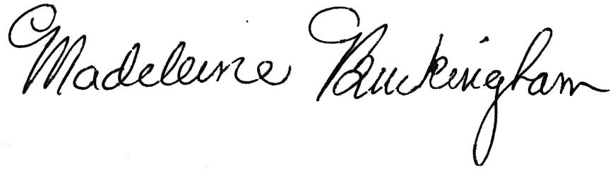
Madeleine Buckingham
Chief Financial Officer

