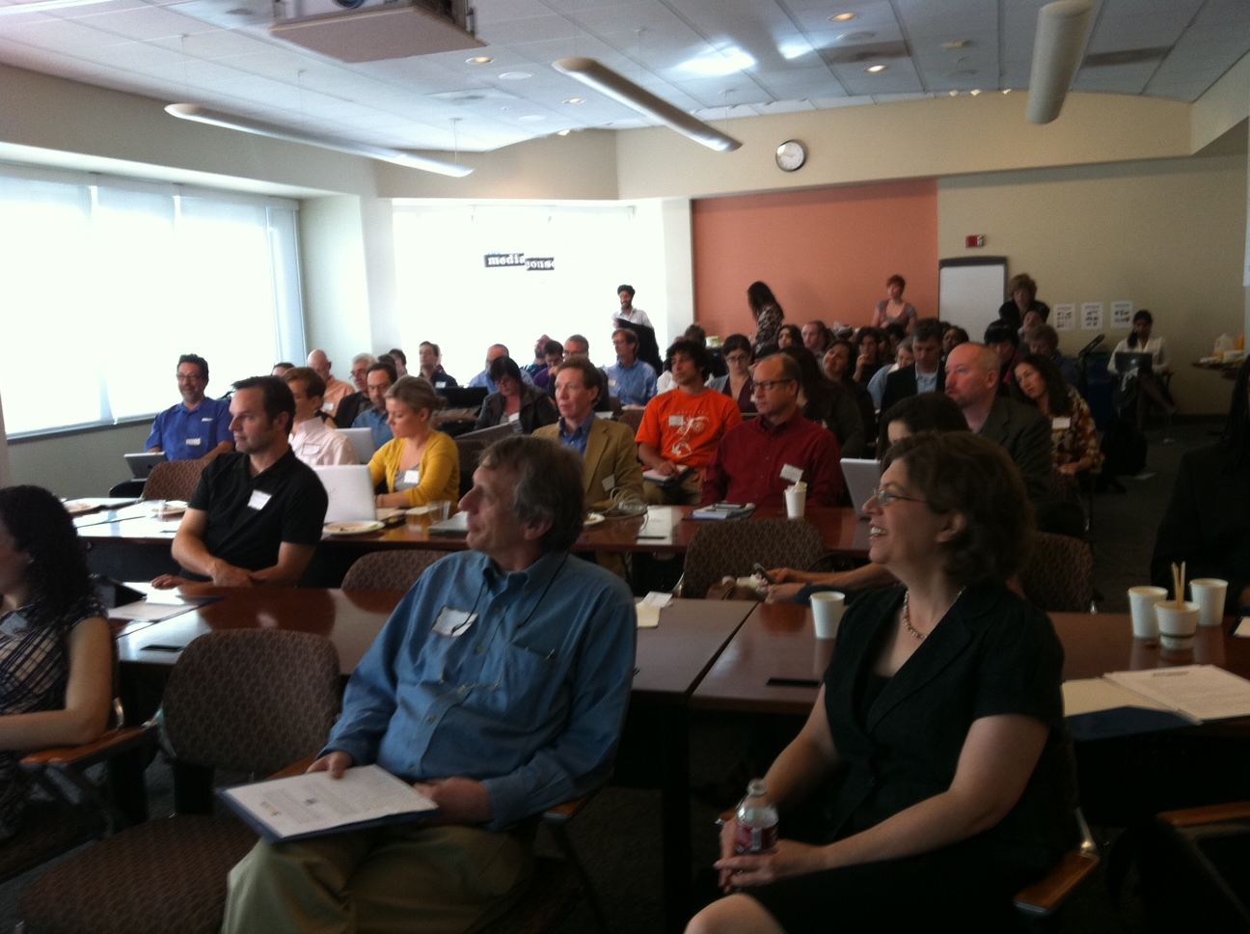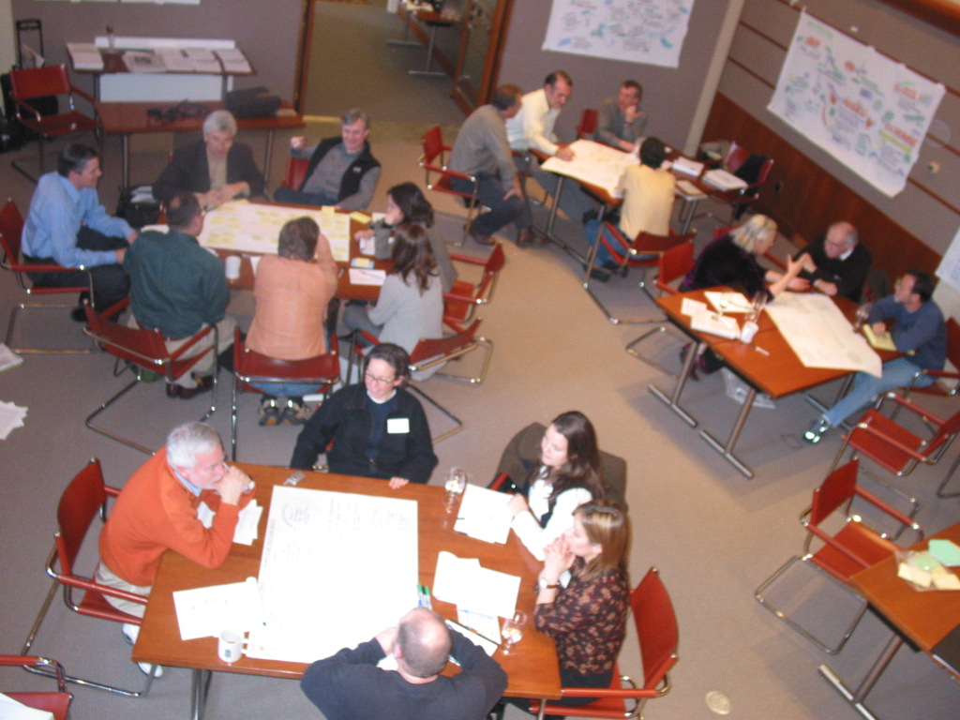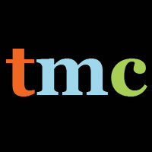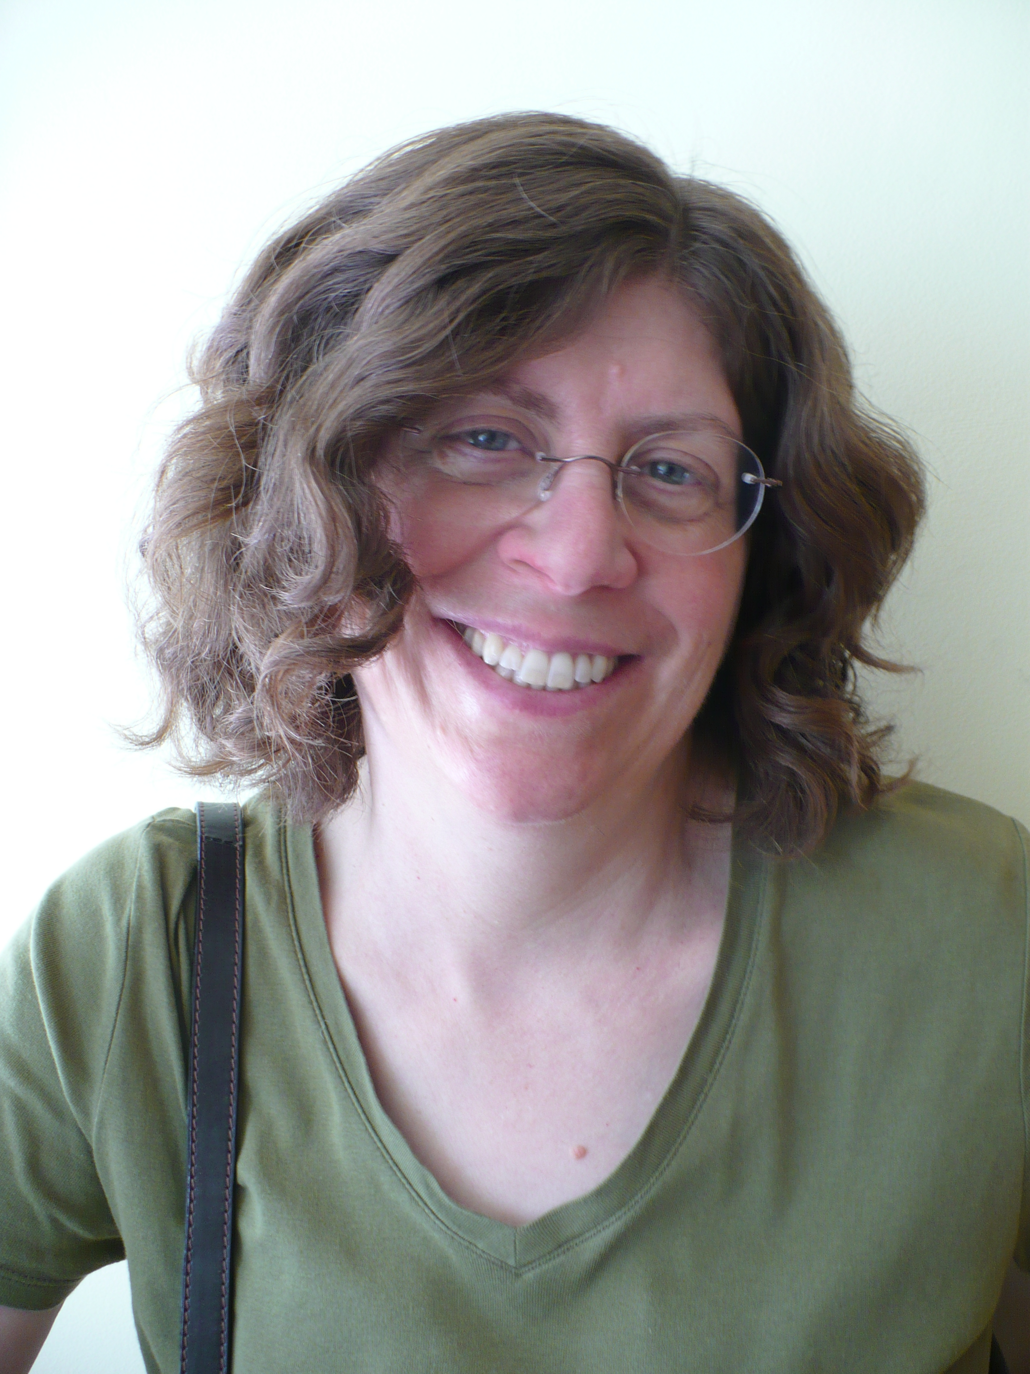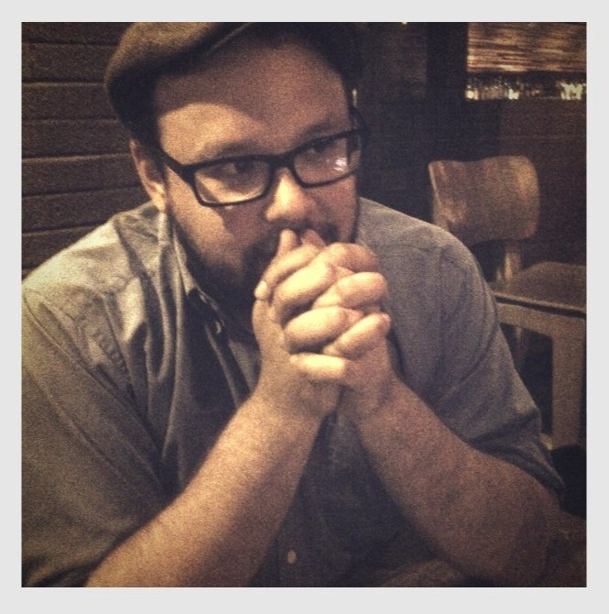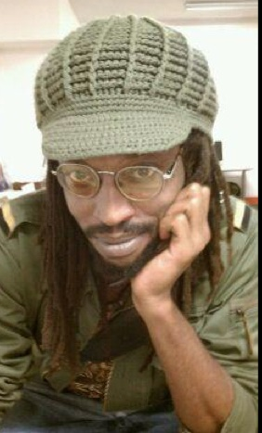

The Community Journalism Training Institute: Be Heard!

A Project of the Media Consortium

The action really started on day eight. I had a cellphone and I was using Twitter, and that was when we saw the pepper spraying of the protestors by Officer Bologna. [I started recording on my phone].

When that video took off, within three days it had over a million hits.

Tim Pool

Imagine that each of your organization’s actions resulted in dozens of tweets, facebooks, instagram photos, and live-streamed videos. What if your volunteers knew how to do a 60 Minutes-style interview with local politicians or police; what if they knew how to take a photo of an event that was compositionally compelling or video that captured the essence of the action?

The Community Journalism Training Institute can make that vision a reality. In our short, high-impact workshops, we empower your volunteers to use equipment they already own and digital access they already have to communicate the power of their activism.

We teach your volunteers how to Be Heard!

You teach your volunteers how to take action in their local communities.

Wouldn’t it be great if they also knew how to amplify their voices?

In the past, local news reporters would cover your activism. They’d grab your press release, interview your volunteers, and tell their story.

But you can’t rely on local news anymore. In today’s digital world, you make news by, literally, *making* news. Today, when you train your volunteers to be activists, you also need to train them to be journalists. You need to train them to tell their own story.

Imagine that each of your organization’s actions resulted in dozens of tweets, facebooks, instagram photos, and Ustreamed videos. What if your volunteers knew how to do a 60 Minutes-style interview with local politicians or police; what if they knew how to take a photo of an event that was compositionally compelling or video that captured the essence of the action?

The Community Journalism Training Institute can make that vision a reality. In our short, high-impact workshops, we empower individuals to use equipment they already own and digital access they already have to communicate the power of their activism.

We teach them how to be heard.

# Give Your Volunteers the Tools to Be Heard!

**Susan Mernit** is the Curriculum and Training Director at CJTI. She is also a journalist: the founder of Oakland Local and a circuit rider for the Knight Community Information Challenge. An experienced media executive for Fortune 200 companies, Susan now focuses on community engagement and audience development. She is highly requested as a speaker, consultant and trainer.

**Who We Are**

**Jo Ellen Green Kaiser** is the Executive Director of the Media Consortium and the Founding Director of CJTI. Before coming to the Media Consortium she worked as a consultant for nonprofit organizations, with a focus on volunteer management. She began her career as an academic, teaching for six years as an assistant professor of English at University of Kentucky. She holds degrees from Yale and UC Berkeley.

**The Media Consortium**

The Media Consortium is a network of the leading independent progressive news media in the United States. Our members include Mother Jones, The Nation, KCET-LinkTV, Free Speech Radio News, Yes!, Truthout, Colorlines.com, & many others.

We launched the Community Journalism Training Institute as a result of the Occupy movement. We saw the power of individuals to change the national conversation. We want to empower every individual who cares passionately about their community and this country’s future to be a change-maker. And that means, knowing how to communicate their activism.

The stories of individual volunteers are different from the stories told by professional activists or activist organizations. The power of the individual volunteer is to communicate in clear, simple, straightforward terms: what they are doing, when they are doing it, and who they are. Journalists will look to your organization, as the volunteer’s host, to explain the how and the why.

Providing your volunteers with this training sends volunteers the strong signal that you value their activism. By empowering your volunteers through training, you develop their skills and give them a way to Be Heard!

**Meet Our Trainers!**

Kwan Booth (Lead Trainer) is an award winning journalist and media strategist working at the intersection of communications, community, art and technology. Kwan is the cofounder of [Oaklandlocal.com](http://Oaklandlocal.com" \t "_blank) and [House of Local](http://Houseoflocal.org" \t "_blank) consulting and a member of the Black Futurist Working Group. He draws on 16 years of online communications expertise to train individuals to make best use of the digital landscape. Kwan has won awards from The Society of Professional Journalists national organization and the Northern California Chapter.

Irene Florez (Spanish-Language Trainer) is multimedia producer, editor and media strategist with deep experience in nonprofit communications as well as news-making. She has worked at Transfair, WAGES, and SEIU as well as at news outlets Making Contact (radio), Free Speech Radio News, and Oakland Local. Irene was born in Bogota, Colombia and is adept at working with diverse communities.

Terry Parris (Livestream Trainer) is a journalist, media-maker and community builder who specializes in user-generated content and citizen-based media. He most recently led the editorial team at Ustream, and previously worked as Managing Editor at Patch.com sites in Danville CA and Detroit.

PLUS: Trainers drawn from our partners around the country including Feet in 2 Worlds (NYC), Women’s Media Center (NYC), Campus Progress (DC), The Uptake (MN), People Power Media (CA/ Toronto) & many more.

**Your House or Our House**

If you wish, we can provide our trainings under your brand identity, in your space, seamlessly.

While our offices are based in the San Francisco Bay Area, we offer trainings across the United States. At your discretion, we can fly out our lead trainers to work with your group, or we can use our excellent partner trainers in your location.

**Custom Training for**

**Your Campaign**

With advance notice, we are able to customize any of our trainings to match your current campaign. For example, if your campaign will ask volunteers to hold protests outside local banks, we will focus on lighting in outdoor spaces, effectively capturing crowds on camera, and in our “plus” workshops, the legal issues that may arise from filming protest events.

**Pricing on Request**

**LiveStreamers’ Special**

2 hours: in person

1 online follow-up session

Master Trainer and Asst will provide hands on instruction for livestreamers, with tips on what makes a compelling stream and how to tag your stream for most hits.

**Think Like a Journalist Plus**

3 hours: in person

2 online follow-up sessions

1-on-1 mentoring for 2 months

Master Trainer, Asst. and local journalist will teach participants how to conduct an interview, how to choose a subject for a photo, how to decide what to film and when. Continuing mentoring designed to help participants solve problems with equipment and facilitate publication of content to various social media outlets.

**Think Like a Journalist**

3 hours: in person

2 online follow-up sessions

Master Trainer, Asst. and local journalist will teach participants how to conduct an interview, how to choose a subject for a photo, how to decide what to film and when.

**Spanish Language**

All of our workshops can be offered in Spanish. Our trainers have deep experience working with a variety of Spanish-speaking populations.

**Be Heard Workshop**

2 hours: in person

30 min follow-up online

Master trainer and assistant will provide hands-on practice for participants. Participants should bring whatever phone or camera they already own.



**Be Heard Webinar**

30-50 minute interactive webinar

Trainer demonstrates ways participants can use their phones, cameras to report on their activism. Webinar is completely interactive.

**Be Heard Workshop Plus**

3 hours: in person

2 online follow-up sessions

Master trainer, assist trainer, and local journalist will provide hands-on practice for participants, including realistic simulations. Participants should bring whatever phone or camera they already own. Refreshments provided



**Be Heard!**

**Introductory Workshop**

50 minutes: in person

Trainer demonstrates ways participants can use their phones and cameras to report on their own activism.

**Custom**

**Think Like a Journalist**



CJTI

Be Heard!

Jo Ellen Green Kaiser  
Director, Community Journalism Training Institute

[director@cjti.org](mailto:director@cjti.org); 415-878-3862

[Web Address]

CONTACT US NOW!